Vitamin D inhibits apoptosis in THP-1 cells infected with mycobacterium tuberculosis through TNF signaling pathway

Apoptosis

Yusheng Yang, Jiezhong Deng, Pan Liu, Jinyue He, Jiulin Tan, Bo Yu, Yun Bai, Fei Luo, Jianzhong Xu, Zehua Zhang.

Zehua Zhang, Department of Orthopedic, Southwest Hospital, Army Medical University, zhangzehuatmmu@163.com

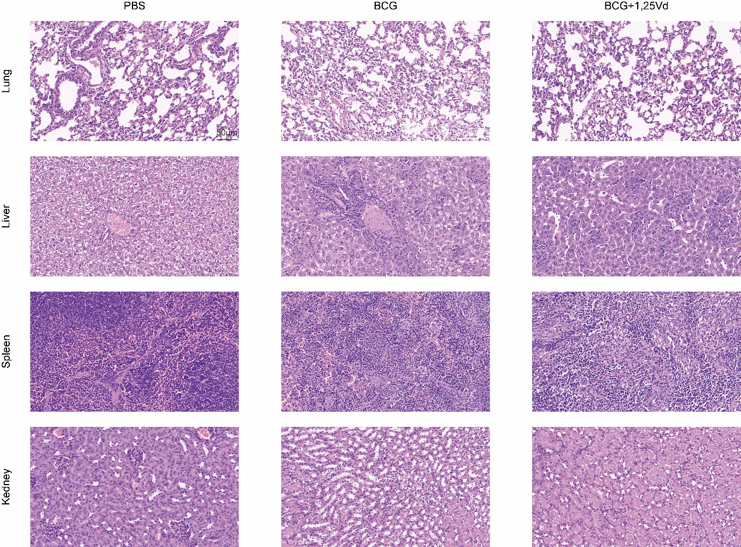
Fig.S1 Histological evaluation of BCG on multiple organ damage in vivo. Hematoxylin and eosin (H&E) staining of liver, spleen, lung and kidney from mice of PBS, BCG and BCG+1,25(OH)₂D₃. Scale bar, 50 µm.

