Electronic Supplementary Information (ESI)

Conformational Investigations on Three Large Dinuclear Triple Helicates by Single Crystal X-ray Diffraction

Kyle J. Howard-Smith^{1†}, Matthew J. Wallis^{1†}, James P. Flood,¹ Hyunsung Min¹, Joseph C. Tadros¹, Ruoming Tian², Mohan M. Bhadbhade², Chrisopher E. Marjo² and Feng Li^{1*}

¹ School of Science, Western Sydney University, Locked Bag 1797, Penrith, NSW, 2571, Australia.
² Mark Wainwright Analytical Centre, University of New South Wales, Sydney, 2052, Australia.

† These authors contributed equally to this work
*Corresponding author: Feng Li, feng.li@westernsydney.edu.au, Tel: +612 9685 9987

Contents

S1. Mass Spectrometry 2
S2. FTIR 4
S3. TGA-DSC 6
S4. SEM-EDS 7
S5. NMR 9
S6. Crystallographic Data Table 10
S7. Average Torsion Angle Calculations 10
S8. Average axis…O Radius Calculations 11
S9. Chelate Ring Angles 12
S10. 4-Thiazolylimine analogue 13
S12. References 13

S1. Mass Spectrometry
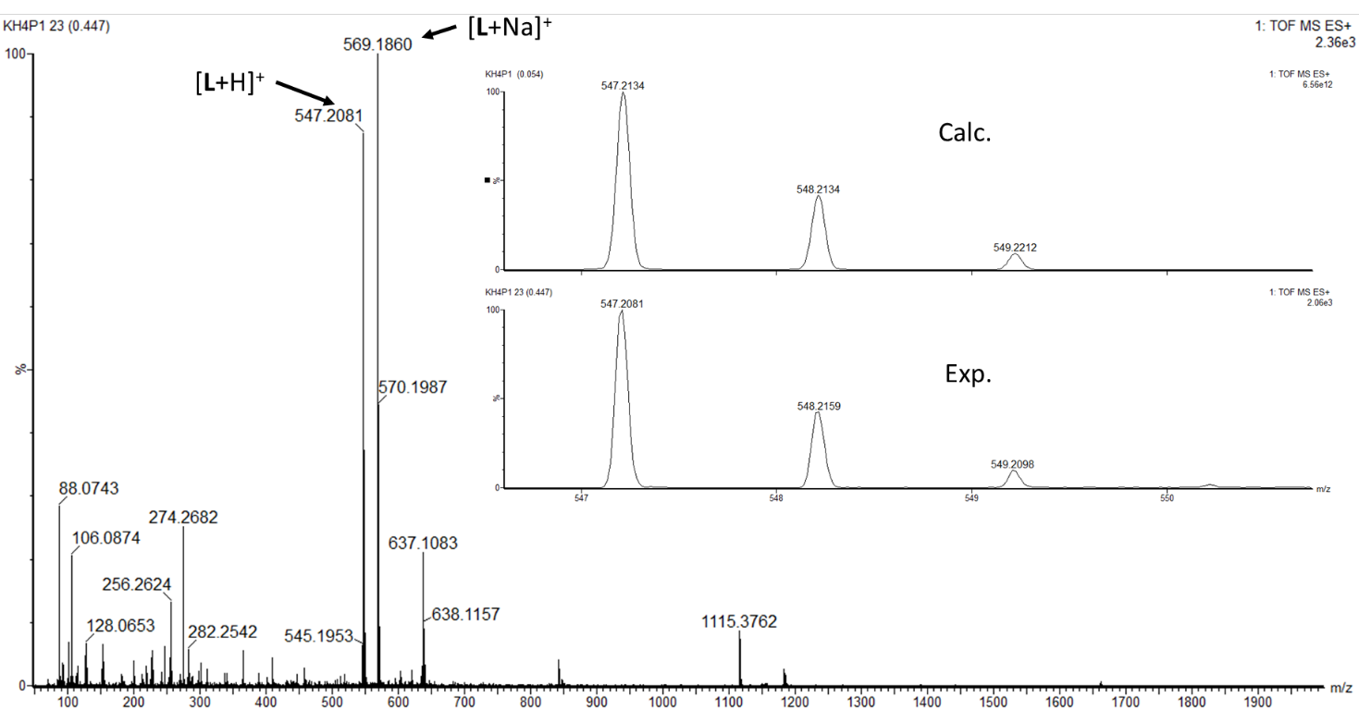
Fig. S1.1 ESI-HRMS spectrum of L. Inset shows calculated and experimental isotopic distribution of [L+H]⁺.

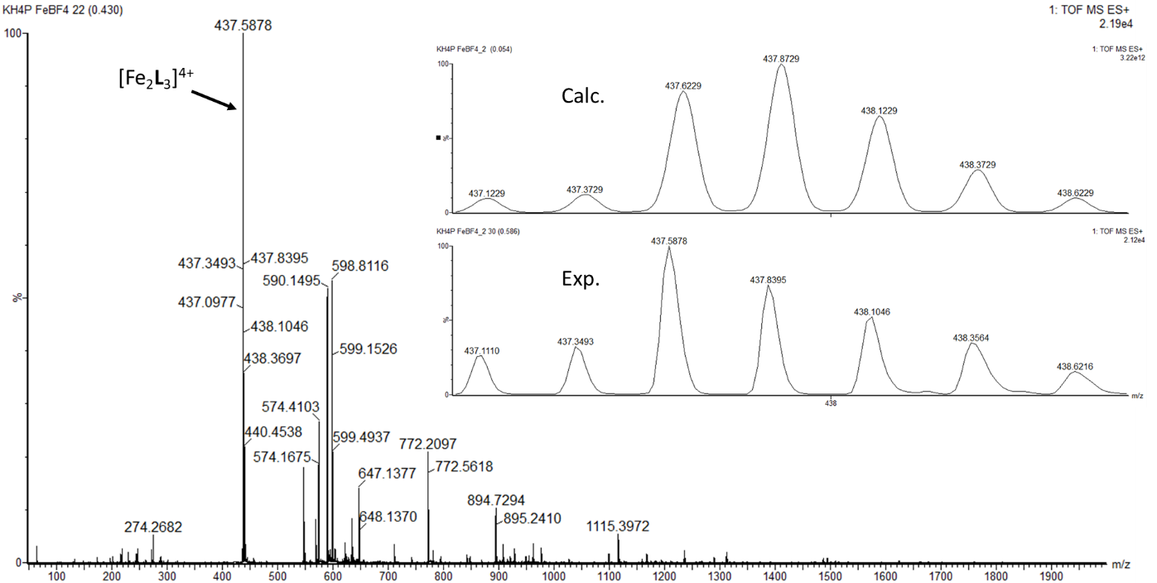
Fig. S1.2. ESI-HRMS spectrum of 1. Inset shows calculated and experimental isotopic distribution of [Fe₂L₃]⁴⁺.
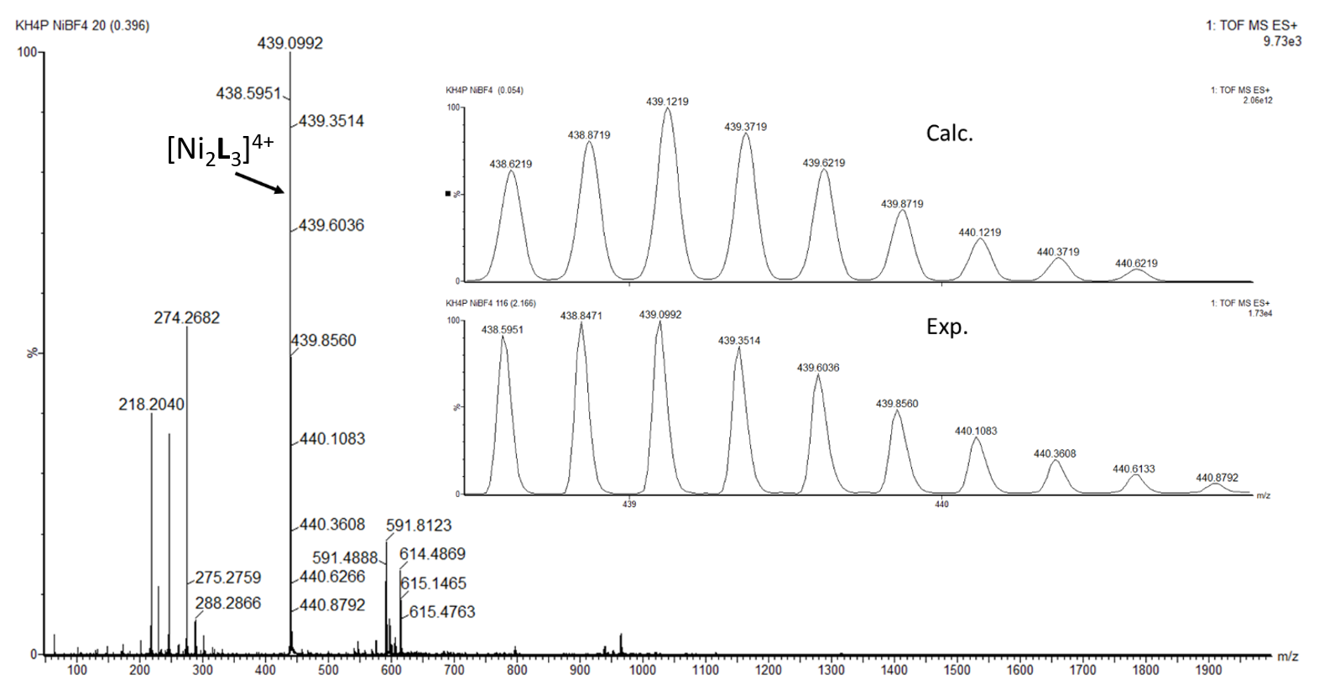
Fig. S1.3. ESI-HRMS spectrum of 2. Inset shows calculated and experimental isotopic distribution of [Ni₂L₃]⁴⁺.
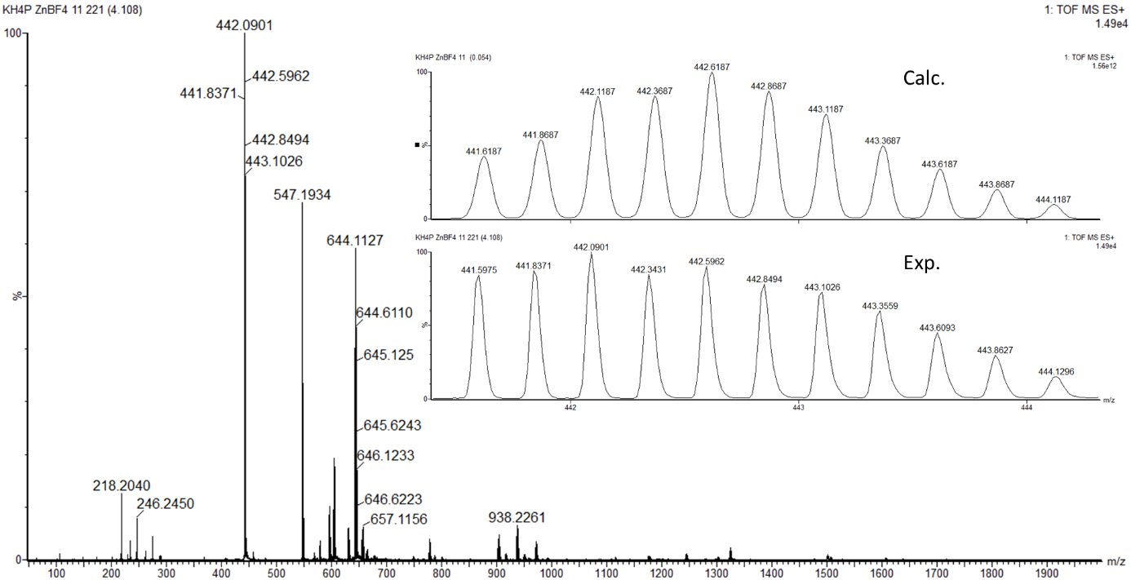
Fig. S1.4. ESI-HRMS spectrum of 3. Inset shows calculated and experimental isotopic distribution of [Zn₂L₃]⁴⁺.

S2. FTIR
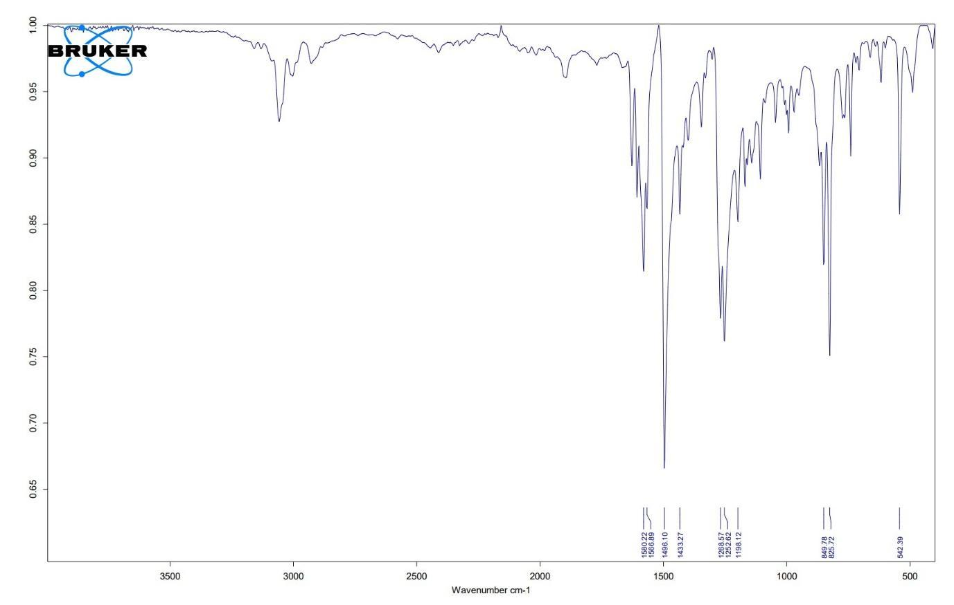
Fig. S2.1. FT-IR spectrum of ligand L
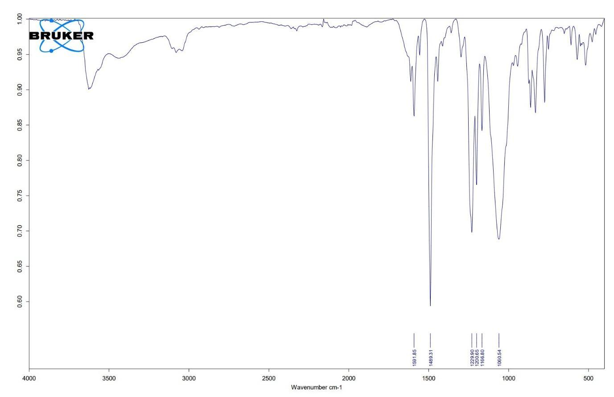
Fig. S2.2. FT-IR spectrum of 1.
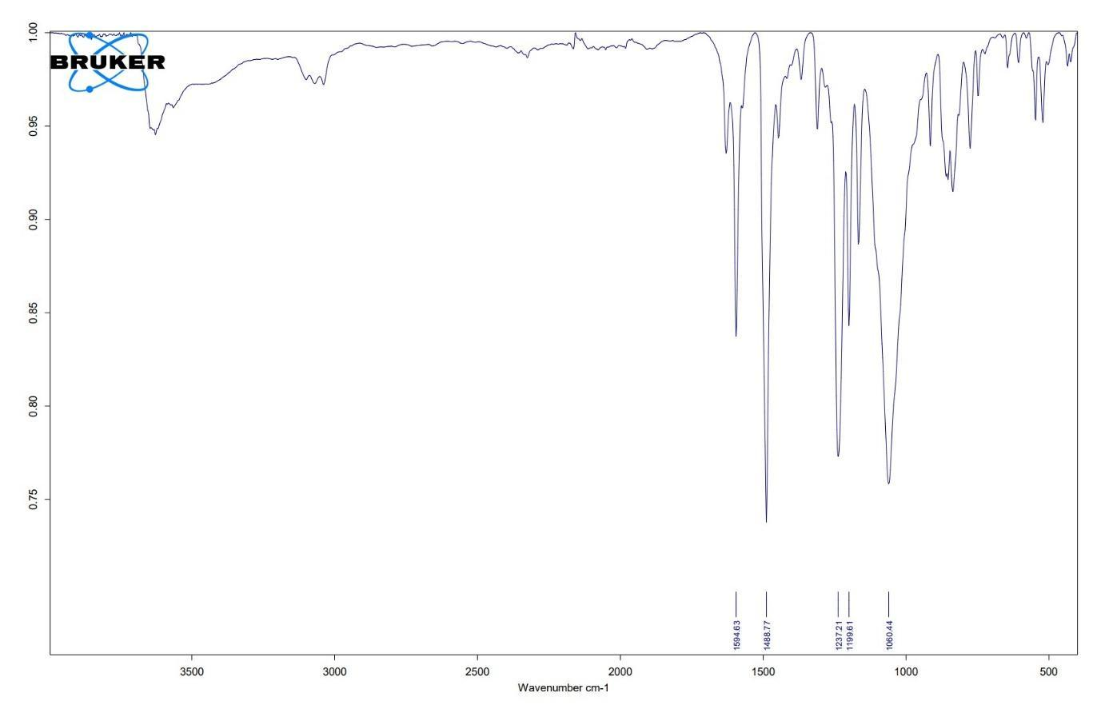
Fig. S2.3. FT-IR spectrum of 2.
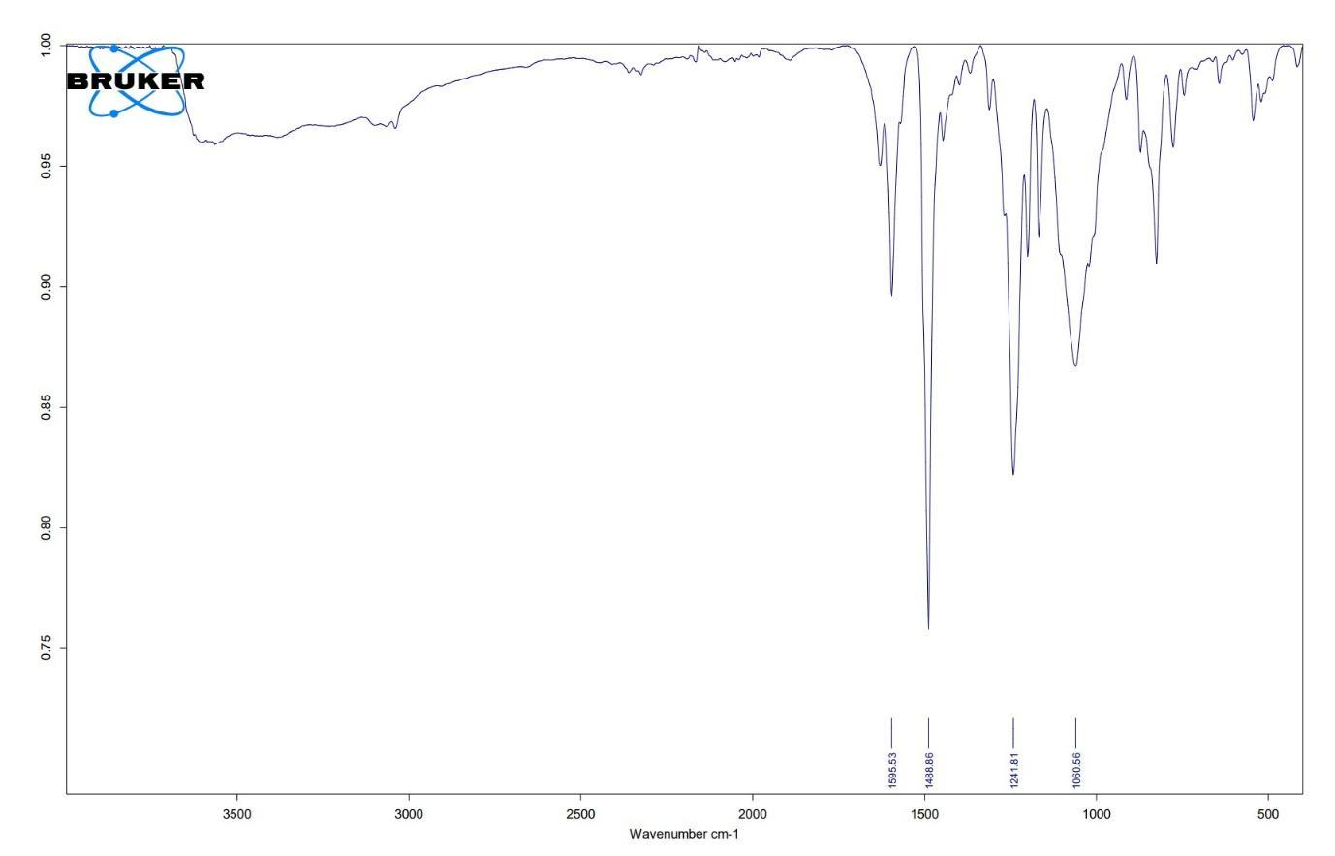
Fig. S2.4. FT-IR spectrum of 3.

S3. TGA-DSC
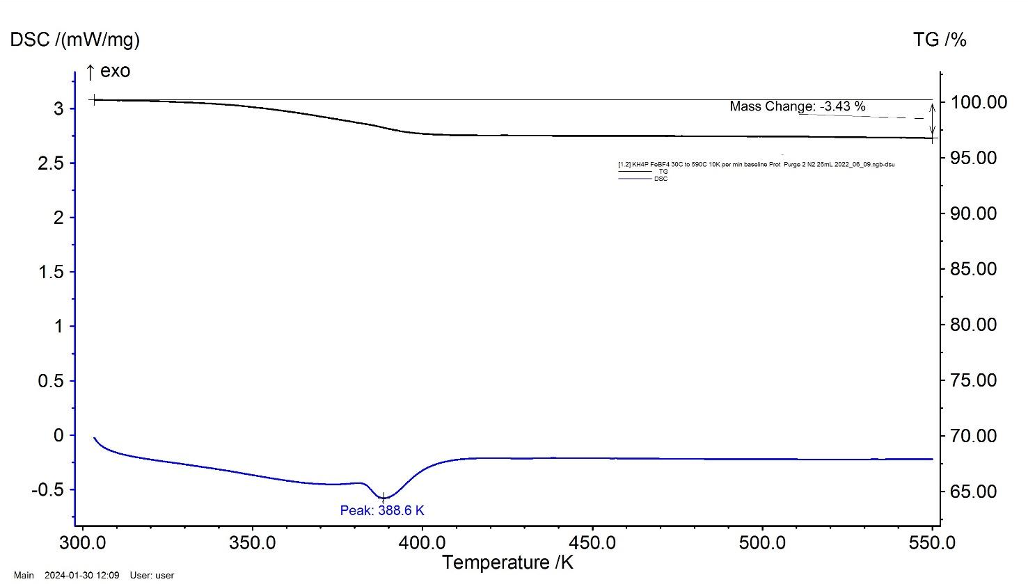
Fig. S3.1. TGA-DSC for 1 dried at room temperature. Blue line indicates DSC, black line indicates TGA.

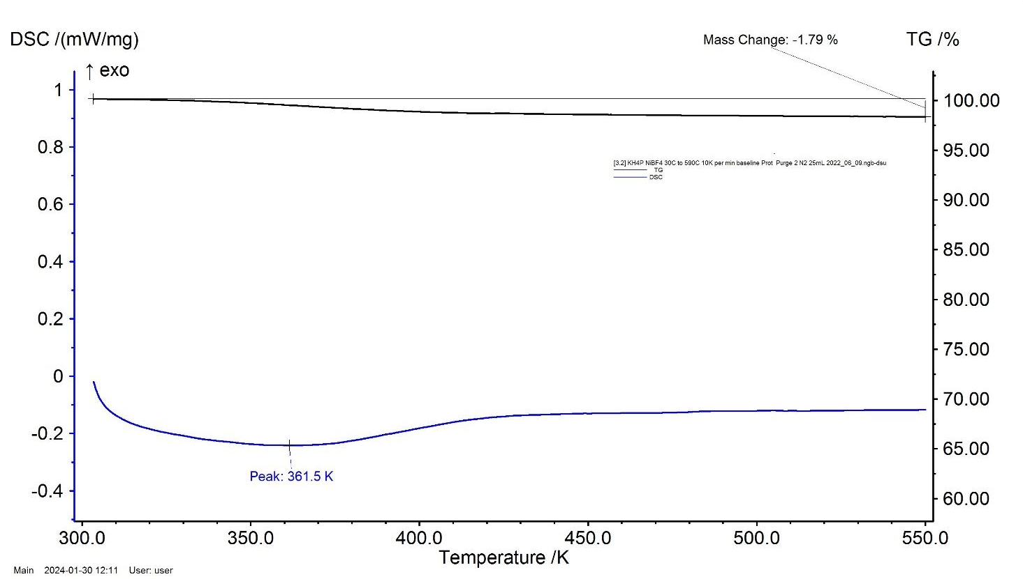
Fig. S3.2. TGA-DSC for 2 dried at room temperature. Blue line indicates DSC, black line indicates TGA.
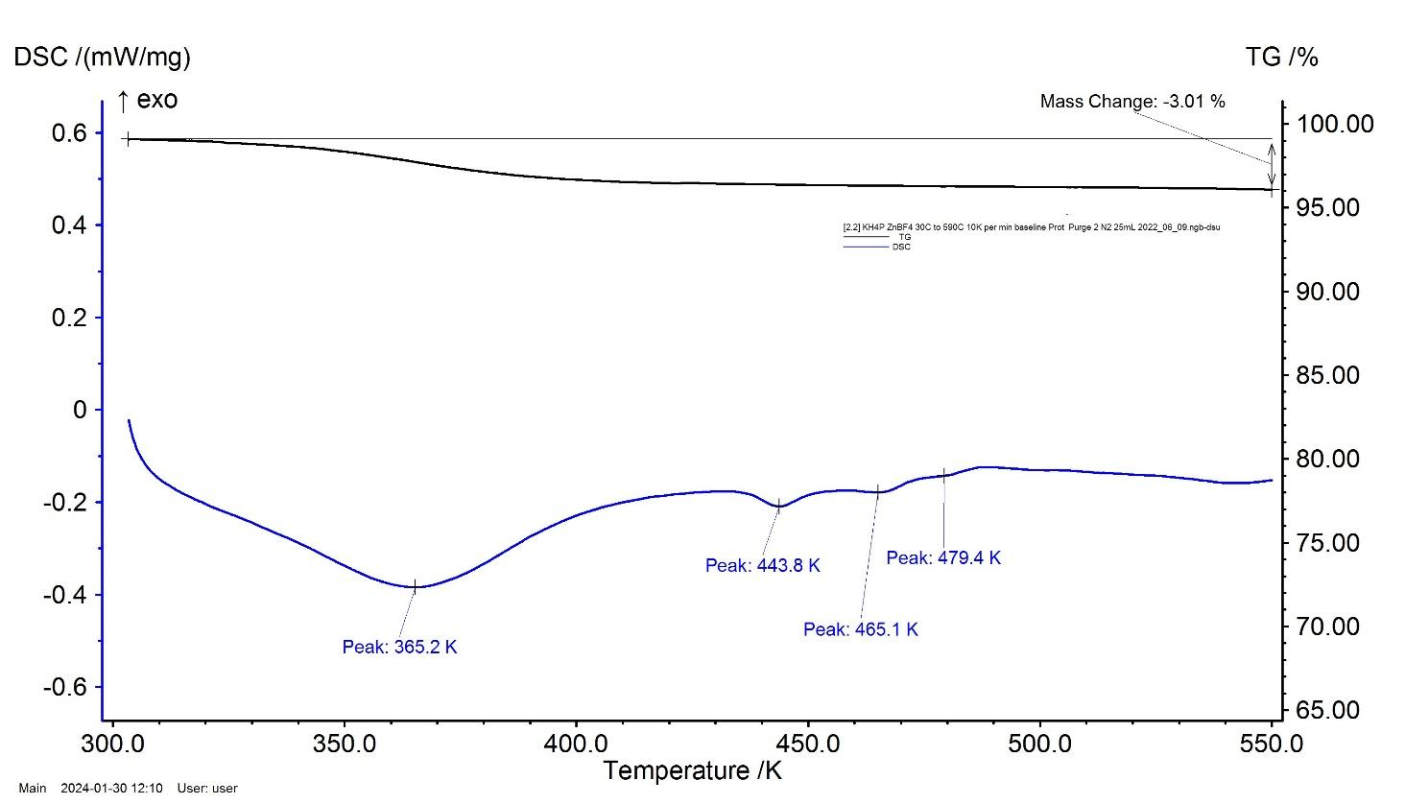
Fig. S3.3. TGA-DSC for 3 dried at room temperature. Blue line indicates DSC, black line indicates TGA.

S4. SEM-EDS
SEM micrographs of complexes 1-3, images for 1 and 2 performed on single crystals, 3 on powder precipitate. EDS analysis reveals the identity of elements in line with what is expected for each complex. Presence of Al in each sample is attributed to the aluminium stub on which each sample was mounted.
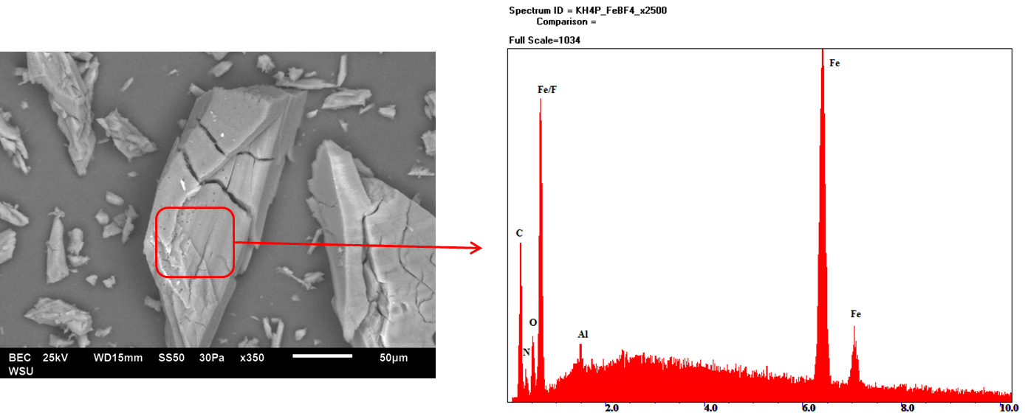
Fig. S4.1. Backscattering SEM micrograph (left) and corresponding EDS analysis (right) of [Fe₂L₃](BF₄)₄
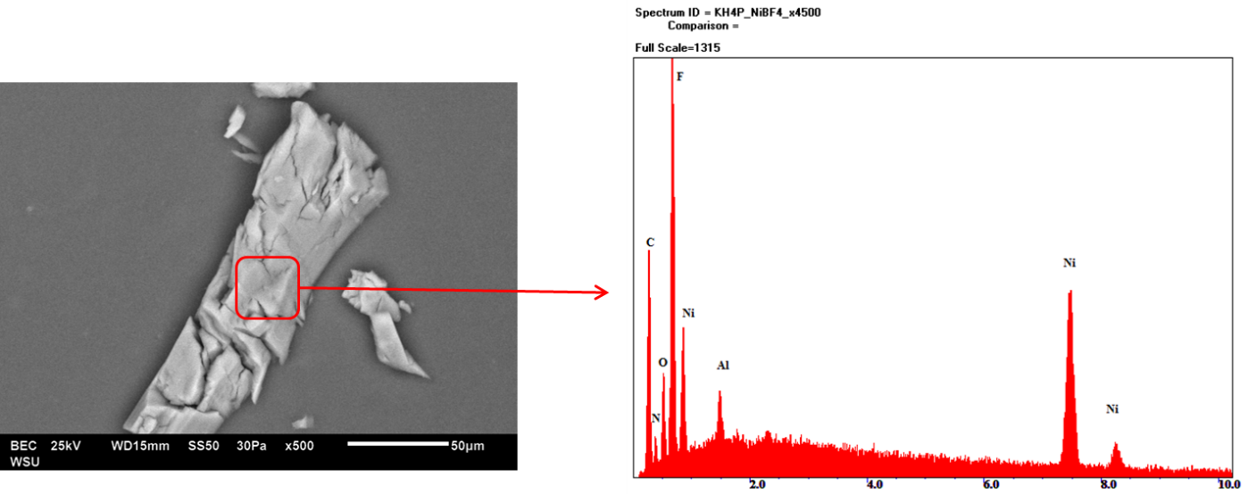
Fig. S4.2. Backscattering SEM micrograph (left) and corresponding EDS analysis (right) of [Ni₂L₃](BF₄)₄
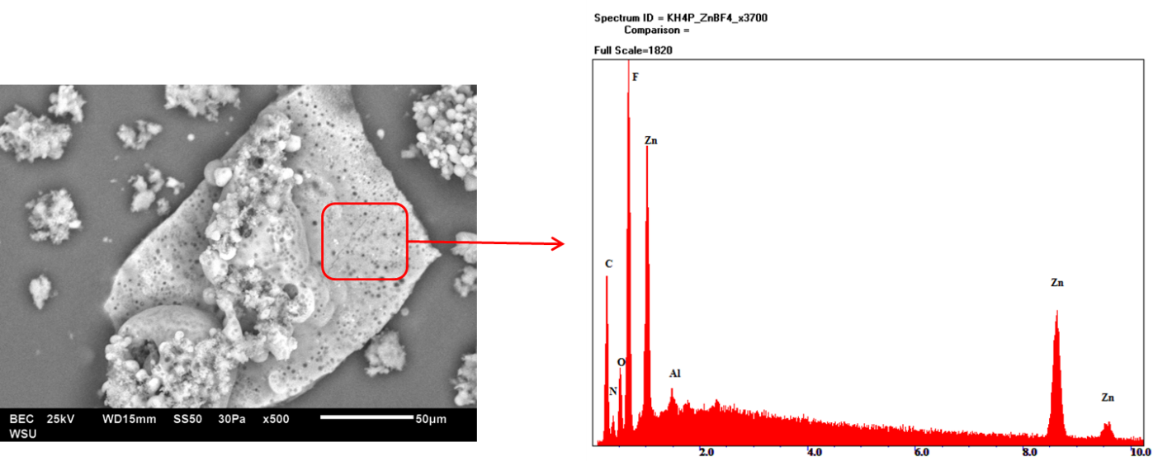
Fig. S4.3. Backscattering SEM micrograph (left) and corresponding EDS analysis (right) of [Zn₂L₃](BF₄)₄

S5. NMR
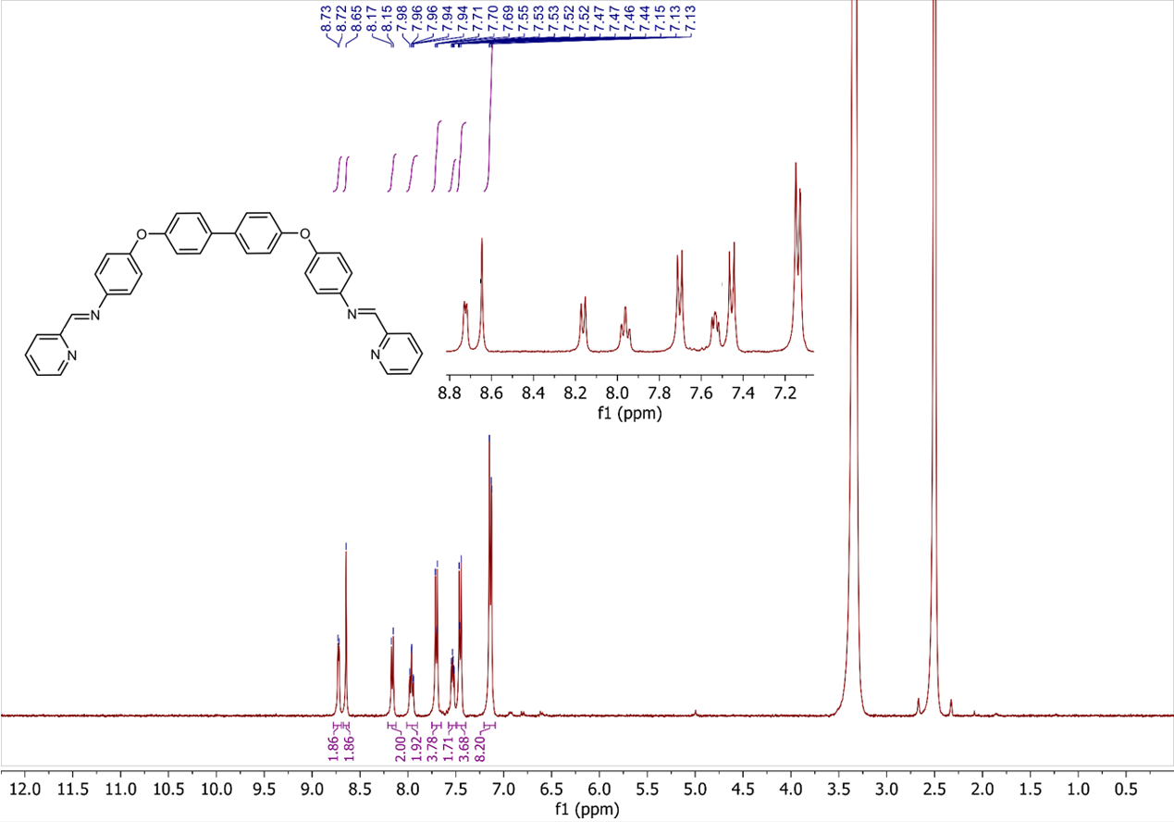
Fig. S5.1. Proton NMR of Ligand L

¹H NMR (400 MHz, DMSO-d₆) δ 8.72 (dd, J = 7.5, 1.6 Hz, 2H, Ar-H), 8.65 (s, 2H, N=C-H of imine), 8.16 (dd, J = 7.5, 1.7 Hz, 2H, Ar-H), 7.96 (td, J = 7.4, 1.5 Hz, 2H, Ar-H), 7.70 (d, J = 8.5 Hz, 4H, Ar-H), 7.53 (td, J = 7.4, 1.6 Hz, 2H, Ar-H), 7.46 (d, J = 8.7 Hz, 4H, Ar-H), 7.20–7.09 (m, 8H, Ar-H).

S6. Crystallographic Data Table
Table S6. Crystallographic data table for complexes 1 – 3 respectively
Identification code | 2329598 | 2329599 | 2329600
Empirical formula | C₁₁₉H_{104.1}B₄F₁₆Fe₂N_{17.5}O_{10.8} | C_{118.4}H_{100.6}B₄F₁₆N_{17.2}Ni₂O_{9.5} | C₁₁₆H_{101.2}B₄F₁₆N₁₆O_{11.6}Zn₂
Formula weight | 2411.03 | 2381.01 | 2382.90
Temperature/K | 120.00 | 120.00 | 105.00
Crystal system | monoclinic | monoclinic | monoclinic
Space group | C2/c | C2/c | C2/c
a/Å | 28.218(4) | 28.147(2) | 28.426(2)
b/Å | 19.335(4) | 19.697(2) | 19.771(2)
c/Å | 21.544(3) | 21.705(2) | 21.5656(18)
α/° | 90 | 90 | 90
β/° | 101.453(6) | 101.738(4) | 101.903(4)
γ/° | 90 | 90 | 90
Volume/Å³ | 11520(3) | 11782(2) | 11859(2)
Z | 4 | 4 | 4
ρ_{calc}g/cm³ | 1.390 | 1.342 | 1.335
μ/mm⁻¹ | 0.346 | 0.409 | 0.494
F(000) | 4972.0 | 4910.0 | 4904.0
Crystal size/mm³ | 0.1 × 0.1 × 0.1 | 0.169 × 0.11 × 0.11 | 0.1 × 0.1 × 0.05
Radiation | MoKα (λ = 0.71073) | MoKα (λ = 0.71073) | MoKα (λ = 0.71073)
2Θ range for data collection/° | 3.858 to 42.152 | 4.136 to 41.828 | 4.354 to 37.966
Index ranges | -28 ≤ h ≤ 28, -19 ≤ k ≤ 19,  -21 ≤ l ≤ 21 | -28 ≤ h ≤ 28, -19 ≤ k ≤ 19,  -21 ≤ l ≤ 21 | -25 ≤ h ≤ 25, -18 ≤ k ≤ 18,  -19 ≤ l ≤ 19
Reflections collected | 80681 | 49647 | 77481
Independent reflections | 6165 [R_{int} = 0.0937, R_{sigma} = 0.0343] | 6227 [R_{int} = 0.1534, R_{sigma} = 0.0691] | 4717 [R_{int} = 0.1086, R_{sigma} = 0.0342]
Data/restraints/parameters | 6165/250/737 | 6227/427/749 | 4717/568/661
Goodness-of-fit on F² | 1.052 | 1.091 | 1.060
Final R indexes [I>=2σ (I)] | R₁ = 0.1051, wR₂ = 0.2784 | R₁ = 0.1250, wR₂ = 0.3117 | R₁ = 0.1035, wR₂ = 0.2708
Final R indexes [all data] | R₁ = 0.1367, wR₂ = 0.3274 | R₁ = 0.1586, wR₂ = 0.3476 | R₁ = 0.1416, wR₂ = 0.3261
Largest diff. peak/hole / e Å⁻³ | 0.99/-0.59 | 0.93/-0.50 | 1.16/-0.66

S7. Average Torsion Angle Calculations

To describe the twist inherent to each helicate species, the average torsion angle between the opposing ring nitrogen donors, with respect to the intermetallic axis was calculated, as per our previous work [1]. This torsion angle was calculated for each of the separate ligand arms, and the average of these values was taken to give the final measurement.
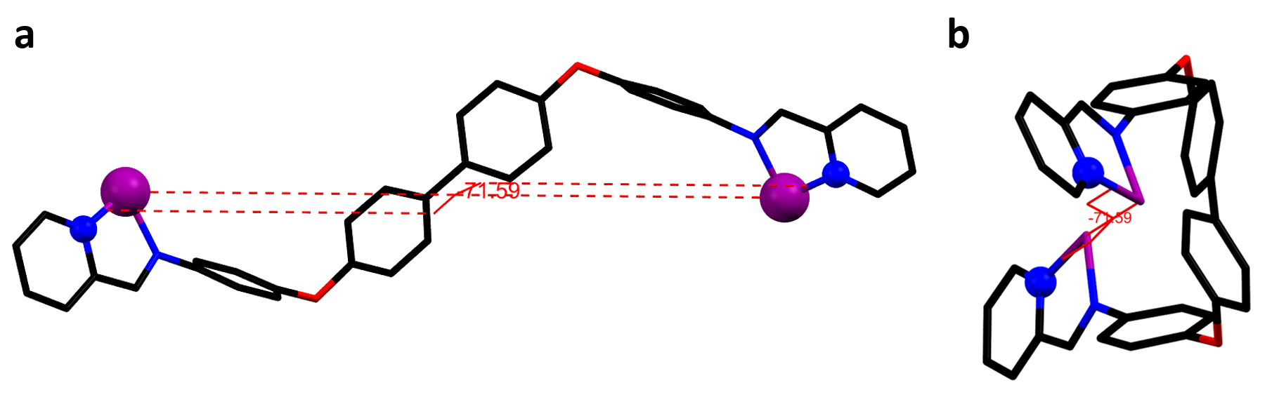

Fig. S7.1. Schematic representation of the torsion angle used to describe the twist of dinuclear triple helicates

S8. Average axis…O Radius Calculations
To represent the spread of the body section of the dinuclear triple helicate assemblies, the average axis…O radius was calculated (Fig. S9.1). To calculate this value for each individual O atom, first the intermetallic distance was calculated (distance between the ith and jth metal centres). The length between the ith metal centre and the relevant Oxygen was measured, as well as the distance between the Oxygen atom and the jth metal atom. Using these values, the area of the triangle containing these three points was calculated using Heron’s formula:
A = SQRT[s*(s-a)*(s-b)*(s-c)]
Where s refers to the semi perimeter, and a, b and c refer to the side lengths. The height was calculated using the relationship between the triangle base, perpendicular height, and area:
h = 2*A*b
Averages were taken after measuring each individual Oxygen atom in the helicate.
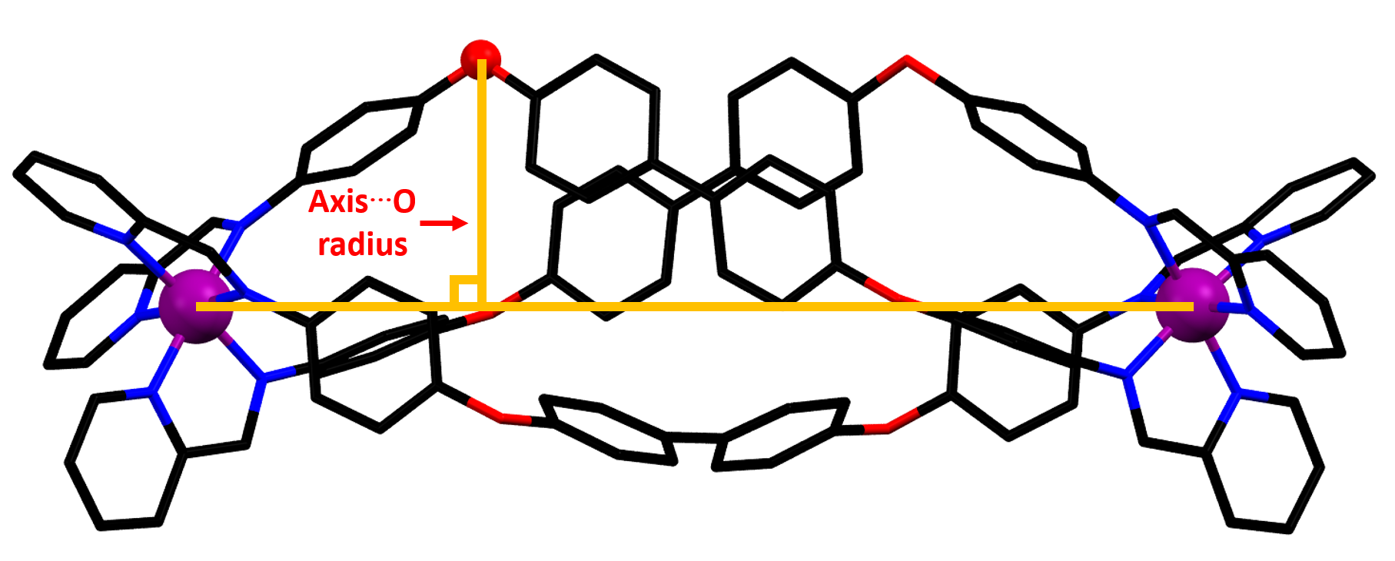 Fig. S8.1. Schematic representation of Axis…O radius.

In our previously reported [LS-LS] Fe^{II} thiazolylimine helicate some oxygens were disordered over two positions. [1] In this case, the axis…O radius was calculated for each conformation, then each value was scaled by the relevant occupancy.

S9. Chelate Ring Angles
Calculation of Pitch and Yaw
The angle between the chelate ring and intermetallic axis can be deconstructed into two components, representing the back and forth rocking and side to side twisting of each chelate ring, relative to the intermetallic axis. To quantify these motions, we adapted the concepts of pitch, roll and yaw, such that the combination of each angular component uniquely described the orientation of each chelate ring relative to the intermetallic axis.
Since we are using a simplistic model, involving only the coordinating N atoms, we assume that the roll component is negligible, and we thus define it to be zero. After taking the coordinates of Fe_{i}, Fe_{j}, N_{i} and N_{j}, we subject them to the following procedure to calculate the pitch and yaw angular components.
● All coordinates were translated such that Fei occupied the origin.
● The cross product of vectors N_{i} and N_{j} was calculated.
● All coordinates rotated about the x axis, such that the cross product lay in the xz axis.
● All coordinates were rotated about the y axis, such that the cross product lay on the z axis. This in turn means that N_{i} and N_{j} both lie in the xy plane.
● All coordinates were rotated about the z axis, such that Fe_{j} lay in the xz plane.
● Yaw was calculated using the Fe_{j} z and x coordinates by arctan(z/x).
● Pitch was calculated using the gradient of the N_{i} - N_{j} interval by arctan(N_{j} y - N_{i} y) / (N_{j} x - N_{i} x).
The signs of all yaw values were taken as positive, and the signs of pitch values were checked using the ratios of the y coordinates of N_{j} and N_{i} to determine the sign. Positive pitch was taken to mean the coordinating N in the thiazole lay closer to the intermetallic axis than the coordinating N of the imine, and the opposite is true in the case of negative pitch. For more detailed explanations, please check references [2,3] in this supporting information.
The calculated values for each chelate ring in all structures can be viewed in Table S10.

Table S9. Chelate ring angles. An asterisk indicates the labelling scheme of ligands in the Fe^{II} 4-thiazolylimine structure (see below).
 | 1  Fe (d⁶) | 2  Ni (d⁸) | 3  Zn (d¹⁰) | * LS-LS (Fe1)  Fe (d⁶) | * LS-LS (Fe2)  Fe (d⁶)
A_{i} 3D (*C_{t}) | 42.706 | 41.928 | 38.829 | 39.863 | 40.551
A_{i} pitch (*C_{t}) | 7.793 | 7.847 | 7.439 | -0.123 | 0.639
A_{i} yaw (*C_{t}) | 42.113 | 41.321 | 38.219 | 39.863 | 40.547
A_{f} 3D (*B_{t}) | 35.898 | 35.211 | 35.002 | 33.570 | 31.979
A_{f} pitch (*B_{t}) | -9.165 | -9.008 | -9.169 | 9.086 | 1.8461
A_{f} yaw (*B_{t}) | 34.860 | 34.184 | 33.927 | 32.457 | 31.931
B 3D (*A_{t}) | 31.069 | 31.717 | 29.13 | 32.128 | 32.082
B pitch (*A_{t}) | 8.304 | 8.533 | 7.692 | 2.766 | 8.297
B yaw (*A_{t}) | 30.046 | 30.093 | 28.182 | 32.022 | 31.102

S10. 4-Thiazolylimine analogue
The 100 K structure previously reported Fe^{II} 4-thiazolylimine analogue has been obtained from the deposted .cif (1997271).[1] The ligand labelling scheme was left unchanged, but in this study the subscript t was used to denote ligands and chelate groups in this structure.
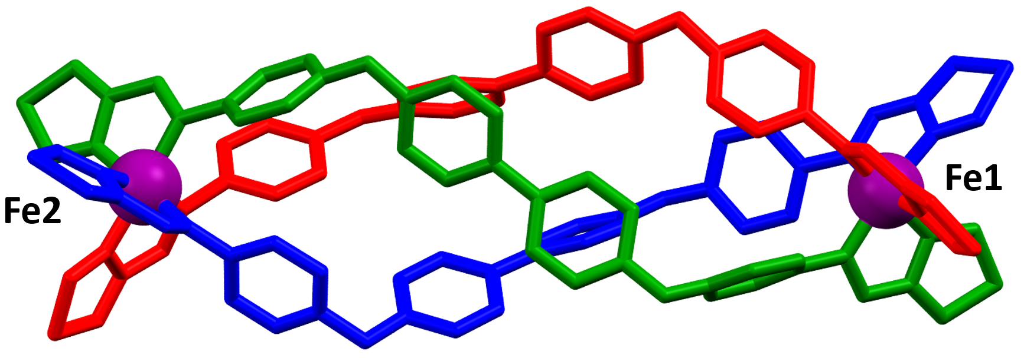
Fig. S10. Dinuclear triple helicate unit in the 100 K structure of the Fe^{II} 4-thiazolylimine analogue. Ligands are designated C_{t} (red), B_{t} (blue), A_{t} (green) and LS Fe^{II} centres are purple.

S12. References
[1] Howard-Smith, K. J. Craze, A. R. Zenno, H. Yagyu, J. Hayami, S. Li, F.: A large dinuclear Fe(II) triple helicate demonstrating a two-step spin crossover. Chem. Comm. 56 (62), 8838-8841 (2020). DOI: 10.1039/D0CC03708G.
[2] Wallis, M. J. Min, H. Lindoy, L. F. Li, F.: Investigating the Conformations of a Family of [M(2)L(3)](4+) Helicates Using Single Crystal X-ray Diffraction. Molecules. 28 (3), 1404 (2023). DOI: 10.3390/molecules28031404
[3] Wallis, M.J., Craze, A.R., Zenno, H., Tokunaga, R., Taira, T., Min, H., Bhadbhade, M.M., Bhattacharyya, S.K., Tian, R., Rich, A.M., Hayami, S., Clegg, J.K., Marjo, C.E., Lindoy, L.F., & Li, F.: J. Mater. Chem. C. 11, 8908-8918 (2023).

