Supplementary Information

Label-Free Evanescent Imaging of Cellular Heterogeneity in Membrane Protein Binding Kinetics
Caixin Huang^{1,2}, Zhaoyang Liu^{1,3}, Jiying Xu^{1,3}, Liangju Li^{1,2}, Yi Chen^{1,3}, Ying Zhao², Pengfei Zhang^{1,3*}
1. Beijing National Laboratory for Molecular Sciences, Key Laboratory of Analytical Chemistry for Living Biosystems, Institute of Chemistry, Chinese Academy of Sciences, Beijing 100190, China
2. School of Pharmacy, Xinxiang Medical University, Xinxiang 453003, China
3. University of Chinese Academy of Sciences, Beijing 100049, China
* Corresponding author contact email: pfzhang@iccas.ac.cn

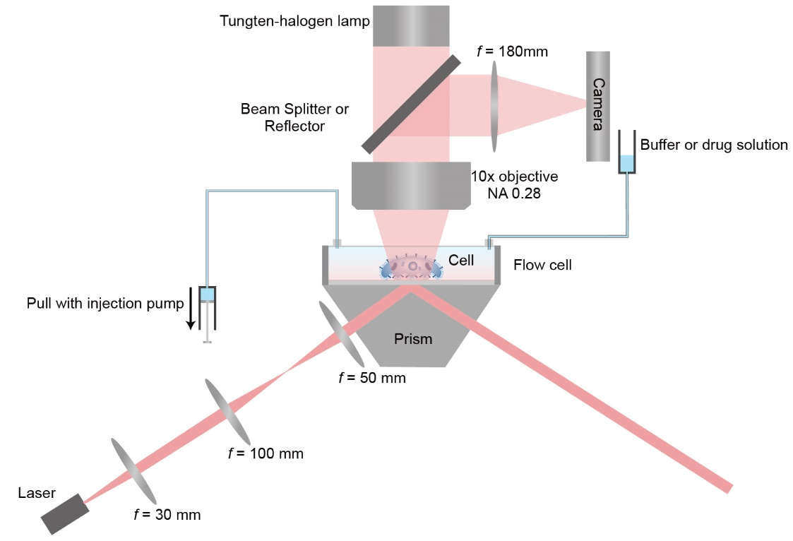
Supplementary Figure 1
Optical setup for ESM.
Light from a laser diode with a center wavelength of 638 nm (HL63023DG, Hitachi) was conditioned by three lenses configured in a 4-f arrangement. Three lenses have focus lengths of 30 mm, 100 mm, and 50 mm, respectively. The distances between the laser and first lens, between the first and second lens, between the second and third lens, and between the third lens and prism surface are set to be 30 mm, 130 mm, 150 mm, and 50 mm to construct the 4-f arrangement. The 4-f arrangement allows scanning the incident angles without changing the illumination area. The scattering of evanescent waves by cells was collected by a Motic 10x objective on the top of cover glasses, and then imaged by the camera (XIMEA MC124MG-SY). A tungsten-halogen lamp was used as the light source for bright field imaging, and the beam splitter was inserted to construct the bright field imaging path. It should be noted that the beam splitter will be replaced with a reflector during ESM imaging processes to avoid reducing the signal intensity.
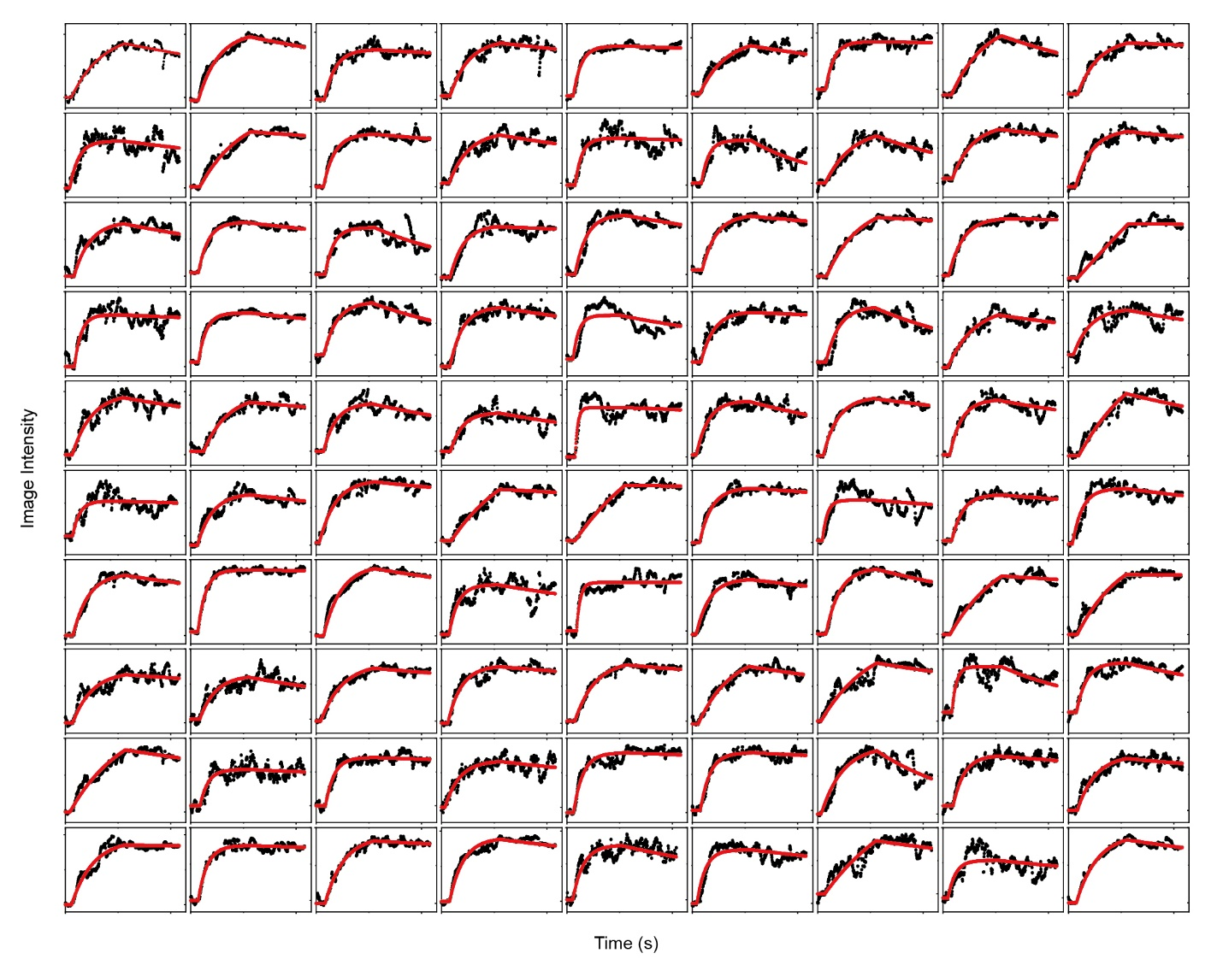
Supplementary Fig. 2
Binding curves from fixed A431 cells interacting with WGA (1st part).
The binding curves of the first 90 individual fixed A431 cells, where the binding curves can be fitted with a first-order binding kinetics model. The fitted lines are presented with red solid lines.

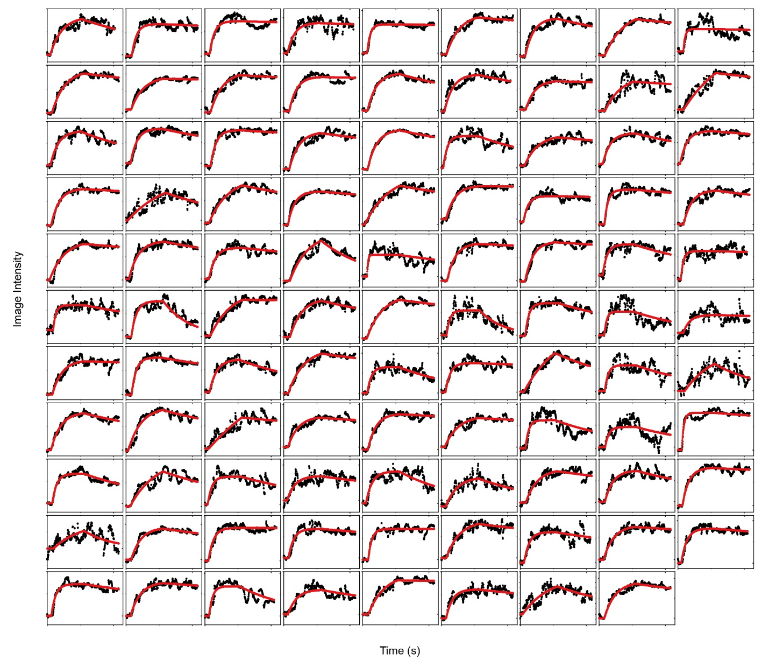
Supplementary Fig. 3
Binding curves from fixed A431 cells interacting with WGA (2nd part).
The binding curves of another 98 individual fixed A431 cells, where the binding curves can be fitted with a first-order binding kinetics model. The fitted lines are presented with red solid lines.

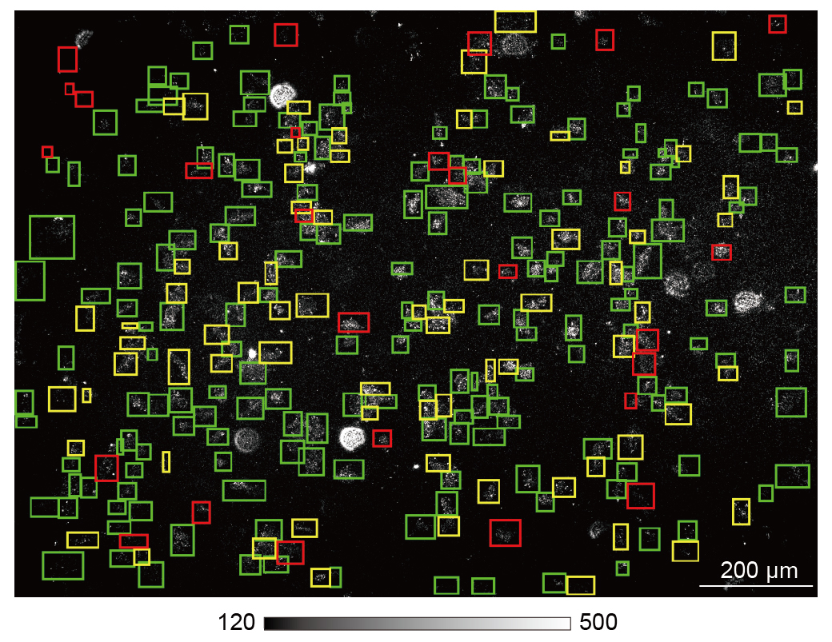
Supplementary Fig. 4
Cellular heterogeneity on features of membrane protein binding behaviors for the individual fixed A431 cells interacting with WGA.
The green zones indicate the individual cells with binding curves that can be fitted with a first-order binding kinetics model. The yellow zones indicate the individual cells with binding curves that have no measurable dissociation curves but can be fitted with the first-order binding kinetics model by assuming the k_{off} to be zero. The red zones indicate the individual cells with binding curves that have no dynamic features.
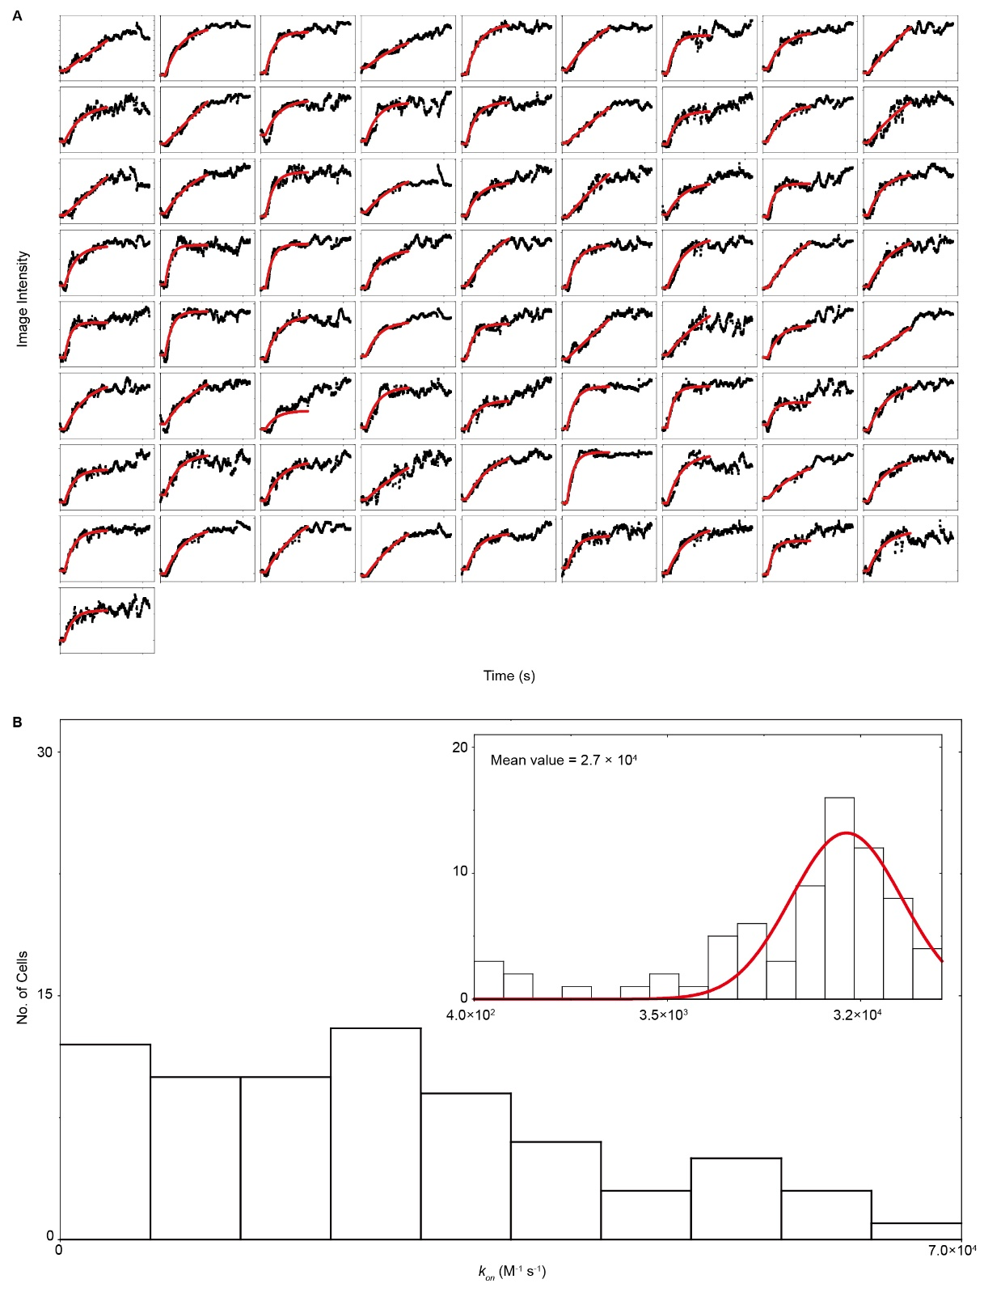
Supplementary Fig. 5
Binding curves from fixed A431 cells interacting with WGA (3rd part).
(A) The binding curves of 73 individual fixed A431 cells, where the binding curves have no measurable dissociation curves but can be fitted with the first-order binding kinetics model by assuming the k_{off} to be zero. The fitted lines are presented with red solid lines. (B) The distributions of k_{on} values achieved from Fig. S5A in linear and semi logarithmic coordinates, where the fitted lines are achieved by Gaussian fitting.
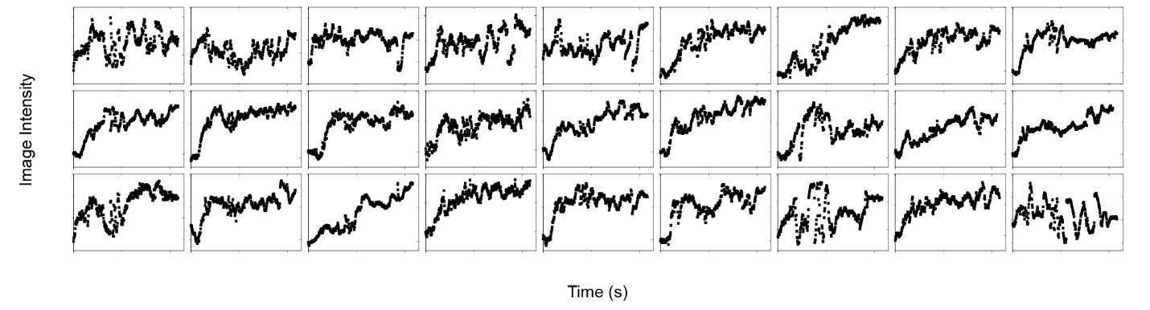
Supplementary Fig. 6
Binding curves from fixed A431 cells interacting with WGA (4th part).
The binding curves of 27 individual fixed A431 cells. The binding curves have no dynamic features.

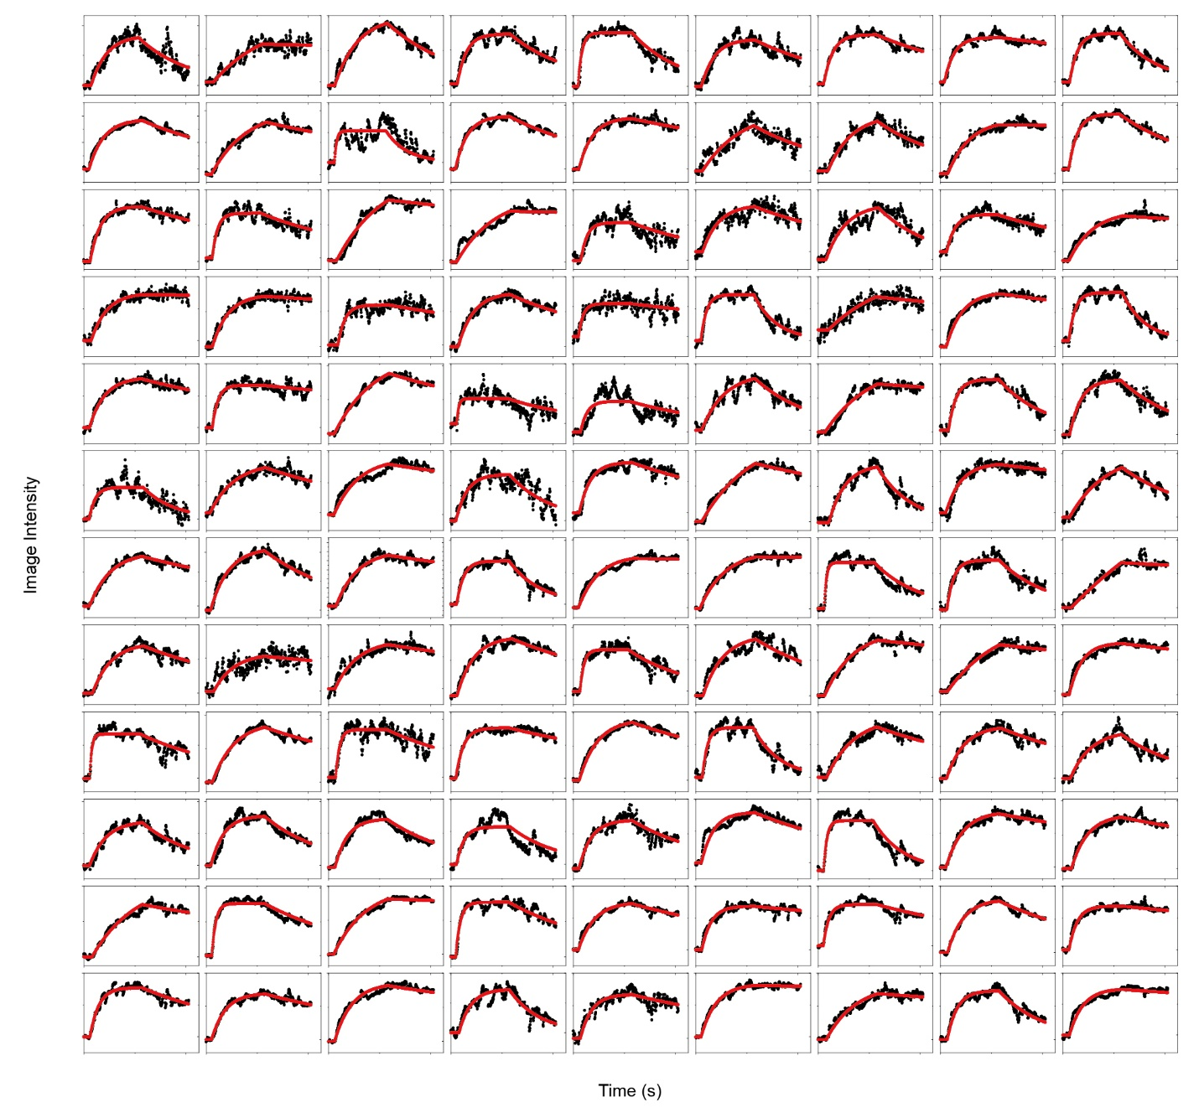
Supplementary Fig. 7
Binding curves from live A431 cells interacting with WGA (1st part).
The binding curves of the first 108 individual live A431 cells, where the binding curves can be fitted with a first-order binding kinetics model. The fitted lines are presented with red solid lines.

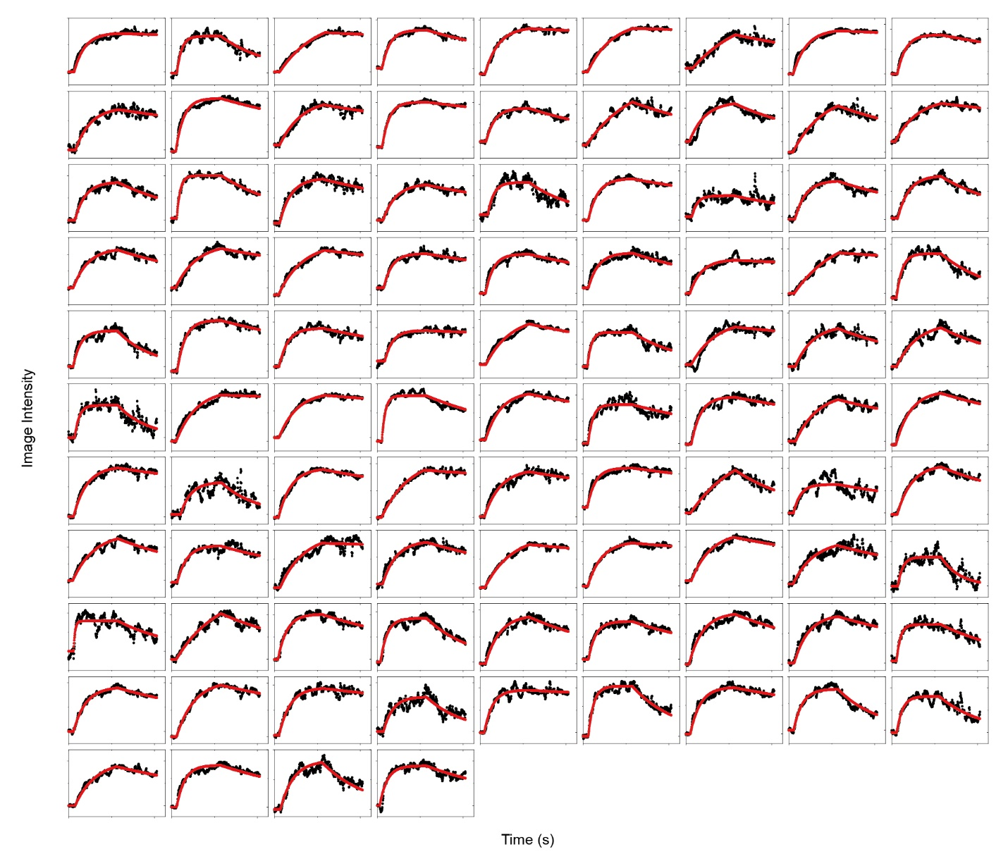
Supplementary Fig. 8
Binding curves from live A431 cells interacting with WGA (2nd part).
The binding curves of another 94 individual live A431 cells, where the binding curves can be fitted with a first-order binding kinetics model. The fitted lines are presented with red solid lines.
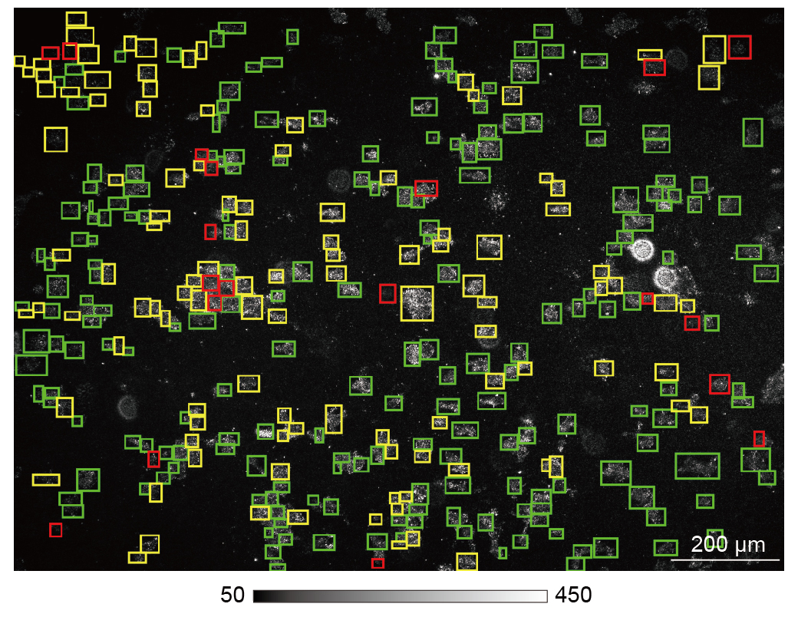
Supplementary Fig. 9
Cellular heterogeneity on features of membrane protein binding behaviours for the individual live A431 cells interacting with WGA.
The green zones indicate the individual cells with binding curves that can be fitted with a first-order binding kinetics model. The yellow zones indicate the individual cells with binding curves that have no measurable dissociation curves but can be fitted with the first-order binding kinetics model by assuming the k_{off} to be zero. The red zones indicate the individual cells with binding curves that have no dynamic features.
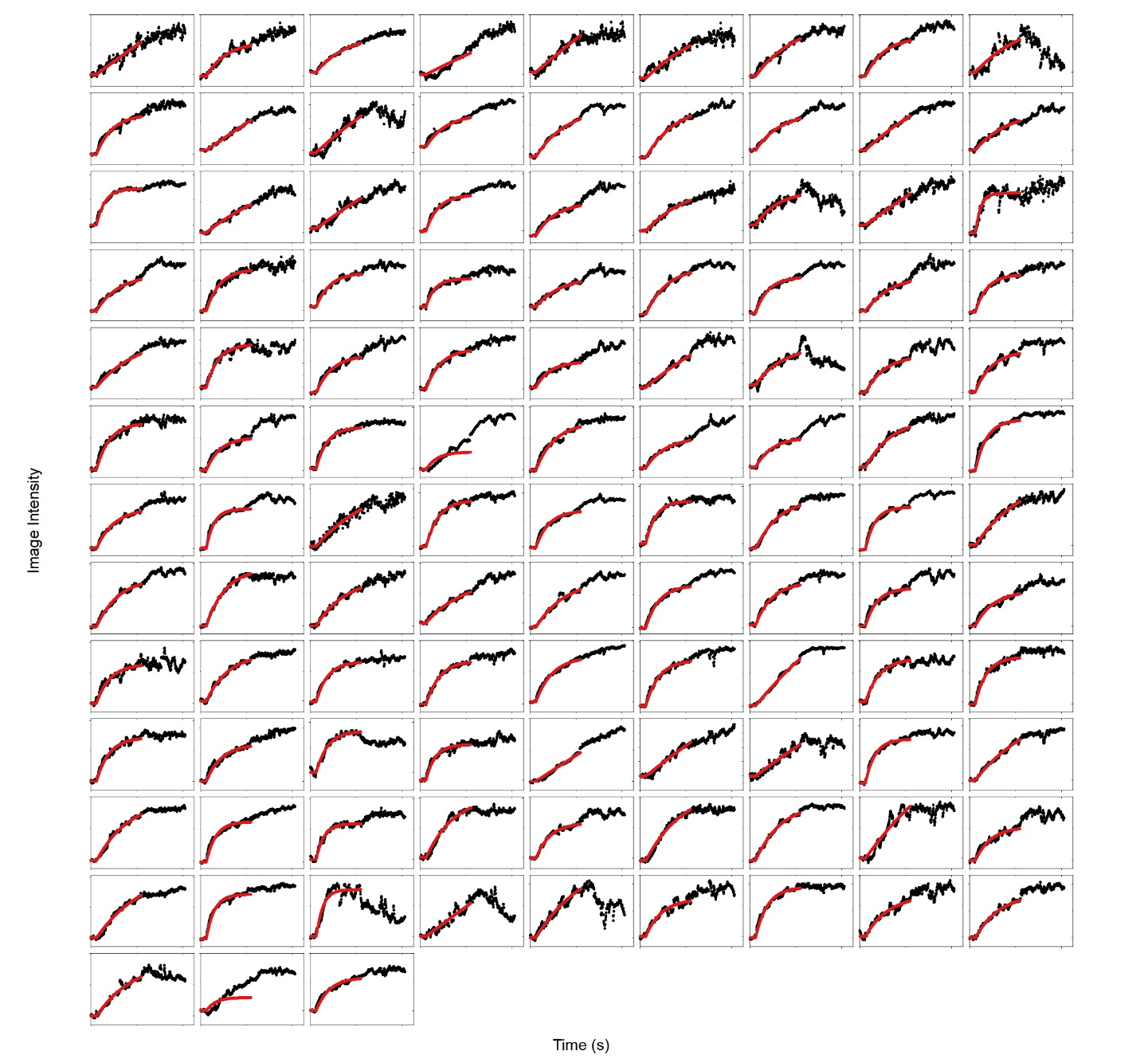
Supplementary Fig. 10
Binding curves from live A431 cells interacting with WGA (3rd part).
The binding curves of 111 individual live A431 cells, where the binding curves have no measurable dissociation curves but can be fitted with the first-order binding kinetics model by assuming the k_{off} to be zero. The fitted lines are presented with red solid lines.
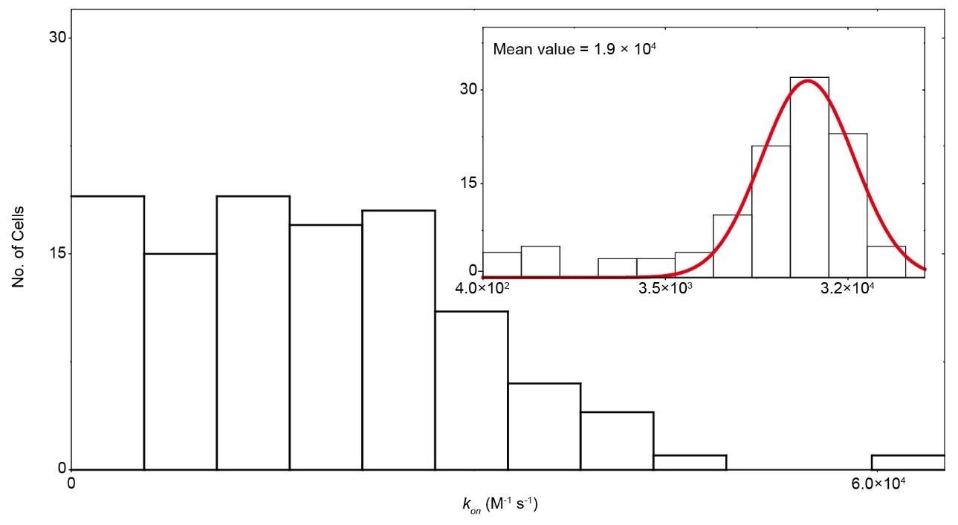
Supplementary Fig. 11
The distributions of k_{on} values achieved from Supplementary Fig. 10 in linear and semi logarithmic coordinates, where the fitted lines are achieved by Gaussian fitting.
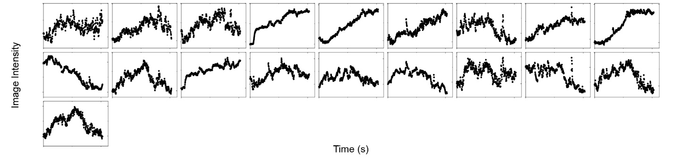
Supplementary Fig. 12
Binding curves from live A431 cells interacting with WGA (4th part).
The binding curves of 19 individual live A431 cells. The binding curves have no dynamic features.
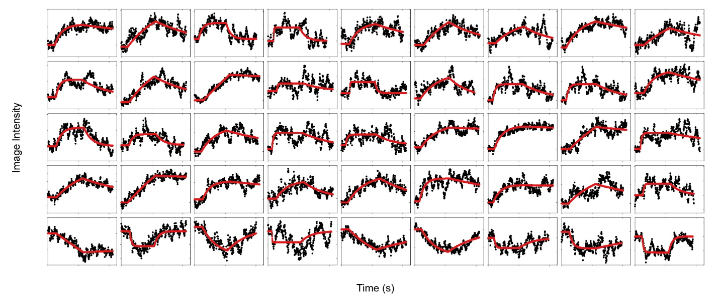
Supplementary Fig. 13
Binding curves from live A431 cells interacting with erlotinib via tracking image intensity variations (1st part).
The binding curves of 45 individual live A431 cells, where the binding curves can be fitted with a first-order binding kinetics model. The fitted lines are presented with red solid lines.

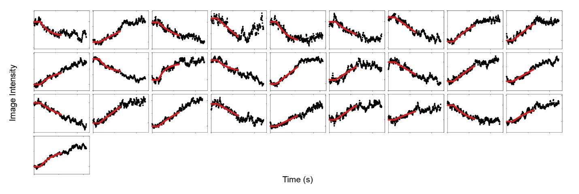
Supplementary Fig. 14
Binding curves from live A431 cells interacting with erlotinib via tracking image intensity variations (2nd part).
The binding curves of 28 individual live A431 cells, where the binding curves have no measurable dissociation curves but can be fitted with the first-order binding kinetics model by assuming the k_{off} to be zero. The fitted lines are presented with red solid lines.
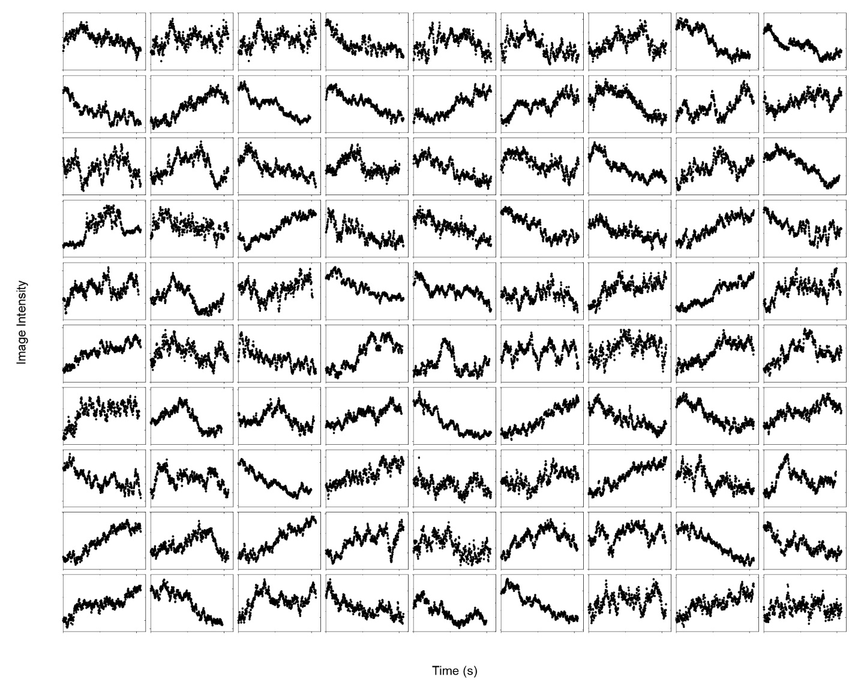
Supplementary Fig. 15
Binding curves from live A431 cells interacting with erlotinib via tracking image intensity variations (3rd part).
The binding curves of the first 90 individual live A431 cells. The binding curves have no dynamic features.
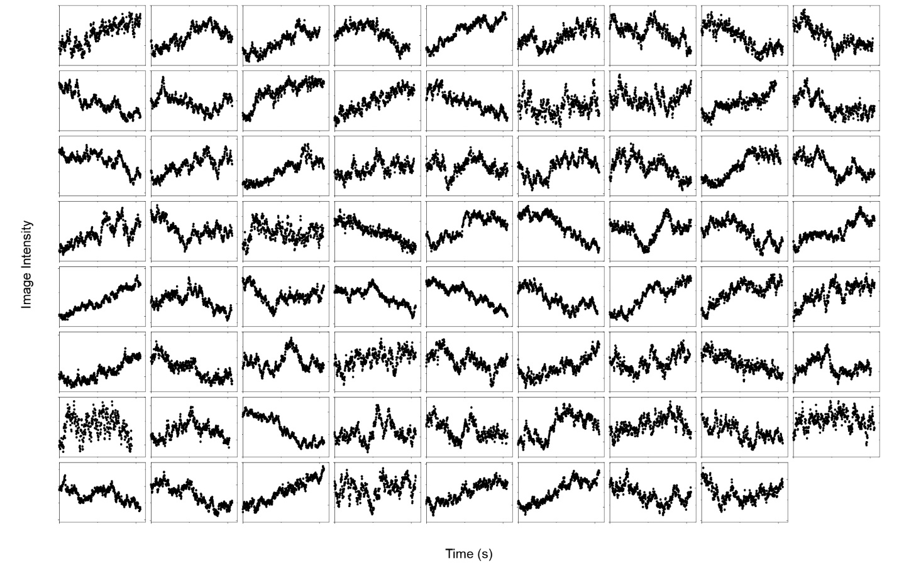
Supplementary Fig. 16
Binding curves from live A431 cells interacting with erlotinib via tracking image intensity variations (4th part).
The binding curves of another 71 individual live A431 cells. The binding curves have no dynamic features.
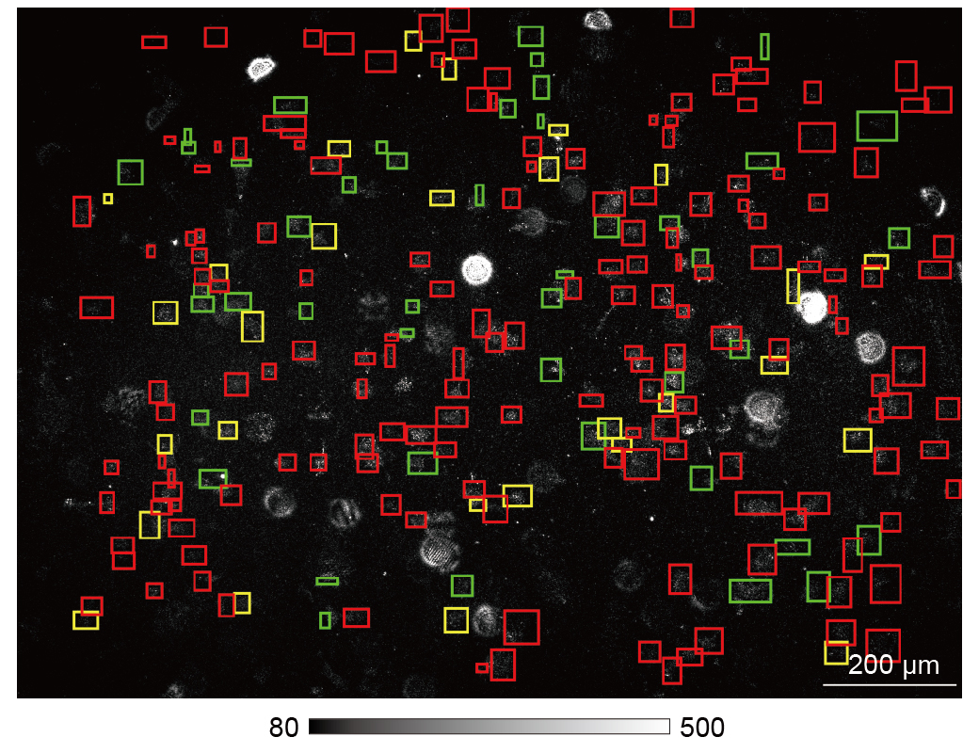
Supplementary Fig. 17
Cellular heterogeneity on features of membrane protein binding behaviours for the individual live A431 cells interacting with erlotinib.
The green zones indicate the individual cells with binding curves that can be fitted with a first-order binding kinetics model. The yellow zones indicate the individual cells with binding curves that have no measurable dissociation curves but can be fitted with the first-order binding kinetics model by assuming the k_{off} to be zero. The red zones indicate the individual cells with binding curves that have no dynamic features.
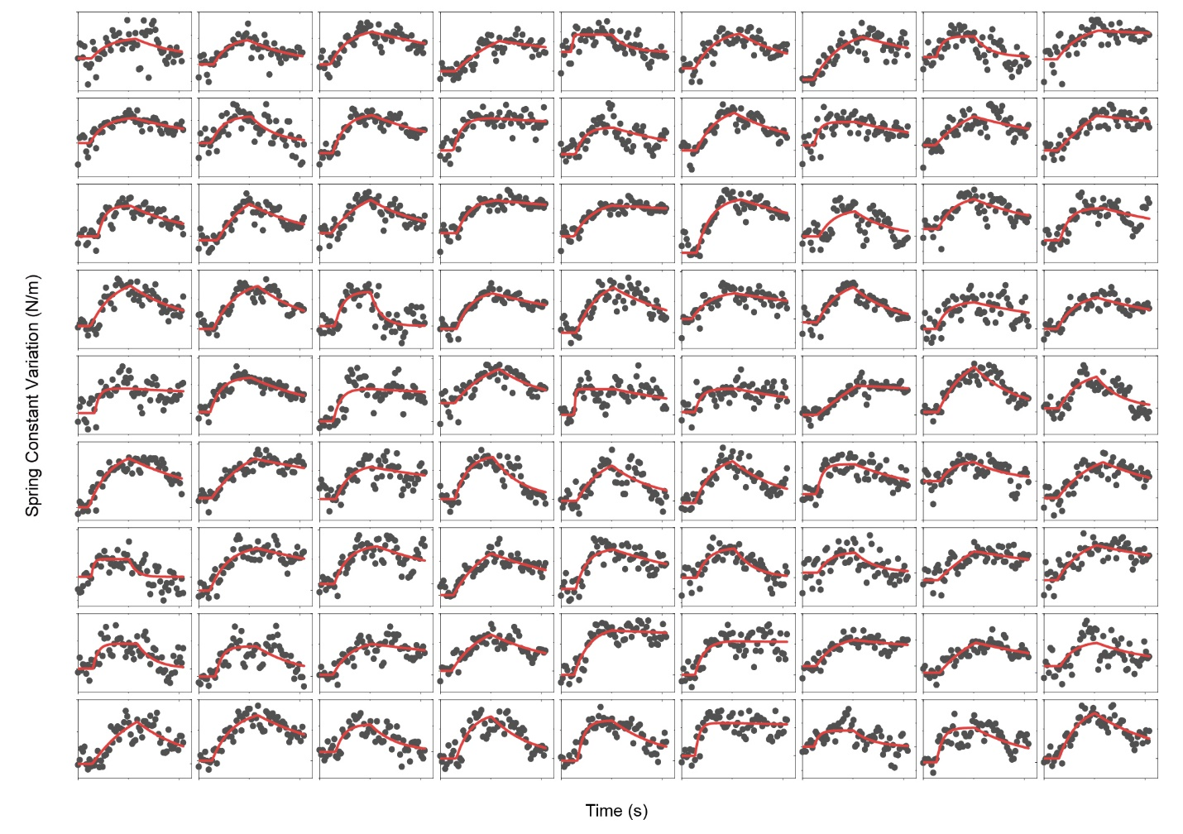
Supplementary Fig. 18
Binding curves from live A431 cells interacting with erlotinib via tracking spring constant variations (1st part).
The binding curves of the first 81 individual live A431 cells, where the binding curves can be fitted with a first-order binding kinetics model. The fitted lines are presented with red solid lines.

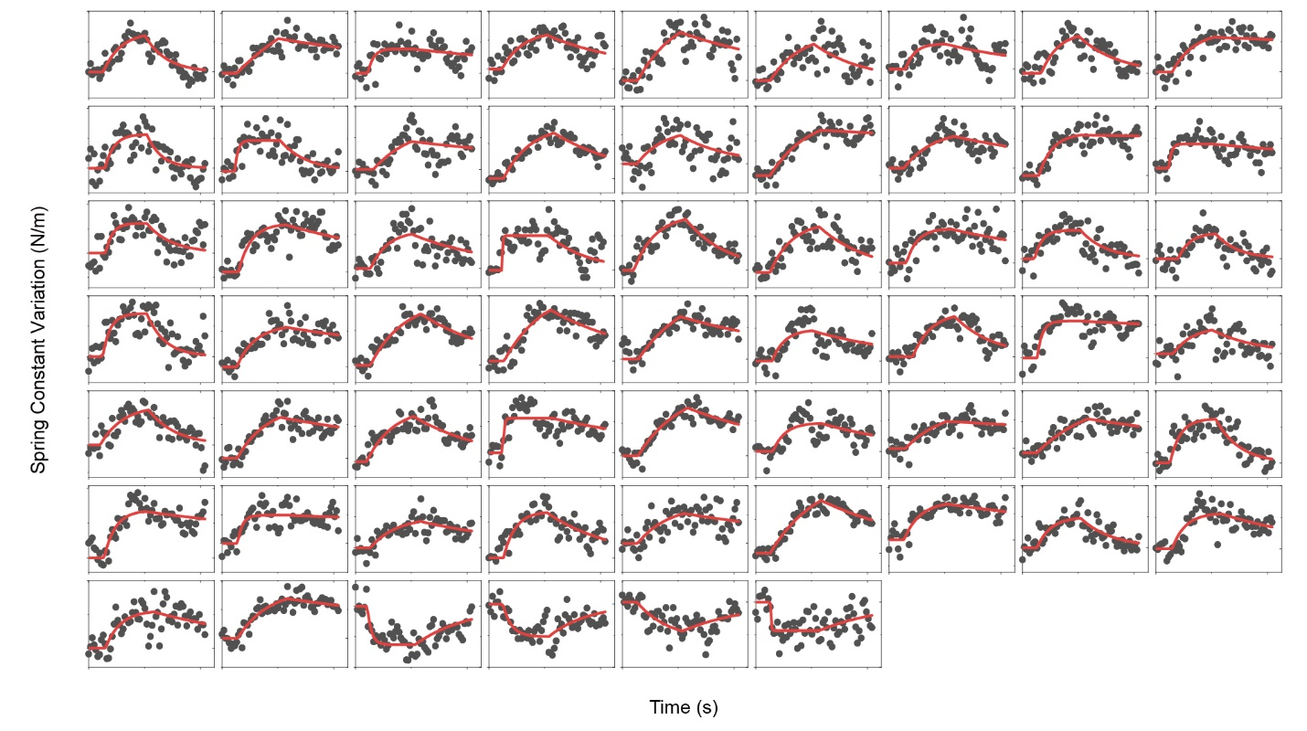
Supplementary Fig. 19
Binding curves from live A431 cells interacting with erlotinib via tracking spring constant variations (2nd part).
The binding curves of another 60 individual live A431 cells, where the binding curves can be fitted with a first-order binding kinetics model. The fitted lines are presented with red solid lines.
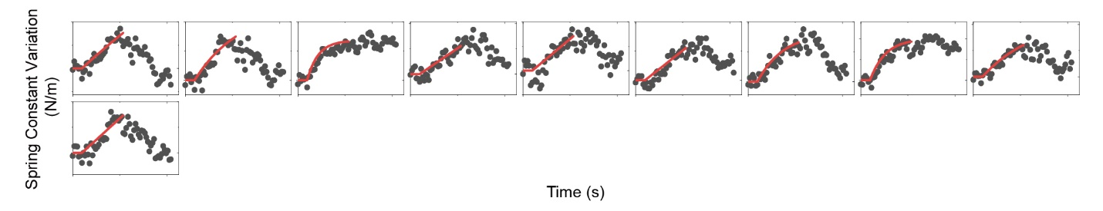
Supplementary Fig. 20
Binding curves from live A431 cells interacting with erlotinib via tracking spring constant variations (3rd part).
The binding curves of 10 individual live A431 cells, where the binding curves have no measurable dissociation curves but can be fitted with the first-order binding kinetics model by assuming the k_{off} to be zero. The fitted lines are presented with red solid lines.
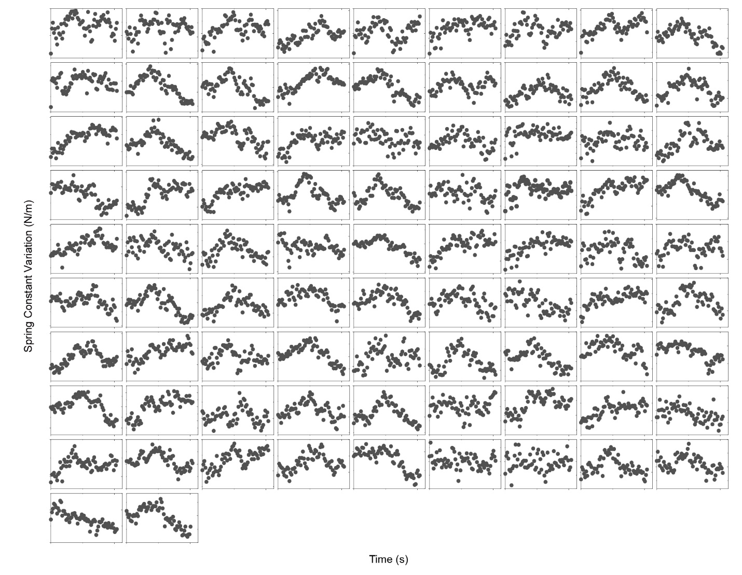
Supplementary Fig. 21
Binding curves from live A431 cells interacting with erlotinib via tracking spring constant variations (4th part).
The binding curves of 83 individual live A431 cells. The binding curves have no dynamic features.
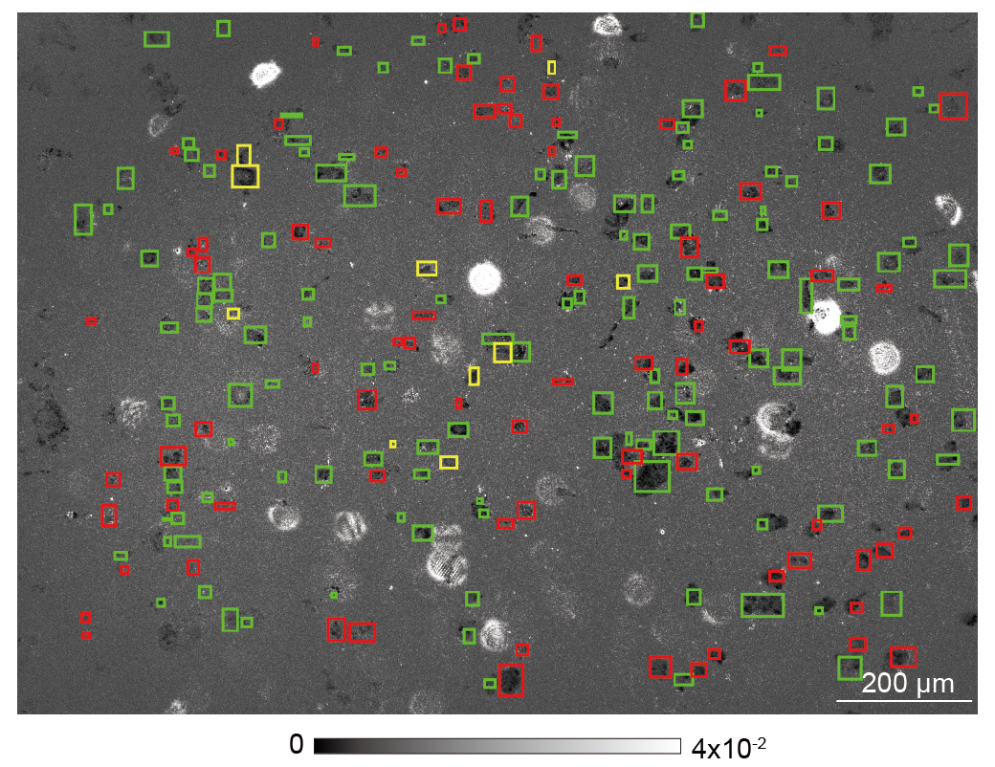
Supplementary Fig. 22
Cellular heterogeneity on features of membrane protein binding behaviours for the individual live A431 cells interacting with erlotinib via tracking spring constant variations.
The green zones indicate the individual cells with binding curves that can be fitted with a first-order binding kinetics model. The yellow zones indicate the individual cells with binding curves that have no measurable dissociation curves but can be fitted with the first-order binding kinetics model by assuming the k_{off} to be zero. The red zones indicate the individual cells with binding curves that have no dynamic features.
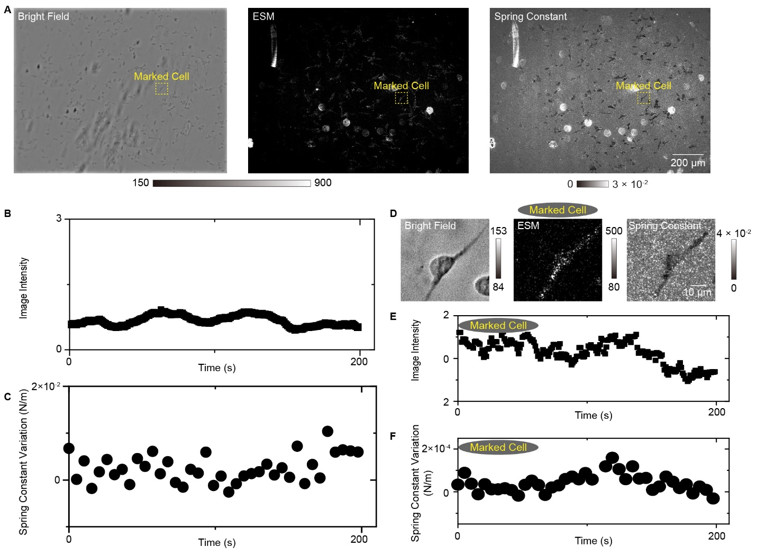
Supplementary Fig. 23
Negative control experiments measuring the response of live RBL-2H3 cells to erlotinib binding.
A) Bright field image, ESM image, and spring constant map of live RBL-2H3 cells. B), and C) The image intensity variation (B) and spring constant variation (C) against time achieved by averaging the signal of all cells within the field of view, showing no dynamics feature. D) Zoomed view of marked region in (A). E), and F) The image intensity variation (E) and spring constants variation (F) against time achieved from the cell shown in (D), showing no dynamics feature.

