Supplementary figures

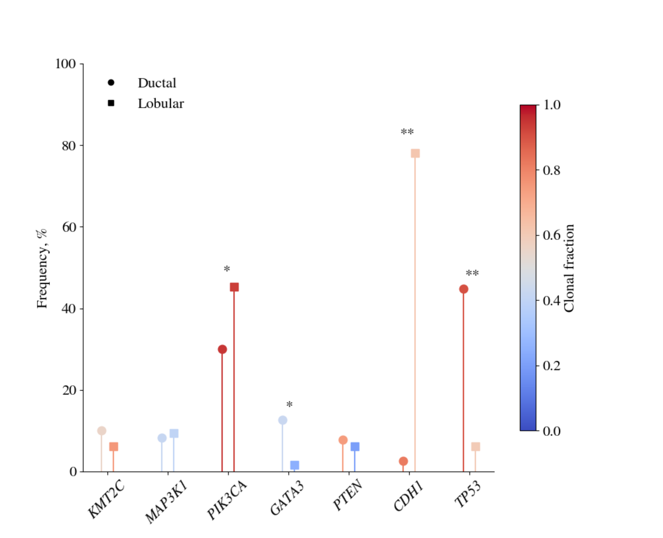

Supplementary figure 1. Frequency and clonality of driver gene mutations in ductal breast cancers and lobular breast cancers. The mutational frequency of driver genes for all ductal breast cancers and all lobular breast cancers, irrespective of screening status. The colour scale corresponds to the total fraction of mutations that are clonal. Genes labelled with ** show a significant difference in frequency imposing a Bonferroni adjusted P-value of 7.46 x 10⁻⁴, and those labelled with * a significant difference at an unadjusted P-value of 0.05.
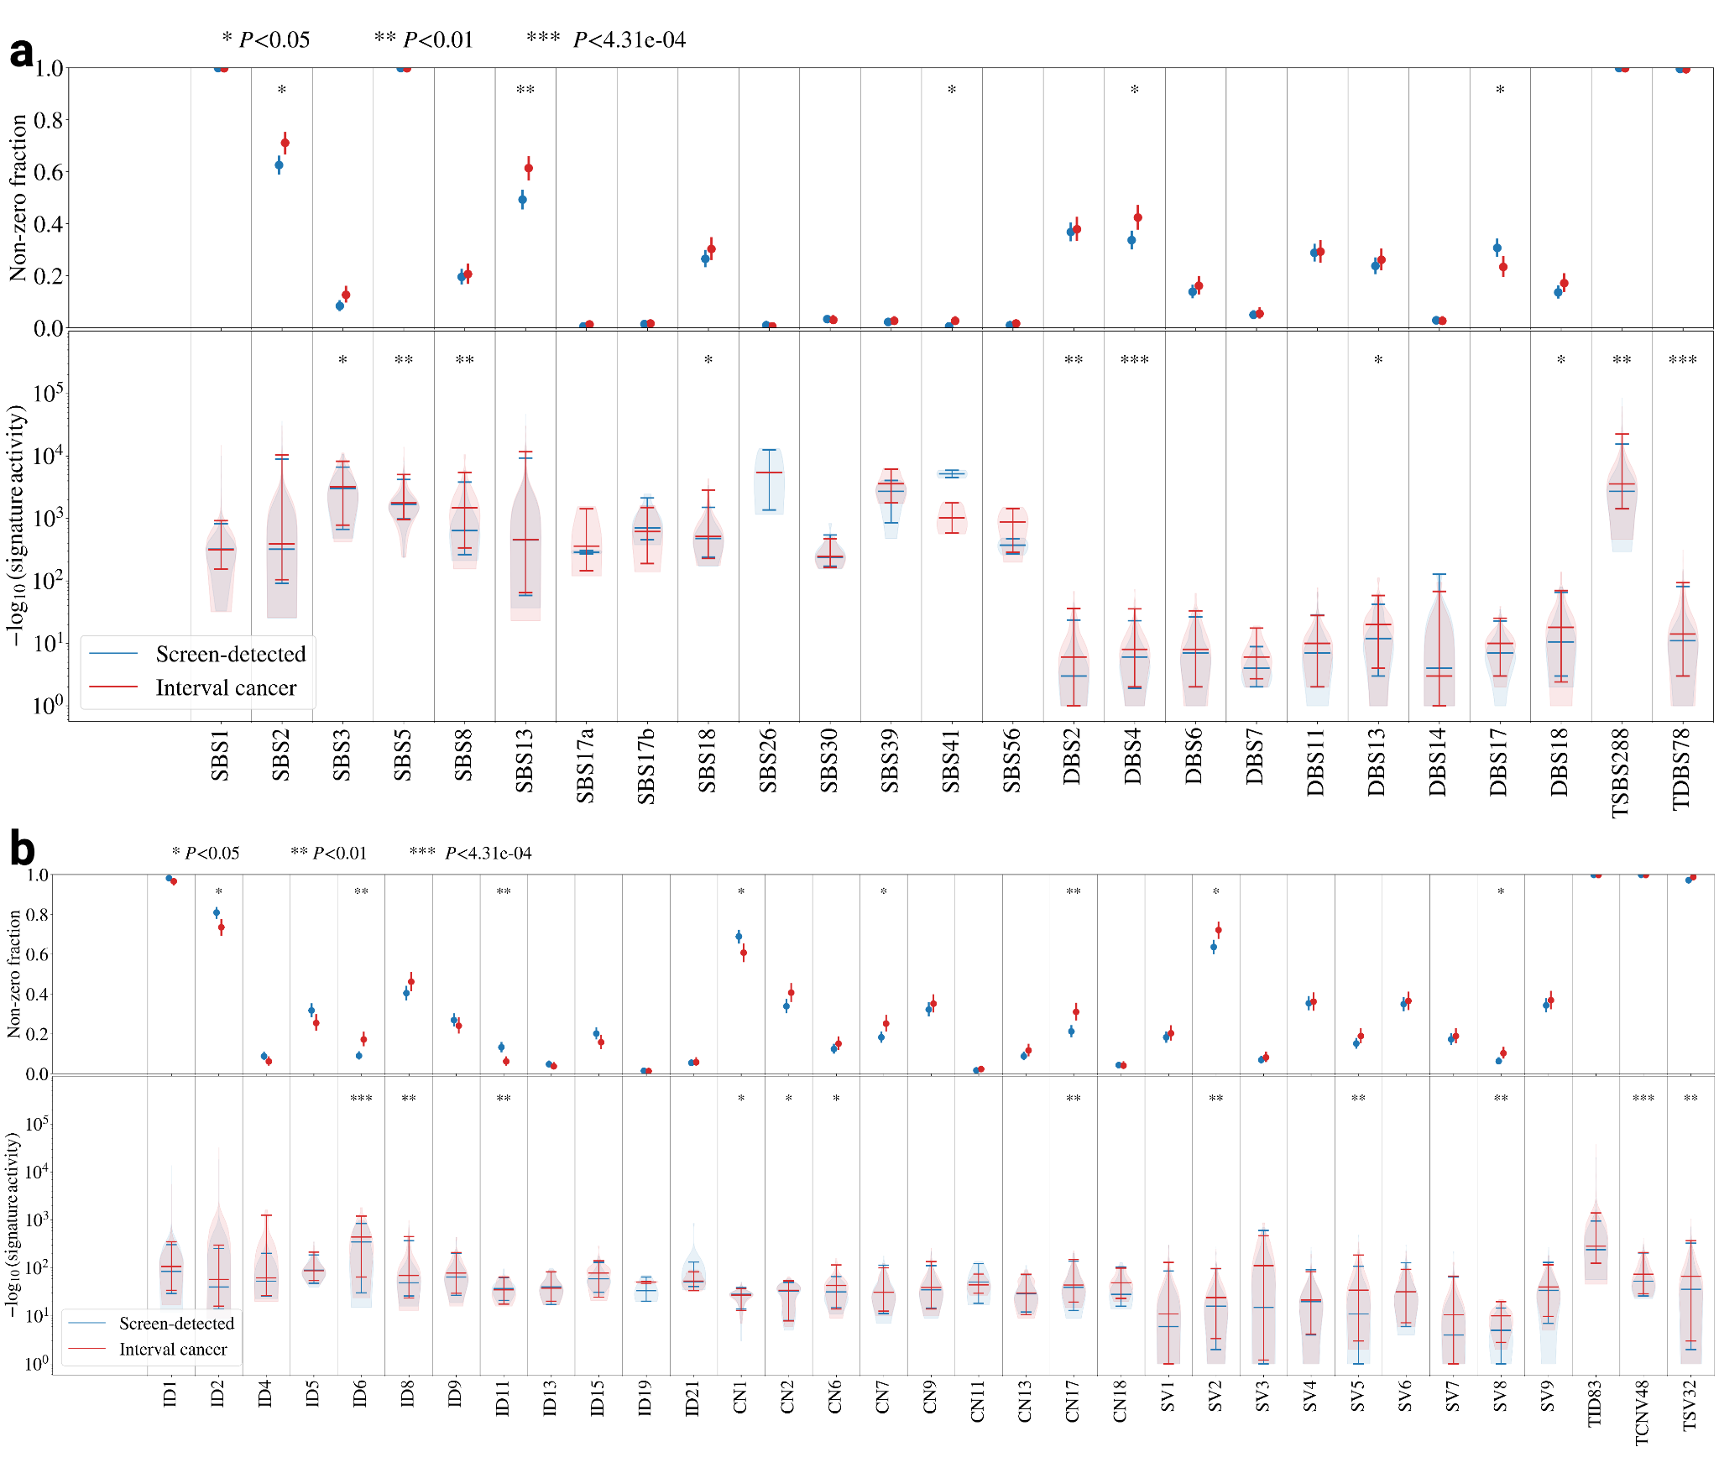

Supplementary figure 2. Frequency and activity of mutational signatures. a) Single base substitution (SBS) and doublet base substitution (DBS) signatures b) Insertion-deletion (ID), copy number (CN) and structural variant (SV) signatures. Each signature displayed has been extracted in at least one sample in this cohort. The proportion of samples with the given signature are displayed in the upper plot, while the distribution of signature activities are displayed in the lower plot. P-values are estimated using a binomial test for the fraction of samples displaying a given signature while a t-test is used to compare the signature activities.

