Supplemental Figure 1: Manhattan plots. Only concordant variants are shown. A: EA; B: AA; C: LA; D: meta-analysis of AA and EA; E: meta-analysis of EA and LA; F: meta-analysis of AA, EA, and LA.
Supplemental Figure 2. LocusZoom plot of each locus in different populations. Note: Only concordant variants were plotted.
Supplemental Figure 3: Manhattan plots of gene-based analyses. A: EA; B: AA; C: LA; D: meta-analysis of AA and EA; E: meta-analysis of EA and LA; F: meta-analysis of AA, EA, and LA.

Supplemental Figure 1: Manhattan plots. Only concordant variants are shown. A: EA; B: AA; C: LA; D: meta-analysis of AA and EA; E: meta-analysis of EA and LA; F: meta-analysis of AA, EA, and LA.
A: EA
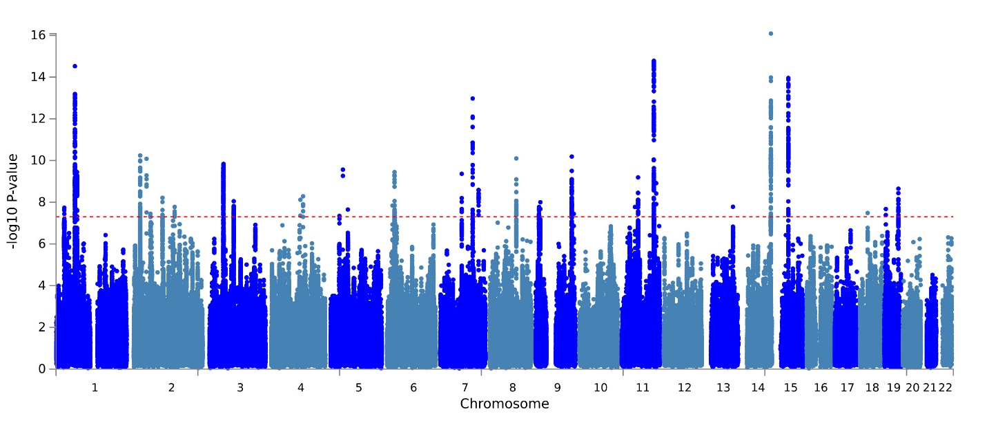
B: AA
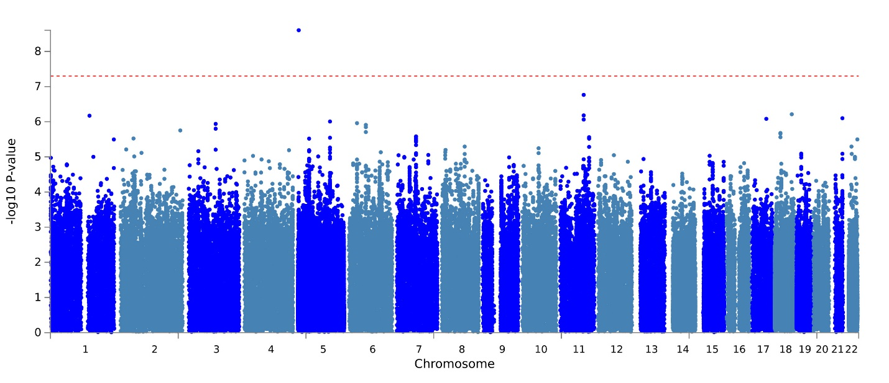
C: LA
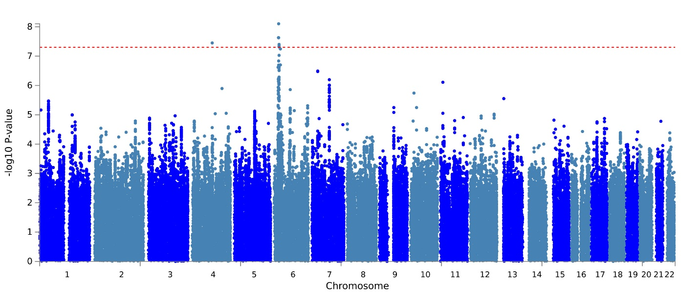
D: meta-analysis of AA and EA
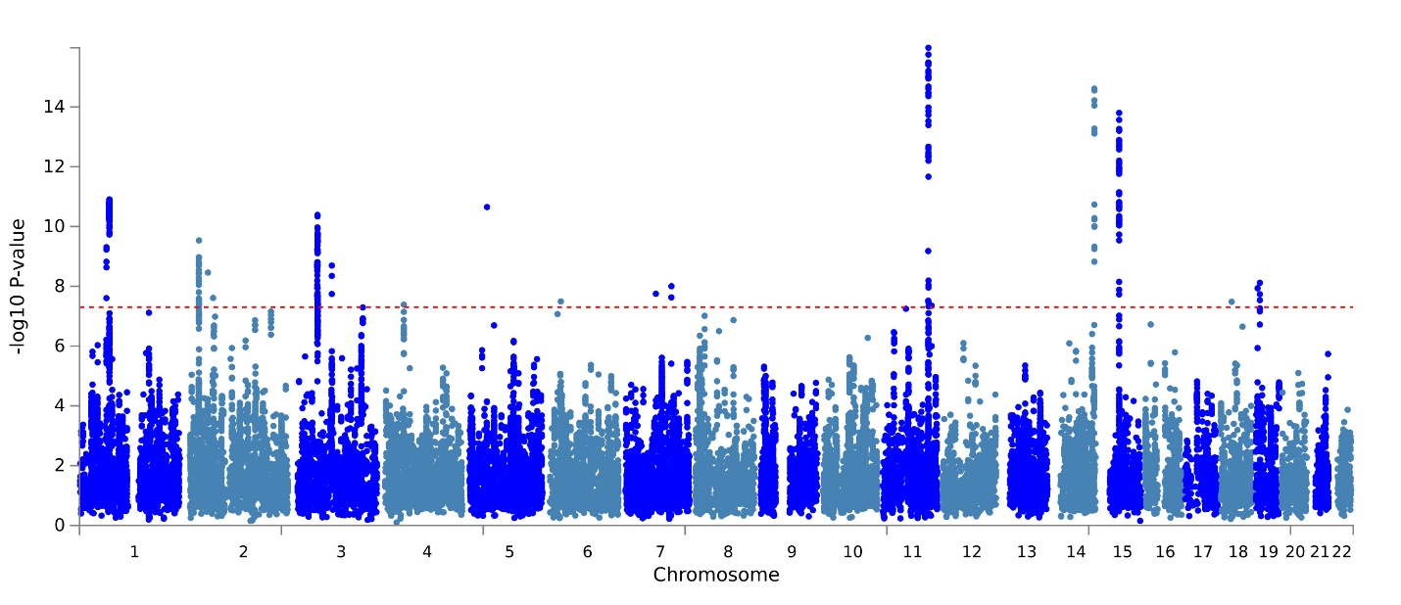
E: meta-analysis of EA and LA
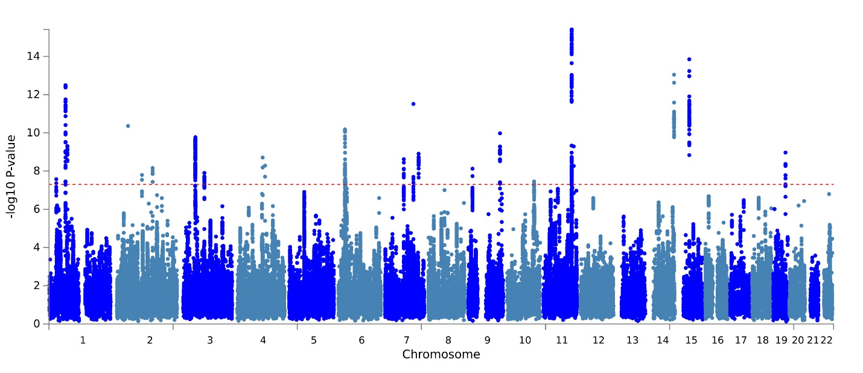
F: meta-analysis of AA, EA, and LA
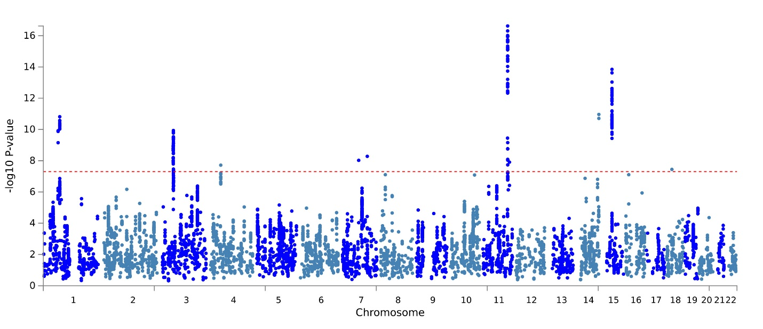

Supplemental Figure 2. LocusZoom plot of each locus in different populations. Note: Only concordant variants were plotted.
Locus 1 EA:
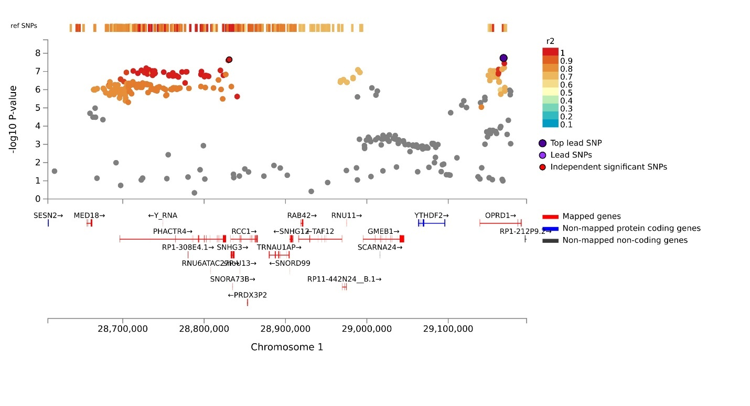
Locus 1 EA_LA:
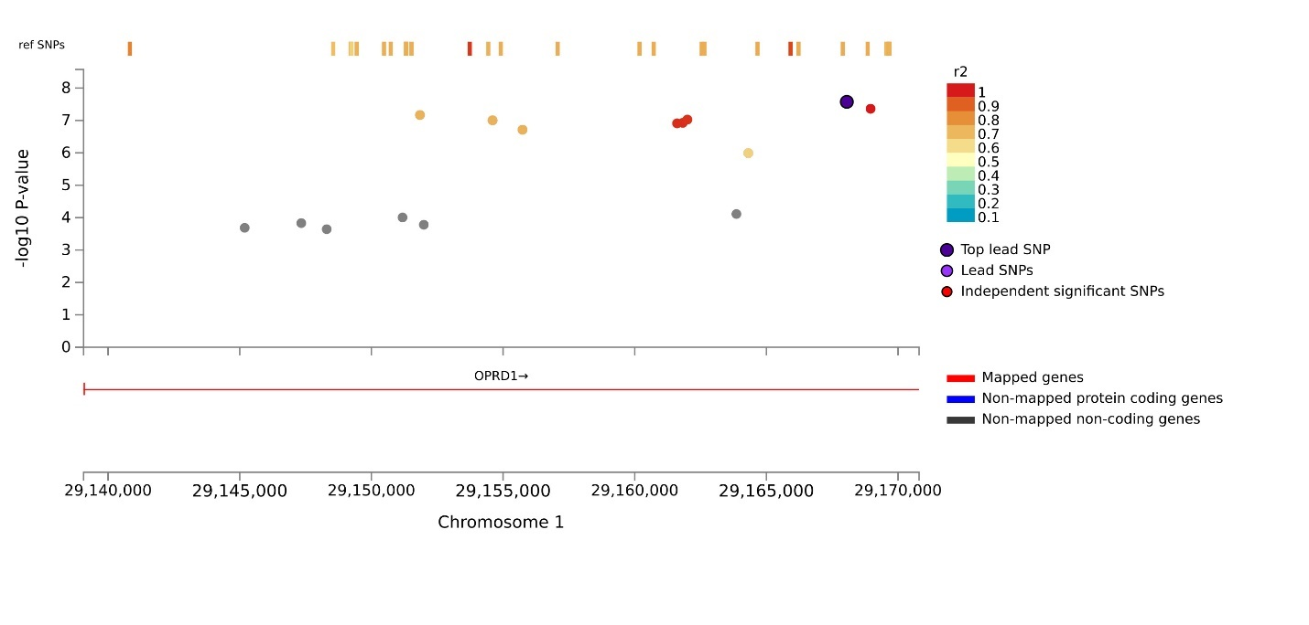
Locus 2 EA:
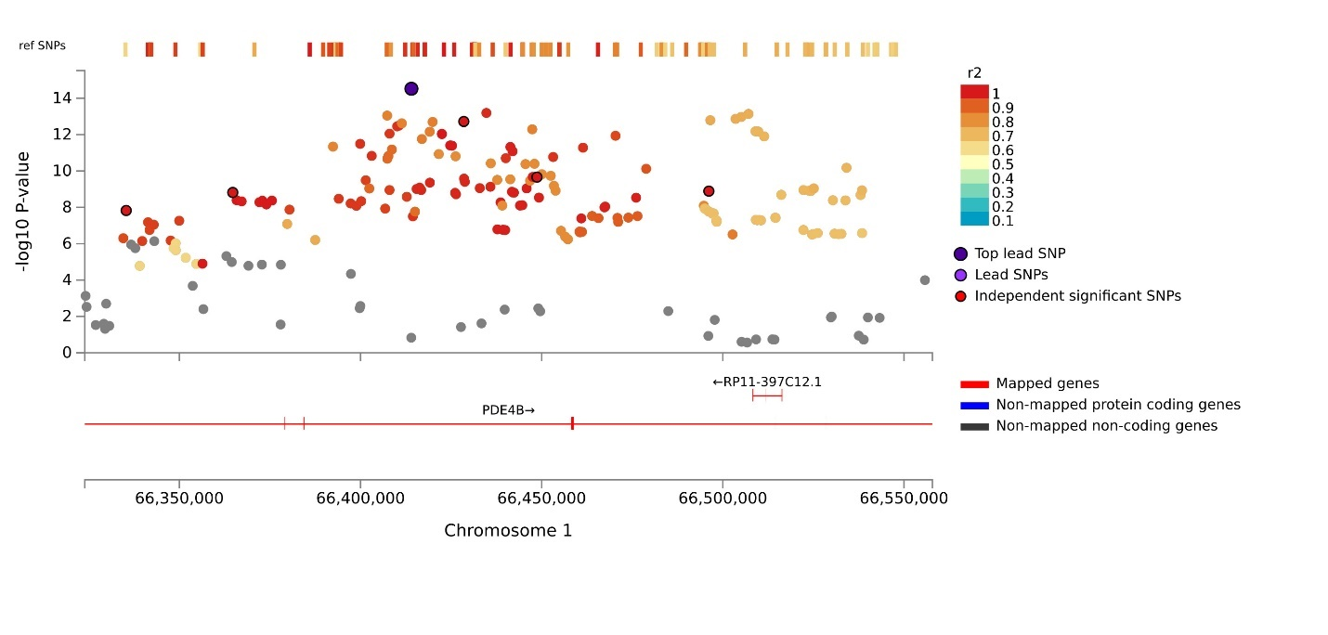
Locus 2 AA_EA:
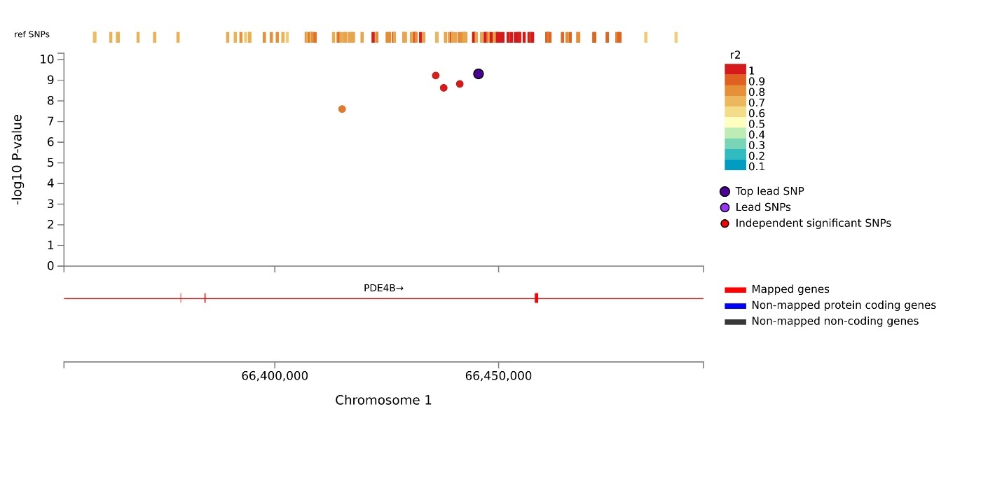
Locus 2 EA_LA:
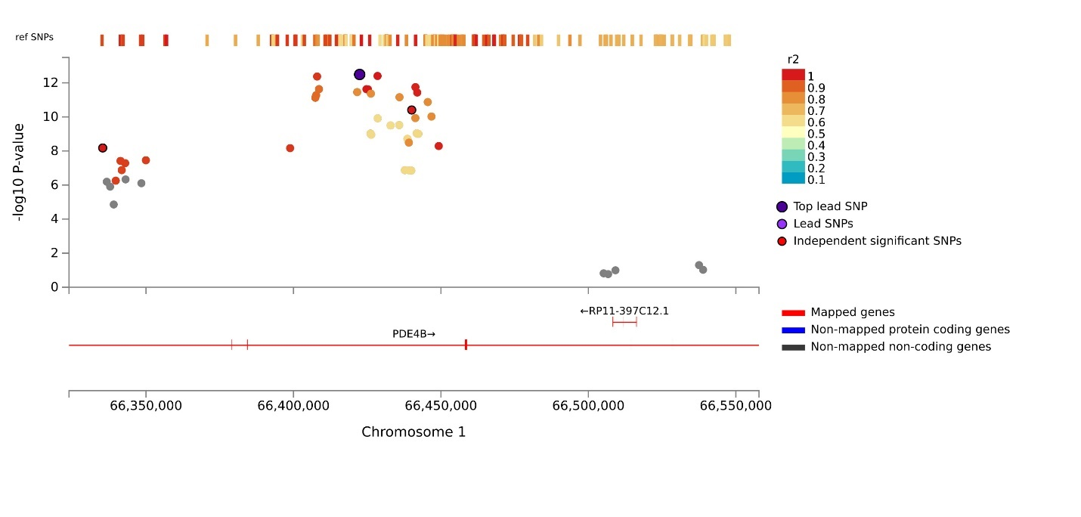
Locus 2 AA_EA_LA:
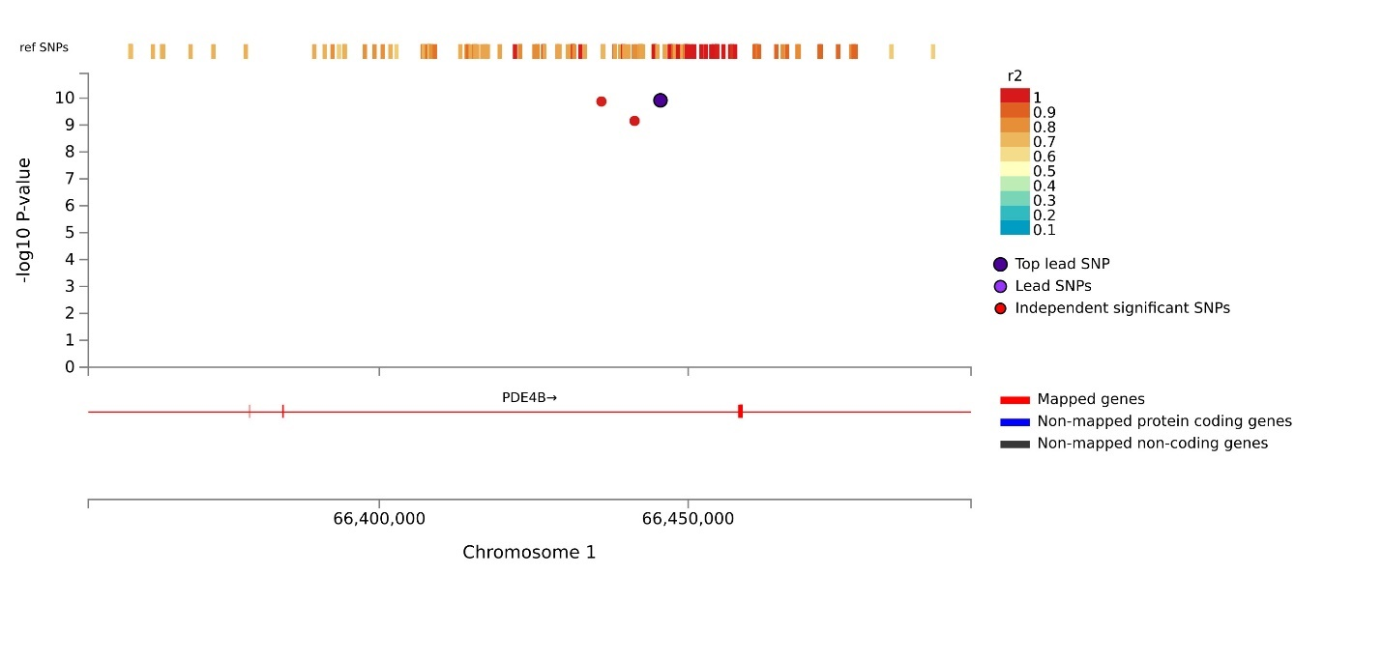
Locus 3 AA_EA:
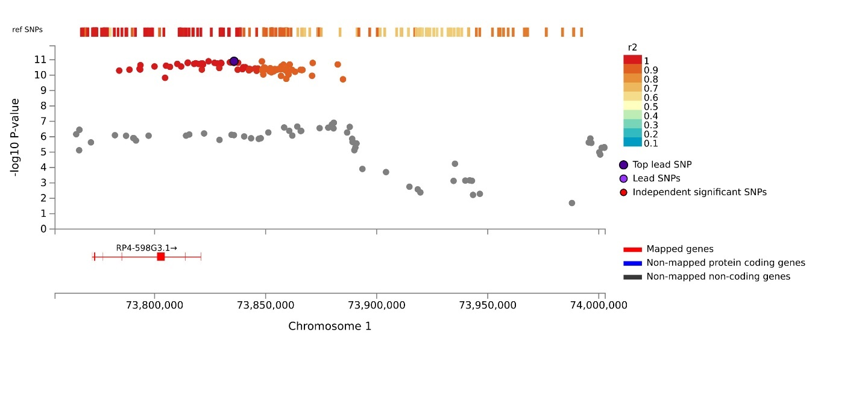
Locus 3 EA:
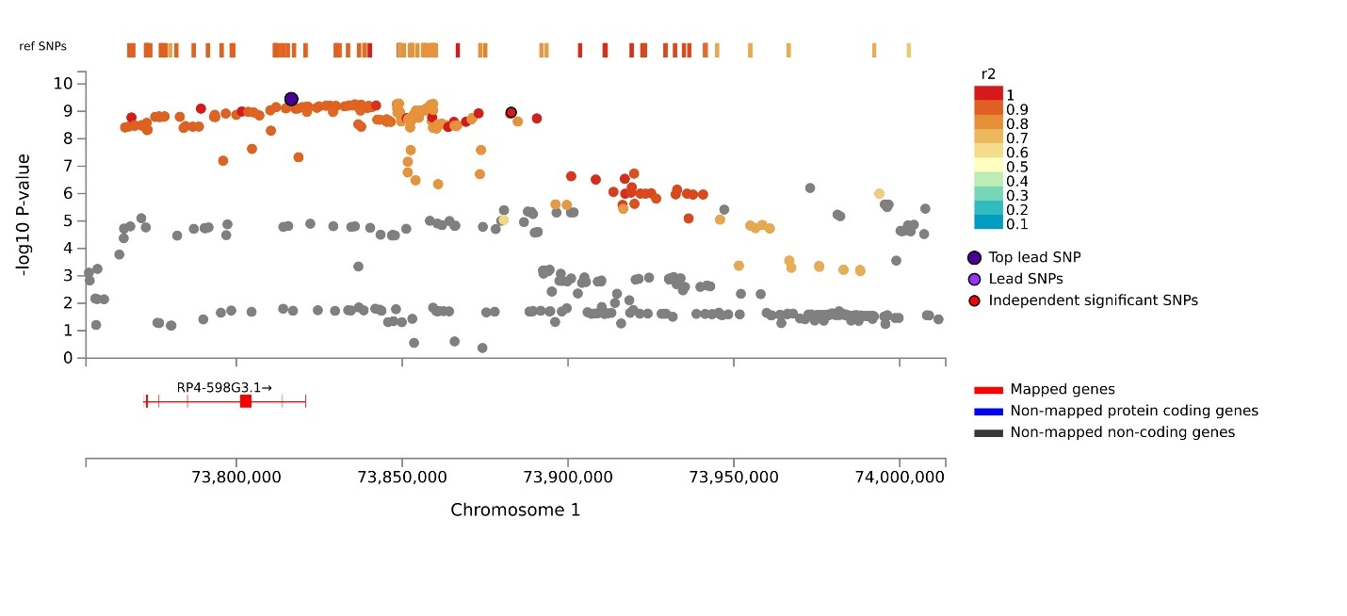
Locus 3 EA_LA:
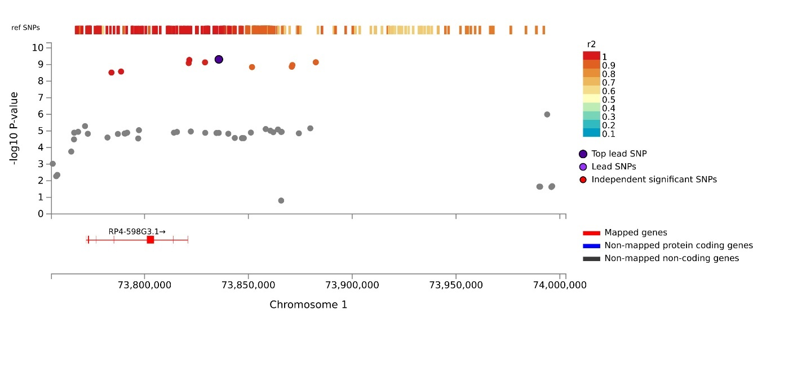
Locus 3 AA_EA_LA:
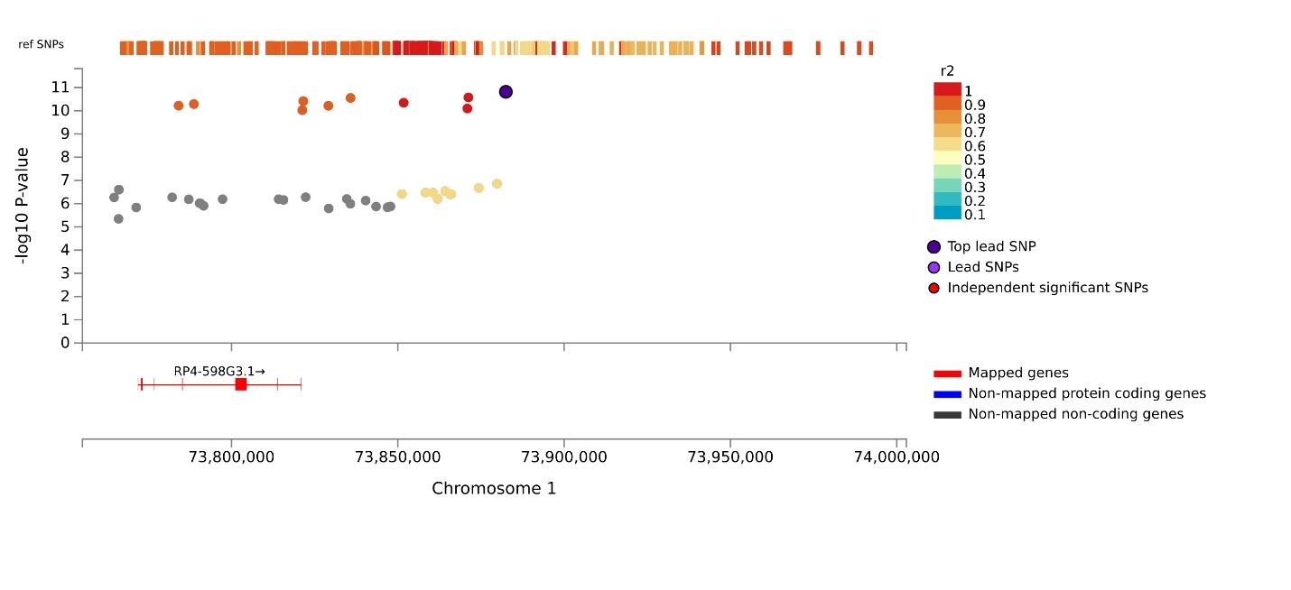
Locus 4 EA:
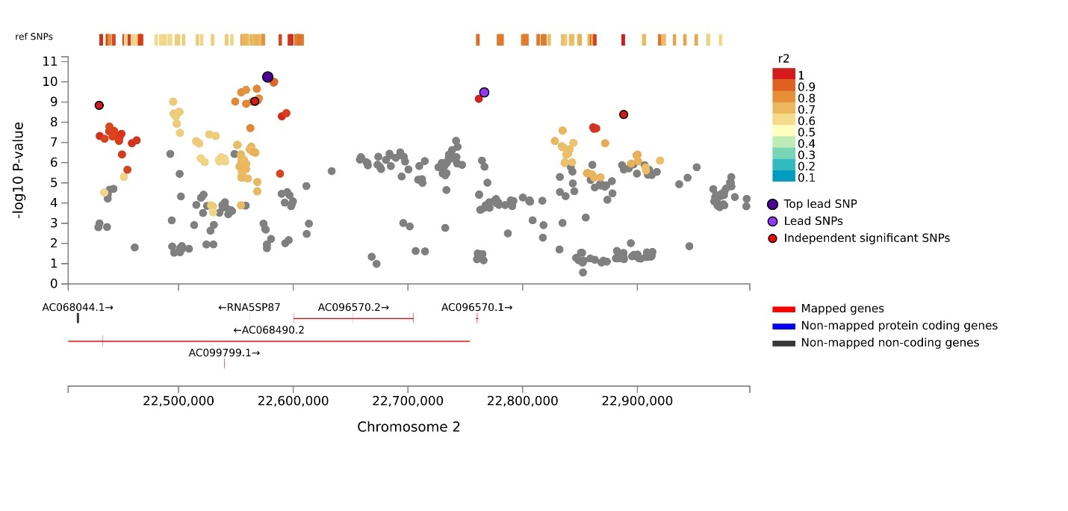
Locus 4 AA_EA rs11124367:
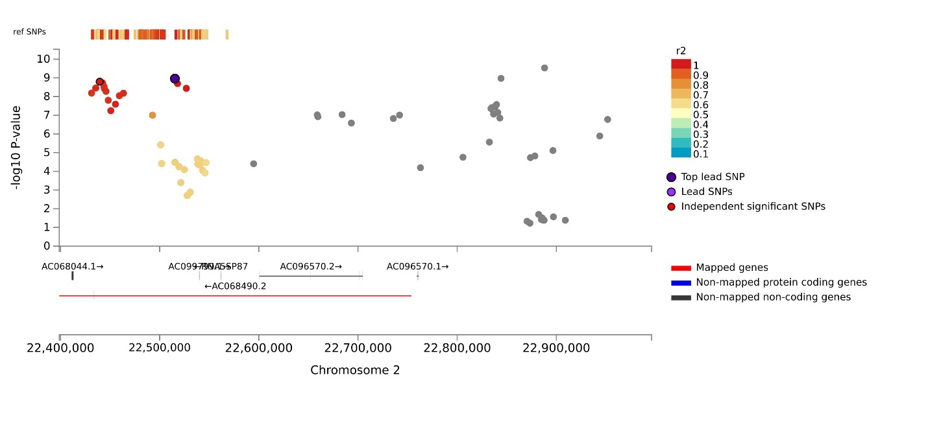
Locus 4 EA_ rs13012903:
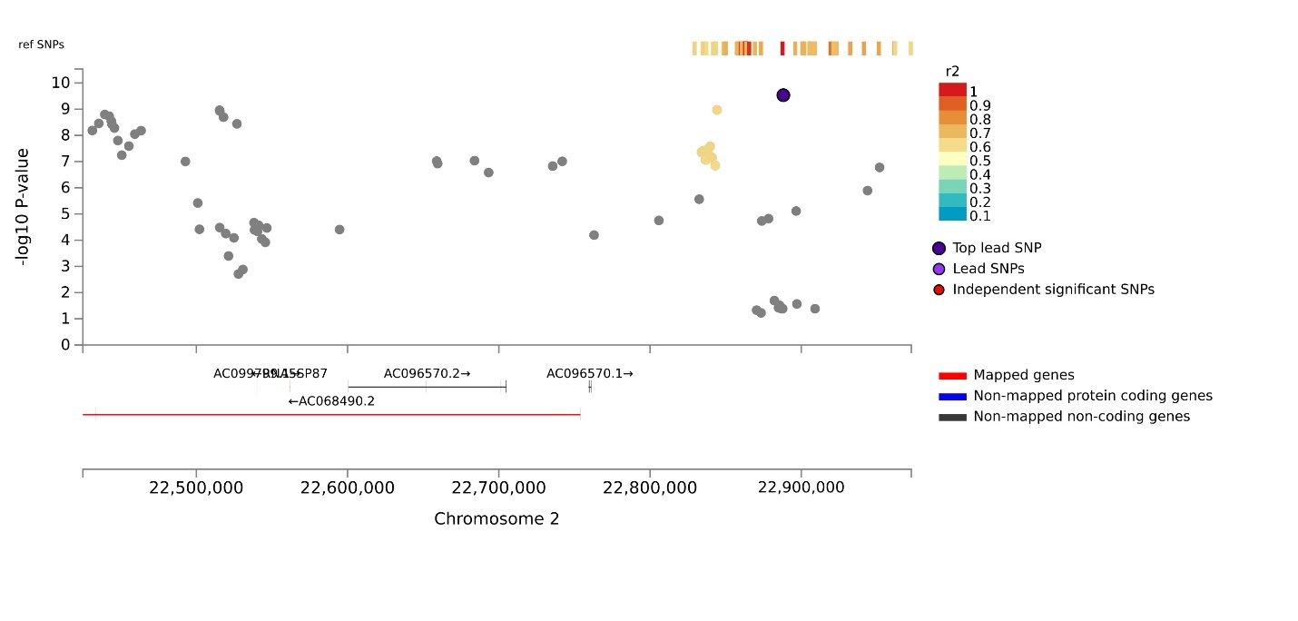
Locus 5 EA_LA:
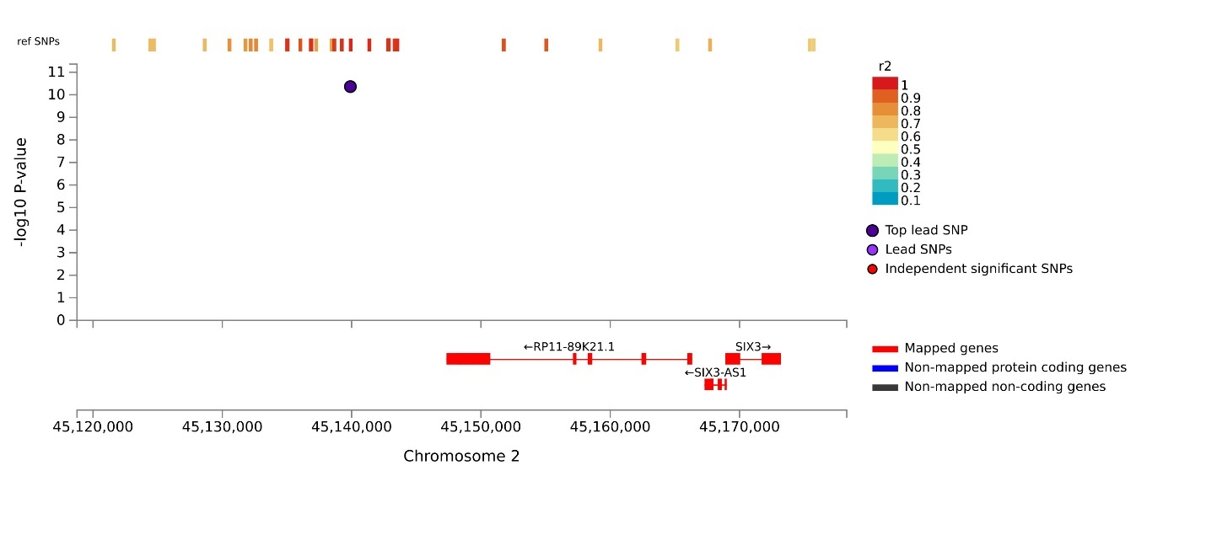
Locus 5 EA:
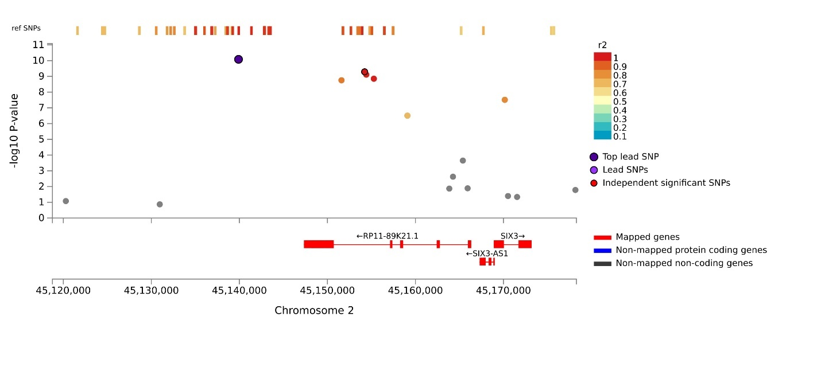
Locus 5 AA_EA:
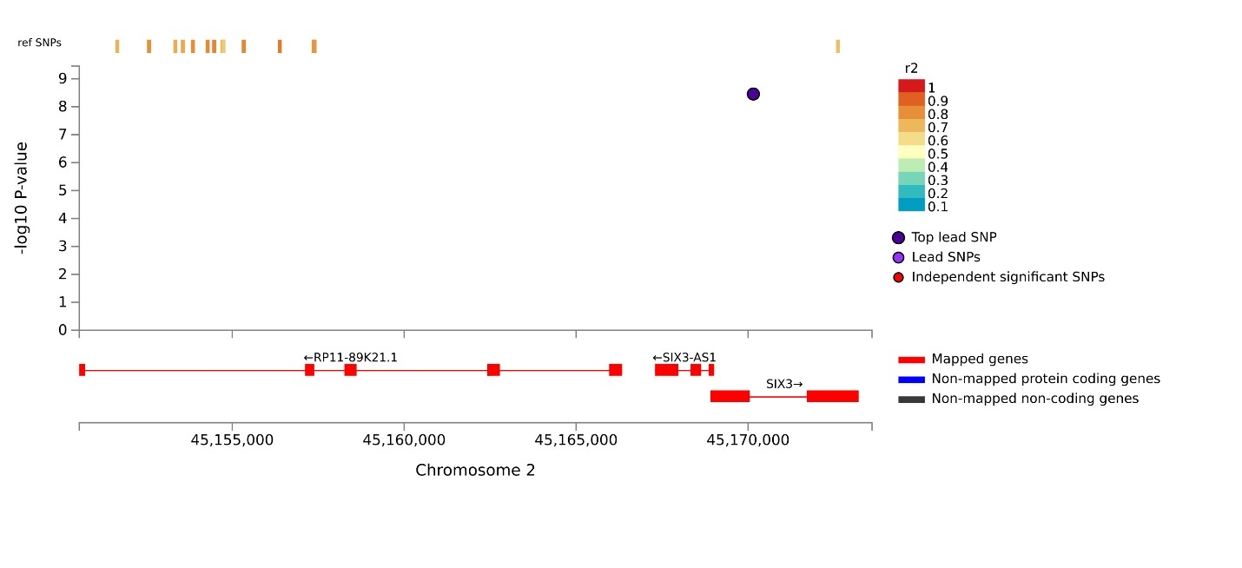
Locus 6 AA_EA:
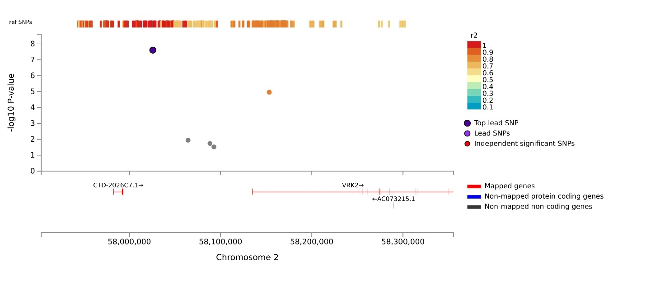
Locus 6 EA:
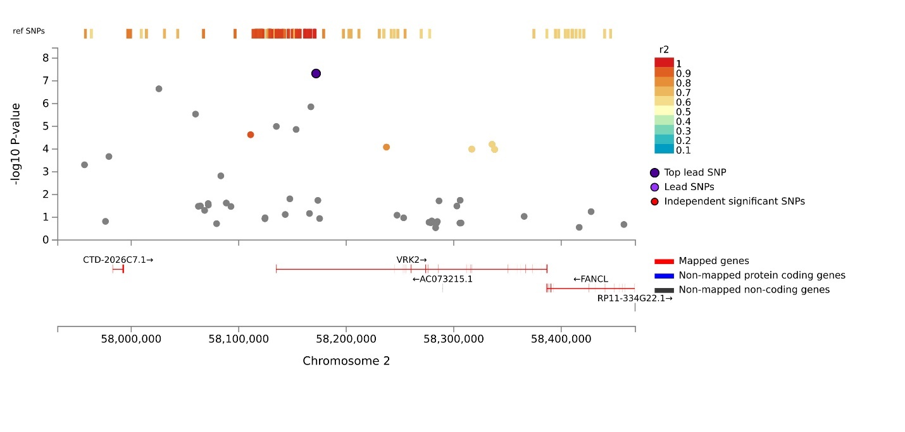
Locus 7 EA:
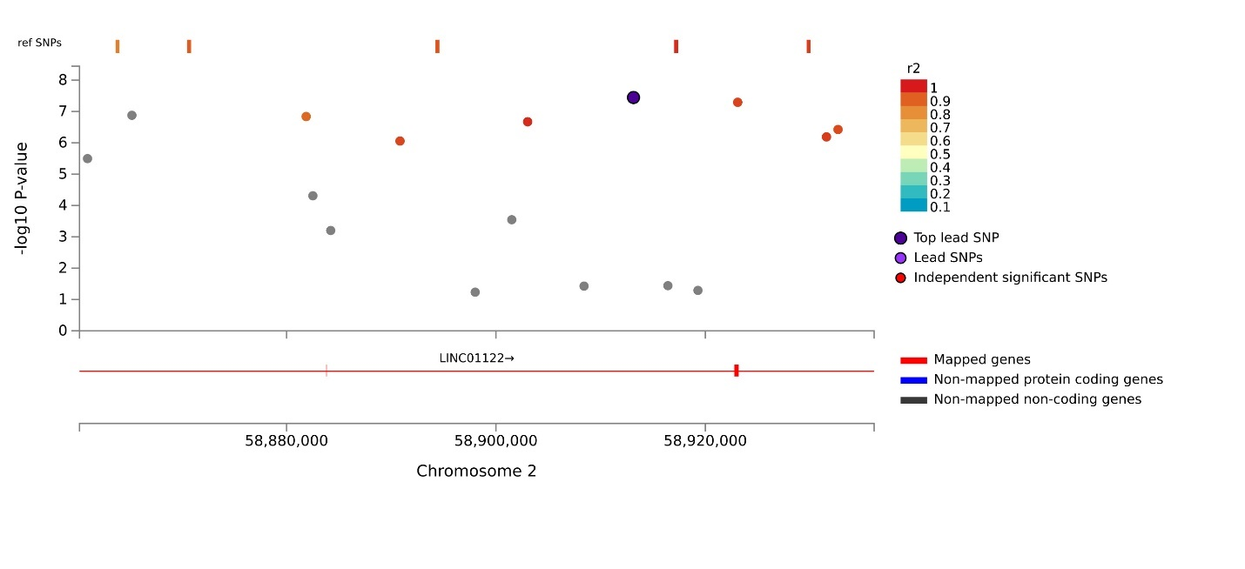
Locus 8 EA:
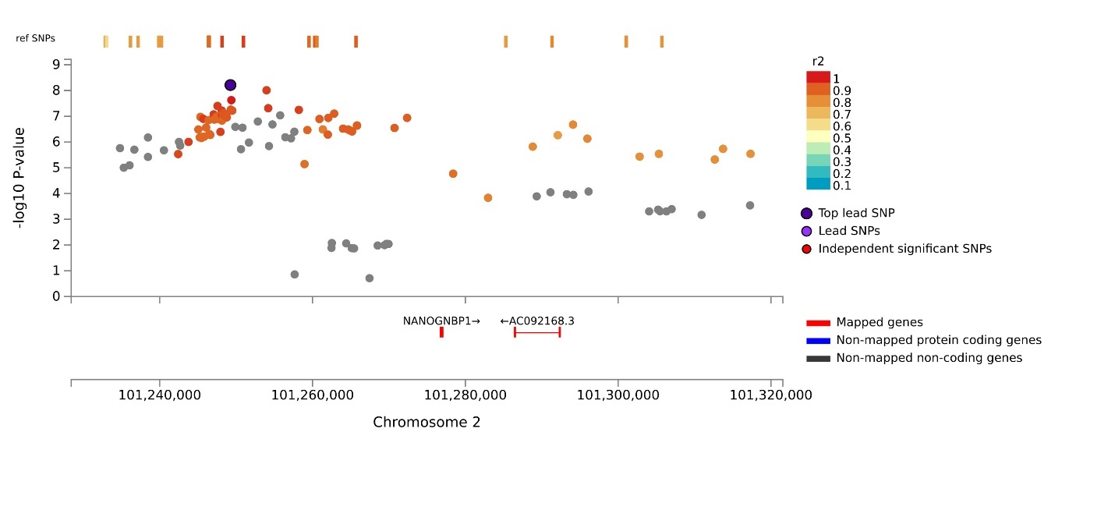
Locus 8 EA_LA:
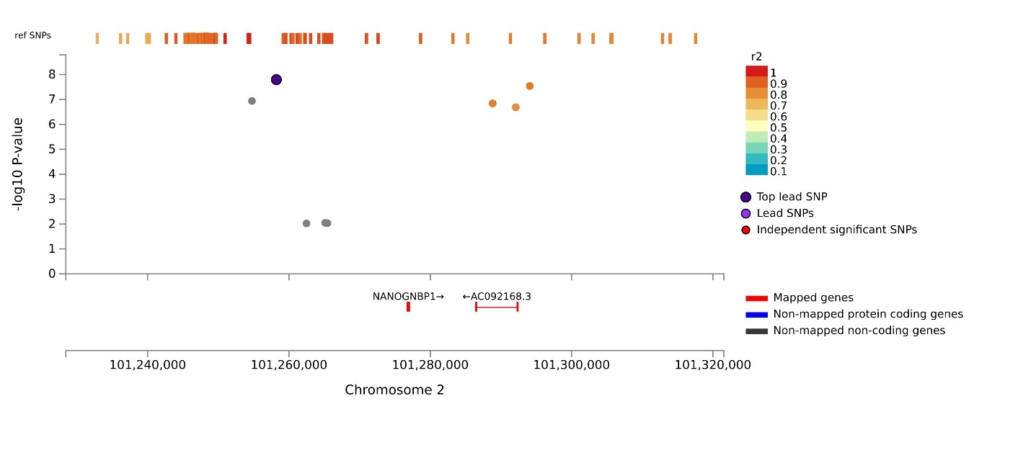
Locus 9 EA_LA:
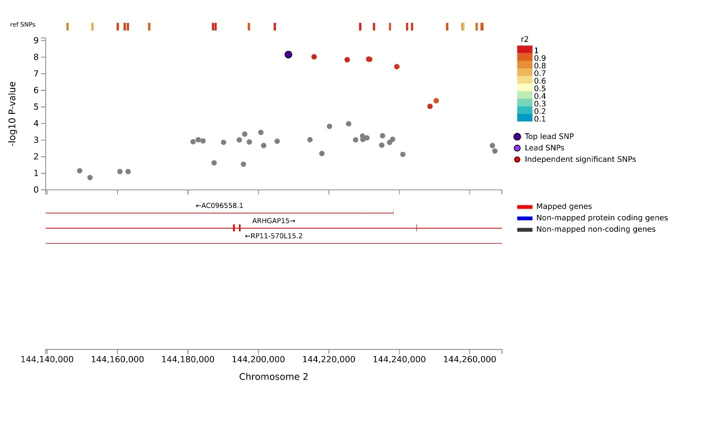
Locus 9 EA:
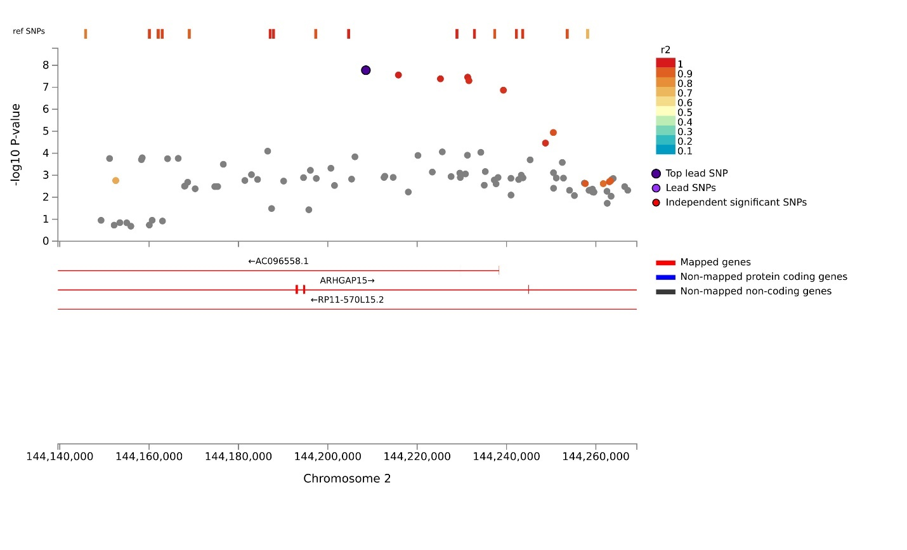
Locus 10 AA_EA:
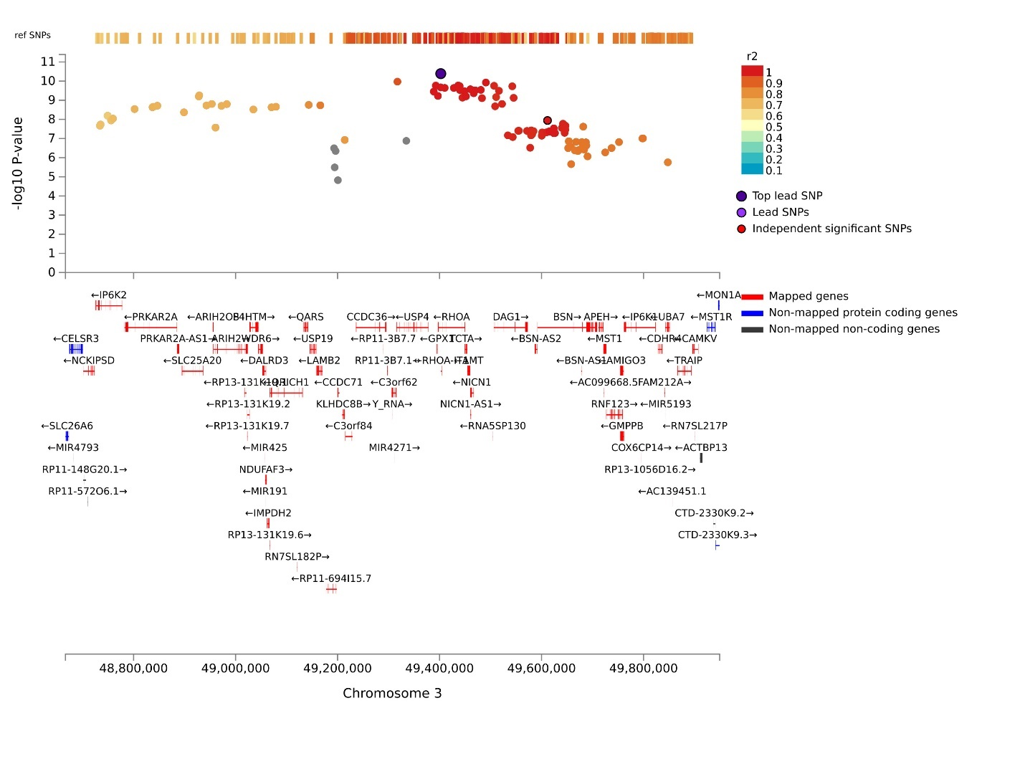
Locus 10 EA:
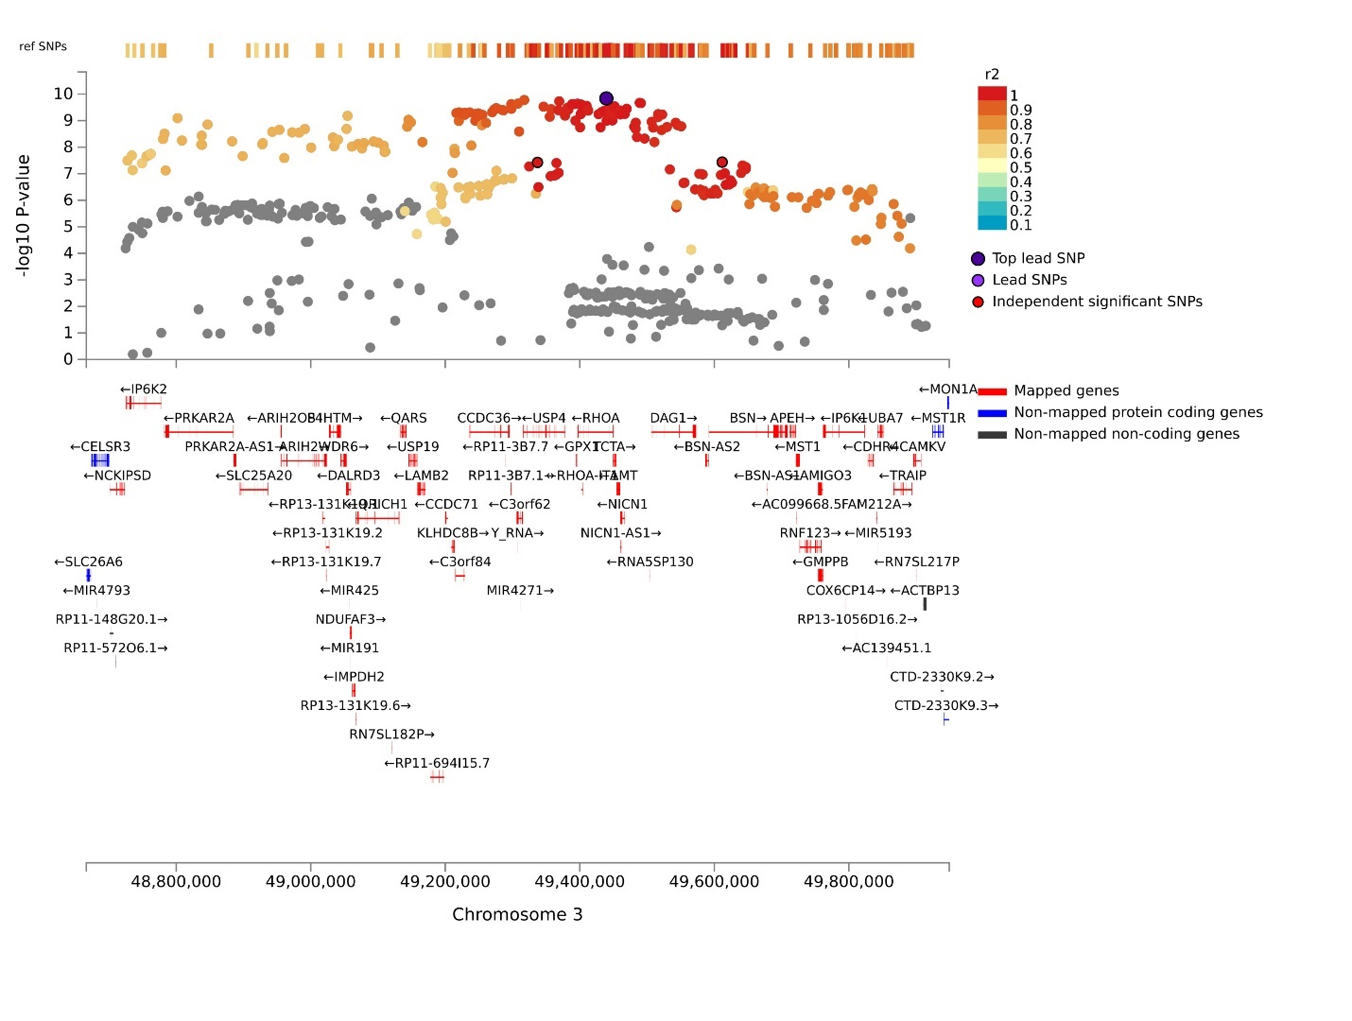
Locus 10 EA_LA:
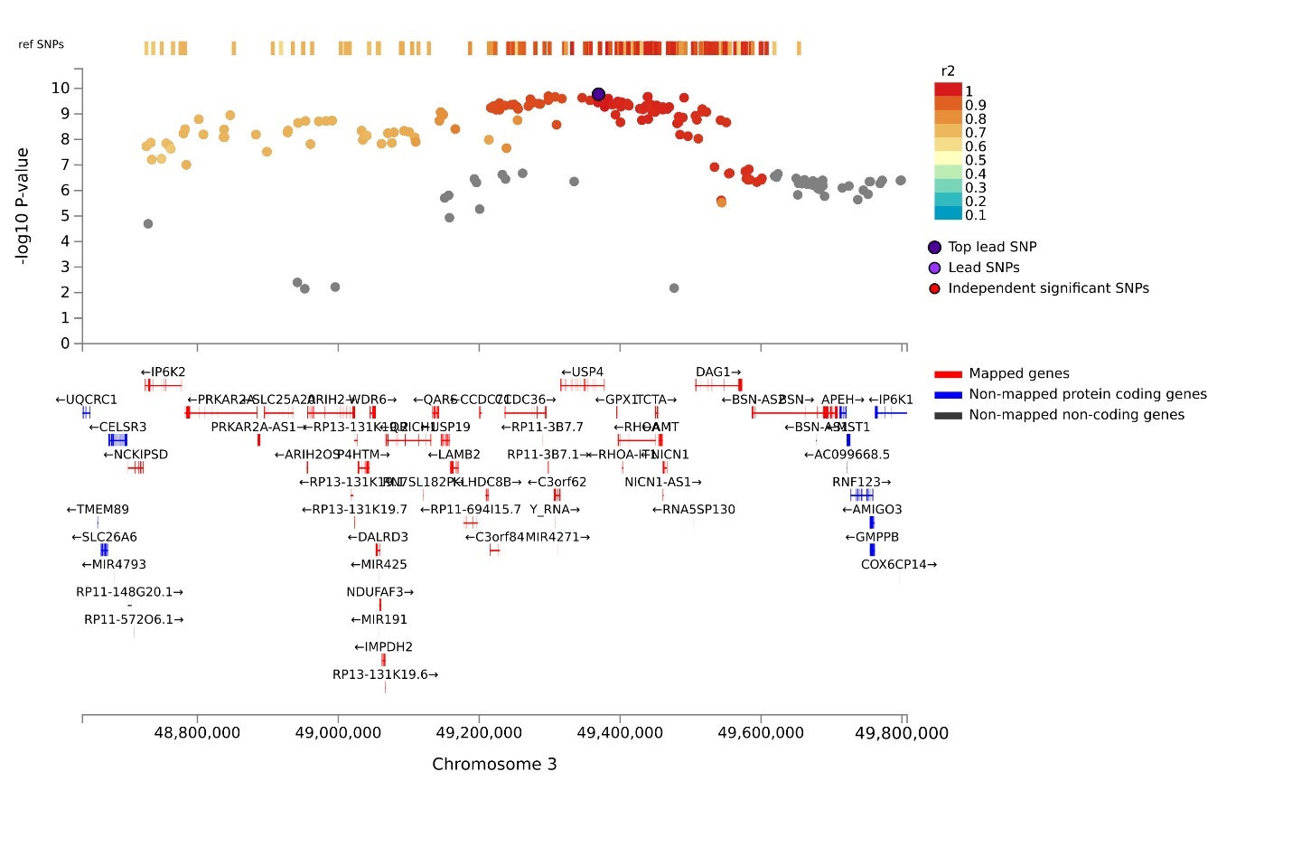
Locus 10 AA_EA_LA:
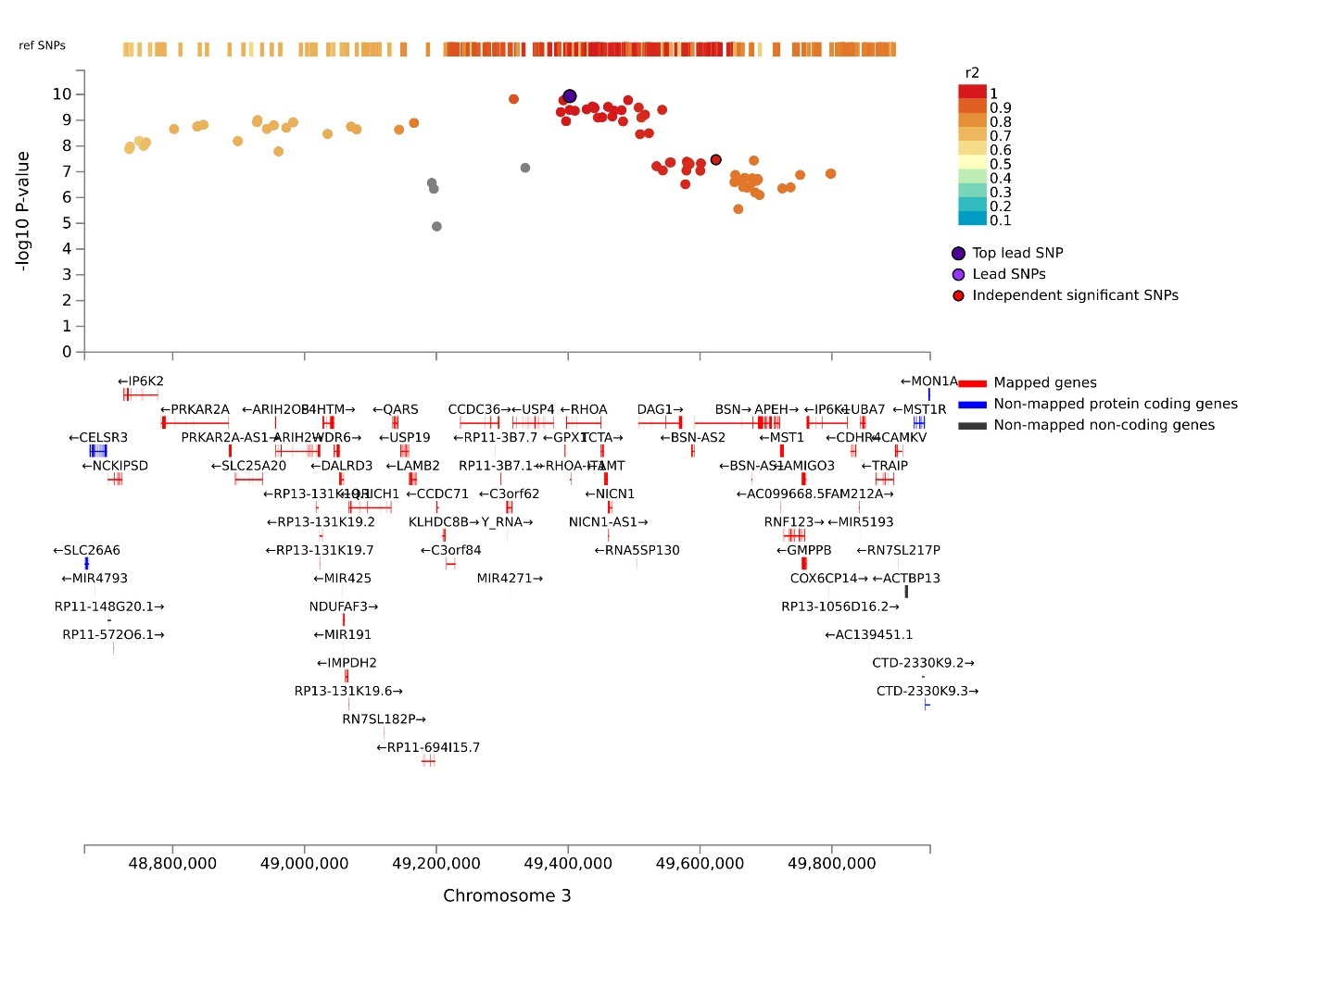
Locus 11 AA_EA:
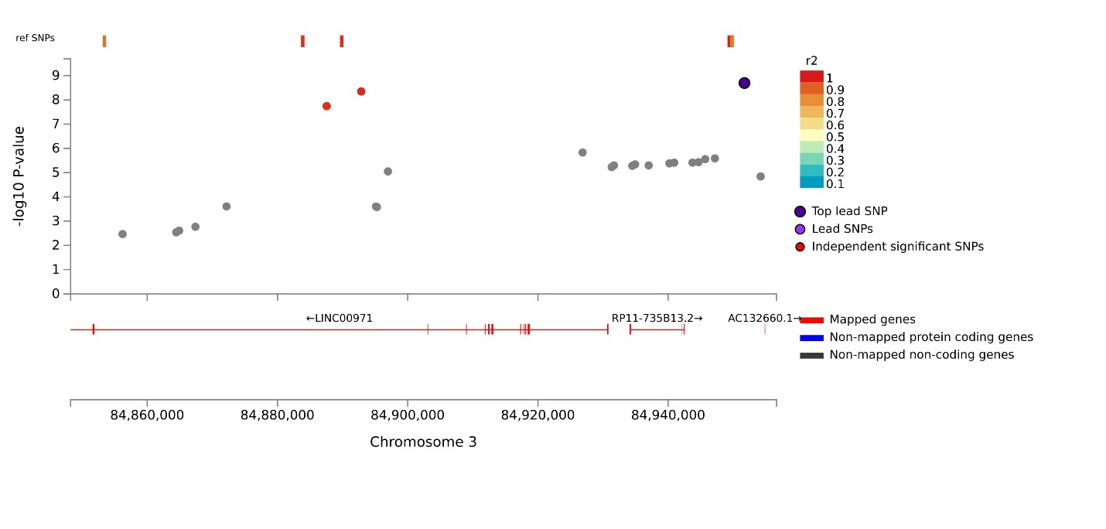
Locus 11 EA:
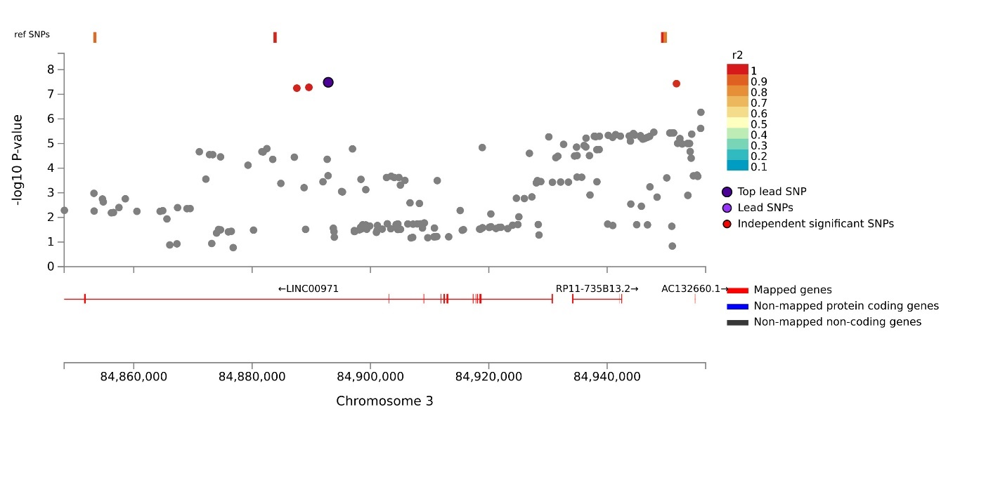
Locus 12 EA:
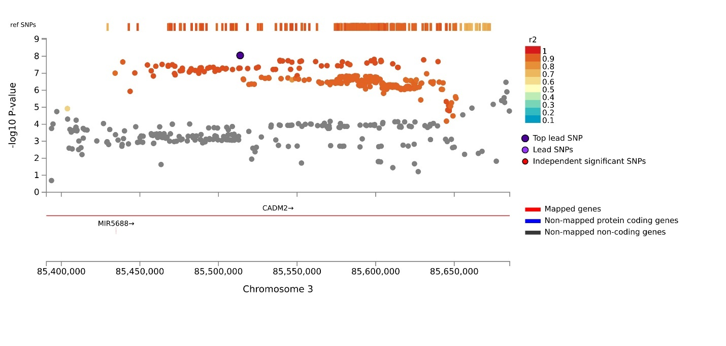
Locus 12 EA_LA:
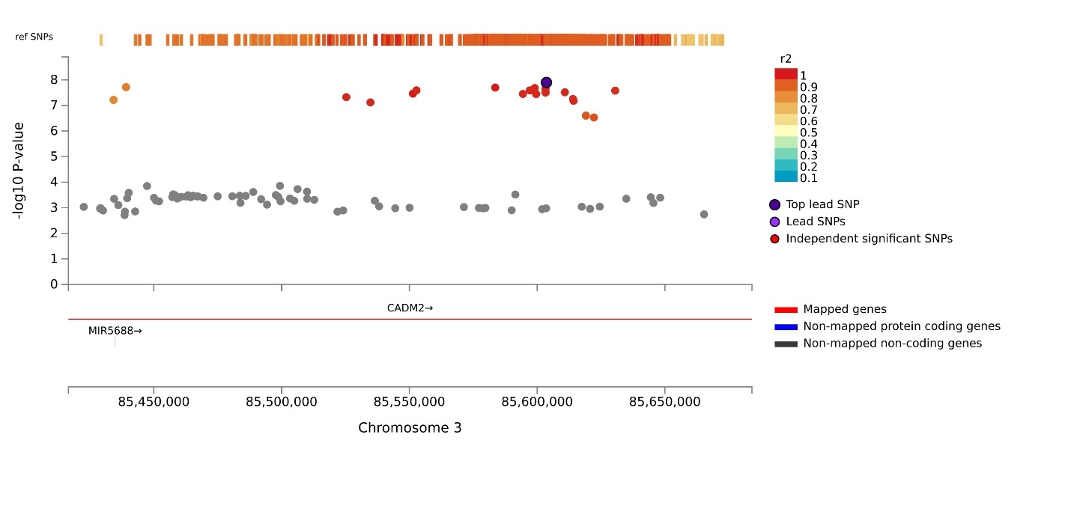
Locus 13 AA_EA_LA:
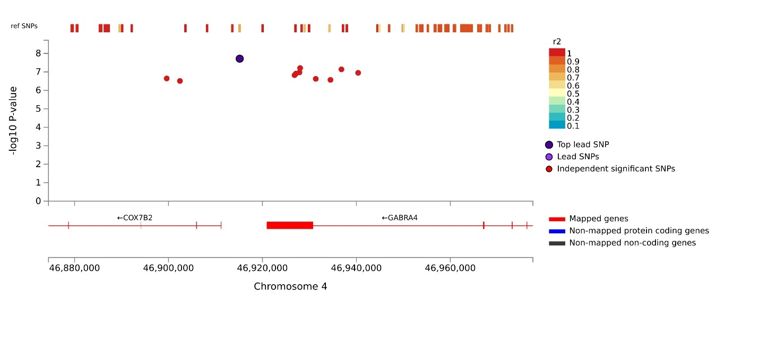
Locus 13 AA_EA:
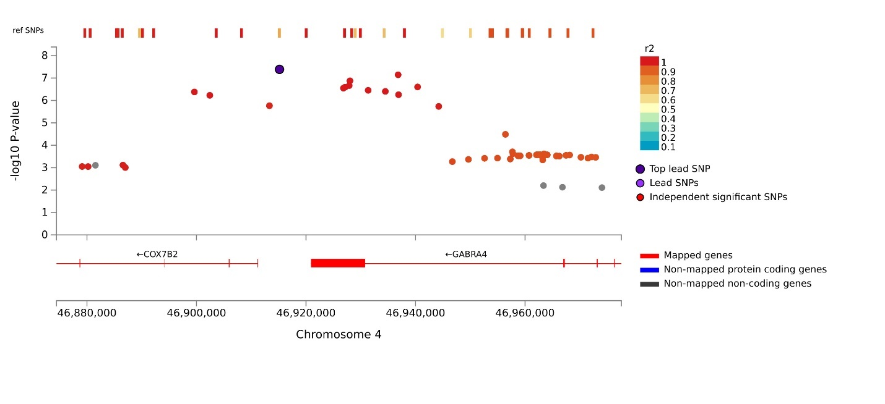
Locus 14 LA:
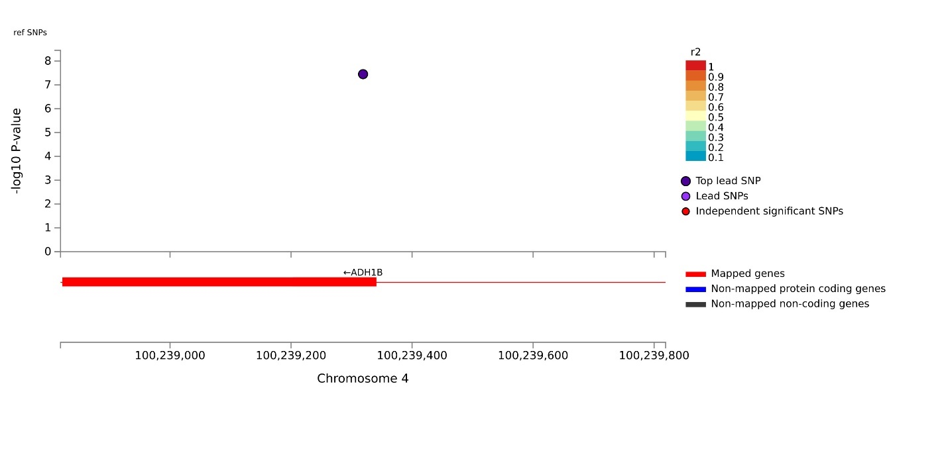
Locus 15 EA_LA:
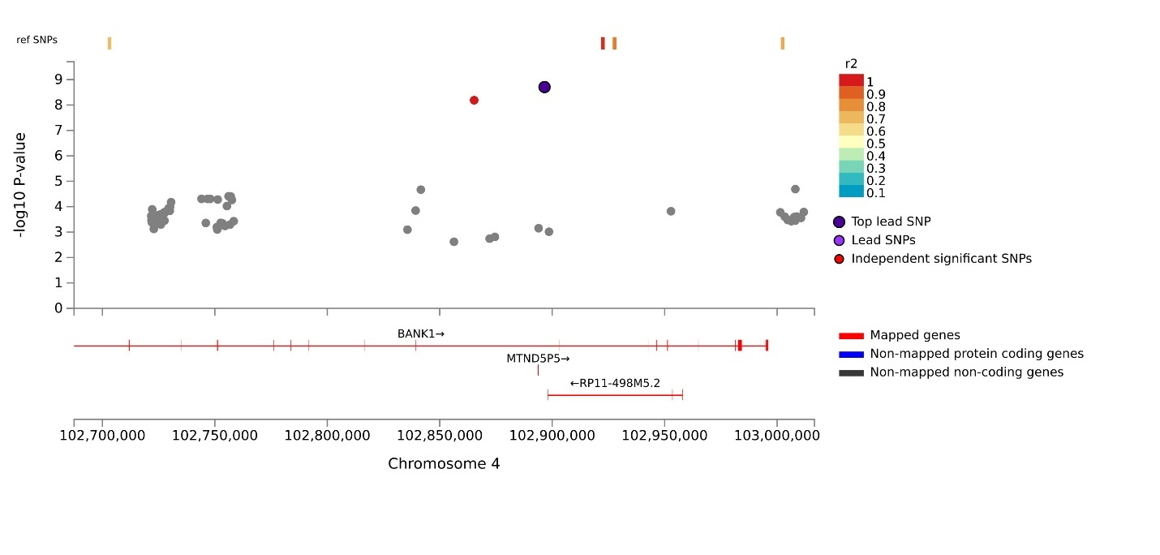
Locus 15 EA:
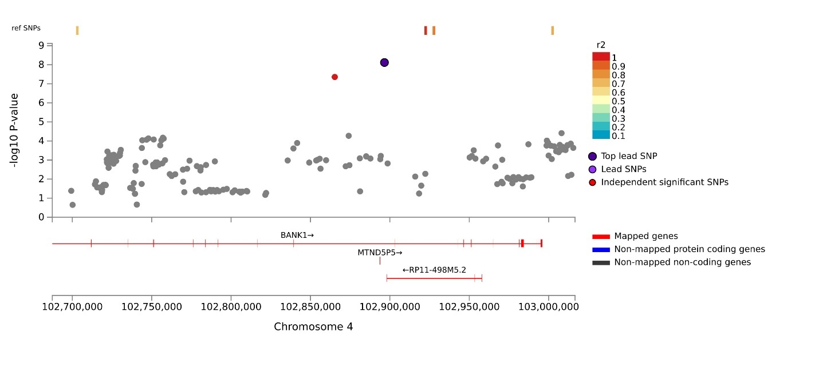
Locus 16 EA:
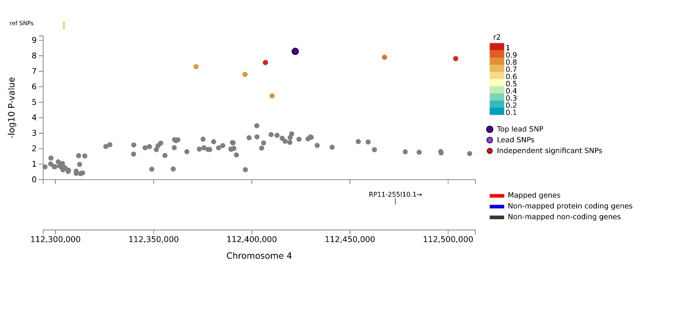
Locus 16 EA_LA:
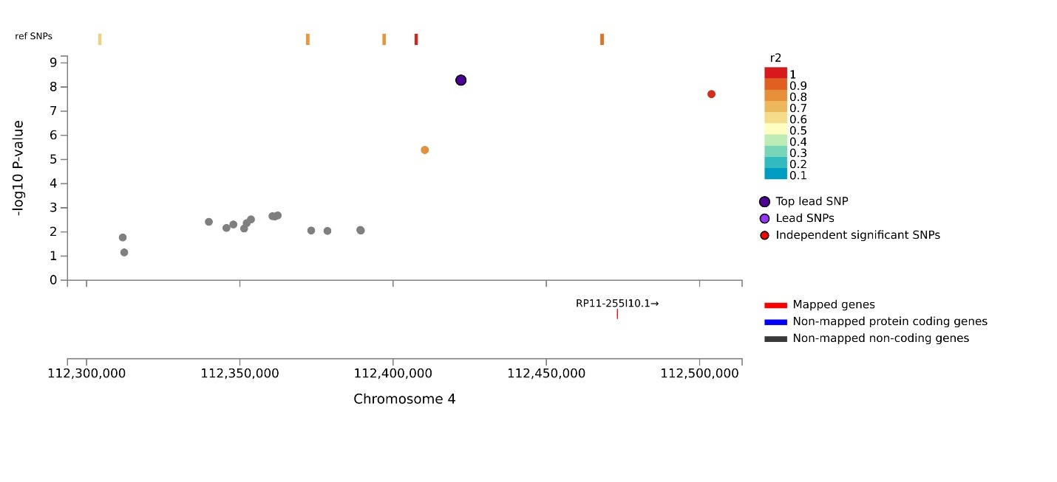
Locus 17 EA:
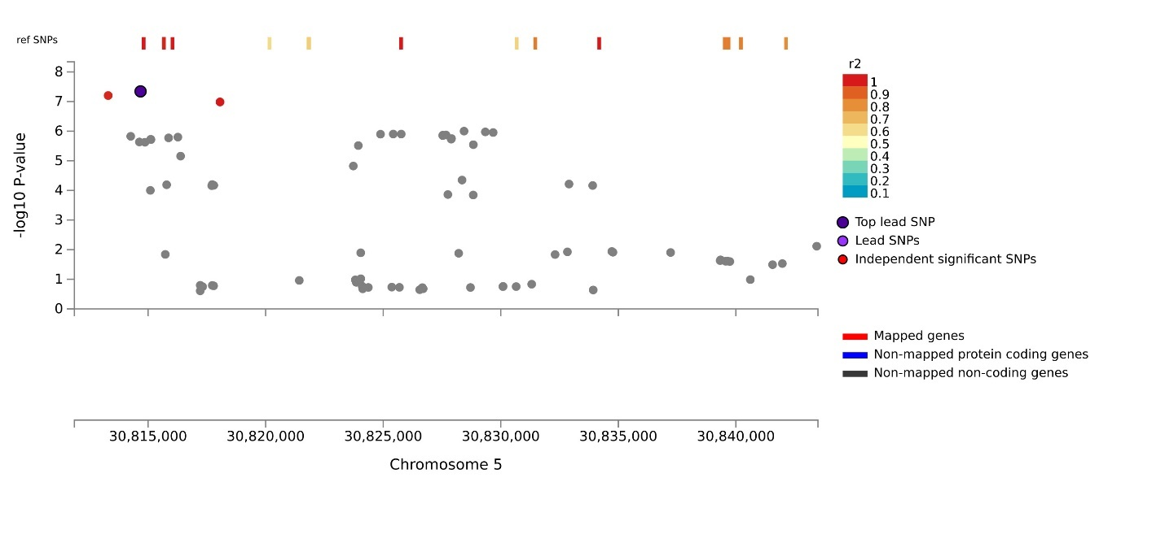
Locus 18 AA_EA:
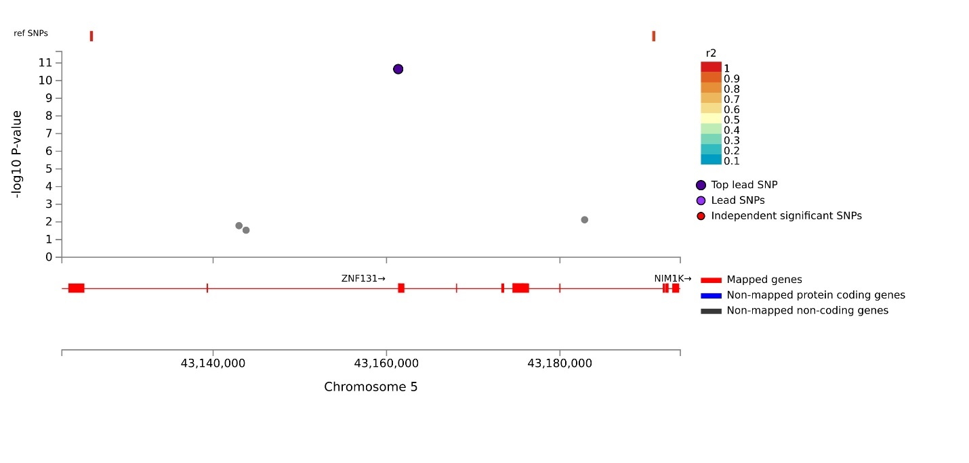
Locus 18 EA:
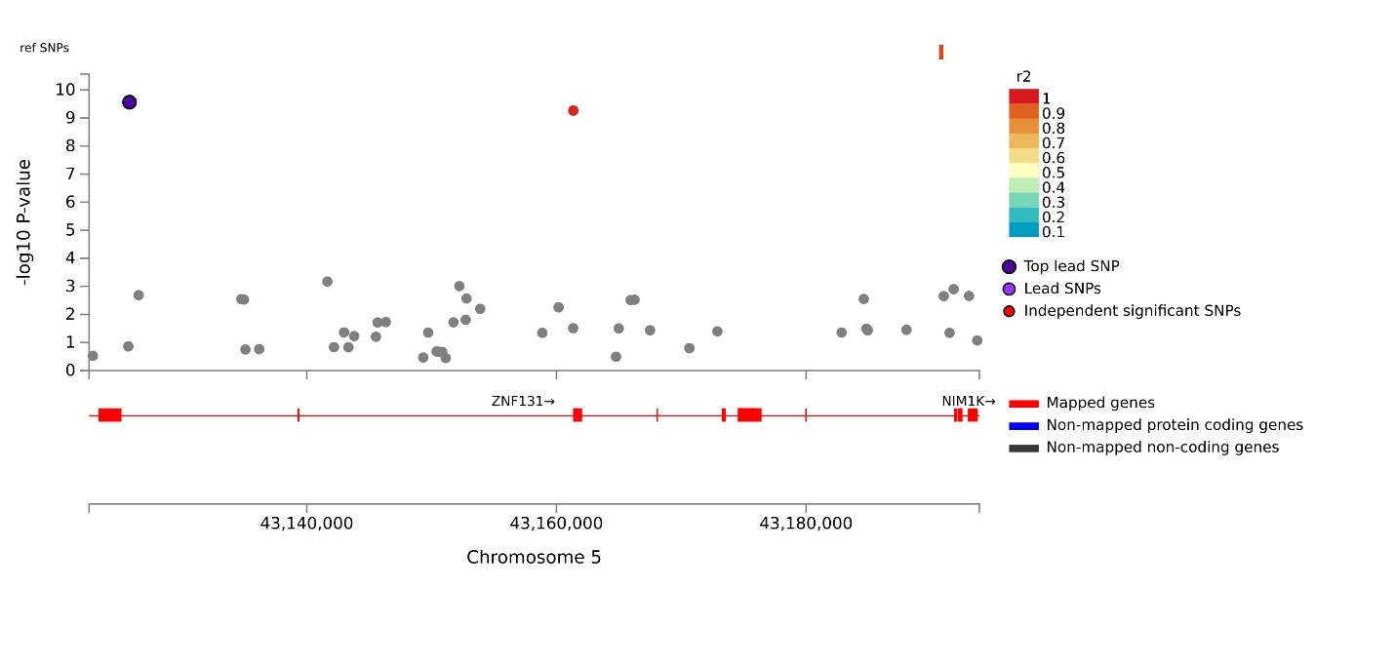
Locus 19 EA:
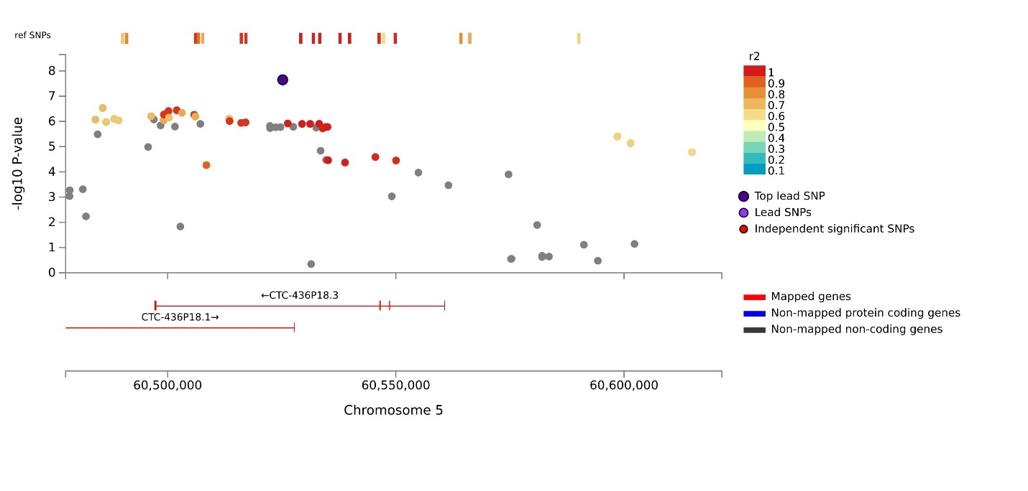
Locus 20 EA:
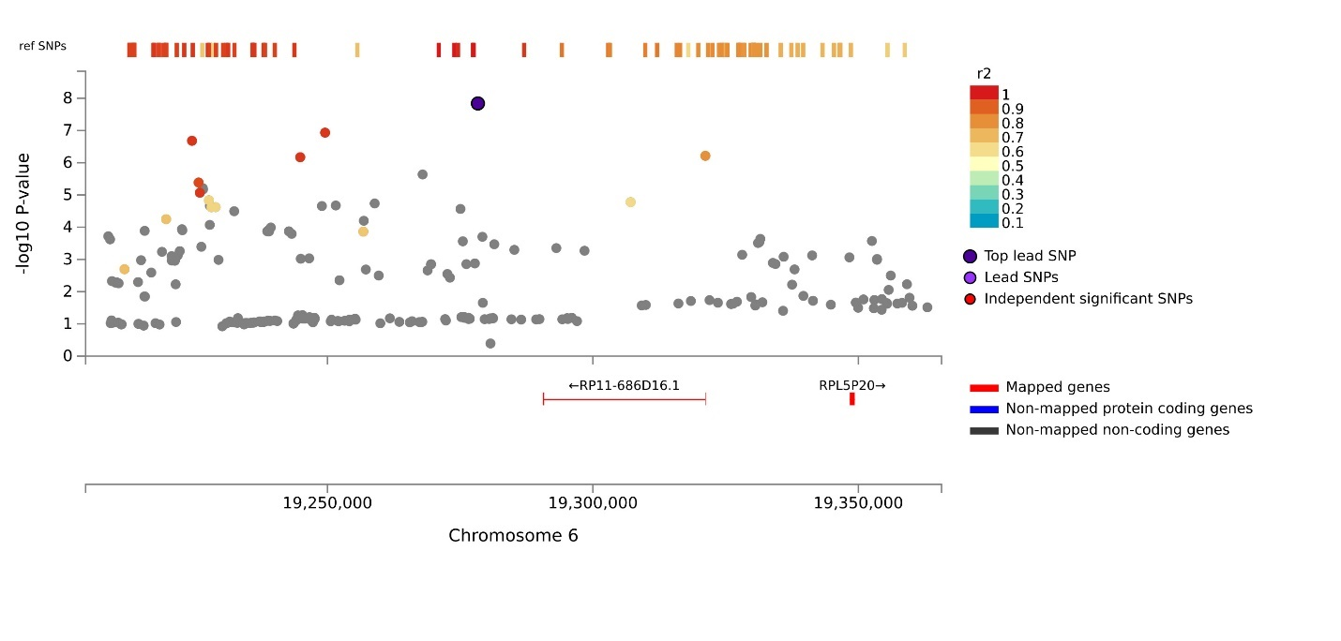
Locus 21 LA:
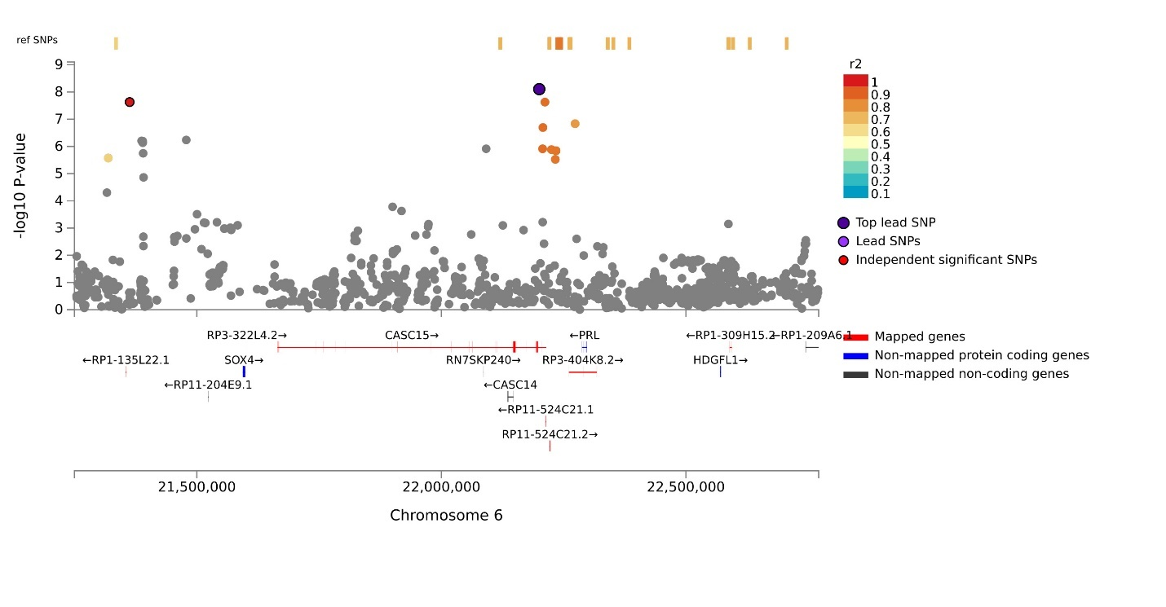
Locus 22 LA:
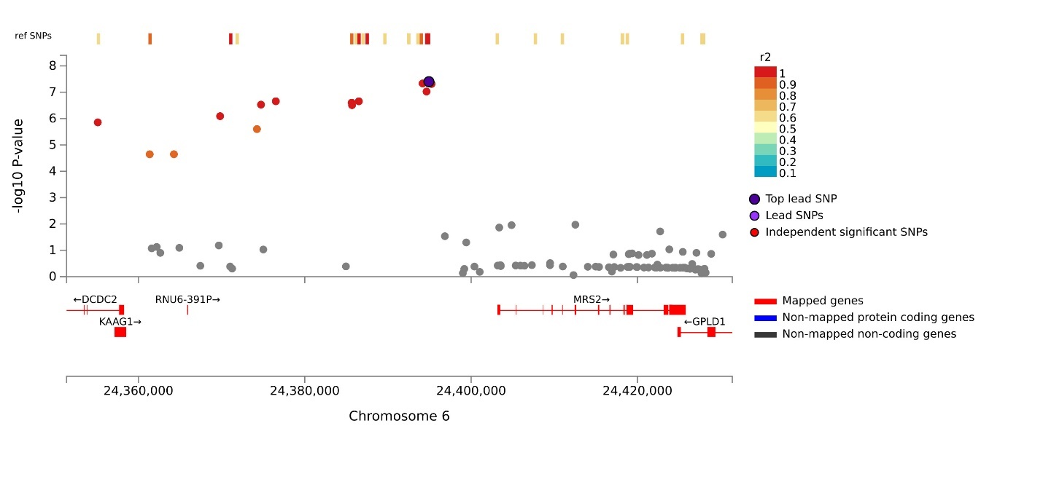
Locus 23 EA_LA:
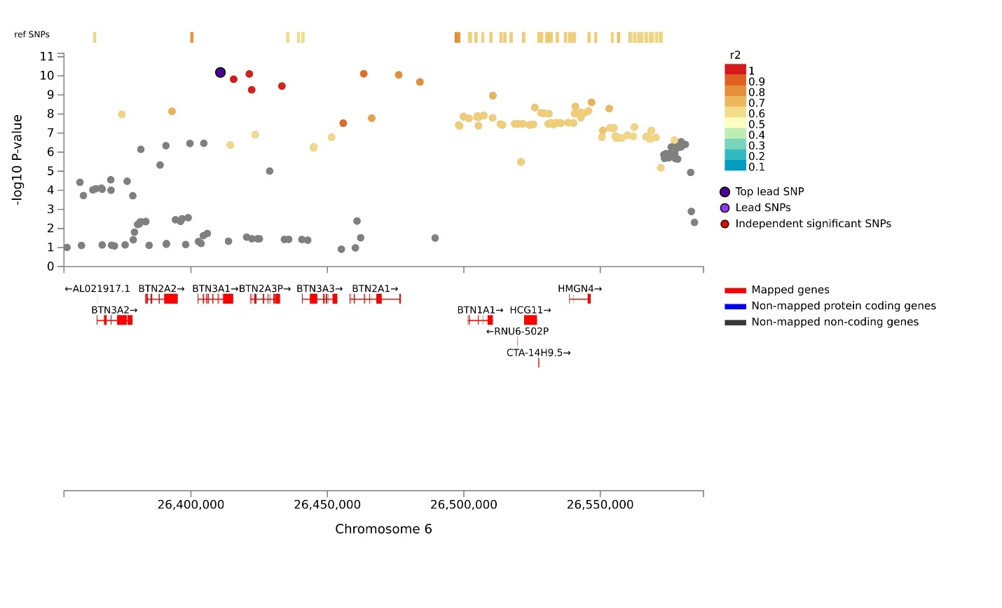
Locus 23 EA:
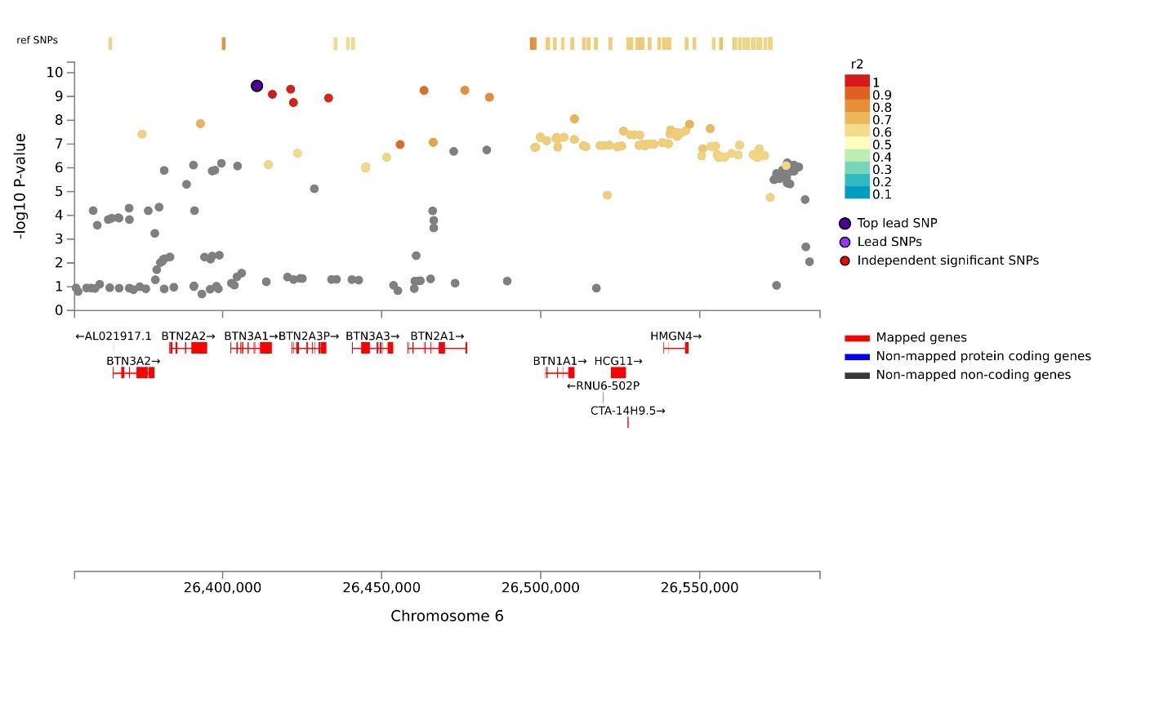
Locus 24 EA_LA:
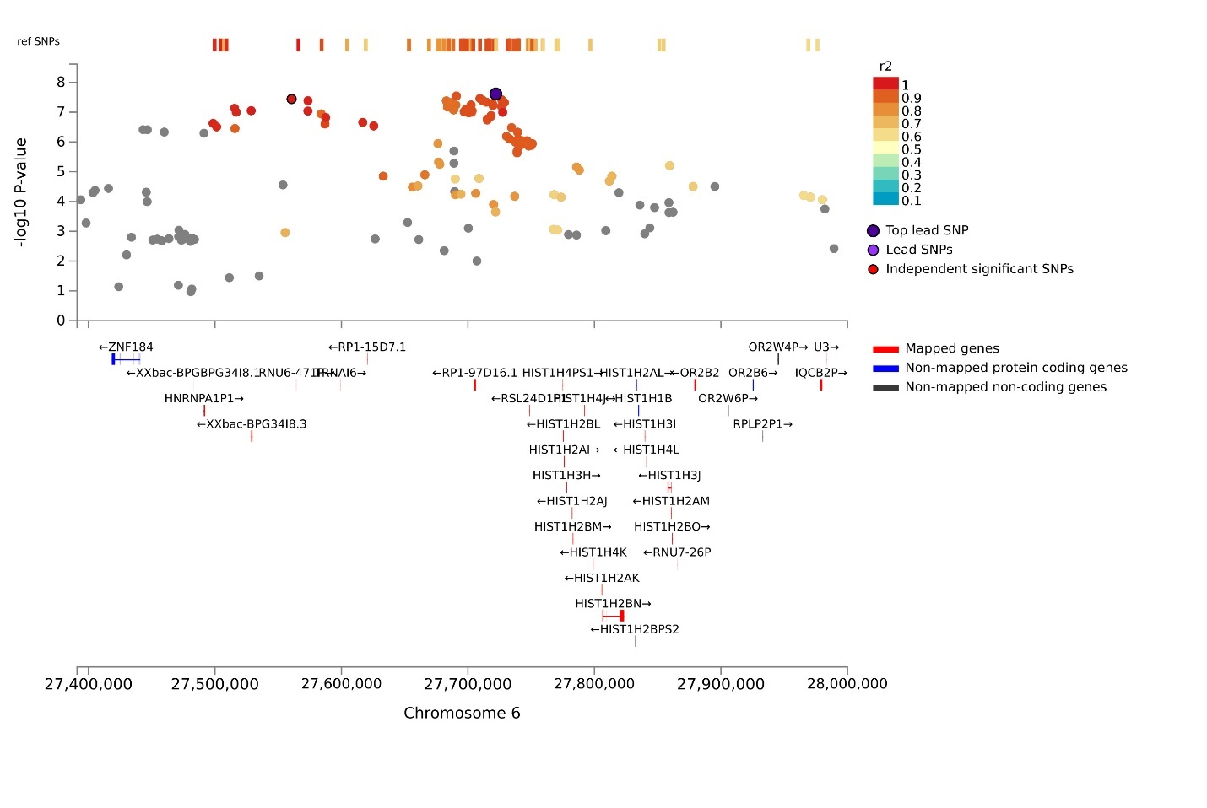
Locus 24 EA:
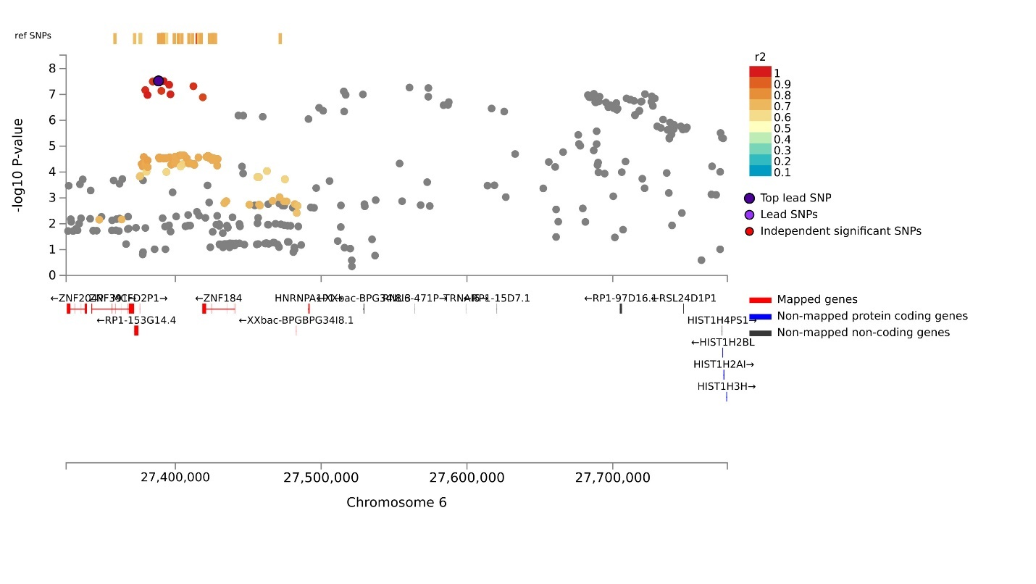
Locus 24 AA_EA:
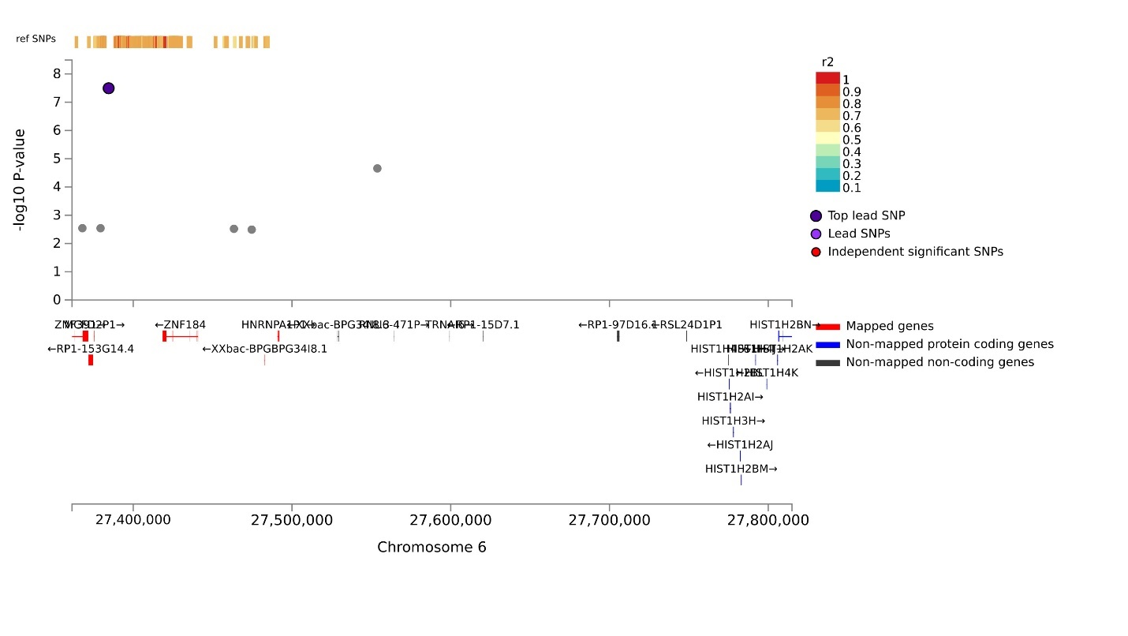
Locus 25 EA:
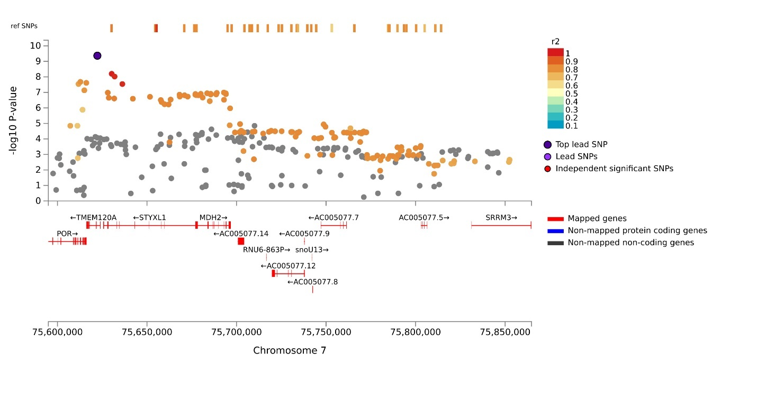
Locus 25 AA_EA:
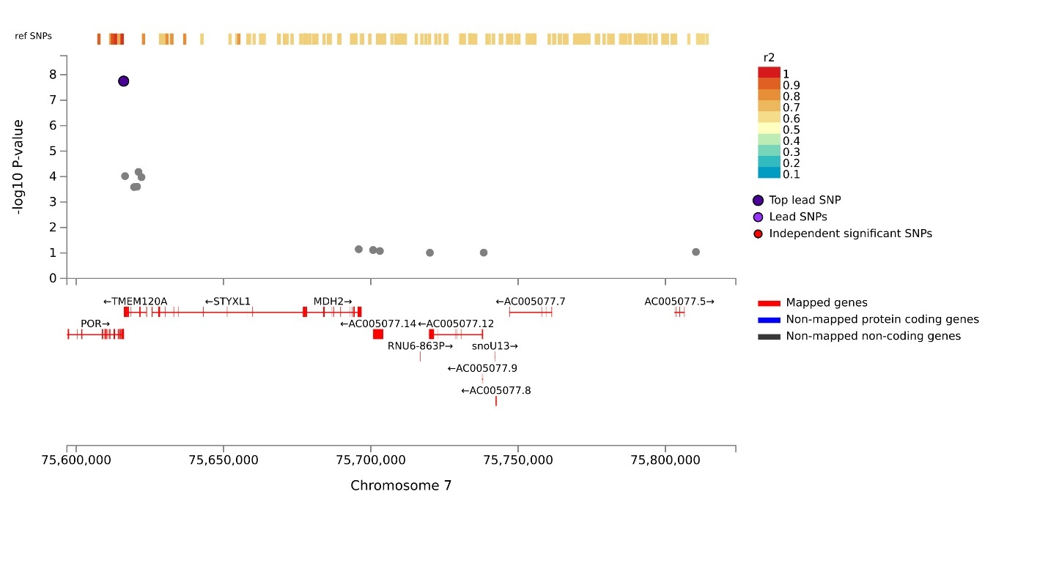
Locus 25 EA_LA:
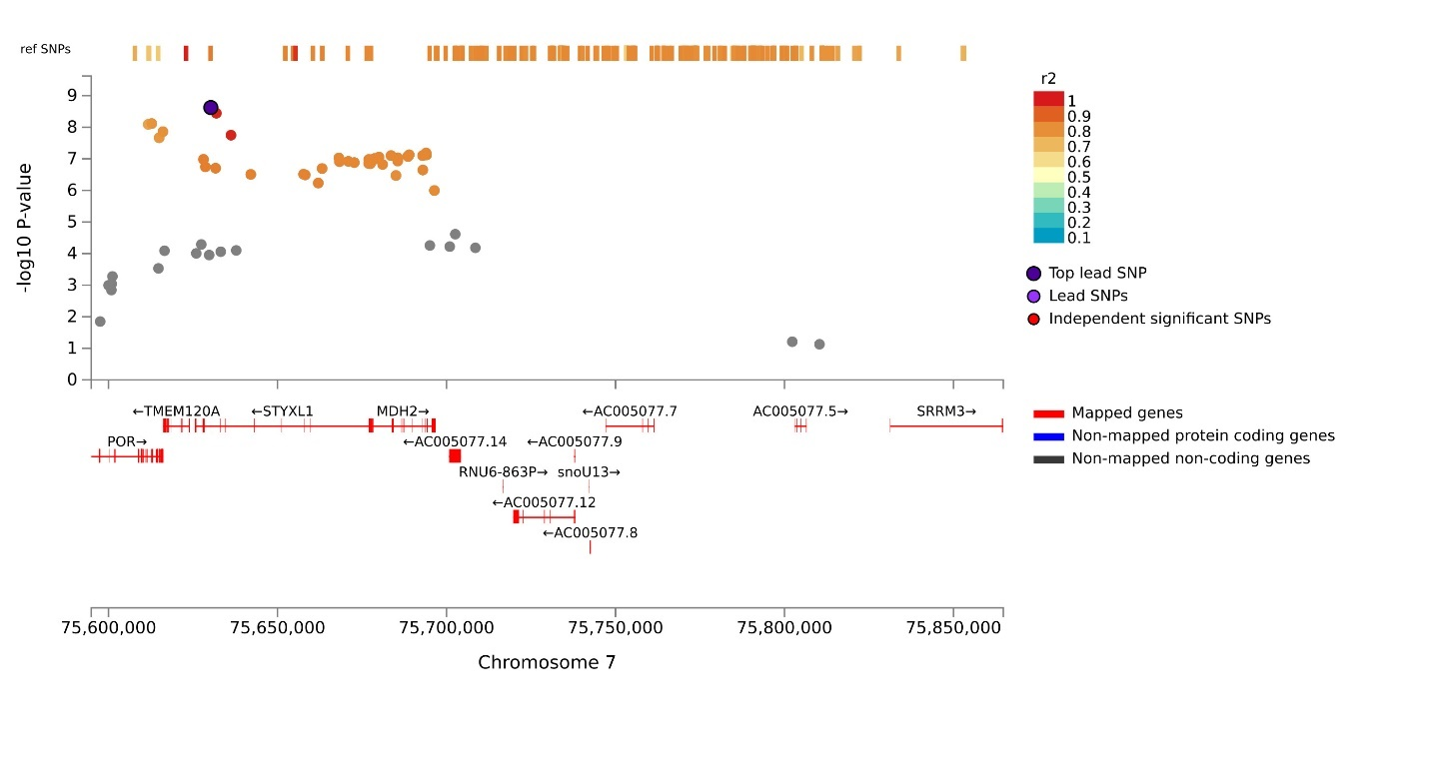
Locus 25 AA_EA_LA:
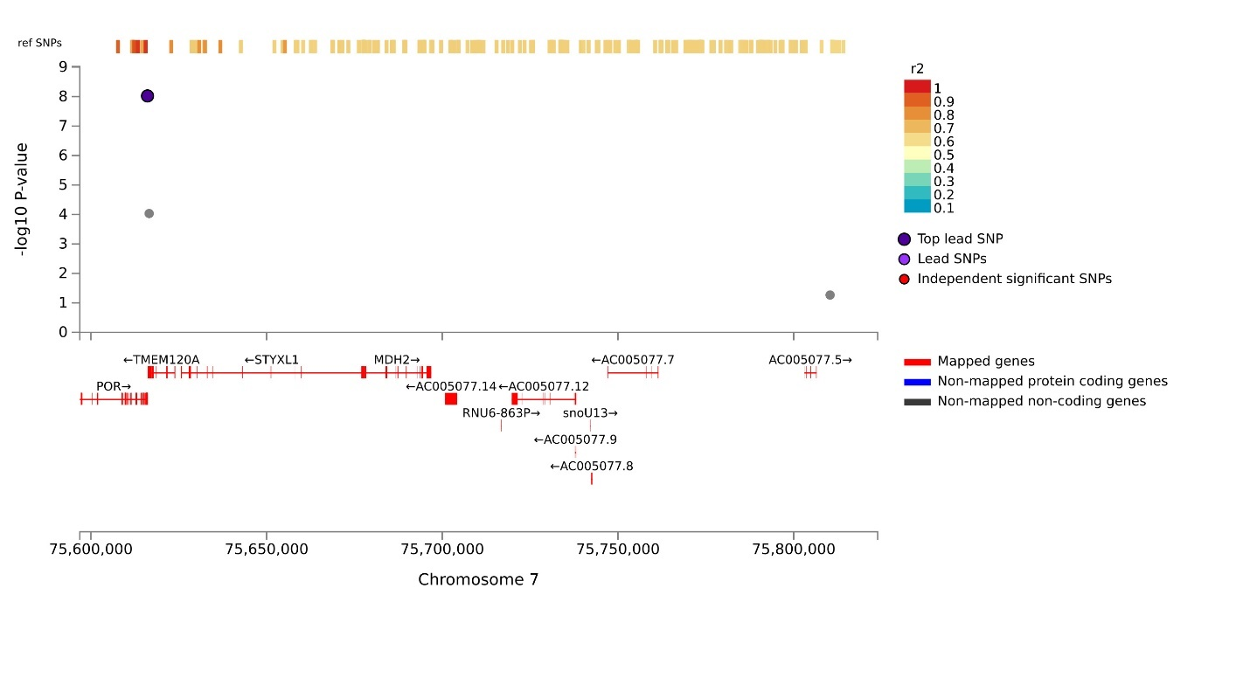
Locus 26 EA:
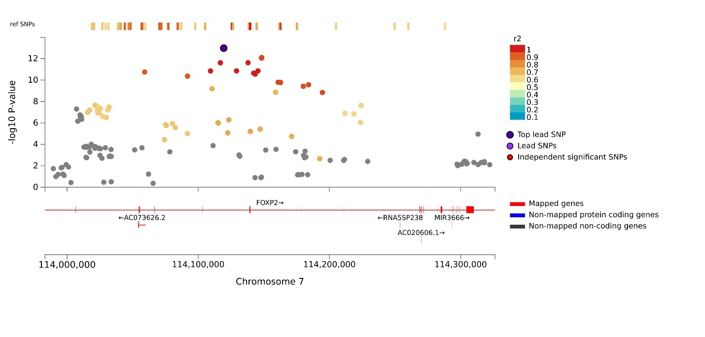
Locus 26 AA_EA:
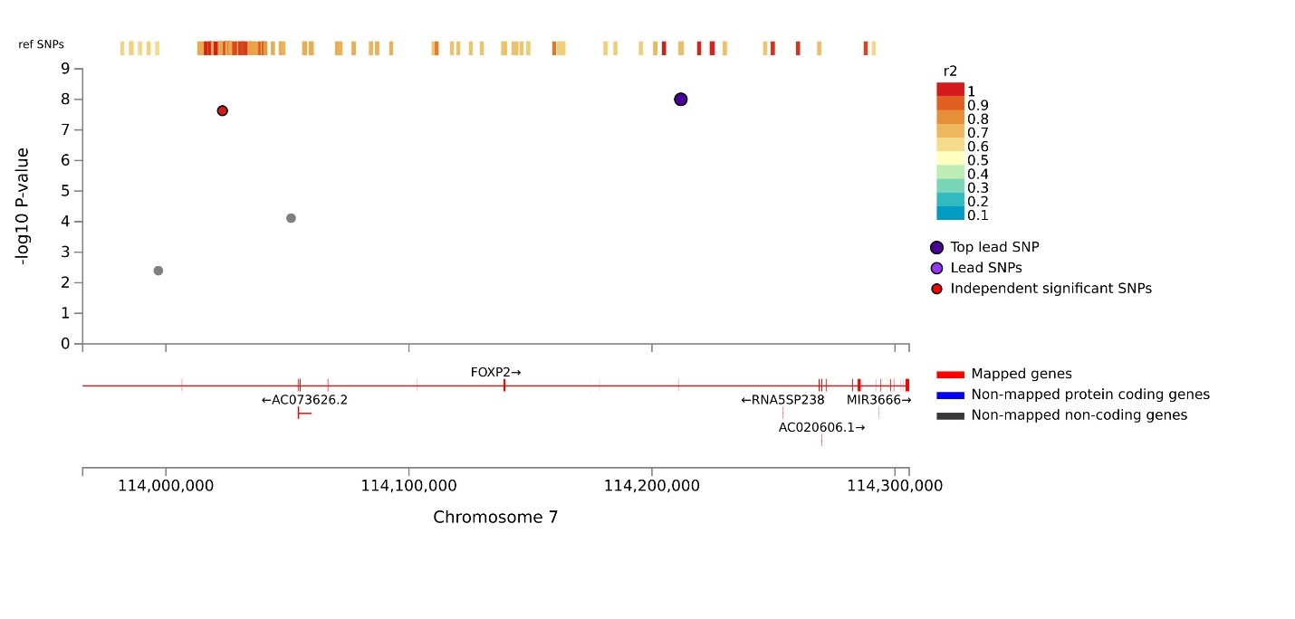
Locus 26 EA_LA:
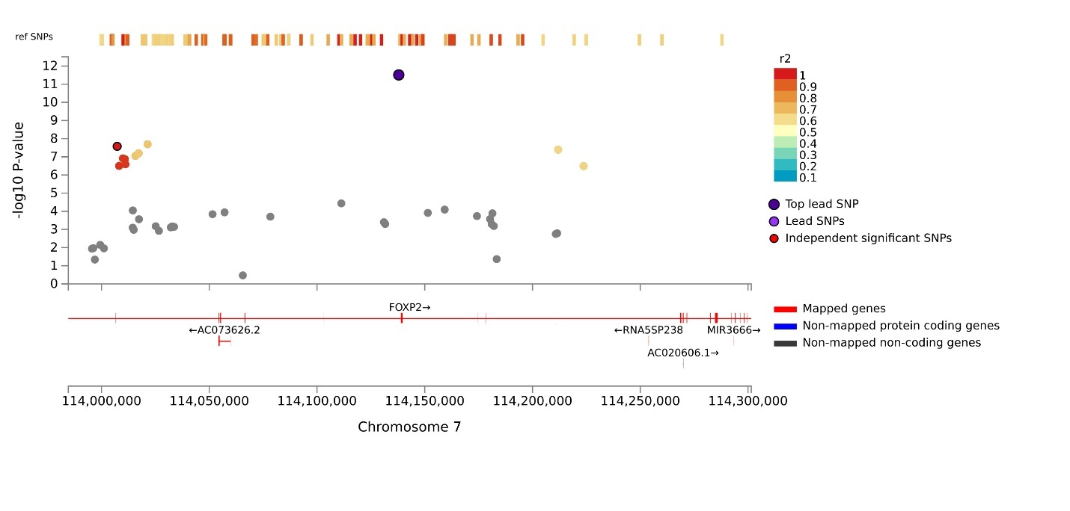
Locus 26 AA_EA_LA:
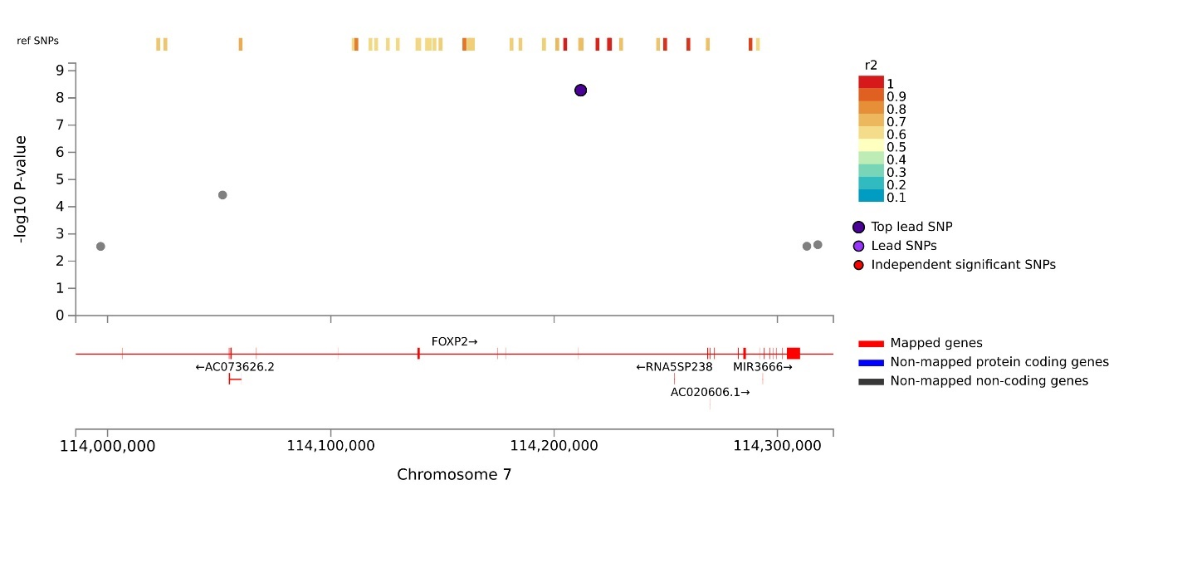
Locus 27 EA:
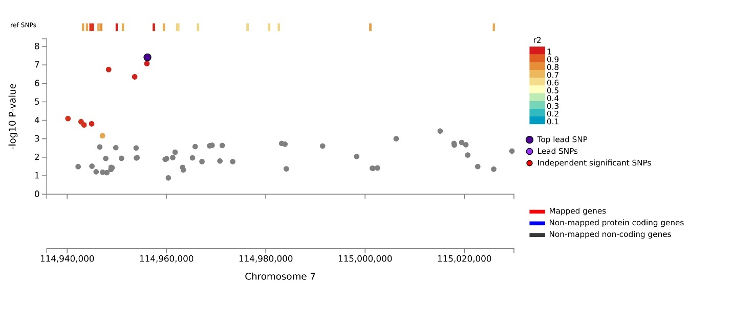
Locus 28 EA_LA:
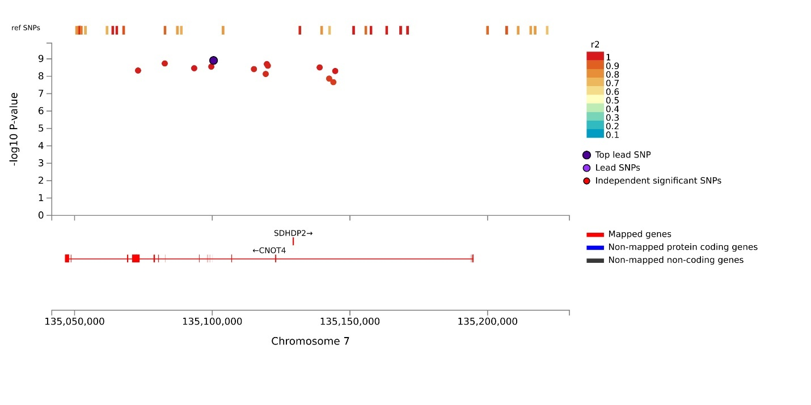
Locus 28 EA:
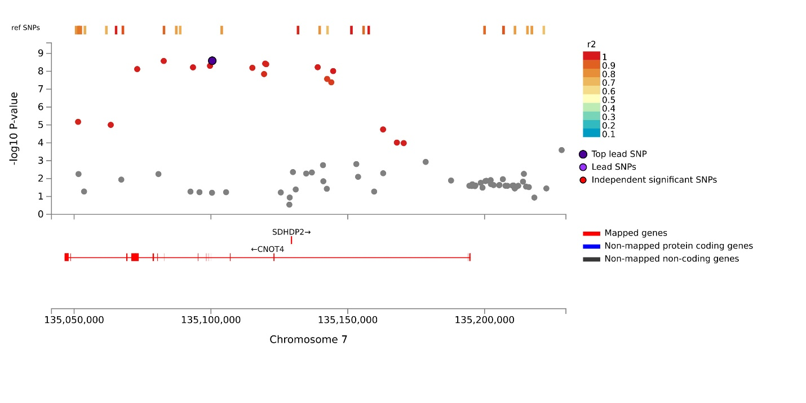
Locus 29 EA:
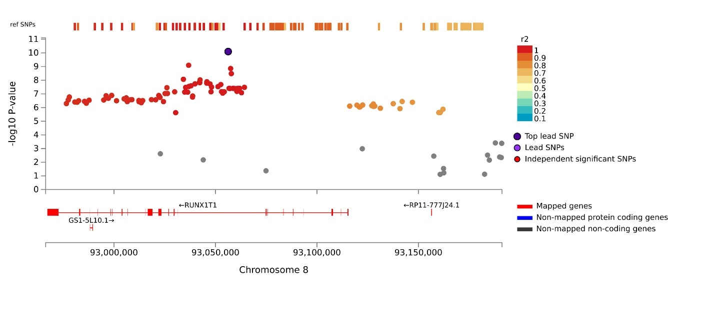
Locus 30 EA:
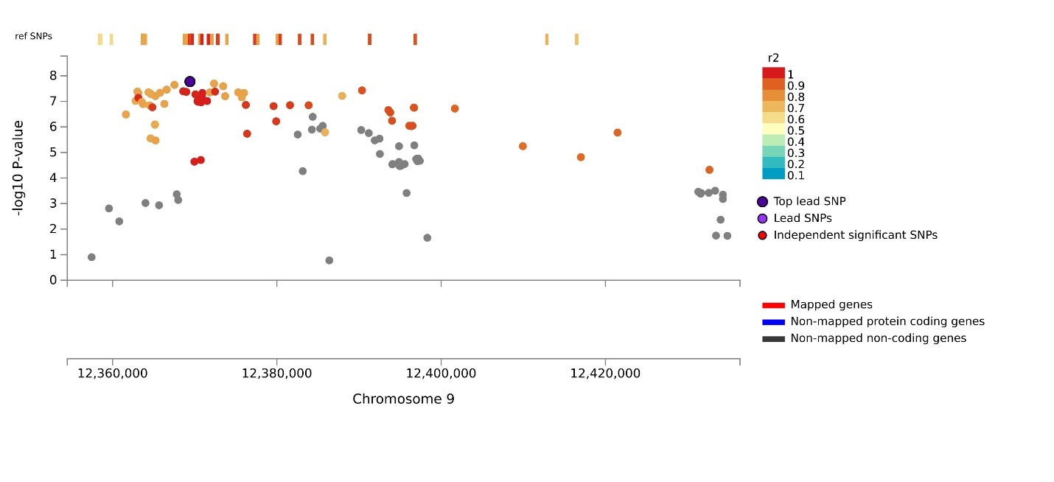
Locus 31 EA_LA:
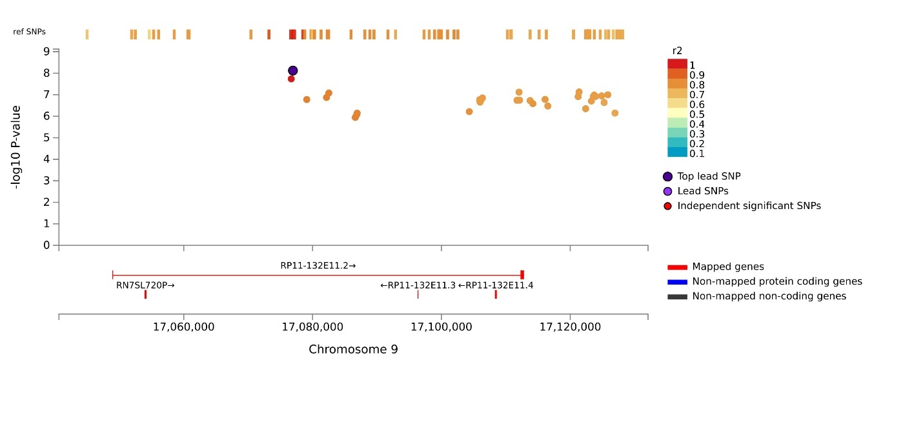
Locus 31 EA:
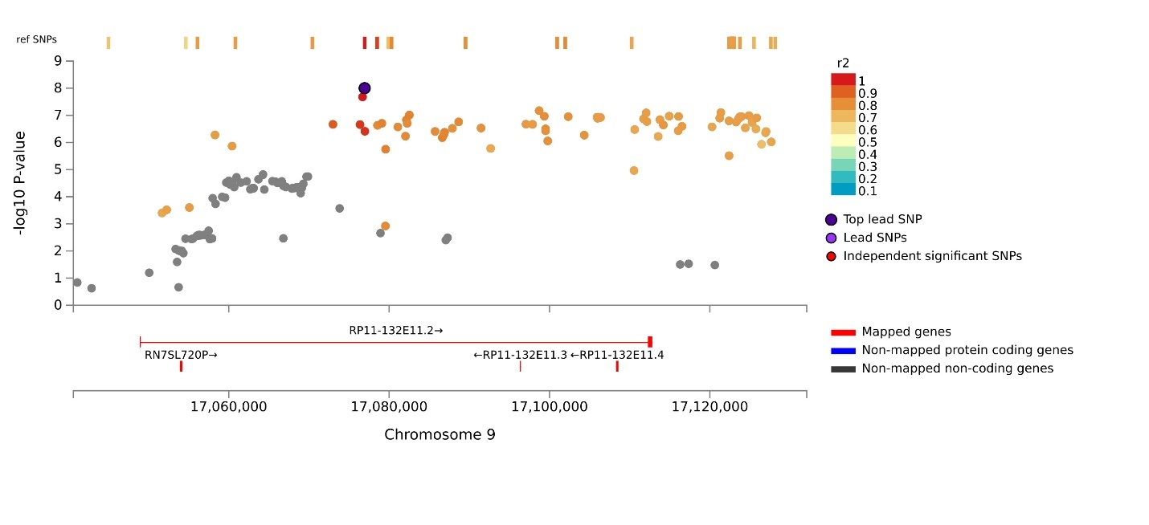
Locus 32 EA:
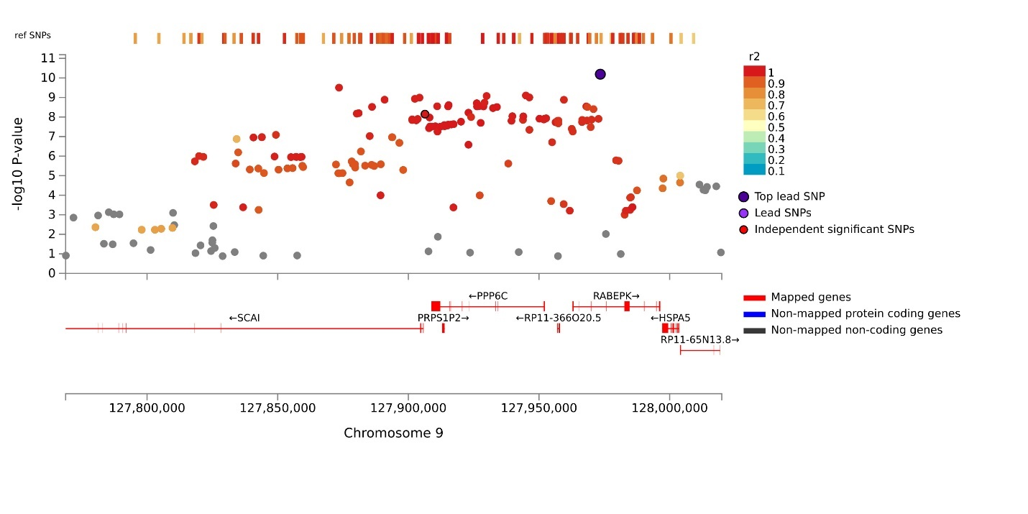
Locus 32 EA_LA:
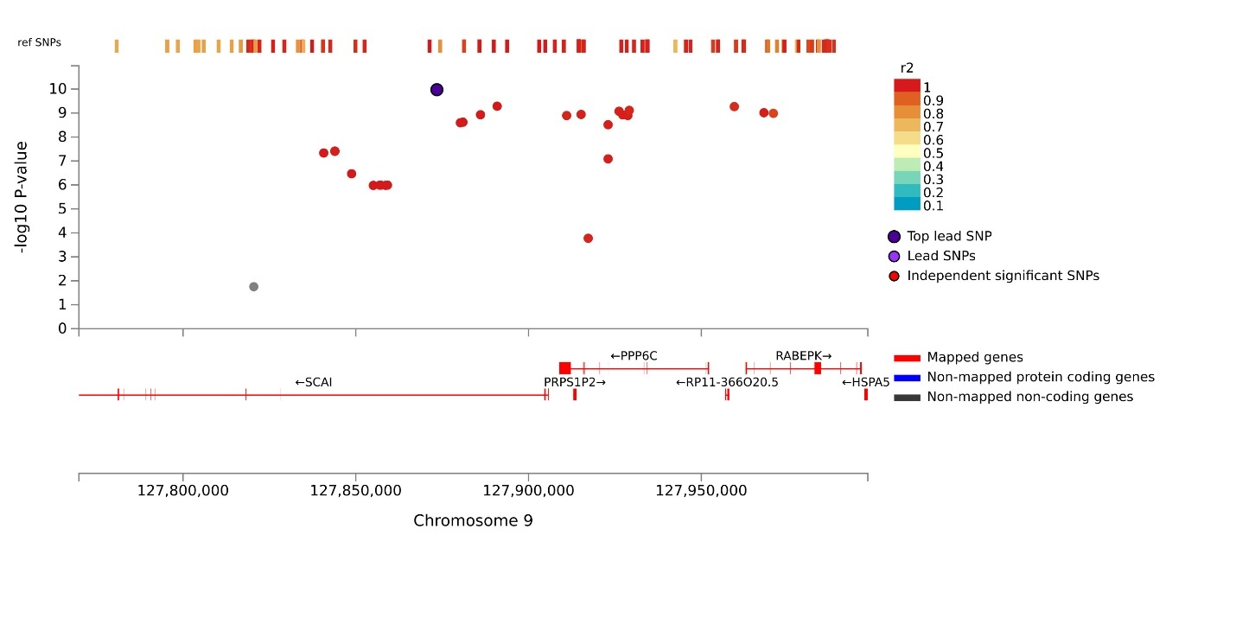
Locus 33 EA:
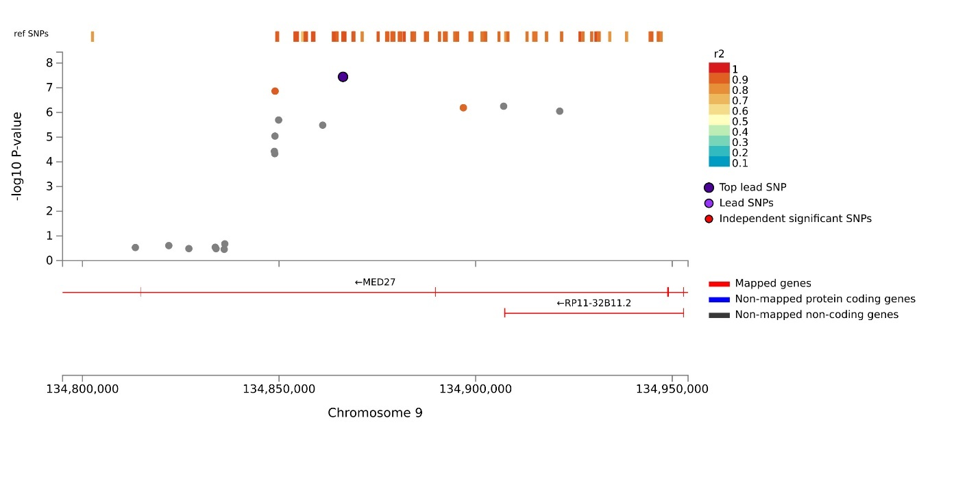
Locus 34 EA_LA:
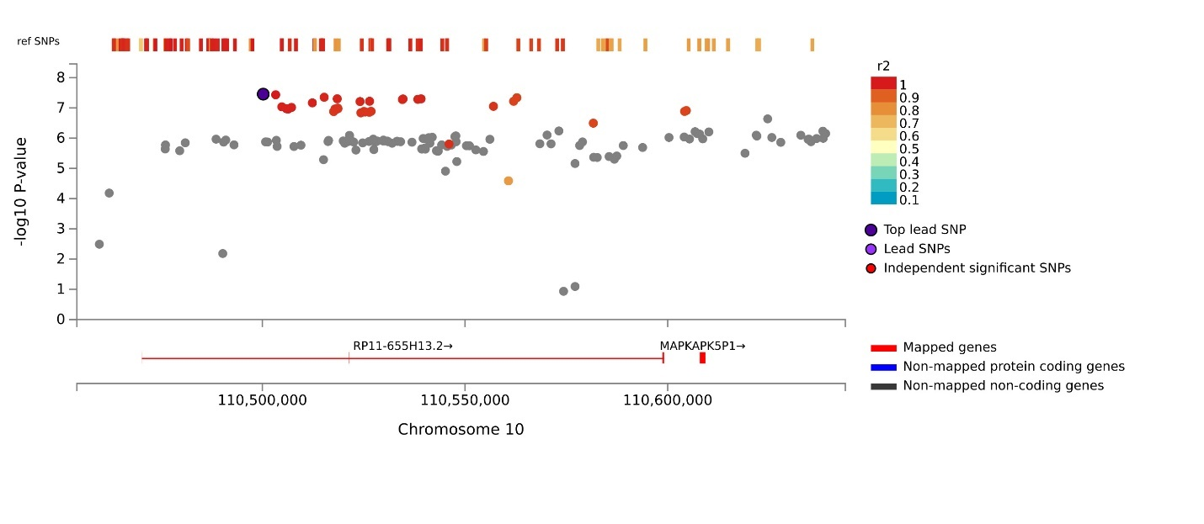
Locus 35 EA:
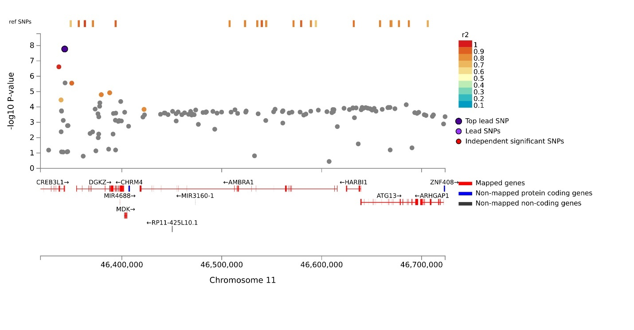
Locus 36 EA:
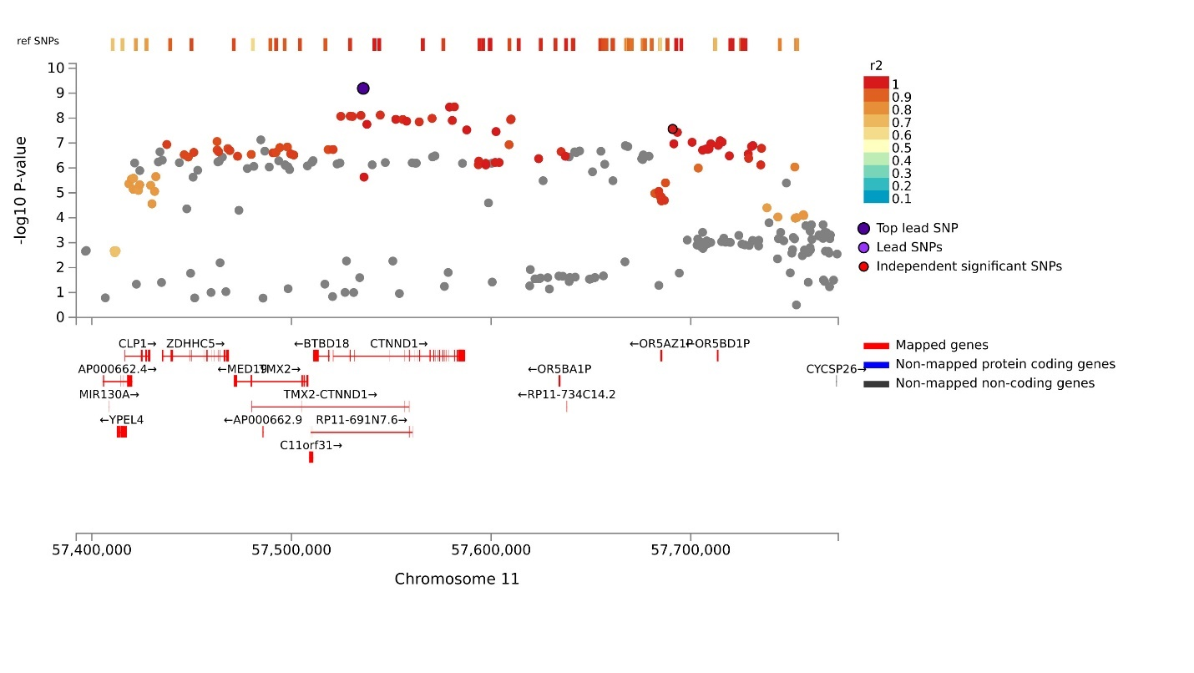
Locus 37 AA_EA_LA rs1116313:
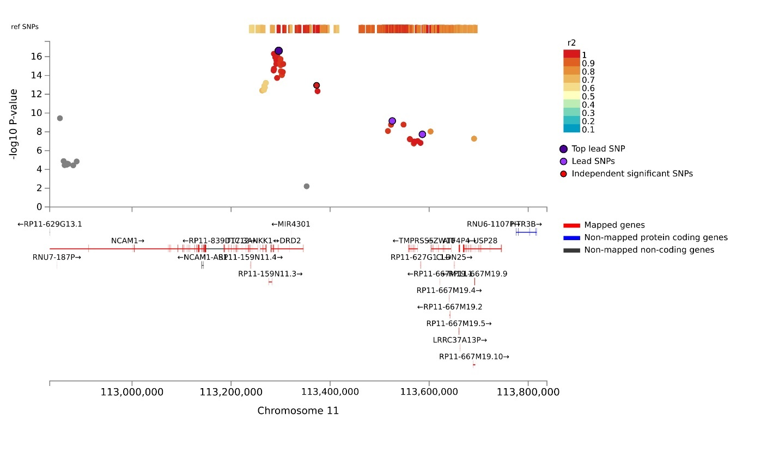
Locus 37 AA_EA_LA rs4444109:
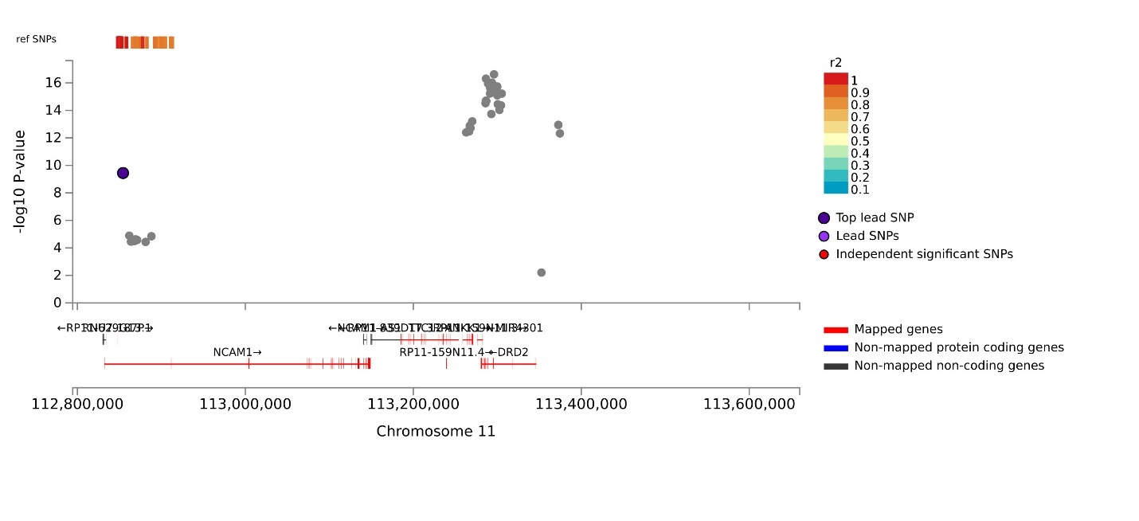
Locus 37 EA rs12363125:
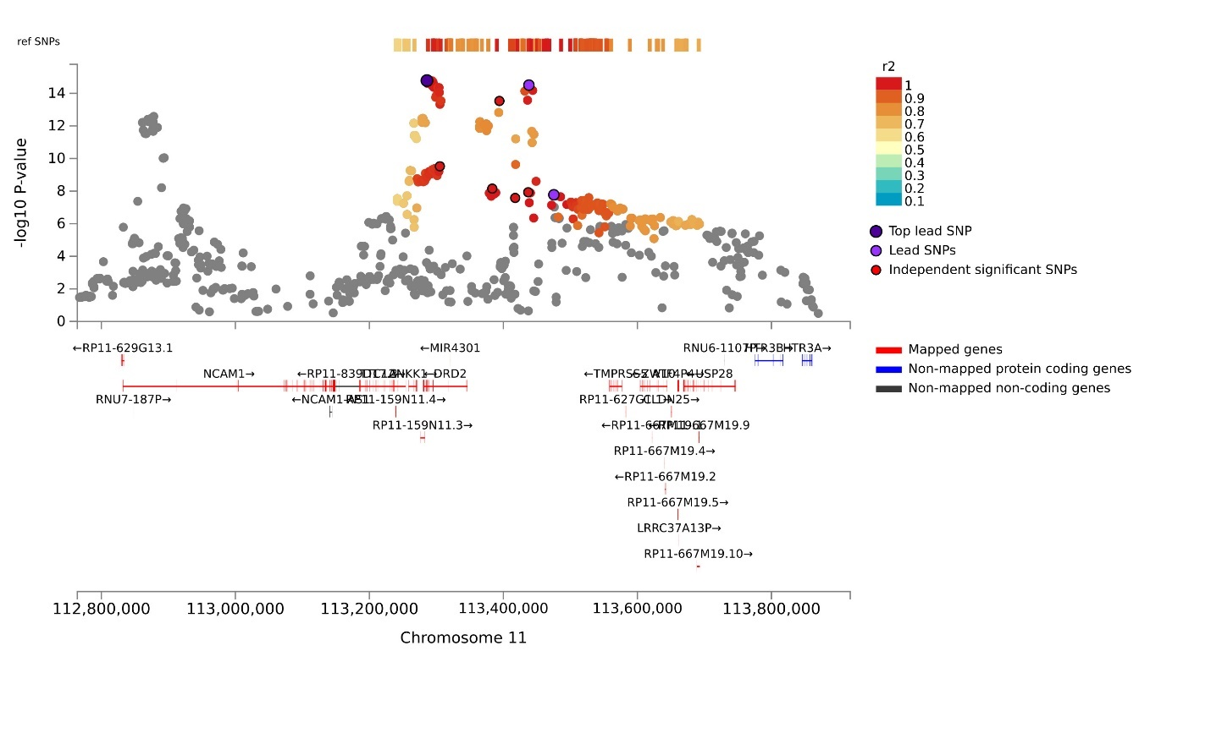
Locus 37 EA rs7118907:
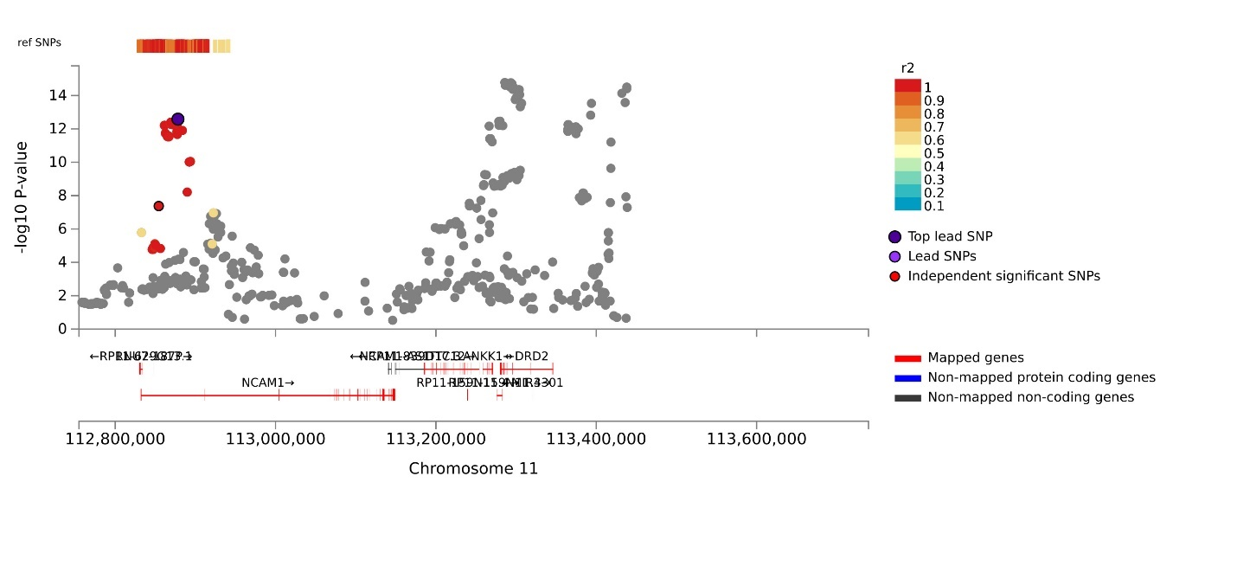
Locus 37 AA_EA:
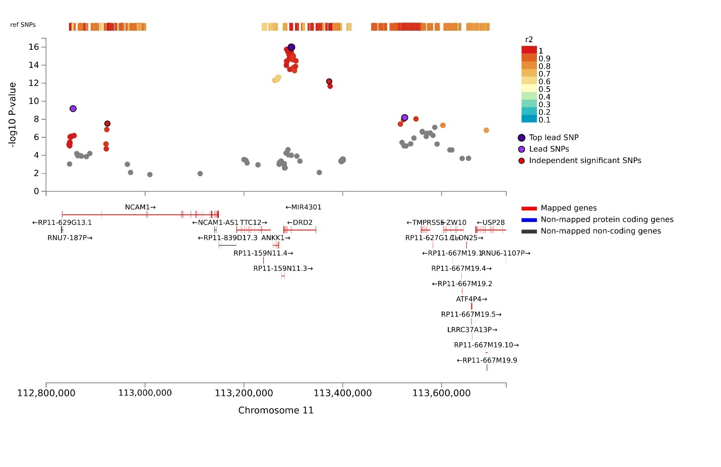
Locus 37 EA_LA rs7118907:
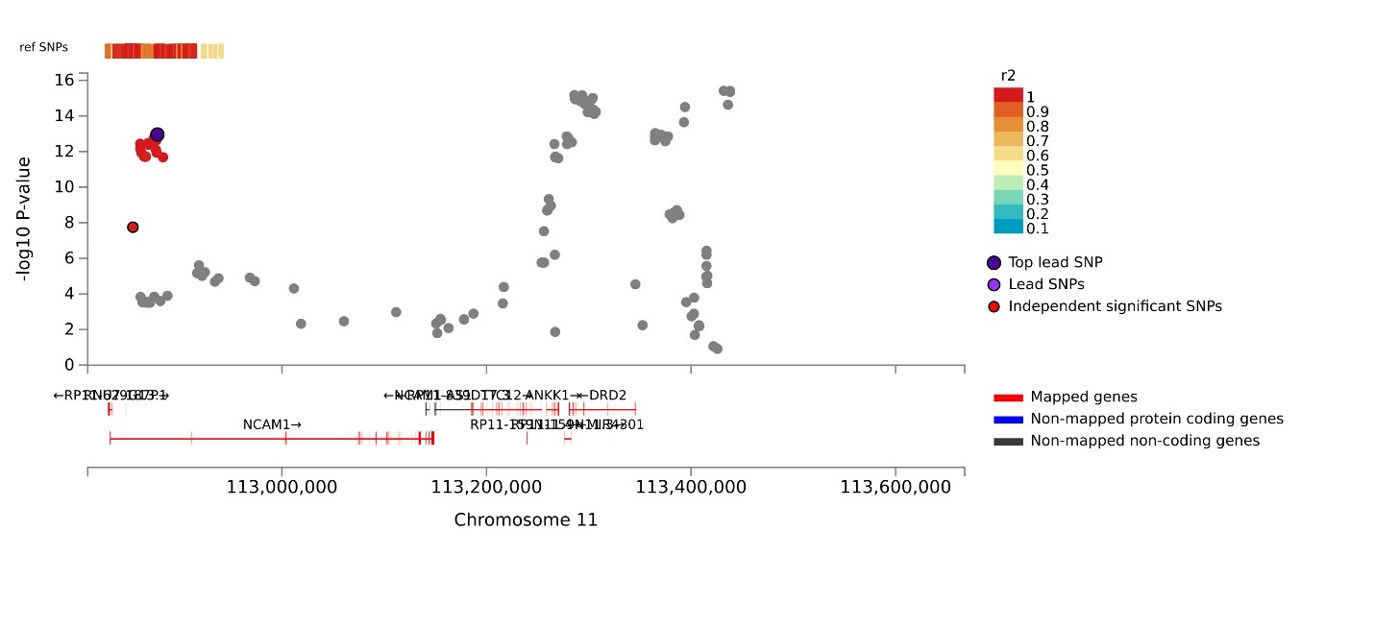
Locus 38 EA_LA rs4936277:
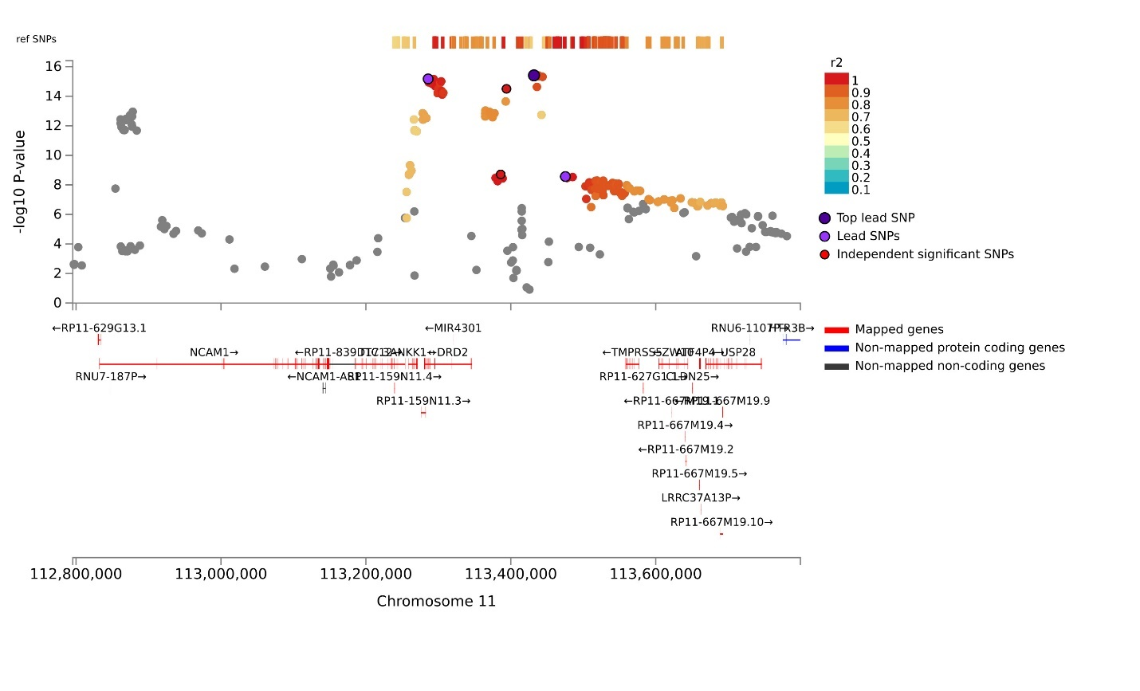
Locus 38 EA_LA:
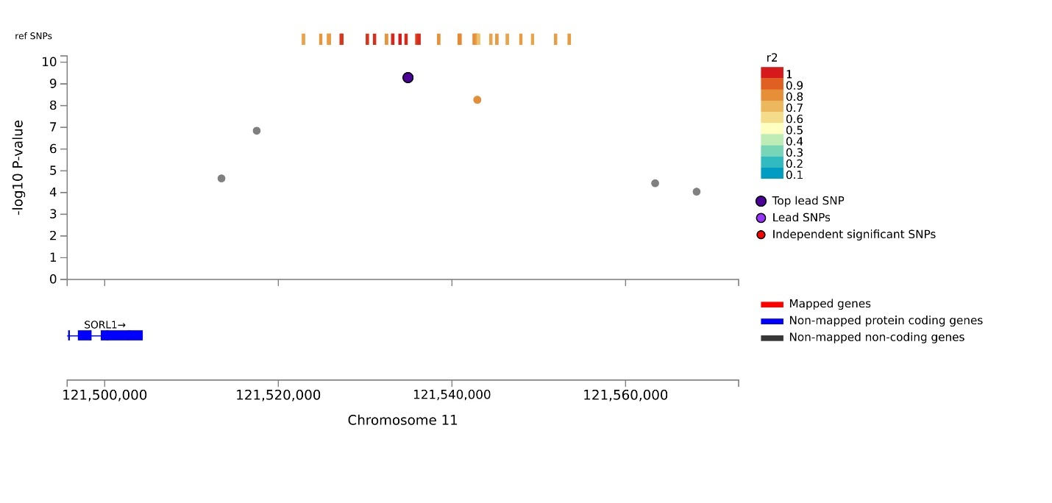
Locus 38 EA:
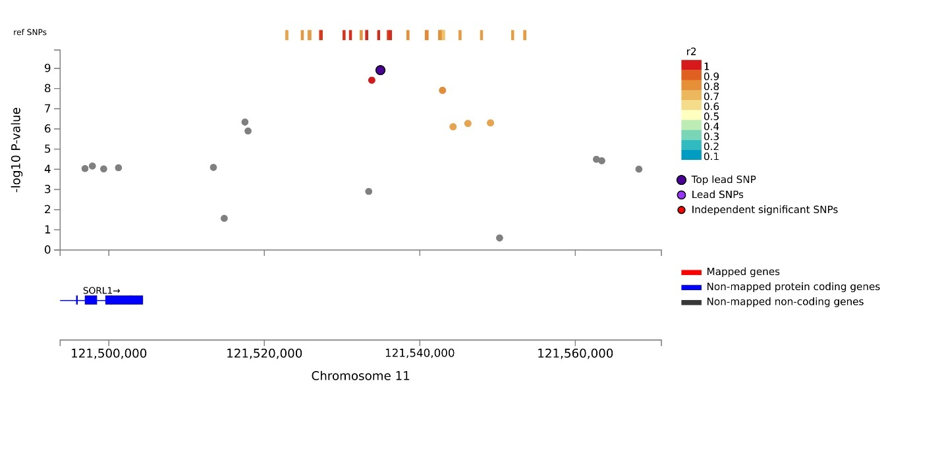
Locus 38 AA_EA:
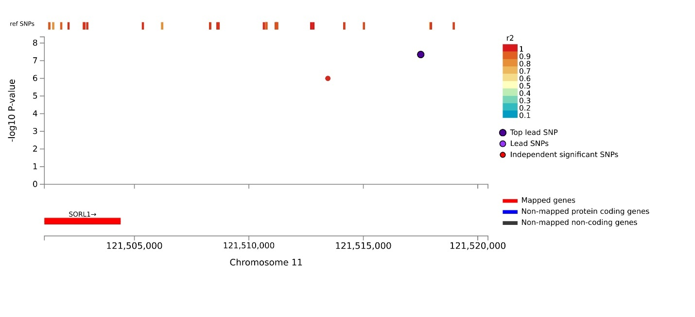
Locus 38 AA_EA_LA:
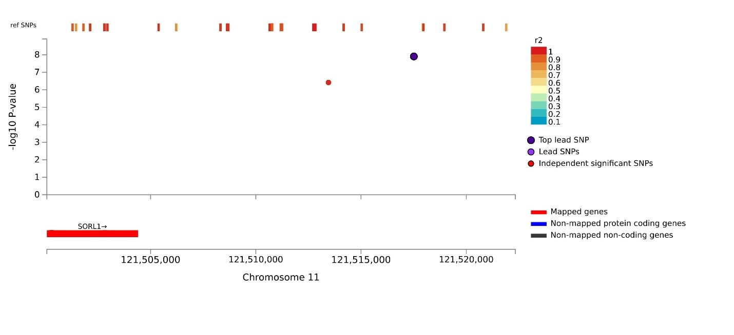
Locus 39 EA:
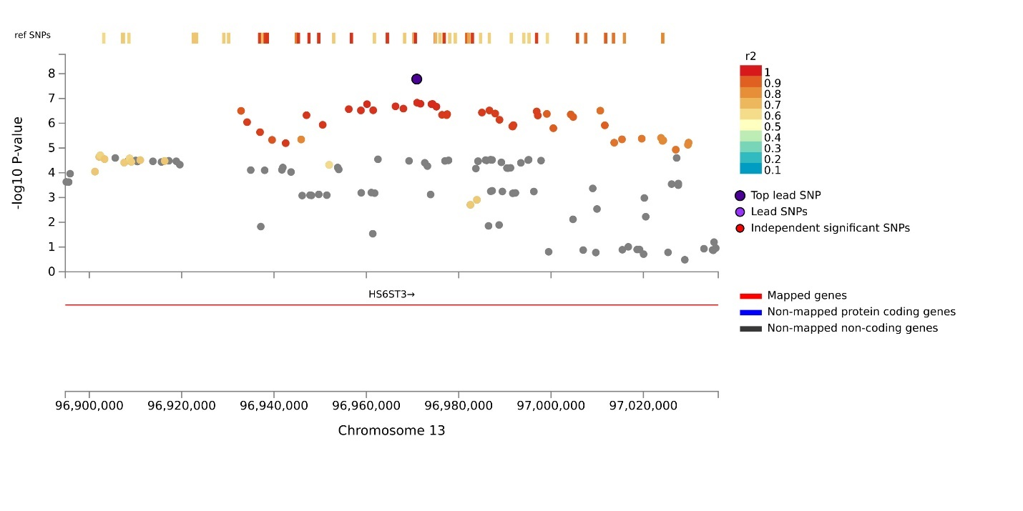
Locus 40 EA:
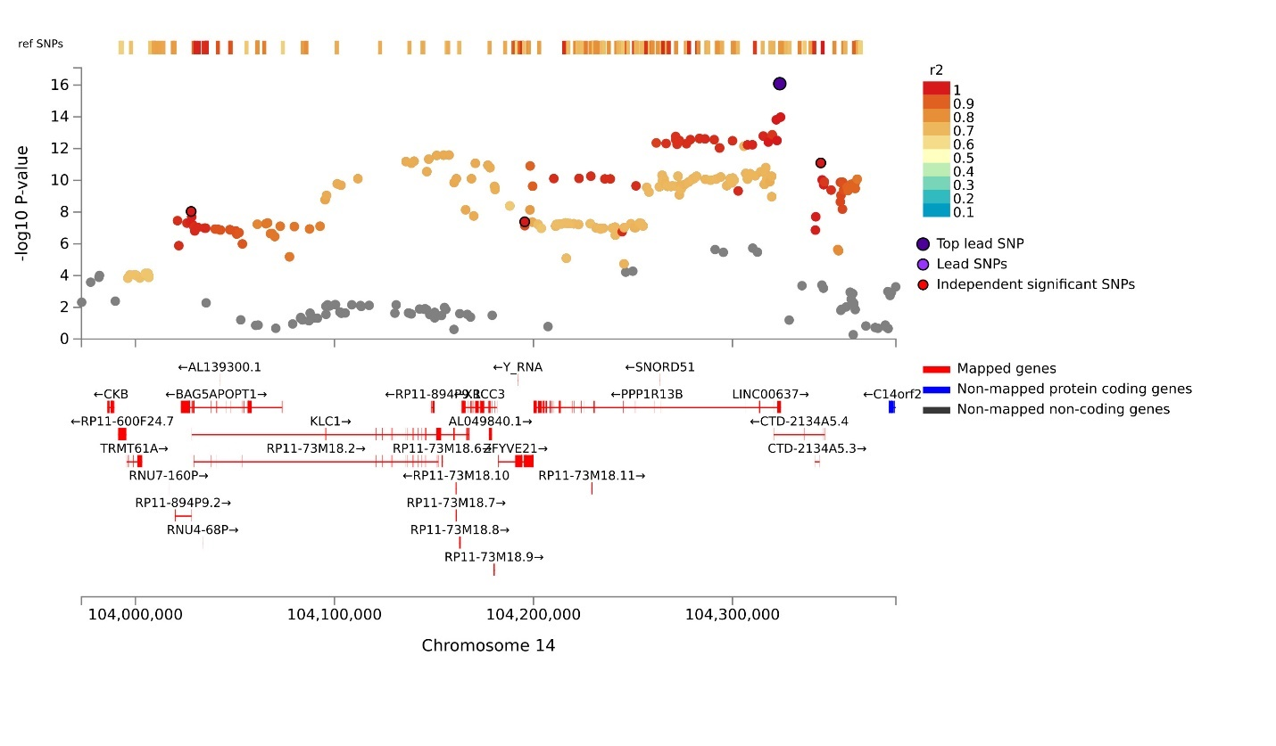
Locus 40 AA_EA:
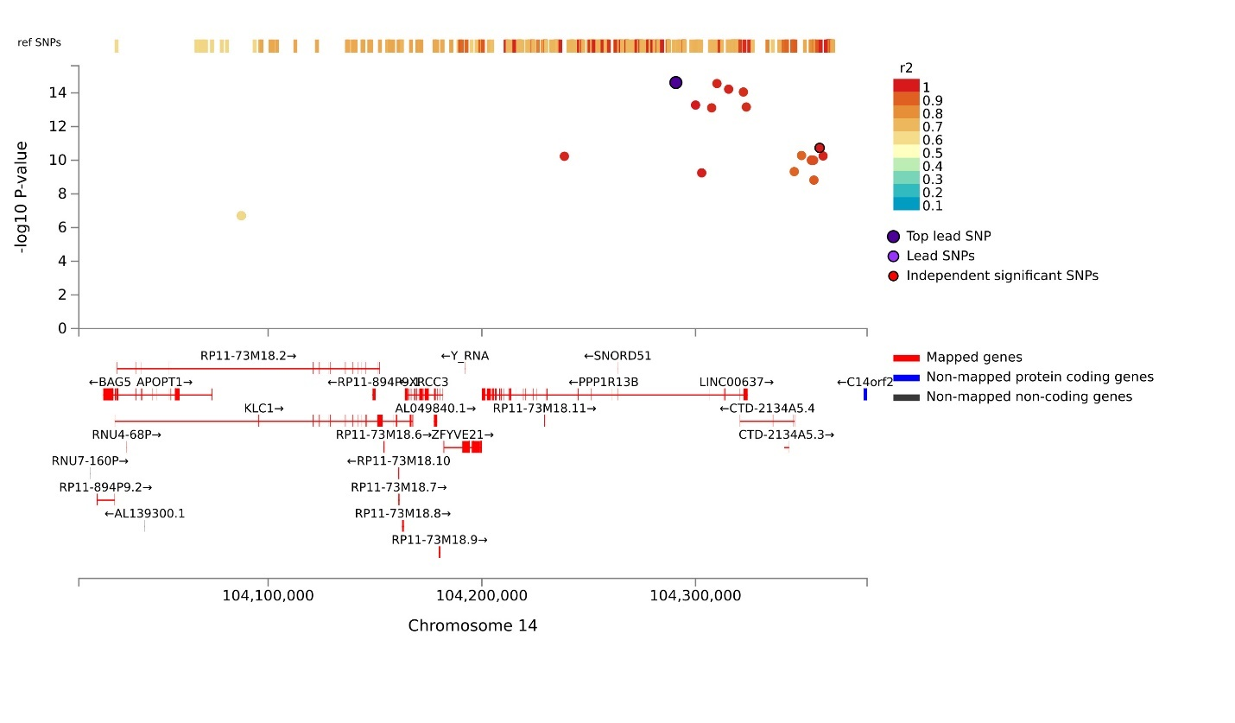
Locus 40 EA_LA:
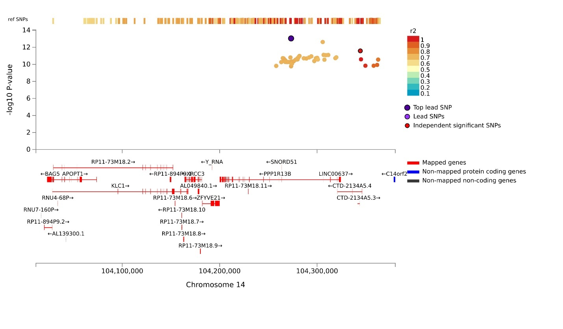
Locus 40 AA_EA_LA:
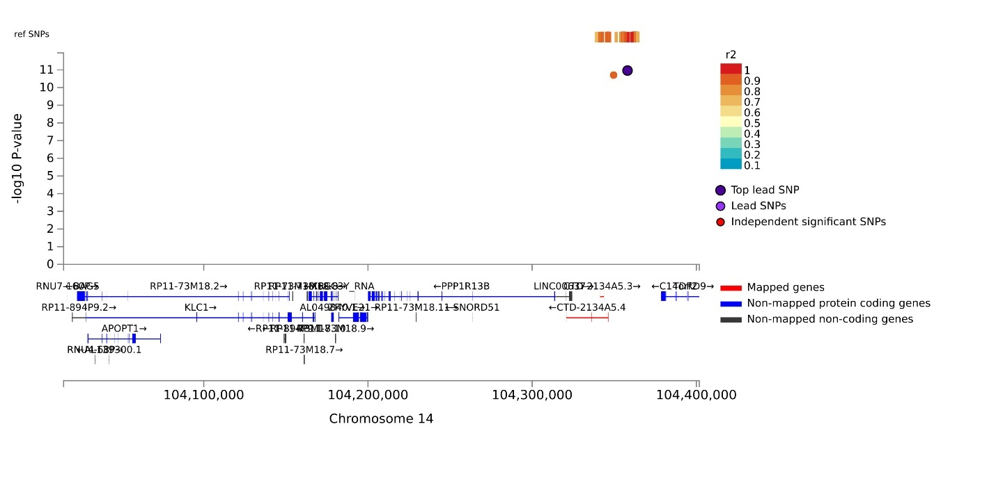
Locus 41 EA:
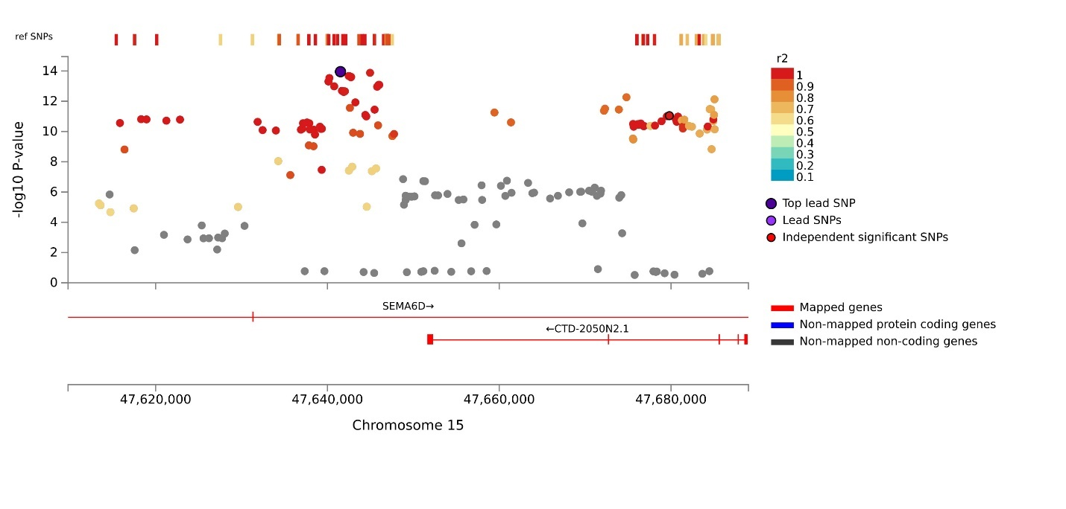
Locus 41 AA_EA:
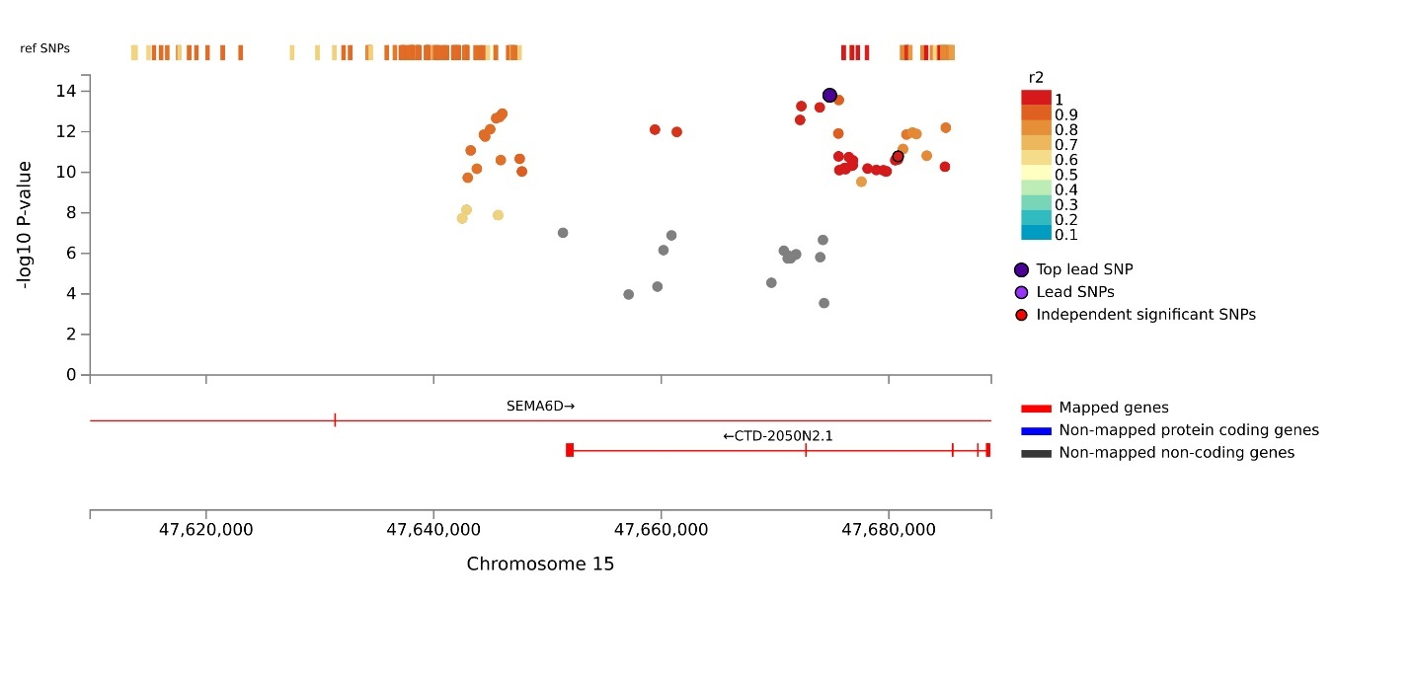
Locus 41 EA_LA:
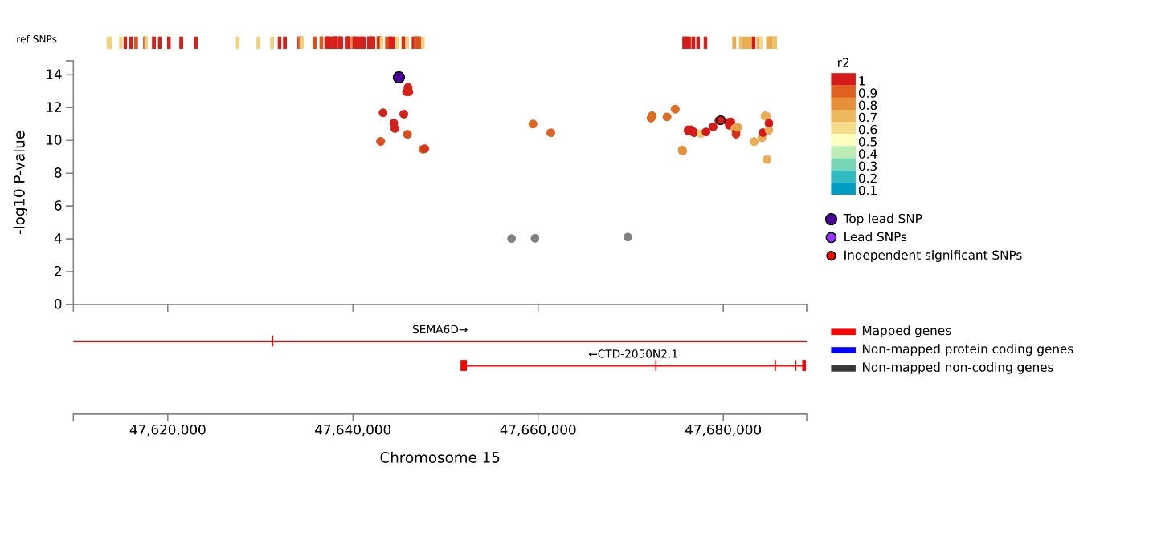
Locus 41 AA_EA_LA:
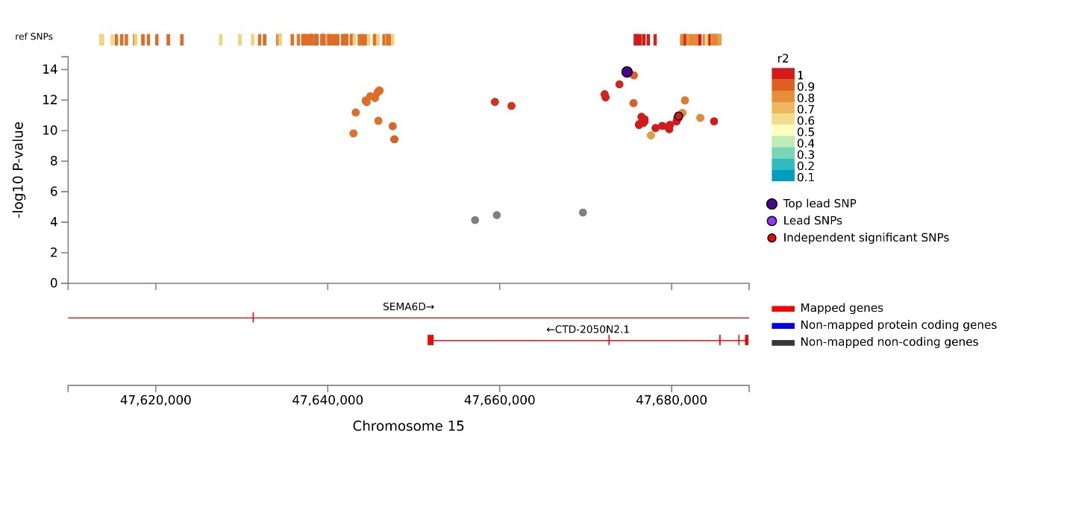
Locus 42 EA:
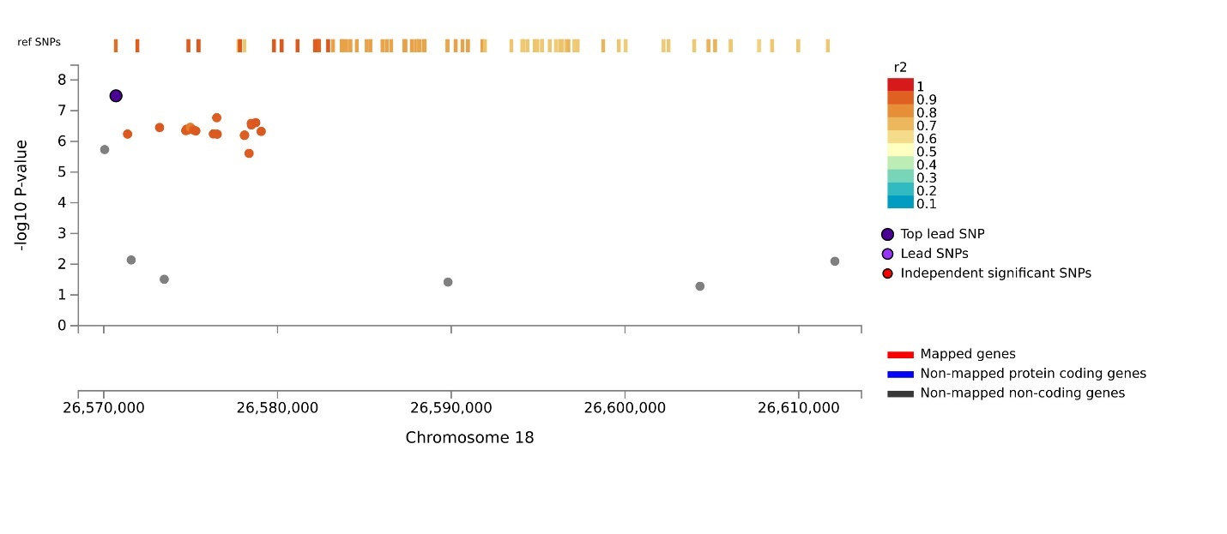
Locus 42 AA_EA:
Locus 42 AA_EA_LA:
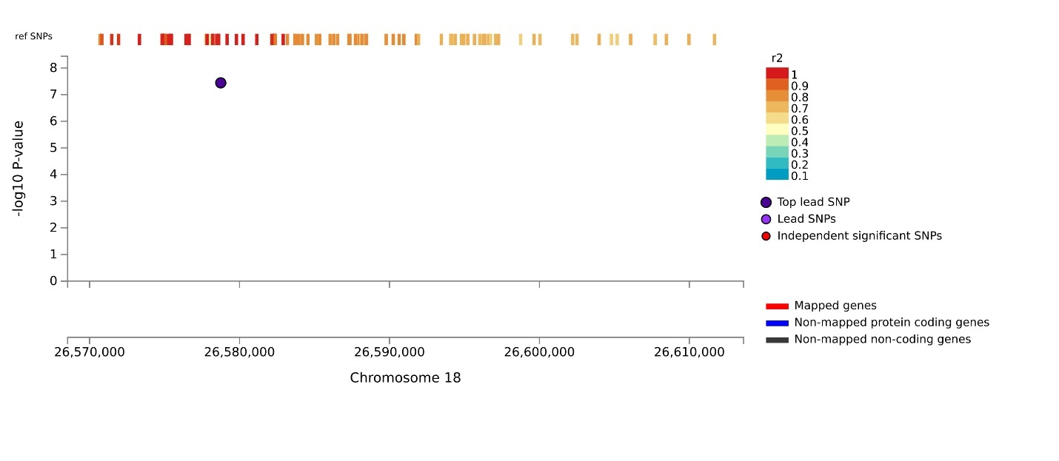
Locus 43 AA_EA:
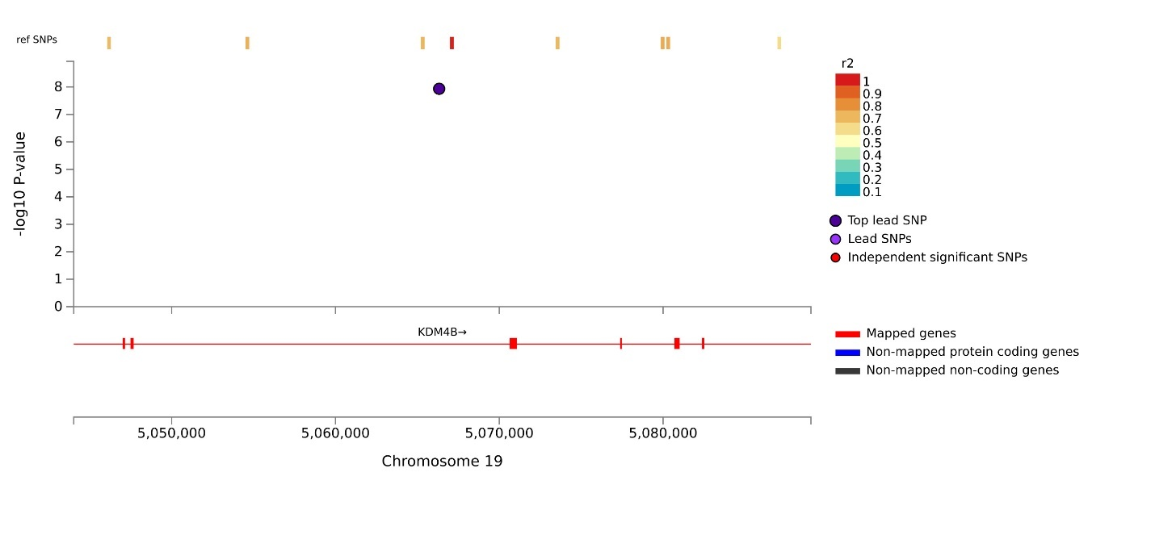
Locus 43 EA:
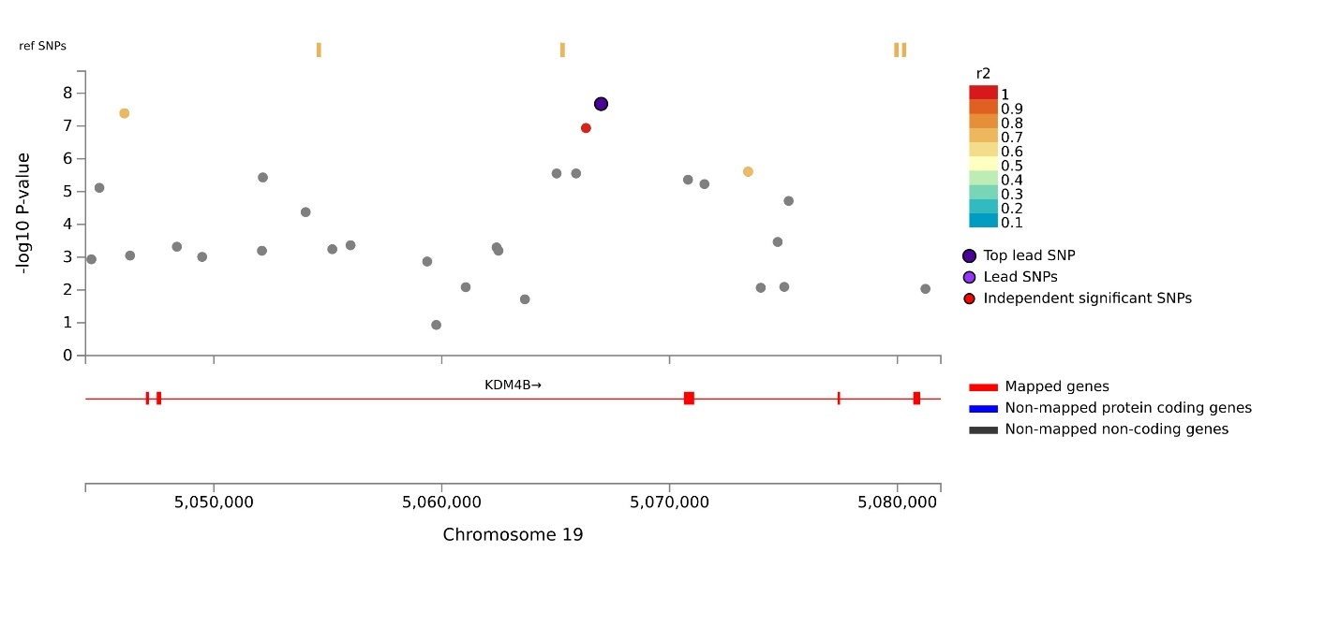
Locus 44 AA_EA:
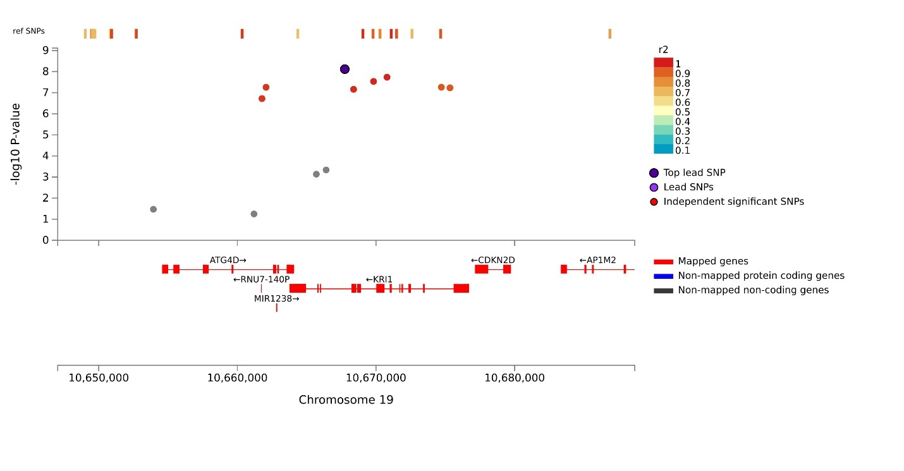
Locus 45 EA_LA:
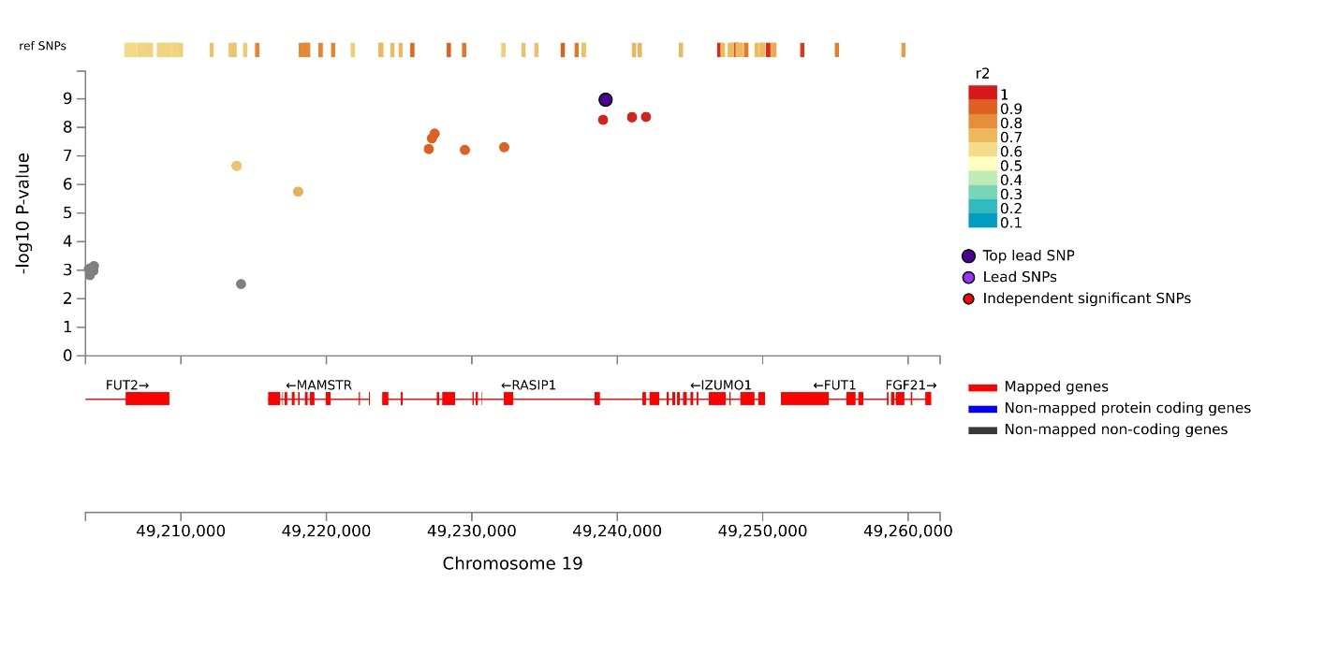
Locus 45 EA:
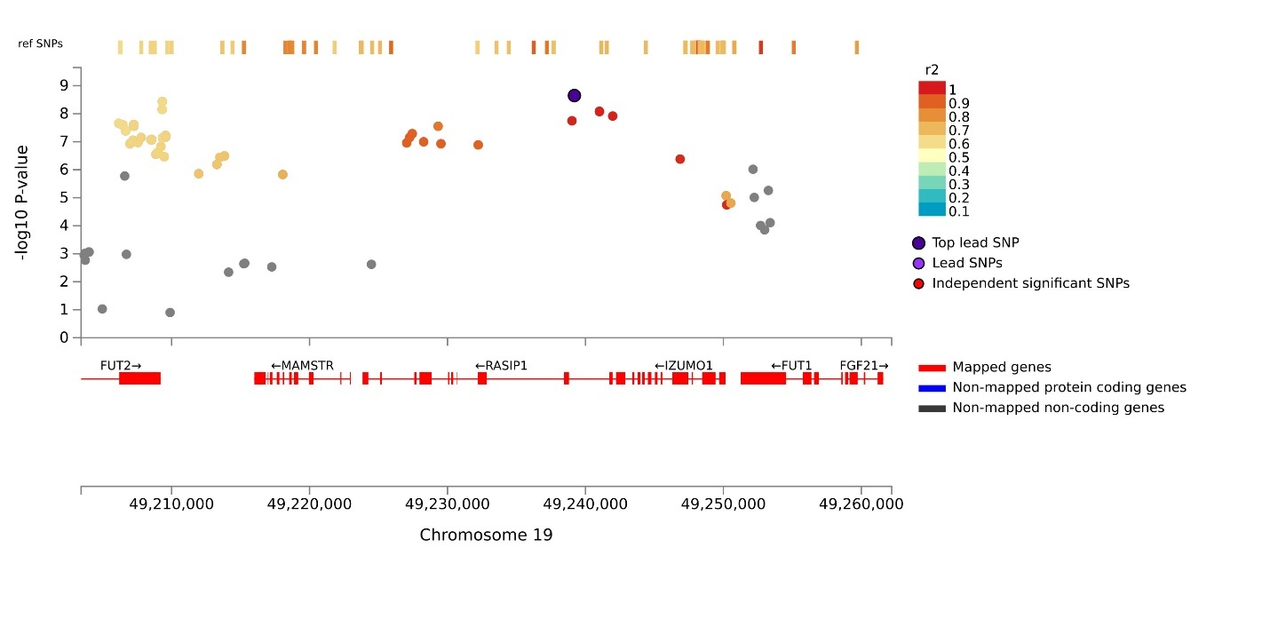
Supplemental Figure 3: Manhattan plots of gene-based analyses. A: EA; B: AA; C: LA; D: meta-analysis of AA and EA; E: meta-analysis of EA and LA; F: meta-analysis of AA, EA, and LA.
A: EA
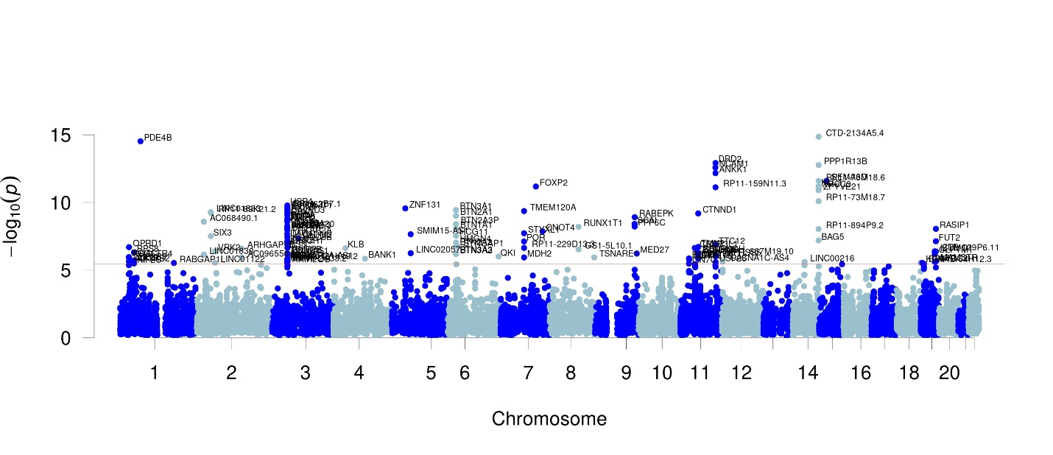
B: AA
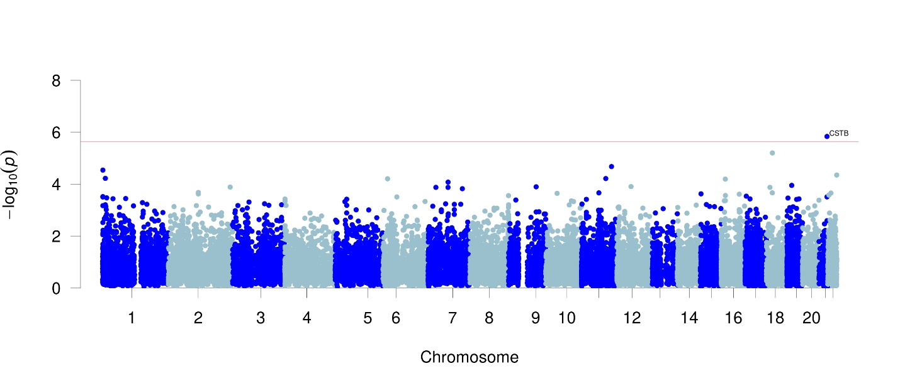
C: LA
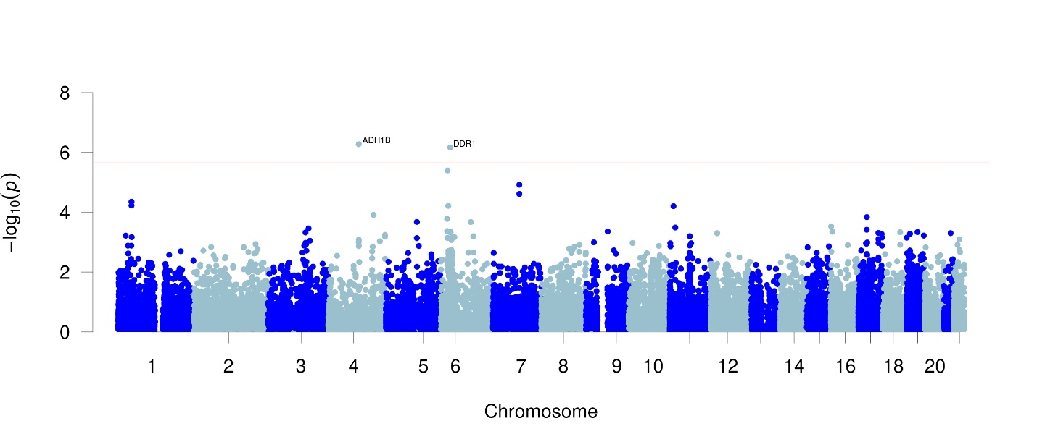
D: meta-analysis of AA and EA
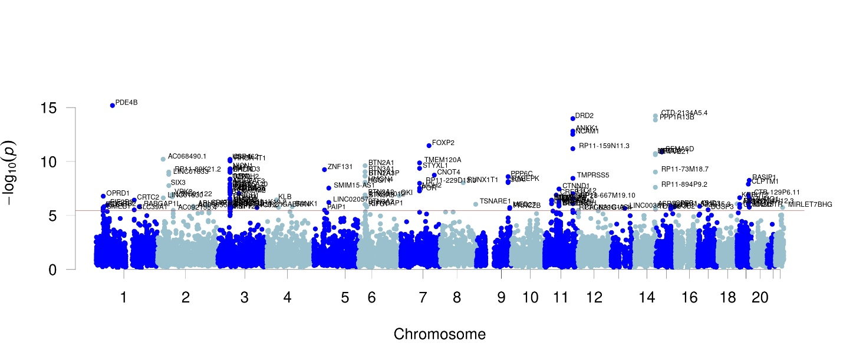
E: meta-analysis EA and LA
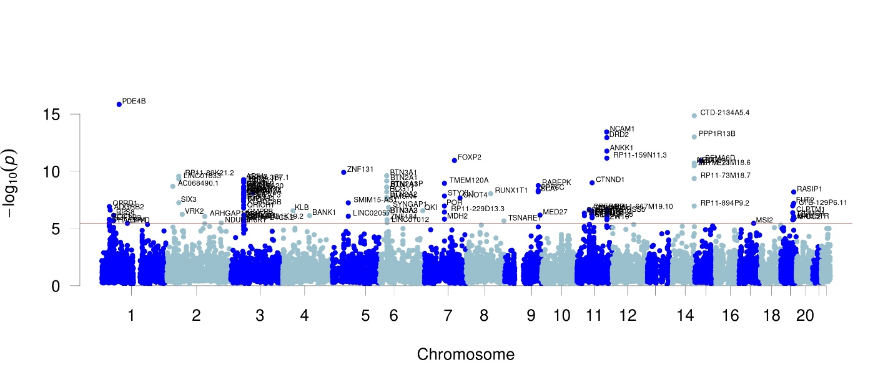
F: meta-analysis of AA, EA, and LA
