Supplementary Information for
The K9 lymphoma assay allows a genetic subgrouping of canine lymphomas with improved risk classification
Antonella Fanelli¹, Luca Licenziato¹, Eugenio Mazzone¹, Sara Divari¹, Andrea Rinaldi², Michele Marino³, Ilaria Maga⁴, Francesco Bertoni^{2,5}, Laura Marconato^{4*}, Luca Aresu^{1*}

¹ Department of Veterinary Sciences, University of Turin, Grugliasco, Turin, Italy.
² Institute of Oncology Research, Faculty of Biomedical Sciences, USI, Bellinzona, Switzerland.
³ MYLAV, Passirana di Rho, Milan, Italy.
⁴ Department of Veterinary Medical Science, University of Bologna, Ozzano dell'Emilia, Bologna, Italy.
⁵ Oncology Institute of Southern Switzerland, Ente Ospedaliero Cantonale, Bellinzona, Switzerland.

*email: luca.aresu@unito.it; laura.marconato@unibo.it

Supplementary Results
Study Population and Clinical Characteristics of dogs with B-cell lymphoma
There were 117 (57.1%) DLBCL, 38 (18.5%) MZL, 21 (10.2%) FL, 11 (5.4%) B-SLL, 10 (4.9%) BL and 8 (3.9%) B-LL. The most represented breeds included mixed-breed dogs (n=51; 24.9%), Rottweiler (n=16; 7.8%), German shepherd dogs (n=12; 5.8%), Golden retriever (n=11; 5.4%) and Labrador retriever (n=11; 5.4%). There were 108 (52.7%) males and 97 (47.3%) females. The median age was 8 years (range, 3 - 15), and the median weight was 26.7 kg (range, 3.0 – 55.7). Forty-three (20.9%) dogs had already been receiving steroids at admission.
The vast majority of dogs (199, 97.1%) underwent a complete staging. Among them, 150 (75.4%) had stage V disease, 40 (20.1%) stage IV disease, 8 (4%) stage III disease, and 1 (0.5%) stage I disease. One hundred and forty-two (69.3%) dogs did not present symptoms at presentation (substage a), while 56 (28.1%) were symptomatic (substage b).
BM was available for flow cytometric evaluation in 194 dogs; it was infiltrated in 130 (67.0%) dogs, with a median of 12% neoplastic cells (range, 1% – 83.8%).
PB was available for flow cytometric evaluation in 196 dogs; it was infiltrated in 125 (63.8%) dogs with a median of 3.6% neoplastic cells (range, 1.1% – 87.5%).
LDH levels were increased in 113 (55.1%) dogs at presentation.

Supplementary Figures

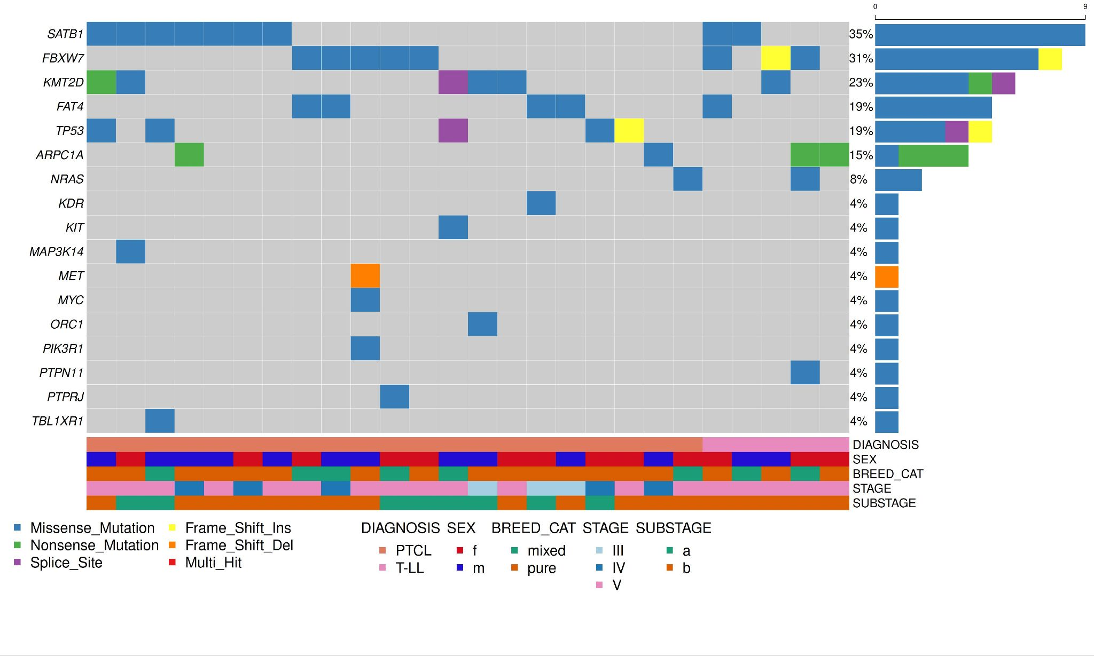
Supplementary Fig. 1. Oncoplot of recurrently mutated genes in aggressive TCLs. Genes of the K9 lymphoma assay harboring putative somatic short variants (SNVs and indels) identified in 40 aggressive TCLs are depicted. Genes are represented in descending order according to the frequency of mutation. Mutation frequency is calculated on dogs harboring at least one protein-coding mutation in one of the panel genes. Different mutation types are identified with different colors. Clinico-pathological data including diagnosis, sex, breed, stage and substage are shown at the bottom.

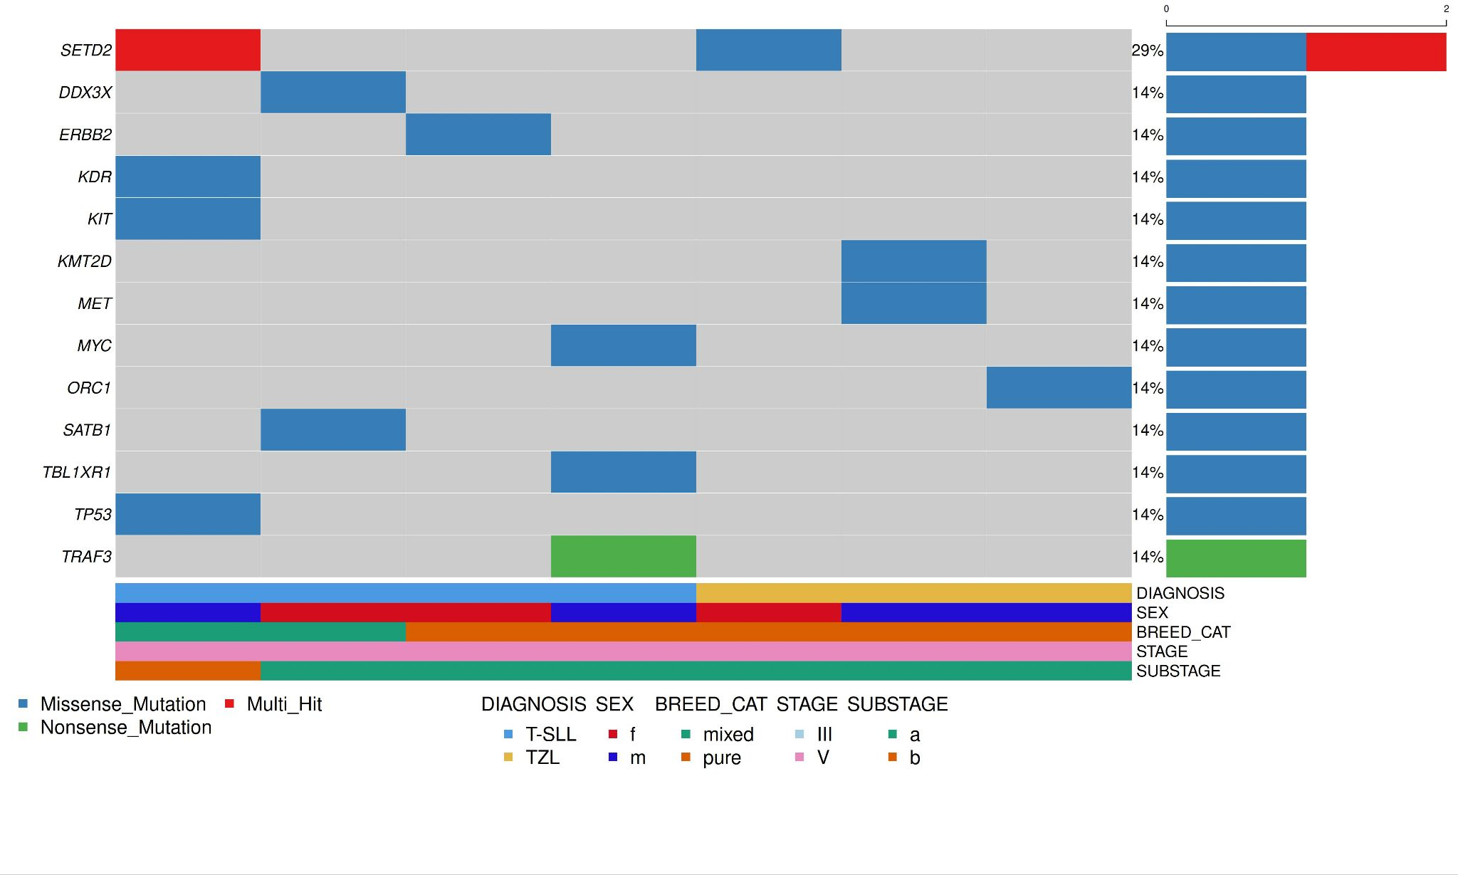
Supplementary Fig. 2. Oncoplot of recurrently mutated genes in indolent TCLs. Genes of the K9 lymphoma assay harboring putative somatic short variants (SNVs and indels) identified in 12 indolent TCLs are depicted. Genes are represented in descending order according to the frequency of mutation. Mutation frequency is calculated on dogs harboring at least one protein-coding mutation in one of the panel genes. Different mutation types are identified with different colors. Clinico-pathological data including diagnosis, sex, breed, stage and substage are shown at the bottom.

