Supplementary Information for

Sequential conformational transition of ArnB, an archaeal ortholog with Sec23/Sec24 core motif

Lukas Korf¹, Wieland Steinchen^{1,2}, Mohamed Watad¹, Filipp Bezold¹, Marian S. Vogt¹, Leon Selbach¹, Alexander Penner¹, Maxime Tourte³, Sebastian Hepp¹, Sonja-Verena Albers³, Lars-Oliver Essen^{1,*}

¹Department of Chemistry, Philipps University, Hans Meerwein-Str. 4, 35043 Marburg, Germany
²Center for Synthetic Microbiology, Philipps University Marburg, Karl-von-Frisch-Str. 14, 35043 Marburg, Germany
³University of Freiburg, Institute for Biology II, Molecular Biology of Archaea, Schaenzlestrasse 1, 79104 Freiburg, Germany
⁴Signalling Research Centres BIOSS and CIBSS, University of Freiburg, 79104 Freiburg, Germany
*corresponding author

Email: essen@chemie.uni-marburg.de
sonja.albers@biologie.uni-freiburg.de

This PDF file includes:

Supplementary text
Figures S1 to S11
Table S1 to S2

Other supplementary materials for this manuscript include the following:

Supplementary Dataset 1 (HDX data)
Supplementary Dataset 2 (proteomics data)
Supplementary Dataset 3 (Foldseek analysis)

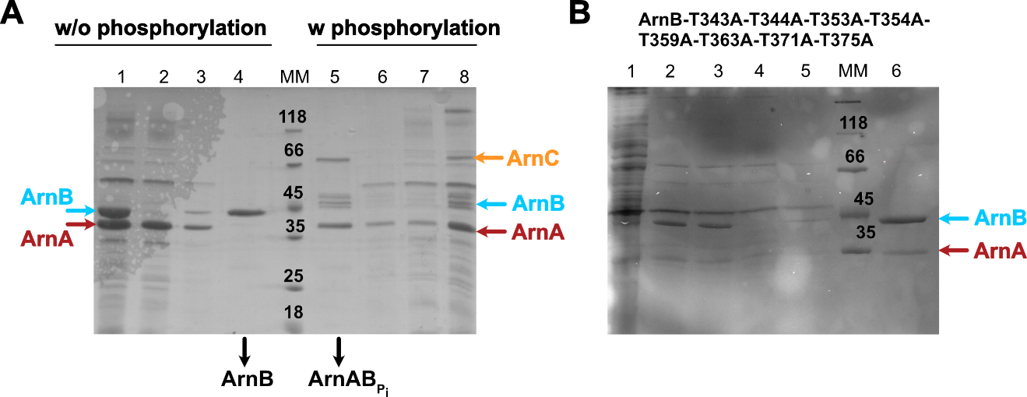

Figure S1: ArnA/ArnB pulldown assays. A: SDS-PAGE with a comparison of Ni-NTA column purifications of ArnA and ArnB without phosphorylation (left part, lanes 1-4) and with phosphorylation by ArnC (right side, lanes 5-8). ArnB is only able to pulldown ArnA when they were subjected to prior phosphorylation. 1: heat step, 2: flow through, 3: wash, 4: elution, MM: molecular marker, 5: elution, 6: wash, 7: flow through, 8: heat step/ P_{i} assay. B: Ni-NTA purification of the multiple ThrAla mutant of ArnB after 60 min phosphorylation by ArnC. Under these prolonged phosphorylation times this mutant of ArnB depleted of threonines in the α-helical domain is still able to pulldown ArnA. 1: lysate, 2: heat step, 3: P_{i} assay, 4: flow through, 5: wash, 6: elution.

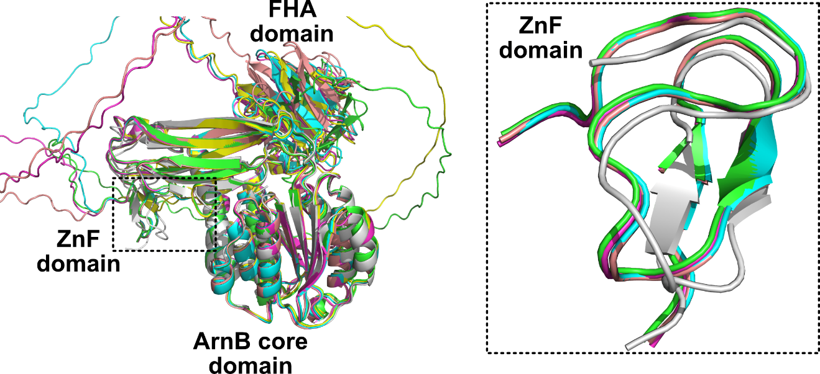
Figure S2: Superposition of experimental and predicted ArnAB complex. Theoretical complexes for ArnAB were predicted by the AlphaFold2-Multimer pipeline and superimposed to the ArnAB crystal structure. Left, complete alignment showing the different models. Disordered regions of the AF2 models correspond to the linker region between the ZnF and FHA domains of ArnA. Right, detail view on the ZnF domains in the ArnAB complex showing only minor deviations from the ArnAB cocrystal structure (gray). The five AF2 models of the ArnAB complex are colored according to their rank in green, cyan, pink, yellow and salmon.

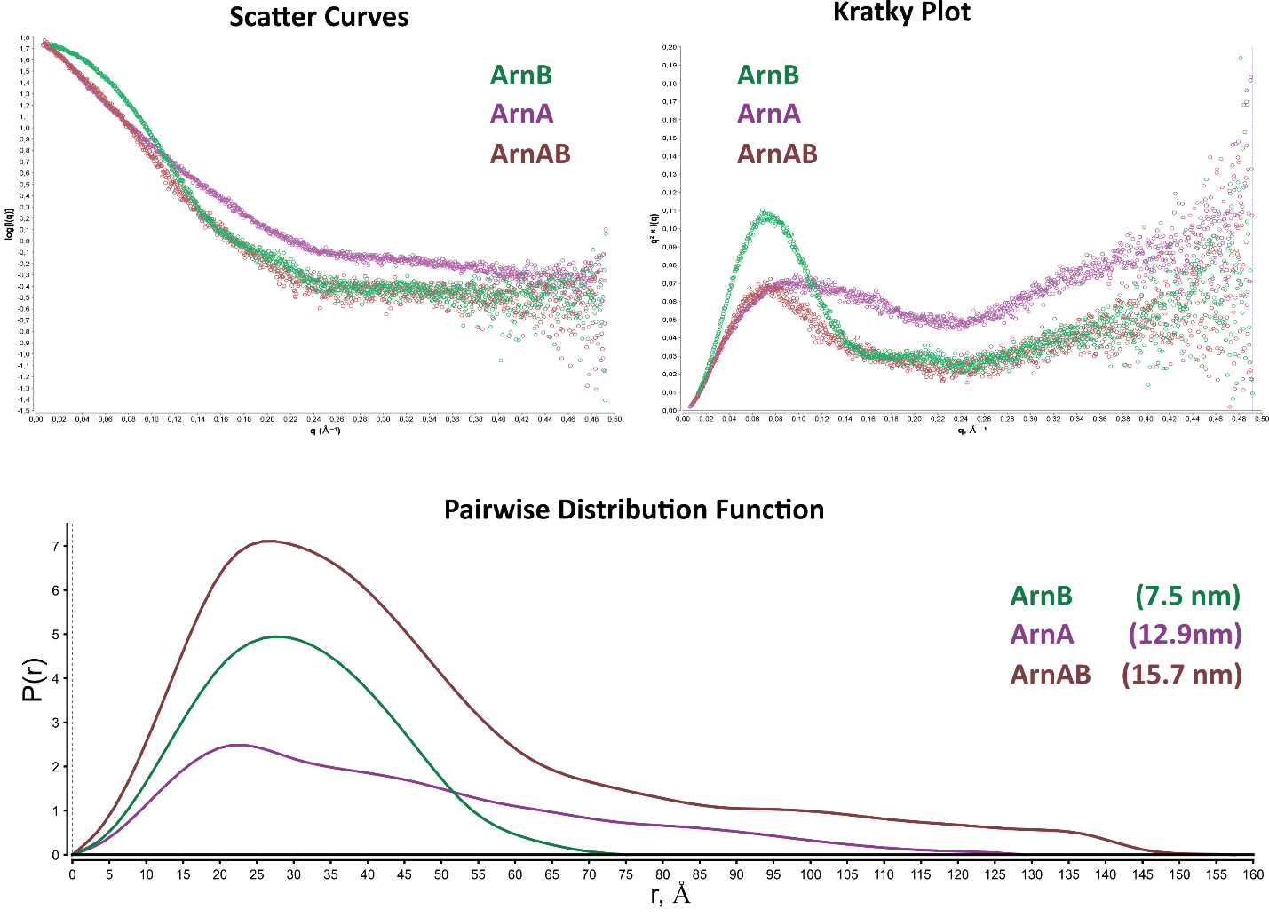
Figure S3: SAXS data analysis with scatter curves, Kratky plot and pairwise distribution function. The plots show the average of technical triplicates for each of the three SAXS samples: loose ArnAB complex (brown), ArnA (purple) and ArnB (green) with D_{max} shown in parentheses.

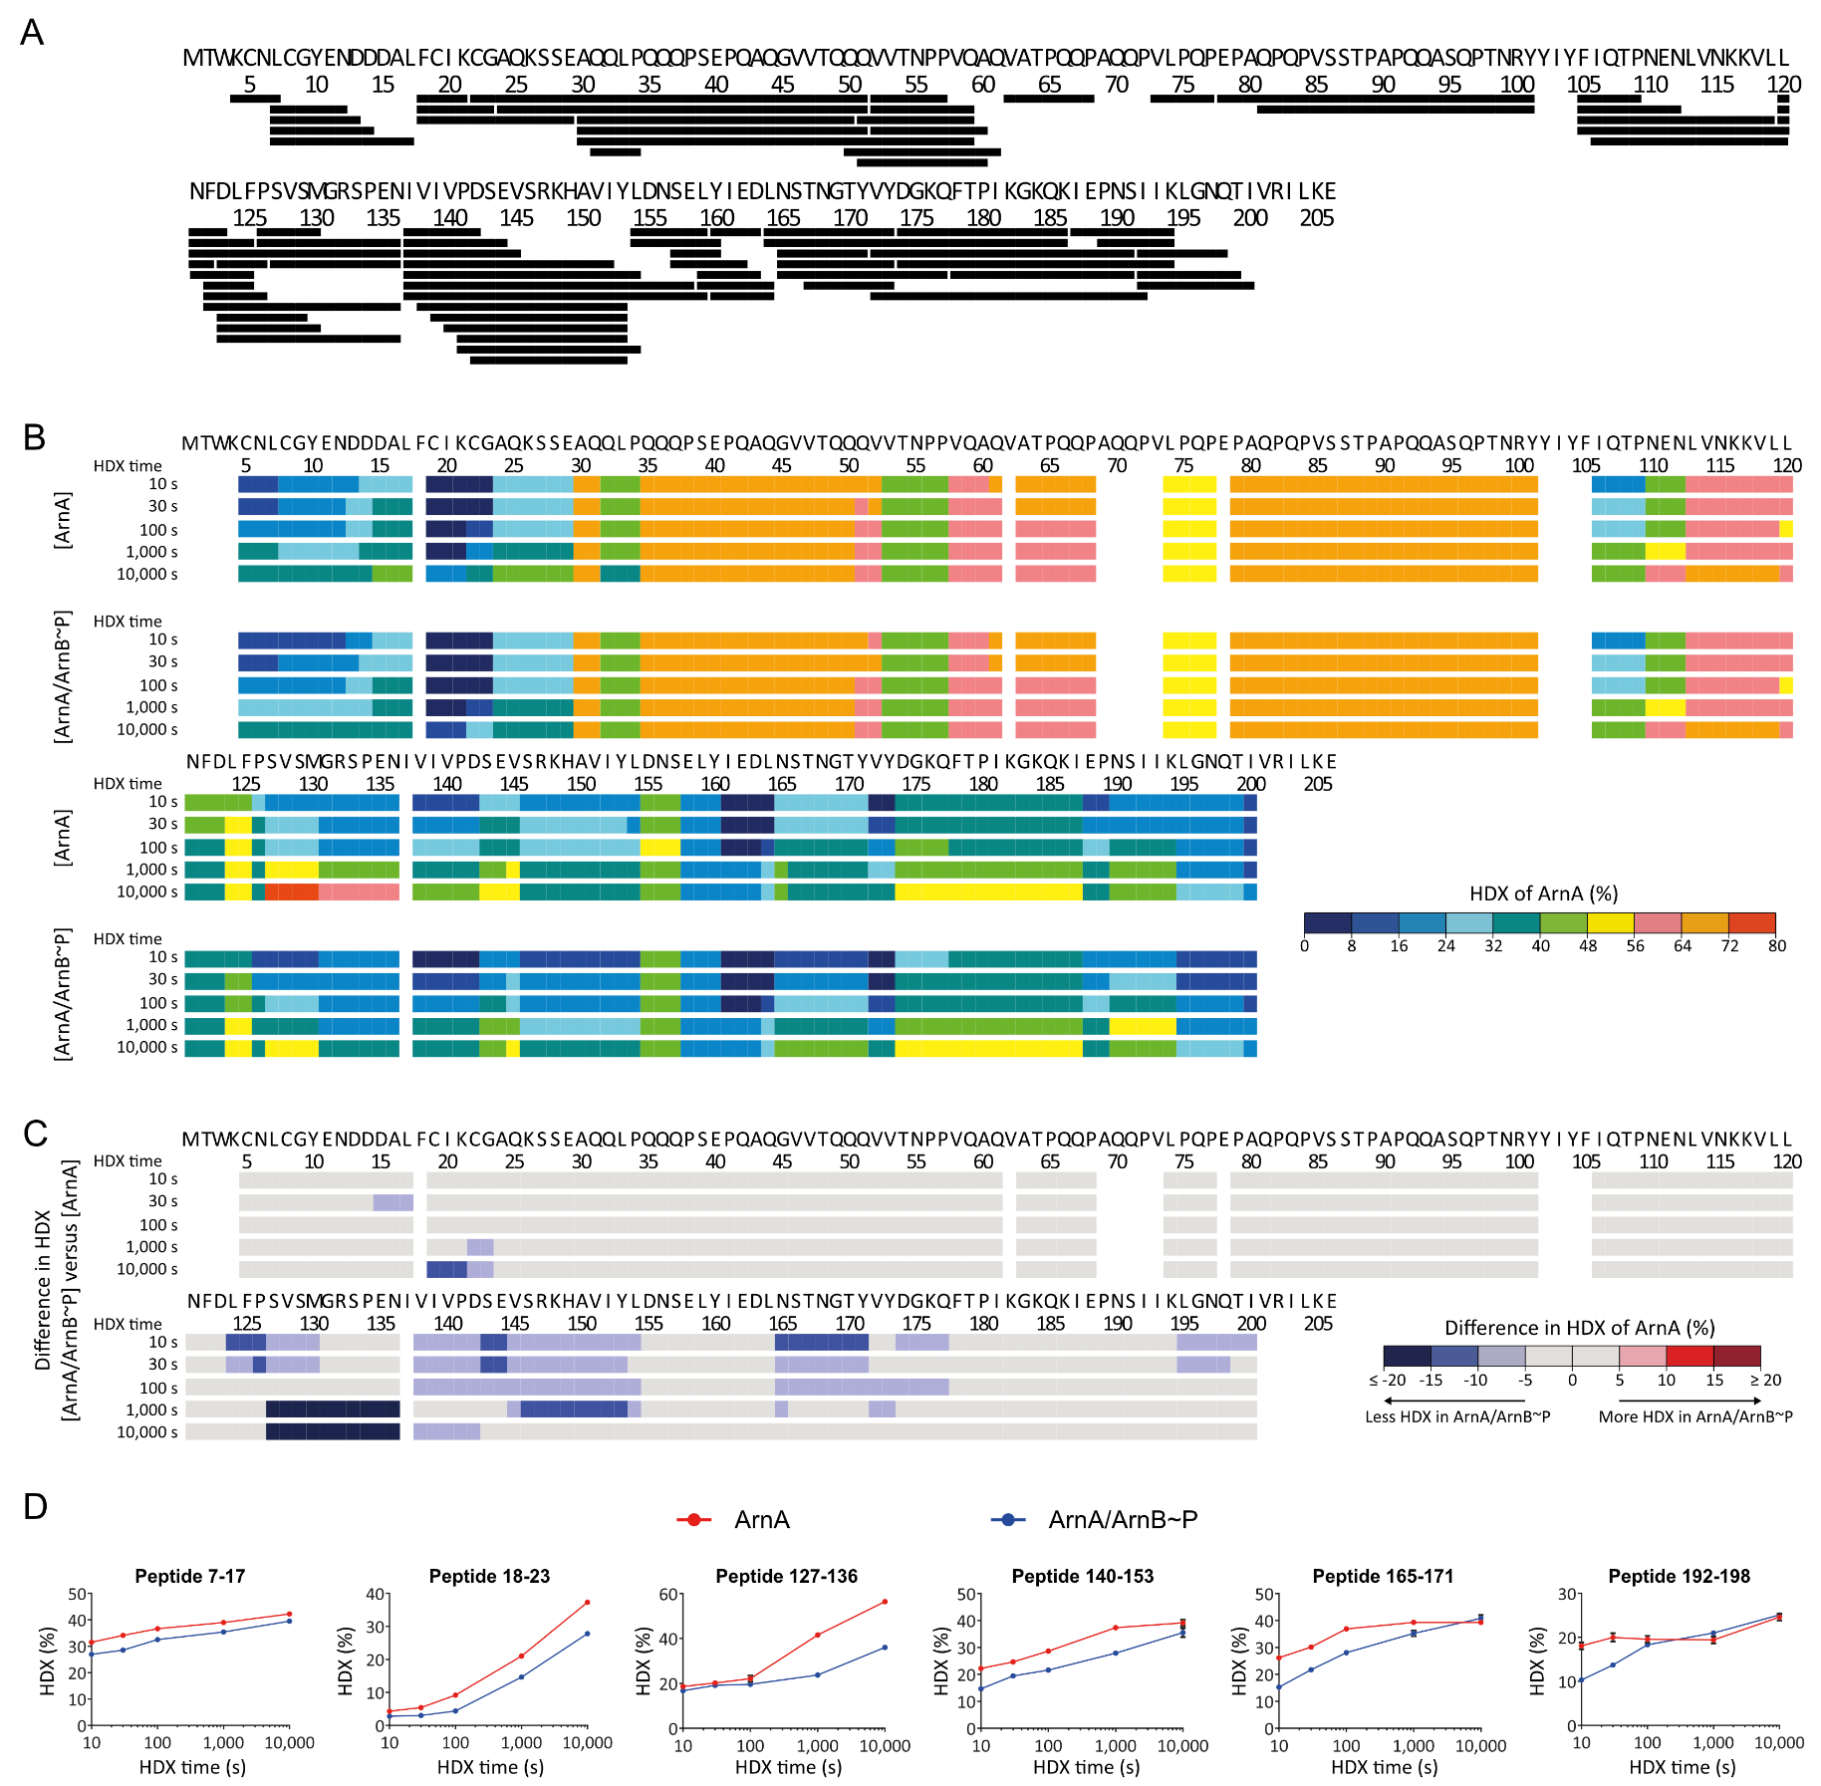

Figure S4: HDX supplementary data evaluation of ArnA. A: Each black bar represents a peptide of ArnA identified in HDX-MS. B: The residue-specific HDX of individual ArnA and that of ArnA in complex with ArnB~P is projected onto the ArnA amino acid sequence. C: The difference in residue-specific HDX between ArnA in complex with ArnB~P and individual ArnA is projected onto the ArnA amino acid sequence. Blue color denotes reduced HDX of ArnA when in complex with ArnB~P. D: Progression of HDX over time for selected representative ArnA peptides derived from ArnA (red) and ArnA/ArnB~P (blue) samples. Data represent mean ± s.d. of n = 3 technical replicates (individual HDX reactions).

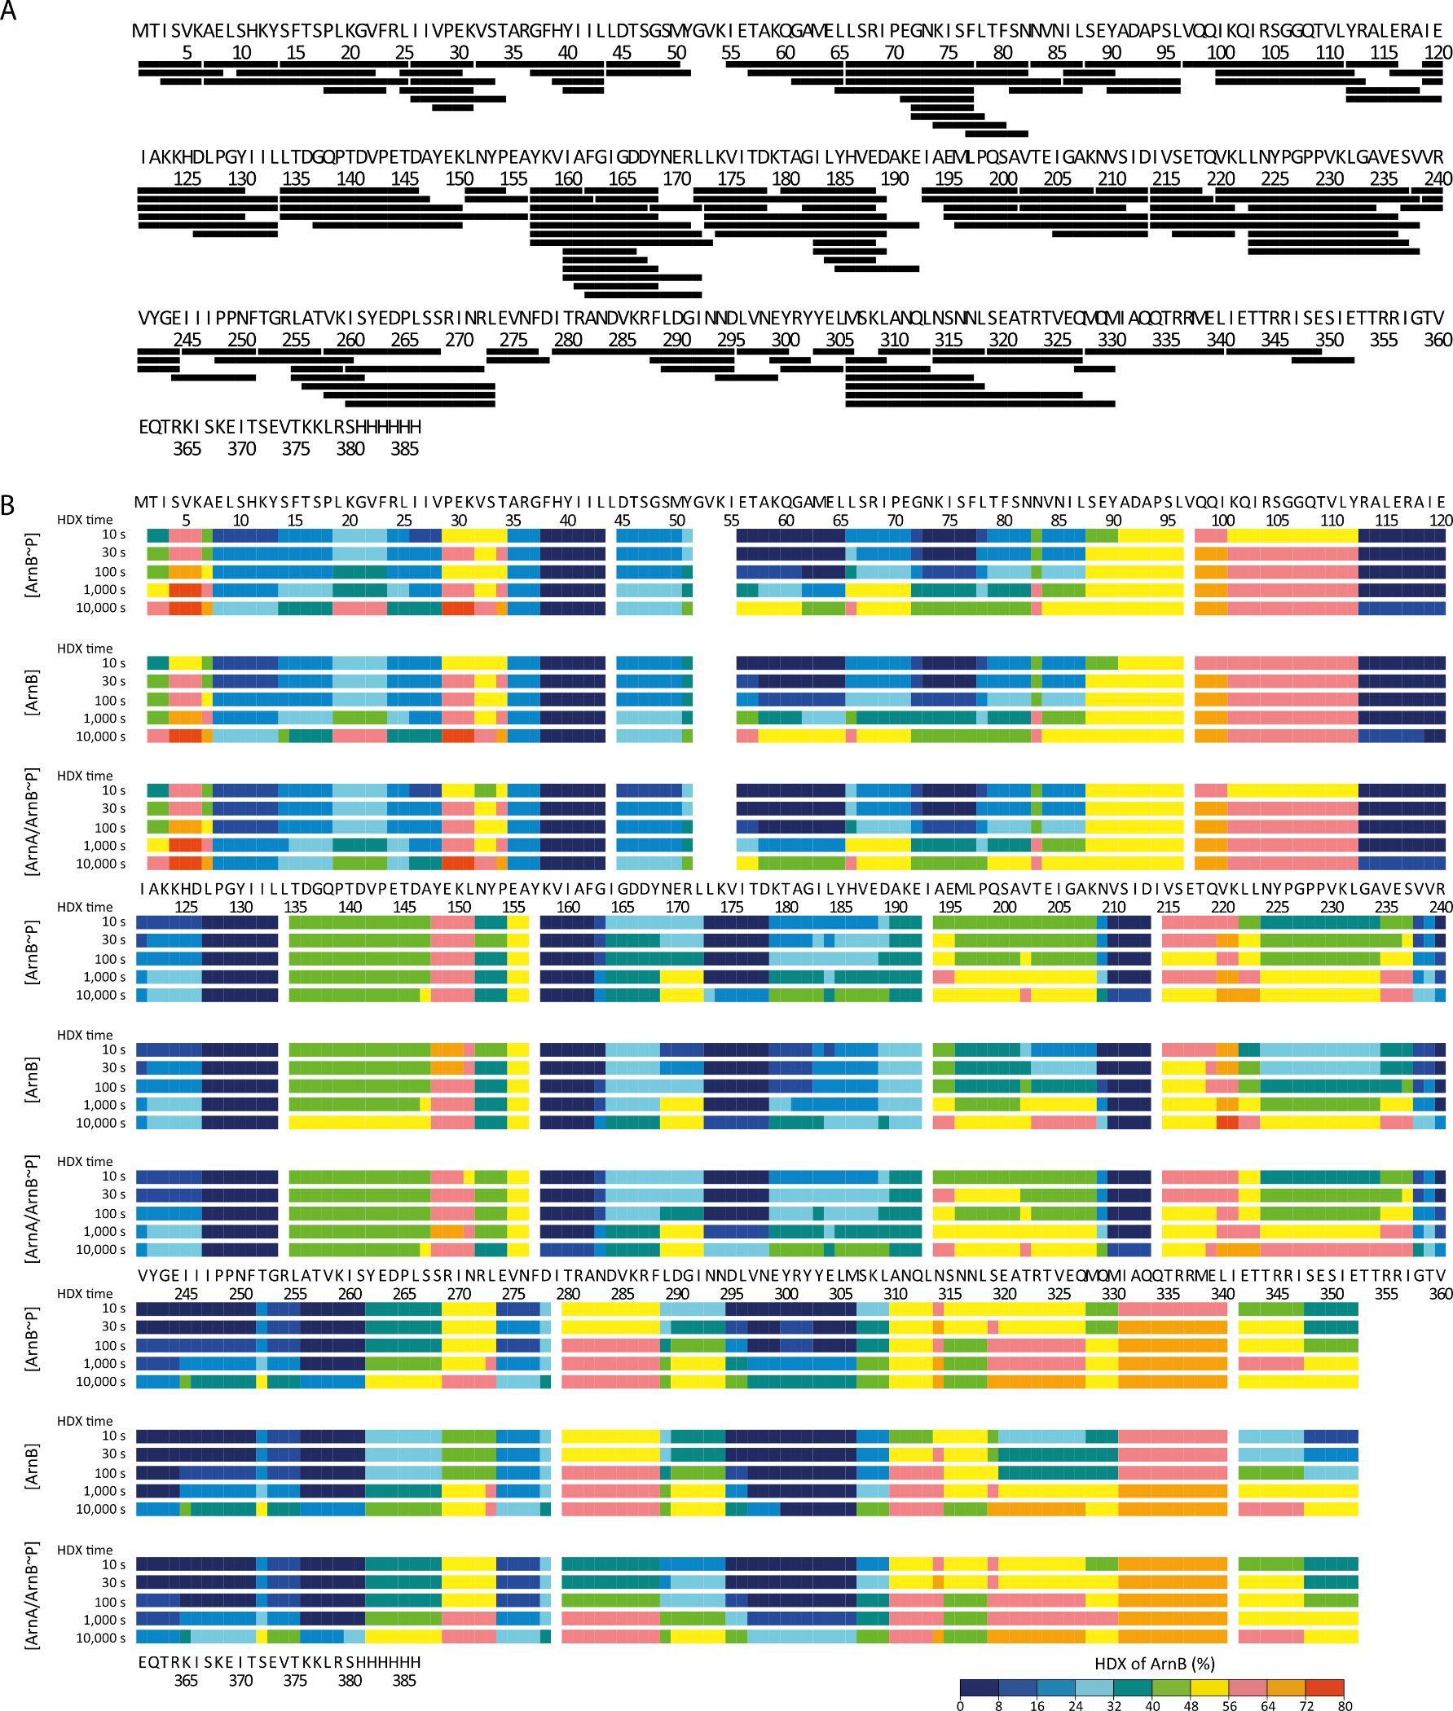

Figure S5: HDX supplementary data evaluation of ArnB. A: Each black bar represents a peptide of ArnB identified in HDX-MS. B: The residue-specific HDX of ArnB, ArnB~P and that of ArnB~P in complex with ArnA is projected onto the ArnB amino acid sequence.
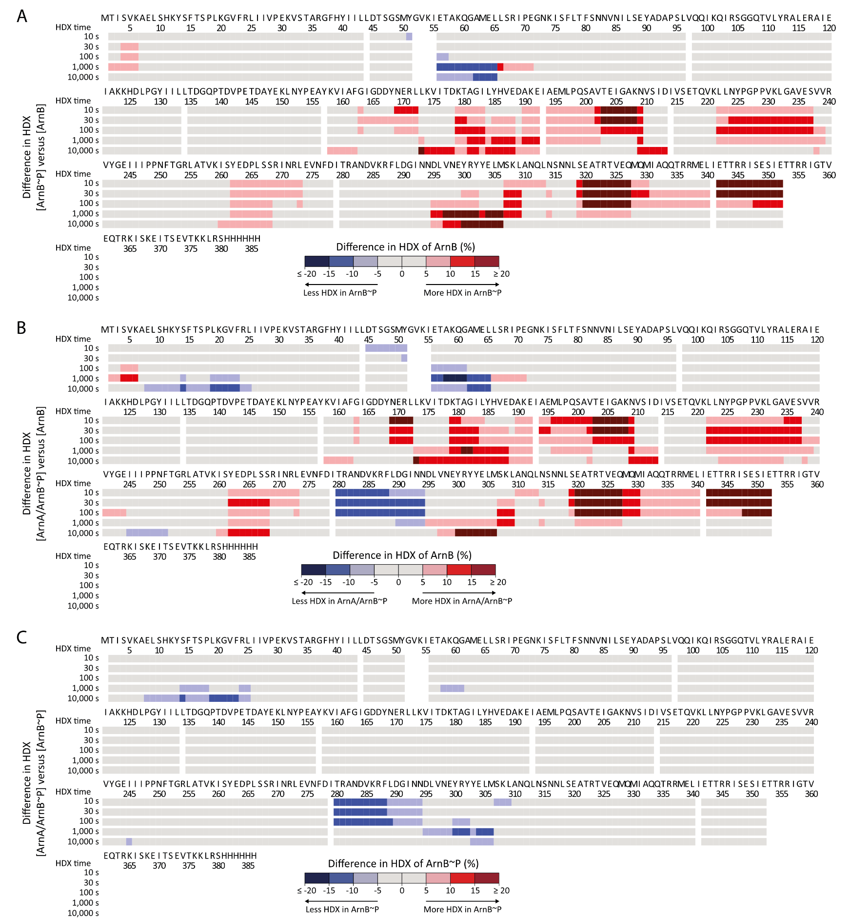

Figure S6: HDX supplementary data evaluation of the impact of phosphorylation and interaction of ArnA and ArnB. A-C: The difference in residue-specific HDX between A: ArnB~P and ArnB, B: ArnA/ArnB~P and ArnB, and C. ArnA/ArnB~P and ArnB~P is projected onto the ArnB amino acid sequence. Red color reflects elevated HDX of ArnB upon phosphorylation (A and B), and blue color reflects reduced HDX upon phosphorylation (A and B) and ArnA binding (B and C).

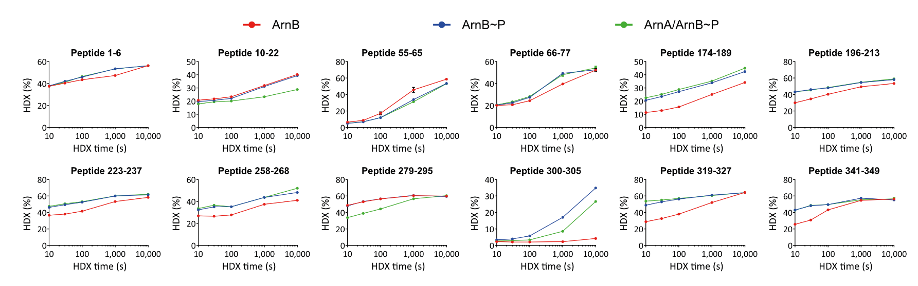
Figure S7: HDX MS of ArnA and ArnB peptides. Progression of HDX over time for selected representative ArnB peptides derived from ArnB (red), ArnB~P (blue) and ArnA/ArnB~P (green) samples. Data represent mean ± s.d. of n = 3 technical replicates (individual HDX reactions).

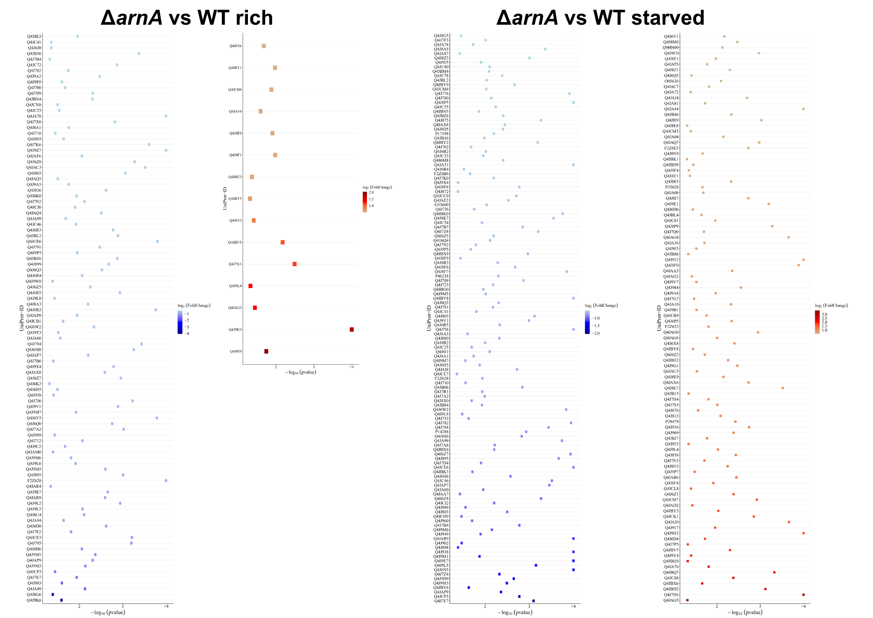
Figure S8: Volcano plot analysis of ΔarnA vs. WT comparison showing Uniprot IDs of over- (red) or under-regulated (blue) proteins in the respective comparison. Only proteins with a significance level of at least p<0.05 and a twofold change were considered. The analysis charts do refer to the indicated knockout strain, i.e. which proteins were up- or down-regulated in the knockout strain in comparison to WT. Higher significant levels are shown towards the right, whereas the degree of changes are ranked from the top to the bottom.
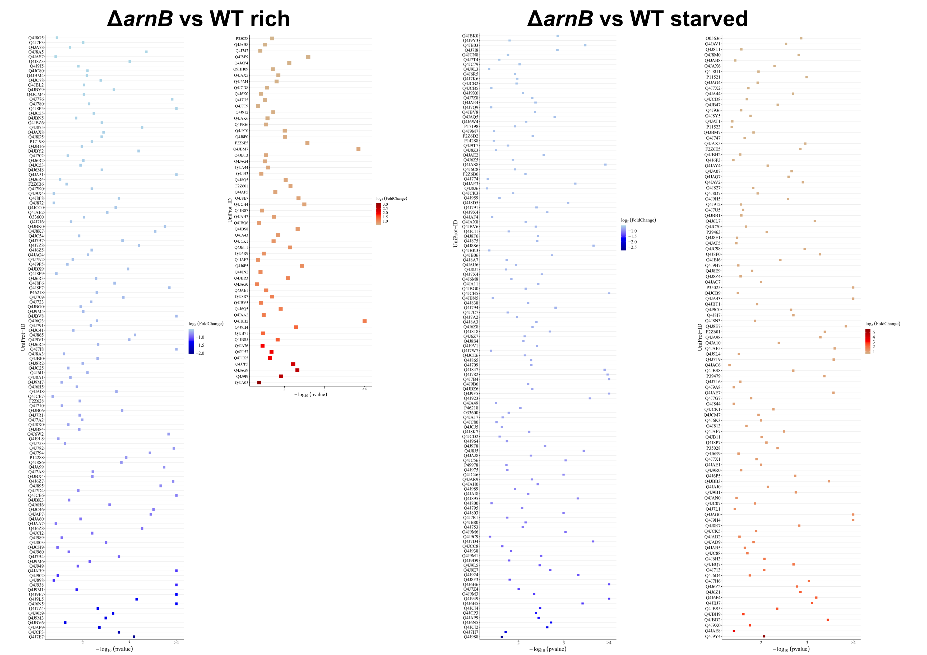
Figure S9: Volcano plot analysis of ΔarnB vs. WT comparison showing Uniprot IDs of over- (red) or under-regulated (blue) proteins in the respective comparison. Only proteins with a significance level of at least p<0.05 and a change of at least 50% were considered. The analysis charts do always refer to the knockout strain, i.e. which proteins were up- or down-regulated relative to the WT; significance levels increase from left to right, level changes from top to bottom. Some of the proteins with minor down-regulated changes under starved conditions were cut off for simplicity but are listed in the proteomics Table S3.

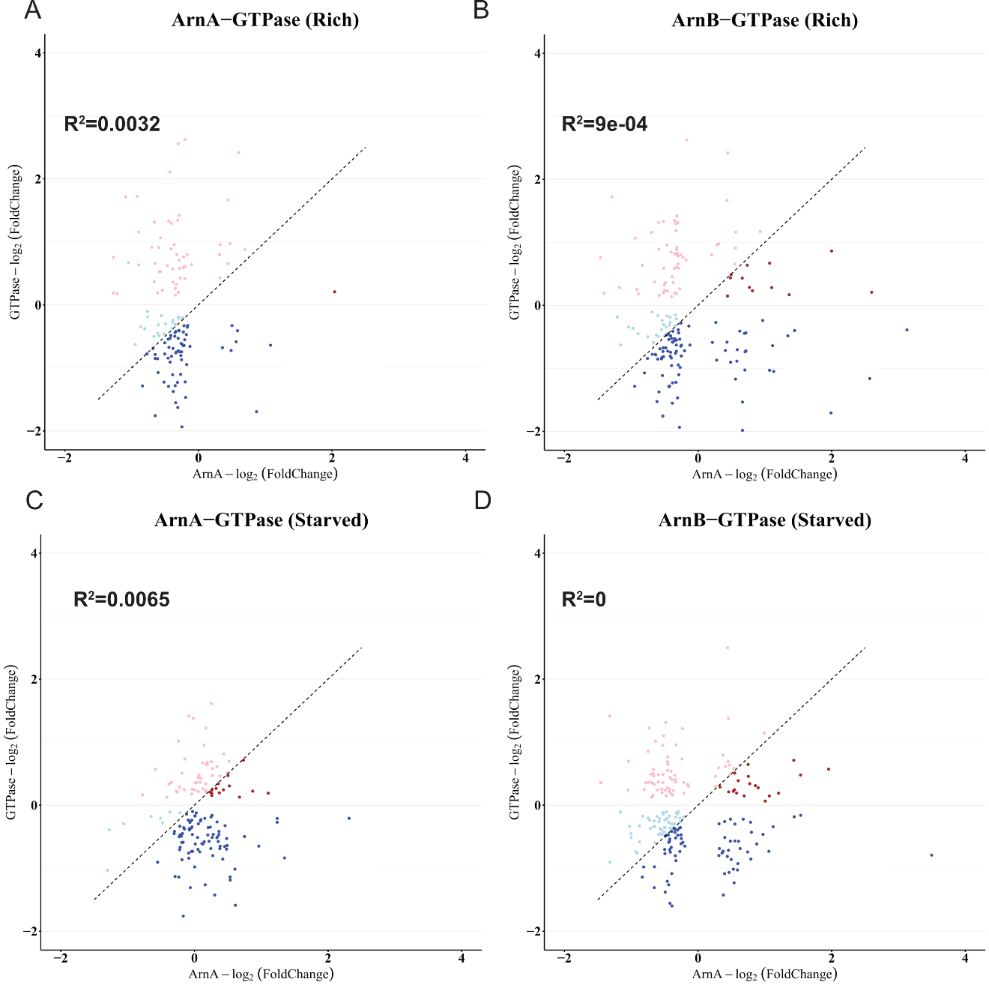

Figure S10: Proteomic changes are independent in SaGPN and ArnA/ArnB knockout strains. A: Correlation plot of the S. acidocaldarius ArnA vs. SaGPN knockout under nutrient-rich conditions, revealing very weak correlation. B: Correlation plot of the S. acidocaldarius ArnB and SaGPN knockout under nutrient-rich conditions. C: S. acidocaldarius ArnA vs. SaGPN knockout under nutrient starvation. D: S. acidocaldarius ArnB vs. SaGPN knockout under nutrient starvation.
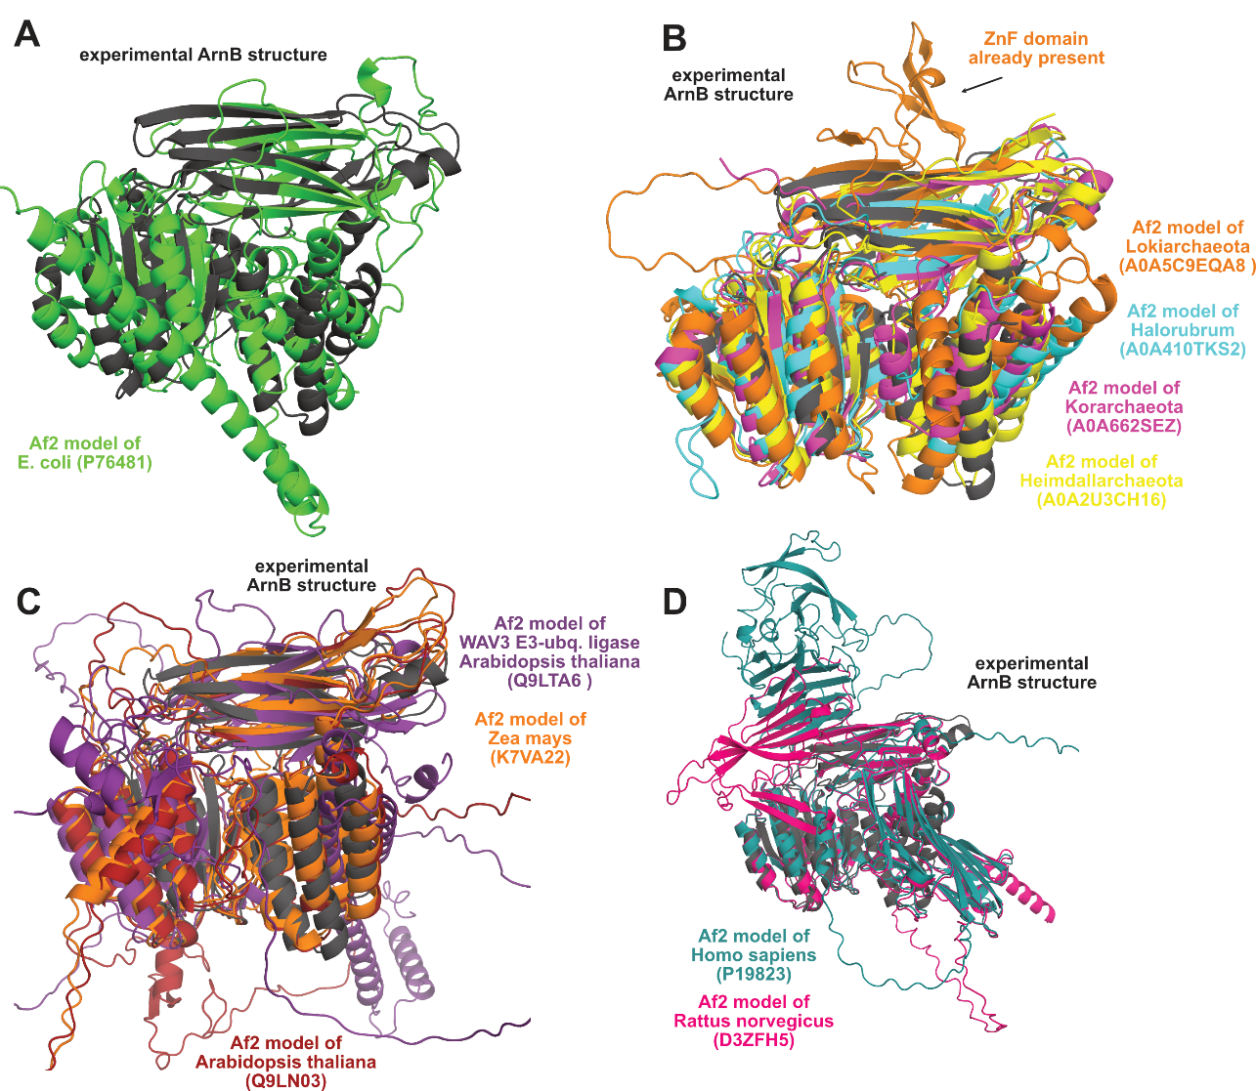

Figure S11: Structural conservation of the Sec23/Sec24 core motif and the ArnB structure. The ArnB crystal structure was subjected to foldseek search; selected hits as predicted by AlphaFold2 were superimposed to the ArnB structure that is representative of the Sec23/24 core motif. A: For the bacterial kingdom, the superposition of YfbK (Uniprot entry P76481) is shown. B: Archaeal orthologs from Lokiarchaeota, Haloarchaea, Korarchaeota and Asgard archaea. Interestingly, the member of the Lokiarchaeota is predicted to include a Sec23/24-like ZnF domain at an analogous position. C: Members of the plant family not belonging to the Sec23/Sec24-family show a high degree of structural conservation of the Sec23/Sec24 core motif, whereas animals hits (D) are predicted to be unrelated in terms of their domain packing. Uniprot identifiers are given in parentheses.

Table S1: Primers used for the side directed mutagenesis. Primers were used on the pETDuetTM-1 coexpression vector encoding both arnB-His₆ and Strep-arnA.

Primer Sequence | Introduced Mutation
CAGTAGAGCAAGCTAGAAAGATATCTAAGG | T363A, fw
CCTTAGATATCTTTCTAGCTTGCTCTACTG | T363A, rev
GAAGAATAGGTGCAGTAGAGCAAAC | T359A, fw
GTTTGCTCTACTGCACCTATTCTTC | T359A, rev
CGAAAGTATAGAGGCAGCTAGAAGAATAGG | T353A_T354A, fw
CCTATTCTTCTAGCTGCCTCTATACTTTCG | T353A_T354A, rev
GCTAATAGAGGCAGCTAGAAGAATAAGCG | T343A_T344A,fw
CGCTTATTCTTCTAGCTGCCTCTATTAGC | T343A_T344A, rev
CTAGTGAAGTTGCTAAGAAGTTGAGG | T375A, fw
CCTCAACTTCTTAGCAACTTCACTAG | T375A, rev
CTAAGGAAATAGCTAGTGAAGTTACTAAG | T371A, fw
CTTAGTAACTTCACTAGCTATTTCCTTAG | T371A, rev

Table S2: Crystallographic table for SaGPN structures.
 | ArnAB complex (8SO5)
Data collection and processing
X-ray source, beamline | SLS, Beamline X06SA  DECTRIS EIGER X 16M  1.00000  I 1 2 1  50.1 Å, 147.4 Å, 62.6 Å  90.00°, 107.16°, 90.00°  49.14 - 2.11 (2.36 - 2.11)  93365 (3307)  3.4 (2.4)  27478 (1375)  55.1 (9.7)  89.9 (52.3)  0.079 (0.505)  0.996 (0.638)  9.2 (1.8)  36.73
Detector
Wavelength (Å)
Space group
Cell dimensions (a, b, c,
α, β, γ)
Resolution (Å)
Total reflections
Multiplicity
Unique reflections
Completeness, spherical (%)†
Completeness, ellipsoidal (%)†
R_{merge}
CC1/2
Mean I/σ(I)
Wilson B-factor (Å²)
Refinement
Resolution (Å) | 49.14 - 2.11 (2.36 - 2.11)  0.2087 (0.3488), 0.2634 (0.2591)  27435 (1363)  0.009  1.10  6473  29  4  48.29  59.11  97.51  2.11  0.37
R_{work}, R_{free}
Reflections (test set)
r.m.s.d. from ideal:
Bond lengths (Å)
Bond angles (°)
Total number of atoms
solvent
ligands
Average B-factor (Å²)
Ligands
Ramachandran favored (%)
Ramachandran allowed (%)
Ramachandran outliers (%)
Statistics for the highest-resolution shell are shown in parentheses. † Dataset was corrected by STARANISO# for anisotropic diffraction. Cut-offs used direction -0.058 a* + 0.994 b* + 0.088 c* for best diffraction (2.11 Å), 0.588 a* + 0.809 c* for worst diffraction (3.54 Å). # Tickle, I.J., Flensburg, C., Keller, P., Paciorek, W., Sharff, A., Vonrhein, C., Bricogne, G. (2016). STARANISO, http://staraniso.globalphasing.org/cgi-bin/staraniso.cgi. Cambridge, United Kingdom: Global Phasing Ltd.

