Supplemental data
Methods
Detailed description of MI
Missing values in the variables used for the adjusted hazard ratios and odds ratios were handled through Multivariate Imputation by chained equations (MICE). For each endpoint, a separate Multiple Imputation (MI) was performed. Following variables were incorporated in the model for MI: MIPI score, cytology, Ki67, treatment group, age, gender, bone marrow, ECOG performance status, white blood cell count (WBC), B symptoms, ratio Lactate Dehydrogenase (LDH) /upper limit LDH (ULDH), initial response and stage, and the respective outcome variables CR/OR or for time-to-event endpoints event/censoring indicator and Nelson-Aalen estimator of the cumulative hazard. Continuous variables were imputed with predictive mean matching, dichotomous variables with logistic regression(1, 2). The plausibility of the imputed values was reviewed by density plots, which compare the density of the original variable and the density of the imputed variable for continuous variables and scatterplots for categorial variables. Furthermore, the imputed values were checked for implausible values. The number of imputed datasets will be based on the statistical efficacy of the estimates. 1% loss of statistical efficacy will be accepted. Let FMI be defined as the fraction of missing data and m the number of imputed datasets. Then, the number of imputed datasets will be calculated with:
$$\frac{FMI}{0.01} ≤m$$
Where FMI is defined as the fraction of missing data and m the number of imputed datasets(3).

Figures
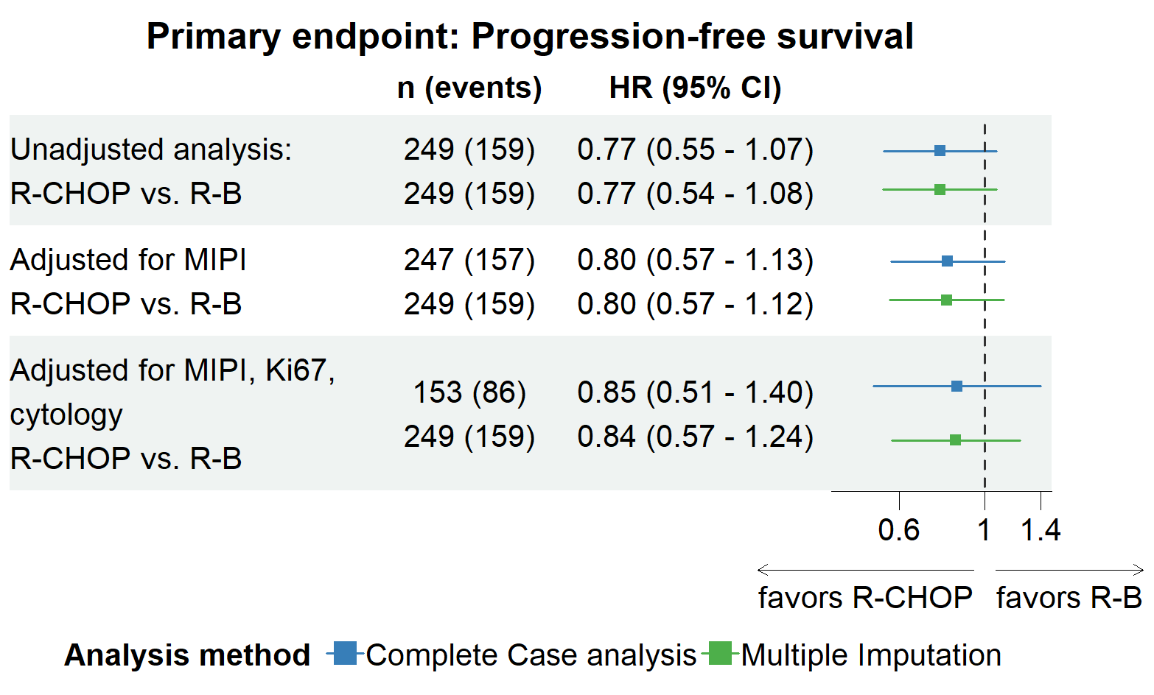
a, Comparison between the complete case analysis and multiple imputation for the primary endpoint progression-free survival
Supplemental Figure 1. Unadjusted and adjusted Hazard ratios (HR) for the treatment effect of R-CHOP vs. R-B for the primary endpoint progression-free survival. The displayed results show both unadjusted and adjusted Hazard Ratios (HRs) with their respective 95% confidence intervals (95% CI), along with the counts of observations and events (n(e)) for the complete case analysis (shown in blue), where only fully available data was utilized. Additionally, the HR and 95% CI intervals (displayed in green) obtained from Multiple Imputations are presented, imputing missing values in MIPI, Ki67 and cytology. Progression-free survival was calculated from start of induction therapy including all patients, who started induction therapy.

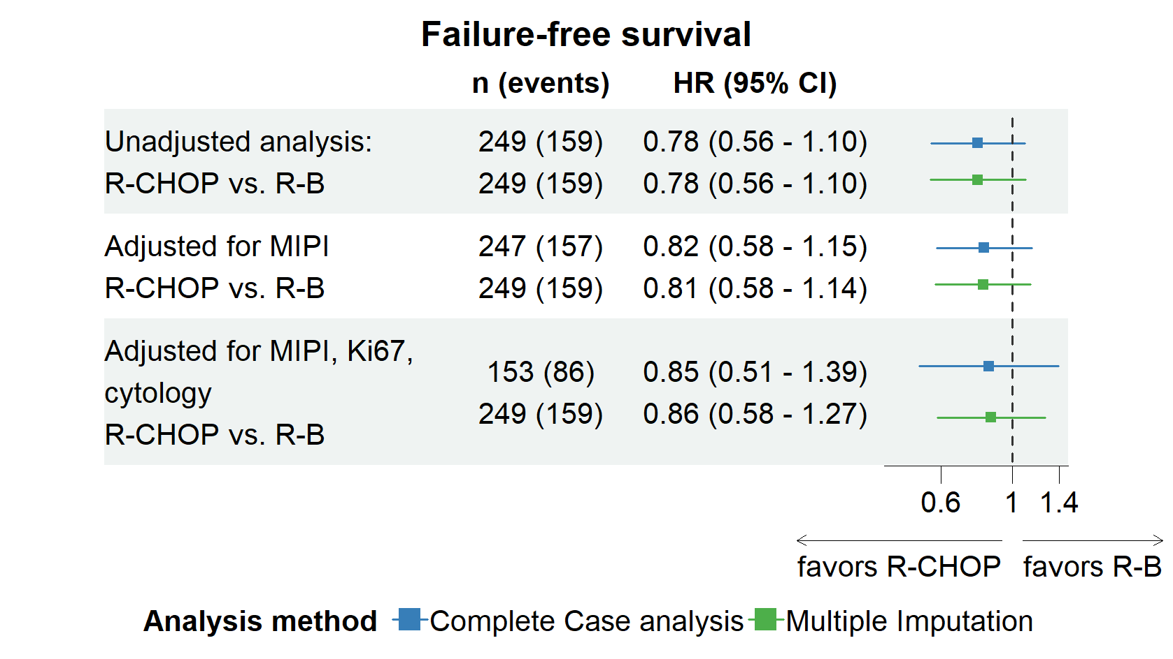
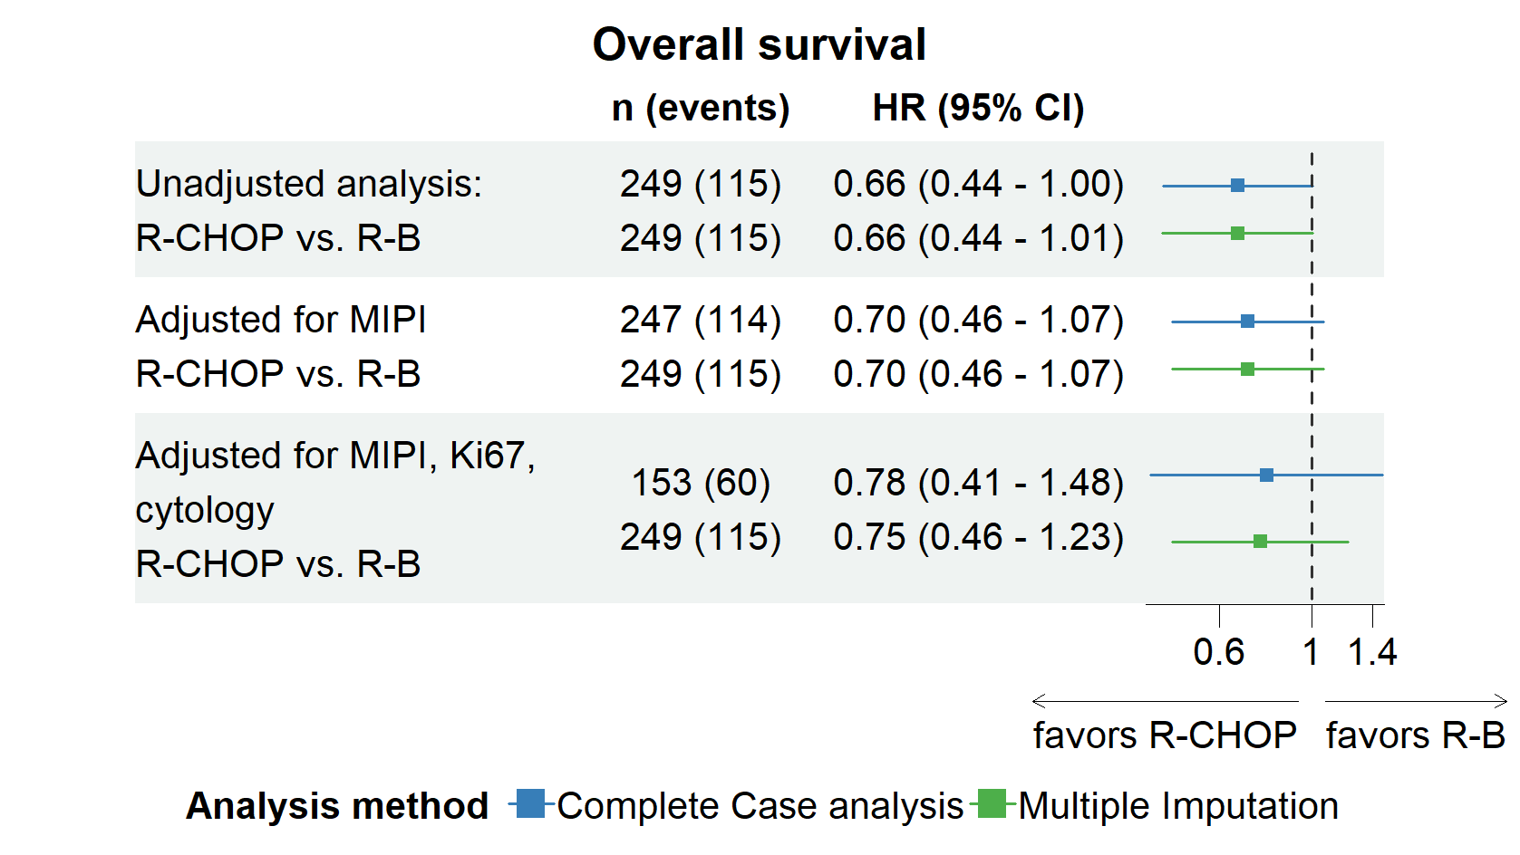
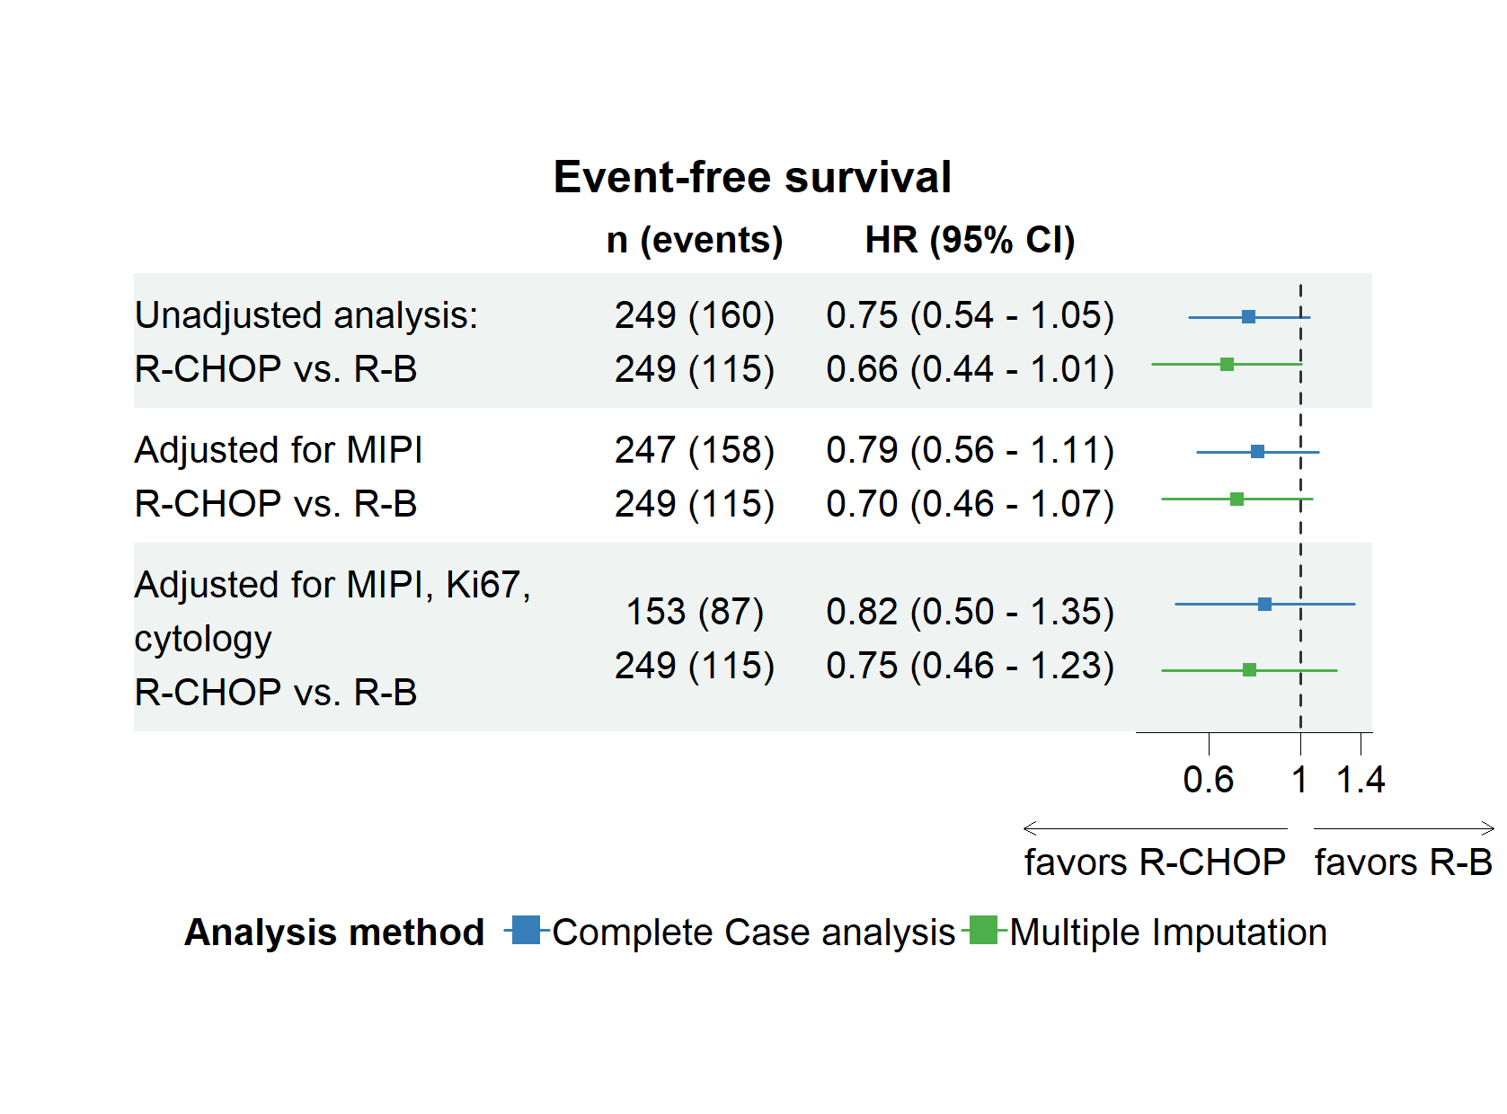
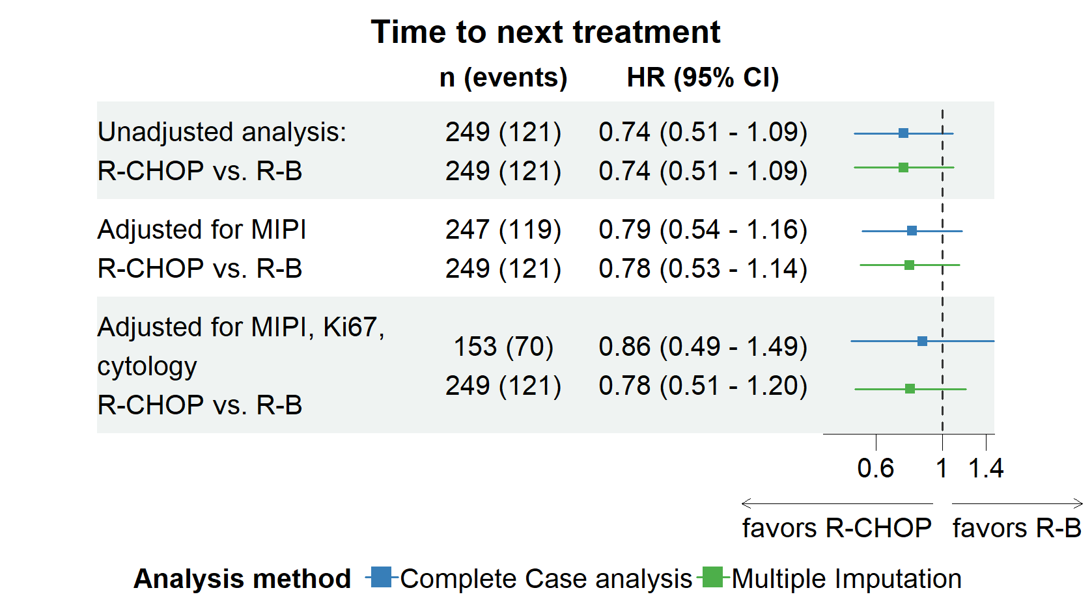
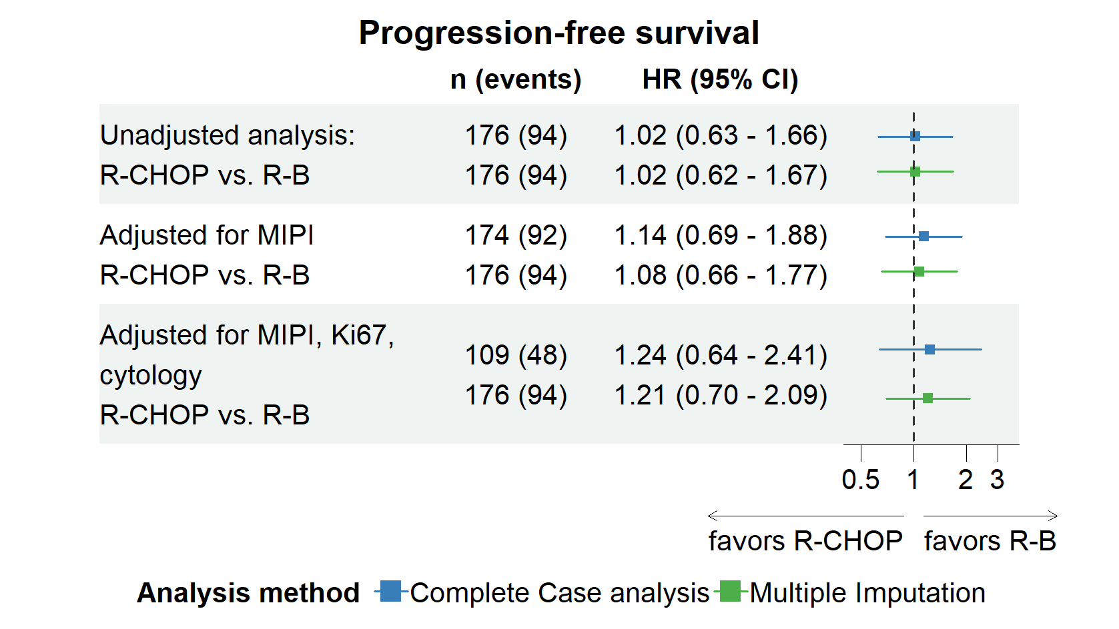
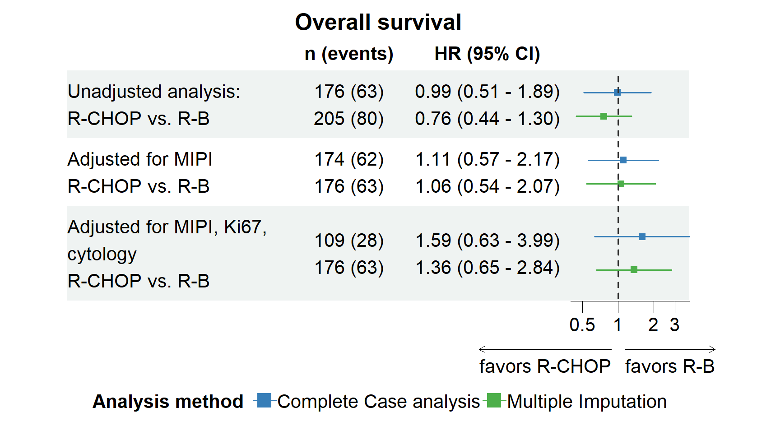
b, Comparison between the complete case analysis and multiple imputation for secondary endpoints
Supplemental Figure 2: Unadjusted and adjusted Hazard ratios (HR) for the treatment effect of R-CHOP vs. R-B for secondary endpoints. The displayed results show both unadjusted and adjusted Hazard Ratios (HRs) with their respective 95% confidence intervals (95% CI), along with the counts of observations and events (n(e)) for the complete case analysis (shown in blue), where only fully available data was utilized. Additionally, the HR and 95% CI intervals (displayed in green) obtained from Multiple Imputations are presented, imputing missing values in MIPI, Ki67 and cytology. Progression-free survival and overall survival was calculated from start of induction therapy including all patients, who started induction therapy as well as from end of induction therapy for all patients, who responded to the induction therapy and started maintenance rituximab.

Comparison of the treatment effect with and without multiple imputation of missing values
a, From start of induction therapy
b, From end of induction therapy

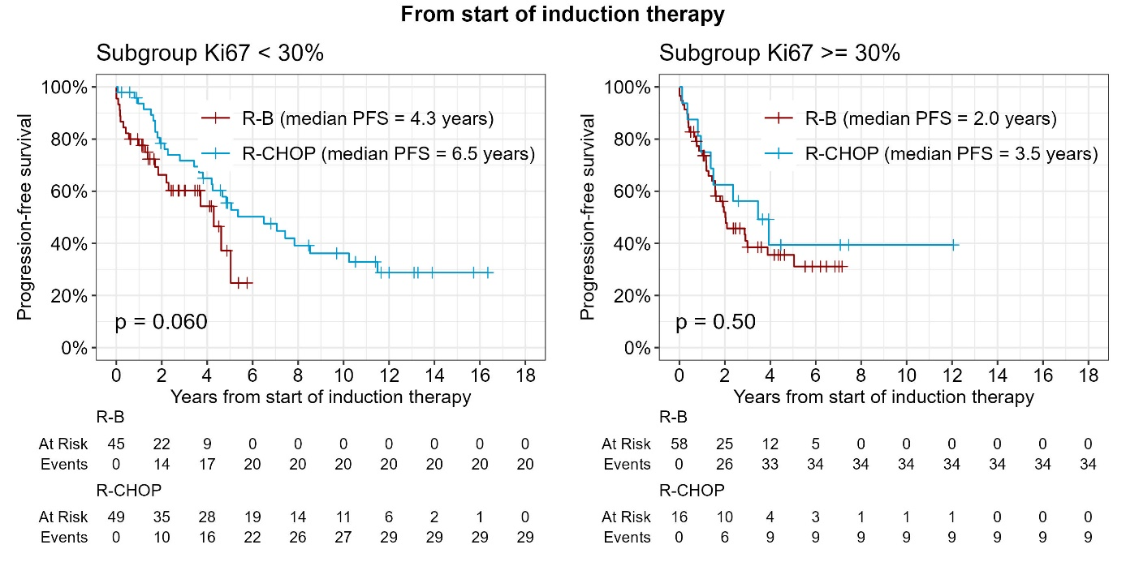
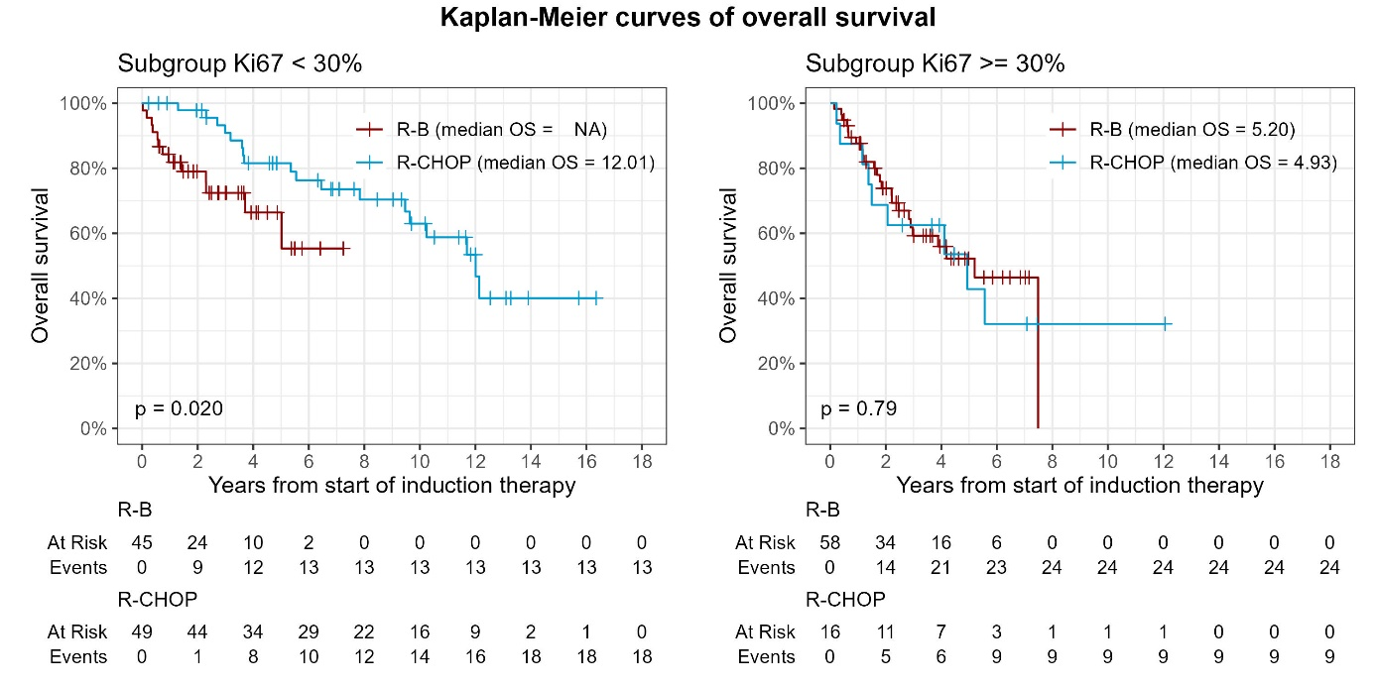
c, Subgroup analysis for Ki67 < 30% and Ki67 ≥ 30% for the primary endpoint progression-free survival
Kaplan-Meier curves
Supplemental Figure 3. Kaplan-Meier curves for R-CHOP and R-B for progression-free survival for the subgroups Ki67 < 30% and Ki67 ≥ 30%. Progression-free survival was calculated from start of induction therapy including all patients, who started induction therapy as well as from end of induction therapy for all patients, who responded to the induction therapy and started maintenance rituximab.

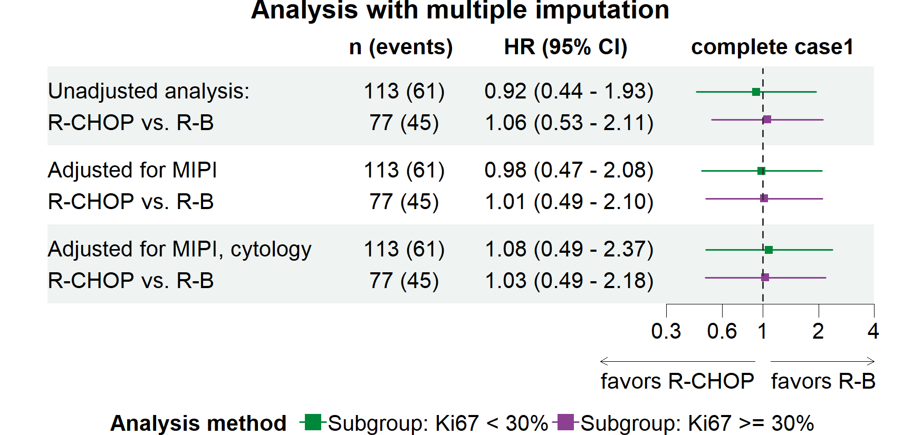
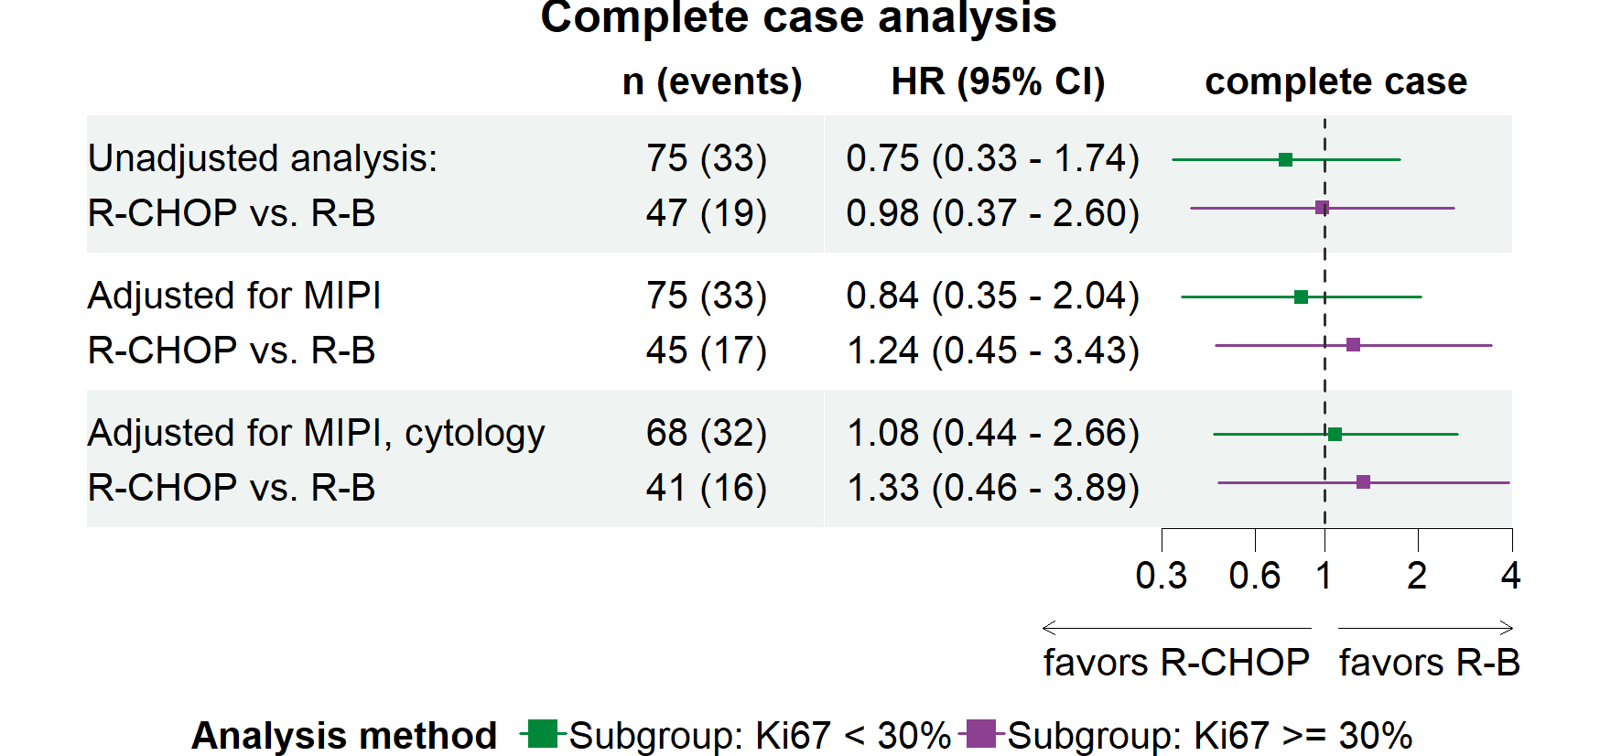
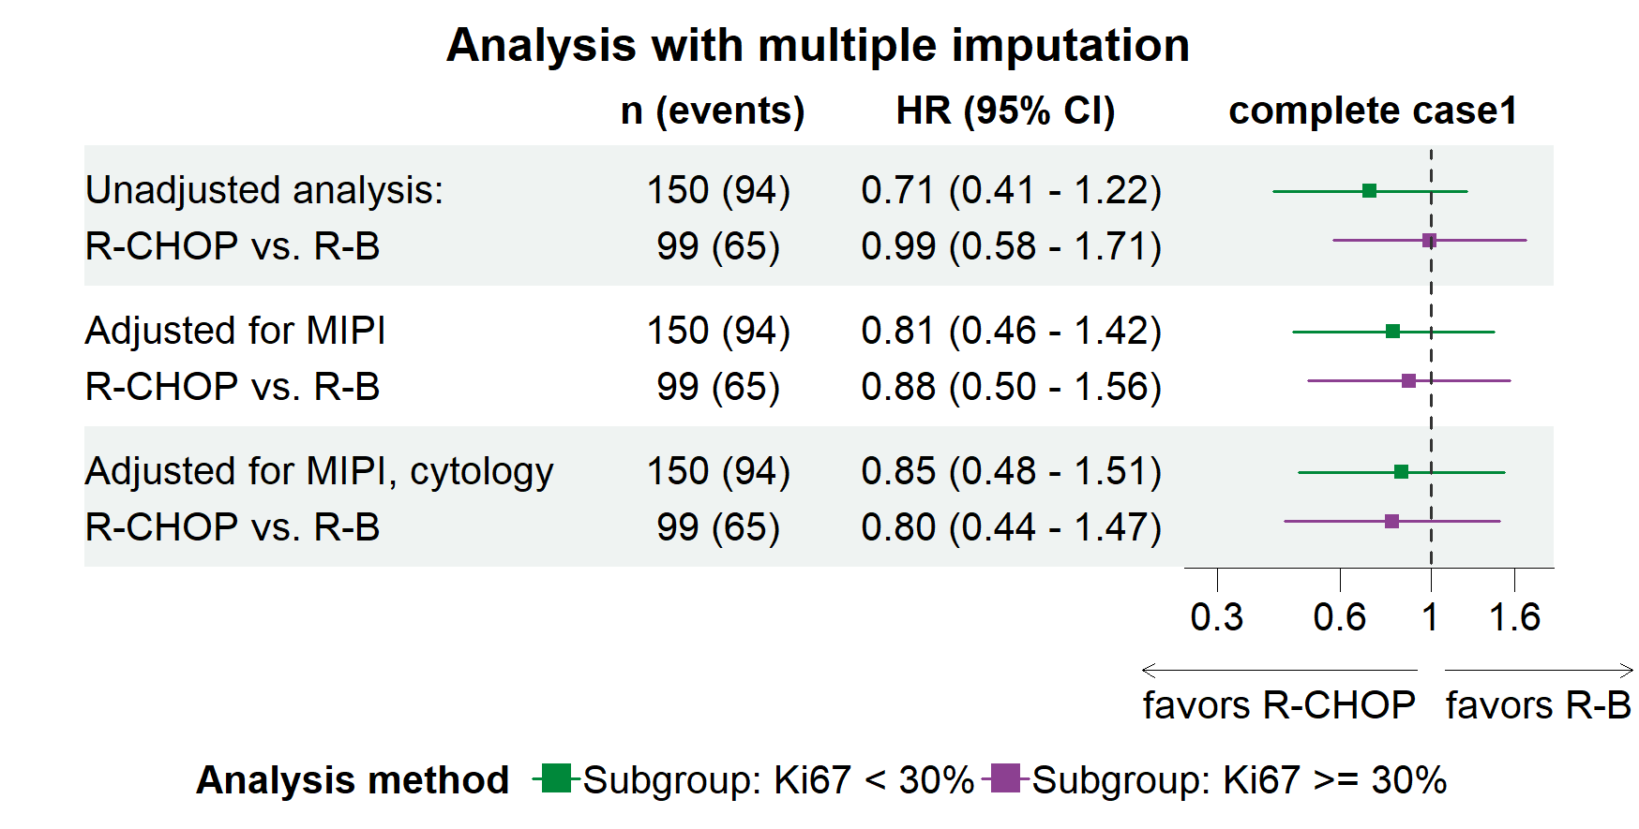
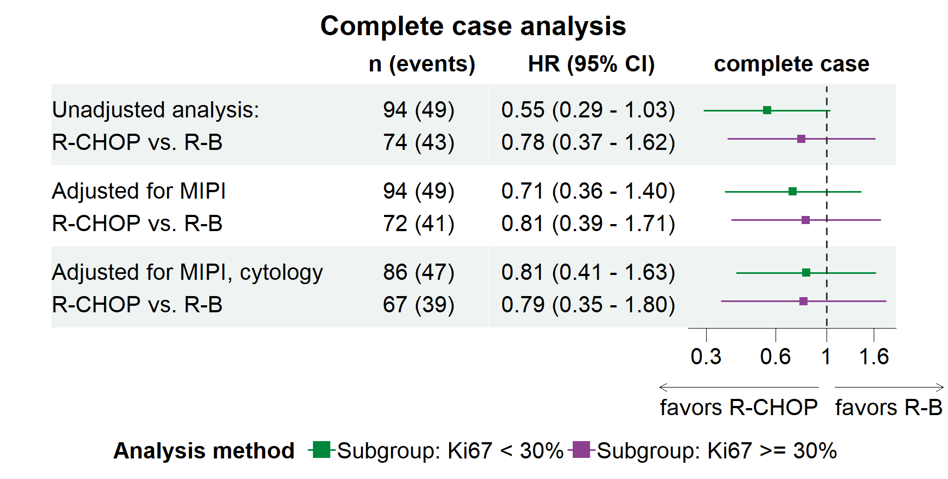
Supplemental Figure 4. Unadjusted and adjusted hazard ratios (HR) for the treatment effect of R-CHOP vs. R-B for progression-free survival for the subgroups Ki67 < 30% and Ki67 ≥ 30%. The displayed results show both unadjusted and adjusted Hazard Ratios (HRs) with their respective 95% confidence intervals (95% CI), along with the counts of observations and events (n(e)) for the complete case analysis (Panel A and C) where only fully available data was utilized. Additionally, the HR and 95% CI intervals (Panel B and D) obtained from Multiple Imputations are presented, imputing missing values in MIPI, Ki67 and cytology. In Panel A and B, progression-free survival was calculated from start of induction therapy including all patients, who started induction therapy. In Panel C and D, progression-free survival was calculated from end of induction therapy for all patients, who responded to the induction therapy and started maintenance rituximab.

From end of induction
From start of induction
Progression-free survival for the subgroups Ki 67 < 30% and Ki67 ≥ 30%
References
1. Austin PC, White IR, Lee DS, van Buuren S. Missing Data in Clinical Research: A Tutorial on Multiple Imputation. Can J Cardiol. 2021;37(9):1322-31.
2. Azur MJ, Stuart EA, Frangakis C, Leaf PJ. Multiple imputation by chained equations: what is it and how does it work? Int J Methods Psychiatr Res. 2011;20(1):40-9.
3. Graham JW, Olchowski AE, Gilreath TD. How many imputations are really needed? Some practical clarifications of multiple imputation theory. Prev Sci. 2007;8(3):206-13.

