Supporting Information

A non-enzymatic electrochemical sensor based on NiCoSe₂/rGO nanosheets for nanomolar range detection of Malathion.
Akhin VPª, Ananda Kumar Srinivasan^{a,*}

Fig S1: Calibration plot of peak current vs square root of scan rate of NiCoSe₂/rGO/ GCE in 0.1 M NaOH solution.
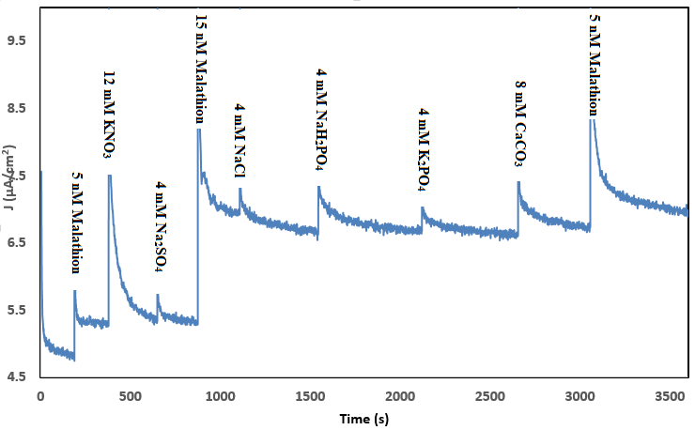
Fig S2: Interference test: Amperometric response recorded using a NiCoSe₂/rGO/GCE in 0.1M NaOH in the presence 1mL of 4 mM NaCl, 4mM NaH₂PO₄, 8mM CaCO₃, 12 mM KNO_{3,} 4 mM CaCO₃, 4 mM K₂PO_{4.} The response of Malathion at 250 (s) ^{th}, 1000th (s) ^{th} and 3200th signals are due to 5 nM, 15nM and 5nM Malathion respectively.
Fig S3: Stability test: Chronoamperometry response of NiCoSe₂/rGO/GCE in 0.1 M NaOH solution in 20 nM Malathion.
Fig S4: Repeatability, CVs of a NiCoSe₂/rGO/GCE were recorded in 0.1M NaOH containing 20nM Malathion in different day’s interval.

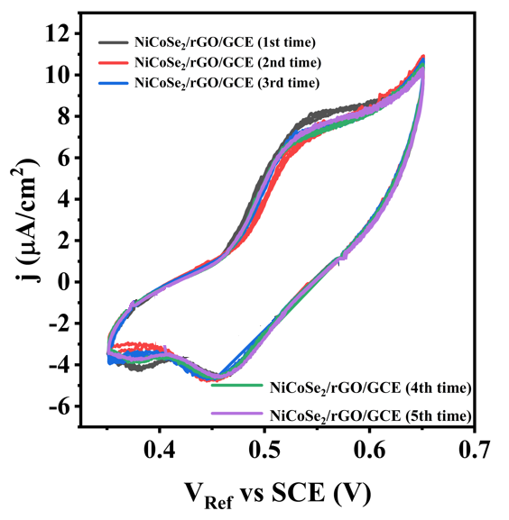
Fig S5: Reproducibility, CVs of five fabricated sensors were recorded in 0.1M NaOH containing 20nM Malathion in different day’s interval.

Fig S6: Real sample analysis: DPV response of Malathion spiked tomato samples in 0.1 M NaOH solution.

