Supplementary Figures and Figure legends
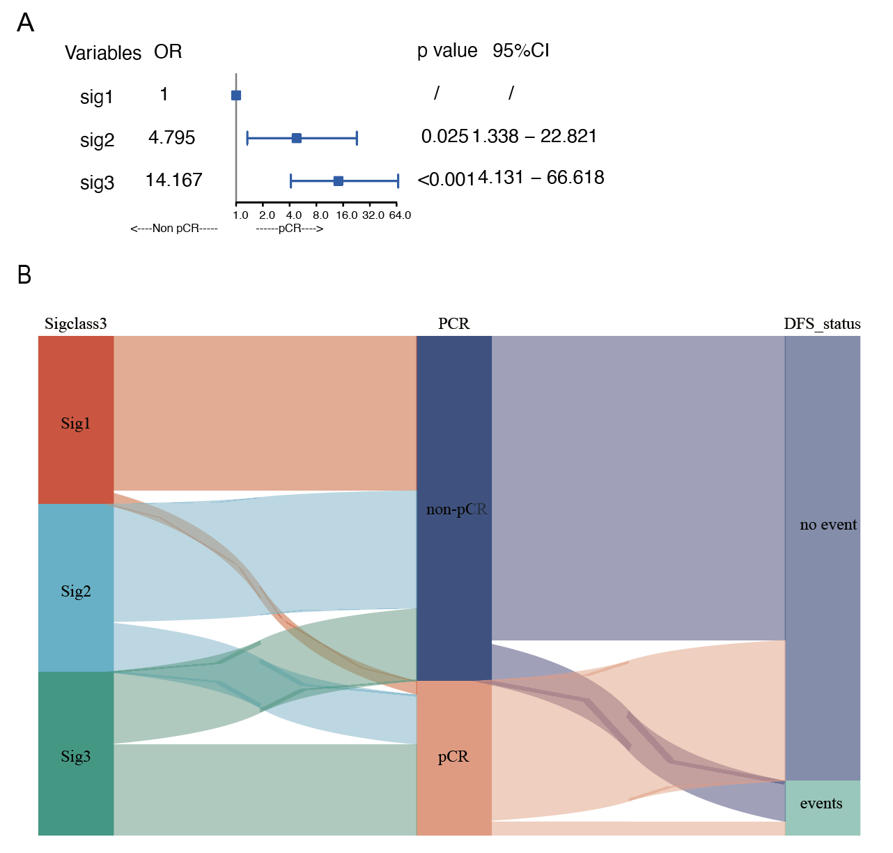
Supplementary Figure 1
(A) Univariate logistics regression analysis showing relationship between Lnc signature and NAC response.
(B) Alluvial diagram showing the connection of Lnc signature and NAC response and DFS status

