Supplementary materials for title “Source Tracking of Carbapenem-Resistant Enterobacteriaceae Outbreaks in Neonatal Patients Revealed Rivers Contaminated with NDM Genes”

Table 1 Genotype distribution of carbapenemase-producing Klebsiella pneumoniae in neonatal ward
Sequence types | Carbapenemase genes | rubber ring of incubator | Humidified water | incubator handle | object surface | Medical staff hand
ST39 | NDM-1 | 1 | 1 |  |  | 1
ST36 | NDM-1 | 1
ST20 | NDM-1 | 1 |  | 1 | 1
ST101 | IMP-4 | 1
ST307 | IMP-4 |  | 1 |  |  | 1
ST11 | KPC-2 |  |  | 1

Table 2 Distribution of carbapenem-resistant organisms (CRO) in rivers
Organisms | Rivers
Stenotrophomonas maltophilia | 27
Acinetobacter baumannii | 13
Acinetobacter lwoffi | 10
Chromobacterium violaceum | 5
Sphingobacterium multivorum | 7
Chryseobacterium indologenes | 5
Pseudomonas.spp | 4
Chryseobacterium meningsepticum | 1
Sphingomonas paucimobilis | 2
Escherichia coli | 3
Klebsiella pneumoniae | 2
Aeromonas hydrophila | 1
Chryseobacterium gleum | 1
Bordetella bronchiseptica | 1
Enterobacter cloacae | 1

Figure 1 Genotypic relationships of carbapenem-resistant Acinetobacter baumannii from patients and ward environment (A) and KPC-2 KP isolates of ST11 randomly selected from neonatal and adult patients (B).

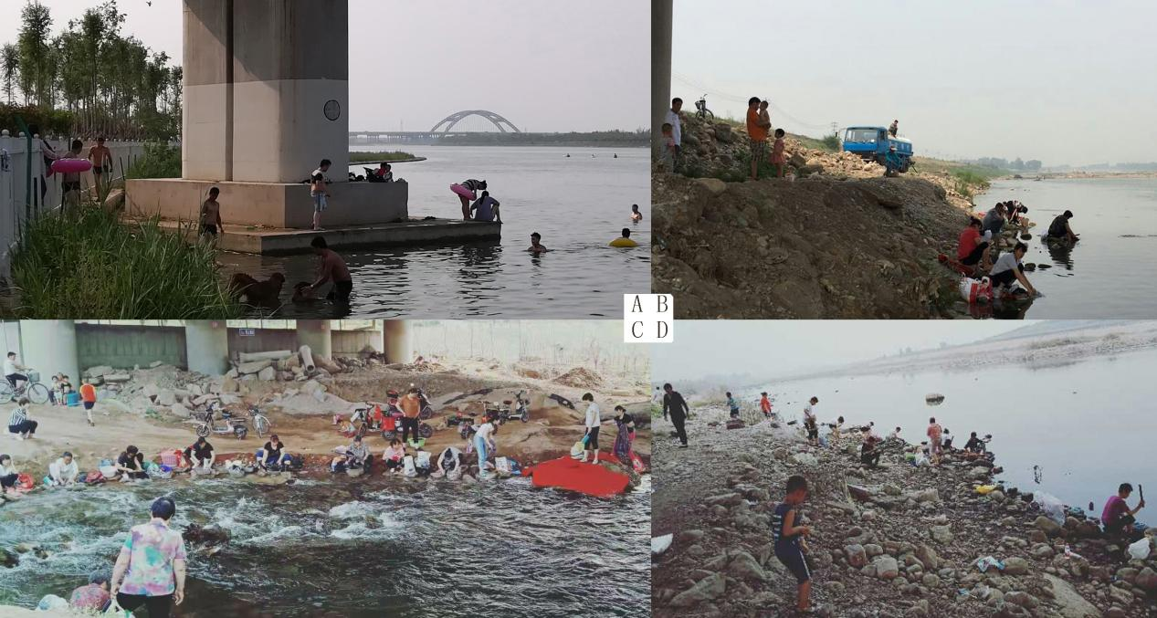
Figure 2 Sampling rivers were closely related to people’s lives. These photos were taken during sampling of rivers that had been confirmed to be contaminated with NDM organisms. Photo A shows swimming and (animals) bathing. Photo B shows pumping water for irrigation and washing. Photos C and D show washing and (children) playing.

