Visible light Induced Photocatalytic Activity of Polypyrrole Decorated Zinc Ferrite Green Nanohybrids Against Cetirizine Hydrochloride Degradation

Shayista Gaffarª, Elham S. Aazam^{c}, Ufana Riaz^{a,b*}
^{a*}Department of Chemistry and Biochemistry, North Carolina Central University, NC, 27707, USA, Corresponding author: ufana2002@yahoo.co.in
^{b}Materials Research Laboratory, Department of Chemistry, Jamia Millia Islamia, New Delhi-110025, India.
^{c}Chemistry Department, Faculty of Science, King Abdul Aziz University, Jeddah, 23622, Saudia Arabia.

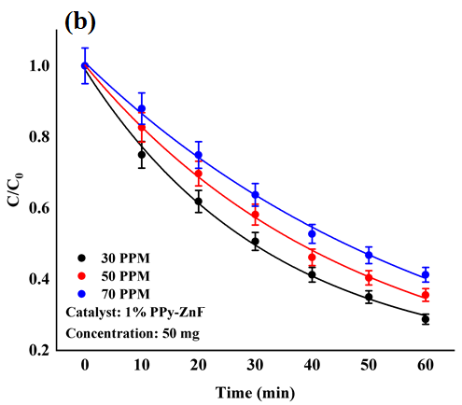
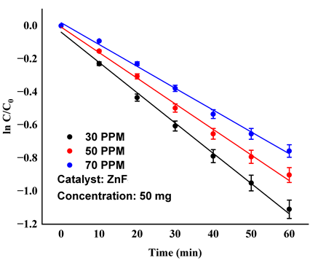
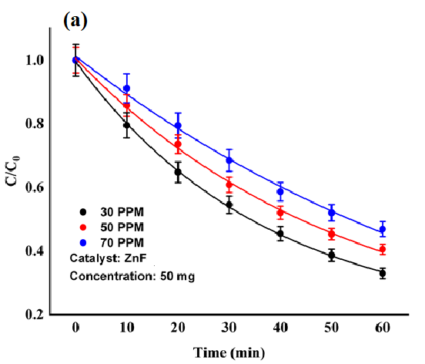
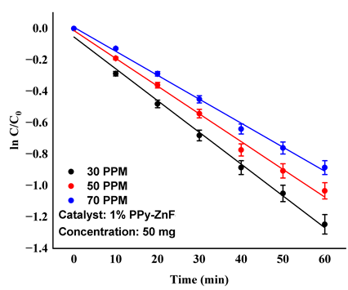

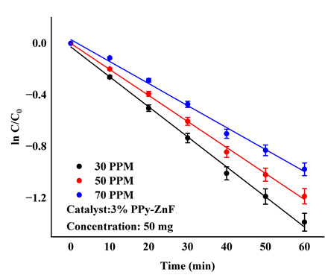
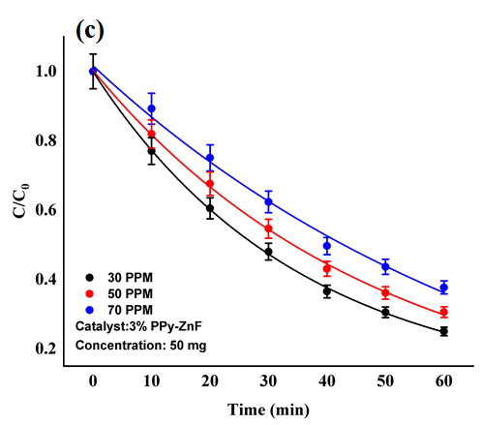
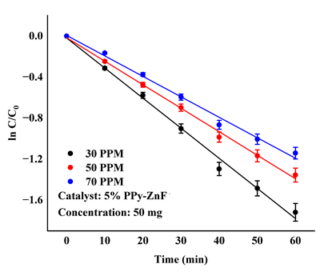
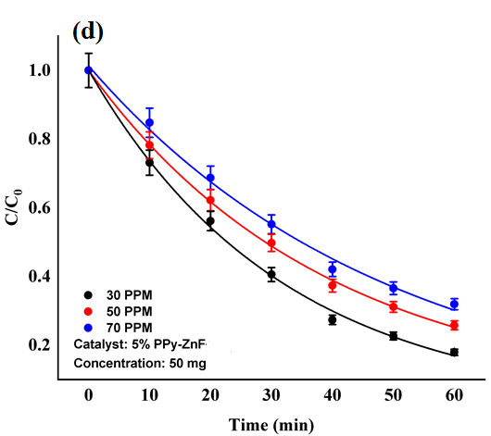

Figure 3 Effect of CTZ-HCl concentration for (a) ZnFe, (b) 1% PPy-ZnFe, (c) 3% PPy-ZnFe, (d) 5% PPy-ZnFe as photo catalysts.

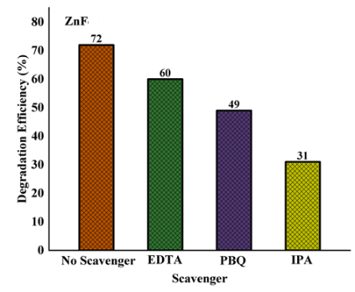
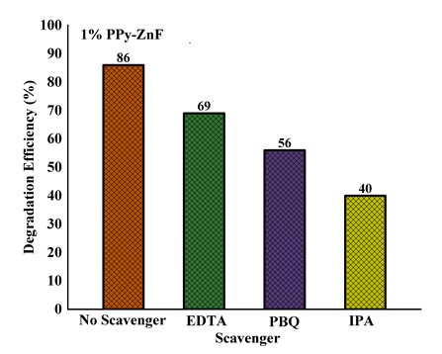
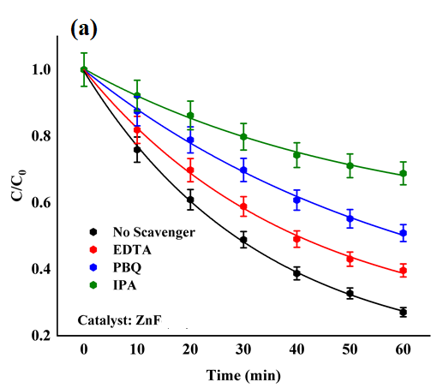
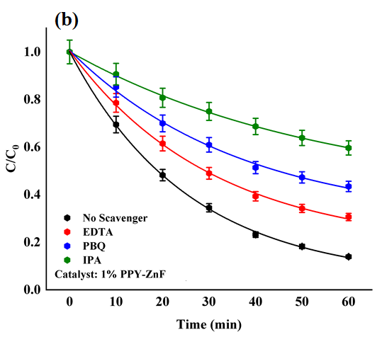

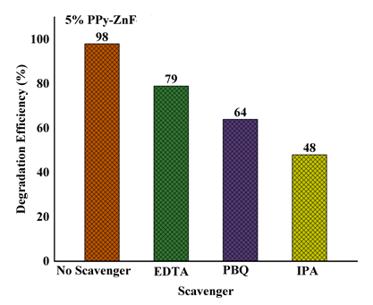
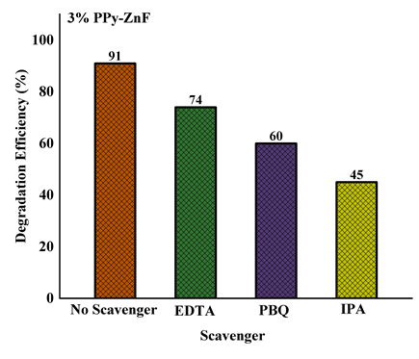
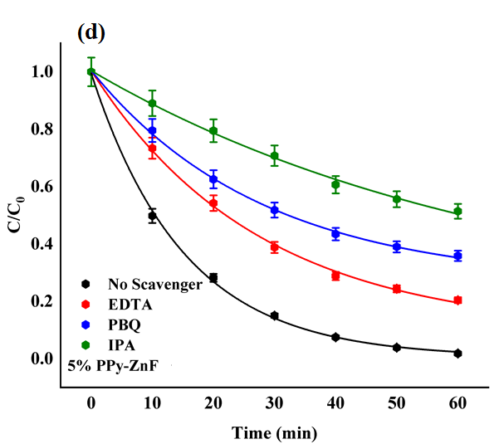
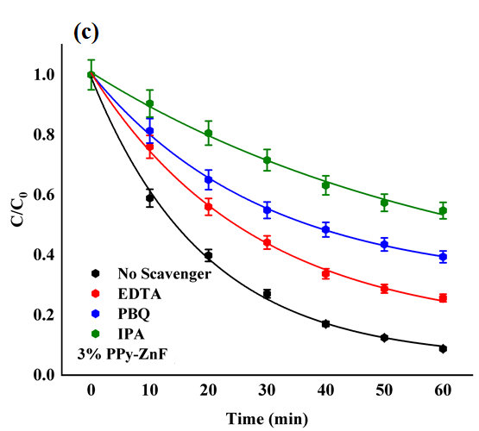

Figure 5 Effect of addition of radical scavenger on (a) ZnFe, (b) 1% PPy-ZnFe, (c) 3% PPy-ZnFe, (d) 5% PPy-ZnFe

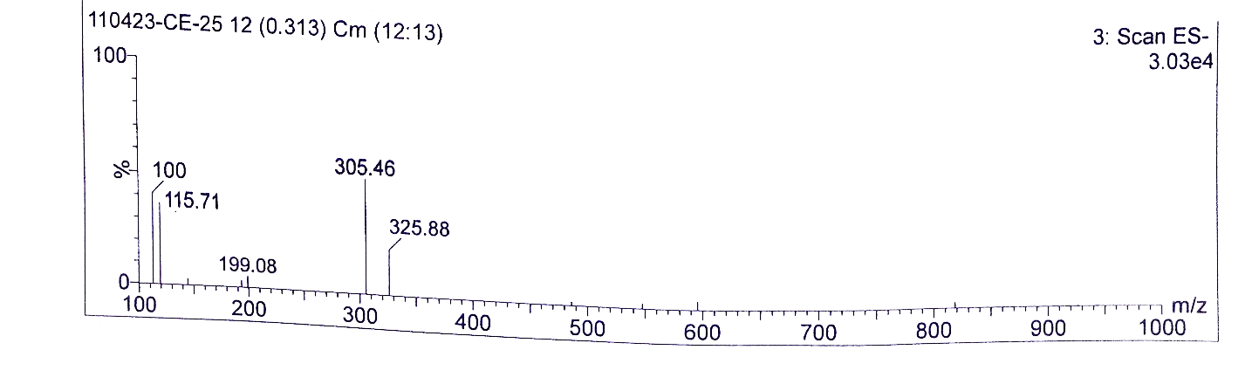
Figure S5 LCMS profile of CTZ-HCl using 5% PPy/ZnFe photocatalyst

