Supplementary Materials
In the Supplementary Material, Table S1 shows the result of sensitive analysis that compared the baseline sample characteristics between eligible and ineligible participants. Table S2 demonstrates the proportion of SLEs in persons with MDD. Figure S1 shows the mediating effects of insomnia symptoms on the relationship between different types of SLEs and SI.

Table S1: Baseline sample characteristics between eligible and ineligible participants
Factor | Total, n (%) | Eligible | Ineligible | P value
Total (N, %) | 1097(100.0) | 511(46.6) | 586(53.4) | NA
Gender (N, %)
Male | 325(29.6) | 168(32.9) | 157(26.8) | 0.033
Female | 772(70.4) | 343(67.1) | 429(73.2)
Age (mean, SD) | 29.4(6.9) | 28.7(6.7) | 30.1(7.0) | 0.001
Marriage (N, %)
Unmarried | 795(72.5) | 379(74.2) | 416(71.0) | 0.494
Married | 280(25.5) | 122(23.9) | 158(27.0)
Missing | 22(2.0) | 10(2.0) | 12(2.0)
Education level (N, %)
Below undergraduate | 472(43.0) | 220(43.1) | 252(43.0) | 0.417
Undergraduate or above | 623(56.8) | 291(56.9) | 332(56.7)
Employed status (N, %) | 2(0.2) | 0(0.0) | 2(0.3)
Unemployed
Employed | 300(27.3) | 158(30.9) | 142(24.2) | 0.043
Missing | 794(72.4) | 352(68.9) | 442(75.4)
Family monthly income (N, %)
<10,000¥ | 391(35.6) | 187(36.6) | 204(34.8) | 0.805
≥10,000¥ | 621(56.6) | 286(56.0) | 335(57.2)
Missing | 85(7.7) | 38(7.4) | 47(8.0)
Smoking (N, %)
No | 606(55.2) | 301(58.9) | 305(52.0) | 0.055
Yes | 486(44.3) | 207(40.5) | 279(47.6)
Missing | 5(0.5) | 3(0.6) | 2(0.3)
Drinking (N, %)
No | 155(14.1) | 79(15.5) | 76(13.0) | 0.453
Yes | 939(85.6) | 431(84.3) | 508(86.7)
Missing | 3(0.3) | 1(0.2) | 2(0.3)
Exercise habit per week (N, %)
No | 701(63.9) | 329(64.4) | 372(63.5) | 0.480
Yes | 391(35.6) | 181(35.4) | 210(35.8)
Missing | 5(0.5) | 1(0.2) | 4(0.7)
Moderate or severe depressive symptom (N, %)
No | 54(4.9) | 29(5.7) | 25(4.3) | 0.349
Yes | 1043(95.1) | 482(94.3) | 561(95.7)
Moderate or severe anxiety symptom (N, %)
No | 215(19.6) | 113(22.1) | 102(17.4) | 0.145
Yes | 880(80.2) | 397(77.7) | 483(82.4)
Missing | 2(0.2) | 1(0.2) | 1(0.2)
Resilience at baseline (N, %)
Weak resilience (≤60) | 1009(92.0) | 471(92.2) | 538(91.8) | 0.630
Greater resilience | 71(6.5) | 34(6.7) | 37(6.3)
Missing | 17(1.5) | 6(1.2) | 11(1.9)
SLEs (N, %)
No | 384(35.0) | 169(33.1) | 215(36.7) | 0.234
Yes | 713(65.0) | 342(66.9) | 371(63.3)

Table S1: Baseline sample characteristics between eligible and ineligible participants.
(Continued)
Factor | Total, n (%) | Eligible | Ineligible | P value
SI at baseline (mean, SD) | 3.9(2.6) | 3.8(2.6) | 4.1(2.6) | 0.121
SI at baseline (N, %)
No | 224(20.4) | 105(20.5) | 119(20.3) | 0.990
Yes | 871(79.4) | 405(79.3) | 466(79.5)
ISI scores (mean, SD) | 15.1(6.4) | 14.9(6.3) | 15.3(6.6) | 0.424
Note. SLEs= Stressful life events; SI= Suicidal ideation; ISI=Insomnia Severity Index.

Table S2: The proportion (%) of SLEs in persons with MDD (n=511).
SLEs | n (%)
01. Life-threatening disease | 33 (6.5)
02. Life-threatening accident | 44 (8.6)
03. Physical assault | 16 (3.1)
04. Bereavement | 58(11.4)
05. Rape | 12(2.3)
06. Other sexual assault | 19(3.7)
07. Witnessed a traumatic event | 76(14.9)
08. Childhood physical abuse | 95(18.6)
09. Adulthood physical abuse | 29(5.7)
10. Threatened | 14(2.7)
11. Humiliated or discriminated | 232(45.4)
12. Extreme fear or helplessness | 215(42.1)

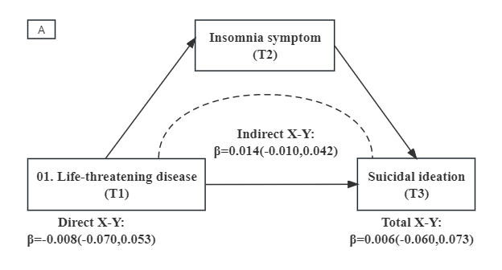 | 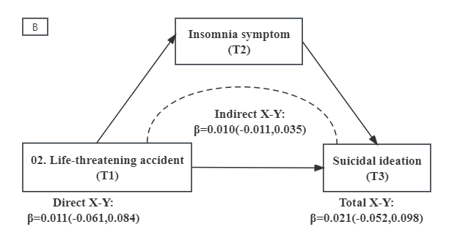 | 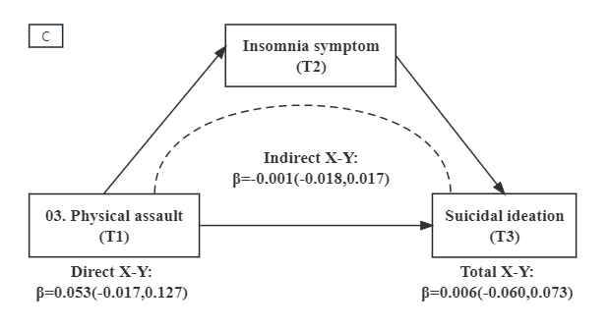
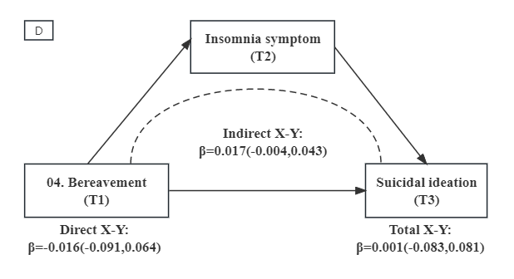 | 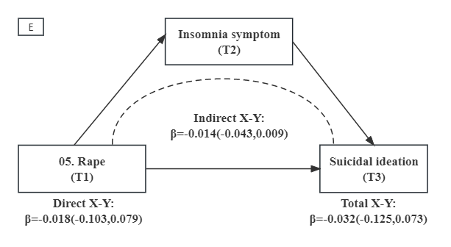 | 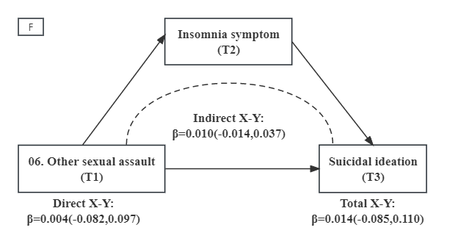
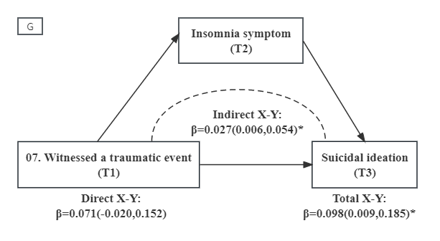 | 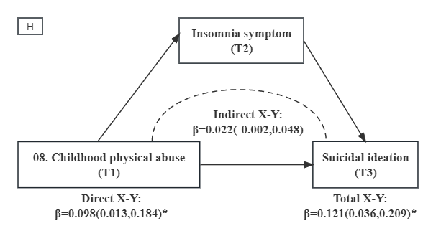 | 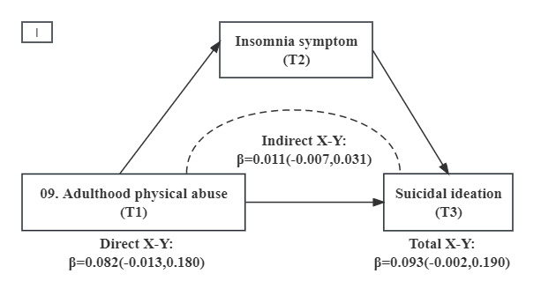
Figure S1: Mediating effects of insomnia symptoms on the relationship between different types of SLEs and SI.

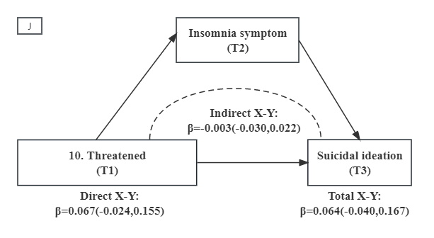 | 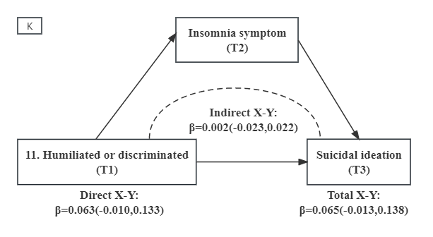 | 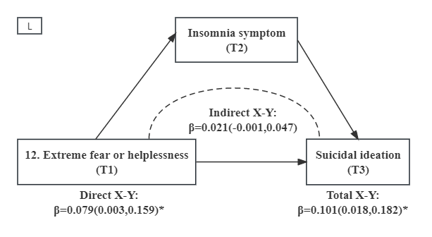
Figure S1: Mediating effects of insomnia symptoms on the relationship between different types of SLEs and SI (continued).
Note: *: P <0.05; **: P <0.01; T1=baseline; T2=12 weeks; T3=24 weeks. The structural equation models for SI were adjusted for gender, age, marriage, education level, employed status, family monthly income, smoking, drinking, exercise habit per week, depressive symptom, anxiety symptom, resilience, SI at baseline

