Supporting Information
Journal name: Journal of Polymer Research
A new α-CBC polymer with elevated heat-resistance prepared via catalytic hydrogenation of α-methylstyrene-butadiene-styrene terpolymer over Ni_{x}Pd/NCNT@MFN monolithic catalyst
Chun-Yan Cao^{a, 1}, Shao-Kang Qian^{a, 1}, Gui-Ping Cao^{a,} *, Jun-Yang Yanª, Peng Gaoª, Shuang Jiª
ª UNILAB, State Key Laboratory of Chemical Engineering, East China University of Science and Technology, 130 Meilong Road, Shanghai, 200237, China
¹ First co-authors: Chun-Yan Cao and Shao-Kang Qian
* Corresponding author. E-mail addresses: gpcao@ecust.edu.cn (Gui-Ping Cao)
- Structure of various α-SBS analyzed via ¹H NMR spectra.
- Adsorption relationships between metal surfaces and four monomer structures.
- DSC analysis curve of PB, PS, SBS, and α-SBS1 before and after hydrogenation.

1. Structure of various α-SBS analyzed via ¹H NMR spectra.
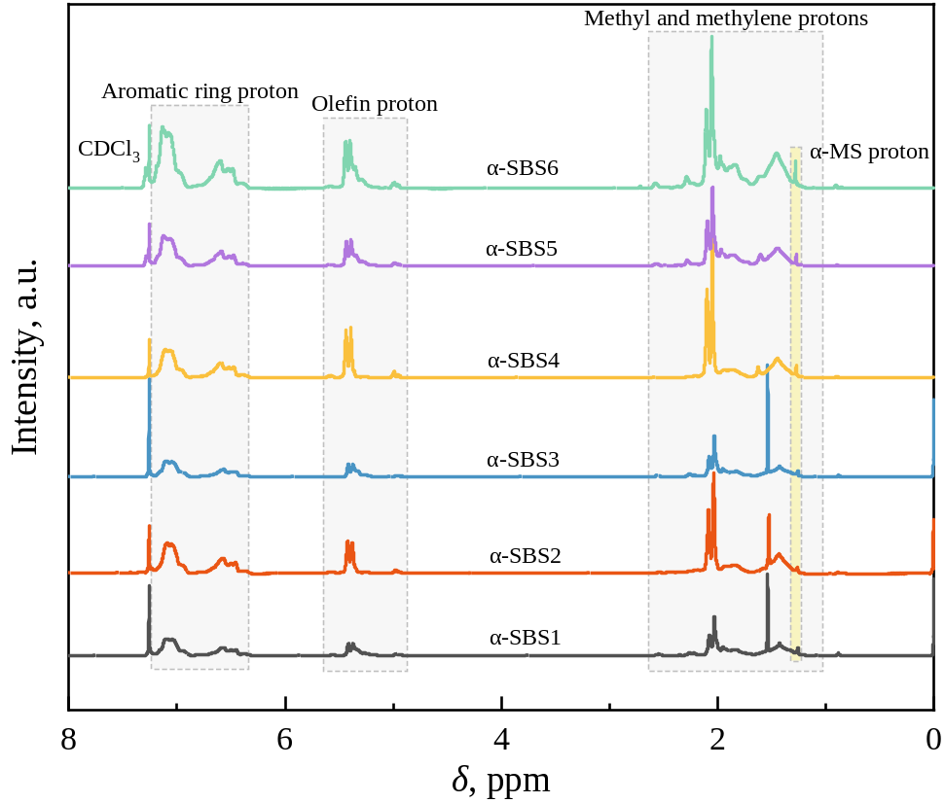
Fig. S1 ¹H NMR spectra of α-SBS1, α-SBS2, α-SBS3, α-SBS4, α-SBS5, and α-SBS6 samples using deuterated chloroform as solvent at 600 M magnetic field

2. Adsorption relationships between metal surfaces and four monomer structures.
Fig. S2 Top view of electron density difference while m₁, m₂, m₃, and m₄ adsorbed on Ni_{x}Pd alloy surface

3. DSC analysis curve of PB, PS, SBS, and α-SBS1 before and after hydrogenation.
Fig. S3 DSC profiles of PB, PS, SBS and α-SBS1 before and after hydrogenation (scanning rate 10 °C/min, heating curve for the second heating process)

