Supplementary Information

Monocyte derived Galectin-9 and PD-L1 differentially impair innate and adaptive immune response in various phases of chronic HBV infection

Debangana Dey¹, Satabdi Biswas¹, Sourina Pal¹, Sarthak Nandi¹, Najma Khatun¹, Rambha Jha¹, Bidhan Chandra Chakraborty², Ayana Baidya¹, Ranajoy Ghosh³, Soma Banerjee¹, SK Mahiuddin Ahammed⁴, Abhijit Chowdhury⁴ and Simanti Datta¹*

¹Centre for Liver Research, School of Digestive and Liver Diseases, Institute of Post Graduate Medical Education and Research, Kolkata, India
²Multidisciplinary Research Unit, Institute of Post Graduate Medical Education and Research, Kolkata, India
³Division of Pathology, School of Digestive and Liver Diseases, Institute of Postgraduate Medical Education and Research, Kolkata, India
⁴Department of Hepatology, School of Digestive and Liver Diseases, Institute of Post Graduate Medical Education and Research, Kolkata, India
Medical Education and Research, Kolkata, India
Addresses correspondence to
Prof. Simanti Datta,
Centre for Liver Research, School of Digestive and Liver Diseases,
Institute of Post Graduate Medical Education and Research,
244, A.J. C. Bose Road, Kolkata-700020, India.
Tel- (91)-(033)-2223 5435; Fax- (91)-(033)-2223 6383
E-mail- seemdatt@gmail.com

Methods
Study subjects and samples
Treatment-naïve patients with CHI [having HBsAg positivity > six months] were included in the study from the OPD of School of Digestive and Liver Diseases (SDLD), I.P.G.M.E.&R., Kolkata, India. All necessary virological, biochemical and clinical assessments were conducted before categorization of these patients into distinct study groups namely, IT, EP-CHB, IC and EN-CHB. IT group included participants having HBeAg-positivity, high HBV-DNA (>10⁷ copies/ml) but normal serum alanine transaminase (ALT) levels (≤40 IU/L) in three consecutive follow-ups within a period of 1 year prior to enrolment and had minimal or no liver necro-inflammation. Both EP-CHB and EN-CHB patients were diagnosed with HBV-DNA>10⁴ copies/ml, ALT>40 IU/L and evidence of active hepatic necro-inflammatory activity, the only difference being presence or absence of detectable HBeAg in their serum. IC were characterized by HBeAg-negativity, HBV-DNA<10⁴ copies/ml and ALT≤ 40 IU/L, both measured on three occasions 3 months apart, with no biochemical, clinical or histological evidence of liver disease.
Patients having co-infection with HIV/HCV/HDV, significant co-morbidities like diabetes mellitus, chronic alcoholism, intravenous drug abuse or evidence of any carcinoma, overt infection or autoimmune disorders were excluded from the study.
In addition, healthy controls (HC) without viral and bacterial infection and chronic or acute illness in preceding 6 months were included as a comparison group for the study. For characterizing HBV-specific T- and B-cells, acutely HBV-infected patients who resolved infection (having HBsAg negativity and positive for antibody against hepatitis B core antigen) were recruited as controls. Written informed consents were taken from all participants. All study protocols were approved by the Ethical Review Committee of I.P.G.M.E.&R.

Assessment of ICMs expressed by monocytes in different study groups
To assess the expression of ICMs, Gal-9, PD-L1 and CTLA-4 on HLA-DR⁺CD14⁺ total monocytes, CD14⁺⁺CD16⁻ classical monocytes, CD14⁺⁺CD16⁺ intermediate monocytes and CD14⁺CD16⁺⁺ non-classical monocytes, freshly collected EDTA-mixed blood from different groups of treatment-naïve chronically HBV infected patients and HC were incubated with anti-HLA-DR-V500, anti-CD14-FITC, anti-CD16-PECY7, anti-Gal-9-PerCP, anti-PD-L1-PE and anti-CTLA-4-APC followed by treatment with FACS Lysing Solution (BD Pharmingen) for erythrocyte lysis. Cells were then washed and acquired on FACSVerse (BD Biosciences). In each set, fluorescence minus one (FMO) control was used to minimize background noise. The flow cytometry data analysis was performed using FCS Express De Novo software.
Quantification of Hepatitis B surface antigen (HBsAg) and cytokines in serum
Serum HBsAg and different cytokines in study subjects were quantified using Abbott Architect i1000sr platform and BD CBA Human Th1/Th2/Th17 Cytokine Kit and IL-1 beta ELISA Kit.
Treatment of sorted monocytes or PBMCs with recombinant (r) HBsAg, rTNF-α, rIL-4 or rIL-1β
From healthy individuals, peripheral blood mononuclear cells (PBMCs) were isolated from freshly collected EDTA-mixed blood using lymphocyte separation media (LSM-1077) (HiMedia) by density gradient centrifugation. The monocytes were sorted from PBMCs using CD14 microbeads and magnetic separation columns (Miltenyi Biotech). 2×10⁶ monocytes were cultured for 48 hours in presence or absence of recombinant HBsAg (20μg/ml) (Abcam) or β‐Galactosidase (20μg/ml) (Sigma-Aldrich). The cells were then harvested followed by staining with anti-CD14-FITC, anti-HLADR-BV421, anti-CD16-PECY7, anti-Gal-9-PerCP and anti-PD-L1-APC followed by washing and acquisition in flow cytometer.
Additionally, in separate sets of experiment, the PBMCs of healthy individuals were treated with rTNF-α (50 ng/ml), rIL-4 (25 ng/ml) or rIL-1β (5 ng/ml) for 3 days or kept untreated. The cells were harvested at day 3, followed by staining with antibodies against HLA-DR, CD14, CD16, Gal-9 and PD-L1. The cells were then washed and acquired in flow cytometer.
Characterization of different adaptive and innate immune cells:
To determine the cytokine production of HBV-specific T-cells, PBMCs were isolated from chronically HBV infected patients belonging to different disease phases and the acutely HBV infected patients who resolved infection, as these patients were supposed to exhibit HBV-specific T-cell response. Briefly, 2x10⁶ PBMCs were stimulated with a set of 15-mer peptides overlapping by 10 residues (OLP) spanning genotype D HBV core protein (5μg/ml) (Mimotopes) for 5 days at 37°C. On the 4th day, the cells were restimulated with 5μg/ml OLP along with 1μg/ml Brefeldin A for overnight. At day 5, the cells were harvested and stained with anti-CD3-PE-CY7, anti-CD4-FITC and anti-CD8-PerCP, washed, permeabilized and fixed with BD Cytofix/Cytoperm kit and again stained with anti-IFN-γ-BV421, anti-IL-2-PE and anti-IL-10-APC antibodies followed by acquisition in FACSVerse.
To characterize the regulatory T-cells (Tregs), the PBMCs were stimulated with anti-CD3/anti-CD28 and cultured for 3 days. The cells were harvested at the end of day 3 and incubated with fluorochrome conjugated antibodies against CD4 and CD25 in proper combination and washed. To evaluate the expression of FOXP3 on CD4⁺CD25⁺ T-cells, cells were incubated with FOXP3 Fix/Perm buffer (Biolegend, USA) and subsequently with FOXP3 washing buffer (Biolegend, USA) for fixation and intranuclear permeabilization. The cells were stained with anti-FOXP3-PE and analysed by flow cytometry.
To determine IL-6 production by HBV-core antigen specific B-cells, PBMCs from HBV infected patients were stimulated with rHBcAg (4μg/ml) for 3 days at 37°C. On the 3rd day, the cells were harvested and stained with anti-CD19-FITC, washed, permeabilized and fixed with BD Cytofix/Cytoperm kit and again stained with anti-IL-6-PE antibody followed by acquisition and analysis.
To ascertain the frequencies of atypical memory B (atMB) cells and regulatory B-cells (Bregs), PBMCs of the study subjects were stimulated with rCD40L (1μg/ml) followed by staining with fluorochrome conjugated antibodies against CD19, CD27 and CD21 in proper combination. The cells were then fixed and permeabilized as before, stained with fluorochrome conjugated anti-IL-10 antibody and acquired using flow cytometry.
To characterize the cytokine production of the NK-cells, PBMCs of the study subjects were stimulated by rIL-12 and rIL-18 (5ng/ml) antibodies for 24 hours followed by harvesting of cells, staining with fluorochrome conjugated antibodies against CD3, CD56 and CD16 in proper combination. The cells were then fixed and permeabilized and again stained with anti- IFN-γ-PE and anti-IL-10-APC. The percentages of IFN-γ- and IL-10-expressing CD3⁻CD56⁺CD16⁺ NK-cells were determined.
Co-culture of CD14⁺monocytes and monocyte-depleted PBMC
CD14⁺-monocytes were sorted from PBMCs of chronically HBV-infected patients, co-cultured with monocyte-depleted PBMC pre-treated with HBV core OLP and anti-CD3/CD28 and the percentages of IFN-γ⁺, IL-2⁺ and IL-10⁺ HBV-specific CD4⁺-/CD8⁺-T-cells and CD4⁺CD25⁺FOXP3⁺-Tregs were evaluated by flow-cytometry as described before. Similar co-culture experiments were performed after pre-treating the monocyte-depleted PBMCs with rHBcAg or rCD40L and the frequencies of IL-6⁺-HBcAg-specific B-cells, atMB-cells and Bregs of chronically HBV-infected patients were determined.
To study the effect of monocytes on the cytokine production by NK-cells, monocytes were cultured with monocyte-depleted PBMCs incubated with rIL-12 and rIL-18 and IFN-γ- and IL-10-expressing NK-cells were analyzed by flow-cytometry. All co-culture experiments were performed in presence/absence of anti-Gal-9- or anti-PD-L1-antibody.
Differentiation of monocytes to macrophages
To differentiate the monocytes into macrophages, 2×10⁷ PBMCs were allowed to adhere for 5 hours in serum free condition. Then the serum free media was replaced carefully with RPMI medium supplemented with 10% FBS and the cells were cultured in presence of M-CSF (50ng/ml) for 7 days. At day 7, the cells were exposed to fresh medium containing either IFN-γ (20 ng/ml) and LPS (100 ng/ml) or IL-4 (25 ng/ml) for additional 24 hours to terminally polarize them to M1- or M2-macrophages respectively. Next, the cells were washed and stained with anti-HLA-DR-V500, anti-CD14-PerCP and anti-CD68-FITC, followed by fixation and permeabilization and staining either with anti-TNF-α-APC or with anti-IL-10-APC. The macrophages were identified as CD14⁺HLA-DR⁺CD68⁺ cells by flow cytometry. The proportion of TNF-α⁺ and IL-10⁺-cells among the macrophages denoted M1 and M2-macrophages respectively and M1-/M2 ratio was calculated.
Immunofluorescence staining
Percutaneous liver biopsy specimens were obtained from selected CHB patients as part of their clinical assessment as deemed necessary by the clinician for studying the liver histopathology. Liver tissues from healthy donors were collected as part of the pre-transplantation assessment for living-donor liver transplantation. Immunohistochemical analysis were performed on stored paraffin embedded tissue blocks of selected CHB patients and healthy donors to study the intrahepatic incidence of Gal-9⁺CD14⁺ and PD-L1⁺CD14⁺ monocytes. Haematoxylin and eosin (H&E) staining was performed with formalin-fixed, paraffin-embedded 6μm liver tissue sections to evaluate the histological status of the liver of study subjects and viewed under light microscope. For immunohistochemical analyses, after deparaffinization, hydration and antigen retrieval, tissue sections were stained with anti-CD14-FITC (1:600 dilution), anti-Gal-9-PerCP (1:700 dilution), anti-PD-L1-APC (1:1000 dilution) followed by washing and cover-mounting with Pro-Long Gold Antifade/DAPI solution. The sections were examined under fluorescence microscope (Leica Thunder Imager, Leica Microsytems, Germany).

Supplementary Table S1 Demographic, biochemical and virological characteristics of HBV-infected individuals belonging to different clinical stages and healthy controls
Characteristics | HC  (N=20) | RESOLVED  ACUTE  (N=10) | IT  (N=10) | EP-CHB  (N=20) | IC  (N=20) | EN-CHB  (N=21)
Age, years Median (Range) | 30  (25-45) | 34  (20-51) | 18  (8-22) | 32  (25-62) | 35  (27-52) | 39  (31-67)
Sex  (Male:Female) | 8:12 | 7:3 | 6:4 | 15:5 | 7:13 | 17:4
HBeAg Status | - | - | Positive | Positive | Negative | Negative
ALT(IU/L) Median (Range) | 17  (12-26) | 29  (15-39) | 30  (21-38) | 106  (50-236) | 23  (12-35) | 111  (48-145)
HBV DNA (copies/ml) Median (Range) | - | - | 1.7X10⁸  (1.2X10⁷-2X10⁸) | 1.4X10⁷  (5.5X10⁴-1.7X10⁸) | 250  (128-700) | 3.3X10⁴  (1.8X10⁴-1X10⁸)

IT, Immunotolerant; EP-CHB, HBeAg-positive chronic hepatitis B; IC, Inactive carriers; EN-CHB, HBeAg-negative chronic hepatitis B; HC, Healthy controls, RESOLVED ACUTE, Acutely HBV infected patients who resolved infection; ALT, alanine aminotransferase; IU, international unit;
Supplementary Table S2 List of Antibodies
SL No. | Reagent Name | Origin/Clone | Cat No. | Company name
1 | Antihuman-CD14-FITC | M5E2 | 555397 | BD Biosciences
2 | Antihuman-HLA-DR-BV421 | L243 | 307636 | BioLegend Inc.
3 | Antihuman-CD16-PECY7 | 3G8 | 557744 | BD biosciences
4 | Antihuman-Galectin-9-PerCP | 9M1-3 | 348910 | BioLegend Inc.
5 | Antihuman-PD-L1-PE | 29E.2A3 | 329705 | BioLegend Inc.
6 | Antihuman-PD-L1-APC | M1H3 | 374513 | BioLegend Inc.
7 | Antihuman-CTLA-4-APC | BNI3 | 555855 | BD Biosciences
8 | Antihuman-CD68-FITC | Y1/82A | 333806 | BioLegend Inc.
9 | Antihuman-CD4-FITC | RPA-T4 | 30056 | BioLegend Inc.
10 | Antihuman-CD25-PECY7 | M-A251 | 561405 | BD Biosciences
11 | Antihuman-FoxP3-PE | 259D/C7 | 560046 | BD Biosciences
12 | Purified anti-CD3 antibody | HIT3a | 300314 | BioLegend Inc.
13 | Purified anti-CD28 antibody | CD28.2 | 302914 | BioLegend Inc.
14 | Antihuman-CD8-PERCP | SK1 | 344708 | BioLegend Inc.
15 | Antihuman- IFN-γ –PE | B27 | 506506 | BioLegend Inc.
16 | Antihuman- IFN-γ –BV421 | 4S.B3 | 564791 | BD Biosciences
17 | Antihuman- TNF-α –APC | MAb11 | 551384 | BD Biosciences
18 | Antihuman- IL-2 –PE | MQ1-17H12 | 500307 | BioLegend Inc.
19 | Antihuman- IL-10 –APC | JES3-19F1 | 554707 | BD Biosciences
20 | Antihuman- IL-10 –PE | JES3-19F1 | 559330 | BD Biosciences
21 | Antihuman- IL-6 –PE | MQ2-6A3 | 559331 | BD Biosciences
22 | Antihuman-CD56-PECY7 | B159 | 557747 | BD Biosciences
23 | Antihuman-CD3-PERCP | SP34-2 | 552851 | BD Biosciences
24 | Antihuman-CD16 BV421 | B73.1 | 360724 | BioLegend Inc.
25 | Antihuman-CD19-FITC | HIB19 | 555412 | BD Biosciences
26 | Antihuman-CD21-BV421 | B-ly4 | 566260 | BD Biosciences
27 | Antihuman-CD27-PECY7 | M-T271 | 560609 | BD Biosciences
28 | Recombinant Human IL-12 | - | 573004 | BioLegend Inc.
29 | Recombinant Human IL-18 | - | 592104 | BioLegend Inc.
30 | Purified-Antihuman -Galectin-9 | 9M1-3 | 348902 | BioLegend Inc.
31 | Purified-Antihuman-CD274 (PD-L1) | 29E.2A3 | 329716 | BioLegend Inc.

Supplementary Figure S1
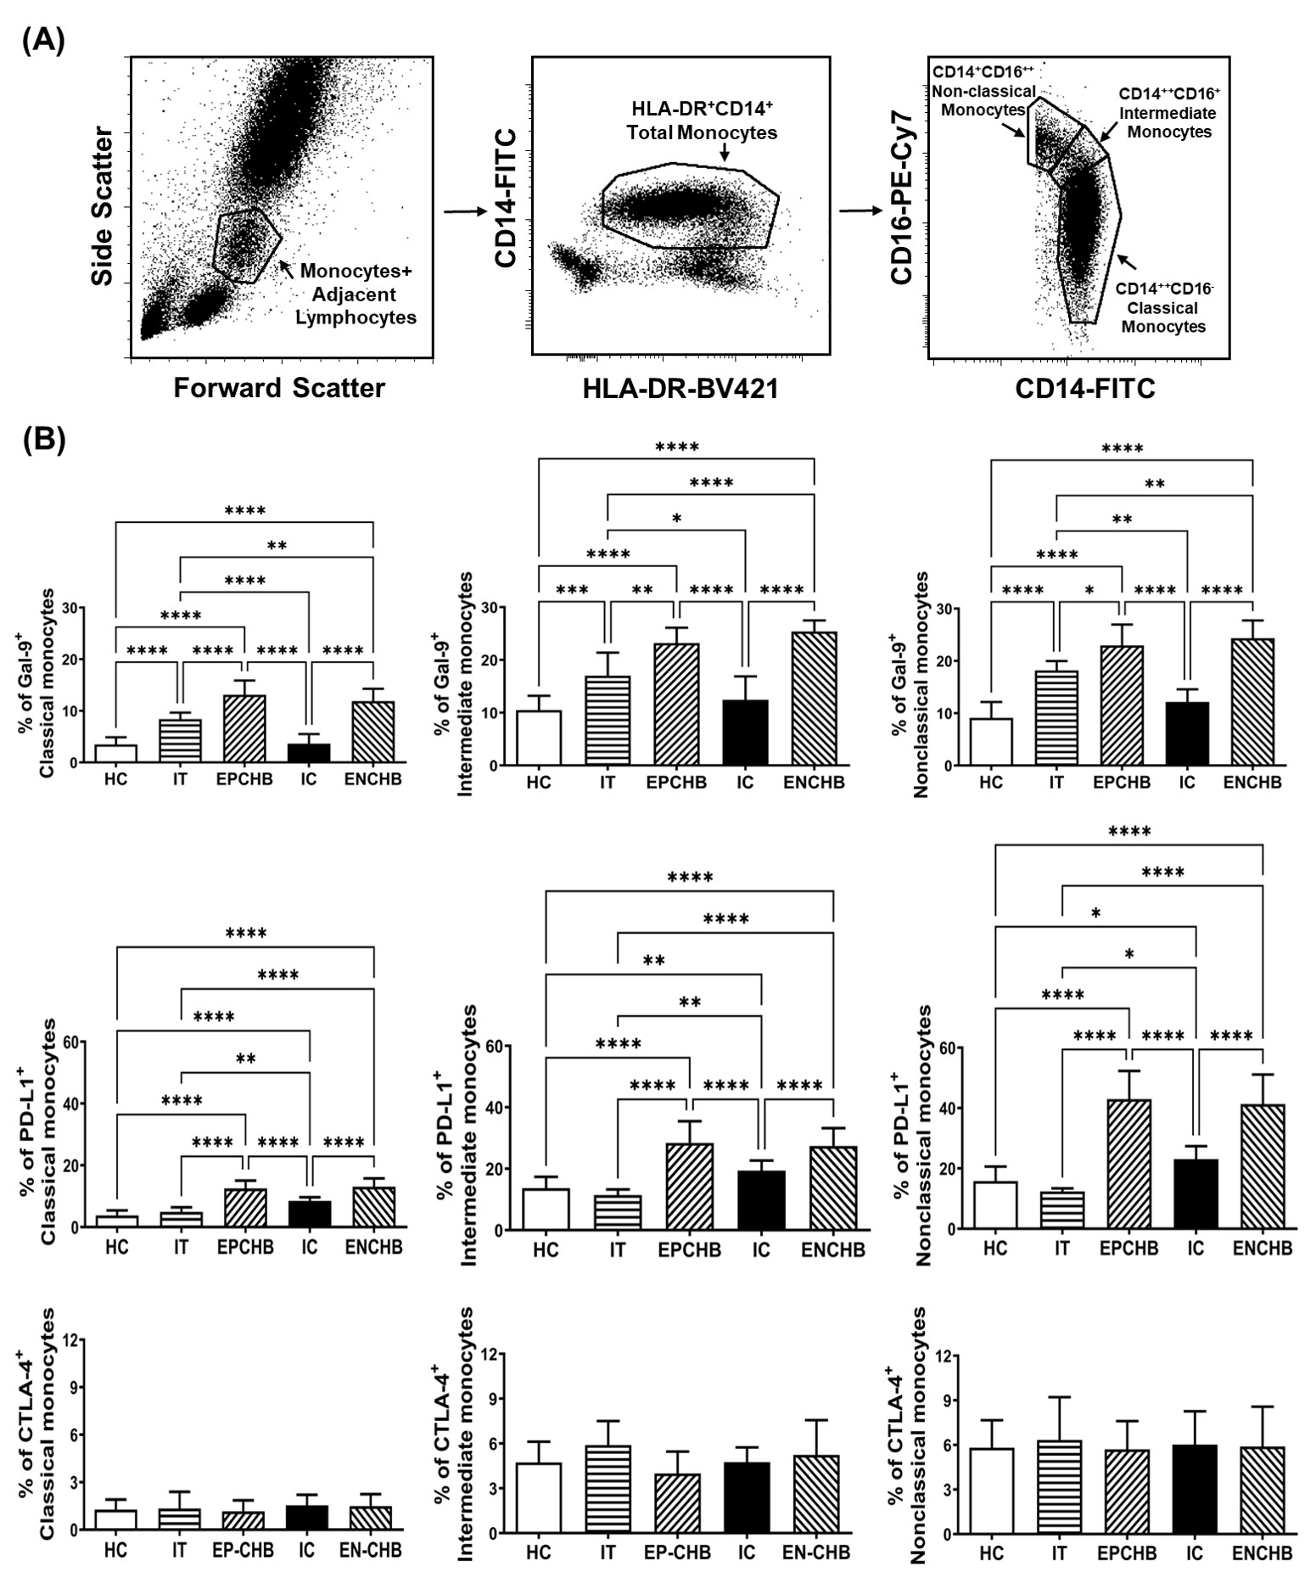
Figure S1 (A) Sequential gating strategy for identification of HLADR⁺CD14⁺ total, HLA-DR⁺CD14⁺⁺CD16⁻ classical, HLA-DR⁺CD14⁺⁺CD16⁺ intermediate and HLA-DR⁺CD14⁺CD16⁺⁺ non-classical monocytes from whole blood using immunophenotyping followed by flow cytometry in all the study groups. On total monocytes and each subset, the expression of Gal-9, PD-L1 or CTLA-4 was determined. (B) Bar diagrams demonstrating pooled data of percentages of classical, intermediate and non-classical monocytes expressing Gal-9 (upper panel), PD-L1(middle panel) and CTLA-4 (lower panel) in Immune-tolerant (IT), HBeAg-positive CHB (EP-CHB), Inactive carriers (IC), HBeAg-negative CHB (EN-CHB) and healthy controls (HC). Statistical significance was assessed by one way ANOVA test followed by Tukey's Multiple Comparison Test. (*P < 0.05, **P < 0.001, ***P < 0.0001 and ***P < 0.00001).
Supplementary Figure S2
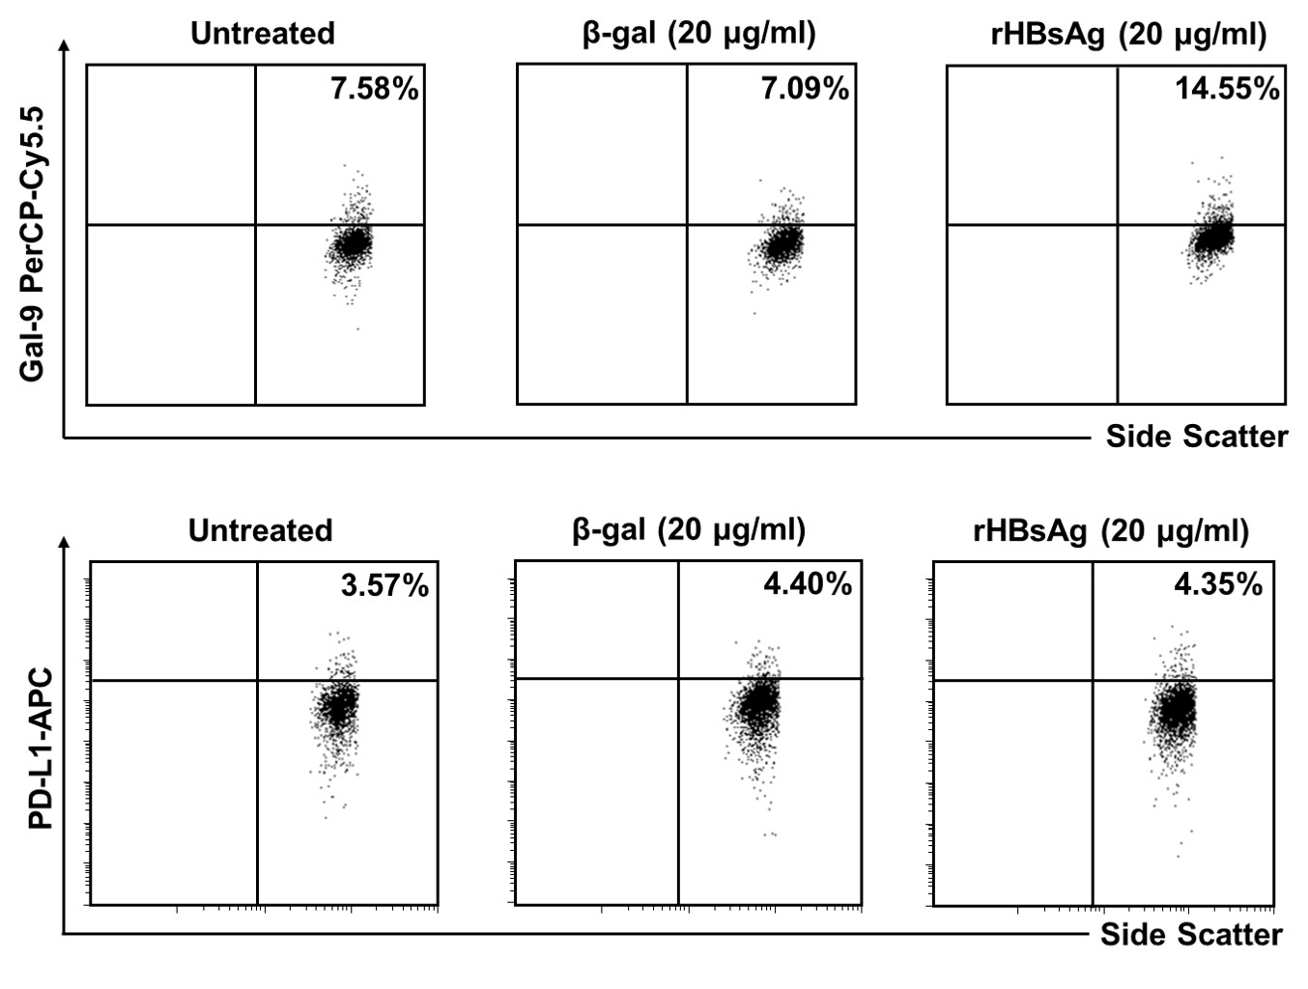
Figure S2 Representative FACS plots displaying the expression of Gal-9 (upper panel) and PD-L1 (lower panel) on sorted CD14⁺ monocytes of a healthy individual following treatment with β‐galactosidase (β‐gal) (20μg/ml) and recombinant Hepatitis B surface antigen (rHBsAg) (20μg/ml).

Supplementary Figure S3

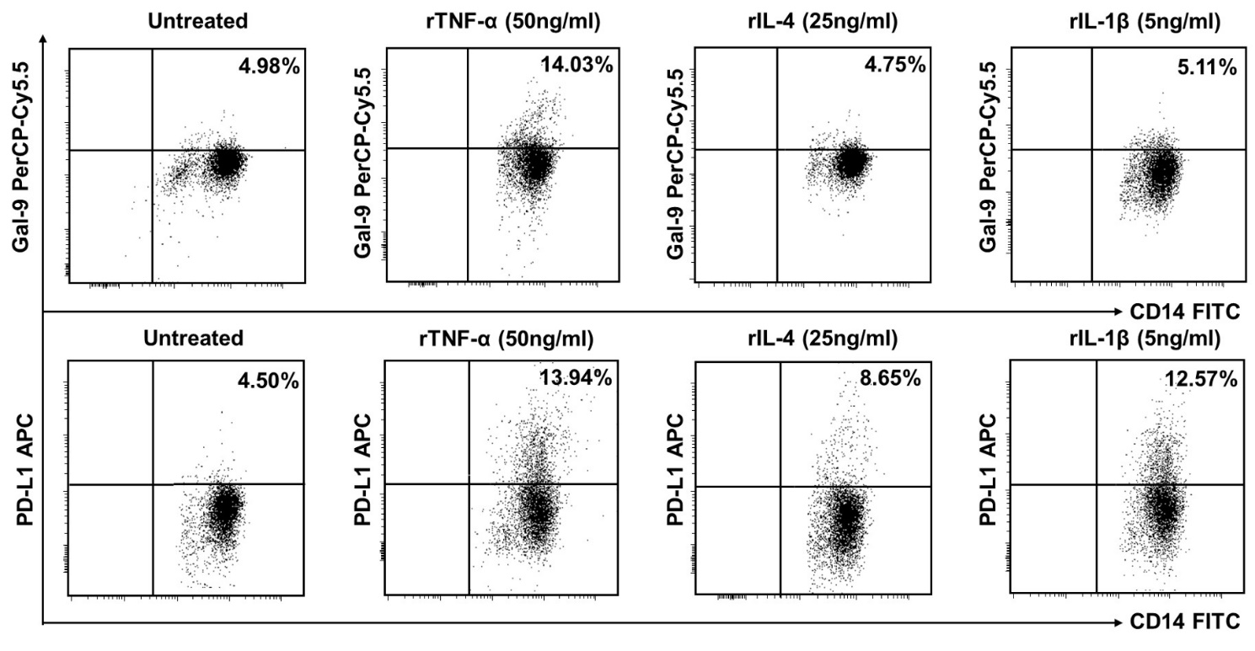

Figure S3 Representative FACS plots displaying the frequencies of monocytes of a healthy control (HC) expressing Gal-9 (upper panel) and PD-L1 (lower panel) following treatment of PBMC with recombinant (r) TNF-α (50ng/ml), rIL-4 (25ng/ml) and rIL-1β (5ng/ml).

Supplementary Figure S4
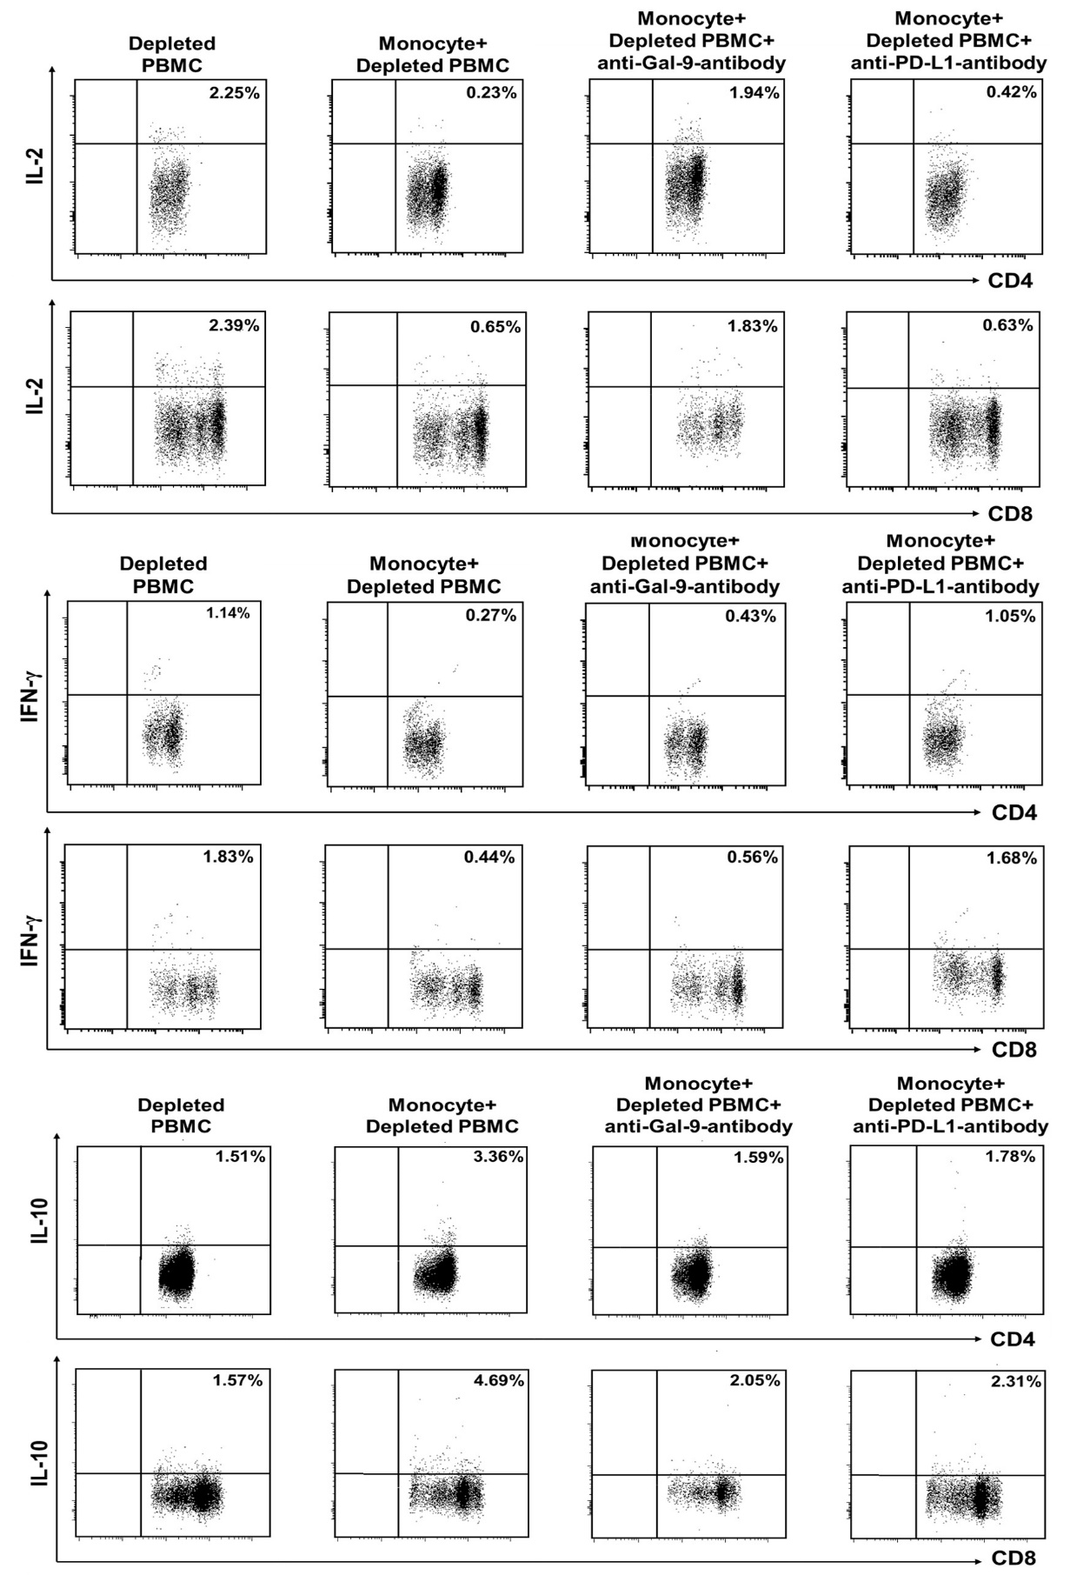
Figure S4 Representative FACS dot plots depicting frequencies of HBV-specific CD4⁺- and CD8⁺-T-cells expressing IL-2 (upper panel), IFN-γ (middle panel) and IL-10 (lower panel) following co-culture of sorted monocytes with HBV core peptide-stimulated autologous monocyte-depleted PBMC in absence or presence of anti-Gal-9-antibody and anti-PD-L1-antibody separately.
Supplementary Figure S5
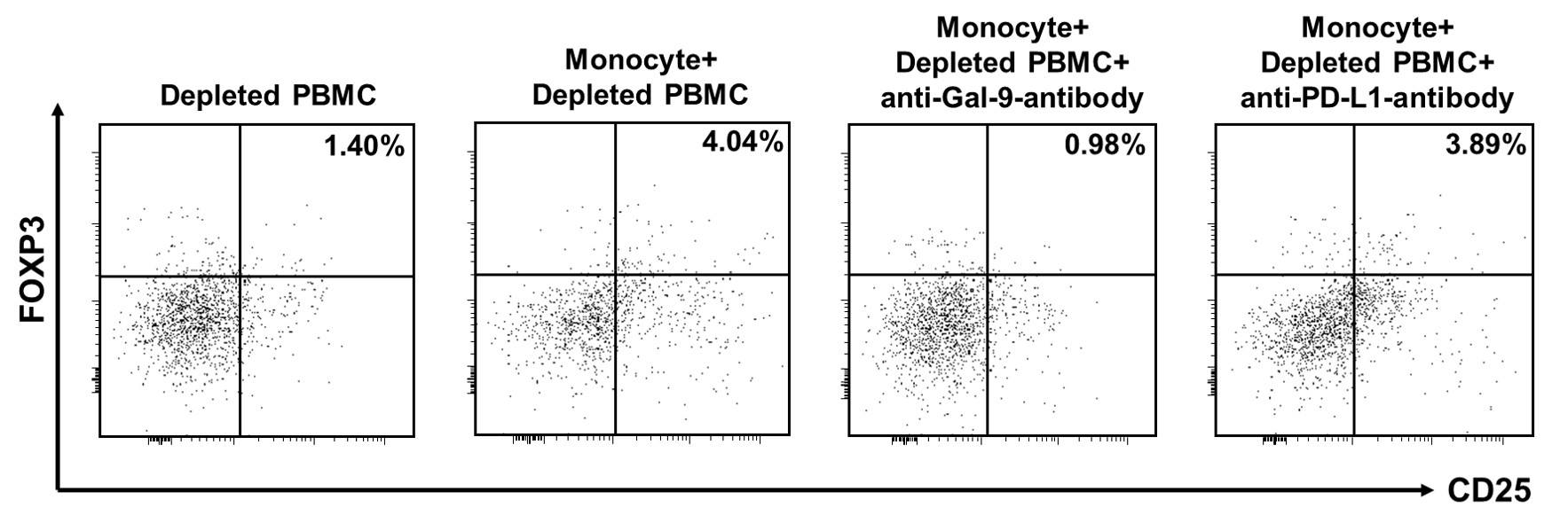
Figure S5 Representative FACS dot plots showing frequencies of gated CD4⁺CD25⁺FOXP3⁺ Tregs following co-culture of sorted monocytes with anti-CD3/anti-CD28-stimulated autologous monocyte-depleted PBMC in absence or presence of anti-Gal-9-antibody and anti-PD-L1 antibody separately.

Supplementary Figure S6
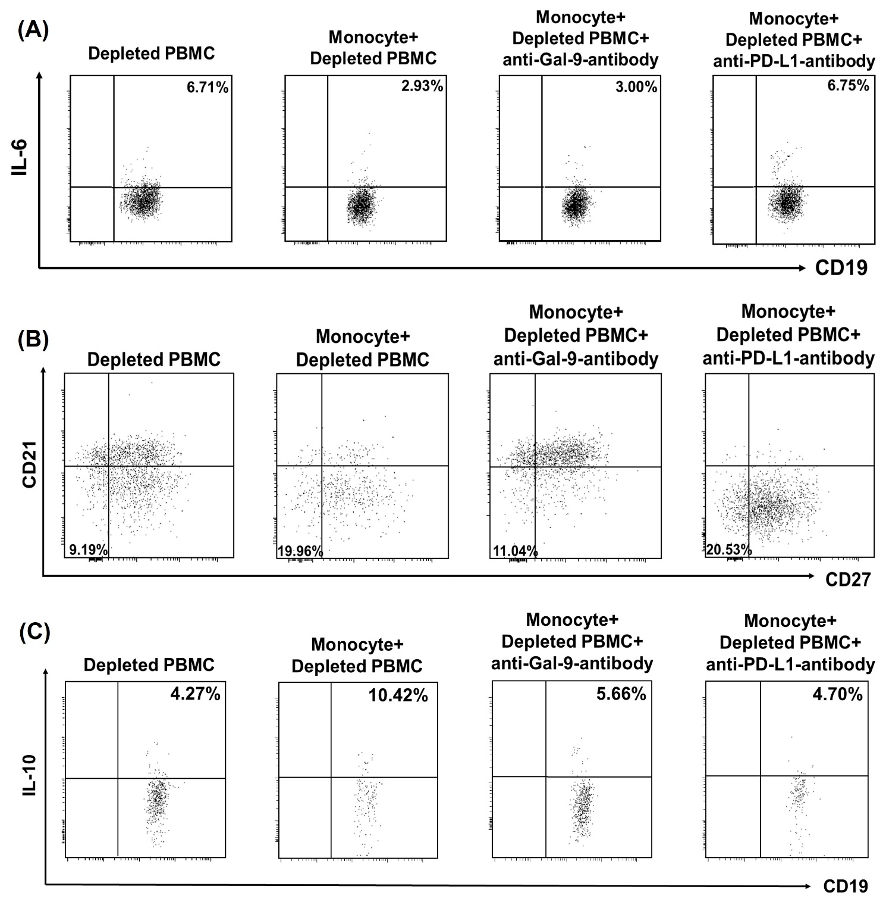
Figure S6 Representative FACS dot plots depicting frequencies of gated (A) CD19⁺IL-6⁺ Hepatitis B core antigen (HBcAg)-specific B cells, (B) CD19⁺CD27⁻CD21⁻ atypical memory B cells and (C) CD19⁺IL-10⁺ regulatory B cells following co-culture of sorted monocytes with recombinant (r) HBcAg-stimulated or rCD40L-stimulated autologous monocyte-depleted PBMC as appropriate in absence or presence of anti-Gal-9-antibody or anti-PD-L1-antibody
Supplementary Figure S7
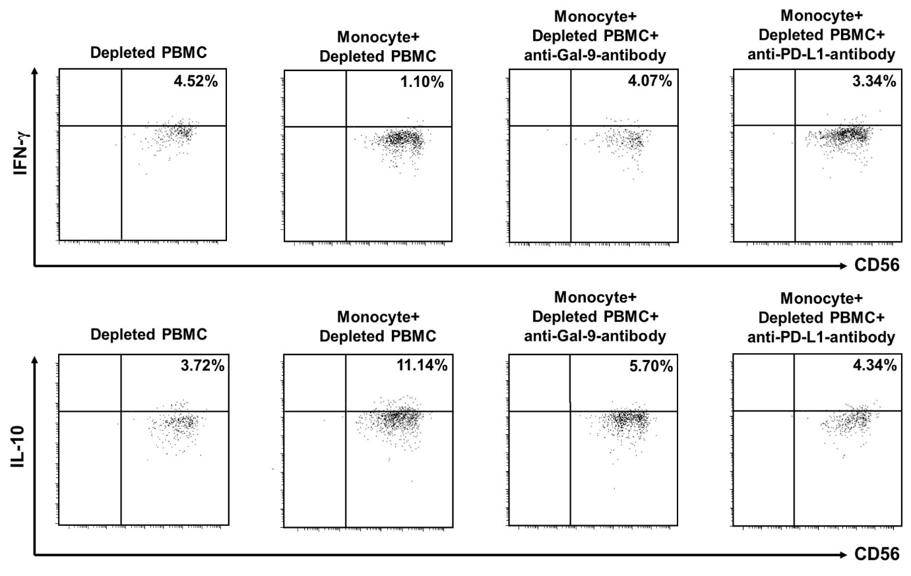

Figure S7 Representative FACS dot plots depicting frequencies of gated CD3⁻CD56⁺CD16⁺ NK cells expressing IFN-γ (upper panel) and IL-10 (lower panel) following co-culture of monocytes with combination of recombinant IL-12 and recombinant IL-18 stimulated autologous monocyte-depleted PBMC in absence or presence of anti-Gal-9-antibody and anti-PD-L1 antibody separately

