Supplementary Information

Local ionic transport enables selective PGM-free bipolar membrane electrode assembly
Mengran Li^{1,2,*, £}, Eric W. Lees^{3, £}, Ju Wen^{4, £}, Siddhartha Subramanian¹, Kailun Yang¹, Justin C. Bui^{5, 6}, Hugo-Pieter Iglesias van Montfort¹, Maryam Abdinejad^{1, 7}, Joost Middelkoop¹, Peter Strasser⁴, Adam Z. Weber³, Alexis T. Bell^{5,6}, Thomas Burdyny^{1,*}

- Department of Chemical Engineering, Delft University of Technology; 9 van der Maasweg, Delft, 2629HZ, the Netherlands
- Department of Chemical Engineering, the University of Melbourne, Melbourne, Victoria, 3010, Australia
- Energy Technologies Area, Lawrence Berkeley National Laboratory, Berkeley, CA 94720, USA
- Chemical Engineering Division, Department of Chemistry, Technical University Berlin, Berlin, Germany
- Chemical Sciences Division, Lawrence Berkeley National Laboratory, Berkeley, CA 94720, USA
- Department of Chemical and Biological Engineering, University of California Berkeley, Berkeley, CA 94720, USA
- Department of Chemical Engineering, Massachusetts Institute of Technology, Cambridge, MA 02139 USA
£ M. Li, E. W. Lees, and J. Wen contributed equally to this work.
*Correspondence to:
M. Li: aaron.li1@unimelb.edu.au
T. Burdyny: t.e.burdyny@tudelft.nl

Theory and model development
A 1D isothermal continuum model was developed for the cation exchange layer (CEL) and catalyst layer (CL) of the BPM-based CO₂ electrolyser MEA based on previous porous electrode models by Weng et al.¹ and Lees et al.² (Fig. S1). The CL domain of the model was assumed to be composed of gas, Sustainion ionomer, and solid Ni MOF-derived catalyst phases with constant volume fractions of 0.37, 0.43, and 0.2, respectively. These values correspond to the volume fractions of the ionomer and catalyst in the ink precursor. The CEL domain was assumed to be impermeable to gas transport and composed entirely of Sustainion ionomer.
Governing equations
The current density ($i_{s}$) and potential ($ϕ_{s}$) profiles in the solid-fraction of the catalyst layer were determined using Ohm’s law,
 | $$∇⋅i_{s}=-∇⋅{(σ}_{eff}ϕ_{s})$$ | Eq. S1
where the effective conductivity ($σ_{eff}$) is estimated based on the nominal conductivity of solid silver $σ_{s}$ using the Bruggeman relation,
 | $$σ_{eff}=ε_{S}^{1.5}σ_{s}$$ | Eq. S2
Steady-state continuity equations were used to determine the flux ($n$) of each chemical species j in the gas-phase ($j=$ CO_{2(g)}, CO_{(g)}, H_{2(g)}, and H₂O_{(g)}) and $i$ in the ionomer-phase species $i$ ($i$ = H⁺_{(aq)}, OH– _{(aq)}, HCO₃– _{(aq)}, CO₃^{2–} _{(aq)}, and K⁺_{(aq)}),
 | $$∇⋅n_{j}=ε_{G}\sum_{j}{R_{k,j}}$$ | Eq. S3
 | $$∇⋅n_{i}=ε_{I}\sum_{i}{R_{k,i}}$$ | Eq. S4
where $ε_{G}$ is the gas-volume fraction in the CL, $ε_{I}$ is the volume fraction of ionomer in the catalyst layer, and $R_{k,i}$is the volumetric rate of generation/consumption by process k of species $j$ or $i$. The gas-phase fluxes ($n_{j}$) were determined using a system of Stefan-Maxwell equations for multi-component mass transport,
 | $$n_{j}=–ρ_{g}D_{j}^{eff}∇ω_{j}–ρ_{G}D_{j}^{eff}ω_{j}\frac{∇M_{n}}{M_{n}}+ρ_{j}u_{G}$$ | Eq. S5
where $ω_{j}$ is the mass fraction of species $j$, $ρ_{G}$ is the density of the gas-phase, $D_{j}^{eff}$ is the effective diffusion coefficients, $M_{n}$ is the average molecular weight. The convective velocity of the gas-phase ($u_{G}$) in the CL pores was determined using the Carman-Kozeny equation,
 | $$u_{G}=-\frac{κ_{sat,CL}κ_{rG,CL}}{μ_{G}}\frac{{\left(ε_{G}\right)}^{3}}{{\left(1–ε_{G}\right)}^{2}}∇p_{G}$$ | Eq. S6
where $μ_{G}$ is the gas viscosity, and $κ_{sat}^{0}$ is the bulk saturated permeability. The relative permeability ($κ_{rG}$) of the gas-phase was estimated based on the correlation given by Zenyuk et al.,³
 | $$κ_{rg,CL}={\left(1–\frac{ε_{I}}{ε_{G}+ ε_{I}}\right)}^{3}$$ | Eq. S7
The final equation used to solve the governing mass balances is given as,
 | $$\sum_{j}{ω_{j}}=1$$ | Eq. S8
The flux of each chemical species in the ionomer-phase ($n_{i}$) was determined using the Nernst-Planck equation for dilute-solutions,
 | $n_{i}=–D_{i}^{eff}∇c_{i}+z_{i}\frac{F}{RT}D_{i}^{eff}c_{i}∇ϕ_{I}$ | Eq. S9
where $z_{i}$ is the charge of the mobile ionic species, $F$ is Faraday’s constant (96485 C/mol), $R$ is the ideal gas constant (8.314 $\frac{J}{mol K}$), $T$ is the temperature (298.15 K), and $ϕ_{I}$ is the ionomer-phase potential. The charge neutrality constraint was used as the final equation to solve the governing mass balance,
 | $\sum_{i}{z_{i}c_{i}}+ρ_{ionomer}IEC_{ionomer}$ = 0 | Eq. S10
Where $ρ_{ionomer}$ and $IEC_{ionomer}$ are the density and ion exchange capacity of the ionomer (units: mol/g wet polymer) in either the CEL or CL.

Charge transfer and source terms
The electrochemical reactions consume reactants and generate products at the ionomer/solid interface according to Faraday’s Law,
 | $$R_{CT,i}=–M_{i}\frac{a_{v}s_{i,k}i_{k}}{n_{k}F}$$ | Eq. S11
where $M_{i}$ is the molar mass of species $i$, $a_{v}$ is the specific surface area of the catalyst layer, $s_{i,k}$ is the stoichiometric coefficient for species $i$ in reaction $k$. We considered the specific surface area ($a_{v}$) to be the interfacial area between the ionomer and solid Ni portions of the CL as follows,
 | $$a_{v}=\frac{ε_{I}}{ε_{G}+ ε_{I}}a_{v}^{0}$$ | Eq. S11
where $a_{v}^{0}$ is the specific surface area of the catalyst without ionomer. The kinetics of the electrochemical reactions are governed by concentration-dependent Butler-Volmer kinetics as given by as per Weng et al.,¹
 | $$i_{CO}= –i_{0,CO}{\left(\frac{c_{CO_{2}}}{1 M} \right)}^{1.5}exp \left(–\frac{α_{c,CO}F}{RT}η_{CO}\right)$$ | Eq. S12
 | $$i_{H_{2}}= –i_{0, H_{2}} \left(–\frac{α_{c,HER}F}{RT}η_{HER}\right)$$ | Eq. S13
Where $i_{0,CO2R}$ and $i_{0,H_{2}}$ are the exchange current densities for the CO₂-to-CO reaction and hydrogen evolution reaction (HER), respectively. $α_{c,HER}$ and $α_{c,CO}$ are the transfer coefficients for the HER and CO2R, respectively. The pH-dependent kinetics of the HER are given by Weng et al.,⁴
 | $$i_{0,H_{2}}= A_{HER}exp⁡(-\frac{\left(83+pH\right)\left[\frac{kJ}{mol}\right]}{RT})$$ | Eq. S14
Where $A_{HER}$ is the collision frequency for the HER. The overpotential of electrochemical reaction k was determined based on the standard reduction potential ($U_{k}^{0}$) and the pH according to the Nernst equation,
 | $$η_{k}=ϕ_{s}–ϕ_{l}–\left(U_{k}^{0}–\frac{2.303RT}{F}pH\right)$$ | Eq. S15
The source terms associated with the acid-base reactions in the ionomer were determined as,
$$R_{B,i}=M_{i}\sum_{i}{s_{i,n}(k_{n}\prod_{s_{i,n} < 0}{{c_{i}}^{-s_{i,n}}}-\frac{k_{n}}{K_{n}}\prod_{s_{i,n} > 0}{{c_{i}}^{s_{i,n}}})}$$ | Eq. S16
where $K_{n}$ is the equilibrium constant of homogeneous reaction $n$, $s_{i,n}$ is the stoichiometric coefficient of species $i$ in homogeneous bulk reaction $n$ ($s_{i,n}<0$ for reactants and $s_{i,n}>0$ for products). $k_{n}$ and $k_{–n}$ are the forward and reverse reaction rate constants for reaction $n$, respectively. The phase-transfer term for CO₂ at the gas-ionomer interface was calculated using a mass transfer correlation,
 | $$R_{PT,CO_{2}}=a_{v}k_{GL,CO_{2}}M_{CO_{2}}\left(H_{CO_{2}}p_{g}y_{CO_{2}}–c_{CO_{2}}\right)$$ | Eq. S17
where $H_{CO_{2}}$ is the Henry’s Law coefficient for CO₂ dissolved in water, $y_{CO{}_{2}}$ is the mole fraction of CO₂ in the gas-phase, and $k_{GL,CO_{2}}$ is the mass transfer coefficient for CO₂ through the ionomer film on the catalyst surface,
 | $$k_{GL,CO_{2}}=\frac{D_{CO_{2}, w}}{δ_{DL}}$$ | Eq. S18
where $D_{CO_{2},w}$ is the diffusion coefficient of CO₂ in water and $δ_{DL}$ is the diffusion boundary layer thickness. This value was estimated based on the pore structure and volume fraction of ionomer as per Weng et al.,¹
 | $$δ_{TF}=r_{CL}\left(1–\sqrt{1–\frac{ε_{I}}{ε_{G}+ ε_{I}}}\right)$$ | Eq. S19
CO and H₂ were assumed to be insoluble in the ionomer and therefore the rate of CO and H generation gas-phase were also calculated by Faraday’s Law,
 | $$R_{PT,j}=–M_{i}\frac{a_{v}s_{j,k}i_{k}}{n_{k}F}$$ | Eq. S20
Effective diffusion coefficients
The effective diffusion coefficients for the gas-phase species ($D_{j}^{eff}$) were determined by considering the molecular and Knudsen diffusivities as parallel resistances as follows,
 | $$D_{j}^{eff}{=\left(\frac{1}{D_{j}^{m}}+\frac{1}{D_{j}^{K}}\right)}^{–1}$$ | Eq. S21
 | $$D_{j}^{m}=\frac{1-ω_{j}}{\sum_{b≠j}{\frac{y_{b}}{D_{j,b}}}}$$ | Eq. S22
 | $$D_{j}^{K}=\frac{2r_{pore}}{3}\sqrt{\frac{8RT}{πM_{j}}}$$ | Eq. S23
Where $D_{j}^{m}$ and $D_{j}^{K}$ are the mass-averaged molecular and Knudsen diffusion coefficients, respectively, of species $j$. $r_{pore}$ is the CL pore radius and $y_{b}$ is the mole fraction of another component gas b. $D_{j,b}$ is the diffusivity of species $j$ in species $b$, which was estimated based on the Fuller method.⁵
The effective diffusion coefficients for the chemical species in the ionomer-phase ($D_{i}^{eff}$ ) were determined based on the porosity and hydration ($λ)$ of the ionomer as per Grew et al.⁶ These equations considers ion transport through the water-filled pore volume of the ionomer ($Φ$),
 | $$D_{i}^{eff}=\frac{Φ^{q_{i}}D_{i,w}}{x_{w}(1+ψ_{i})}$$ | Eq. S24
 | $$Φ= \frac{λV_{W}}{λV_{W} + V_{M}}$$ | Eq. S25
 | $$x_{w}=\frac{λ}{λ + 1}$$ | Eq. S26
$ψ_{i}$ is the ratio between species-solvent and species-membrane interaction effects, which is defined based on the reduced molecular weight of species $i$ in the membrane ($M_{i,M}$) and in water ($M_{i,w}$),
 | $$ψ_{i}=\frac{1}{λ}{(\frac{V_{M}}{V_{w}})}^{\frac{2}{3}}{(\frac{M_{i,M}}{M_{i, w}})}^{\frac{1}{2}}$$ | Eq. S27
 | $$M_{i,M}={(\frac{1}{M_{i}}+\frac{1}{M_{M}})}^{-1}$$ | Eq. S28
 | $$M_{i,w}={(\frac{1}{M_{i}}+\frac{1}{M_{w}})}^{-1}$$ | Eq. S29
where $V_{w}$ is the molar volume of water and the molecular weight of the membrane ($M_{M}$) is estimated as 10,000 g mol^{–1}. The molar volume of the membrane ($V_{M}$) was calculated based on the ion exchange capacity (IEC) and the density of the ionomer ($ρ{}_{ionomer}$),
 | $$V_{M}=\frac{1}{ρ_{ionomer}IEC}$$ | Eq. S30
$q_{i}$ is a tortuosity parameter set to values of 1.5 for co-ion transport (e.g., CO₃^{2–} transport in the cation exchange ionomer of the CEL) and 1 for counter-ion transport (e.g., OH– transport in the Sustainion ionomer of the CL) .${ V}_{W}$ is the molar volume of water, $V_{M}$ is the molar volume of water in the polymer, and x_{w} is the mole fraction of water in the ionomer.
The hydration of the CEL ionomer $λ_{CEL}$ was estimated by interpolating between the experimentally-measured values for the CEL of a BPM in K⁺ and H⁺ forms as per Bui et al.,⁷
 | $$λ_{CEL}=λ_{x_{H^{+}}= 0}+x_{H^{+}}λ_{x_{H^{+}}= 1}$$ | Eq. S31
where $λ_{x_{H^{+}}= 0}$= 6 and $λ_{x_{H^{+}}= 1}$= 9 are the hydration values obtained from fitting experimental electrodialysis data⁶ and $x_{H^{+}}$ is the fraction of negatively-charged groups in the CEL that are charge-balanced by H⁺,
 | $$x_{H^{+}}= \frac{c_{H^{+}}}{ρ_{CEL}IEC_{CEL}}$$ | Eq. S32
The hydration value of the Sustainion ionomer ($λ_{Sustainion}$) was calculated by interpolating the values measured by Luo et al.⁸ for CO₃^{2–} and OH– forms of Sustainion at 100% relative humidity,
 | $$λ_{Sustainion}=λ_{x_{{CO}_{3}^{2-}=0}}+x_{{CO}_{3}^{2-}}λ_{x_{{CO}_{3}^{2-} }= 1}$$ | Eq. S33
Where $x_{{CO}_{3}^{2-}}$ is given as,
 | $$x_{{CO}_{3}^{2-}}= \frac{c_{CO_{3}^{2-}}}{ρ_{AEL}IEC_{AEL}}$$ | Eq. S34

Boundary conditions and Donnan equilibrium
The boundary conditions for the model are summarized in Figure S1. The water dissociation interface of the BPM exists at the left-hand side of the model domain. At this interface, the ionic fluxes were defined based on the transference number for H⁺ ($t_{H_{+}}$) as per Lees et al.,²
 | $$n_{H^{+}}{\left.​\right|}_{x=0}=-t_{H^{+}}\int_{x = L_{CEL}}^{x = L_{CEL}+ L_{CL}}{\frac{\left(i_{CO}+i_{H_{2}}\right)}{n_{WD}F}}dx$$ | Eq. S35
 | $$n_{K^{+}}{\left.​\right|}_{x=0}=-(1-t_{H^{+}})\int_{x = L_{CEL}}^{x = L_{CEL}+ L_{CL}}{\frac{\left(i_{CO}+i_{H_{2}}\right)}{n_{WD}F}}dx$$ | Eq. S36
where $n_{WD}$ is the moles of H⁺ produced by water dissociation per mole of electron passed through the circuit. The measured $t_{H_{+}}$ value from the BPMEA cell experiment with 0.1 M KOH as the anolyte was used in the model. The flux of all other species in the ionomer was assumed to be 0 at the water dissociation interface, given that the titration experiment performed after electrolysis showed low carbonate crossover to the anolyte (<1% of the total charge passed),
 | $$n_{i≠K^{+}, H^{+}}{\left.​\right|}_{x=0}=0$$ | Eq. S37
The reference potential for the ionomer-phase was also defined at the water dissociation interface,
 | $$ϕ_{l}{\left.​\right|}_{x=0}=0$$ | Eq. S38
The potential and concentration profiles at the interface between the CEL and Sustainion ionomer in the CL were determined based on the Donnan equilibrium,
 | $${ϕ_{l}|}_{x = L_{CEL}–}={ϕ_{l}|}_{x = L_{CEL}+}–\frac{RT}{z_{i}F}ln\left(\frac{c_{i, x = L_{CEL}+}}{c_{i, x = L_{CEL}–}}\right)$$ | Eq. S39
where $c_{i, x = L_{CEL}+}$and $c_{i, x = L_{CEL}–}$ are the concentrations of species $i$ in the Sustainion CL ionomer and CEL membrane, respectively. A Dirichlet boundary condition was imposed on the concentration of chemical species in the ionomer at the CL/GDL interface,
 | $$c_{i}{\left.​\right|}_{x = L_{CEL}+ L_{CL}}=c_{i}^{Bulk}$$ | Eq. S40
where $c_{i}^{Bulk}$ is the bulk electrolyte composition corresponding to 1 M KHCO_{3(aq)} under a CO₂-saturated atmosphere (pH = 7.6). The CO₂ concentration in the bulk is calculated according to Henry’s Law,
 | $$c_{{CO}_{2}}^{Bulk} = H_{CO_{2}}p_{g}y_{CO_{2}}$$ | Eq. S41
The flux of chemical species j in the gas-phase was set to 0 at the CEL/CL interface and a mass transfer correlation was used to simulate the transport of CO₂, H₂O, CO, and H₂ through the gas diffusion layer,
 | $${n_{j}|}_{x = L_{CEL}}=0$$ | Eq. S42
 | $${n_{j}|}_{x = L_{CEL}+ L_{CL}}={-k}_{MT}\left(ω_{j}^{Bulk}-ω_{j}{\left.​\right|}_{x=L_{CEL}+L_{CL}}\right)$$ | Eq. S43
where $ω_{j}^{Bulk}$ represent the mass fraction of chemical species j in the bulk humidified CO₂ stream. $ω_{j}{\left.​\right|}_{x=L_{CEL}+L_{CL}}$ is the mass fraction at the CL/GDL interface and $k_{MT}$ is a mass transfer coefficient for a flat-plate geometry as per Weng et al.¹ The pressure at the CL/GDL interface was set to 1 atm to solve the momentum balance,
 | $${p_{G}|}_{x = L_{CEL}+ L_{CL}}=1 atm$$ | Eq. S44
Finally, the solid-phase potential at the CL/GDL interface was varied from –1.5 to –2.5 V to simulate different current densities. Table S1 below shows the pertinent parameters used in the governing equations and boundary conditions.

Table S1: 1D continuum model parameters
Parameter | Value | Unit | Reference  (in Supplementary Information)
CL properties
$$L_{CL}$$ | 10 | μm | Experiment
$$a_{v}^{0}$$ | 1$×$10⁷ | m^{–1} | ¹
$$ε_{G}$$ | 0.37 | — | Experiment
$$ε_{I}$$ | 0.43 | — | Experiment
$$ε_{S}$$ | 0.20 | — | Experiment
$$κ_{sat,CL}^{0}$$ | 8$×$10^{–16} | m² | ¹
$$σ_{s}$$ | 100 | S cm^{–1} | ¹
$$r_{CL}$$ | 5 | μm | ²
$$λ_{x_{{CO}_{3}^{2-}=1}}$$ | 11 | — | ⁸
$$λ_{x_{{CO}_{3}^{2-}=0}}$$ | 25 | — | ⁸
CEL properties
$$L_{CEL}$$ | 75 | μm | ⁷
$$⍴_{M}$$ | 1 | g mL^{–1} | ⁷
$$IEC$$ | 1.81 | mmol g^{–1} | ⁷
$$λ_{x_{H^{+}}= 1}$$ | 9 | — | ⁷
$$λ_{x_{H^{+}}= 0}$$ | 6 | — | ⁷
$$t_{H^{+}}$$ | 0.99 | — | Experiment
Homogeneous
Reactions
$$k_{1}$$ | 3.71$×$10^{–2} | s^{–1} | ¹
$$K_{1}$$ | 10^{–6.37} | M | ¹
$$k_{2}$$ | 59.44 | s^{–1} | ¹
$$K_{2}$$ | 10^{–10.32} | M | ¹
$$k_{3}$$ | 2.2$×$10³ | L mol^{–1} s^{–1} | ¹
$$k_{4}$$ | 6.0$×$10⁹ | L mol^{–1} s^{–1} | ¹
$$K_{W}$$ | 10^{–14} | M² | ¹
Electrochemical Reactions
$$U_{CO}^{0}$$ | –0.11 | V | ¹
$$i_{0,CO}$$ | 1.05$×$10^{–4} | mA cm^{–2} | Fit value
$$α_{c,CO}$$ | 0.30 | — | Fit value
$$U_{HER}^{0}$$ | 0 | V | ¹
$$i_{0, HER, acid}$$ | 0.63 | mA cm^{–2} | Fit value
$$α_{c,HER}$$ | 0.47 | — | Fit value
$$A_{HER}$$ | 8840 | mA cm^{–2} | Fit value
Bulk concentrations in the liquid phase
$$c_{H^{+}}^{Bulk}$$ | 10^{–7.6} | M | Equilibrium
$$c_{K^{+}}^{Bulk}$$ | 1 | M | Electroneutrality
$$c_{{OH}^{-}}^{Bulk}$$ | 10^{–6.4} | M | Equilibrium
$$c_{{HCO}_{3}^{-}}^{Bulk}$$ | 1 | M | Electroneutrality
$$c_{{CO}_{3}^{2-}}^{Bulk}$$ | 0 | M | Equilibrium
Liquid phase transport
$$D_{H^{+}, w}$$ | 9.31$×$10^{–5} | cm² s^{–1} | ¹
$$D_{K^{+}, w}$$ | 1.96$×$10^{–5} | cm² s^{–1} | ¹
$$D_{{OH}^{–}, w}$$ | 4.95$×$10^{–5} | cm² s^{–1} | ¹
$$D_{{HCO}_{3}^{-},w}$$ | 1.19$×$10^{–5} | cm² s^{–1} | ¹
$$D_{{CO}_{3}^{2-}, w}$$ | 0.80$×$10^{–5} | cm² s^{–1} | ¹
$$D_{CO_{2}, w}$$ | 1.66$×$10^{–5} | cm² s^{–1} | ¹
Bulk mass fractions for the gas phase
$$ω_{CO}^{Bulk}$$ | 0 | — | Inlet conditions
$$ω_{H_{2}}^{Bulk}$$ | 0 | — | Inlet conditions
$$ω_{{CO}_{2}}^{Bulk}$$ | 0.779 | — | Inlet conditions
$$ω_{H_{2}O}^{Bulk}$$ | 0.221 | — | Inlet conditions

Experimental

Imidazolate-derived Ni-N-C catalyst synthesis
The imidazolate-derived Ni-N-C (NiNC-IMI) catalyst for the cathode was synthesized following the reported approach.⁹ Briefly, we first mixed 0.03 mol Ni(NO₃)₂.6H₂O (equivalent to 8.724 g) with 24 g imidazole compound in 600 mL deionized water, and then added 1200 mL 0.3 M NaOH solution into the mixture with a dosing rate of 60 mL min⁻¹. After stirring the solution for 6 h, we collected the solids via vacuum filtration, washed till the filtrate reached pH neutral, and finally freeze dried. We annealed the dried sample under flowing nitrogen (~ 80 mL min⁻¹) at 800 °C for 3 h at a ramping rate of 5 °C min⁻¹, soaked the annealed sample in 200 mL ~1 M H₂SO₄ stirred for 10 h, washed the acid-treated solids several times with water till pH neutral, and freeze dry the samples to obtain the imidazolate-derived Ni-N-C catalyst (short for NiNC-IMI).

Cathode preparation
We prepared the gas-diffusion electrode for the cathode by spray coating the NiNC-IMI-based catalyst ink onto the microporous layer surface of the gas-diffusion layer prepared from DeNora. (GDL2)⁹. We prepared the catalyst ink by mixing and sonicating 85 mg NiNC-IMI catalyst, Nafion or Sustainion ionomers solutions with 15 wt% or 30 wt% of ionomer with reference to the catalyst mass, 100 μL deionized water, and 2900 μL isopropanol for 15 min.

Anode preparation
The anode is a nickel foam coated with Ni/Fe oxides as prepared according to a prior report by Wang et al.¹⁰. In brief, we soaked a nickel foam (supplier name) in 3M HCl aqueous solution overnight, rinsed the foam with deionized water, soaked the foam in an ethanol/isopropanol mixture (50:50 vol%) for 5 min, rinsed it again with deionized water, and then deposit nickel-iron catalyst onto the foam surface by soaking the foam in a solution containing 3.5 mM Ni(NO₃)₂ and 1 mM Fe(NO₃)₃ for three days. Subsequently, the treated foam was rinsed with deionized water, dried under vacuum for 5 h, and then activated and stored in 1M KOH solution.

CO₂ electrolysis performance evaluation
The cell was purchased from Dioxide Materials and served to evaluate the performance of the bipolar membrane-based membrane electrode assembly. The cell comprises a cathode, an anode, and a bipolar membrane (Fumasep FBM). A mass flow controller fed the CO₂ channel with a constant flow of humidified CO₂, while a peristaltic pump fed the anolyte channel with KOH aqueous solution at a flow rate of 30 mL min⁻¹. The volume of the anolyte was kept at 100 mL for measurement over different current densities (50 - 300 mA cm⁻²), and at 500 mL for measurement over 150 h stability test at 100 mA cm⁻². We applied 50 sccm CO₂ for the cell test of varied current densities, 20 sccm for the stability test.
A potentiostat (VersaSTAT xxx) served to perform electrochemical measurements over the cell in a two-electrode configuration, including chronopotentiometry and impedance analyses. We measured the flow rates of the effluent gas streams using a mass flow meter and subsequently analyzed their product concentration every 5 min using online gas chromatography (Compact GC). The GC is equipped with molecular sieve 5A columns for two thermal conductivity detectors for hydrogen and carbon monoxide detection. After the electrochemical tests, the analytes were collected for pH measurement by using a pH meter and liquid product analyses by using a nuclear magnetic resonance spectroscopy.
To introduce a PVDF buffer layer, we first sonicated a Merck Omnipore™ membrane filter (0.45 μm pore size, and 65 um in thickness) in deionized water for 5 min, and then placed the membrane filter in between the bipolar membrane and cathode before the cell test.
During the short-term stability test, we monitored the inlet pressure of the cell using a pressure transducer and applied a water (1-2 mL) pulse periodically into the CO₂ channel to wash off the salt precipitation when the inlet pressure increased. The GC injections for the stability took place every 5 h.
The Faradaic efficiency of the gas product was calculated by using the following equation:
 | $$FE_{product}=\frac{P×\dot{V}×c_{product}×F}{R×T×z×J}$$ | Eq. S40
Where $P$ is the pressure (101325 Pa), $\dot{V}$ is the volumetric flow rate, and $c_{product}$ is the volume fraction of the gas product, $F$ is the Faraday constant (96485 s A mol⁻¹), R is the gas constant (8.314 m³ Pa K⁻¹mol⁻¹), $T$ is the temperature, $z$ is the number of charges transferred to the product, and $J$ is the total current.
The CO₂-calibrated mass flow meter reading can be converted to flow rate by:
 | $$\dot{V}=\frac{MFM}{C_{CO_{2}}}×C_{mix}$$ | Eq. S41
 | $$\frac{1}{C_{mix}}= \sum_{i}{\frac{c_{i}}{C_{i}}}$$ | Eq. S42
Where $MFM$ is the averaged MFM reading of 30 s duration before the GC injections, $C_{i}$ is the gas conversion factor for gas i, $C_{mix}$ is the gas conversion factor for the gas mixture, and $c_{i}$ indicates the volume fraction of the gas i. The gas conversion factor is 0.74 for CO₂, 1.00 for CO, 1.01 for hydrogen, and 0.79 for water vapor.
We used the relative humidity of the outlet flow to estimate the water vapor volume fraction via the below equation:
 | $$c_{water vapor}=\frac{RH×P_{sat}}{P}$$ | Eq. S43
Where the $RH$ is the relative humidity, and $P_{sat}$ is the water vapor saturated pressure (2.34 kPa at 20 °C).
The CO₂-to-CO utilization efficiency was calculated from:
 | $$ε=\frac{{\dot{n}}_{CO_{2}→CO}}{{\dot{n}}_{CO_{2}, t}}=\frac{{\dot{V}}_{CO}}{{\dot{V}}_{CO_{2}, in}- {\dot{V}}_{CO_{2}, out}}$$ | Eq. S44
Where ${\dot{n}}_{CO_{2}→CO}$ is the molar flow rate of CO₂ consumed to produce CO, ${\dot{n}}_{CO_{2}, t}$ is the molar flow rate of CO₂ consumed within the cell during the reaction, ${\dot{V}}_{CO}$ is the volumetric CO production rate, ${\dot{V}}_{CO_{2}, in}$ is the CO₂ feed rate, and ${\dot{V}}_{CO_{2}, out}$ is the CO₂ flow rate in the effluent.
Current density can be calculated by:
 | $$j=\frac{J}{A}$$ | Eq. S45
Where $A$ is the active electrode area (5 cm²).
The partial current density can be obtained via:
 | $$PCD_{product}= j× FE_{i}$$ | Eq. S46

Determination of the concentration of K⁺ and carbonate ions
We determined the concentration of K⁺ ions in the anolyte by using the dynamic equivalent point titration technique performed by Metrohm 848 Titrino Plus instrument. Specifically, 20 mL anolyte samples before and after stability test were continuously stirred in a beaker, where a pH probe was immersed in the solution to record the pH changes while 0.1067 M HCl solution was dosed into the solution via a syringe pump. The volume of HCl dosage was recorded during the titration. The equivalent point is determined from the steepest change of pH profile as a function of the acid dosage. Because the anolyte after stability contains CO₃²⁻ species, there will be several equivalent points due to the CO₃^{2—}HCO₃—H₂CO₃ equilibrium reaction. The equivalent point at pH = ~ 4 indicates that all the anions in the solution were replaced with Cl⁻ from the acid and helped us estimate the total K⁺ concentration in the anolyte. The total K⁺ ion concentration can be calculated from the below equation:
 | $$C_{K^{+}}=\frac{C_{HCl}×V_{HCl}}{V_{sample}}$$ | Eq. S47
Where $C_{HCl}$ represents the concentration of the HCl solution, $V_{HCl}$ represents the acid dosage, and $V_{sample}$ represents the volume of the sample for titration.
To determine the carbonate concentration in the used anolyte, we introduced excess 2 mL 1 M BaCl₂ solution into 30 mL anolyte after stability test to remove CO₃²⁻ ions from the liquid system by precipitating all the CO₃²⁻ ions in the form of BaCO₃. Because the pH is above 12 for the anolyte after stability test, we can safely conclude that only OH⁻ and CO₃²⁻ were present in the anolyte. We separated the solid precipitate from the solution by using a centrifuge and collected the supernatant for the titration following the same steps as described above to determine the concentration of OH⁻. Then we can estimate the concentration of CO₃²⁻ from the following equations:
 | $$C_{OH^{-}}=\frac{C_{HCl}×V_{HCl}}{V_{sample}×\frac{30}{32}}$$ | Eq. S48
 | $$C_{CO_{3}^{2-}}=\frac{C_{K^{+}}-C_{OH^{-}}}{2}$$ | Eq. S49

Supplementary data
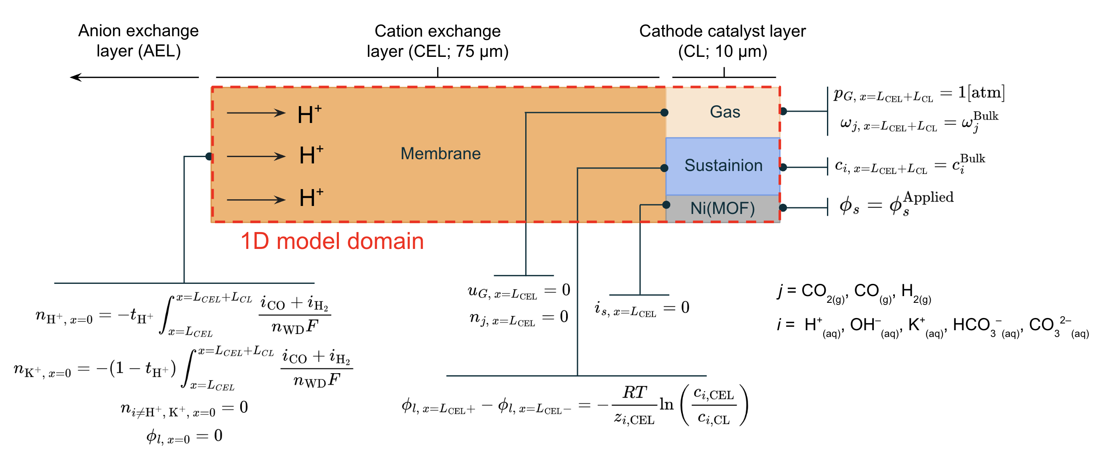Fig. S1 Schematic diagram of 1D continuum model domains and boundary conditions for the relevant phases.

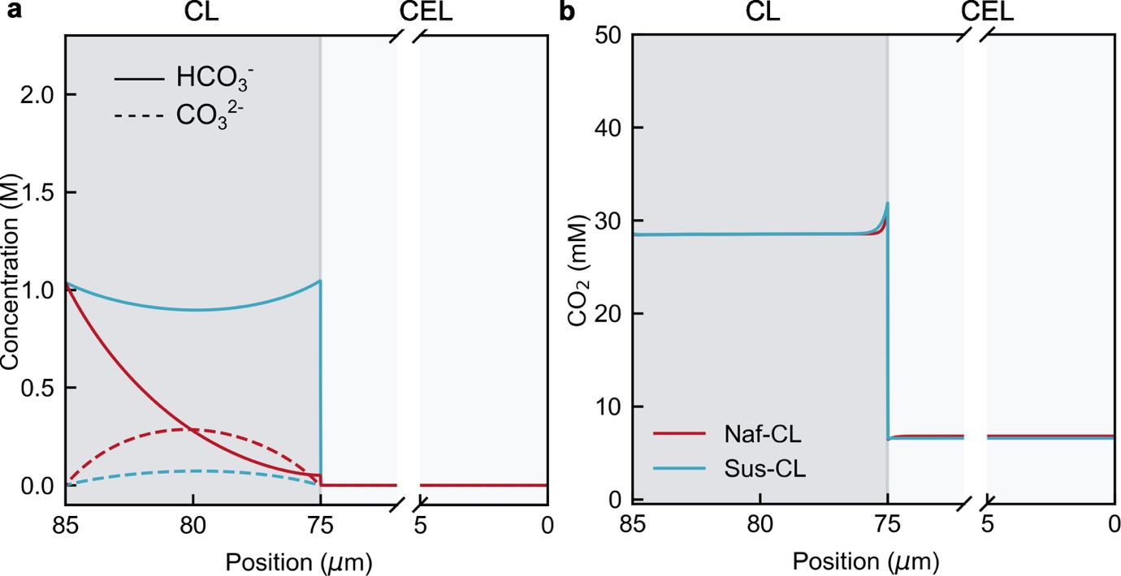
Fig. S2 Comparison of the modelled concentrations of HCO₃⁻, CO₃²⁻, and CO₂ for Naf-CLs and Sus-CLs across CL and CEL.

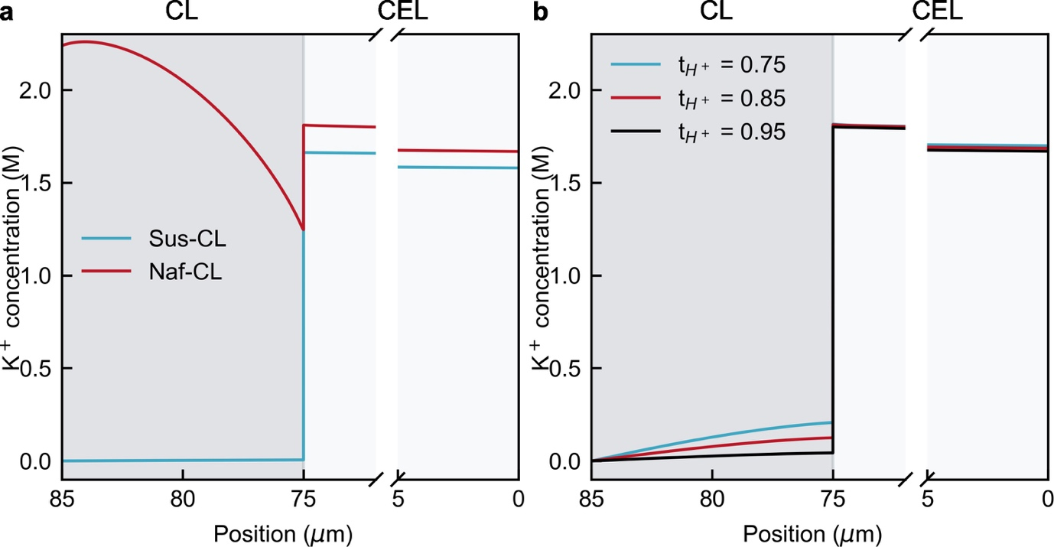
Fig. S3 Concentration profiles of K⁺ for (a) different ionomers and (b) proton transference numbers.

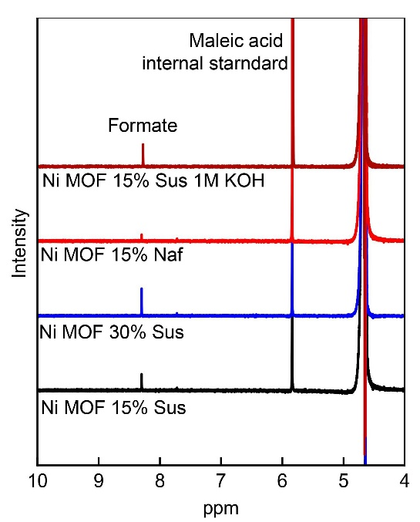
Fig. S4 NMR spectra of the anolyte after the test.

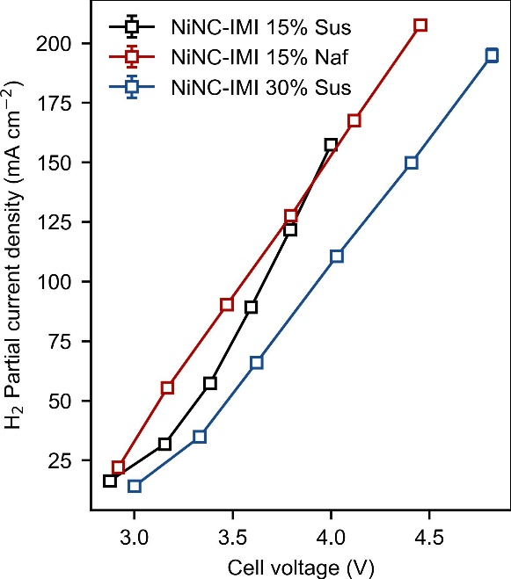
Fig. S5 Comparison of H₂ partial current densities against cell potentials between Ni MOF derived catalysts with 15% Sustainion, Nafion, and 30% Sustainion ionomers.

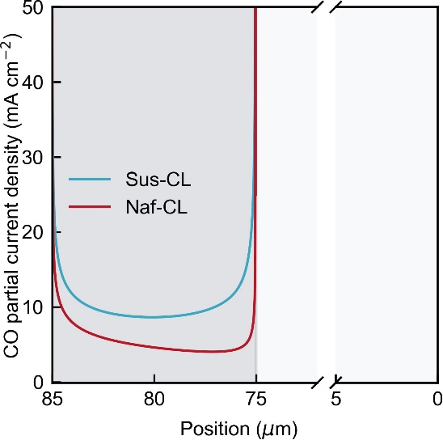
Fig. S6 Model predicted local partial current density of CO evolution within Sus- and Naf-CL.

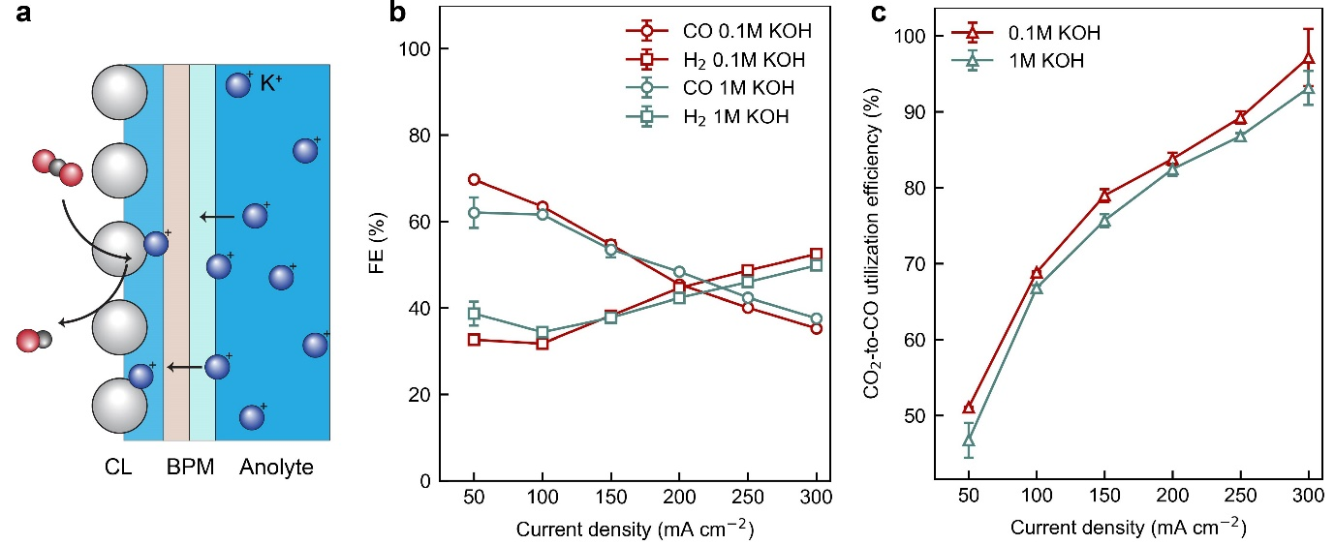
Fig. S7 (a) A schematic illustration of anolyte concentration effect on cation crossover. Comparison of the (b) CO Faradaic efficiency and (c) CO₂-to-CO utilization efficiency versus total current densities with 0.1 M or 1 M KOH aqueous anolyte. The BPMEA cell used cathodes with NiNC-IMI catalyst with 15% Sustainion ionomer as the catalyst layer.

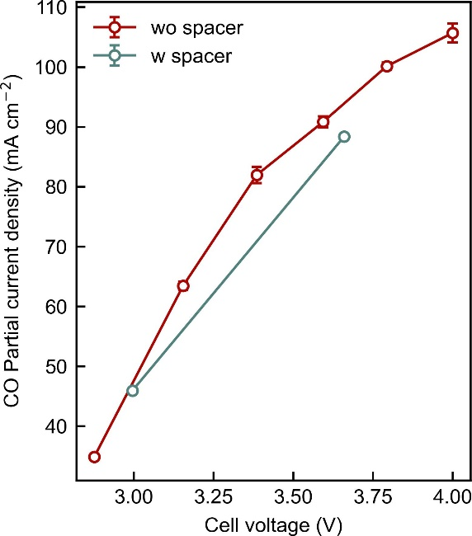
Fig. S8 Comparison of CO partial current density as a function of cell voltage for cells with and without spacer at between CL|CEL.

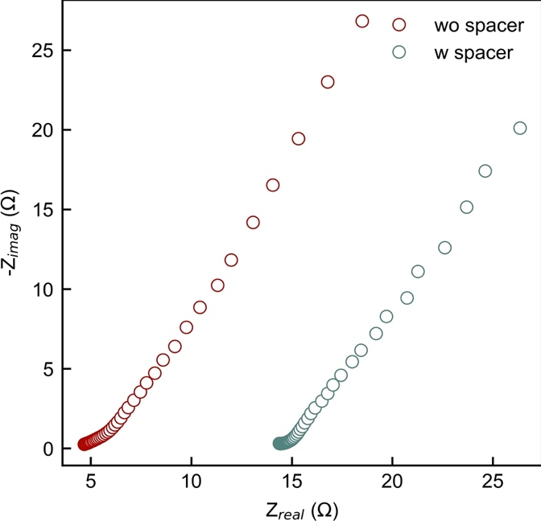
Fig. S9 Electrochemical impedance spectra of the BPMEA cells with and without spacer at open circuit voltage before CO₂ electrolysis conditioning.

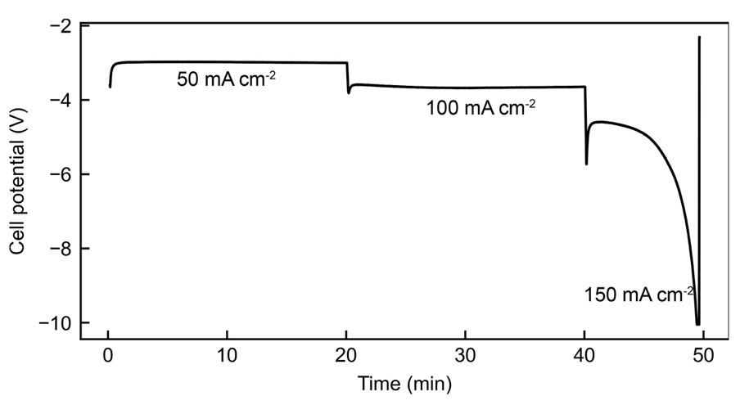
Fig. S10 The cell overpotential overshoot for the BPMEA cell with the spacer at 150 mA cm⁻².

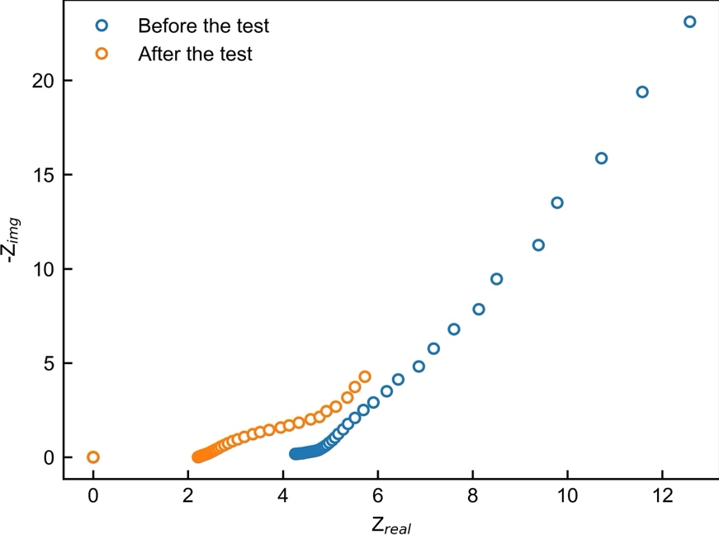
Fig. S11 Comparison of the electrochemical impedance analyses of the BPMEA cell at open circuit potential before and after the 150 h stability test.

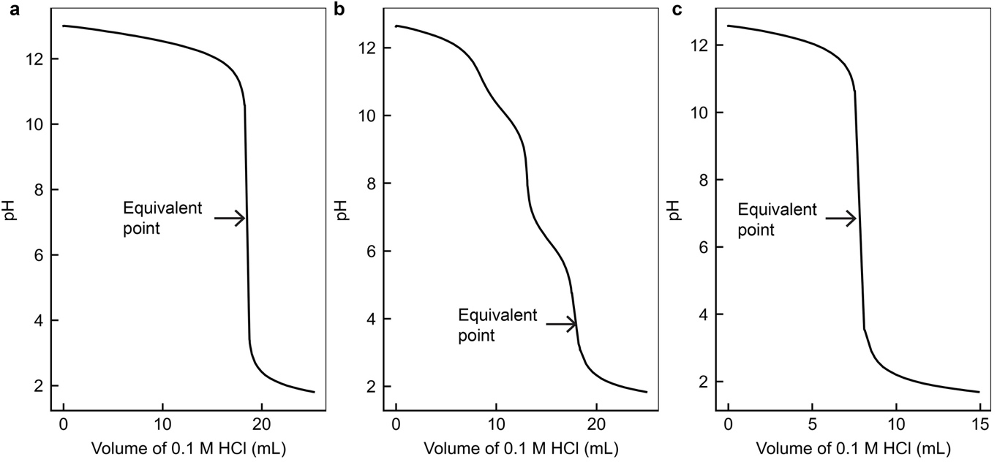
Fig. S12 Examples of the titration curves for (a) fresh 0.1 M KOH anolyte, (b) anolyte after stability test, and (c) supernatant of the anolyte with excess BaCl₂ and carbonate removed after stability test.

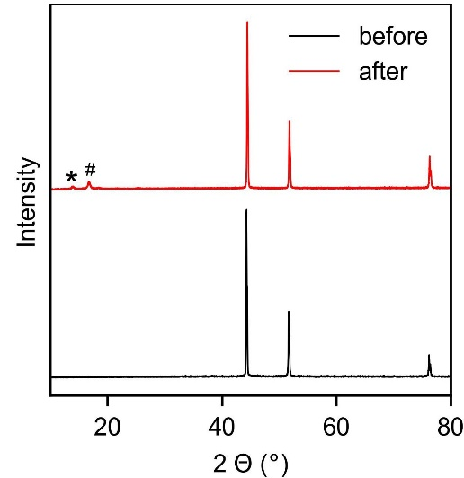
Fig. S13 Comparison of X-ray diffraction of the nickel mesh anode before and after 150 h stability test. The peak indicated by asterisk is related to the K_{0.14}NiO₂ phase (PDF 74-1792), and the peak highlighted by hashtag should be relevant to the phase similar to K₉Ni₂O₇ (PDF 71-1987).

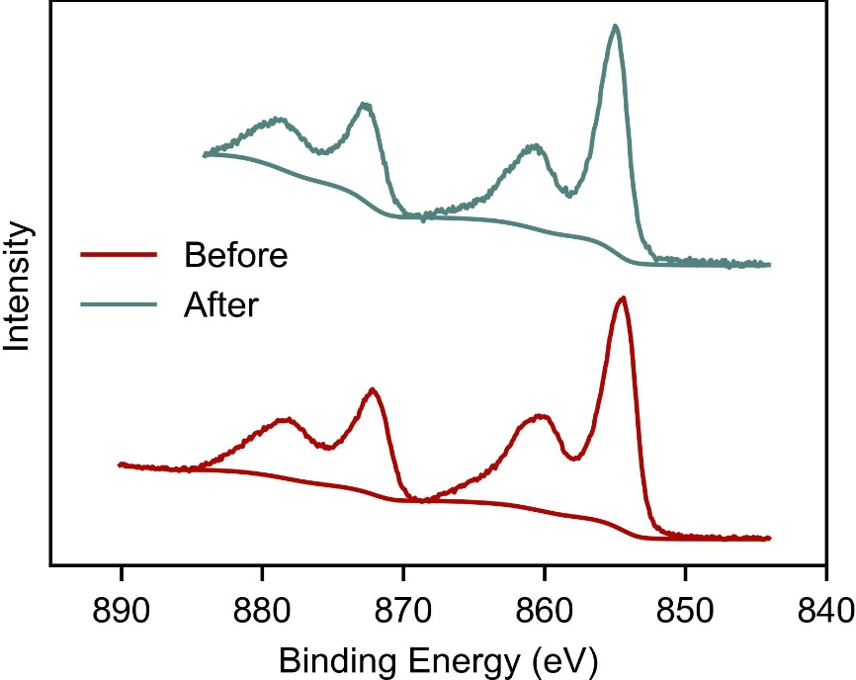
Fig. S14 X-ray photoelectron spectra of Ni 2p over the nickel mesh anode before and after 150 h stability test.

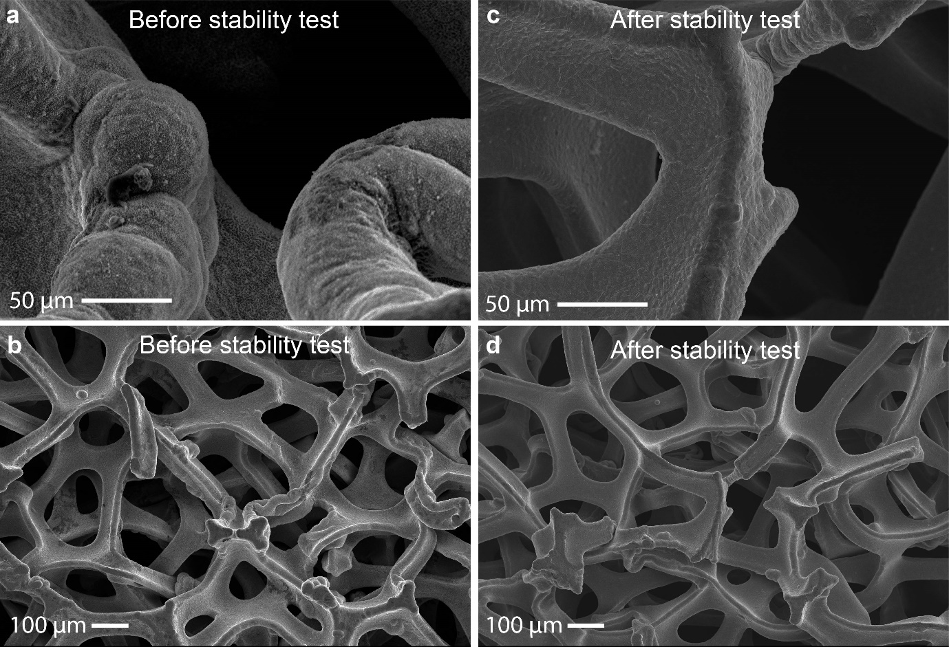
Fig. S15 Scanning electron micrographs of the nickel mesh anode surface microstructure (a, b) before and (c,d) after the stability test.

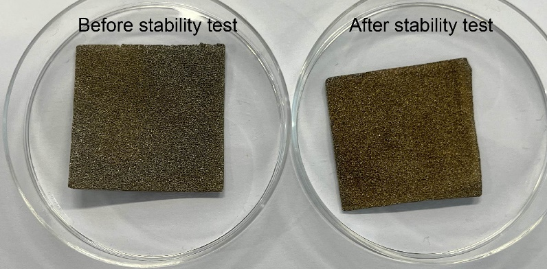
Fig. S16 Photos of the nickel mesh anode before and after the stability test.

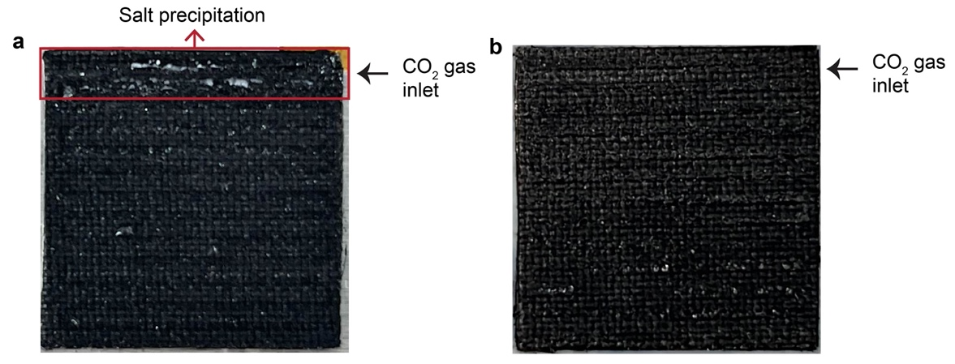
Fig. S17 Images of the GDL side facing the CO₂ channels after (a) 40 h and (b) 150 h CO₂ electrolyses under 100 mA cm⁻² with 1 L 0.1M KOH as the anolyte.

sReferences
1. Weng, L. C.; Bell, A. T.; Weber, A. Z., Modeling gas-diffusion electrodes for CO2 reduction. Phys Chem Chem Phys 2018, 20 (25), 16973-16984.
2. Lees, E. W.; Bui, J. C.; Song, D. T.; Weber, A. Z.; Berlinguette, C. P., Continuum Model to Define the Chemistry and Mass Transfer in a Bicarbonate Electrolyzer. Acs Energy Lett 2022, 7 (2), 834-842.
3. Zenyuk, I. V.; Medici, E.; Allen, J.; Weber, A. Z., Coupling continuum and pore-network models for polymer-electrolyte fuel cells. International Journal of Hydrogen Energy 2015, 40 (46), 16831-16845.
4. Weng, L. C.; Bell, A. T.; Weber, A. Z., Towards membrane-electrode assembly systems for CO2 reduction: a modeling study. Energ Environ Sci 2019, 12 (6), 1950-1968.
5. Fuller, E. N.; Schettle, P. D.; Giddings, J. C., A New Method for Prediction of Binary Gas-Phase Diffusion Coeffecients. Ind Eng Chem 1966, 58 (5), 19-+.
6. Grew, K. N.; Chiu, W. K. S., A Dusty Fluid Model for Predicting Hydroxyl Anion Conductivity in Alkaline Anion Exchange Membranes. J Electrochem Soc 2010, 157 (3), B327-B337.
7. Bui, J. C.; Digdaya, I.; Xiang, C. X.; Bell, A. T.; Weber, A. Z., Understanding Multi-Ion Transport Mechanisms in Bipolar Membranes. Acs Appl Mater Inter 2020, 12 (47), 52509-52526.
8. Luo, X. Y.; Kushner, D. I.; Kusoglu, A., Anion exchange membranes: The effect of reinforcement in water and electrolyte. J Membrane Sci 2023, 685.
9. Brückner, S. F., Q.; Ju, W.; Galliani, D.; Testolin, A.; Klingenhof, M.; Ott, S.; Strasser, P. , Design and Diagnosis of high-performance CO2-to-CO electrolyzer cells. ChemRxiv 2023.
10. Wang, K. Y.; Tao, H. L.; Liang, C.; Li, S. Y.; Wu, Y. L.; Wang, Y. X.; Zhuang, L. Z.; Lian, C.; Liu, H. L.; Xu, Z., Regulating multiscale structures of nickel-iron-based electrocatalysts for efficient water oxidation. Cell Rep Phys Sci 2022, 3 (5).

