Supplementary tables
Supplementary Table 1. Educational attainment of participants of both surveys and the 2021 US census for females aged 18-49 years
 | Total | Less than a high school graduate | High school graduate | Some college, no degree | Associate’s degree (occupational) | Associate’s degree (academic) | Bachelor’s degree | Master’s degree | Professional degree | Doctoral degree
Original survey | 234ª | 2.6% | 17.9% | 21.8% | 6.4% | 9.0% | 25.6% | 10.7% | 2.6% | 3.4%
Amended survey | 672^{b} | 3.0% | 26.3% | 23.4% | 6.1% | 7.3% | 21.0% | 9.4% | 1.3% | 2.2%
2021 census (000) | 67,816 | 8.4% | 22.9% | 19.0% | 3.9% | 6.5% | 25.4% | 11.0% | 1.2% | 1.6%
Footnotes:
ªExcludes 4 individuals who indicated their education level as “other” or “prefer not to say.”
^{b}Excludes 8 individuals who indicated their education level as “other” or “prefer not to say.”
US, United States

Supplementary Table 2. Percentage of participants from each racial category who answered “yes” to the following questions in the original survey
 | Racial categories (only females aged 18-49 years)
 | Black/African American only | White only | Others
Number of participants who responded “yes” | 45 | 102 | 91
I feel like a human guinea pig when testing a new vaccine | 73.3% | 51.0% | 56.0%
I do not trust vaccines and/or vaccine research | 57.8% | 38.2% | 44.0%
I do not trust pharmaceutical companies | 62.2% | 51.0% | 50.5%
People in my community have been mistreated in clinical trials before | 57.8% | 43.1% | 51.6%
People might judge me if I participate in a vaccine trial | 48.9% | 27.5% | 46.2%
I must share private medical data when I participate | 66.7% | 39.2% | 57.1%
My data/genetic materials/samples may be used in ways I do not agree with | 62.2% | 58.8% | 59.3%

Supplementary Figure

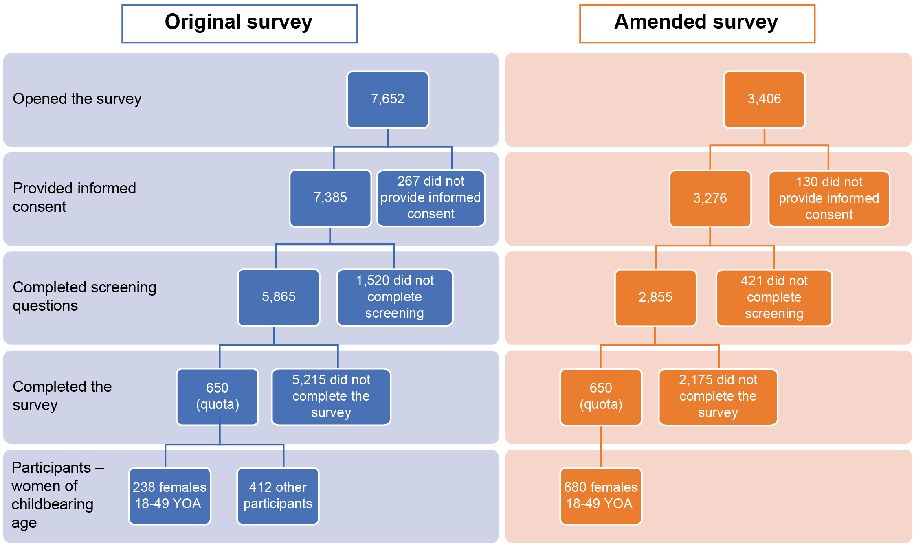
Supplementary Fig. 1. Survey participant disposition
Footnote:
Most “dropouts” were due to reaching quota requirements and screening criteria (e.g., screened out under 18-year-olds, males from the amended survey, individuals who preferred not to declare their race, nonbinary individuals, etc.).
YOA, years of age

