Supplemental figures and tables for “Local tree cover predicts mosquito species richness and disease vector presence in a tropical countryside landscape”
November 29, 2023

Figure S1. At the 1000 m spatial scale, species richness increased with percent tree cover only where mean annual temperatures are low – intermediate. In the warmest climates surveyed, species richness was low even at high tree cover. Points representing each survey site are colored by mean annual temperature.
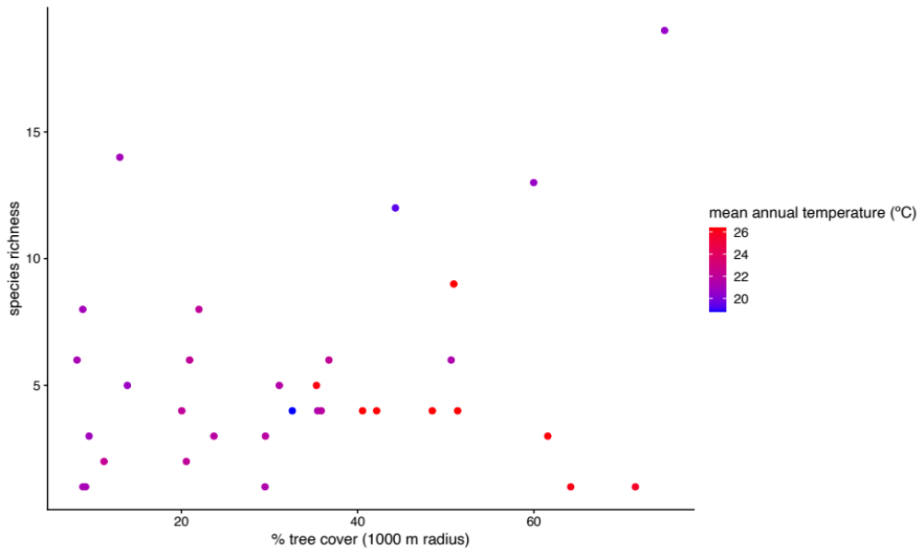

Figure S2. At the 1000 m spatial scale, Ae. albopictus occurrence is negatively correlated with tree cover, and positively correlated with mean annual temperature.

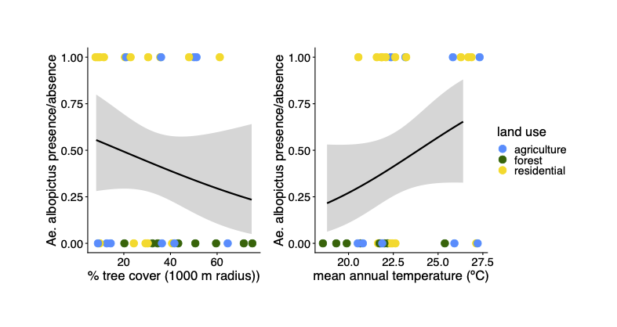

Table S1. Number of sites in each land use category where each mosquito species was present.

Species | Agriculture | Forest | Residential | Total
Culex quinquefasciatus | 4 | 1 | 12 | 17
Aedes albopictus | 4 | 0 | 11 | 15
Culex nigripalpus | 4 | 5 | 4 | 13
Wyeomyia adelpha/guatemala | 3 | 6 | 3 | 12
Limatus durhamii | 3 | 0 | 5 | 9
Wyeomyia complosa | 2 | 5 | 1 | 8
Limatus asulleptus | 2 | 2 | 3 | 7
Aedes angustivittatus | 4 | 2 | 0 | 6
Trichoprosopon digitatum | 4 | 2 | 0 | 6
Aedes allotecnon | 1 | 4 | 0 | 5
Culex lactator | 0 | 0 | 5 | 5
Culex sp. 1 | 2 | 2 | 1 | 5
Psorophora ferox | 3 | 2 | 0 | 5
Trichoprosopon pallidiventer | 2 | 3 | 0 | 5
Aedes sp. 1 | 1 | 3 | 0 | 4
Aedes aegypti | 1 | 1 | 1 | 3
Culex coronator | 1 | 1 | 1 | 3
Culex erythrothorax | 1 | 1 | 1 | 3
Haemagogus sp. | 2 | 1 | 0 | 3
Trichoprosopon sp. 3 DJS-2020 | 0 | 3 | 0 | 3
Wyeomyia sp. RCH-1 | 3 | 0 | 0 | 3
Coquillettidia nigricans | 0 | 0 | 2 | 2
Culex mollis | 0 | 1 | 1 | 2
Culex restrictor | 0 | 2 | 0 | 2
Haemagogus janthinomys | 1 | 1 | 0 | 2
Mansonia titillans | 1 | 0 | 1 | 2
Orthopodomyia sp. | 0 | 1 | 1 | 2
Trichoprosopon sp. 1 | 0 | 1 | 1 | 2
unidentified Culicidae 4 | 1 | 1 | 0 | 2
Wyeomyia luteoventralis | 1 | 1 | 0 | 2
Wyeomyia undulata | 0 | 0 | 1 | 2
Aedes ferox | 0 | 1 | 0 | 1
Aedes infirmatus | 1 | 0 | 0 | 1
Aedes sexlineatus | 0 | 1 | 0 | 1
Aedes trivittatus | 0 | 1 | 0 | 1
Anopheles albimanus | 1 | 0 | 0 | 1
Culex interrogator | 0 | 0 | 1 | 1
Culex sp. 2 | 0 | 1 | 0 | 1
Orthopodomyia MBI-02 | 0 | 0 | 1 | 1
Psorophora albipes | 0 | 1 | 0 | 1
Psorophora funiculus | 1 | 0 | 0 | 1
Sabethes undosus | 0 | 1 | 0 | 1
Trichoprosopon sp. 5 DJS-2020 | 0 | 1 | 0 | 1
unidentified Culicidae 1 | 0 | 1 | 0 | 1
unidentified Culicidae 2 | 0 | 1 | 0 | 1
unidentified Culicidae 3 | 1 | 0 | 0 | 1
Wyeomyia aporonoma | 0 | 0 | 1 | 1
Wyeomyia sp. 2 | 1 | 0 | 0 | 1

Table S2. Results of generalized linear models estimating the effects of tree cover across spatial scales on species richness. Significant models are highlighted with bold text.

Tree cover radius (m) | Estimated effect | Standard error | Z-value | p-value | AIC
30 | 3.04 x 10⁻³ | 3.38 x 10⁻³ | 0.90 | 3.68 x 10⁻¹ | 177.06
40 | 4.53 x 10⁻³ | 3.53 x 10⁻³ | 1.28 | 2.00 x 10⁻¹ | 176.31
50 | 5.00 x 10⁻³ | 3.65 x 10⁻³ | 1.37 | 1.70 x 10⁻¹ | 176.10
60 | 6.34 x 10⁻³ | 3.78 x 10⁻³ | 1.68 | 9.37 x 10⁻² | 175.18
70 | 6.88 x 10⁻³ | 3.77 x 10⁻³ | 1.83 | 6.76 x 10⁻² | 174.70
80 | 7.62 x 10⁻³ | 3.85 x 10⁻³ | 1.98 | 4.79 x 10⁻² | 174.13
90 | 8.45 x 10⁻³ | 3.97 x 10⁻³ | 2.13 | 3.33 x 10⁻² | 173.45
100 | 8.52 x 10⁻³ | 4.01 x 10⁻³ | 2.13 | 3.36 x 10⁻² | 173.44
110 | 8.94 x 10⁻³ | 4.07 x 10⁻³ | 2.20 | 2.81 x 10⁻² | 173.14
120 | 9.68 x 10⁻³ | 4.16 x 10⁻³ | 2.33 | 2.00 x 10⁻² | 172.54
130 | 9.71 x 10⁻³ | 4.17 x 10⁻³ | 2.33 | 1.99 x 10⁻² | 172.52
140 | 1.01 x 10⁻² | 4.27 x 10⁻³ | 2.36 | 1.83 x 10⁻² | 172.37
150 | 1.07 x 10⁻² | 4.31 x 10⁻³ | 2.47 | 1.34 x 10⁻² | 171.84
160 | 1.10 x 10⁻² | 4.36 x 10⁻³ | 2.52 | 1.17 x 10⁻² | 171.60
170 | 1.13 x 10⁻² | 4.39 x 10⁻³ | 2.57 | 1.02 x 10⁻² | 171.36
180 | 1.17 x 10⁻² | 4.48 x 10⁻³ | 2.60 | 9.31 x 10⁻³ | 171.19
190 | 1.19 x 10⁻² | 4.53 x 10⁻³ | 2.62 | 8.67 x 10⁻³ | 171.04
200 | 1.23 x 10⁻² | 4.55 x 10⁻³ | 2.71 | 6.81 x 10⁻³ | 170.67
250 | 1.29 x 10⁻² | 4.69 x 10⁻³ | 2.76 | 5.82 x 10⁻³ | 170.37
300 | 1.28 x 10⁻² | 4.71 x 10⁻³ | 2.72 | 6.48 x 10⁻³ | 170.50
350 | 1.31 x 10⁻² | 4.80 x 10⁻³ | 2.72 | 6.58 x 10⁻³ | 170.48
400 | 1.30 x 10⁻² | 4.99 x 10⁻³ | 2.61 | 9.18 x 10⁻³ | 170.97
450 | 1.26 x 10⁻² | 5.16 x 10⁻³ | 2.44 | 1.48 x 10⁻² | 171.70
500 | 1.20 x 10⁻² | 5.31 x 10⁻³ | 2.25 | 2.43 x 10⁻² | 172.48
550 | 1.14 x 10⁻² | 5.42 x 10⁻³ | 2.11 | 3.50 x 10⁻² | 173.08
600 | 1.11 x 10⁻² | 5.50 x 10⁻³ | 2.02 | 4.37 x 10⁻² | 173.43
650 | 1.08 x 10⁻² | 5.58 x 10⁻³ | 1.93 | 5.30 x 10⁻² | 173.75
700 | 1.06 x 10⁻² | 5.67 x 10⁻³ | 1.88 | 6.06 x 10⁻² | 173.99
750 | 1.04 x 10⁻² | 5.76 x 10⁻³ | 1.80 | 7.13 x 10⁻² | 174.27
800 | 1.01 x 10⁻² | 5.84 x 10⁻³ | 1.73 | 8.28 x 10⁻² | 174.55
850 | 9.96 x 10⁻³ | 5.94 x 10⁻³ | 1.68 | 9.38 x 10⁻² | 174.80
900 | 9.69 x 10⁻³ | 6.03 x 10⁻³ | 1.61 | 1.08 x 10⁻¹ | 175.07
950 | 9.35 x 10⁻³ | 6.12 x 10⁻³ | 1.53 | 1.26 x 10⁻¹ | 175.35
1000 | 9.09 x 10⁻³ | 6.22 x 10⁻³ | 1.46 | 1.44 x 10⁻¹ | 175.57
Table S3. Generalized linear model results estimating effects of percent tree cover calculated at a 1000m radius around survey sites and mean annual temperature on mosquito species richness.

Environmental variable | Estimate | Standard Error | Z-value | p-value
% tree cover at 1000 m radius | 6.64 x 10⁻³ | 6.40 x 10⁻³ | 1.04 | 0.30
Mean annual temperature | -2.45 x 10⁻² | 7.09 x 10⁻² | -3.49 x 10⁻¹ | 0.73
Tree cover * temperature | -7.87 x 10⁻³ | 3.65 x 10⁻³ | -2.16 | 0.031 *

Table S4. Results of generalized linear models estimating the effects of tree cover across spatial scales on Aedes albopictus presence. Significant models are highlighted with bold text.

Tree cover radius (m) | Estimated effect | Standard error | Z-value | p-value | AIC
30 | -2.21 x 10⁻² | 1.24 x 10⁻² | -1.78 | 7.43 x 10⁻² | 45.04
40 | -2.75 x 10⁻² | 1.42 x 10⁻² | -1.93 | 5.32 x 10⁻² | 44.01
50 | -3.48 x 10⁻² | 1.63 x 10⁻² | -2.13 | 3.29 x 10⁻² | 42.30
60 | -3.26 x 10⁻² | 1.59 x 10⁻² | -2.05 | 4.08 x 10⁻² | 43.30
70 | -3.48 x 10⁻² | 1.65 x 10⁻² | -2.11 | 3.52 x 10⁻² | 42.75
80 | -3.89 x 10⁻² | 1.81 x 10⁻² | -2.15 | 3.17 x 10⁻² | 42.13
90 | -3.95 x 10⁻² | 1.83 x 10⁻² | -2.15 | 3.12 x 10⁻² | 42.27
100 | -3.91 x 10⁻² | 1.86 x 10⁻² | -2.11 | 3.50 x 10⁻² | 42.55
110 | -4.23 x 10⁻² | 1.96 x 10⁻² | -2.16 | 3.09 x 10⁻² | 42.01
120 | -4.19 x 10⁻² | 1.96 x 10⁻² | -2.13 | 3.29 x 10⁻² | 42.38
130 | -4.25 x 10⁻² | 1.99 x 10⁻² | -2.14 | 3.26 x 10⁻² | 42.30
140 | -4.35 x 10⁻² | 2.06 x 10⁻² | -2.11 | 3.47 x 10⁻² | 42.41
150 | -4.24 x 10⁻² | 2.03 x 10⁻² | -2.09 | 3.67 x 10⁻² | 42.77
160 | -4.39 x 10⁻² | 2.09 x 10⁻² | -2.10 | 3.56 x 10⁻² | 42.63
170 | -4.36 x 10⁻² | 2.11 x 10⁻² | -2.07 | 3.84 x 10⁻² | 42.85
180 | -4.19 x 10⁻² | 2.08 x 10⁻² | -2.01 | 4.45 x 10⁻² | 43.41
190 | -4.16 x 10⁻² | 2.10 x 10⁻² | -1.98 | 4.77 x 10⁻² | 43.62
200 | -4.24 x 10⁻² | 2.14 x 10⁻² | -1.98 | 4.78 x 10⁻² | 43.60
250 | -4.09 x 10⁻² | 2.21 x 10⁻² | -1.86 | 6.34 x 10⁻² | 44.33
300 | -3.64 x 10⁻² | 2.12 x 10⁻² | -1.72 | 8.56 x 10⁻² | 45.15
350 | -3.30 x 10⁻² | 2.06 x 10⁻² | -1.60 | 1.10 x 10⁻¹ | 45.80
400 | -3.19 x 10⁻² | 2.06 x 10⁻² | -1.55 | 1.21 x 10⁻¹ | 46.07
450 | -3.17 x 10⁻² | 2.06 x 10⁻² | -1.54 | 1.24 x 10⁻¹ | 46.14
500 | -3.27 x 10⁻² | 2.07 x 10⁻² | -1.58 | 1.15 x 10⁻¹ | 46.01
550 | -3.32 x 10⁻² | 2.08 x 10⁻² | -1.60 | 1.10 x 10⁻¹ | 45.94
600 | -3.21 x 10⁻² | 2.05 x 10⁻² | -1.57 | 1.17 x 10⁻¹ | 46.10
650 | -3.07 x 10⁻² | 2.02 x 10⁻² | -1.52 | 1.28 x 10⁻¹ | 46.31
700 | -2.88 x 10⁻² | 1.98 x 10⁻² | -1.45 | 1.46 x 10⁻¹ | 46.61
750 | -2.66 x 10⁻² | 1.96 x 10⁻² | -1.36 | 1.73 x 10⁻¹ | 46.94
800 | -2.50 x 10⁻² | 1.94 x 10⁻² | -1.29 | 1.98 x 10⁻¹ | 47.19
850 | -2.37 x 10⁻² | 1.94 x 10⁻² | -1.22 | 2.22 x 10⁻¹ | 47.38
900 | -2.26 x 10⁻² | 1.93 x 10⁻² | -1.17 | 2.42 x 10⁻¹ | 47.53
950 | -2.17 x 10⁻² | 1.93 x 10⁻² | -1.12 | 2.62 x 10⁻¹ | 47.66
1000 | -2.11 x 10⁻² | 1.94 x 10⁻² | -1.08 | 2.79 x 10⁻¹ | 47.75
Table S5. Generalized linear model results estimating effects of percent tree cover calculated at a 1000m radius around survey sites and mean annual temperature on Ae. albopictus presence.

Environmental variable | Estimate | Standard Error | Z-value | p-value
% tree cover at 1000 m radius | -7.76 x 10⁻² | 3.75 x 10⁻² | -2.074 | 0.038 *
Mean annual temperature | 6.62 x 10⁻¹ | 3.35 x 10⁻² | 1.974 | 0.048 *
Tree cover * temperature | -2.31 x 10⁻³ | 1.55 x 10⁻² | -0.149 | 0.882

Table S6. Generalized dissimilarity modeling results for mosquito community turnover along environmental gradients of mean annual temperature, elevation, geographic distance, and tree cover calculated for different radii surrounding survey sites.
 | sum of coefficients
Tree cover radius (m) | percent tree cover | mean annual temperature | geographic distance | elevation | intercept | percent deviance explained
30 | 0.609 | 0.614 | 0.444 | 0 | 1.697 | 4.968
40 | 0.799 | 0.66 | 0.451 | 0 | 1.621 | 5.932
50 | 0.865 | 0.59 | 0.375 | 0 | 1.617 | 7.159
60 | 0.706 | 0.606 | 0.382 | 0 | 1.675 | 6.172
70 | 0.709 | 0.602 | 0.379 | 0 | 1.672 | 6.192
80 | 0.743 | 0.59 | 0.37 | 0 | 1.664 | 6.416
90 | 0.723 | 0.607 | 0.39 | 0 | 1.666 | 6.149
100 | 0.678 | 0.623 | 0.381 | 0 | 1.686 | 5.562
110 | 0.73 | 0.614 | 0.362 | 0 | 1.673 | 5.955
120 | 0.691 | 0.628 | 0.381 | 0 | 1.685 | 5.539
130 | 0.714 | 0.627 | 0.362 | 0 | 1.68 | 5.715
140 | 0.709 | 0.629 | 0.363 | 0 | 1.685 | 5.505
150 | 0.686 | 0.634 | 0.371 | 0 | 1.691 | 5.222
160 | 0.707 | 0.631 | 0.36 | 0 | 1.688 | 5.244
170 | 0.67 | 0.635 | 0.369 | 0 | 1.703 | 4.874
180 | 0.593 | 0.64 | 0.394 | 0 | 1.727 | 4.28
190 | 0.562 | 0.64 | 0.406 | 0 | 1.739 | 4.043
200 | 0.577 | 0.636 | 0.403 | 0 | 1.738 | 4.055
250 | 0.445 | 0.634 | 0.453 | 0 | 1.797 | 3.268
300 | 0.361 | 0.646 | 0.501 | 0 | 1.846 | 2.955
350 | 0.332 | 0.653 | 0.519 | 0 | 1.872 | 2.972
400 | 0.331 | 0.651 | 0.503 | 0 | 1.869 | 3.042
450 | 0.314 | 0.659 | 0.503 | 0 | 1.872 | 2.957
500 | 0.306 | 0.667 | 0.499 | 0 | 1.873 | 2.896
550 | 0.297 | 0.675 | 0.499 | 0 | 1.875 | 2.846
600 | 0.272 | 0.68 | 0.506 | 0 | 1.878 | 2.776
650 | 0.25 | 0.684 | 0.51 | 0 | 1.879 | 2.716
700 | 0.236 | 0.689 | 0.512 | 0 | 1.88 | 2.678
750 | 0.222 | 0.692 | 0.514 | 0 | 1.881 | 2.648
800 | 0.203 | 0.697 | 0.513 | 0 | 1.883 | 2.614
850 | 0.521 | 0.703 | 0.163 | 0 | 1.887 | 2.558
900 | 0.125 | 0.708 | 0.53 | 0 | 1.891 | 2.514
950 | 0.107 | 0.711 | 0.534 | 0 | 1.893 | 2.497
1000 | 0.1 | 0.712 | 0.535 | 0 | 1.893 | 2.492

