Extended Data Figures for “Intensified global volcanism during Late Pleistocene glacial strength shift” by Jack Longman et al.

Extended Data Figures

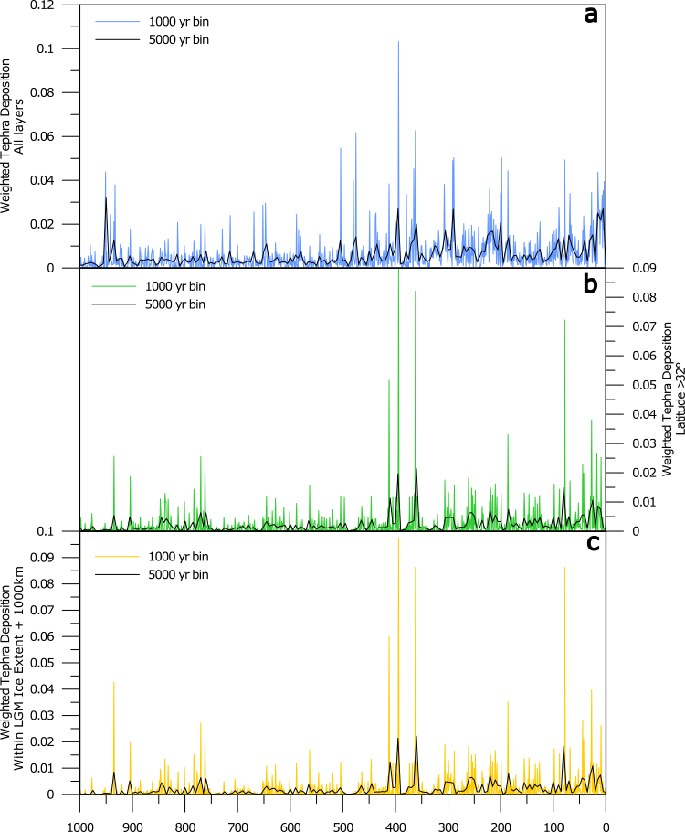
Extended Data Figure 1: All weighted datasets produced in this study. Comparison of weighted global tephra deposition dataset (a) with reduced datasets as described in Methods. (b) Weighted dataset of all tephra layers located at >32°, representative of high-latitude volcanism. (c) Weighted dataset of all tephra layers located below the ice extent of the last glacial maximum (LGM) plus 1000 km. Ice coverage is taken from ref.¹. In all panels, coloured lines indicate the datasets binned at 1000-year intervals, with black lines representing 5000-year bins.
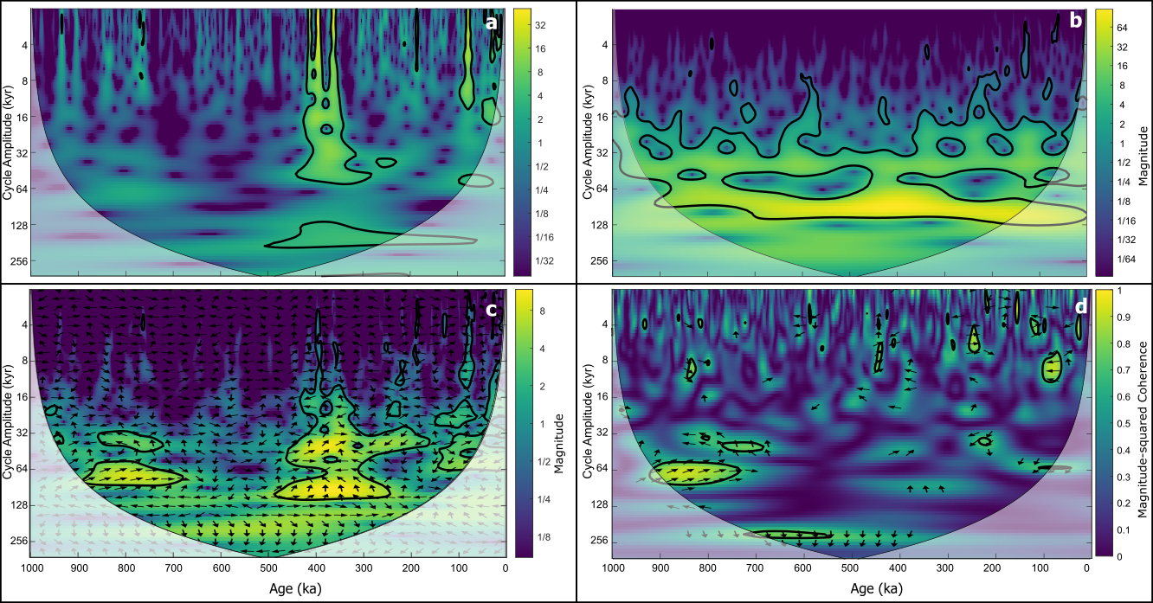
Extended Data Figure 2: Comparison of cyclicity between weighted tephra dataset screened only to include layers at >32° (see Methods), and benthic δ¹⁸O stack. (a) and (b) show wavelet analysis of the weighted tephra dataset screened to include only layers located >32°, and the benthic δ¹⁸O stack^{2,3}, respectively. (c) Wavelet transform coherence (WTC) of the two datasets, demonstrating the cross-correlation of the two signals in frequency and time space (see Methods). (d) Cross wavelet transform (XWT) of the two datasets showing the interaction between the wavelet transform of the two datasets. In a-c colour indicates the magnitude of correlation between wavelet transform and the dataset. In d, colour indicates the transformed magnitude of coherence between the datasets. In c and d, phase arrows indicate lead-lag between datasets, with only those significant at the 95th percentile highlighted in d. In all panels, dark black lines enclose regions with >95% confidence and white shaded areas indicate the cone of influence, where edge effects become important.
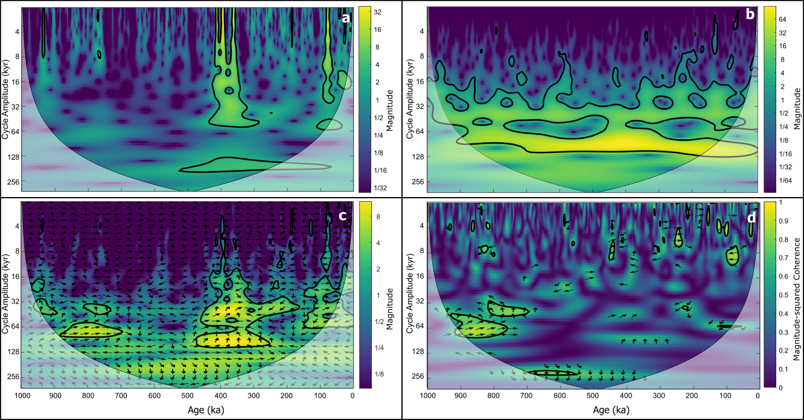
Extended Data Figure 3: Comparison of cyclicity between weighted tephra dataset screened only to include layers under the last glacial maximum extent + 1000km (see Methods) and benthic δ¹⁸O stack. (a) and (b) show wavelet analysis of the weighted tephra dataset screened to include only layers under the last glacial maximum extent + 1000km, and the benthic δ¹⁸O stack^{2,3}, respectively. (c) Wavelet transform coherence (WTC) of the two datasets, demonstrating the cross-correlation of the two signals in frequency and time space (see Methods). (d) Cross wavelet transform (XWT) of the two datasets showing the interaction between the wavelet transform of the two datasets. In a-c colour indicates the magnitude of correlation between wavelet transform and the dataset. In d, colour indicates the transformed magnitude of coherence between the datasets. In c and d, phase arrows indicate lead-lag between datasets, with only those significant at the 95th percentile highlighted in d. In all panels, dark black lines enclose regions with >95% confidence and white shaded areas indicate the cone of influence, where edge effects become important.

