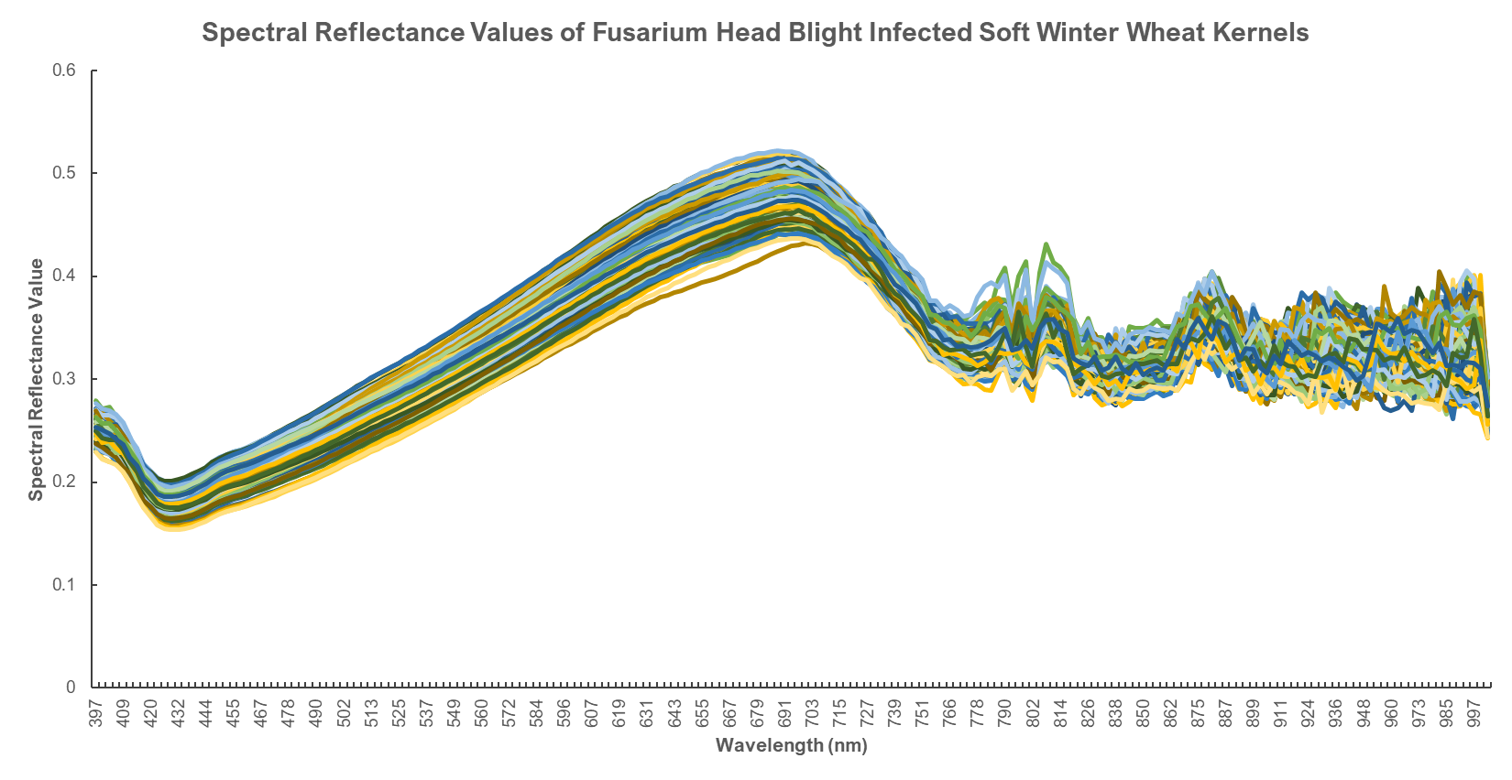Supplementary Figure 1. Spectral profile showing variation in raw spectral reflectance values among genotypes evaluated across all 204 wavebands generated.

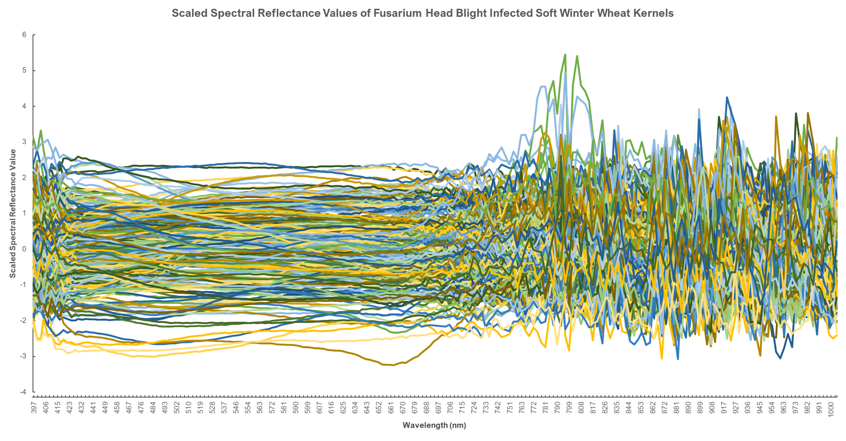Supplementary Figure 2. Spectral profile variation in scaled spectral reflectance values among genotypes evaluated across all 204 wavebands generated.

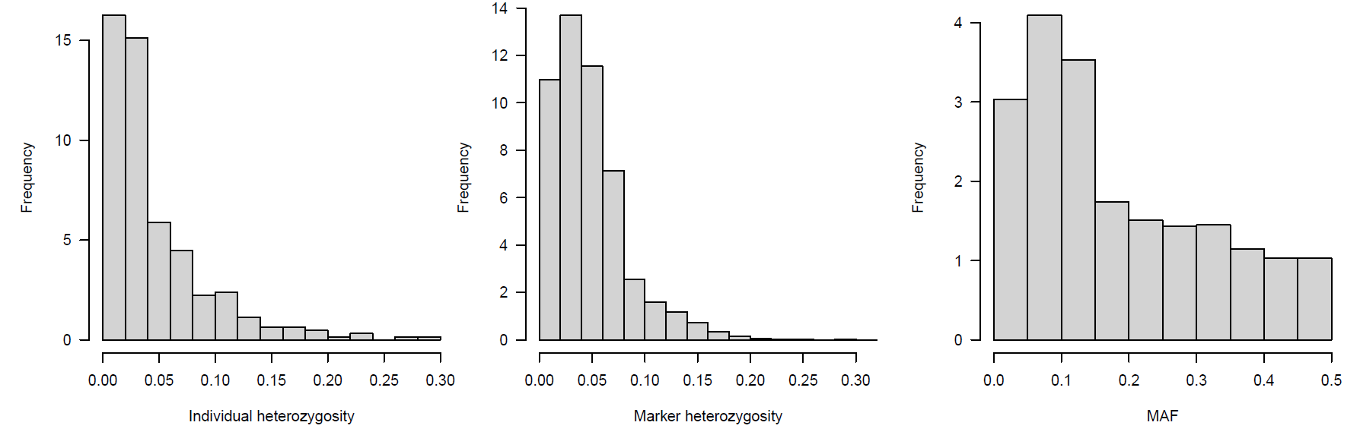
Supplementary Figure 3. Frequency distributions showing heterozygosity of (a) genotypes and (b) markers, (c) minor alleles.

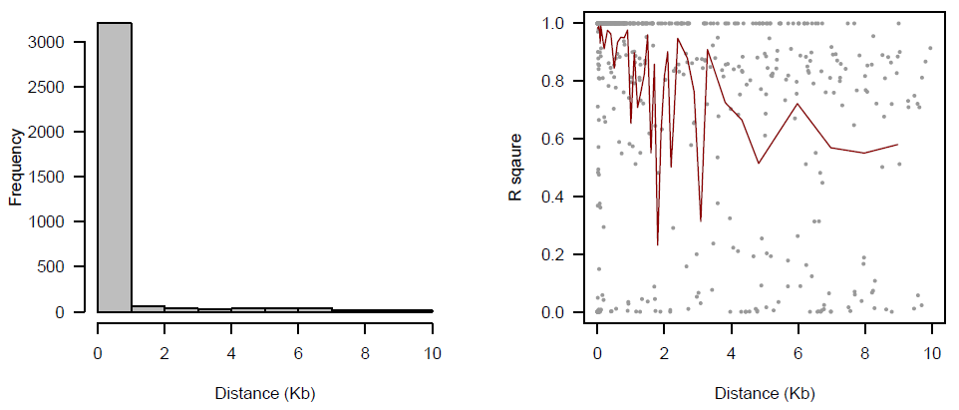
Supplementary Figure 4. (a) Frequency distribution of marker density and (b) linkage disequilibrium (LD) decay over distance calculated on sliding windows with 100 adjacent markers. (Red line is the moving average of the 10 adjacent markers.

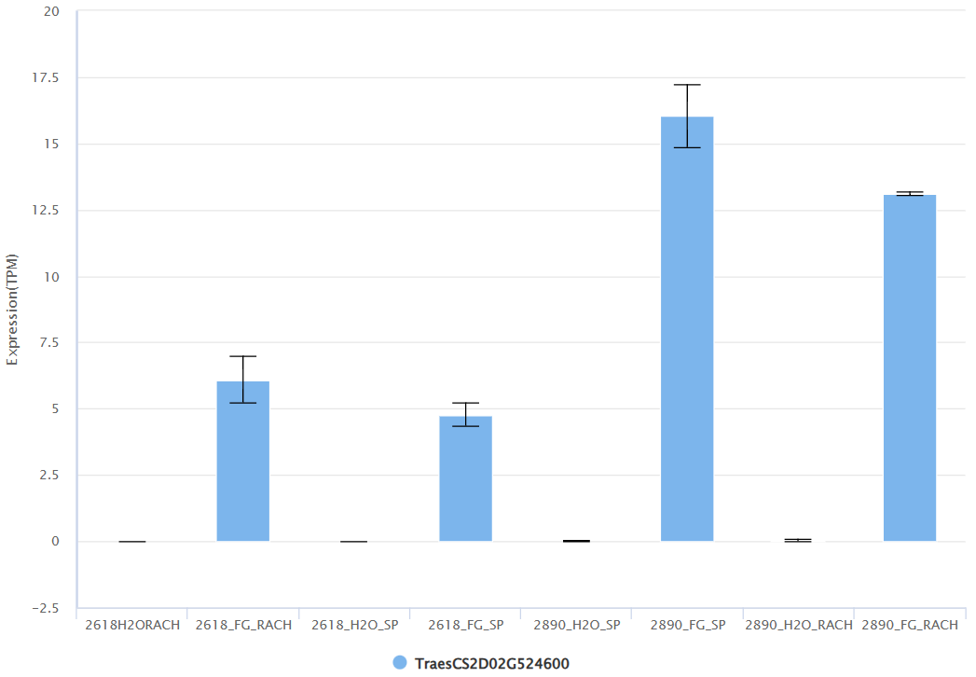
Supplementary Figure 5. Expression of TraesCSD02G524600 in near isogenic lines bearing a 2DL FHB-resistance introgression region (Biselli et al., 2018: Graph and data downloaded from WheatOmics1.0 (Ma et. al., 2018))

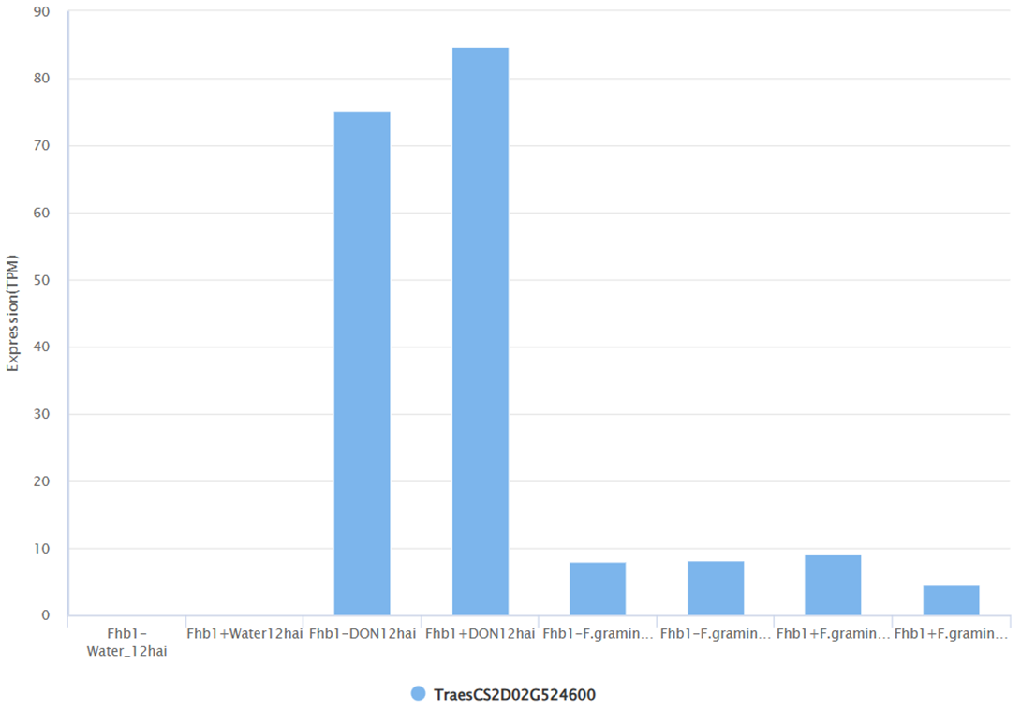
Supplementary Figure 6. Expression of TraesCSD02G524600 in near isogenic lines bearing and lacking FHB1 introgression (Graph and data downloaded from WheatOmics1.0 (Ma et. al., 2018))

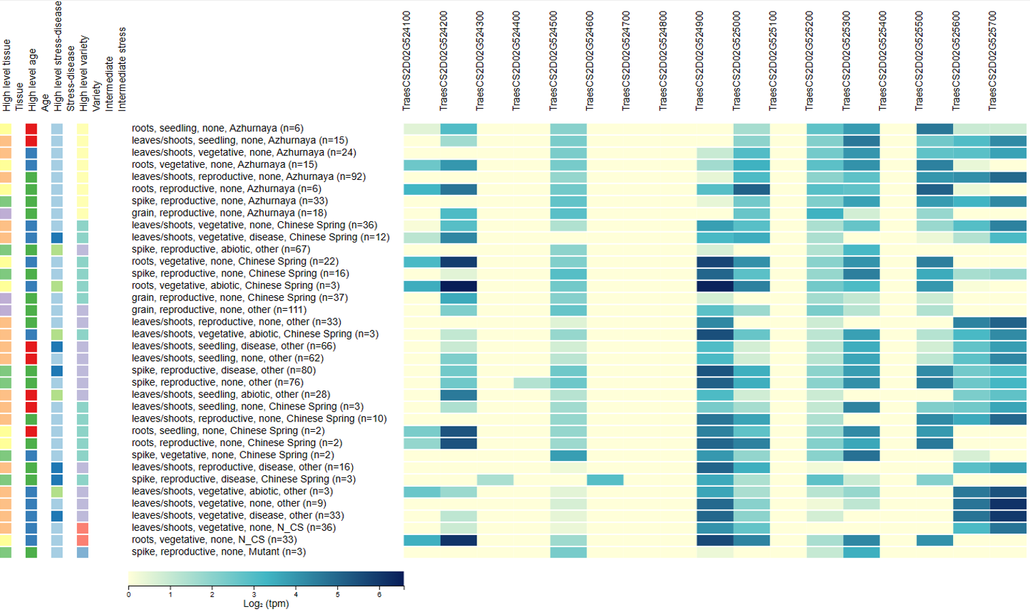

Supplementary Figure 7. Differential gene expression of TraesCSD02G524600 and its adjacent genes in the 2DL genomic region at various tissue types, developmental stages, and stress conditions
(Graph and data downloaded from Wheat Expression Browser (Ramirez-Gonzalez et. al., 2021

