Supplementary File 1. Manhattan plots and corresponsing quantial-quantile plot showing genome wide analysis using Principal Component (PC) 1 of Twenty Four Binned Wavebands (Windows) using BLINK model GAPIT in R.
DON | 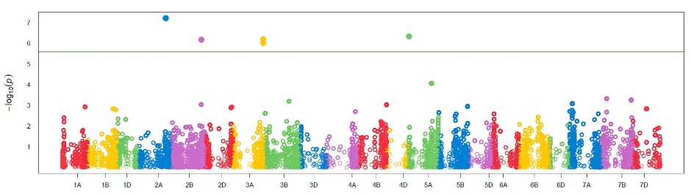 | 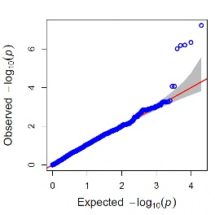
Window 1  (397.32 – 452.25 nm) | 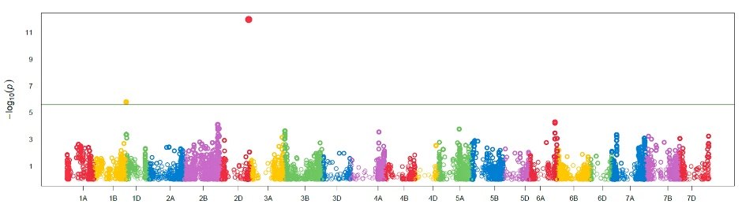 | 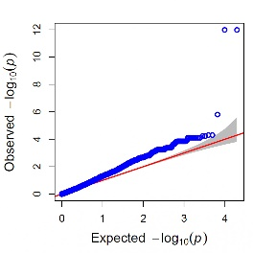
Window 2  (411.74 – 466.77 nm) | 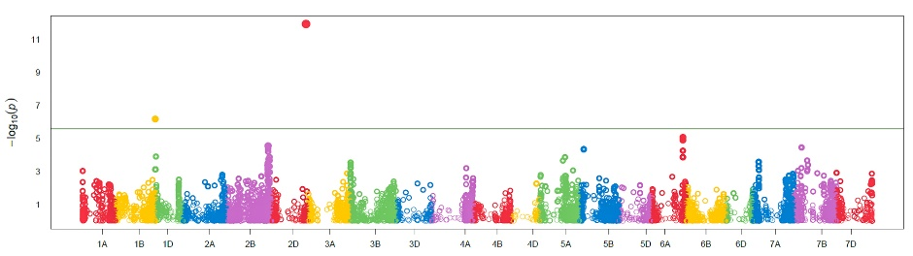 | 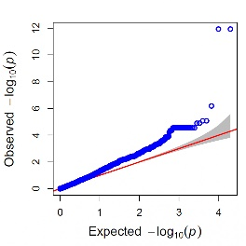
Window 3  (426.19 – 481.32 nm) | 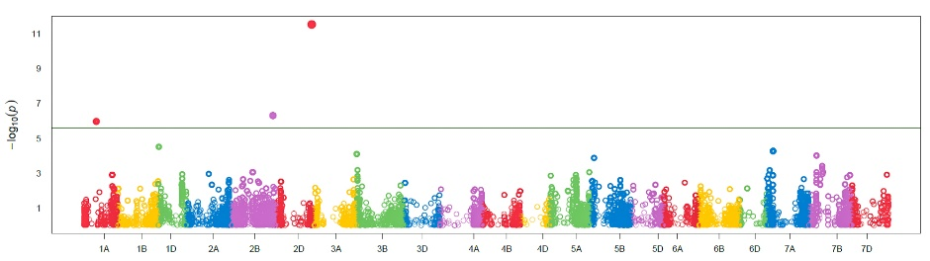 | 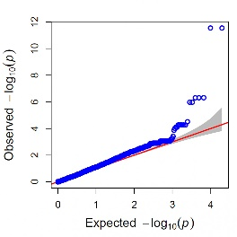
Window 4  (437.56 – 492.97 nm) | 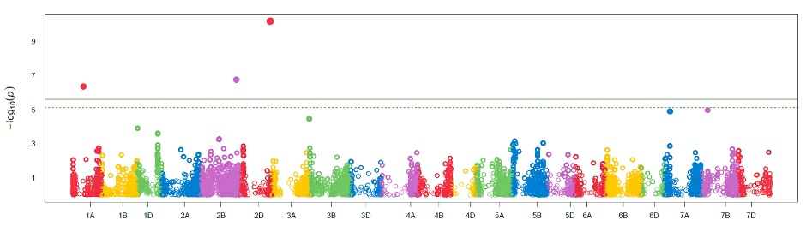 | 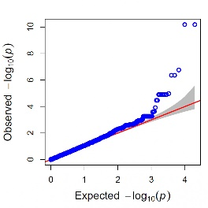
Window 5  (455.16 – 510.48 nm) | 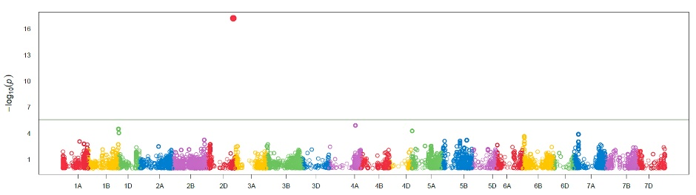 | 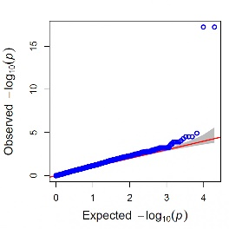
Window 6  (469.68 – 525.1 nm) | 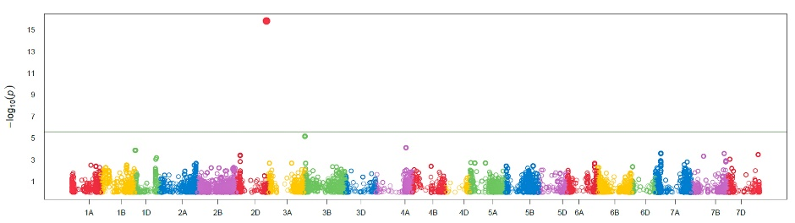 | 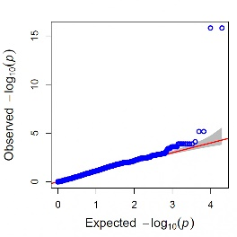
Window 7  (484.23 – 539.75 nm) | 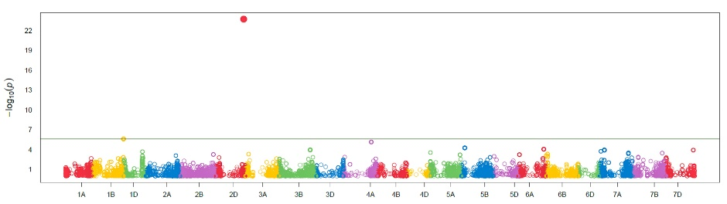 | 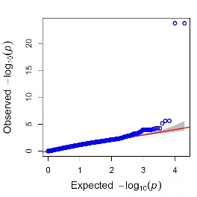
Window 8  (498.8 – 544.43 nm) | 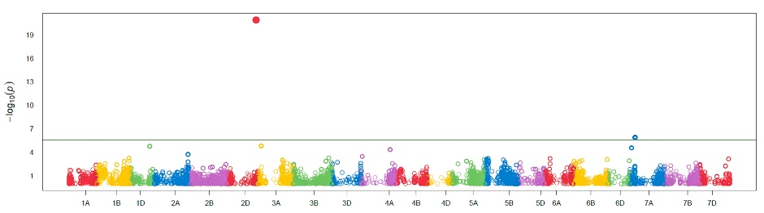 | 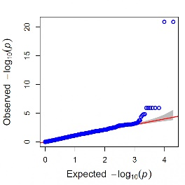
Window 9  (513.4 – 569.12 nm) | 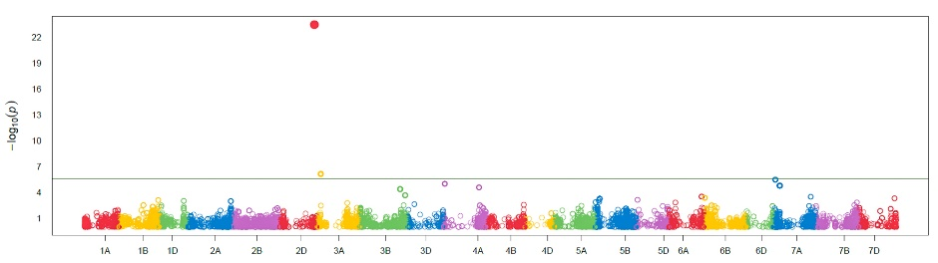 | 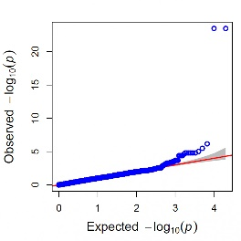
Window 10  (528.03 – 583.85 nm) | 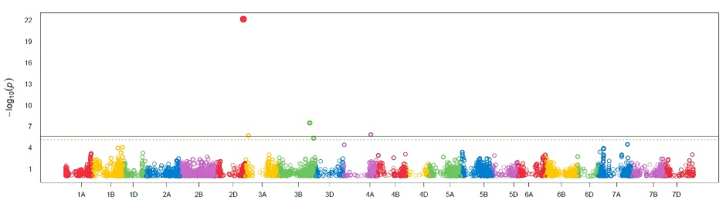 | 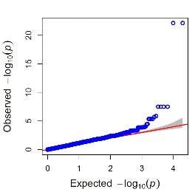
Window 11  (542.68 – 598.6 nm) | 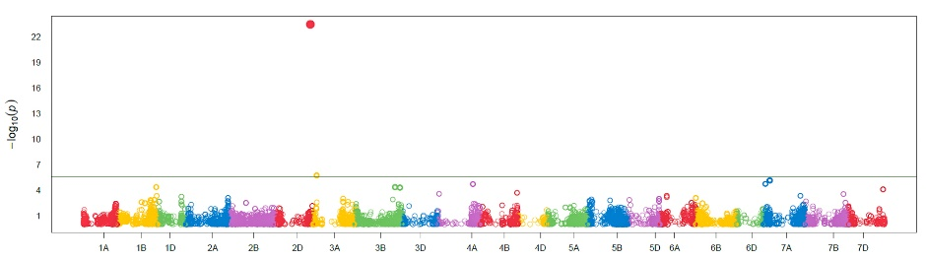 | 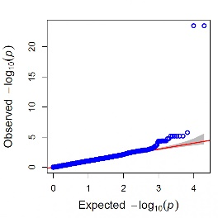
Window 12  (557.36 – 613.38 nm) | 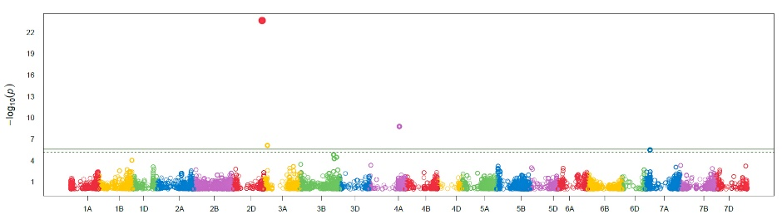 | 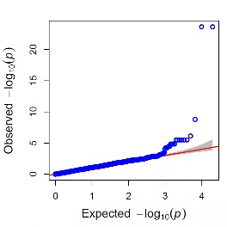
Window 13  (572.07 – 628.18 nm) | 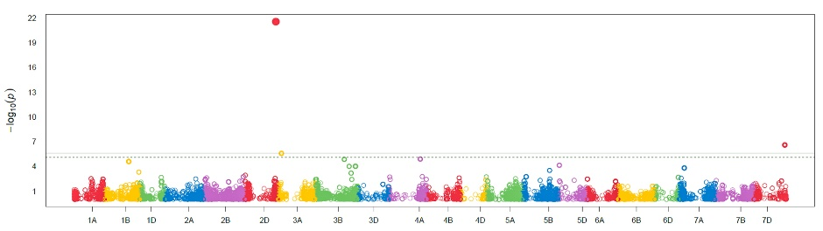 | 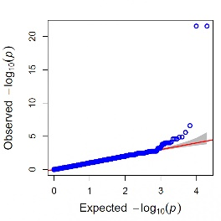
Window 14  (601.55 – 643.01 nm) | 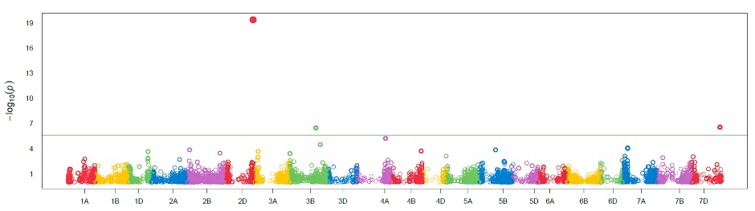 | 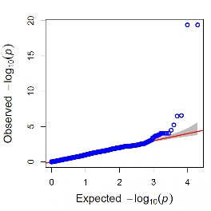
Window 15  (601.55 – 643.01 nm) | 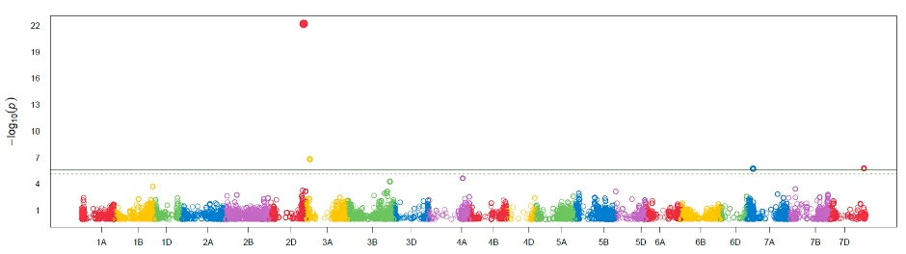 | 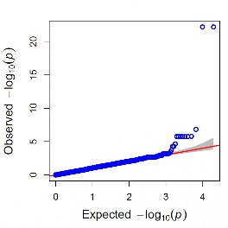
Window 16  (616.34 – 672.75 nm) | 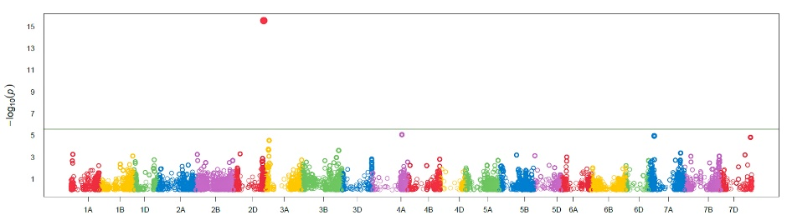 | 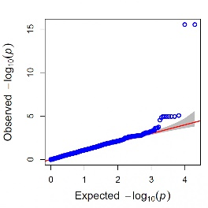
Window 17  (631.15 – 687.65 nm) | 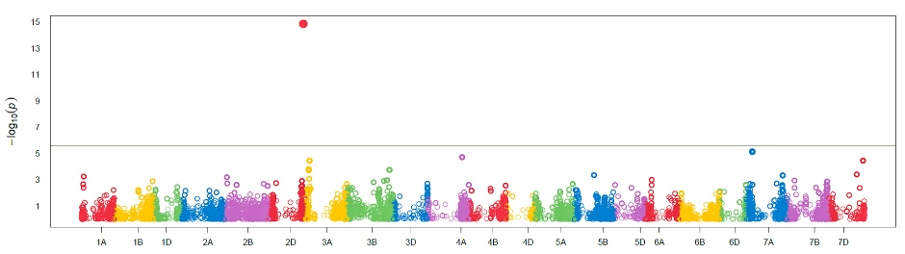 | 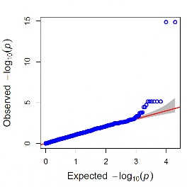
Window 18  (645.98 – 702.58 nm) | 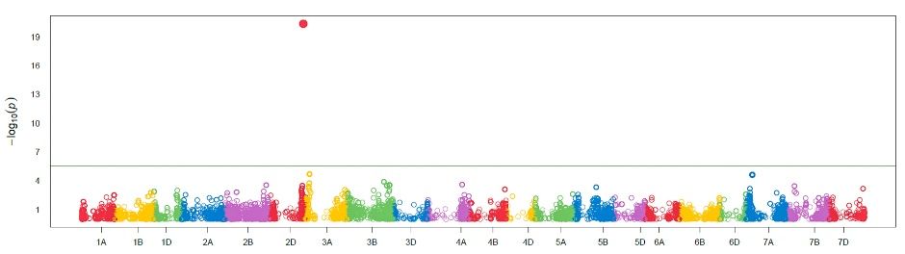 | 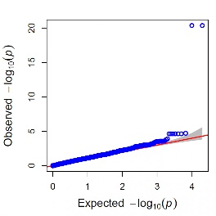
Window 19  (660.84 – 717.54 nm) | 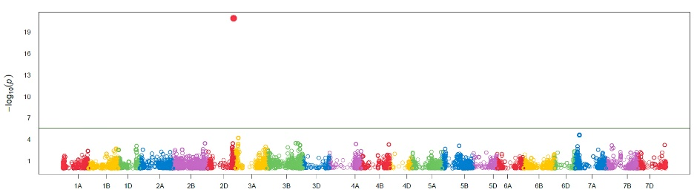 | 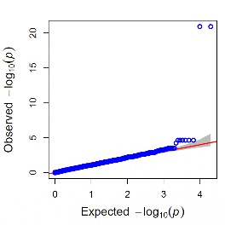
Window 20  (675.73 – 732.53 nm) | 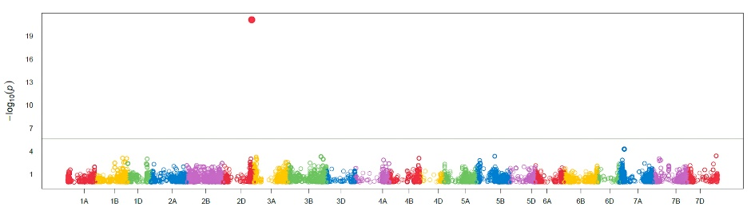 | 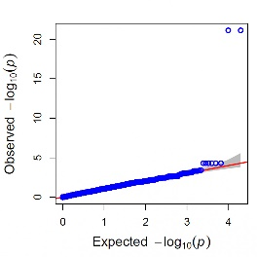
Window 21  (690.64 – 747.53 nm) | 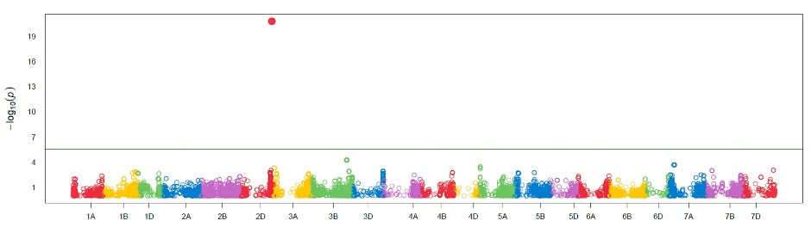 | 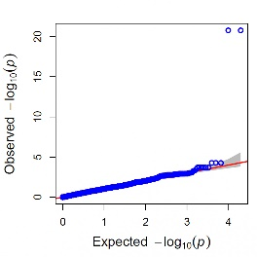
Window 22  (705.57 – 765.58 nm) | 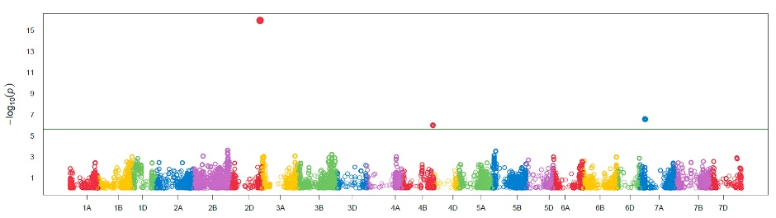 | 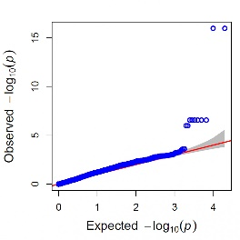
Window 23  (720.54 – 780.65 nm) | 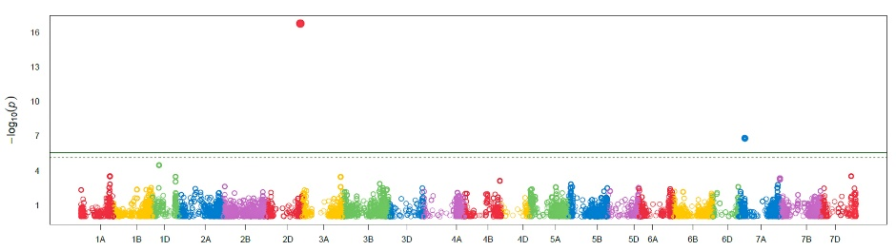 | 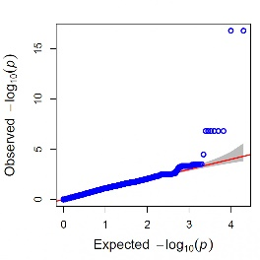
Window 24  (735.53 - 795.74 nm) | 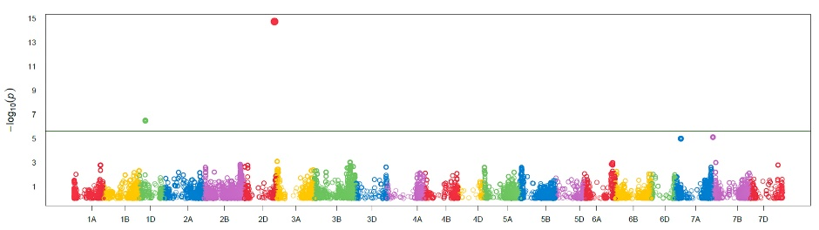 | 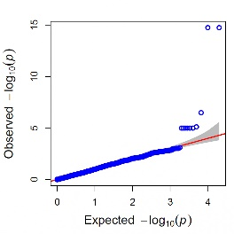
Window 25  (750.54 - 810.86 nm) | 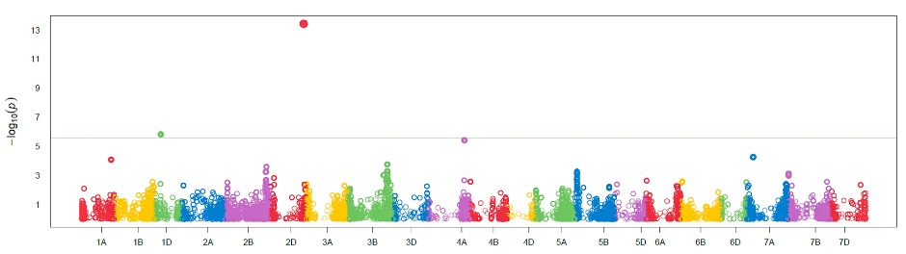 | 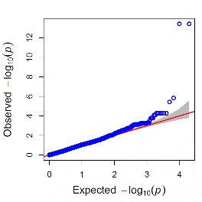
Window 26  (768.6 - 822.98 nm) | 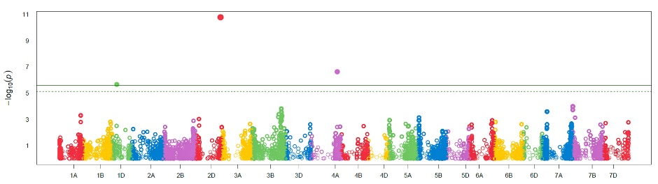 | 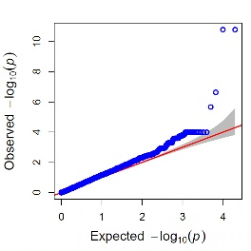
Window 27  (783.67 - 841.18 nm) | 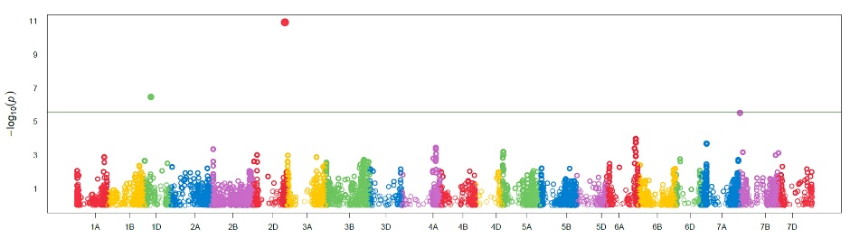 | 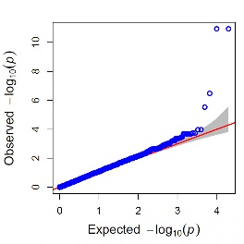
Window 28  798.77 - 856.37 nm | 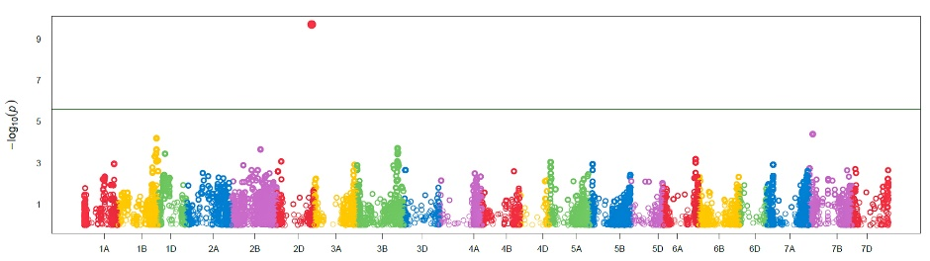 | 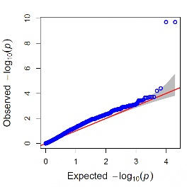
Window 29  (813.89 - 871.6 nm) | 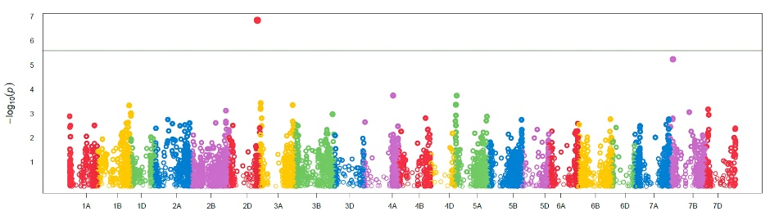 | 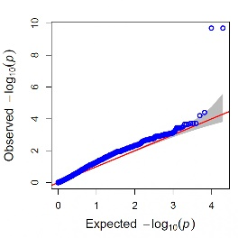
Window 30  (829.04 - 886.84 nm) |  | 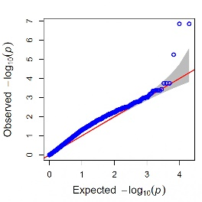
Window 31  (844.22 - 902.12 nm) | 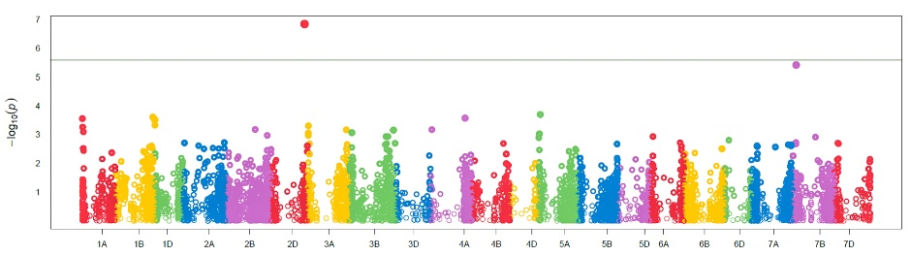 | 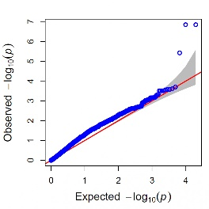
Window 32  (859.42 - 912.42 nm) | 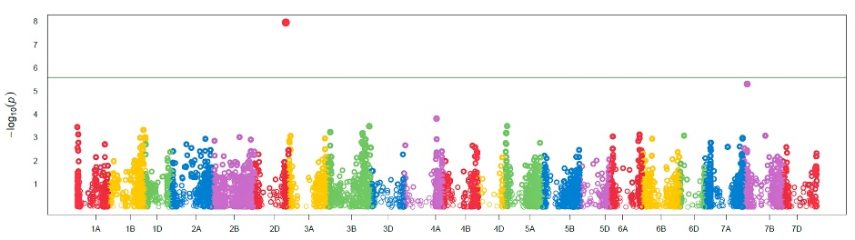 | 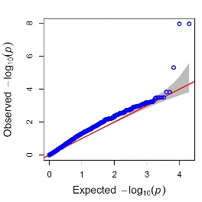
Window 33  (874.64 - 932.74 nm) | 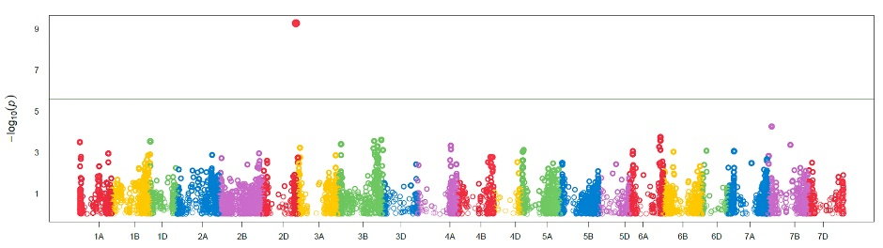 | 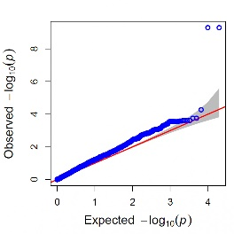
Window 34  (889.9 - 948.1 nm) | 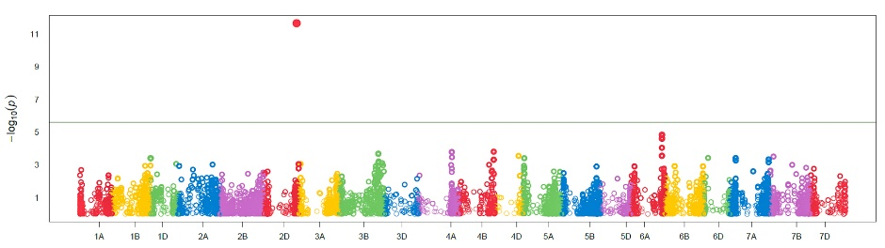 | 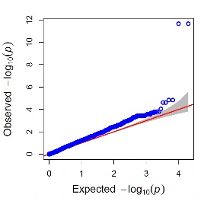
Window 35  (905.18 - 963.47 nm) | 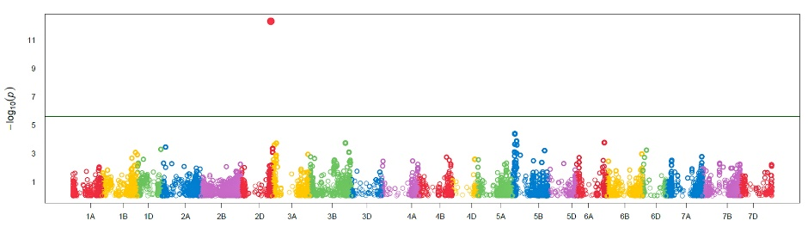 | 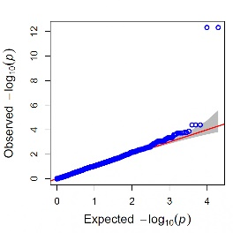
Window 36  (920.48 - 978.88 nm) | 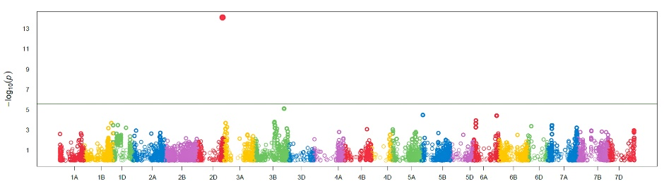 | 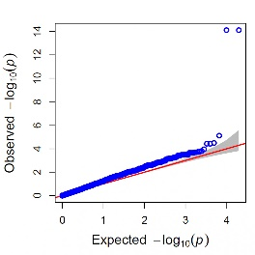
Window 37  (935.81 - 994.31 nm) | 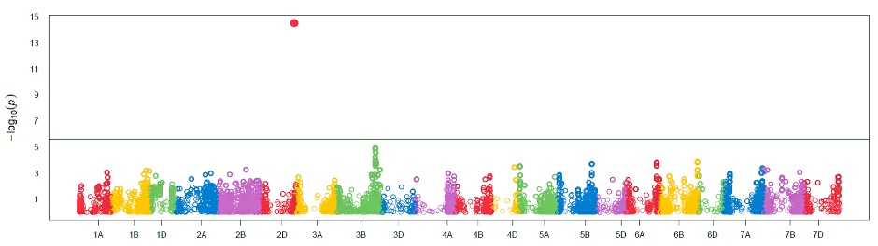 | 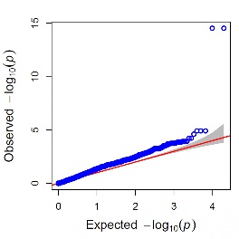
Window 38  (951.17 - 1003.58 nm) | 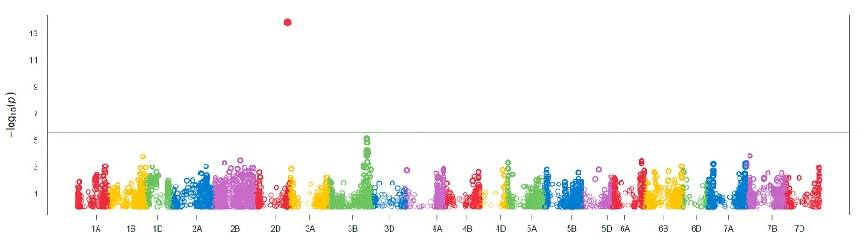 | 