Supplementary Data_additional file 1.
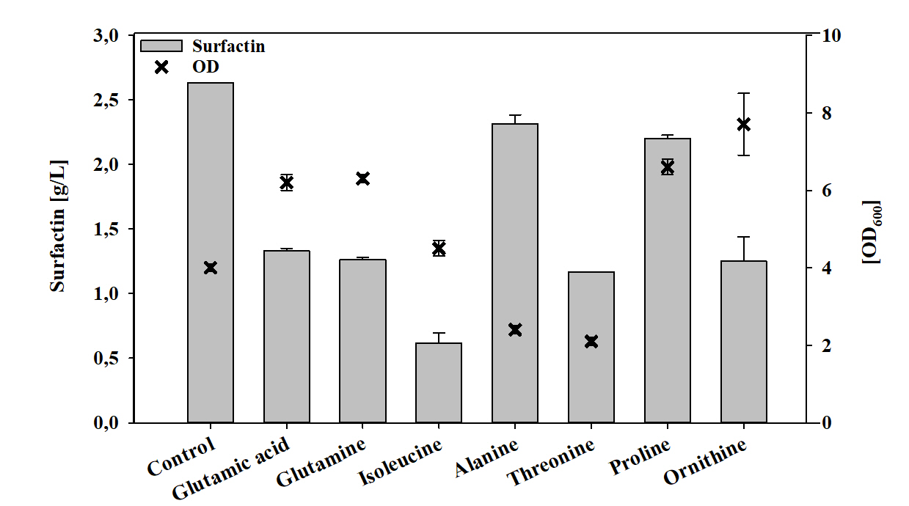
Overview about production of surfactin and corresponding optical densities (OD₆₀₀) of B. subtilis BMV9 (3NA sfp+) after 48 h cultivation in mineral salt medium supplemented with 30 mM of different amino acids.

