Supplementary Data_ additional file 2.
A: Plipastatin variants detected by MS analysis in B. subtilis standard (Lipofabrik, france). Precursor ions (M+H)⁺, retention time, diagnostic fragment ions and corresponding Plipastatin homologue are shown.
m/z (M+H)⁺ | Retention time (min) | Diagnostic ions | Plipastatin homologue
Plipastatin variants with unsaturated fatty acid chain
1503,8759 | 26,34 | 994/1108 | Plipastatin B C₁₇
1489,8545 | 25,66 | 994/1108 | Plipastatin B C₁₆
1475,8384 | 25,24 | 994/1108 | Plipastatin B C₁₅
1475,8384 | 25,58 | 980/1094 | Plipastatin X C₁₆
1475,8384 | 25,97 | 966/1080 | Plipastatin A C₁₇
1461,8229 | 24,60 | 994/1108 | Plipastatin B C₁₄
1461,8229 | 25,28 | 966/1080 | Plipastatin A C₁₆
1447,8053 | 24,22 | 994/1108 | Plipastatin B C₁₃
1447,8053 | 24,51 | 980/1094 | Plipastatin X C₁₄
1447,8053 | 24,85 | 966/1080 | Plipastatin A C₁₅
1433,7936 | 23,62 | 994/1108 | Plipastatin B C₁₃
1433,7936 | 23,90 | 980/1094 | Plipastatin X C₁₄
1433,7936 | 24,25 | 966/1080 | Plipastatin A C₁₄
Plipastatin variants with saturated fatty acid chain
1519,8682 | 25,49 | 994/1108 | Plipastatin B C₁₈
1505,8489 | 24,82 | 994/1108 | Plipastatin B C₁₇
1505,8489 | 25,49 | 966/1080 | Plipastatin A C₁₉
1491,8314 | 24,40 | 994/1108 | Plipastatin B C₁₆
1491,8314 | 25,05 | 966/1080 | Plipastatin A C₁₈
1477,8169 | 23,83 | 994/1108 | Plipastatin B C₁₅
1477,8169 | 24,40 | 966/1080 | Plipastatin A C₁₇
1463,8021 | 23,42 | 994/1108 | Plipastatin B C₁₄
1463,8021 | 23,68 | 980/1094 | Plipastatin X C₁₅
1463,8021 | 24,11 | 966/1080 | Plipastatin A C₁₆
1449,7896 | 23,42 | 966/1080 | Plipastatin A C₁₅
1435,7753 | 22,99 | 966/1080 | Plipastatin A C₁₄
Unknown plipastatin variants with saturated fatty acid chain
1523,8621 | 23,97 | 1012/1126 | Plipastatin Y C?
1509,8499 | 23,56 | 1012/1126 | Plipastatin Y C?
1495,8342 | 22,97 | 1012/1126 | Plipastatin Y C?
1495,8342 | 23,56 | 972 and/or 1112 | Plipastatin U C?
1481,818 | 23,16 | 984/1098 | Plipastatin W C?

Detailed data of extracted-ion chromatograms of plipastatin standard produced by B. subtilis (Lipofabrik, France) and the extracts of plipastatin mono-producer BMV12 strain in exponential phase and in stationary phase. Strain BMV12 was cultivated in mineral salt medium supplemented with 30 mM ornithine.

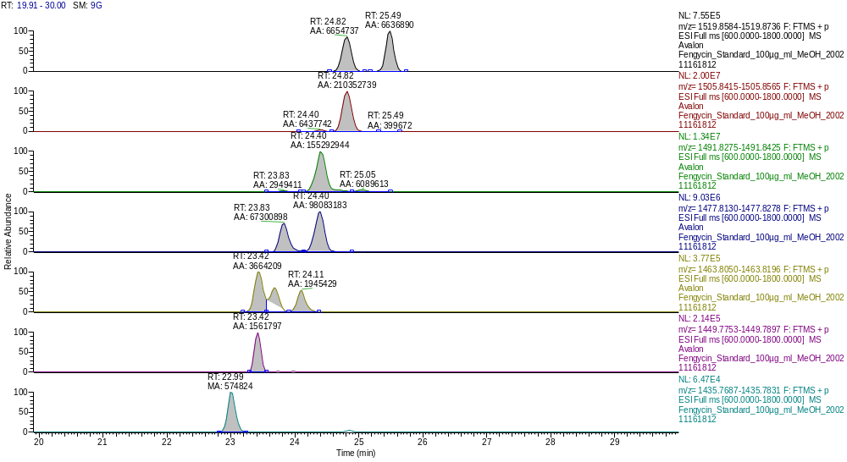
Plipastatin A C14s
Plipastatin A C15s
Plipastatin X C15s
Plipastatin A C16s
Plipastatin B C15s
Plipastatin A C17s
Plipastatin B C15s
Fengycin A C18s
Plipastatin B C16s
Fengycin A C19s
Plipastatin B C17s
Plipastatin B C18s
Extracted-ion chromatogram of Standard: Plipastatin A and B with saturated fatty acid chains
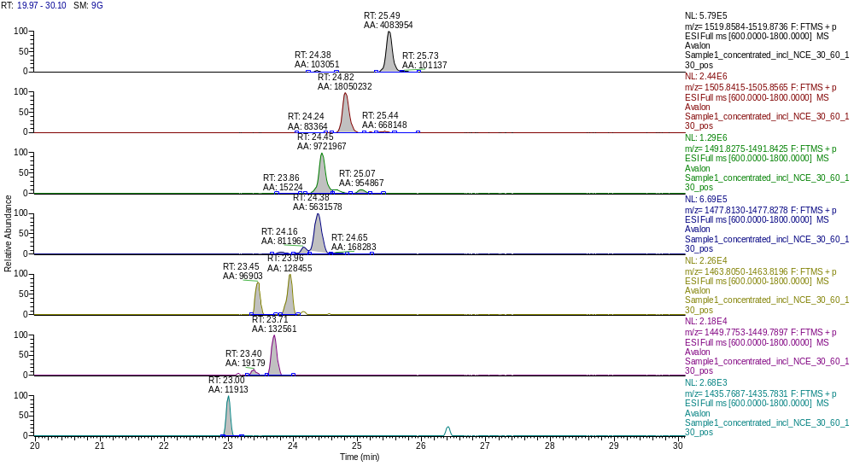
Unknown Plipastatin or substance
with almost identical m/z
Plipastatin
Plipastatin B C16s
Plipastatin A C14s
Plipastatin A C15s
Plipastatin B C14s
Plipastatin A C16s
Plipastatin B C15s
Plipastatin A C17s
Plipastatin A C19s
Plipastatin B C17s
Plipastatin B C18s
Extracted-ion chromatogram of BMV12 in exponential phase: Plipastatin A and B with saturated fatty acid chains
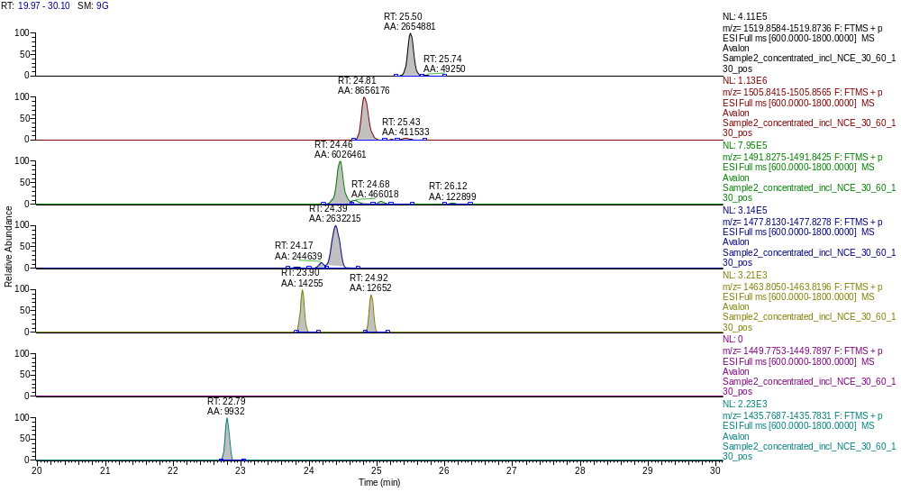
m/z value not found, may be below detection limit
Unknown Plipastatin or
substance with almost identical m/z
Putative Plipastatin A C14s
Plipastatin A C16s
Plipastatin A C17s
Plipastatin B C16s
Plipastatin A C19s
Plipastatin B C17s
Plipastatin B C18s
Extracted-ion chromatogram of BMV12 in stationary phase: Plipastatin A and B with saturated fatty acid chains
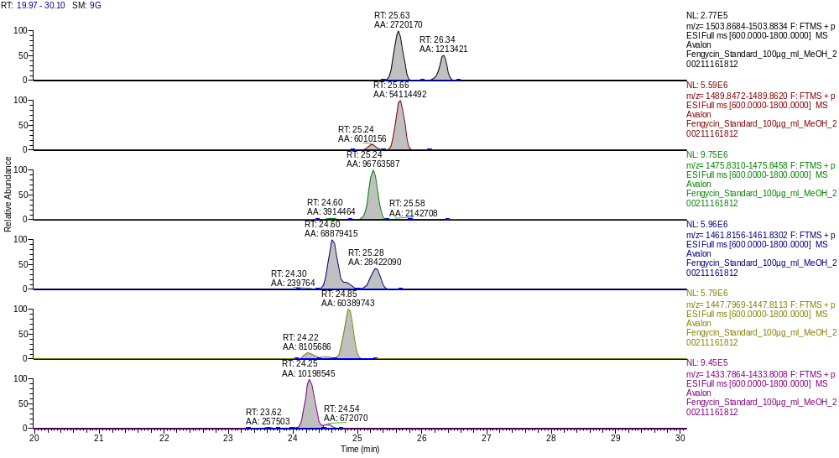
Unknown Plipastatin
Unknown Plipastatin
Putative Plipastatin B C112u
Plipastatin A C14u
Plipastatin B C13u
Plipastatin A C15u
Plipastatin B C14u
Plipastatin A C16u
Plipastatin B C15u
Plipastatin B C16u
Plipastatin B C17u
Extracted-ion chromatogram of Standard: Plipastatin A and B with unsaturated fatty acid chains
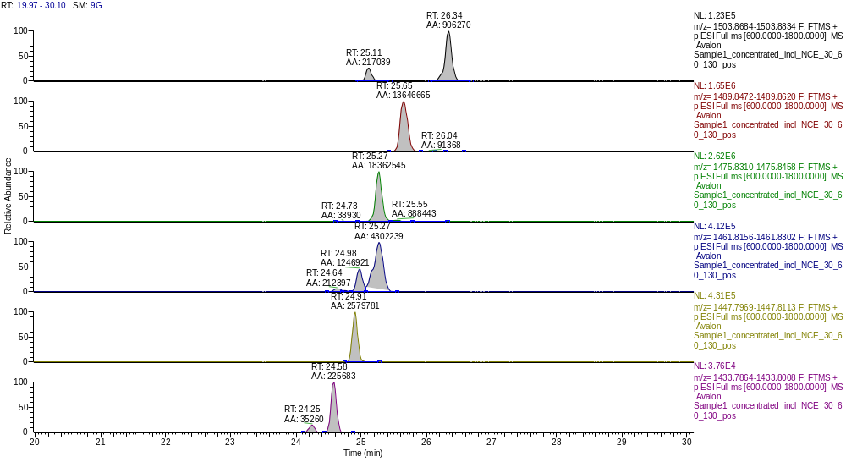
Unknown Plipastatin or
substance with almost identical m/z
Unknown Plipastatin or
substance with almost identical m/z
Plipastatin A C14u
Plipastatin A C15u
Plipastatin B C14u
Plipastatin X C15u
Plipastatin A C16u
Plipastatin B C15u
Plipastatin B C16u
Plipastatin B C17u
Extracted-ion chromatogram of BMV12 exponential in phase: Plipastatin A and B with unsaturated fatty acid chains
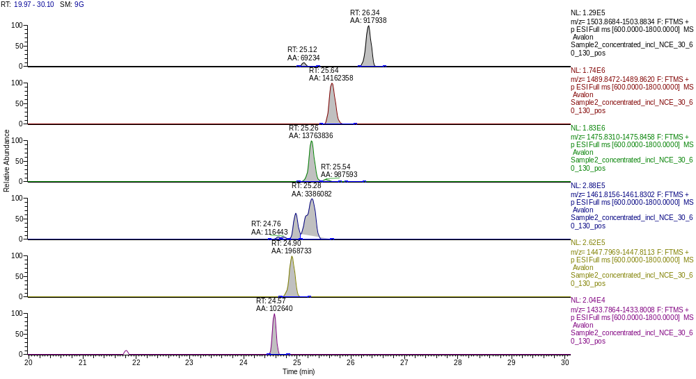
Unknown Plipastatin or substance
with almost identical m/z
Putative Plipastatin X C16u
Unknown Plipastatin or substance
with almost identical m/z
Plipastatin A C15u
Plipastatin B C14u
Plipastatin X C15u
Plipastatin A C16u
Plipastatin B C15u
Plipastatin B C16u
Plipastatin B C17u
Extracted-ion chromatogram of BMV12 in stationary phase: Plipastatin A and B with unsaturated fatty acid chains
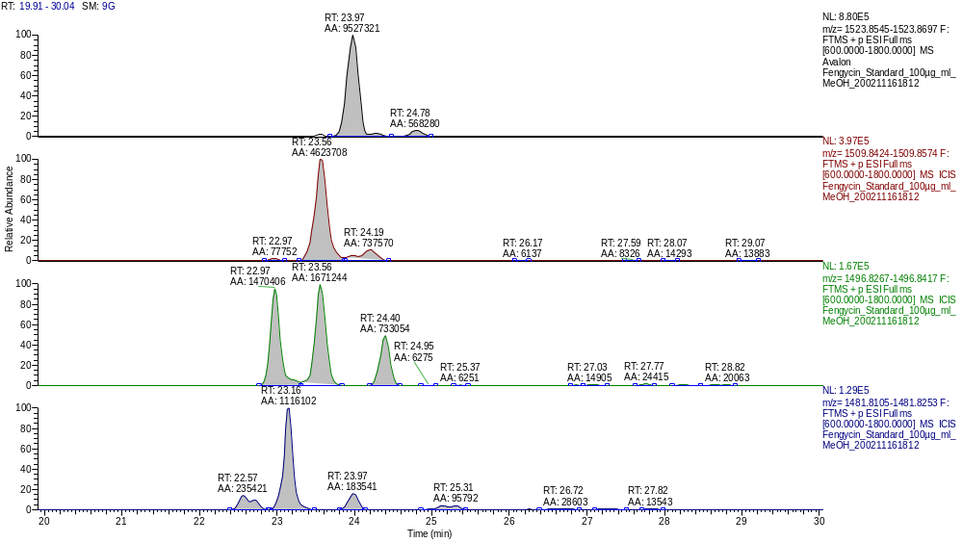
Unkown Plipastatin or substance*
with almost identical m/z
Plipastatin W C?s
Plipastatin W C?s
Plipastatin Y C?s
Plipastatin Y C?s
Plipastatin Y C?s
Extracted-ion chromatogram of Standard: Plipastatin Y and W with saturated fatty acid chains
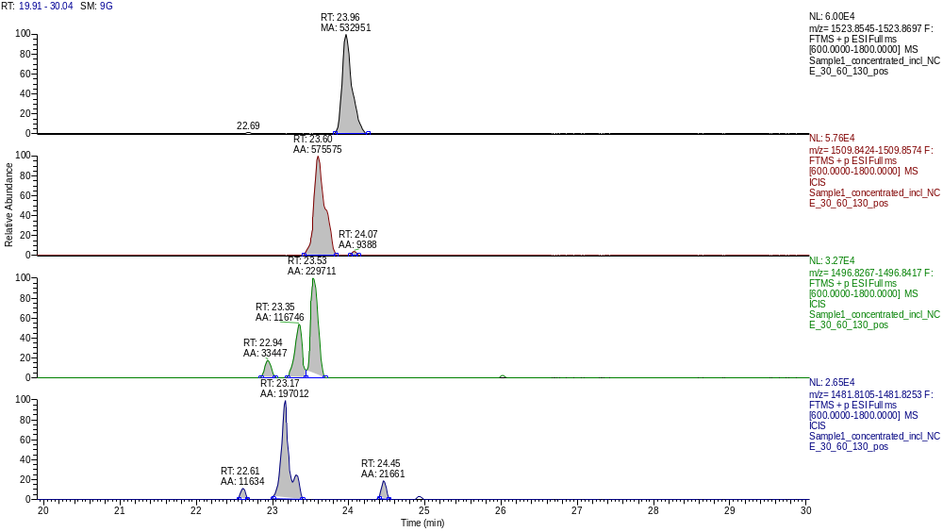
Plipastatin W C?s
Plipastatin Y C?s
Plipastatin W C?s
Plipastatin U C?s
Plipastatin Y C?s
Plipastatin Y C?s
Extracted-ion chromatogram of BMV12 in exponential phase: Plipastatin Y and W with saturated fatty acid chains
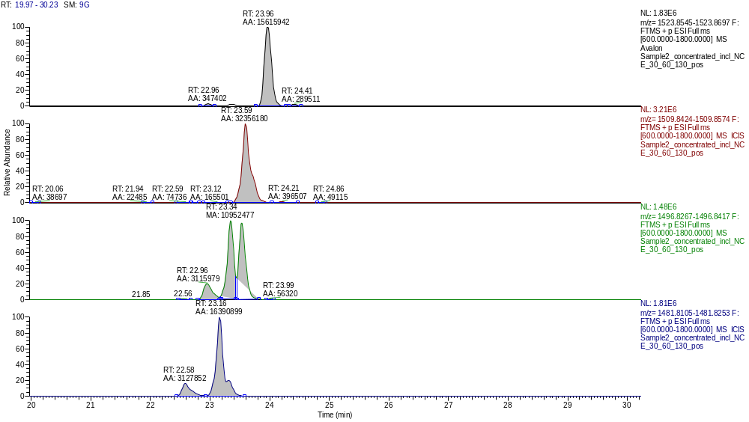
Plipastatin W C?s
Plipastatin Y C?s
Plipastatin W C?s
Plipastatin U C?s
Plipastatin Y C?s
Plipastatin Y C?s
Extracted-ion chromatogram of BMV12 in stationary phase: Plipastatin Y and W with saturated fatty acid chains

