Supplementary Data_additional file 1.
A: Overview about production of surfactin and corresponding optical densities (OD₆₀₀) of different mutant strains after 48 h cultivation in mineral salt medium;
BMV9: control strain (3NA sfp+), BMV10: repaired degQ expression, BMV11: promoter exchange of pps operon, BMV12: deletion of srfA operon, BMV13: combination of promoter exchange and srfA operon deletion, BMV14: combination of promoter exchange and repaired degQ expression.

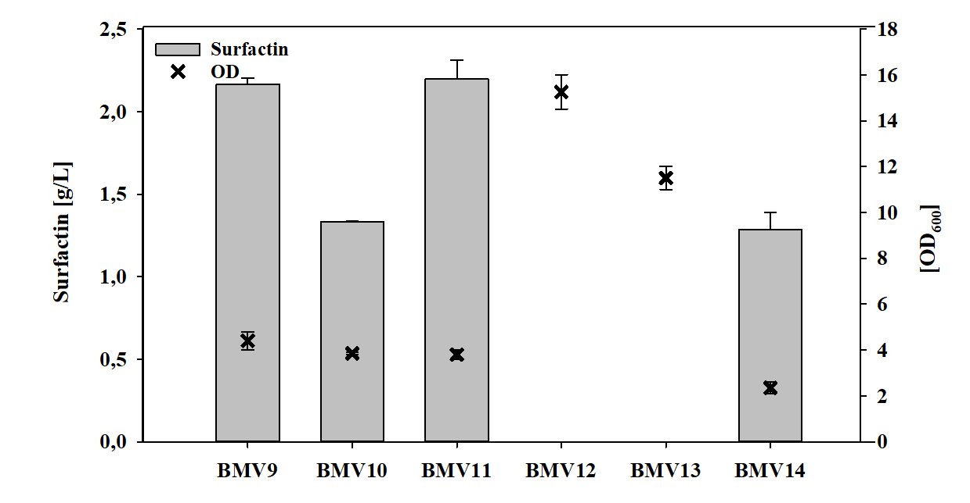

B: Overview about production of surfactin and corresponding optical densities (OD600) of B. subtilis BMV9 (3NA sfp+) after 48 h cultivation in mineral salt medium supplemented with 30 mM of different amino acids.
