Supplementary Materials for
A novel multi-scale microstructure to address the strength/ductility trade off in high strength steel for fusion reactors

Peng Gong¹, T.W.J. Kwok^{2,3}, Yiqiang Wang⁴, Huw Dawson⁴, R. Goodall¹, D. Dye²*, W. Mark Rainforth¹*
This PDF file includes:
Materials and Methods
Figs. S1 to S8
Table S1 to S2
References

Materials and Methods

3.1 Materials
The composition of the new RAFM steel investigated in this study is listed in Table 1. The steel was produced as 20mm×20mm×200mm in an arc melting furnace with an argon atmosphere. The ingots were then homogenized at 1250 °C for 1 hour followed by quenching in oil to room temperature. The steels were then hot rolled at 1150-1100 °C down to a thickness of 12 mm for the first pass, following the second pass at 950-900 °C with reducing thickness to 8mm. The Stage 2 samples were quenched at this stage. Stage 3 samples were then given a third pass operated at 850-800 °C down to the final thickness of 4mm. Samples were austenitised at 980 °C for 1 hour followed by water quenched and ageing at 750 °C for 1.5 hours followed by air-cooling. A schematic diagram showing the overall process route is given in Fig. 1. All heat treatments were undertaken in an Ar atmosphere in order to prevent oxidation and decarburization. The Eurofer97 steel used in the current study was provided by Karlsruhe Institute of Technology (KIT) in the form of a 6 mm thick plate, with a chemical composition summarized in Table S1.
Table S1. Chemical compositions of the maraging steels (wt. %)
Materials | C | Si | Mn | Cr | V | Ta | Ti | W | Fe
Trimodel RAFM steel | 0.11 | 0.25 | 0.4 | 9 | 0.2 | 0.07 | 0.01 | 1.1 | Bal.
Eurofer97 steel | 0.11 | -- | 0.55 | 8.95 | 0.2 | 0.12 | -- | 1.06 | Bal.

3.2 Tensile testing
Tensile testing was also conducted for each processing condition at a constant strain rate of 10⁻⁴s⁻¹ using the sample geometry as shown in Fig. S1 at room temperature using a Zwick (BTC T1-FR020 TN A50) universal testing machine. Tensile tests were conducted three times for each condition.
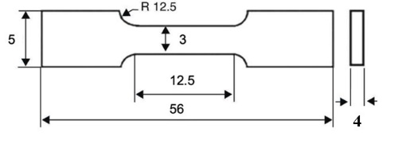
Fig. S1 Tensile sample geometry (lengths in mm)

3.3 Microstructure analysis
Microstructural observations were performed by electron backscatter diffraction (EBSD), and transmission electron microscopy (TEM). Specimens for EBSD observation were prepared by standard metallographic methods, which included grinding from P400 to P1200 and polishing up to 0.04 μm colloidal silica particles. The EBSD analyses were undertaken on a FEI-Nova 600 and JEOL JSM 7900 operating at 20 KV with a beam step size of 0.15-0.1 μm. The HKL Channel 5 system (Oxford Instruments, Oxfordshire, United Kingdom) was used for data acquisition and analysis. The microstructural constituents can be distinguished by EBSD on the basis of following parameters: (1) the band contrast (BC) map depends on the distortions of the crystal lattice; (2) Kernel Average Misorientation map (KAM) by analysing the average misorientation angle of a give point with all its neighbours. 6 Kikuchi lines and 1.5 angular tolerances were employed to index the Kikuchi patterns to prevent misidentification.
Thin specimens for TEM were cut from the heat-treated blanks, and ground to about 60 μm using conventional techniques. The foils for TEM studies were prepared by standard electropolishing. Electropolishing was performed in a Tenupol Model twin-jet electropolishing unit, using a solution of 50 ml perchloric acid, 600 ml methanol and 350 ml butyl alcohol at a temperature of -40°C. TEM studies were conducted in a JEOL-F200 microscope operating at an accelerating voltage of 200 kV. The microstructural analyses were performance in STEM mode so as to show the highest dislocation density.
3.4 Small-angle neutron scattering
Small-Angle neutron scattering (SANS) experiments were performed on the Sans2d and ZOOM beamlines at the ISIS Pulsed Neutron Source UK [70]. A magnetic field of ~ 1.6T was applied to saturate the ferritic matrix which allows the separation of the magnetic and nuclear scattering, as shown in Fig. 3 (b). Specimens with dimension of ~ 10 mm × ~10 mm × ~1 mm were prepared with a final 1200 grit SiC grinding. A sample-to-detector distance of 4 meters was used to provide scattering vector, q, covering a range of 0.004 to 0.3 Å⁻¹ as follow:
q=4πsinθ/λ (1)
where 2θ is the scattering angle and λ is neutron wavelengths. The neutron beam size was 8 mm in diameter and the measurement time for each sample was 1.5 hrs. To avoid collecting scattering signal from multi-Bragg diffraction, only neutrons with wavelengths, λ, from 4.7 to 16.5 Å were selected for data analysis [71-74]. One-dimensional nuclear and “nuclear + magnetic” scattering intensity plots, I (intensity) versus q were obtained by partial azimuthal averaging in sectors around the horizontal and vertical axes of the transmitted beam respectively using the software Mantidplot [75], as shown in Fig. 3 (a).
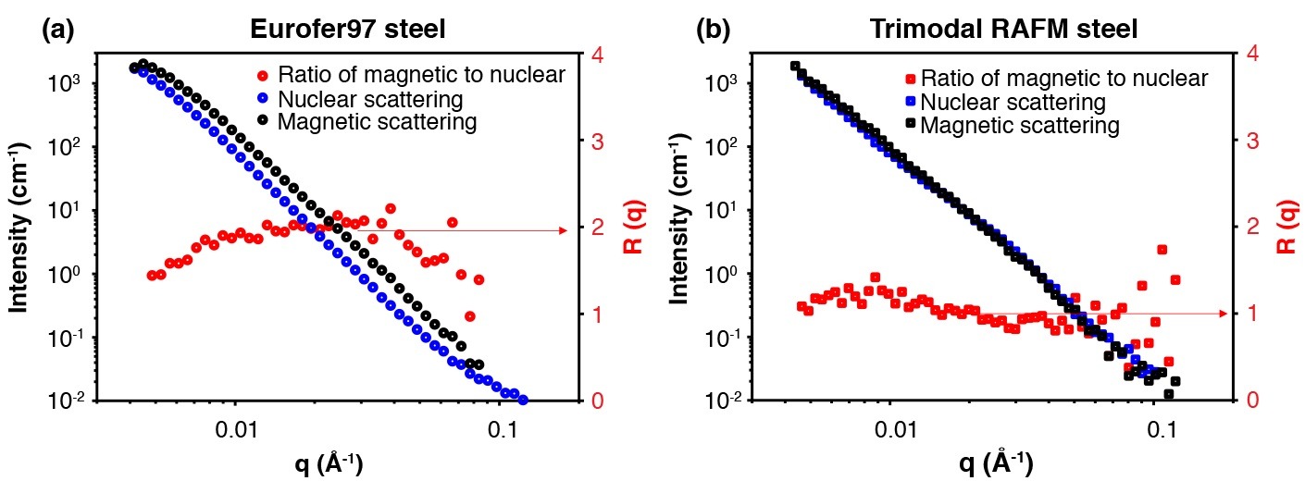
Fig. S2. One-dimensional nuclear and magnetic small angle neutron scattering patterns of I (left hand axis) and R(q) (right hand) axis versus scattering vector, q, obtained from the (a) Eurofer97 steel and (b) Tribomal RAFM steel.
Fig. S2 (a) and S2 (b) show one-dimensional plots of magnetic (blue) and nuclear (black) scattering intensity versus scattering vector for the tribodal RAFM steel and the EUROFER97 steel, respectively. In the Eurofer97 steel, both the magnetic and nuclear signals follow a q⁻⁴ variation (known as the Porod Law) over the entire q-range until the background level is reached at q > 0.1 Å⁻¹. This indicates that the primary contribution to scattering is from large particles or features with size typically > 2π/q_{min} (> 150 nm). These will typically be metallic carbides (i.e., Cr₂₃C₆). The magnetic scattering contribution of Cr₂₃C₆ in Eurofer97 steel is larger than the nuclear scattering contribution because of the larger magnetic contrast factor compared to the nuclear contrast factor (refer to Supplementary Table S2). The current SANS measurement shows that the number density and volume percent of MX type nanoscale precipitates formed in Eurofer97 steel is extremely low.
In contrast, the SANS results obtained from the tribodal RAFM steel indicate that both magnetic and nuclear scattering intensities deviate from a q⁻⁴ Porod-type behaviour at q ∼0.007 Å⁻¹. This deviation arises from the formation of nanoscale (d ≤ 60 nm) MX precipitates.
Table S2. Values of nuclear (ρ_{nuc}) and magnetic (ρ_{mag}) scattering length density, nuclear (Δρ_{nuc}) and magnetic (Δρ_{ma}) contrast factor of phases potentially relevant to this study. Detailed calculation can be found in [6]. Precipitate phases which are paramagnetic generally considered to have a zero magnetic scattering length density.
Phase | ρ_{nuc}  (10¹⁴m⁻²) | ρ_{mag}  (10¹⁴m⁻²) | Δρ_{nuc}  (10¹⁴m⁻²) | Δρ_{mag}  (10¹⁴m⁻²) | R(q)=(Δρ_{mag}/Δρ_{nuc )}²
Fe | 7.93 | 5 | / | / | /
Cr23C6 | 4.15 | 0 | 3.78 | 5 | 1.75
VC | 3.43 | 0 | 4.5 | 5 | 1.23
TiC | 1.63 | 0 | 6.3 | 5 | 1.55
TiN | 3.04 | 0 | 4.89 | 5 | 1.04

To determine the average chemical composition of the precipitate in both Eurofer97 and the Tribomal RAFM steel samples, the corresponding ratio of magnetic to nuclear scattering, R(q), was calculated and is shown in the left-hand axis of Fig. 3 as red and square circles. The average value of R(q) exhibited a shift from approximately 2 (in Eurofer97) to approximately 1 (in the Tribomal RAFM steel), indicating the formation of a new type of precipitate with a much lower R(q) value. Comparison with theoretical calculations (refer to Supplementary Table S2) suggest that R(q) = ~1 represents the formation of VC/TiN precipitates in the tribodal RAFM steel.
To further analyses the precipitate size and volume percent (f_{v}) in the tribodal RAFM steel, the Porod region due to the large carbides and the incoherent background in the nuclear SANS signal were subtracted and plotted in Fig. S3 (a). This was done to obtain a meaningful scattering signal only from nano-sized precipitates. The Kratky plot, Iq² versus q is then plotted in Fig. S3 (b). In the Kratky plot, a characteristic particle size, R_{max}, (the “pseudo-Guinier radius”), can be determined from the maximum q_{max} in the plot [72] as follow:
R_{max}=$\sqrt{3}$/q_{max}=9.6 nm (2)
q_{max}=0.179 nm⁻¹ (3)
The volume percent of the precipitate was calculated from nuclear SANS sign using equation:
$\text{Q=}\int_{\text{0}}^{\text{∞}}{\text{I}\left(\text{q}\right){\text{q}}^{\text{2}}\text{dq=2}{\text{π}}^{\text{2}}{\left({\text{ρ}}_{\text{ρ}}\text{-}{\text{ρ}}_{\text{m}}\right)}^{\text{2}}{\text{f}}_{\text{v}}\left(\text{1-}{\text{f}}_{\text{v}}\right)}$ (4)
where ρ_{p} and ρ_{m} are the nuclear scattering length densities of precipitate and matrix respectively. The q-range for integration was extrapolated to 10⁻⁵ Å⁻¹ for low q and 10 Å⁻¹ for high q with the Guinier equation and the Porod law, respectively, as recommended in Ref. [72]. Thus f_{v}= 0.0016 was calculated using the SasView software [76].
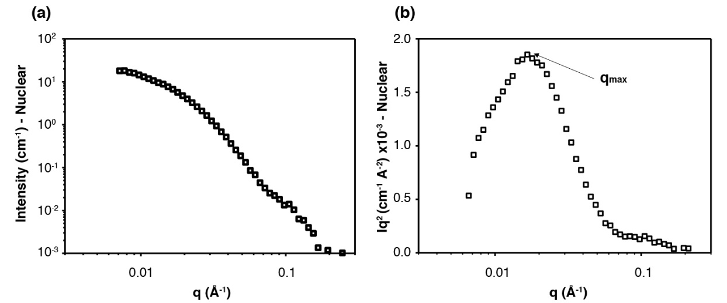
Fig. S3 (a) SANS nuclear scattering from the tribodal RAFM steel following subtraction of Porod Law behaviour and incoherent scattering background and (b) Kratky plot (Iq² versus q) of the Fig. S3 (a).

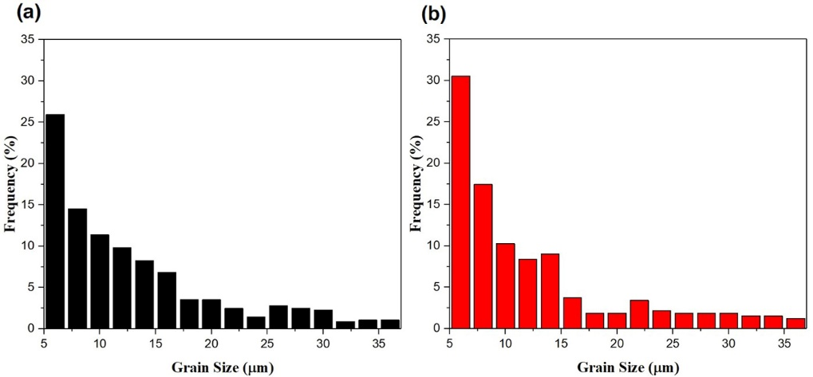
Fig. S4 Grain size distribution from (a) two-stage bimodal RAFM steel; (b) three-stage Trimodal RAFM steel.
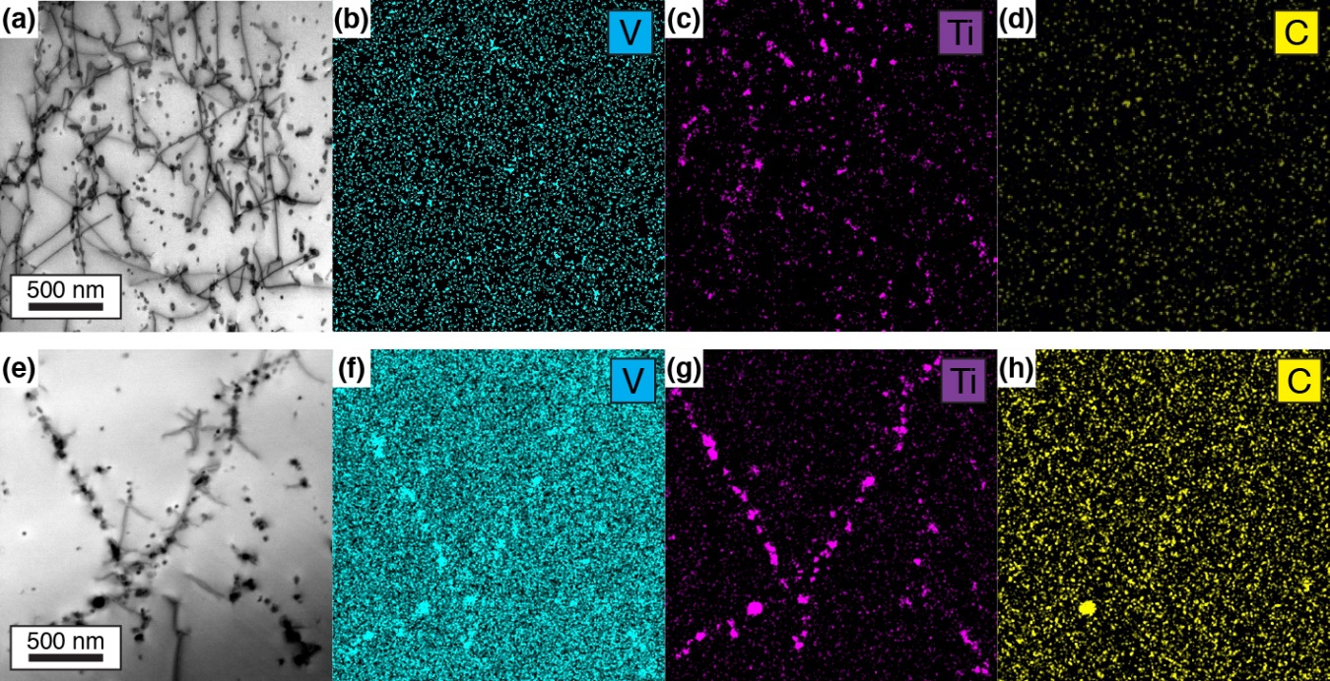
Fig. S5 STEM-BF and EDS maps in the coarsen ferrite region in the three-stage processed Trimodal RAFM steel, showing the finer scale (V,Ti)C located on the dislocations and dislocation cells: (a) STEM-BF of nanoscale precipitates pinned on the dislocations; (b) V map from (a); (c) Ti map from (a); (d) C map from (a); (e) STEM-BF of nanoscale precipitates pinned on the dislocation cell structures; (f) V map from (e); (g) Ti map from (e); (h) C map from (e).
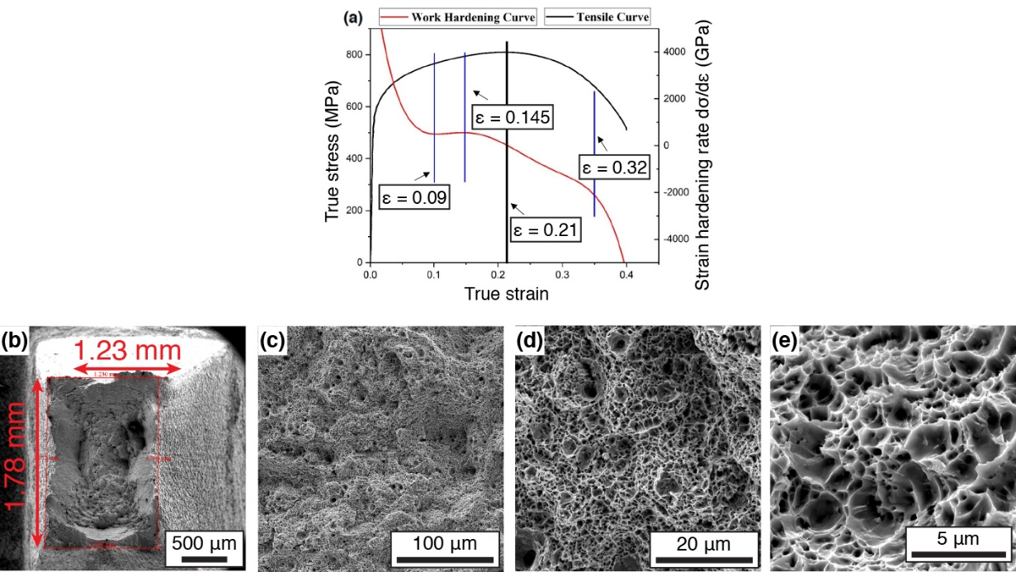
Fig. S6 (a) True stress-strain curve of the Trimodal RAFM steel, and (b-e) SEM images of the fracture surface of specimens: (b) low magnification of fracture surface; (c-e) magnification increasing on the dimpled fracture surface.
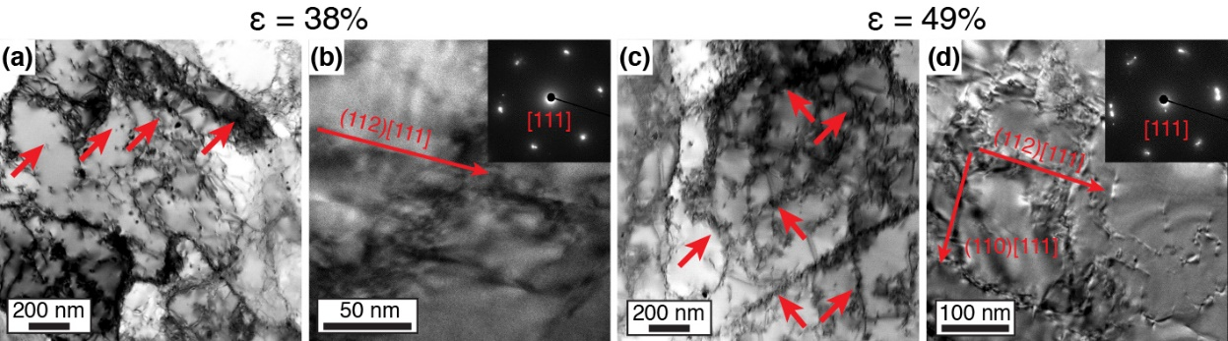
Fig. S7 Bright field (S)TEM micrographs and the corresponding dark field images of the three-stage processed Trimodal RAFM steel showing planar dislocation structures (a, b) tensile strain of 38% with (a) BF STEM image; (b) BF TEM image and corresponding selected area diffraction pattern (SADP) showing (112)[111] OR relationship; (c, d) tensile strain of 49%; (c) BF STEM image; (d) BF TEM image and corresponding selected area diffraction pattern (SADP) showing two types of (110)[111] and (112)[111] OR relationship.
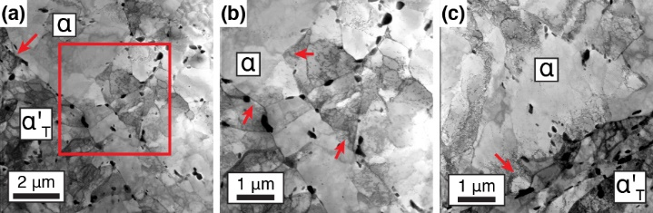
Fig. S8 Bright field STEM micrographs of the three-stage processed Trimodal RAFM steel at the tensile strain of 9%: (a) low magnification of BF STEM showing bulging dual phase boundaries, marked by red arrows; (b) high magnification of BF STEM from (a) in red rectangle; (c) high magnification of BF STEM from different region showing the high dislocation density near the dual phase boundaries.

References
1. A. Morán, R. Coto, J. Belzunce, J. M. Artímez, Experimental development at a pilot plant scale of a Reduced Activation Ferritic/Martensitic RAFM steel. Adv Sci Tech. 73, 36–40 (2010).
2. S. J. Zinkle, L. L. Snead, Designing Radiation Resistance in Materials for Fusion Energy. Nuclear Fusion 57, 92005 (2017).
3. M. Calcagnotto, Y. Adachi, D. Ponge, D. Raabe, Deformation and fracture mechanisms in fine- and ultrafine-grained ferrite/martensite dual-phase steels and the effect of aging. Acta Mater. 59, 658–670 (2011).
4. Y. Fang, X. Chen, B. Madigan, H. Cao, S. Konovalov, Effects of strain rate on the hot deformation behavior and dynamic recrystallization in China low activation martensitic steel. Fusion Eng. Des. 103, 21–30 (2015).
5. S. M. G. De Vicente, N. A. Smith, L. El-guebaly, S. Ciattaglia, L. Di Pace, M. Gilbert, R. Mandoki, S. Rosanvallon, Y. Someya, K. Tobita, Overview on the management of radioactive waste from fusion facilities : ITER , demonstration machines and power plants. Nucl. Fusion 62, 085001 (2022).
6. K. D. Zilnyk, H. R. Z. Sandim, R. E. Bolmaro, R. Lindau, A. Möslang, A. Kostka, D. Raabe, Long-term microstructural stability of oxide-dispersion strengthened Eurofer steel annealed at 800 °C. J. Nucl. Mater. 448, 33–42 (2014).
7. A. Puype, L. Malerba, N. De Wispelaere, R. Petrov, J. Sietsma, Effect of processing on microstructural features and mechanical properties of a reduced activation ferritic / martensitic EUROFER steel grade. J. Nucl. Mater. 494, 1–9 (2017).
8. S. Goyal, J. Veerababu, G. V. P. Reddy, R. Sandhya, K. Laha, S. Goyal, J. Veerababu, G. V. P. Reddy, R. Sandhya, K. Laha, S. Goyal, J. Veerababu, G. V. P. Reddy, R. Sandhya, K. Laha, Assessment of fatigue response of thermally aged reduced activation ferritic-martensitic steel based on finite element analysis. Materials at High Temperatures 3409, 170–178 (2015).
9. H. Tanigawa, E. Gaganidze, T. Hirose, M. Ando, S. J. Zinkle, R. Lindau, E. Diegele, Development of benchmark reduced activation ferritic/martensitic steels for fusion energy applications. Nucl. Fusion 57, 092004 (2017).
10. G. Federici, W. Biel, M. R. Gilbert, R. Kemp, N. Taylor, R. Wenninger, European DEMO design strategy and consequences for materials. Nucl. Fusion 57, 092002 (2017).
11. R. Ramachandran, S. Julie, R. Rajaraman, R. Govindaraj, C. David, G. Amarendra, High-temperature radiation damage studies of Re duce d Activation Ferritic/Martensitic (RAFM) steel at fusion relevant He/dpa ratio using positron beam based Doppler broadening spectroscopy. J. Nucl. Mater. 544, 152697 (2021).
12. T. E. García, C. Rodríguez, F. J. Belzunce, C. Suárez, Estimation of the mechanical properties of metallic materials by means of the small punch test. J. Alloys Comp. 582, 708–717 (2006).
13. M. Serrano, M. Hern, P. Fern, A. M. Lancha, J. Lape, Metallurgical properties of reduced activation martensitic steel Eurofer Õ 97 in the as-received condition and after thermal ageing. J. Nucl. Mater. 311, 495–499 (2002).
14. P. Aubert, F. Tavassoli, M. Rieth, E. Diegele, Y. Poitevin, Review of candidate welding processes of RAFM steels for ITER test blanket modules and DEMO. J. Nucl. Mater. 417, 43–50 (2011).
15. D. T. Pierce, J. Bentley, J. A. Jime, Stacking fault energy measurements of Fe-Mn-Al-Si austenitic twinning-induced plasticity steels. Scr. Mater. 66, 753–756 (2012).
16. M. Barbarino, On the brink of a new era in nuclear fusion R & D. Nat. Rev Phys. 4, 2–4 (2022).
17. B. Hardo, The EU Fusion Programme, Europhysics News 29(6), 206–208 (1998).
18. P. Fern, The effect of triple ion beam irradiation on cavity formation on pure EFDA iron. J. Nucl. Mater. 479, 100–111 (2016).
19. R. Lindau, A. Möslang, M. Rieth, M. Klimiankou, E. Materna-Morris, A. Alamo, A. A. F. Tavassoli, C. Cayron, A. M. Lancha, P. Fernandez, N. Baluc, R. Schäublin, E. Diegele, G. Filacchioni, J.W. Rensman, B.v.d. Schaaf, E. Lucon, W. Dietz, Present development status of EUROFER and ODS-EUROFER for application in blanket concepts. Fusion Eng. Des. 75–79, 989–996 (2005).
20. S. Liu, J. Sun, F. Wei, M. Lu, Numerical simulation and experimental research on temperature and stress fi elds in TIG welding for plate of RAFM steel. Fusion Eng. Des. 136, 690–693 (2018).
21. M. Rieth, A. M, Correlation of microstructural and mechanical properties of neutron irradiated EUROFER97 steel. J. Nucl. Mater. 538, 152231 (2020).
22. L. Tan, Y. Yang, J. T. Busby, Effects of alloying elements and thermomechanical treatment on 9Cr Reduced Activation Ferritic-Martensitic (RAFM) steels. J. Nucl. Mater. 442, S13–S17 (2013).
23. V. Krsjak, T. Shen, J. Degmova, S. Sojak, E. Korpas, P. Noga, W. Egger, B. Li, V. Slugen, F. A. Garner, On the helium bubble swelling in nano-oxide dispersion-strengthened steels. J. Mater. Sci. Technol. 105, 172–181 (2022).
24. B. Van Der Schaaf, D. S. Gelles, S. Jitsukawa, A. Kimura, R. L. Klueh, A. Mo, G. R. Odette, Progress and critical issues of reduced activation ferritic/martensitic steel development. J. Nucl. Mater. 283–287, 52–59 (2000).
25. E. Gaganidze, H. Schneider, B. Dafferner, J. Aktaa, Embrittlement behavior of neutron irradiated RAFM steels. J. Nucl. Mater. 355, 81–85 (2006).
26. E. Lucon, R. Chaouadi, M. Decr, Mechanical properties of the European reference RAFM steel (EUROFER97) before and after irradiation at 300 °C. J. Nucl. Mater. 329–333, 1078–1082 (2004).
27. E. Gaganidze, H. Schneider, B. Dafferner, J. Aktaa, High-dose neutron irradiation embrittlement of RAFM steels. J. Nucl. Mater. 355, 83–88 (2006).
28. S. Jitsukawa, K. Suzuki, N. Okubo, Irradiation effects on reduced activation ferritic/martensitic steels-tensile, impact, fatigue properties and modelling. Nucl. Fusion 49, 115006 (2009).
29. A. F. Ta, J. Rensman, M. Schirra, K. Shiba, Materials design data for reduced activation martensitic steel type F82H. Fusion Eng. Des. 61–62, 617–628 (2002).
30. L. Tan, Y. Katoh, A. F. Tavassoli, J. Henry, M. Rieth, H. Sakasegawa, H. Tanigawa, Q. Huang, Recent status and improvement of reduced-activation ferritic-martensitic steels for high-temperature service. J. Nucl. Mater. 479, 515–523 (2016).
31. A. Paúl, A. Beirante, N. Franco, E. Alves, J. A. Odriozola, Phase Transformation and Structural Studies of EUROFER RAFM Alloy. Mater. Sci. Forum. 514-516, 500–504 (2006).
32. S. J. Zinkle, J. L. Boutard, D. T. Hoelzer, A. Kimura, R. Lindau, G. R. Odette, M. Rieth, L. Tan, H. Tanigawa, Development of next generation tempered and ODS reduced activation ferritic/martensitic steels for fusion energy applications. Nucl. Fusion 57, 92005 (2017).
33. A. Paúl, E. Alves, L. C. Alves, C. Marques, R. Lindau, J. A. Odriozola, Microstructural characterization of Eurofer-ODS RAFM steel in the normalized and tempered condition and after thermal aging in simulated fusion conditions. Fusion Eng. Des. 75–79, 1061–1065 (2005).
34. E. Kozeschnik, H. K. D. H. Bhadeshia, Influence of silicon on cementite precipitation in steels. Mater. Sci. Tech. 24, 343–347 (2008).
35. Z. Dapeng, L. Yong, L. Feng, W. Yuren, Z. Liujie, D. Yuhai, ODS ferritic steel engineered with bimodal grain size for high strength and ductility. Mater. Lett. 65, 1672–1674 (2011).
36. H. S. Arora, A. Ayyagari, J. Saini, K. Selvam, S. Riyadh, M. Pole, H. S. Grewal, High Tensile Ductility and Strength in Dual-phase Bimodal Steel through Stationary Friction Stir Processing. Sci. Rep.9, 1972 (2019).
37. T. W. J. Kwok, K. M. Rahman, X. Xu, I. Bantounas, J. F. Kelleher, S. Dasari, T. Alam, Design of a high strength, high ductility 12 wt % Mn medium manganese steel with hierarchical deformation behaviour. Mater. Sci. Eng. A 782, 139258 (2020).
38. D. Ponge, G. Gottstein, Necklace formation during dynamic recrystallization: mechanisms and impact on flow behavior. Acta Mater. 46, 69–80 (1998).
39. O. Bouaziz, C. P. Scott, G. Petitgand, Nanostructured steel with high work-hardening by the exploitation of the thermal stability of mechanically induced twins. Scr. Mater. 60, 714–716 (2009).
40. C. Mao, C. Liu, L. Yu, H. Li, Y. Liu, Mechanical properties and tensile deformation behavior of a reduced activated ferritic-martensitic (RAFM) steel at elevated temperatures. Mater. Sci. Eng. A 725, 283–289 (2018).
41. S. S. M. Tavares, P. D. Pedroza, J. R. Teodósio, T. Gurova, Mechanical properties of a quenched and tempered dual phase steel. Scr. Mater. 40, 887–892 (1999).
42. A. Bayram, A. Uǧuz, M. Ula, Effects of Microstructure and Notches on the Mechanical Properties of Dual-Phase Steels. Mater. Charact. 43, 259–269 (1999).
43. Y. Mazaheri, A. Kermanpur, A. Najafizadeh, Nanoindentation study of ferrite-martensite dual phase steels developed by a new thermomechanical processing. Mater. Sci. Eng. A 639, 8–14 (2015).
44. Y. Il Son, Y. K. Lee, K. T. Park, C. S. Lee, D. H. Shin, Ultrafine grained ferrite-martensite dual phase steels fabricated via equal channel angular pressing: Microstructure and tensile properties. Acta Mater. 53, 3125–3134 (2005).
45. H. Li, S. Gao, Y. Tian, D. Terada, A. Shibata, N. Tsuji, Influence of Tempering on Mechanical Properties of Ferrite and Martensite Dual Phase Steel. Mater. Today Proc. 2, S667–S671 (2015).
46. A. S. Podder, D. Bhattacharjee, R. K. Ray, Effect of Martensite on the Mechanical Behavior of Ferrite-Bainite Dual Phase Steels. ISIJ Int. 47, 1058–1064 (2007).
47. A. A. Sayed, S. Kheirandish, Affect of the tempering temperature on the microstructure and mechanical properties of dual phase steels. Mater. Sci. Eng. A. 532, 21–25 (2012).
48. A. Ghaheri, A. Shafyei, M. Honarmand, Effects of inter-critical temperatures on martensite morphology, volume fraction and mechanical properties of dual-phase steels obtained from direct and continuous annealing cycles. Mater. Des. 62, 305–319 (2014).
49. J. Chen, C. Liu, Y. Liu, B. Yan, H. Li, Effects of tantalum content on the microstructure and mechanical properties of low-carbon RAFM steel. J. Nucl. Mater. 479, 295–301 (2016).
50. Y. B. Chun, S. H. Kang, S. Noh, T. K. Kim, D. W. Lee, S. Cho, Y. H. Jeong, Effects of alloying elements and heat treatments on mechanical properties of Korean reduced-activation ferritic-martensitic steel. J. Nucl. Mater. 455, 212–216 (2014).
51. A. Puype, L. Malerba, N. De Wispelaere, R. Petrov, J. Sietsma, Effect of W and N on mechanical properties of reduced activation ferritic/martensitic EUROFER-based steel grades. J. Nucl. Mater. 502, 282–288 (2018).
52. H. He, S. Huang, H. Wang, X. Huang, Isothermal holding processes of a reduced activation ferritic/martensitic steel to form a bainitic/martensitic multiphase microstructure and its mechanical properties. Mater. Sci. Eng. A. 822, 141645 (2021).
53. B. H. Kim, J. Moon, S. D. Kim, J. H. Jang, T. H. Lee, H. U. Hong, H. C. Kim, K. M. Cho, C. H. Lee, Effect of concentrations of Ta and Ti on microstructure and mechanical properties of 9Cr-1W reduced activation ferritic/martensitic steel. Fusion Eng. Des. 151, 111364 (2020).
54. M. Calcagnotto, Y. Adachi, D. Ponge, D. Raabe, Deformation and fracture mechanisms in fine- and ultrafine-grained ferrite/martensite dual-phase steels and the effect of aging. Acta Mater. 59, 658–670 (2011).
55. Z. Liu, D. Li, G. Qiao, Y. Li, Nanometer martensite flakes in high-temperature deformation-induced ferrite grains of a low-carbon steel. ISIJ International 56, 777–780 (2007).
56. Z. Xiong, A. A. Saleh, E. V Pereloma, Strain-induced ferrite formation and its effect on mechanical properties of a dual phase steel produced using laboratory simulated strip casting. J. Alloys Compd. 721, 291-306 (2017)
57. A. Mohamadizadeh, A. Zarei-hanzaki, S. Heshmati-manesh, A. Imandoust, The effect of strain induced ferrite transformation on the microstructural evolutions and mechanical properties of a TRIP-assisted steel. Mater. Sci. Eng. A 607, 621–629 (2014).
58. A. Kundu, D. P. Field, Influence of plastic deformation heterogeneity on development of geometrically necessary dislocation density in dual phase steel. Mater. Sci. Eng. A 667, 435–443 (2016).
59. D. Kuhlmann-Wilsdorf, Theory of Plastic Deformation : - properties of low energy dislocation structures. Mater. Sci. Eng. A 113, 1–41 (1989).
60. C. Laird, P. Charsely, H. Mughrabi, Low Energy Dislocation Structures Produced by Cyclic Deformation. Mater. Sci. Eng. 81, 433–450 (1986)
61. M. Taneike, F. Abe, K. Sawada, Creep-strengthening of steel at high temperatures using nano-sized carbonitride dispersions. Nature. 424, 294–296 (2003).
62. E8/E8M-13a Standard Test Methods for Tension Testing of Metallic Materials, American National Standards Institute.
63. S. Berbenni, V. Favier, M. Berveiller, Impact of the grain size distribution on the yield stress of heterogeneous materials. Int. J. Plast. 23, 114–142 (2007).
64. Y. M. Wang, E. Ma, Three strategies to achieve uniform tensile deformation in a nanostructured metal. Acta Mater. 52, 1699–1709 (2004).
65. Y. Wang, M. Chen, F. Zhou, E. Ma, High tensile ductility in a nanostructured metal. Nature. 419, 912–915 (2002).
66. D. Orlov, J. Zhou, S. Hall, M. Ota-Kawabata, K. Ameyama, Advantages of architectured harmonic structure in structural performance. IOP Conf. Ser. Mater. Sci. Eng. 580, 12019 (2019).
67. Y. Hsieh, L. Zhang, T. Chung, Y. Tsai, J. Yang, In-situ transmission electron microscopy investigation of the deformation behavior of spinodal nanostructured δ-ferrite in a duplex stainless steel. SMM. 125, 44–48 (2016).
68. L. Zhang, R. Song, C. Zhao, F. Yang, Work hardening behavior involving the substructural evolution of an austenite-ferrite Fe-Mn-Al-C steel. Mater. Sci. Eng. A. 640, 225–234 (2015).
69. D. Witkin, Z. Lee, R. Rodriguez, S. Nutt, E. Lavernia, Al-Mg alloy engineered with bimodal grain size for high strength and increased ductility. Scr. Mater. 49, 297–302 (2003).
70. R. Heenan, S. Rogers, D. Turner, A. Terry, J. Treadgold, S. King Small angle neutron scattering using Sans2d. Neutron news 22 (2), 19–21 (2011).
71. G.T. Wignall, F. Bates, Absolute calibration of small-angle neutron scattering data. J. Appl. Crystallogr. 20 (1), 28–40 (1987).
72. F. De Geuser, A. Deschamps, Precipitate characterisation in metallic systems by small-angle X-ray or neutron scattering. C. R. Phys. 13(3), 246–256 (2012).
73. Y. Wang, S. Clark, V. Janik, R. Heenan, D.A. Venero, K. Yan, D. McCartney, S. Sridhar, P. Lee, Investigating nano-precipitation in a V-containing HSLA steel using small angle neutron scattering. Acta Mater. 145, 84–96(2018).
74. P. Gong, X. Liu, A. Rijkenberg, W. Rainforth, The effect of molybdenum on interphase precipitation and microstructures in microalloyed steels containing titanium and vanadium. Acta Mater. 161, 374–387 (2018).
75. Arnold, Owen, Jean-Christophe Bilheux, J. M. Borreguero, Alex Buts, Stuart I. Campbell, L. Chapon, Mathieu Doucet et al. Mantid-Data analysis and visualization package for neutron scattering and μ SR experiments. Nuclear instruments and methods in physics research section a: accelerators, spectrometers, detectors and associated equipment 764, 156–166 (2014).
76. M. Doucet, H. J. Cho, G. Alina, Z. Attala, J. Bakker, W. Bouwman, P. Butler, K. Campbell, T. Cooper-Benun, C. Durniak, L. Forster, M. Gonzales, R. Heenan, A. Jackson, S. King, P. Kienzle, J. Krzywon, T. Nielsen, L. O'Driscoll, W. Potrzebowski, S. Prescott, R. Ferraz Leal, P. Rozycko, T. Snow, A. Washington, SasView Version 5.0.3. https://www.sasview.org (accessed 2020-08-24).

