Table S1. Mitochondrial cytochrome b (Cytb) sequences downloaded from NCBI for primer development.
Species | Genbank Accession Number
Pterois volitans | KP641131.1
P. miles | KU833279.1
P. lunulata | MH685607.1
P. radiata | FJ607318.1
P. antennata | FJ607316.1
Dendrochirus biocellatus | FJ607320.1
D. brachypterus | FJ607321.1

Table S2. Species used for testing assay specificity. Both target and non-target species are listed including taxonomic family and species, as well as the institution from which we obtained the tissue/DNA extraction and the original ID. Abbreviations: REEF, Reef Environmental Education Foundation; FWC-FBC, Florida Fish and Wildlife Conservation Commission's Florida Biodiversity Collection; SI-NMNH, Smithsonian Institution's National Museum of Natural History; KU-BINMS, Kansas University's Biodiversity Institute and Natural History Museum; UF-FMNH, University of Florida's Florida Museum of Natural History.
Family | Species | Tissue Source | Original ID
Target
Scorpaenidae | Pterois volitans | REEF | NA
Scorpaenidae | Pterois miles | KU-BINMS | 7009
Non-target
Atherinopsidae | Menidia beryllina | FWC-FBC | FSBC 24215
Carangidae | Decapterus punctatus | FWC-FBC | FSBC 25399
Scombridae | Scomberomorus cavalla | FWC-FBC | FSBC 34079
Scorpaenidae | Helicolenus dactylopterus | KU-BINMS | 1011
Scorpaenidae | Neomerinthe beanorum | SI-NMNH | USNM 407005
Scorpaenidae | Neomerinthe hemingwayi | FWC-FBC | 28780
Scorpaenidae | Phenacoscorpius nebris | SI-NMNH | USNM 422671
Scorpaenidae | Pontinus castor | SI-NMNH | USNM 415344
Scorpaenidae | Pontinus longispinis | KU-BINMS | 4003
Scorpaenidae | Pontinus nematophthalmus | SI-NMNH | USNM 431746
Scorpaenidae | Pontinus rathbuni | UH-FMNH | 239842
Scorpaenidae | Scorpaena agassizii | KU-BINMS | 3505
Scorpaenidae | Scorpaena albifimbria | SI-NMNH | USNM 415289
Scorpaenidae | Scorpaena brachyptera | FWC-FBC | FSBC 35616
Scorpaenidae | Scorpaena brasiliensis | FWC-FBC | 28885
Scorpaenidae | Scorpaena calcaratca | FWC-FBC | FSBC 23905
Scorpaenidae | Scorpaena dispar | UH-FMNH | 165155
Scorpaenidae | Scorpaena inermis | SI-NMNH | USNM 406402
Scorpaenidae | Scorpaena isthmensis | FWC-FBC | FSBC 35747
Scorpaenidae | Scorpaena plumeiri | KU-BINMS | 102
Scorpaenidae | Scorpaenodes barrybrowni | SI-NMNH | USNM 442086
Scorpaenidae | Scorpaenodes caribbaeus | SI-NMNH | USNM 413610
Scorpaenidae | Scorpaenodes tredecimspinosus | SI-NMNH | USNM 413408

Figure S1
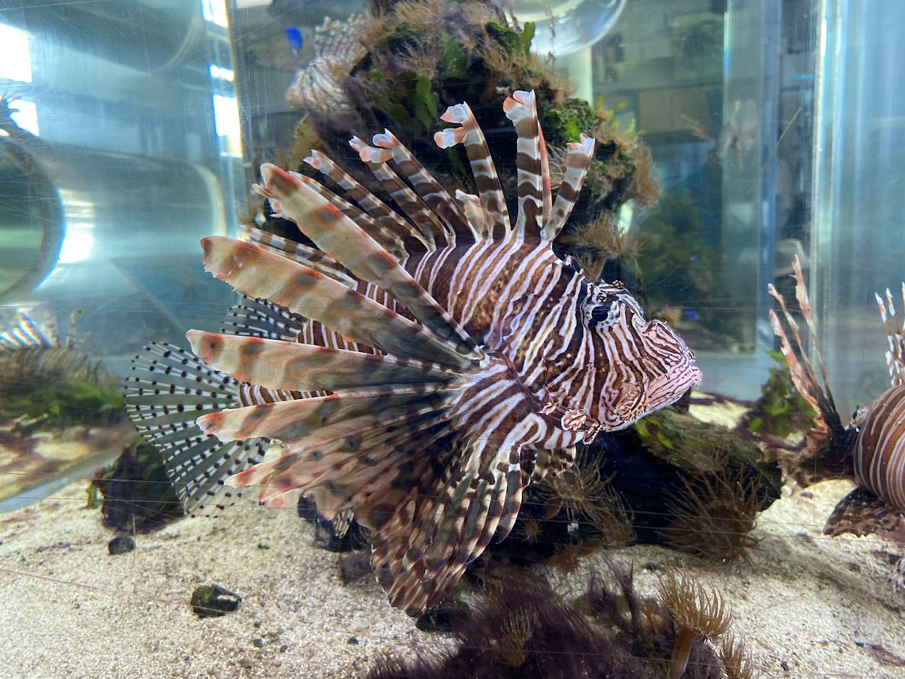
Figure S1. Photo of lionfish from the 2650-liter saltwater tank at the Sunrise Fish Dive Surf tackle shop in Port Canaveral Florida. Water was collected from this tank and used to test our assay. The tank contained eight lionfish and a few small non-scorpaenids. As this picture indicates, lionfish made up the bulk of the fish biomass in this tank. Water was collected and filtered, and DNA was extracted from the filters. Later these extractions were used to test our Taq-man assay.

Figure S2

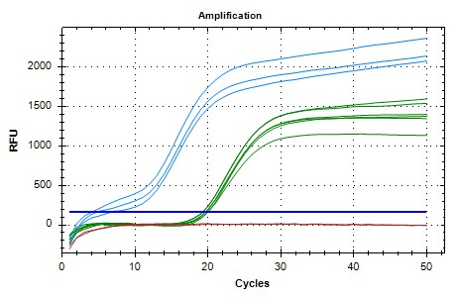
Figure S2. Representative qPCR curves. Shown are qPCR assays run using three types of template DNA including 1) gBlock (Table 1) (light blue); DNA extracted from 1-liter water samples taken from a 2650-liter saltwater tank containing lionfish (green, Fig. S2), and deionized water (no template negative control, red).

