Supplementary Tables

Supplementary Table 1. Antibodies used in the study.
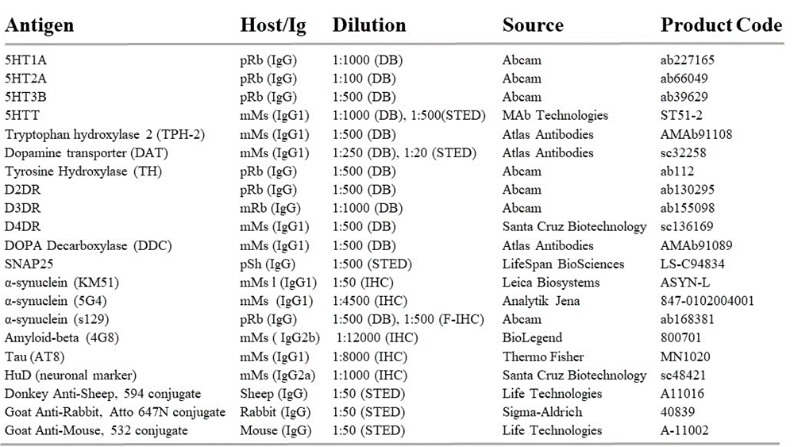
DB – dot blot; IHC – immunohistochemistry; m – monoclonal; p – polyclonal; Ms – mouse; Rb – rabbit, Gt – goat, Dk – donkey.

