Supplementary Figures

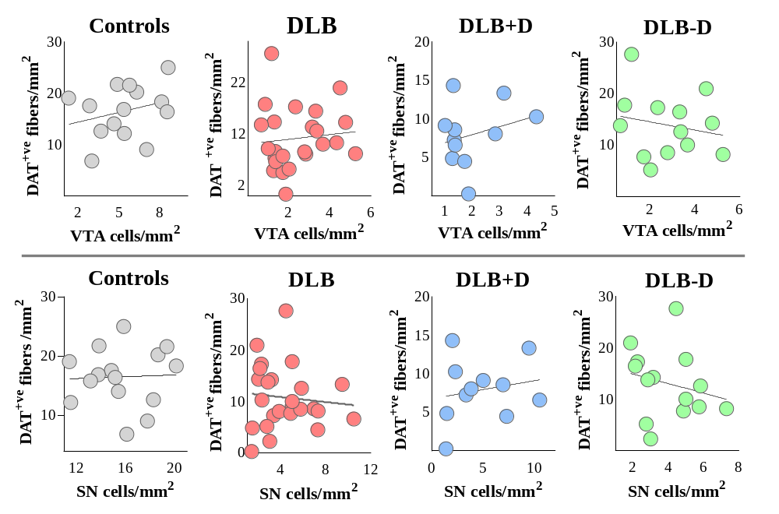
Supplementary Figure 1. Effect of dopaminergic neurons in VTA and SN on dopaminergic fibers in sgACC.
Top) Correlations between DAT+ve fibre density in sgACC and dopaminergic neurons in VTA; Bottom) and dopaminergic neurons in SN within controls, DLB cases with and without depression.

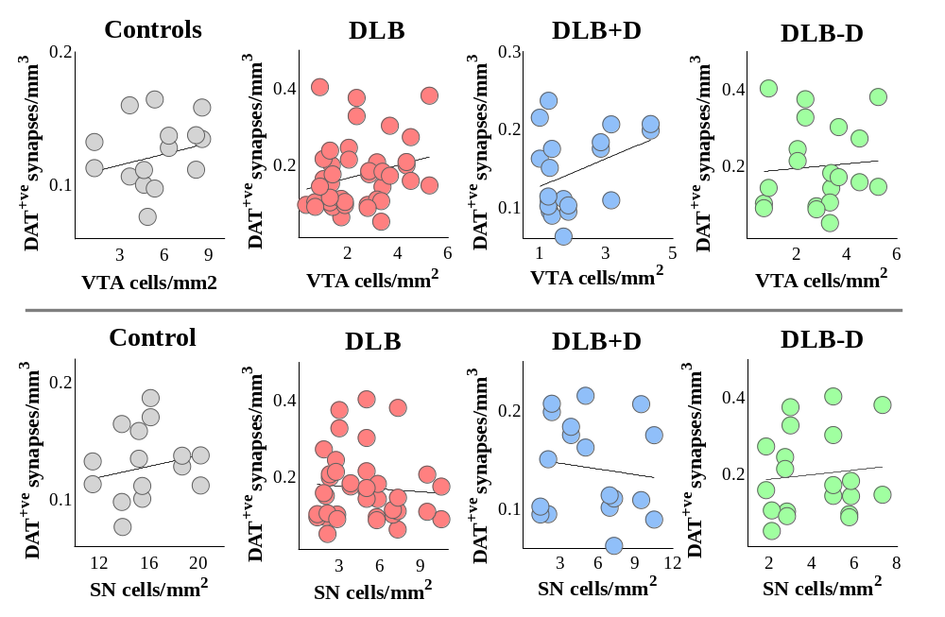
Supplementary Figure 2. Effect of dopaminergic neurons in VTA and SN on dopaminergic synapses in sgACC.
Top) Correlations between DAT+ve synapses in sgACC and dopaminergic neurons in VTA; Bottom) and dopaminergic neurons in SN within controls, DLB cases with and without depression. Significant positive correlation between dopaminergic neurones in VTA and DAT positive synapses in sgACC in DLB cases with depression (*p<0.05).

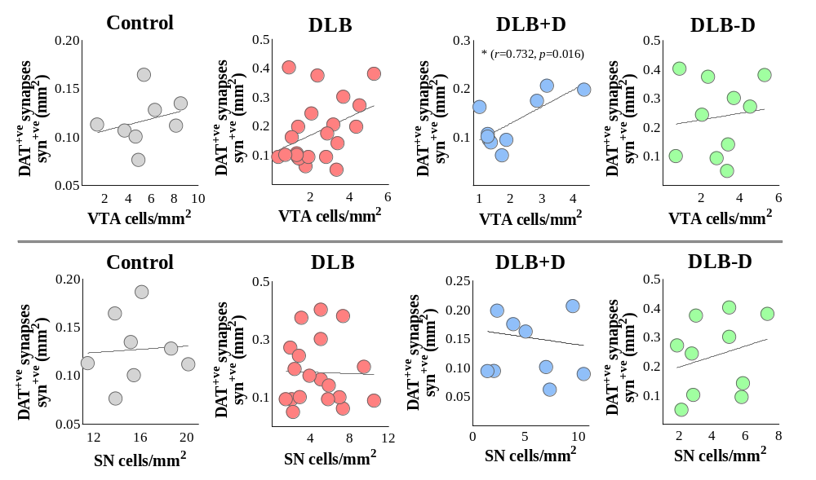
Supplementary Figure 3. Effect of dopaminergic neurons in VTA and SN on α-synuclein positive dopaminergic synapses in sgACC.
Top) Correlations between α-synuclein positive DAT+ve synapses in sgACC and dopaminergic neurons in VTA; Bottom) and dopaminergic neurons in SN within controls, DLB cases with and without depression. Significant positive correlation between dopaminergic neurones in VTA and α-synuclein positive DAT positive synapses in sgACC was observed in DLB cases with depression (*p<0.05).

