Sup. Figure 4.
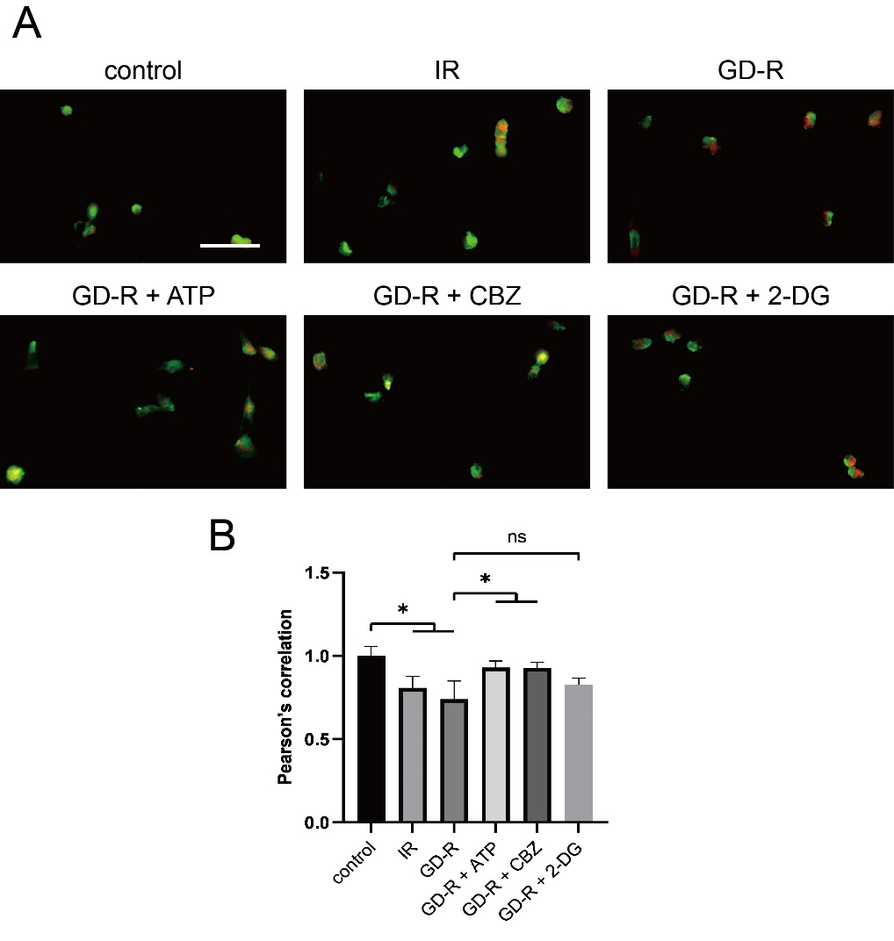
Sup. Figure 4. IR and GD-R induced dislocation of mTOR from lysosomes through inhibiting the function of V-ATPase. (A) IF images of mTOR (red) and LAMP1 (green). (B) Statistical analysis of colocalization of mTOR and LAMP1. Scale bar: 50 μm.
All data are shown as the mean ± SD (n=3). ns: not significant, *P < 0.05; t test.

