Sup. Figure 1.
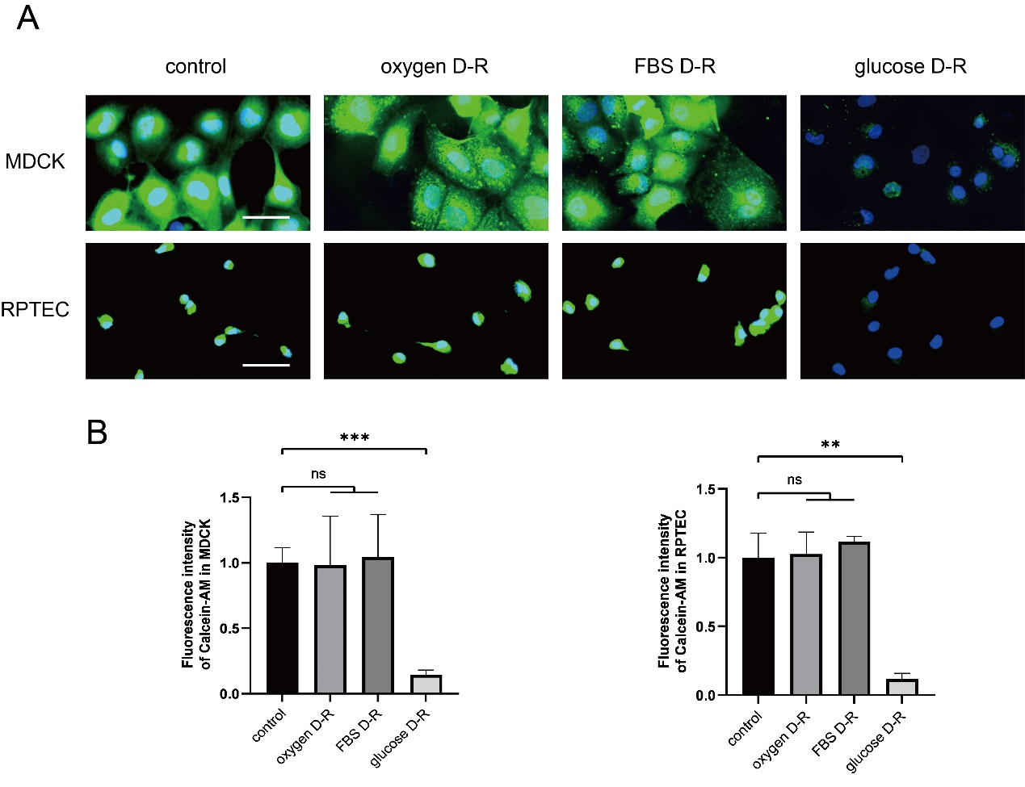Sup. Figure 1. The glucose deprivation-reperfusion is the key stimulator of increasing LIP in MDCK and RPTEC, while FBS or oxygen deprivation-reperfusion did not increase LIP. (A) Fluorescence images of calcein-AM. (B) Statistical analysis of relative fluorescence intensity of calcein-AM. Scale bar: 50 μm.
All data are shown as the mean ± SD (n=3). ns: not significant, **P < 0.01, ***P < 0.001; t test.

