Sup. Figure 8.
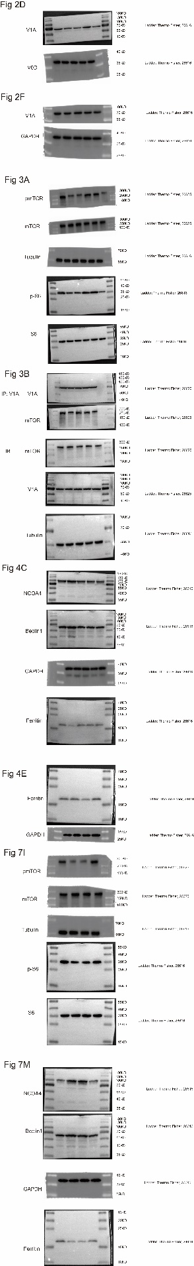

Sup. Figure 8. The original western blots.

