Sup. Figure 3.
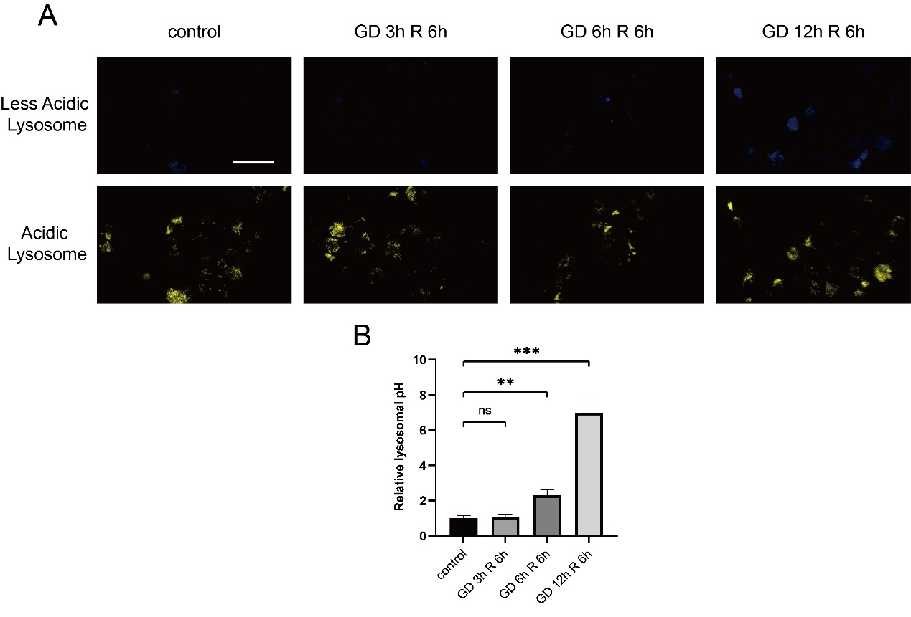
Sup. Figure 3. GD-R induced the alkalization of lysosomes in HK2 cells in a time-dependent manner. (A) Fluorescence images of LysoSensor. (B) Statistical analysis of the ratio of blue to yellow fluorescence intensity of LysoSensor. Scale bar: 50 μm.
All data are shown as the mean ± SD (n=3). ns: not significant, **P < 0.01, ***P < 0.001; t test.

