Sup. Figure 2.
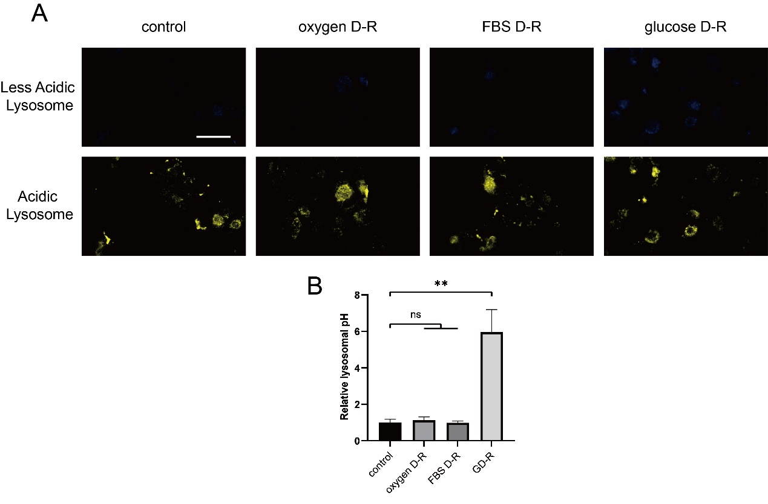
Sup. Figure 2. GD-R induced the alkalization of lysosomes in HK2 cells, while oxygen and FBS deprivation did not affect lysosomal pH levels. (A) Fluorescence images of Lysosensor. (B) Statistical analysis of the ratio of blue to yellow fluorescence intensity of Lysosensor. Scale bar: 50 μm.
All data are shown as the mean ± SD (n=3). ns: not significant, **P < 0.01; t test.

