Sup. Figure 7.

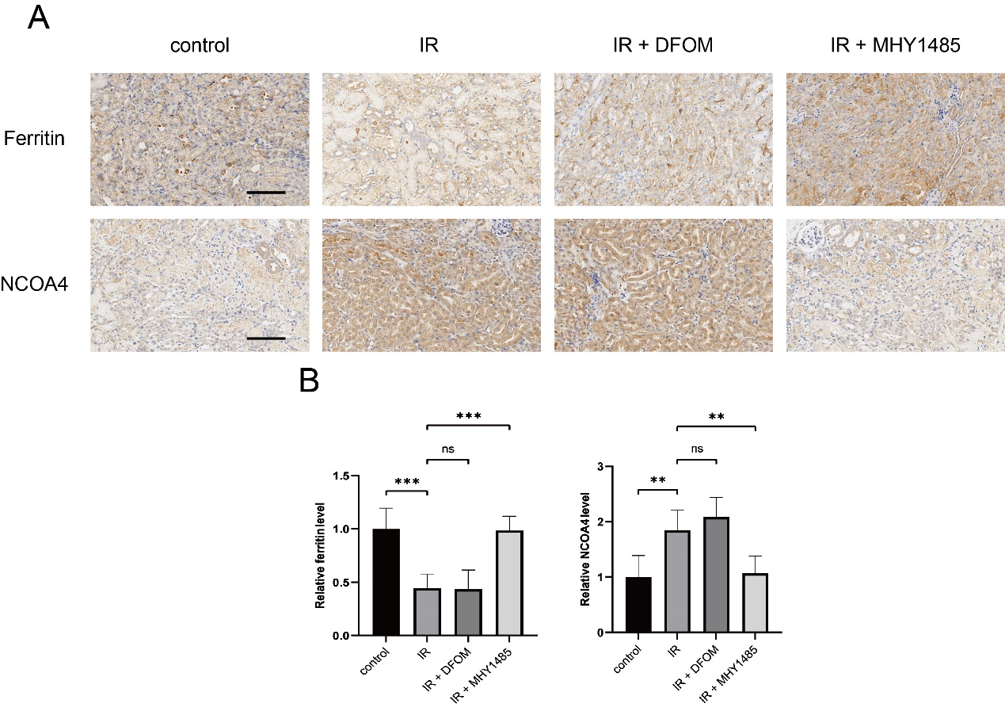
Sup. Figure 7. The increase of NCOA4 and decrease of Ferritin induced by IR were attenuated by MHY1485. (A) IHC images of Ferritin and NCOA4. (B) Statistical analysis of relative positive area of Ferritin and NCOA4. Scale bar: 100μm.
All data are shown as the mean ± SD (n=5). ns: not significant, **P < 0.01, ***P < 0.001; t test.

