Supplementary Table 1 Summary of all identified B-cell epitopes for constructing CMEV candidates.
Pathogens  (No. of total epitope) | Genes (No. of total epitope) | Protein name | Epitope sequence | Secondary structure | Length  (amino acid residues) | No. of analyzed program | RPS (%) | Accession No. | Reference
E. tarda  (13) | DegP (2) | Serine endoprotease | AQALPSLAPMLEKVMPSVVSINVE | ------HHHHHHHHHHHHEEEE-- | 24 | 3 | 89.0 | PVD94192.1 | 16
E. tarda  (13) | DegP (2) | Serine endoprotease | VPSQFQQFFGEDSPLCQPGSP | -----HHH------------- | 21 | 2 | 89.0 | PVD94192.1 | 16
E. tarda  (13) | Eta2 (1) | Skp-like molecular chaperone | EKIAVVNVASVFQQLPQRDAVAKQ | --EEEEEHHHHHHH---------- | 24 | 3 | 83.0 | ADR31356.1 | 17
E. tarda  (13) | Esa1 (5) | Putative surface antigen | LEDFYYSVGKYNATVKAVVTPLPR | ---HHH------EEEEEEEE---- | 24 | 3 | 79.0 | ADK94171.1 | 18
E. tarda  (13) | Esa1 (5) | Putative surface antigen | RVDLKLVFTEGKSAQIQQINIVGNH | --EEEEEEE-----EEEEEEE---- | 25 | 3 | 79.0 | ADK94171.1 | 18
E. tarda  (13) | Esa1 (5) | Putative surface antigen | IKQLLGRYGYAYPCVQTQPE | -HHHHHH------------- | 20 | 3 | 79.0 | ADK94171.1 | 18
E. tarda  (13) | Esa1 (5) | Putative surface antigen | KDKTVVLHMNIDAGNRYYVRQIRFV | ---EEEEEEEE-----EEEEEEEE- | 25 | 3 | 79.0 | ADK94171.1 | 18
E. tarda  (13) | Esa1 (5) | Putative surface antigen | RTGLGYVHNDLSDMQPQVAMW | ----------------EE--- | 21 | 2 | 79.0 | ADK94171.1 | 18
E. tarda  (13) | OmpA (2) | Outer membrane protein A | KAQGIQLAAKLSYPLMDNLDVYTRL | ---EEEEEH---------------- | 25 | 2 | 55.0 | GAC63059.1 | 19
E. tarda  (13) | OmpA (2) | Outer membrane protein A | KPRAALINCLAPDRRVVIEVKGI | -----EE-------EEEEEEE-- | 23 | 3 | 55.0 | GAC63059.1 | 19
E. tarda  (13) | GapA (1) | Glyceraldehyde-3-phosphate dehydrogenase A | TDEAVVSTDFNGEVCTSVFDA | ---EEE-------HHHHHH-- | 21 | 3 | 71.4 | SPW31014.1 | 20
E. tarda  (13) | Eta21 (2) | Putative peptidase | KGSVNLSFNCQVQYQRSQCAIHLET | ---EEEE--EEEEEE---EEEE--- | 25 | 3 | 69.0 | ACY64541.1 | 16
E. tarda  (13) | Eta21 (2) | Putative peptidase | SQQSGVVDIAPEAYQKLRQTFLSALTL | -----EEE--HHHHHHHHHHHHH---- | 27 | 2 | 69.0 | ACY64541.1 | 16
F. columnare  (9) | OmeP (3) | Outer membrane efflux protein precursor | KLTLSQLIFDGSYLVGLESAKTYLKI | --HHHHHH----EEE-----EEEE-- | 26 | 3 | 68.0 | ANO47148.1 | 21
F. columnare  (9) | OmeP (3) | Outer membrane efflux protein precursor | YGDVLLAQESIMIVERNKVILEKTL | ---HHH----EEEEE---EEE---- | 25 | 2 | 68.0 | ANO47148.1 | 21
F. columnare  (9) | OmeP (3) | Outer membrane efflux protein precursor | RQLYTSQQAYLQSMVEVITK | ---HHHHHHHHHHHHHHH-- | 20 | 3 | 68.0 | ANO47148.1 | 21
F. columnare  (9) | DnaK (6) | Molecular chaperone DnaK | TAAALAYGLDKAAHDKKIAVYDL | -HHHHHHH---------EEEE-- | 23 | 2 | Increase survival rate > 30% | PDS21884.1 | 22
F. columnare  (9) | DnaK (6) | Molecular chaperone DnaK | TEINLPYITATASGPKHLVQTLT | ------EEEE------EEEEE-- | 23 | 3 | Increase survival rate > 30% | PDS21884.1 | 22
F. columnare  (9) | DnaK (6) | Molecular chaperone DnaK | KFEQLADSLVKRSMEPVVKAL | --HHHHHHHHHHHHHHHHH-- | 21 | 2 | Increase survival rate > 30% | PDS21884.1 | 22
F. columnare  (9) | DnaK (6) | Molecular chaperone DnaK | DIDEVILVGGSTRIPVIQEQVEKF | ---EEEEE------HHHHHHHH-- | 24 | 3 | Increase survival rate > 30% | PDS21884.1 | 22
F. columnare  (9) | DnaK (6) | Molecular chaperone DnaK | RKSQVFSTAVDNQPSVEIHVLQGE | ----EEEE-------EEEEEE--- | 24 | 3 | Increase survival rate > 30% | PDS21884.1 | 22
F. columnare  (9) | DnaK (6) | Molecular chaperone DnaK | HLDGIPPAPRGVPQIEVTFD | -------------EEEEE-- | 20 | 3 | Increase survival rate > 30% | PDS21884.1 | 22
F. noatunensis  (20) | ClpB (7) | ATP-dependent chaperone ClpB | NNPVLIGEPGVGKTAIVEGLAQR | ---EEE------HHHHHHHHH-- | 23 | 2 | No data | PLR04593.1 | 23
F. noatunensis  (20) | ClpB (7) | ATP-dependent chaperone ClpB | RLKSVLKELSKQEGNVILFIDEL | -HHHHHHHHHH----EEEEE--- | 23 | 3 | No data | PLR04593.1 | 23
F. noatunensis  (20) | ClpB (7) | ATP-dependent chaperone ClpB | RFQKVLVDEPTVEDTIAILRG | ---EEEE-------HHHH--- | 21 | 3 | No data | PLR04593.1 | 23
F. noatunensis  (20) | ClpB (7) | ATP-dependent chaperone ClpB | SFLHKRVIGQDQAIKAVSNA | --HHHHH-----HHHHH--- | 20 | 2 | No data | PLR04593.1 | 23
F. noatunensis  (20) | ClpB (7) | ATP-dependent chaperone ClpB | RKPYSVILLDEVEKAHADIFNILLQVLDD | ----EEEEE--HHH-HHHHHHHHHH  HH-- | 29 | 3 | No data | PLR04593.1 | 23
F. noatunensis  (20) | ClpB (7) | ATP-dependent chaperone ClpB | EIAKIQIKRLEKRLADLSIGLEV | --HHHHHHHHHHHHHH------- | 23 | 2 | No data | PLR04593.1 | 23
F. noatunensis  (20) | ClpB (7) | ATP-dependent chaperone ClpB | ENPLALKLLDGEFKAEDKIVVDID | -----EEEE---------EEEE-- | 24 | 2 | No data | PLR04593.1 | 23
F. noatunensis  (20) | GroEL (6) | Molecular chaperone GroEL | VNTLANAVKVTLGPKGRNVVLDKSF | --HHHHHHHHH------EEEEE--- | 25 | 3 | 22.0-50.0 | ALK94214.1 | 24
F. noatunensis  (20) | GroEL (6) | Molecular chaperone GroEL | ARLVEELKALSKPCSDPKSIEQVGT | -HHHHHHHHH---------H----- | 25 | 2 | 22.0-50.0 | ALK94214.1 | 24
Supplementary Table 1 (cont.) Summary of all identified B-cell epitopes for constructing CMEV candidates.
Pathogens  (No. of total epitope) | Genes (No. of total epitope) | Protein name | Epitope sequence | Secondary structure | Length  (amino acid residues) | No. of analyzed program | RPS (%) | Accession No. | Reference
F. noatunensis  (20) | GroEL (6) | Molecular chaperone GroEL | DELDVVEGMQFDRGYLSPYF | ----EE---E---------- | 20 | 2 | 22.0-50.0 | ALK94214.1 | 24
F. noatunensis  (20) | GroEL (6) | Molecular chaperone GroEL | ENPYILIVDKKISNIRDLLPILEGV | ---EEEEEE--H-HHHHHHHHHH-- | 25 | 3 | 22.0-50.0 | ALK94214.1 | 24
F. noatunensis  (20) | GroEL (6) | Molecular chaperone GroEL | LATLVVNNMRGVVKVCAVKAP | HHHHHH-----EEEEEE---- | 21 | 3 | 22.0-50.0 | ALK94214.1 | 24
F. noatunensis  (20) | GroEL (6) | Molecular chaperone GroEL | HGIALLRKAIEAPLRQIVSNAGGESSVVVNQVK | --HHHHHHHHHHHHHHHHHH----HHHHHH--- | 33 | 3 | 22.0-50.0 | ALK94214.1 | 24
F. noatunensis  (20) | IglB (3) | Intracellular growth locus protein B | KYIQKVITVIDKLIDLQVNSII | -HHHHHHHHHHHHHHH------ | 22 | 3 | No data | ABK90199.1 | 23
F. noatunensis  (20) | IglB (3) | Intracellular growth locus protein B | WLKVQEVCQEDYDNVEVSILDVK | ---HHHHH------EEEEEEE-- | 23 | 3 | No data | ABK90199.1 | 23
F. noatunensis  (20) | IglB (3) | Intracellular growth locus protein B | SNACFFSVNSAKKVEEFVDG | ---EEEE----HHHHHHH-- | 20 | 2 | No data | ABK90199.1 | 23
F. noatunensis  (20) | OmpA (4) | Outer membrane protein A | QYNQLVGRVFAGLGEGVVNF | --HHHHHHHHHHH------- | 20 | 3 | No data | KXO64237.1 | 23
F. noatunensis  (20) | OmpA (4) | Outer membrane protein A | AAQTVAMPTIDESKYVLPAGIKQ | ---EEE--------EEEE----- | 23 | 2 | No data | KXO64237.1 | 23
F. noatunensis  (20) | OmpA (4) | Outer membrane protein A | EDGVACYTVNGDDVTVYLDTK | ---EEEEEE----EEEEE--- | 21 | 3 | No data | KXO64237.1 | 23
F. noatunensis  (20) | OmpA (4) | Outer membrane protein A | KAIASFVNFIKDSNISSVTVKGY | -HHHHHHHHHH-----EEEEE-- | 23 | 2 | No data | KXO64237.1 | 23
S. iniae  (14) | SagH (2) | Streptolysin S export transmembrane protein SagH | LINMLVTNYVDNAKTYDSIVKLYPQT | -HHHHHHHHH-----HHHHHHH---- | 26 | 2 | 80.0-92.6 | EKB52946.1 | 25
S. iniae  (14) | SagH (2) | Streptolysin S export transmembrane protein SagH | LINQLSHISPIKWVNDSLFFIIFG | -----------EE----EEEEEE- | 24 | 3 | 80.0-92.6 | EKB52946.1 | 25
S. iniae  (14) | Sia10 (1) | Putative secretory protein Sia10 | KAGSILQSSAGGYGHVAYVESVGS | ----EEE------EEEEEEE---- | 24 | 2 | 73.9-92.3 | ADJ51067.1 | 18
S. iniae  (14) | Pdha1 (2) | Pyruvate dehydrogenase (acetyl-transferring) E1 subunit alpha | NTPHLYTRAEAYGIPGFYCED | -----------------E--- | 21 | 3 | 66.7-74.1 | ESR10610.1 | 26
S. iniae  (14) | Pdha1 (2) |  | YGAVLALDKKDVFAPTYRDVFPGVKF | ---EEE----------HHHHHH---- | 26 | 2 | 66.7-74.1 | OHX26599.1 | 26
S. iniae  (14) | Sip11 (3) | Periplasmic_Binding_Protein_Type_2 | ASKPVADIVFGGSYTQYAQHPSLFEK | -------EEE---------------- | 26 | 2 | 69.7 | ADE61838.1 | 27
S. iniae  (14) | Sip11 (3) | Periplasmic_Binding_Protein_Type_2 | ANIKVIYPEEGSVFLPASAA | --EEEEE-----EEEE---- | 20 | 3 | 69.7 | ADE61838.1 | 27
S. iniae  (14) | Sip11 (3) | Periplasmic_Binding_Protein_Type_2 | DYDYVIKHKEDIVKHYSDIFVDLQS | ---EEHH-HHHHHHHHHHHEEE--- | 25 | 3 | 69.7 | ADE61838.1 | 27
S. iniae  (14) | Eno (3) | Enolase | SIITDVYAREVLDSRGNPTLEVEVYT | ---HHHHHHHHH------EEEEEEE- | 26 | 3 | 63.0 | EKB52954.1 | 3
S. iniae  (14) | Eno (3) | Enolase | WGAEVFHALKKILKERGLVTA | ---HHHHHHHHHHHH------ | 21 | 2 | 63.0 | EKB52954.1 | 3
S. iniae  (14) | Eno (3) | Enolase | KYNQLLRIEDQLGEVAQYKGIK | ---HHHHHHHHHHHH------- | 22 | 2 | 63.0 | EKB52954.1 | 3
S. iniae  (14) | Gapdh (3) | Glyceraldehyde-3-phosphate dehydrogenase | ELGSVPAMTTQEVDFVYASA | -------------EEEE--- | 20 | 2 | 63.0-77.8 | RLU98986.1 | 26
S. iniae  (14) | Gapdh (3) | Glyceraldehyde-3-phosphate dehydrogenase | KRVLVMDKVADQLIANVKTLVDKLSI | --EEHHHHHHHHHHHHHHHHHH  H--- | 26 | 3 | 63.0-77.8 | RLU98986.1 | 26
S. iniae  (14) | Gapdh (3) | Glyceraldehyde-3-phosphate dehydrogenase | DITPLIDTKAADFVEGLVQD | ----------HHHHHHHH-- | 20 | 2 | 63.0-77.8 | RLU98986.1 | 26
TilLV  (27) | Tis 1 (4) | Hypothetical protein | LRIVDSDLYSERSCCWVIEKEGRVVCKST | --EE---------EEEEEE---EEEE--- | 29 | 3 | No data | QJD15201.1 | 28
TilLV  (27) | Tis 1 (4) | Hypothetical protein | AIFLSHPFFRLLSSVVETHARSVLSKVSAVYTA | ---H—HHHHHHHHHHHHHHHH  HHHHHHHHH-- | 33 | 3 | No data | QJD15201.1 | 28
TilLV  (27) | Tis 1 (4) | Hypothetical protein | DLLFASCHNLSLKKSYISVASL | ---HH----------EEEE--- | 22 | 2 | No data | QJD15201.1 | 28
Supplementary Table 1 (cont.) Summary of all identified B-cell epitopes for constructing CMEV candidates.
Pathogens  (No. of total epitope) | Genes (No. of total epitope) | Protein name | Epitope sequence | Secondary structure | Length  (amino acid residues) | No. of analyzed program | RPS (%) | Accession No. | Reference
TiLV  (27) | Tis 1 (4) | Hypothetical protein | SDLDPLVPHRLLVSESDVSKIRVARQAHLKSLGL | ---------EEEE------EEEE-HHHHHH---- | 34 | 3 | No data | QJD15201.1 | 28
TiLV  (27) | Tis 2 (4) | Hypothetical protein | RSHTVKDVHRSLLTADKSLRKSFCFR | ----HHHHHHHHHH--HHHH------ | 26 | 3 | No data | AMR44594.1 | 6
TiLV  (27) | Tis 2 (4) | Hypothetical protein | LDKDLPLLPIRPKLESRVAVKK | ---------------------- | 22 | 3 | No data | AMR44594.1 | 6
TiLV  (27) | Tis 2 (4) | Hypothetical protein | TIEGLVVNLDDVVRGFYLDKAKVTVLSRS | --EEEEEE---HHHEEE-----EEEEE-- | 29 | 2 | No data | AMR44594.1 | 6
TiLV  (27) | Tis 2 (4) | Hypothetical protein | KAMLLISCSPGTYAKKRKVAVQE | --EEEEE----------EEEE-- | 23 | 2 | No data | AMR44594.1 | 6
TiLV  (27) | Tis 3 (5) | Hypothetical protein | PKATVRCILNNDATYVCSEQEY | ---EEEEEE-----EEE----- | 22 | 3 | No data | QJD15138.1
TiLV  (27) | Tis 3 (5) | Hypothetical protein | PKATVRCILNNDATYVCSEQEY | ---EEEEEE-----EEE----- | 24 | 3 | No data | QJD15138.1
TiLV  (27) | Tis 3 (5) | Hypothetical protein | RYTVASHKPATQKILPLPASAPLARELLMLI | --EE-----------------HHHHHHHH-- | 31 | 2 | No data | QJD15138.1
TiLV  (27) | Tis 3 (5) | Hypothetical protein | RWDVILLLECLDSTRVSQAVAQH | --HHHHHHH--------HHHH-- | 23 | 3 | No data | QJD15138.1
TiLV  (27) | Tis 3 (5) | Hypothetical protein | NRHRLALSVCKDEFRKGYQLAS | ---EEEEEE--HHHH------- | 22 | 2 | No data | QJD15138.1
TiLV  (27) | Tis 4 (5) | Hypothetical protein | VGRSLILTSRWTEYCATCVPAL | ---EEEEE-----HHH------ | 22 | 2 | No data | QAB07938.1 | 6
TiLV  (27) | Tis 4 (5) | Hypothetical protein | HNSLLRVCVRIEVWKARYVSLVALD | ----EEEEEEEE----EEEEEEE-- | 25 | 3 | No data | QAB07938.1 | 6
TiLV  (27) | Tis 4 (5) | Hypothetical protein | QWFPYLSGDSYRACPGLVGGY | --------------------- | 21 | 2 | No data | QAB07938.1 | 6
TiLV  (27) | Tis 4 (5) | Hypothetical protein | IIPPPRFLIIGHRLQIGDQVTLREL | ------EEEEEEE------EEE--- | 25 | 3 | No data | QAB07938.1 | 6
TiLV  (27) | Tis 4 (5) | Hypothetical protein | DLLEECIAIQKQDGVIKCKRSGKSLYHCLKET | --HHHHHHHH----EEEE------HHHHHH-- | 32 | 3 | No data | QAB07938.1 | 6
TiLV  (27) | Tis 5 (2) | Hypothetical protein | ECRDLEVYSTVLPGQCDCTR | -----EEEEEE--------- | 20 | 3 | No data | QAB07939.1 | 29
TiLV  (27) | Tis 5 (2) | Hypothetical protein | KQVPFYGSIKVLVFRRLRVVCFKTFFY | --------HHHHHHHHHHEEEE----- | 27 | 3 | No data | QAB07939.1 | 29
TiLV  (27) | Tis 6 (4) | Hypothetical protein | HFYLQDCPMSWLRVIRTLTLFSTLFS | ---------HHHHHHHHHHHHHHH-- | 26 | 3 | No data | AWK60418.1 | 29
TiLV  (27) | Tis 6 (4) | Hypothetical protein | LFETSLCLSKRRPIFSTCML | -------------------- | 20 | 2 | No data | AWK60418.1 | 29
TiLV  (27) | Tis 6 (4) | Hypothetical protein | TKQCWVLVESLEENHSPYKCHFSAVEVLLPA | ---EEEEEEH----------EEEEHHHH--- | 31 | 2 | No data | AWK60418.1 | 29
TiLV  (27) | Tis 6 (4) | Hypothetical protein | LNPVIDLSISPPVTVRSCCKI | --------------------- | 21 | 3 | No data | AWK60418.1 | 29
TiLV  (27) | Tis 7 (2) | Hypothetical protein | VPLKWKYEVSPGLPVRRVLAQ | -----EEE------HHHHH-- | 21 | 3 | No data | QMT29729.1
TiLV  (27) | Tis 7 (2) | Hypothetical protein | RSALVTSTRPLTELSRVATYLEA | ---EE-------HHHHHHHHH-- | 22 | 2 | No data | QMT29729.1
TiLV  (27) | Tis 10 (1) | Hypothetical protein | DEVDLEMDDCDSAIPEWARVDFN | ----------------------- | 23 | 2 | 44.5-61.1 | QIH29432.1 | 30
A. hydrophila  (20) | OmpA (10) | Porin OmpA | SVATLELVMHPNRSTYVAPVAAPAP | --EEEEEEE-------EE------- | 25 | 2 | 75.5-82.3 | AVP83691.1 | 31
A. hydrophila  (20) | OmpA (10) | Porin OmpA | EPVPEPVVVDKNFALSSDVLFAF | ------EEE----------EE-- | 23 | 3 | 75.5-82.3 | AVP83691.1 | 31
A. hydrophila  (20) | OmpA (10) | Porin OmpA | PEGVAALNTLYQQIVDVQPKDGSAVVVGYT | --HHHHHHHHHHHHHH------EEEEEE-- | 30 | 3 | 75.5-82.3 | AVP83691.1 | 31
A. hydrophila  (20) | OmpA (10) | Porin OmpA | RARTVADFLVGKGLPAGKVAI | ---HHHHHHHH---------- | 21 | 2 | 75.5-82.3 | AVP83691.1 | 31
A. hydrophila  (20) | OmpA (10) | Porin OmpA | KAKAQLIACLAPDRRVEVRVTGVQQV | -----EEEE-----EEEEEEEE---- | 26 | 2 | 75.5-82.3 | AVP83691.1 | 31
A. hydrophila  (20) | OmpA (10) | Porin OmpA | AQLAQLTMKIGLPVSESLDLY | -HHHHHHHH------------ | 21 | 3 | 75.5-82.3 | AVP83691.1 | 31
A. hydrophila  (20) | OmpA (10) | Porin OmpA | ARTVADYLVGKGLPAGKVNV | --HHHHHHH----------- | 20 | 2 | 75.5-82.3 | AVP83691.1 | 31
Supplementary Table 1 (cont.) Summary of all identified B-cell epitopes for constructing CMEV candidates.
Pathogens  (No. of total epitope) | Genes (No. of total epitope) | Protein name | Epitope sequence | Secondary structure | Length  (amino acid residues) | No. of analyzed program | RPS (%) | Accession No. | Reference
A. hydrophila  (20) | OmpA (10) | Porin OmpA | KKELIVCLAPDRRVEVKVEGIS | ---EEEEE-----EEEEEE--- | 22 | 2 | 75.5-82.3 | AVP86728.1 | 31
A. hydrophila  (20) | OmpA (10) | Porin OmpA | TLKPAASQALDNLFSQIVAA | ----HHHHHHHHHHHHHH-- | 20 | 2 | 75.5-82.3 | ANR98238.1 | 31
A. hydrophila  (20) | OmpA (10) | Porin OmpA | SKPALIACLAPDRRVEVRLEGVS | ----EEEEE----EEEEEE---- | 23 | 2 | 75.5-82.3 | ANR98238.1 | 31
A. hydrophila  (20) | Tdr (6) | TonB-dependent receptor | RAPTAPATPHNVQKLDRLSLGL | -----------HHHHHH----- | 22 | 2 | 95.6 | AJQ54916.1 | 32
A. hydrophila  (20) | Tdr (6) | TonB-dependent receptor | DASQSALYLQDEFSLGDLALTLS | -----EEEE--------EEEE-- | 23 | 2 | 95.6 | AJQ54916.1 | 32
A. hydrophila  (20) | Tdr (6) | TonB-dependent receptor | KIKVTGSRISRVDVEGATPVVAISK | -EEEE---EEEEE------EEEE-- | 25 | 2 | 95.6 | ORJ65912.1 | 32
A. hydrophila  (20) | Tdr (6) | TonB-dependent receptor | QATVSLRGLGSERTLVLLNGK | --EEEEE-----EEEEEE--- | 21 | 3 | 95.6 | ORJ65912.1 | 32
A. hydrophila  (20) | Tdr (6) | TonB-dependent receptor | TVYVNGRYHINDSVDFVPQLIGSRVT | -EEE--EEE-----HHHHHHHH---- | 26 | 3 | 95.6 | ORJ65912.1 | 32
A. hydrophila  (20) | Tdr (6) | TonB-dependent receptor | DLNLSLDYYYIKIDDVIQLA | ----EEEEEEEEE--EE--- | 20 | 3 | 95.6 | ORJ65912.1 | 32
A. hydrophila  (20) | Aer (4) | Aerolysin | EPVYPDQLRLFSLGQEVCGDK | --------EEEE--------- | 21 | 3 | 55.0-100.0 | KTA90213.1 / AKJ36485.1 | 33
A. hydrophila  (20) | Aer (4) | Aerolysin | LSQSVRPTVPAHSKIPVKIELYK or LSQSVRPTVPARSKIPVKIELYK | ---------------EEEEEE-- | 23 | 3 | 55.0-100.0 | KTA90213.1 / AKJ36485.1 | 33
A. hydrophila  (20) | Aer (4) | Aerolysin | KFQWPLVGETELAIEIAASQS | ----------EEEEEEE---- | 21 | 2 | 55.0-100.0 | KRW48464.1 | 33
A. hydrophila  (20) | Aer (4) | Aerolysin | TVSVEARPTVPPHSSLPVRVALYKSN | -EEEE------------EEEEEE--- | 26 | 3 | 55.0-100.0 | KRW48464.1 | 33
S. agalactiae  (14) | Bac (10) | C protein beta antigen | ASELVKDDSVKTTEVAAKPYPS | ------------EEE------- | 22 | 3 | 57.1-76.2 | BAE45252 | 13
S. agalactiae  (14) | Bac (10) | C protein beta antigen | DALLELENQFNETNRLLHIKQ | --HHHHHHHHHHHHHHEE--- | 21 | 2 | 57.1-76.2 | BAE45252 | 13
S. agalactiae  (14) | Bac (10) | C protein beta antigen | PELKQLEEEAHSKLKQVVED | ---HHHHHHHHHHHHHHH-- | 20 | 2 | 57.1-76.2 | BAE45252 | 13
S. agalactiae  (14) | Bac (10) | C protein beta antigen | EKYFLTPFNKIKQIVDDLDK | -------HHHHHHHHH---- | 20 | 2 | 57.1-76.2 | BAE45252 | 13
S. agalactiae  (14) | Bac (10) | C protein beta antigen | KIAVSKYMSKVLDGVHQHLQK | --HHHHHHHHHHHHHHHHH-- | 21 | 3 | 57.1-76.2 | BAE45252 | 13
S. agalactiae  (14) | Bac (10) | C protein beta antigen | APRVPESPKTPEAPHVPESP | -------------------- | 20 | 2 | 57.1-76.2 | BAE45252 | 13
S. agalactiae  (14) | Bac (10) | C protein beta antigen | TPDVPKLPDVPKLPDVPKLPDAPKLP | -------------------------- | 26 | 3 | 57.1-76.2 | BAE45252 | 13
S. agalactiae  (14) | Bac (10) | C protein beta antigen | NTKVTVVFDKPTDADKLHLKEVT | --EEEEEE--------EEE---- | 23 | 3 | 57.1-76.2 | BAE45252 | 13
S. agalactiae  (14) | Bac (10) | C protein beta antigen | RTVRLALGQTGSDVHVYHVKE | --EEEEE------EEEEEE-- | 21 | 3 | 57.1-76.2 | BAE45252 | 13
S. agalactiae  (14) | Bac (10) | C protein beta antigen | VENGQVVFKTNHFSLFAIKTL | ----EEEEE-----EEEE--- | 21 | 3 | 57.1-76.2 | BAE45252 | 13
S. agalactiae  (14) | Rib (1) | Surface protein Rib | AKVVVTYPDGSKDTVYVTVKVVDP | -EEEEE-------EEEEEEEE--- | 24 | 3 | 57.1-76.2 | EAO72273 | 13
S. agalactiae  (14) | Sip (1) | Group B Streptococcal surface immunogenic protein | EVKSVPVAQKAPTATPVAQP | ---EE--------------- | 20 | 3 | 57.1-76.2 | AUP09114 | 13
S. agalactiae  (14) | Csf (1) | Cell surface protein | VQGVYLLKTPLPLPEYYIGLNVYF | ---EEEE--------EEEE--E-- | 24 | 3 | 57.1-76.2 | AIK73093 | 13
S. agalactiae  (14) | Spb (1) | Surface protein Spb1 | GTEKVYQYVIKDTMPSASVVDL | ---HHHHHHHH----------- | 22 | 3 | 57.1-76.2 | WP_000913277 | 13
Note: "H” and “E” in secondary structure indicate α-helix and β-sheet structures; The number in blanket indicates total number of identified epitopes of each pathogen
Supplementary Table 2 The supported data for the selected B-cell epitopes of constructed CMEV candidates.
Pathogens | Epitope sequence | Secondary structure | Hydropho-bicity (%) | Length  (amino acid residues) | Position from N-terminus | No. of analyzed program | RPS (%) | Reference
E. tarda | AQALPSLAPMLEKVMPSVVSINVE | ------HHHHHHHHHHHHEEEE-- | 66.67 | 24 | 35-58 | 3 | 89.0 | 16
E. tarda | EKIAVVNVASVFQQLPQRDAVAKQ | --EEEEEHHHHHHH---------- | 54.17 | 24 | 37-60 | 3 | 83.0 | 17
F. columnare | RQLYTSQQAYLQSMVEVITK | ---HHHHHHHHHHHHHHH-- | 35.00 | 20 | 410-429 | 3 | 68.0 | 21
F. columnare | KFEQLADSLVKRSMEPVVKAL | --HHHHHHHHHHHHHHHHH-- | 52.38 | 21 | 298-318 | 2 | Increase survival rate > 30% | 22
F. columnare | DIDEVILVGGSTRIPVIQEQVEKF | ---EEEEE------HHHHHHHH-- | 45.83 | 24 | 327-350 | 3 | Increase survival rate > 30% | 22
F. noatunensis | RKPYSVILLDEVEKAHADIFNILLQVLDD | ----EEEEE--HHH-HHHHHHHHHHHH-- | 51.72 | 29 | 670-698 | 3 | No data | 23
F. noatunensis | EIAKIQIKRLEKRLADLSIGLEV | --HHHHHHHHHHHHHH------- | 47.83 | 23 | 774-796 | 2 | No data | 23
F. noatunensis | KYIQKVITVIDKLIDLQVNSII | -HHHHHHHHHHHHHHH------ | 50.00 | 22 | 71-92 | 3 | No data | 23
F. noatunensis | HGIALLRKAIEAPLRQIVSNAGGESSVVVNQVK | --HHHHHHHHHHHHHHHHHH----HHHHHH--- | 48.48 | 33 | 438-470 | 3 | 22.0-50.0 | 24
S. iniae | DYDYVIKHKEDIVKHYSDIFVDLQS | ---EEHH-HHHHHHHHHHHEEE--- | 32.00 | 25 | 319-343 | 3 | 69.7 | 27
S. iniae | KYNQLLRIEDQLGEVAQYKGIK | ---HHHHHHHHHHHH------- | 31.82 | 22 | 407-428 | 2 | 63.0 | 6
S. iniae | KRVLVMDKVADQLIANVKTLVDKLSI | --EEHHHHHHHHHHHHHHHHHHH--- | 53.85 | 26 | 288-313 | 3 | 63.0-77.8 | 26
TiLV | AIFLSHPFFRLLSSVVETHARSVLSKVSAVYTA | ---H—HHHHHHHHHHHHHHHHH  HHHHHHHH-- | 54.55 | 33 | 153-188 | 3 | No data | 28
TiLV | KQVPFYGSIKVLVFRRLRVVCFKTFFY | --------HHHHHHHHHHEEEE----- | 51.85 | 27 | 295-321 | 3 | No data | 29
TiLV | HFYLQDCPMSWLRVIRTLTLFSTLFS | ---------HHHHHHHHHHHHHHH-- | 50.00 | 26 | 2-27 | 3 | No data | 29
A. hydrophila | PEGVAALNTLYQQIVDVQPKDGSAVVVGYT | --HHHHHHHHHHHHHH-----EEEEEE-- | 46.67 | 30 | 223-252 | 3 | 75.5-82.3 | 30
A. hydrophila | TVYVNGRYHINDSVDFVPQLIGSRVT | -EEE--EEE-----HHHHHHHH---- | 38.46 | 26 | 293-320 | 3 | 95.6 | 32
A. hydrophila | TVSVEARPTVPPHSSLPVRVALYKSN | -EEEE------------EEEEEE--- | 50.00 | 26 | 299-324 | 3 | 55.0-100.0 | 33
S. agalactiae | DALLELENQFNETNRLLHIKQ | --HHHHHHHHHHHHHHEE--- | 38.10 | 21 | 146-166 | 2 | 57.1-76.2 | 13
S. agalactiae | KIAVSKYMSKVLDGVHQHLQK | --HHHHHHHHHHHHHHHHH-- | 38.10 | 21 | 747-767 | 3 | 57.1-76.2 | 13
S. agalactiae | GTEKVYQYVIKDTMPSASVVDL | ---HHHHHHHH----------- | 40.91 | 22 | 214-235 | 3 | 57.1-76.2 | 13
Note: "H” and “E” in secondary structure indicate α-helix and β-sheet structures
Supplementary Figure 1. Amino acid type prediction of the CMEVs. [A-C] The amino acid profile of OSLM0467, OSLM2629, and OSLM4294. Orange, green, red, and blue represented amino acid types of small nonpolar, hydrophobic, polar, and aromatics plus cysteine, respectively.
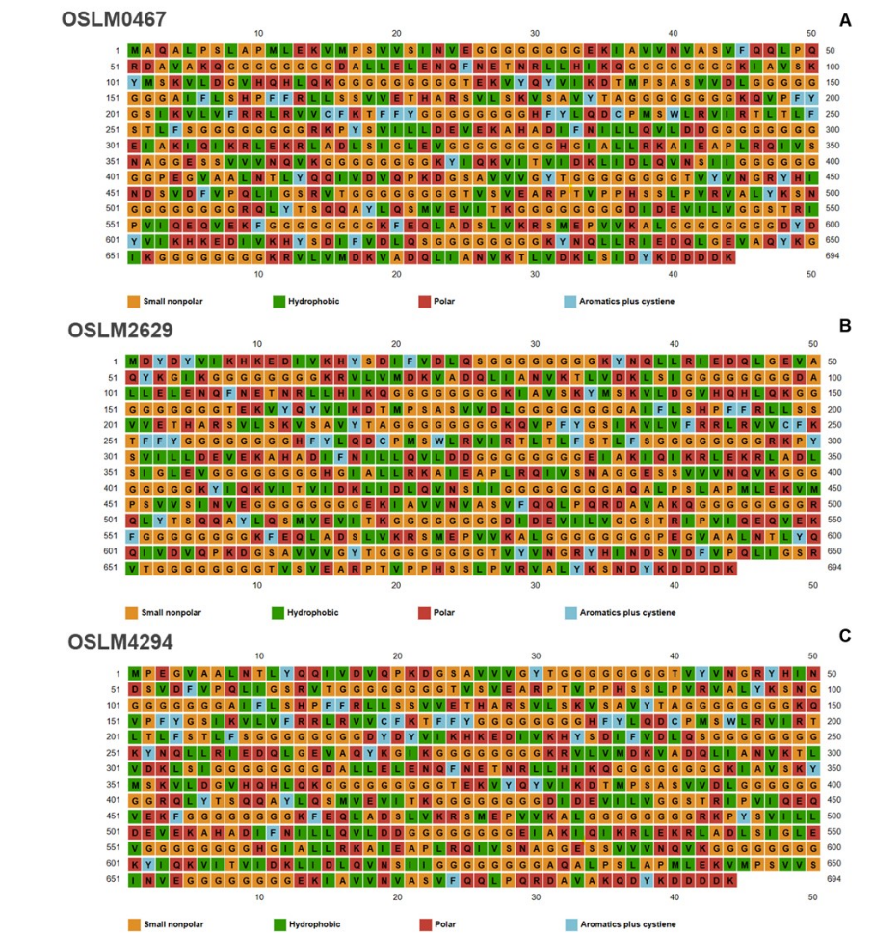

Supplementary Figure 2. In silico simulation of the immune responses after vaccination with the selected CMEVs. [A-C] The district isotypes of the PLB cell population (IgM, IgG1, IgG2), [D-F] B-cell population per state, [G-I] T-Helper cell induction, [K-M] Cytotoxic T-cell proliferation, and [N-P] NK cell stimulation after post-vaccination with OSLM0467, OSLM2629 and OSLM4294.
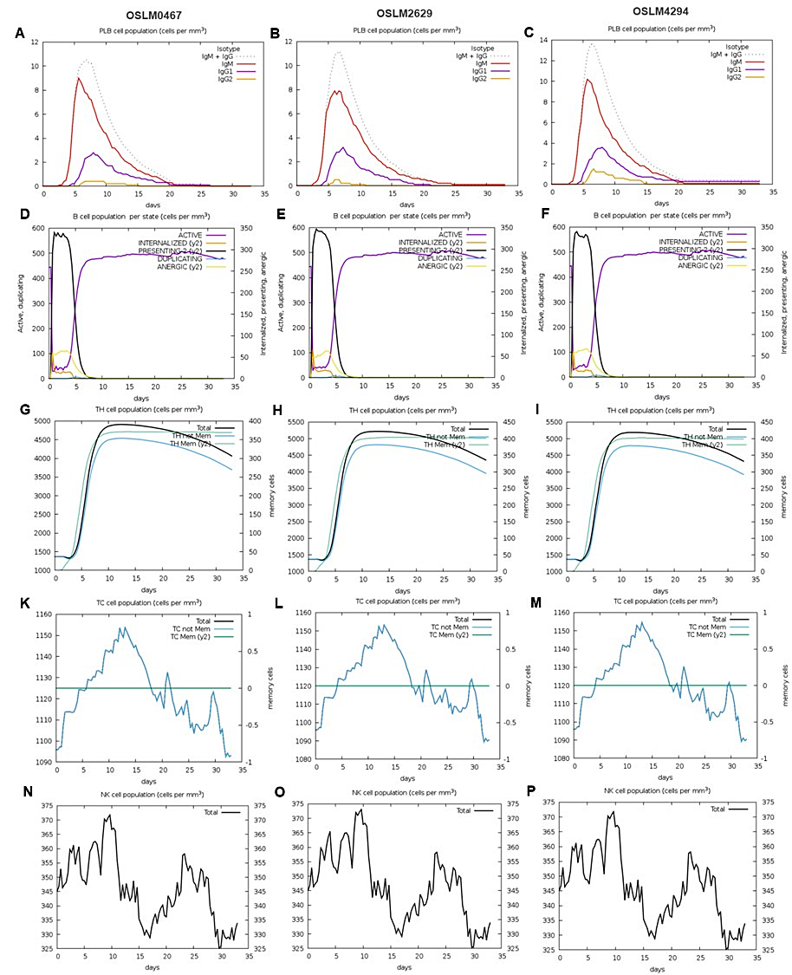

Supplementary Figure 3. Histogram of the codon-optimized CMEV candidates based on codon bias of E. coli and Nile tilapia (Oreochromis niloticus 113 CDS gene). [A-C] The codon quality distribution of the OSLM0467, OSLM2629, and OSLM4294 which adjusted to E. coli codon usage, and [G-I] adapted to O. niloticus codon bias. The plot explained the percentage of sequence codons that fall into a certain quality class. The CAI of the optimized CMEV genes was 0.94 and 0.87 for E. coli [A-C] and O. niloticus [G-I] adaptations. The average GC content in the ideal range (between 30%-80%) of CMEVs adjusted to E. coli was observed in [D-F] and adapted to O. niloticus was noticed in [J-L].
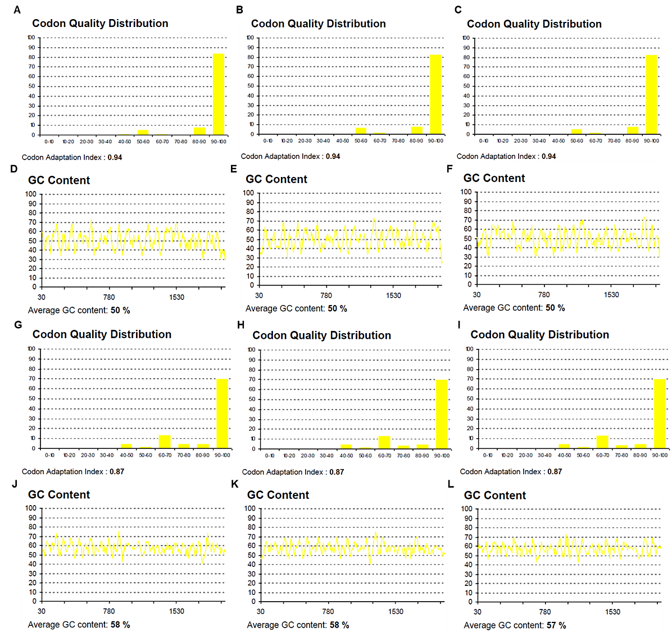

Supplementary Figure 4. The MFE secondary structure of the optimized CMEVs’ RNA folding. [A-C] The predicted RNA structures of OSLM0467, OSLM2629, and OSLM4294, respectively. Green, red, yellow, blue, and orange colors indicated the structures of stems (canonical helices), multiloops (junctions), interior loops, hairpin loops, and 5' and 3' unpaired regions.

