SUPPLEMENTARY MATERIAL

Article title: On testing the effectiveness of soil microbial inoculants in integrated pest management for commercial tomato production

Journal:
Agronomy for Sustainable Development

Authors: Zhivko Minchev^{1,9,}, Beatriz Ramírez-Serrano^{1,10}, Laura Dejana¹, Ana S. Lee Díaz², Guadalupe Zitlalpopoca-Hernandez³, Dimitri Orine⁴, Haymanti Saha⁵, Dimitra Papantoniou^{6,7}, Juan M. García¹, Alicia Gonzalez-Céspedes⁸, Paolina Garbeva², Nicole M. van Dam^{6,7}, Roxina Soler⁹, David Giron¹⁰, Ainhoa Martínez-Medina¹¹, Arjen Biere⁵, Thure Hauser³, Nicolai V. Meyling³, Sergio Rasmann⁴, María J. Pozo^{1,*}

Affiliations:
¹Department of Soil and Plant Microbiology, Estación Experimental del Zaidín, CSIC, Calle Profesor Albareda 1, 18008 Granada, Spain
²Department of Microbial Ecology, The Netherlands Institute of Ecology (NIOO-KNAW), Droevendaalsesteeg 10, 6708 PB Wageningen, The Netherlands
³Department of Plant and Environmental Sciences, University of Copenhagen, Thorvaldsensvej 40, 1871 Frederiksberg C, Denmark
⁴Institute of Biology, University of Neuchâtel, Rue Emile-Argand 11, 2000 Neuchâtel, Switzerland
⁵Department of Terrestrial Ecology, Netherlands Institute of Ecology (NIOO-KNAW), Droevendaalsesteeg 10, 6708 PB Wageningen, The Netherlands
⁶German Centre for Integrative Biodiversity Research (iDiv) Halle-Jena-Leipzig, Puschstrasse 4, 04103 Leipzig, Germany
⁷Institute of Biodiversity, Friedrich-Schiller Universität Jena, Dornburger Str. 159, 07743 Jena, Germany
⁸Estación Experimental Cajamar, Paraje las Palmerillas, 25, 04710 El Ejido, Spain
⁹Agronomical Development Department, Business Unit Microbiology, Koppert Biological Systems, Veilingweg 14, 2651 BE Berkel en Rodenrijs, The Netherlands
¹⁰Institut de Recherche sur la Biologie de l'Insecte (IRBI), UMR 7261 CNRS/Université de Tours, Avenue Monge, Parc Grandmont, 37200 Tours, France
¹¹Department of Plant-Microbe Interactions, Institute of Natural Resources and Agrobiology of Salamanca, CSIC, Calle Cordel de Merinas 40, 37008 Salamanca, Spain
* Corresponding author
E-mail address of the corresponding author:

- Supplementary figures

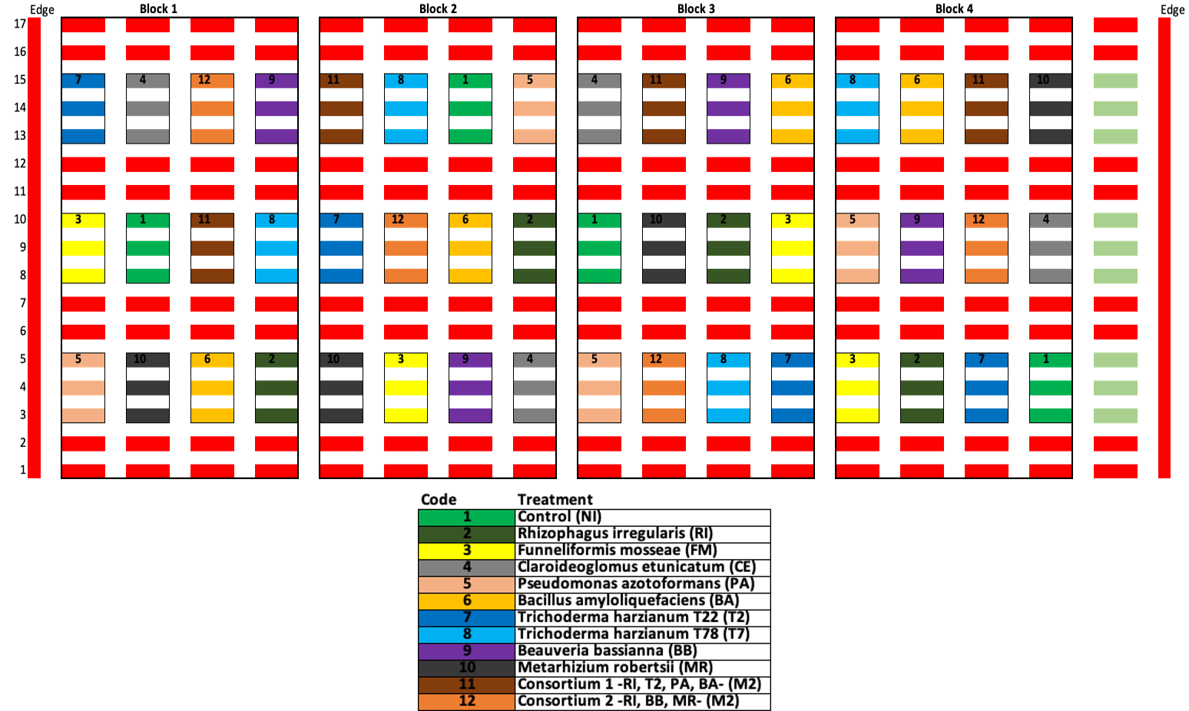
Figure S1. Treatment distribution within the greenhouse, consisting of 12 treatments, and four blocks. Each block contains 6 plants from each treatment grouped together giving a total of 24 plants for each treatment. Groups of plants from different treatments are randomly distributed within the different blocks. Each rectangle represents 2 plants. Red color indicates border plants.

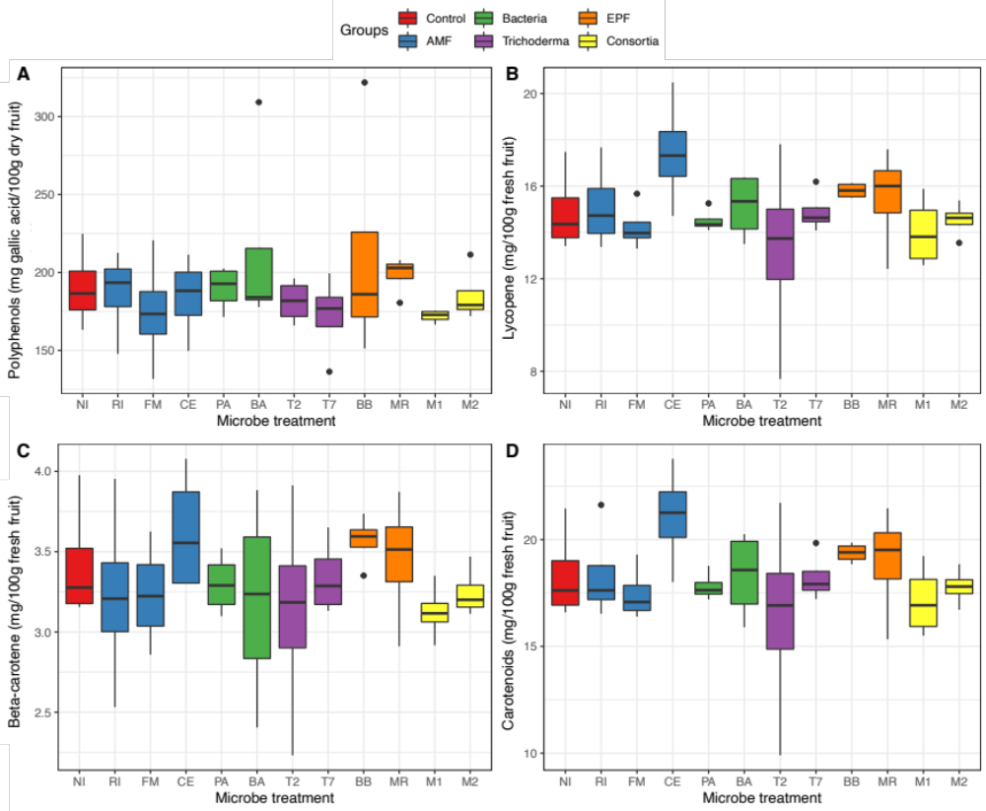

Figure S2. Effect of the microbial treatments on fruit nutritional properties. Tomato fruit content in (A) total polyphenols, (B) lycopene, (C) beta-carotene, and (D) total carotenoids. Plants were inoculated with: R. irregularis (RI), F. mosseae (FM), C. etunicatum (CE), P. azotoformans (PA), B. amyloliquefaciens (BA), T. afroharzianum T22 (T2) and T. harzianum T78 (T7), B. bassiana (BB), M. robertsii (MR), consortium 1 (M1) including RI+PA+BA+T2 and consortium 2 (M2) including RI+BB+MR. Non-inoculated plants were included as a control (NI). Boxes represent the interquartile range, black lines represent the median, whiskers represent maximum and minimum within 1.5 times the interquartile range, and black dots represent outliers.

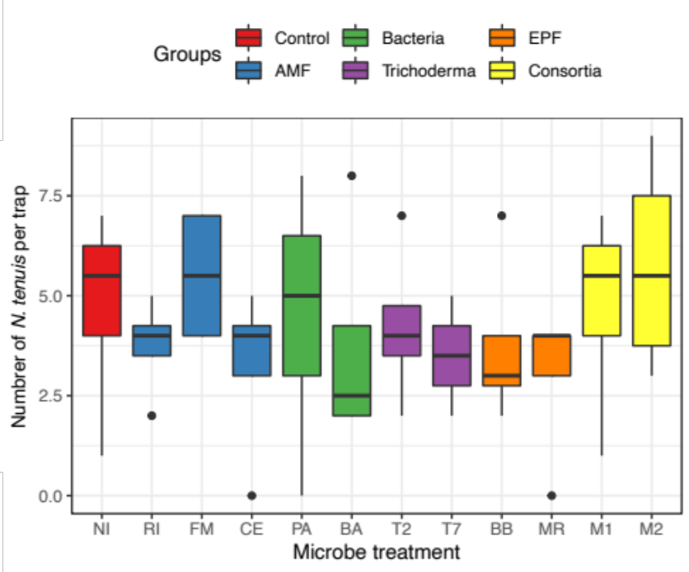

Figure S3. Impact of microbial inoculation on N. tenuis incidence. Plants were inoculated with: R. irregularis (RI), F. mosseae (FM), C. etunicatum (CE), P. azotoformans (PA), B. amyloliquefaciens (BA), T. afroharzianum T22 (T2) and T. harzianum T78 (T7), B. bassiana (BB), M. robertsii (MR), consortium 1 (M1) including RI+PA+BA+T2 and consortium 2 (M2) including RI+BB+MR. Non-inoculated plants were included as a control (NI). Boxes represent the interquartile range, black lines represent the median, whiskers represent maximum and minimum within 1.5 times the interquartile range, and black dots represent outliers.

- Supplementary tables

Table S1. Irrigation scheme and nutrient supply during the cropping season.
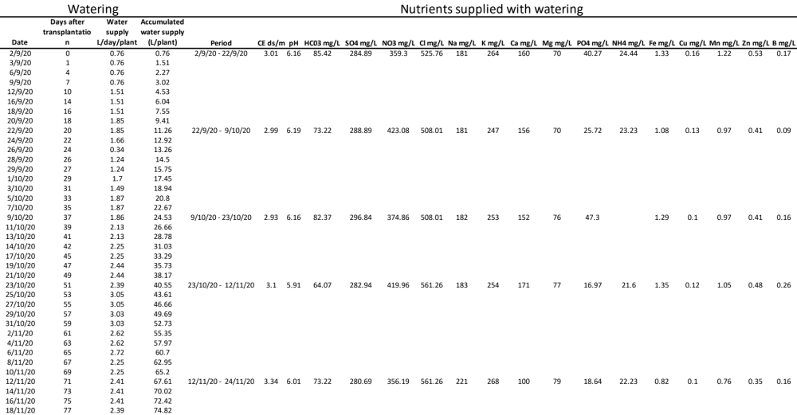

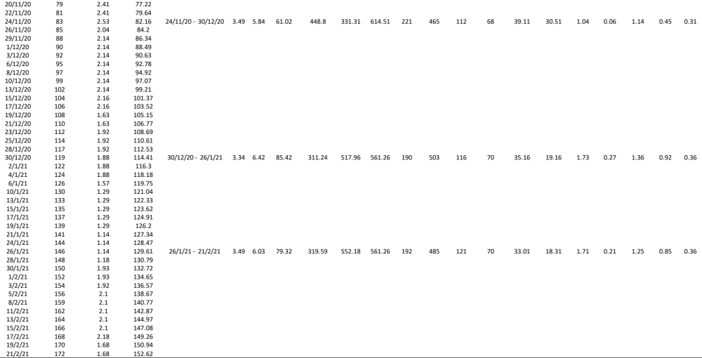

Table S2. Overview of the statistical analyses performed on each of the 17 variables measured during the experiment.
Theme | Variable | Unit | N | Model | Distribution | Blocking factors
Plant growth, nutritional status and flowering | Plant height | Length (cm) | 284 | lm | Normal | block
Plant growth, nutritional status and flowering | CN | Ratio | 144 | lm | Normal | block
Plant growth, nutritional status and flowering | Flowers | Count | 144 | lm | Normal | block
Fruit yield | Tomato production | Weight (g) | 480 | glm | Quasipoisson | day + day/block
 |  |  |  |  |  | block
Fruit quality and nutraceutical value | ºBrix | Relative amount | 48 | lm | Normal | block
Fruit quality and nutraceutical value | %Acidity | Percentage | 48 | lm | Normal | block
Fruit quality and nutraceutical value | Maturity index | Ratio | 48 | lm | Normal | block
Fruit quality and nutraceutical value | %Dry weight | Percentage | 48 | lm | Normal | block
Fruit quality and nutraceutical value | Total polyphenols | Relative amount | 48 | lm | Normal | block
Fruit quality and nutraceutical value | Lycopene | Relative amount | 48 | lm | Normal | block
Fruit quality and nutraceutical value | b-carotene | Relative amount | 48 | lm | Normal | block
Fruit quality and nutraceutical value | Caroteoinds | Relative amount | 48 | lm | Normal | block
Insect incidence | Thrips | Count | 144 | glm | Quasipoisson | block
Insect incidence | Tuta absoluta | Presence/absence | 284 | glm | Binomial | block
Insect incidence | Nesidiocoris tenuis | Count | 48 | lm | Normal | block
Insect incidence | Whiteflies | Count | 48 | lm | Normal | block
Pathogen incidence | Powdery mildew | Presence/absence | 144 | glm | Binomial | block

Table S3. Effect of microbial inoculation on tomato fruit quality parameters. Plants were inoculated with: R. irregularis (RI), F. mosseae (FM), C. etunicatum (CE), P. azotoformans (PA), B. amyloliquefaciens (BA), T. afroharzianum T22 (T2) and T. harzianum T78 (T7), B. bassiana (BB), M. robertsii (MR), consortium 1 (M1) including RI+PA+BA+T2 and consortium 2 (M2) including RI+BB+MR. Non-inoculated plants were included as a control (NI). Numbers are mean value ± standard error. Asterisks indicate statistically significant difference compared to the control (*p<0.05).

