< Supplementary information >
Metabolic Brain Disease
Tribuli Fructus alleviates 1-methyl-4-phenyl 1,2,3,6-tetrahydropyridine (MPTP)-induced Parkinson’s disease by suppressing neuroinflammation via JNK signaling
Jin Hee Kim, Eugene Huh, Jin Se Kim, Youngji Kwon, Hyeyoon Eo, In Gyoung Ju, Yujin Choi, Hae-Jee Yoon, So-Ri Son, Dae Sik Jang, Seon-Pyo Hong, Myung Sook Oh*

* Corresponding author: Myung Sook Oh, K.M.D., Ph.D.
Department of Oriental Pharmaceutical Science and Kyung Hee East-West Pharmaceutical Research Institute, College of Pharmacy, Kyung Hee University, Seoul, 02447, Republic of Korea
Tel.: +82 2 961 9436; Fax: +82 2 963 9436; E-mail address: msohok@khu.ac.kr

Material & Method
Materials
Dulbecco’s Modified Eagle’s Medium (DMEM), fetal bovine serum (FBS), penicillin-streptomycin (P/S) were purchased from Hyclone Laboratories, Inc. (Logan, UT, USA). JNK, phospho-JNK were purchased from Cell Signaling Technology (Danvers, MA, USA). Rabbit anti-ionized calcium-binding adapter molecule-1 (Iba-1) was purchased from Fujifilm Wako (Chuo-Ku, Osaka, Japan). Rabbit anti-tyrosine hydroxylase (TH) was purchased from Merck Millipore (Burlington, MA, United States). Mouse HRP-conjugated β-actin antibody and goat anti-Glial fibrillary acidic protein (GFAP) were purchased from Santa Cruz Biotechnology (Temecula, CA, USA). Anti-rabbit horseradish peroxidase (HRP) secondary antibodies were purchased from Enzo Life Science, Inc. (Farmingdale, NY, USA). Skim milk was purchased from BD Transduction Laboratories (Franklin Lakes, NJ, USA). Polyvinylidene difluoride (PVDF) was purchased from Millipore (Burlington, MA, USA). Tetramethylethylenediamine, protein assay reagent, acrylamide and enhanced chemiluminescence (ECL) reagent were purchased from Bio-Rad Laboratories (Hercules, CA, USA). Radio-immunoprecipitation assay (RIPA) buffer and protease/phosphatase inhibitor cocktail were obtained from Thermo Fisher Scientific (Waltham, MA, USA). 3,4-Dihydroxy-L-phenylalanine (L-DOPA), benserazide, paraformaldehyde (PFA), MPTP, hydrogen peroxide, 3,3-diaminobenzidine (DAB), 3-(4,5-Dimethyl-2-thiazolyl)-2,5-diphenyl-2H-tetrazolium bromide (MTT) and all other reagents were purchased from Sigma-Aldrich (St. Louis, MO, USA) unless noted. Biotinylated goat anti-rabbit antibody, biotinylated horse anti-goat antibody, avidin–biotin complex (ABC), normal goat serum and normal horse serum were purchased from Vector Labs (Burlingame, CA, USA). TRIzol reagent was purchased from Life technologies (Carlsbad, CA, USA).
Pole test
The pole test was performed six days after the last MPTP injection. The mice were placed head-up on a pole (diameter = 8 mm, height = 55 cm, rough surface). The times required for head down (T-turn) and landing (T-LA) were recorded.
Rotarod test
The rotarod test was performed 6 days after the last MPTP injection and the next day. The rotarod device contained a rotating spindle (7.3 cm in diameter) and five separate compartments for the simultaneous examination of five mice. The rotarod tests were performed at a constant speed between 10 and 12 rpm. The training was conducted by placing the mouse on a spindle whenever it fell on the ground. During the test session, the test was performed at the same rotational speed as that of the training. The time that remained on the rotating spindle until the first drop (latency time) was recorded.
RNA extraction and qRT-PCR analysis
Cultured cells were seeded in 6 well plates at a density of 5×10⁵ cells/well in DMEM supplemented with 1% P/S and 10% FBS. After 48 h, cells were starved by replacing serum-free DMEM and were treated with TF (50, 100, or 100 µg/ml) in serum-free DMEM for 30 min. TF-treated cells were harvested after 5 h 30 min of LPS (1000 ng/ml) stimulation in 6-well plates. Total RNA was extracted using the TRIzol reagent according to the manufacturer’s instructions. Total RNA was reverse-transcribed to cDNA using TOPscript™ RT DryMIX (Enzynomics, Daejeon, Republic of Korea), and RT-PCR was performed using TOPreal™ qPCR 2X PreMIX (SYBR Green; Enzynomics), and the CFX Connect Real-Time PCR System (Bio-Rad Laboratories, CA, USA). Primers synthesized by COSMO Genetech (Seoul, Republic of Korea) were follows; iNOS: forward, 5’-GTGTTCTTTGCTTCCATGCT-3’, reverse, 5’-AGTTGCTCCTCTTCCAAGGT-3’; COX-2: forward, 5’-TGGGGTGATGAGCAACTATT-3’, reverse, 5’-AAGGAGCTCTGGGTCAAACT-3’; TNF-α: forward, 5’-GATTATGGCTCAGGGTCCAA-3’, reverse, 5’-GCTCCAGTGAATTCGGAAAG-3’; IL-6: forward, 5’-CCGGAGAGGAGACTTCACAG-3’, reverse, 5’-TTGCCATTGCACAACTCTTT-3’; GAPDH: forward, 5’-TGAATACGGCTACAGCAACA-3’, reverse, 5’- AGGCCCCTCCTGTTATTATG-3’.
HPLC analysis for 70% ethanol extract of T. terrestris.
The crude extract was dissolved in 50% methanol at a concentration of 50 mg/mL. The sample was then subjected to sonication for 10 minutes at room temperature. Terrestriamide was isolated through a previously described method. A terrestriamide standard solution was prepared by dissolving it in 10% DMSO in methanol to a final concentration of 0.5 mg/mL. Calibration standards were created by serial dilution of the standard solution and adjusting the concentrations to 15.125, 31.25, 62.5, 125, 250, and 500 μg/mL. To prepare for HPLC analysis, all samples and standard solutions were filtered through a 0.2 μm PTFE filter (Whatman Inc., Maidstone, UK). The analysis was performed using a ThermoFisher Vanquish UHPLC system (ThermoFisher Scientific Inc., Waltham, MA, USA) equipped with a LTQ iontrap MS^{n} system, and the column utilized was a ThermoFisher Hypersil GOLD VANQUISH (150 x 2.1 mm, 1.9 μm). The mobile phase had a flow rate of 0.3 mL/min and consisted of 0.1% formic acid in water (solvent A) and 0.1% formic acid in acetonitrile (solvent B). The linear gradient elution scheme was as follows: 0–3 minutes, 10% B; 3–40 minutes, 40% B; 40–41 minutes, 100% B; 41–47 minutes, 100% B; 47–47.5 minutes, 10% B. The initial conditions were restored for 3 minutes after elution to ensure stability. The injection volume was 5.0 μL, and detection was performed at 320 nm. The analysis was repeated in triplicate to ensure reproducibility.

Figure S1. UHPLC-UV chromatogram of TRTE (A) and terrestriamide (B; RT 20.1 min) at 320 nm.
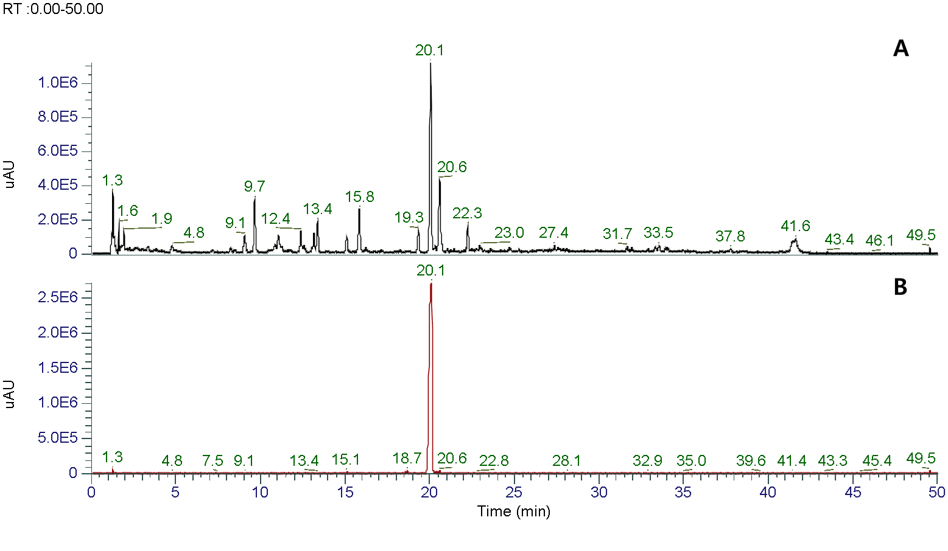

Figure S2. ESI-MS (negative) spectrum of terretriamide (m/z = 326.21 [M]⁻).
Table S1. Calibration curve of terrestriamide
Standard solution | Regression equation | R²
terrestriamide | Y = 47912X − 215333 | 0.9996

Table S2. Content of terrestriamide in 70% ethanol extract of T. terrestris.
 |  |  |  | terrestriamide
 | area | ppm | Extract conc. | Conc. (%) | Conc. (mg/100g)
Mean | 11,308,072 | 231.52 | 50 mg/mL | 0.46 | 463.05
SD | 24,470 | 0.51 |  | 0.001 | 1.02

Note: All the results are shown as the mean n = 3.
R²: values near 1 denotes a good fit, ppm: μg/mL, Conc: concentration, SD: standard deviation

Kim, Hyung Sik, et al. "Phenolic amides from Tribulus terrestris and their inhibitory effects on nitric oxide production in RAW 264.7 cells." Archives of Pharmacal Research 41 (2018): 192-195.

