ONLINE SUPPLEMENT
TITLE: Major alteration of Lung Microbiome and the Host Reaction in critically ill COVID-19 Patients with high viral load
AUTHORS: Ingrid G. Bustos Moya^{#1,2}, Rosana Wiscovitch-Russo^{#3}, Harinder Singh^{#3}, Benjamín L. Sievers^{4,5}, Michele Matsuoka⁴, Marcelo Freire⁴, Gene S. Tan^{4,6}, Mónica P. Cala⁷, Jose L. Guerrero⁷, Ignacio Martin-Loeches⁸, Norberto Gonzalez-Juarbe^{*, 3, 9}, Luis Felipe Reyes^{*,1,10,11.}
AFFILIATIONS: ¹Unisabana Center of Translational Science, Universidad de La Sabana, Chia, Colombia; ²Bioscience Ph.D., Engineering faculty, Universidad de la Sabana, Chia, Colombia; ³Infectious Diseases and Genomic Medicine Group, J Craig Venter Institute, 9605 Medical Center Drive Suite 150, Rockville, MD, USA; ⁴Infectious Disease Group, J Craig Venter Institute, 4120 Capricorn Ln, La Jolla, CA, USA. ⁵Department of Medicine, University of Cambridge, Cambridge, UK; ⁶Division of Infectious Diseases and Global Public Health, Department of Medicine, University of California San Diego, La Jolla, CA 9203; ⁷MetCore-Metabolomics Core Facility, Vice-Presidency of Research and Knowledge Creation, Universidad de Los Andes, Bogotá, Colombia; ⁸Multidisciplinary Intensive Care Research Organization (MICRO), St James's Hospital, Dublin, Ireland; ⁹Department of Cell Biology and Molecular Genetics, University of Maryland, College Park, MD, USA. ¹⁰Clinica Universidad de La Sabana, Chia, Colombia; ¹¹Pandemic Sciences Institute, University of Oxford, Oxford, United Kingdom.

MATERIALS AND METHODS SUPPLEMENT
Cytokines/Chemokines/growth factor measures:
The 45-plex panel comprised five distinct target groups, which encompassed a comprehensive range of analytes. These target groups encompassed:
- Th1/Th2 (GM-CSF, IFN gamma, IL-1 beta, IL-2, IL-4, IL-5, IL-6, IL-8, IL-12p70, IL-13, IL-18, TNF alpha),
- Th9/Th17/Th22/Treg (IL-9, IL-10, IL-17A (CTLA-8), IL-21, IL-22, IL-23, IL-27),
- Inflammatory Cytokines (IFN alpha, IL-1 alpha, IL-1RA, IL-7, IL-15, IL-31, TNF beta),
- Chemokines (Eotaxin (CCL11), GRO alpha (CXCL1), IP-10 (CXCL10), MCP-1 (CCL2), MIP-1 alpha (CCL3), MIP-1 beta (CCL4), RANTES (CCL5), SDF-1 alpha),
- Growth Factors (BDNF, EGF, FGF-2, HGF, NGF, PDGF-BB, PIGF-1, SCF, VEGF-A, VEGF-D).
This comprehensive panel allowed for the simultaneous measurement of a wide array of biomarkers, enabling a thorough assessment of the immune and inflammatory responses under investigation.
Ranges of targets included in the 45-plex kit in pg/ml in accordance with Lot# 313189-002.
Cytokine | Upper Limit | Lower Limit
BDNF | 7949.16 | 2.02
EGF | 15894.37 | 2.65
Eotaxin (CCL11) | 2852.60 | 0.69
FGF-2 | 13120.67 | 3.39
GM-CSF | 158342.87 | 20.04
GRO alpha (CXCL1) | 3121.73 | 2.29
HGF | 25360.16 | 5.90
IFN alpha | 2572.49 | 0.61
IFN gamma | 33816.64 | 9.16
IL-1 alpha | 2008.79 | 0.80
IL-1 beta | 10651.66 | 2.56
IL-1RA | 153583.11 | 43.45
IL-2 | 18373.37 | 9.72
IL-4 | 49186.16 | 15.14
IL-5 | 37812.50 | 9.81
IL-6 | 30036.61 | 12.90
IL-7 | 3022.18 | 0.71
IL-8 (CXCL8) | 10614.14 | 2.46
IL-9 | 29574.15 | 7.99
IL-10 | 6302.29 | 1.54
IL-12p70 | 30133.89 | 7.84
IL-13 | 32286.79 | 4.16
IL-15 | 17623.40 | 3.45
IL-17A (CTLA-8) | 10793.27 | 3.08
IL-18 | 17235.49 | 14.81
IL-21 | 64061.97 | 15.83
IL-22 | 159893.49 | 24.25
IL-23 | 63804.35 | 28.25
IL-27 | 79444.34 | 18.42
IL-31 | 46053.98 | 11.86
IP-10 (CXCL10) | 7418.33 | 2.09
LIF | 7038.35 | 4.21
MCP-1 (CCL2) | 16034.22 | 4.24
MIP-1 alpha (CCL3) | 763.22 | 1.84
MIP-1 beta (CCL4) | 51933.97 | 8.07
NGF beta | 25686.50 | 6.36
PDGF-BB | 18481.39 | 3.84
PlGF-1 | 6221.12 | 1.45
RANTES (CCL5) | 267.88 | 1.45
SCF | 4035.00 | 0.88
SDF-1 alpha | 29185.67 | 16.64
TNF alpha | 20976.44 | 5.45
TNF beta | 24683.66 | 6.24
VEGF-A | 19967.79 | 5.29
VEGF-D | 6896.20 | 2.04

FIGURE LEGEND SUPLEMENT
Supplemental Figure 1: Low environmental and reagent contamination detected in most PCR negative controls (molecular grade water). A. Read count ranges from 274-11,934. The high amount of sample contamination was detected in PCR-negative controls 45 and 47. B. Abundance plot of the top 15 Genus showed mostly environmental- and reagent-associated taxa with some host-associated taxa. Moving forward, the environmental- and reagent-associated taxa were removed from the Nasal and SOT samples.
Supplemental Figure 2: Second bronchial lavage of patients with COVID-19 who developed ventilator-associated pneumonia shows the differential abundance of pulmonary microbiome.
Supplemental Figure 3: Differential changes in microbial genus associated with SARS-CoV-2 titers.

FIGURES
Figure 1.
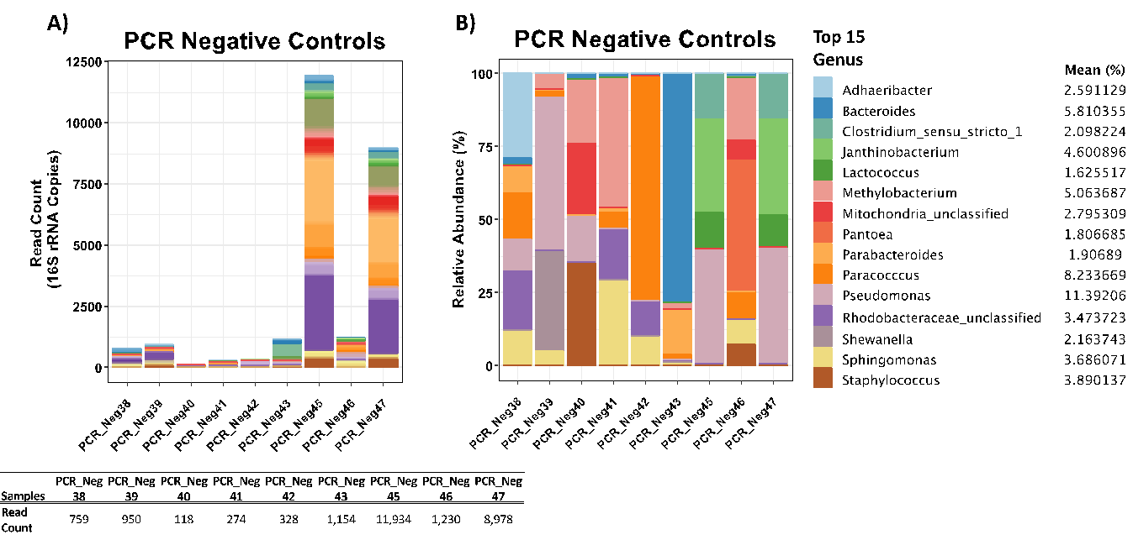

Figure 2.
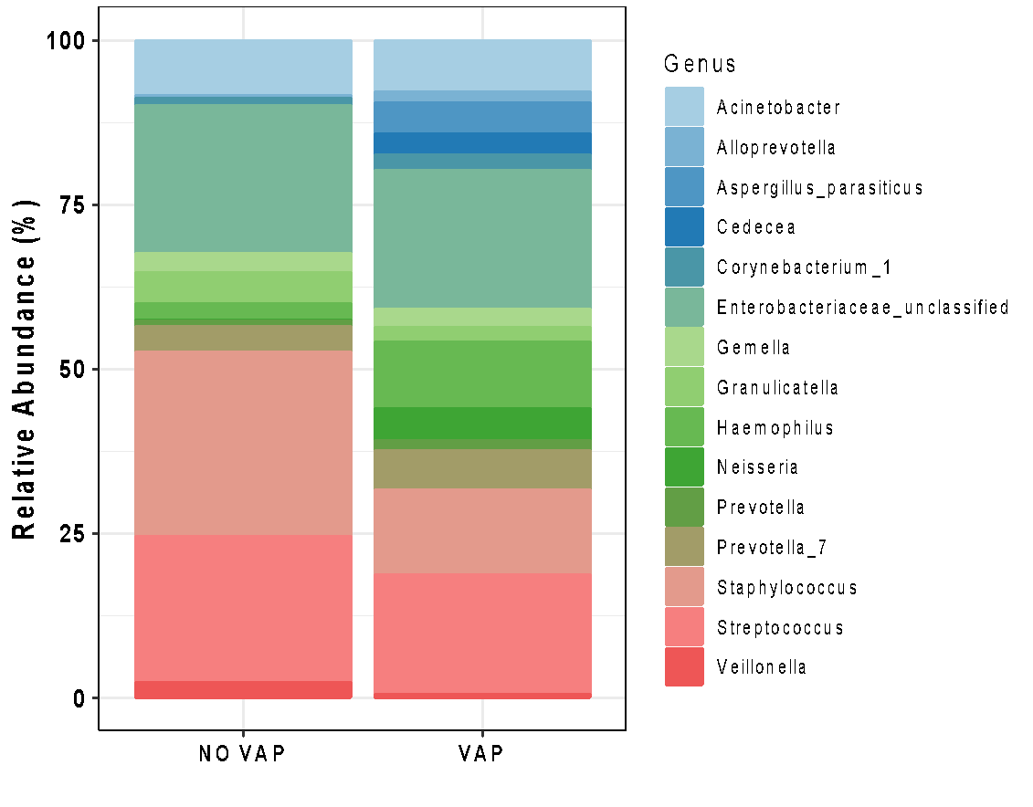

Figure 3.
