Table 1. Several Amino Acid (AA) characteristics. All atoms colour are shown in the Figure 1.

# | Amino Acid | Structure |  | I  /  ZwI | D,  Dipole moment, Debye | Polarization, C/m² | Type
# | Amino Acid | I (initial pristine) | ZwI (zwitterionic) |  | D,  Dipole moment, Debye
1 | Glycine  (Gly, G) | 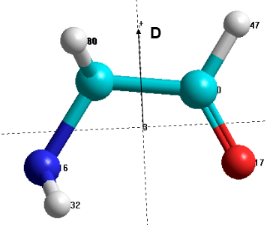 |  | I  ZwI | 1.8  11.5 | 0.1  0.6 | SC
2 | Alanine  (Ala, A) | 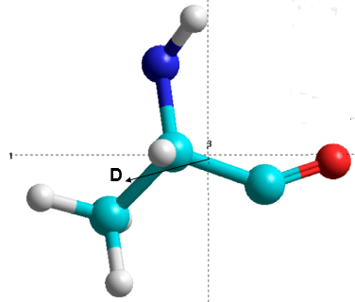 | 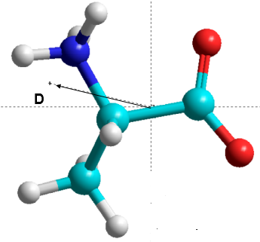 | I  ZwI | 1.85  11.03 | 0.087  0.45 | HSC
3 | Phenyl-alanine  (Phe, F) | 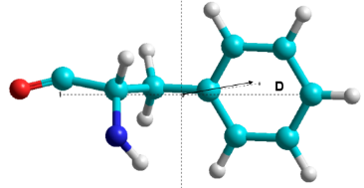 |  | I  ZwI | 2.938  10.56 | 0.0676  0.2276 | BSC
4 | Leucine  (Leu, L) | 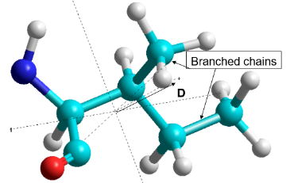 |  | I  ZwI | 2.763  10.013 | 0.0766  0.2562 | BCAA
5 | Iso-leucine  (Ile, I) | 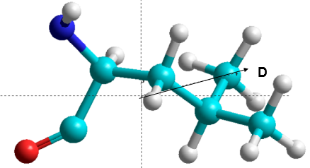 |  | I  ZwI | 2.814  9.926 | 0.078  0.2538 | BCAA
6 | Valine  (Val, V) | 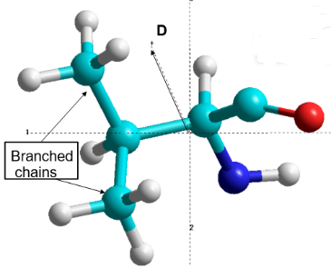 |  | I  ZwI | 1.396  9.973 | 0.045  0.292 | BCAA

