Figure 1B
CitH3 -17KDa

H3 -17KDa

PAD4 -74KDa

β-actin -42KDa

Figure 1D
CitH3 -17KDa

H3 -17KDa

PAD4 -74KDa

β-actin -42KDa

Figure 3B
CitH3 -17KDa

H3 -17KDa

PAD4 -74KDa

β-actin -42KDa

Figure 3H
CitH3 -17KDa

H3 -17KDa

PAD4 -74KDa

β-actin -42KDa

Figure 4G
Drp1 -82KDa

MFN1 -71KDa

MFN2 -84KDa

OPA1 -115KDa

GAPDH -36KDa

Figure 5G
Drp1 -82KDa

MFN1 -71KDa

MFN2 -84KDa

OPA1 -115KDa

GAPDH -36KDa

Supplemental Figure 6A
GPX4 -17KDa

ACSL4 -79KDa

TFR1 -85KDa

SLC7A11 -35KDa

GAPDH -37KDa

Supplemental Figure 6B
GPX4 -17KDa

ACSL4 -79KDa

TFR1 -85KDa

SLC7A11 -35KDa

GAPDH -37KDa

Supplemental Figure 6F
PI3K -85KDa

AKT -60KDa

p-AKT -60KDa

GAPDH -37KDa

Supplemental Figure 6G
PI3K -85KDa

AKT -60KDa

p-AKT -60KDa

GPX4 -17KDa

ACSL4 -79KDa

TFR1 -85KDa

SLC7A11 -35KDa

GAPDH -37KDa

Supplemental Figure 8C
CD9 -25KDa

CD63 -63KDa

Alix -100KDa

Calnexin -90KDa

Supplemental Figure 11C
CD9 -25KDa

CD63 -63KDa

Alix -100KDa

TOMM20 -16KDa

TSG101 -45KDa

Supplemental Figure 12C
CitH3 -17KDa

H3 -17KDa

PAD4 -74KDa

β-actin -42KDa

Supplemental Figure 13B
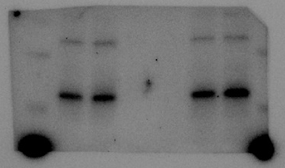
CitH3 -17KDa

H3 -17KDa

PAD4 -74KDa

β-actin -42KDa

