SUPPORTING INFORMATION

Analysis of the interaction of antimalarial agents with Plasmodium falciparum Glutathione Reductase through molecular mechanical calculations.

F. H. do C Ferreira¹, L. R. Pinto¹, B. A. Oliveira², L. V. Daniel³, M. Navarro³, G. Y. Sánchez Delgado^{*3}

¹NEQC: Núcleo de Estudos em Química Computacional,
²SINTBIOMOL: Tecnologia em fármacos: Síntese de Biomoléculas, Avaliação Biológica e Repercussões Ambientais
³LaQBIC: Laboratório de Química Bioinorgânica e Catálise
Departamento de Química, Universidade Federal de Juiz de Fora, Campus Universitário Martelos, 36.036-900 Juiz de Fora, MG, Brasil.

*Corresponding author. E-mail: gysdelgado@ice.ufjf.br

Figure S1. 3D structures of the (a) CQH-PfGR and (b) CQH₂-PfGR complexes, showing the interactions with the main residues in contact with the ligand after docking in the PfGR active site.

Figure S2. 3D structures of the (a) AQ-PfGR and (b) AQH-PfGR complexes, showing the interactions with the main residues in contact with the ligand after docking in the PfGR active site.
Figure S3. 3D structures of the (a) (R,S)MQ-PfGR and (b) (S,R)MQ-PfGR complexes, showing the interactions with the main residues in contact with the ligand after docking in the PfGR active site.

Reduction potential calculation (Eº)
In order to estimate the tendency to reduce the antimalarial drugs (CQ, AQ, PQ, MQ, and ATV; Figure 3), the standard reduction potential (Eº) was calculated for these mentioned compounds along with the reference inhibitors MB and MD. The Eº was calculated in an aqueous solution according to equation 1, based on the half-reactions of the electrochemical cell in relation to the standard hydrogen electrode (SHE) (equation 1). The absolute potential value of SHE was modified from 4.28 V (pH=0) to 3.55 V, in order to express the reduction potential relative to the NADPH/NADP⁺ redox couple at pH=7. The half-cell potential for NADPH/NADP⁺ redox system is estimated at around -0.32 V vs SHE at pH=7 [1,2]. Note that the Gibbs free energy, ∆$G_{redox,aq}^{o}$ in equation (1), must be expressed in units of eV.
$E^{o}\left(V\right)=-\frac{{∆G}_{redox}^{o}}{2}-E_{SHE,aq}^{o}$ (1)

The geometry optimization of oxidized and reduced species was carried out at aqueous solution at level B3LYP/6-31+G(d) [3,4]. The same level of theory was applied to the calculate the Gibbs free energy at 1 atm and 298.15 K using the CPCM [5] solvation method (water, ε=78.355). All calculations were performed in the ORCA 5.0.1 computational package [6].

(b)
(a)
Figure S4. B3LYP optimized structures of the Chloroquine in the oxidized and reduced form. Bond lengths are given in Angstrom (Å) (a). Molecular electrostatic potentials (MEP) of oxidized and reduced species of Chloroquine (b).

Figure S5. B3LYP optimized structures of the Amodiaquine in the oxidized and reduced form. Bond lengths are given in Angstrom (Å) (a). Molecular electrostatic potentials (MEP) of oxidized and reduced species of Amodiaquine (b).

Figure S6. B3LYP optimized structures of the drugs Atovaquone (ATV), Mefloquine (MQ), Primaquine (PQ), and the inhibitor of PfGR Methylene blue (MB) and Menadione (MD) in the oxidized and reduced forms. Bond lengths are given in Angstrom (Å).

(b)
(a)
Figure S7. Correlation between the antiplasmodial activity against CQ-sensitive (a) and CQ-resistant strains (b) and estimated docking binding energies for drug-PfGR system.

Figure S8. 3D structures of the (a) Methylene blue(MB)-PfGR and (b) Xantane(Xt)-PfGR complexes, showing the interactions with the main residues in contact with the ligand after docking in the PfGR cavity.

Figure S9. Binding modes of AQ and its protonation states after docking cavity enzyme, highlighting the drug conformations and the comparison between them (a). 3D structures of the AQ-PfGR (b) and AQH-PfGR (c) complexes are presented, showing the interactions with the main residues in direct contact with the ligand.
Figure S10. 3D structures of the Medanione(MD)-PfGR complex showing the interactions with the main residues in contact with the ligand after docking in the PfGR cavity.

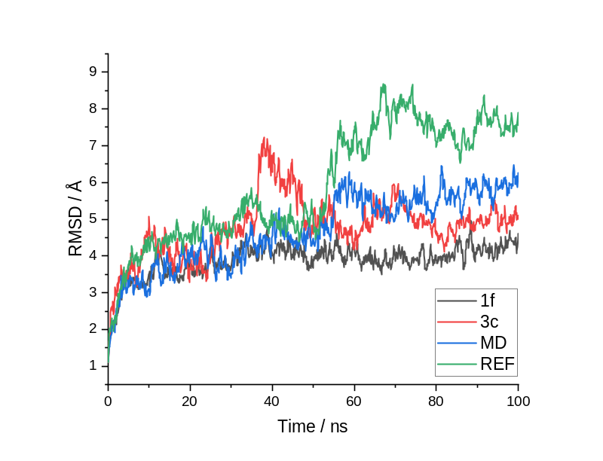
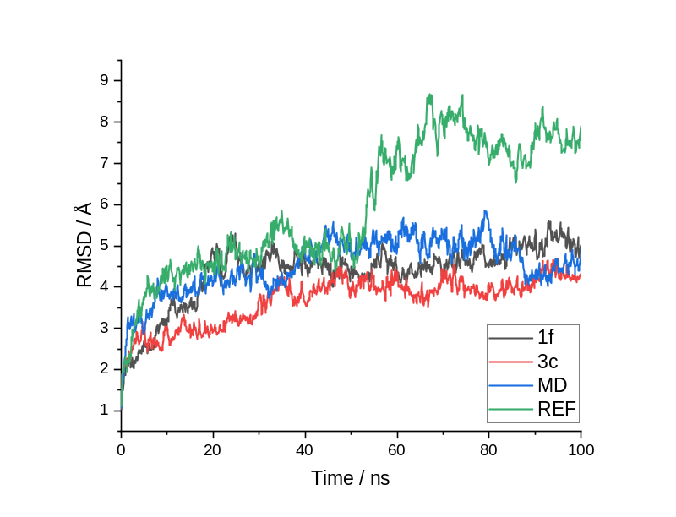
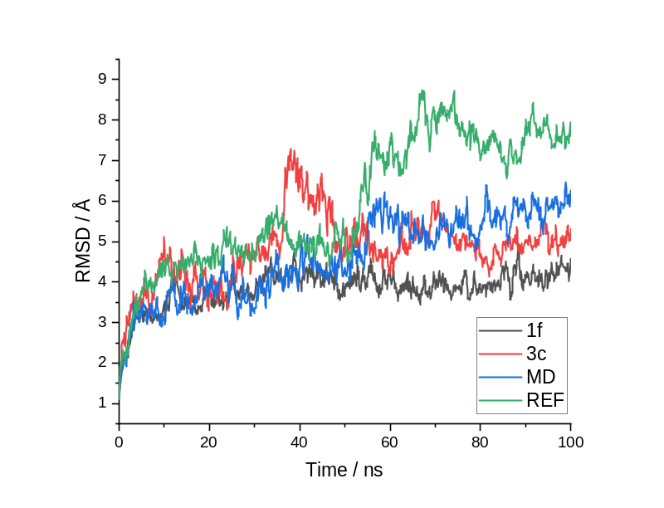
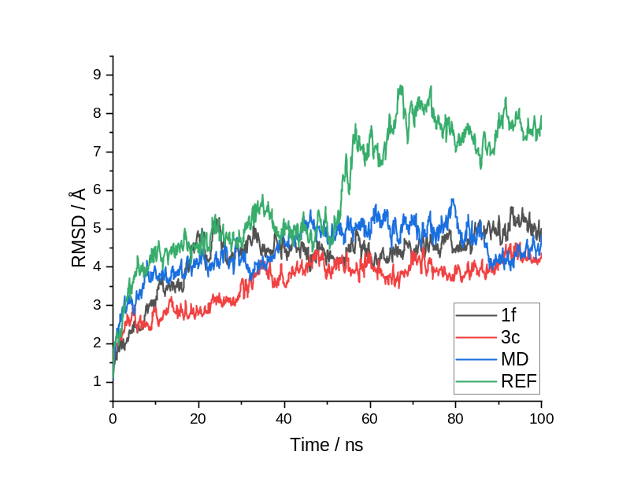
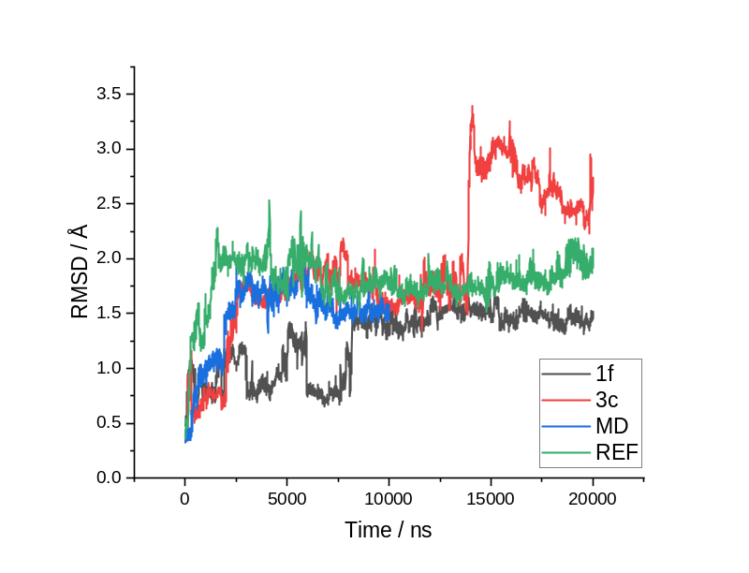
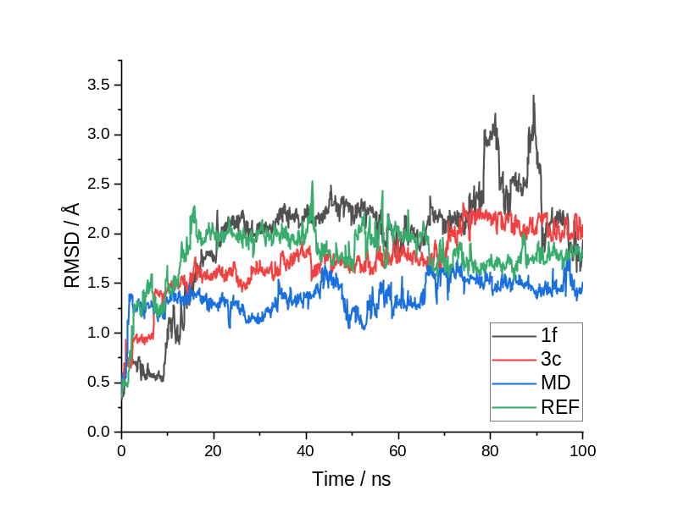
a)
b)
c)
Active site
Intersubunit cavity

Figure S11. Root mean square of structure deviation analysis along the 100 ns of the molecular dynamic’s trajectory. RMSD analyses were separated in groups: (a) for all residues in the simulation, (b) for the protein residues and (c) for the FAD cofactor molecule. First column of graphs is related to the active site and the second regards the intersubunit cavity.

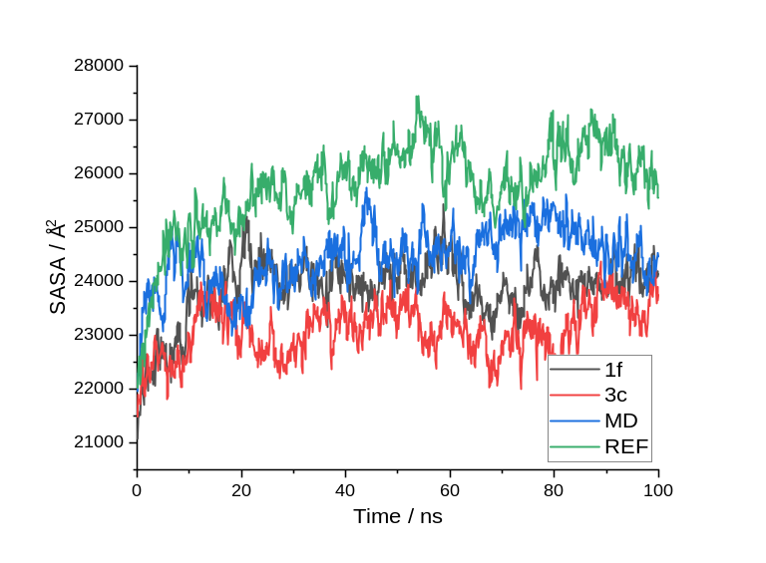
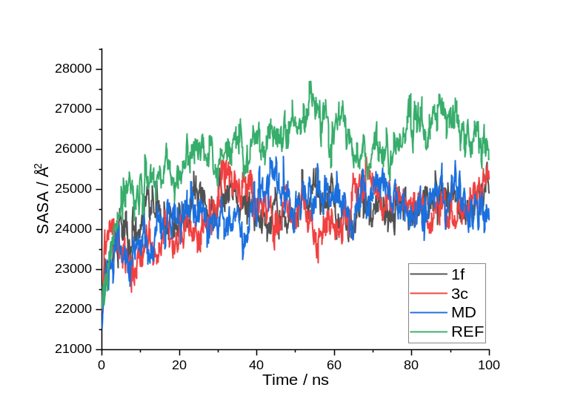
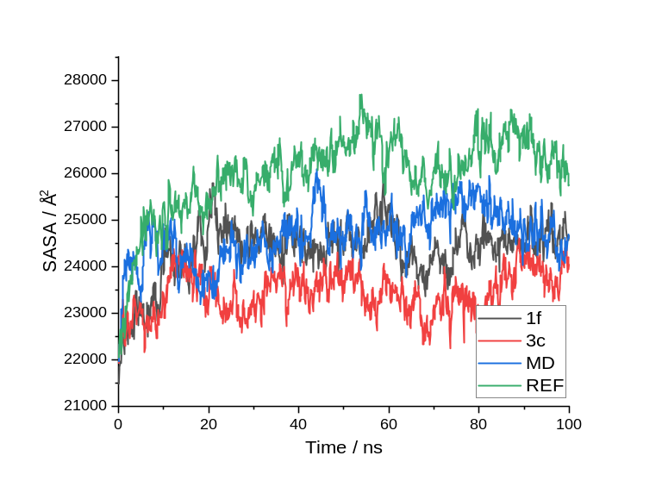
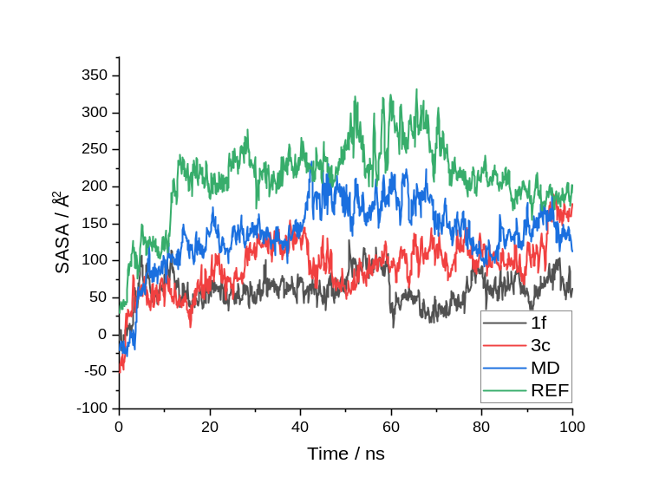
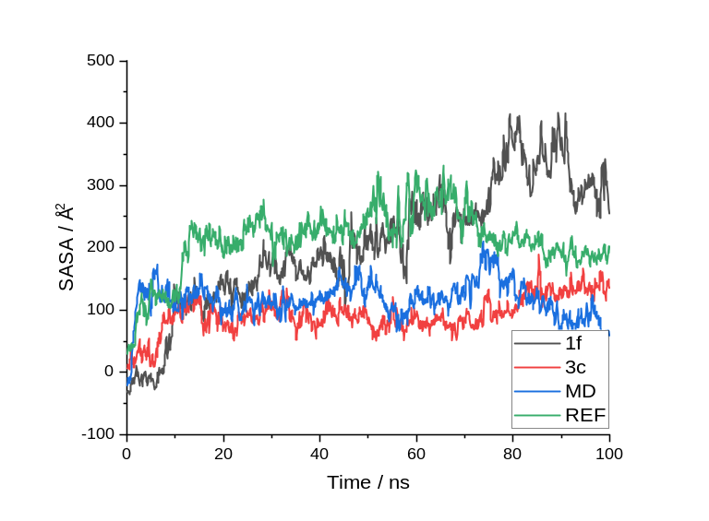
Active site
Intersubunit cavity
a)
b)
c)

Figure S12. Solvent accessible surface area analysis along the 100 ns of the molecular dynamic’s trajectory. SASA analyses were separated in groups: (a) for all residues in the simulation, (b) for the protein residues and (c) for the FAD cofactor molecule. First column of graphs is related to the active site and the second regards the intersubunit cavity.

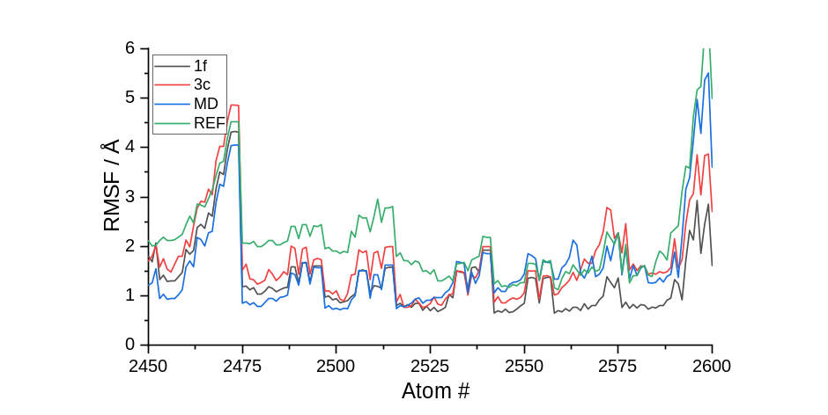
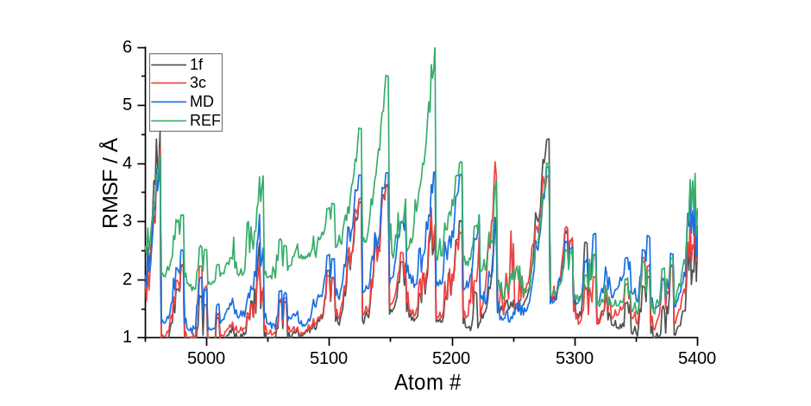
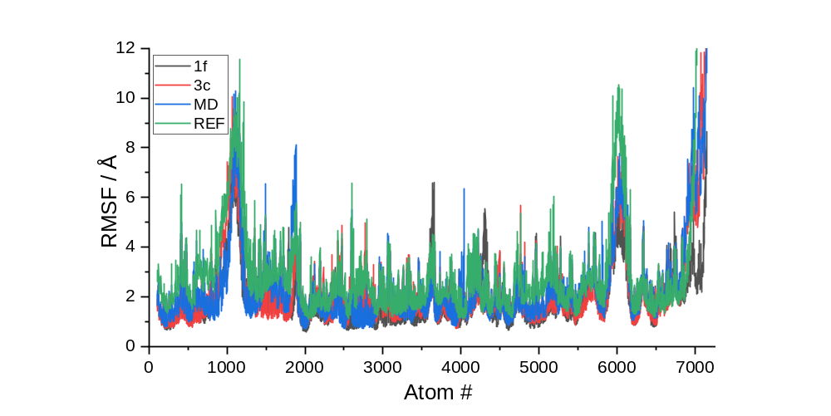
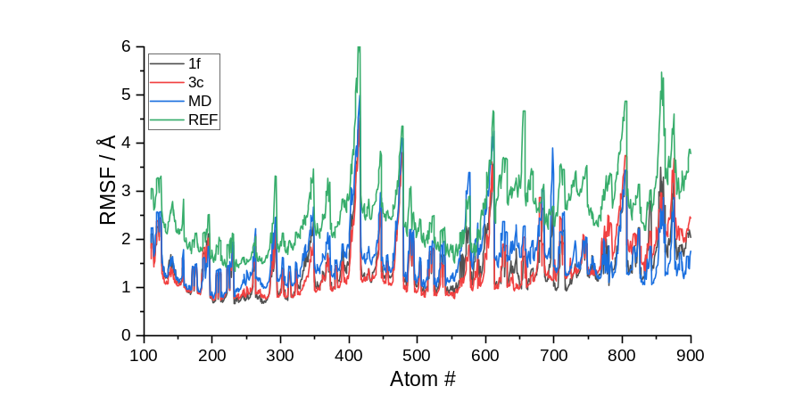

Figure S13. Root mean square of atomic fluctuation analysis along the 100 ns of the molecular dynamics’ trajectory in the active site (Site 1). Some regions of interest were zoomed in for the sake of clarity.
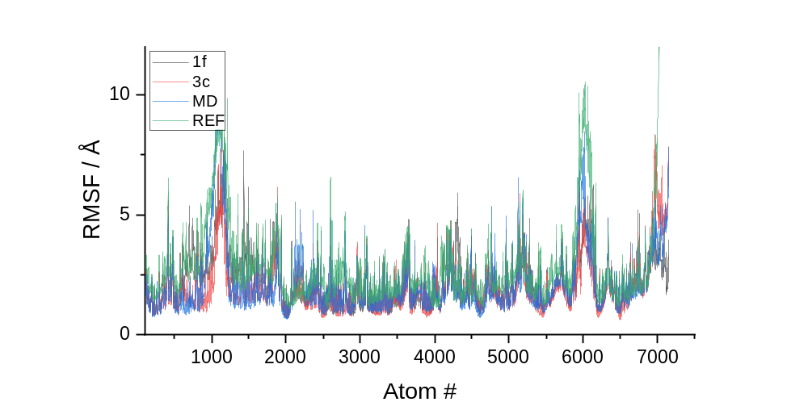
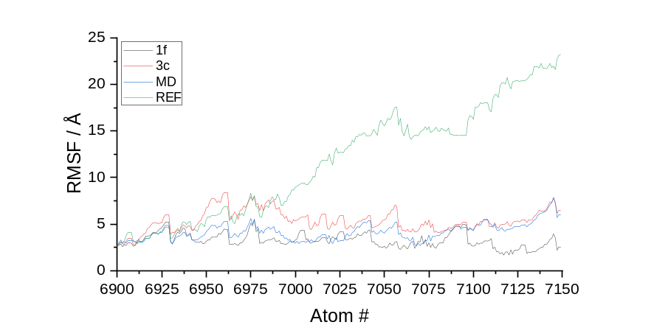
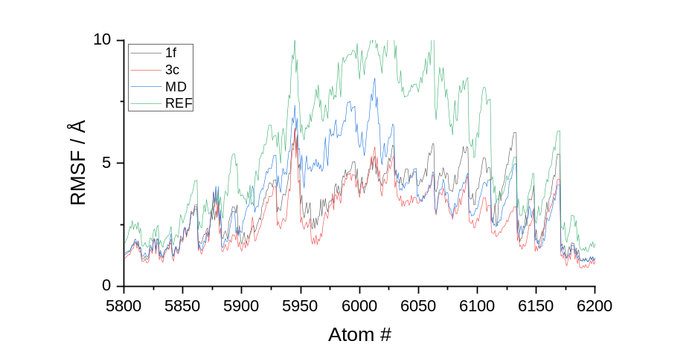
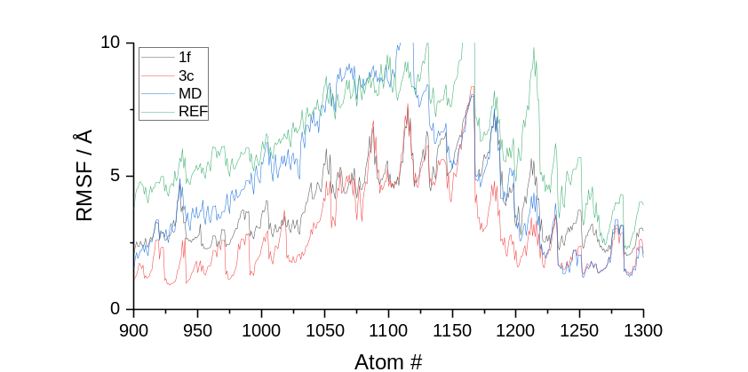

Figure S14. Root mean square of atomic fluctuation analysis along the 100 ns of the molecular dynamics’ trajectory in the Intersubunit cavity (Site 2). Some regions of interest were zoomed in for the sake of clarity.
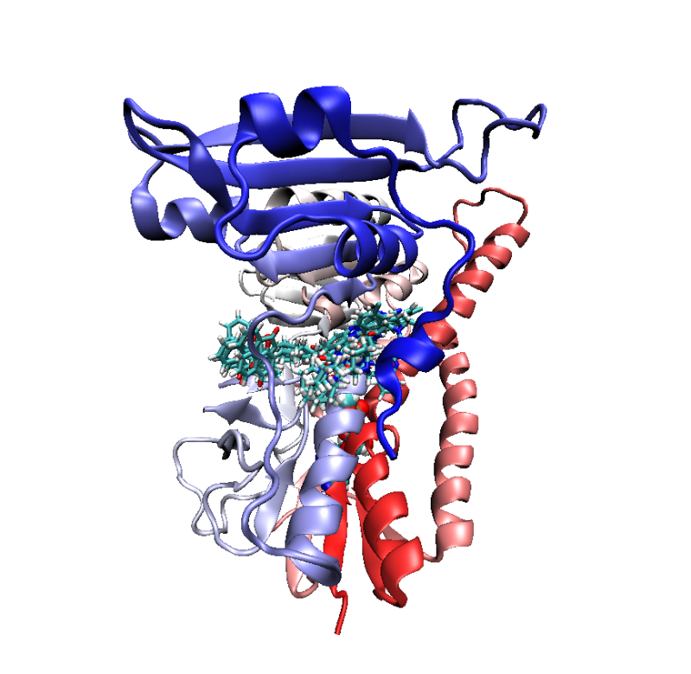
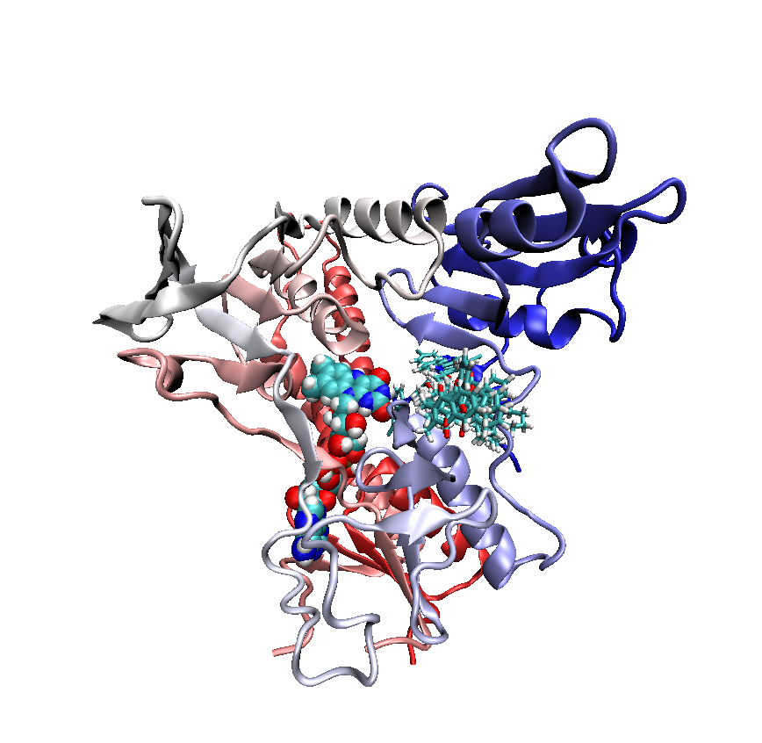

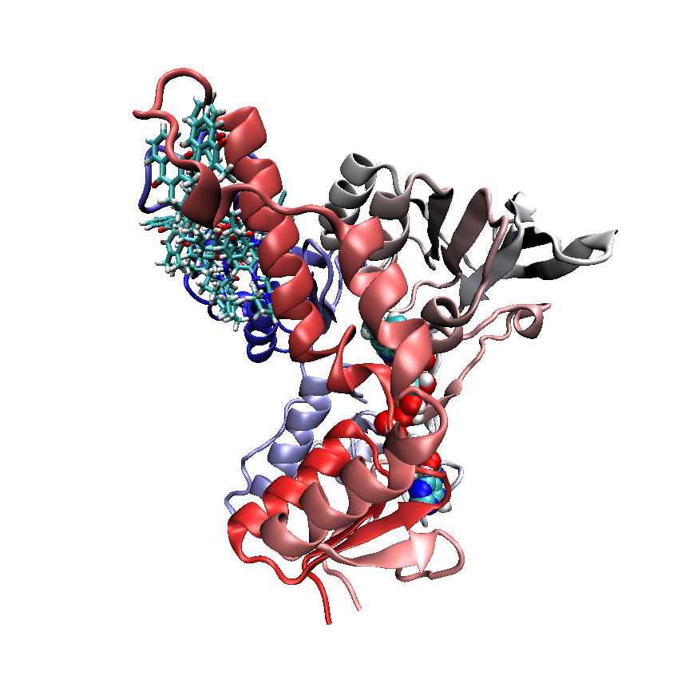
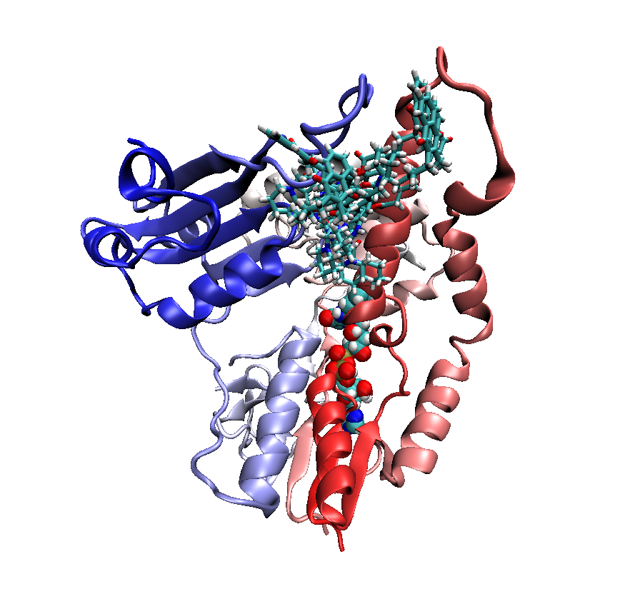
Active site
Intersubunit cavity

Figure S13. Superposition of 5 poses 2000 frames separated along the molecular dynamics trajectory for compound 1f.

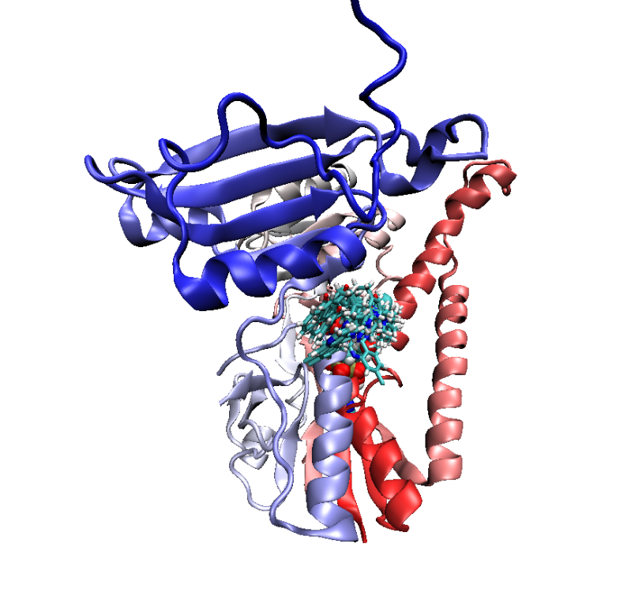
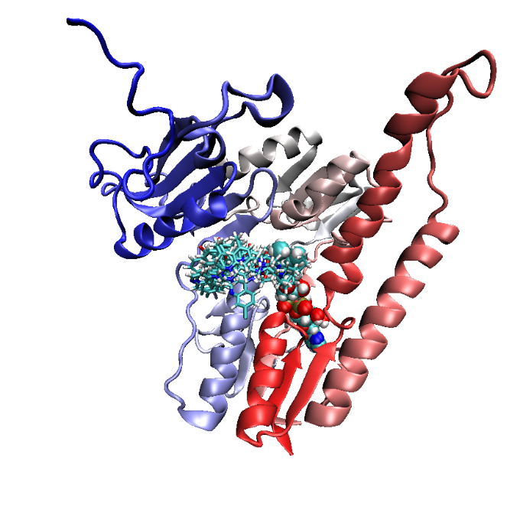
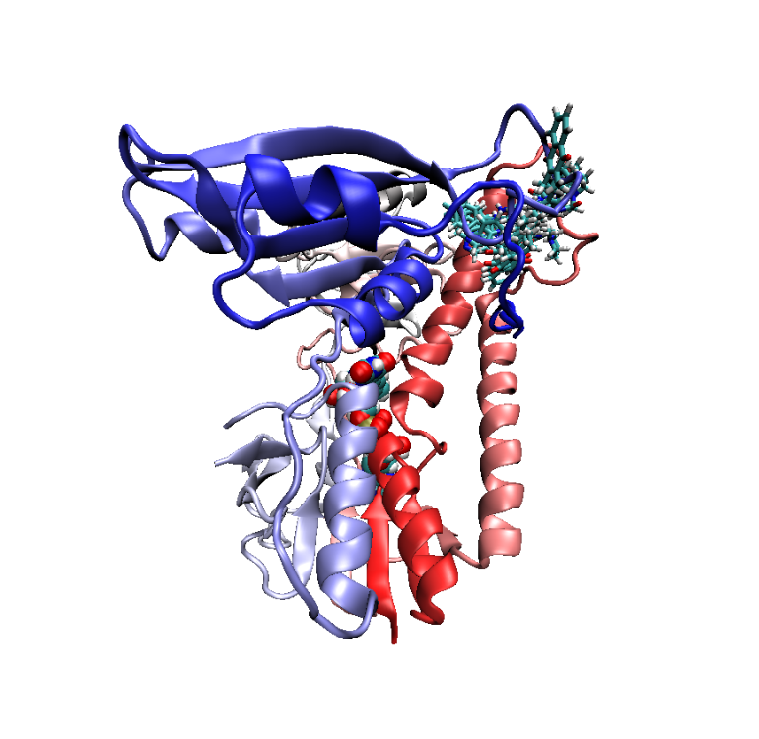
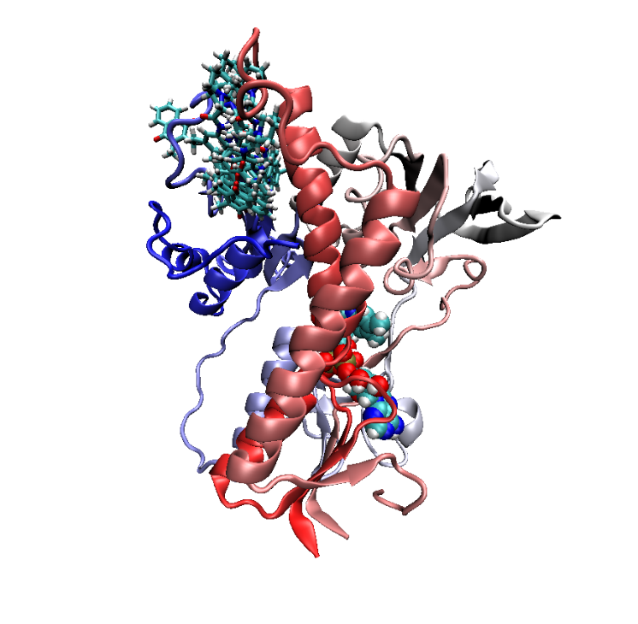
Active site
Intersubunit cavity

Figure S14. Superposition of 5 poses 2000 frames separated along the molecular dynamics trajectory for compound 3c.

References
1. KANO K (2002) Redox Potentials of Proteins and Other Compounds of Bioelectrochemical Interest in Aqueous Solutions. Review of Polarography 48:29–46. https://doi.org/10.5189/revpolarography.48.29.
2. Voet D, G. Voet J, W. Pratt C (2016) Fundamentals of Biochemistry: Life at the Molecular Level, 5th ed. Wiley.
3. Becke AD (1993) Density‐functional thermochemistry. I. The effect of the exchange‐only gradient correction. J Chem Phys 98:5648–5652. https://doi.org/10.1063/1.462066
4. W. J. Hehre, R. Ditchfield and J. A. Pople (1972) Self‒Consistent Molecular Orbital Methods. XII. Further Extensions of Gaussian‒Type Basis Sets for Use in Molecular Orbital Studies of Organic Molecules. J. Chem. Phys. 56, 2257. https://doi.org/10.1063/1.1677527
5. Vincenzo B, Cossi M (1998) Quantum Calculation of Molecular Energies and Energy Gradients in Solution by a Conductor Solvent Model. J. Phys. Chem. A 102:1995–2001. https://doi.org/10.1021/jp9716997
6. Neese F (2022) Software update: The ORCA program system—Version 5.0. WIREs Computational Molecular Science 12:. https://doi.org/10.1002/wcms.1606

