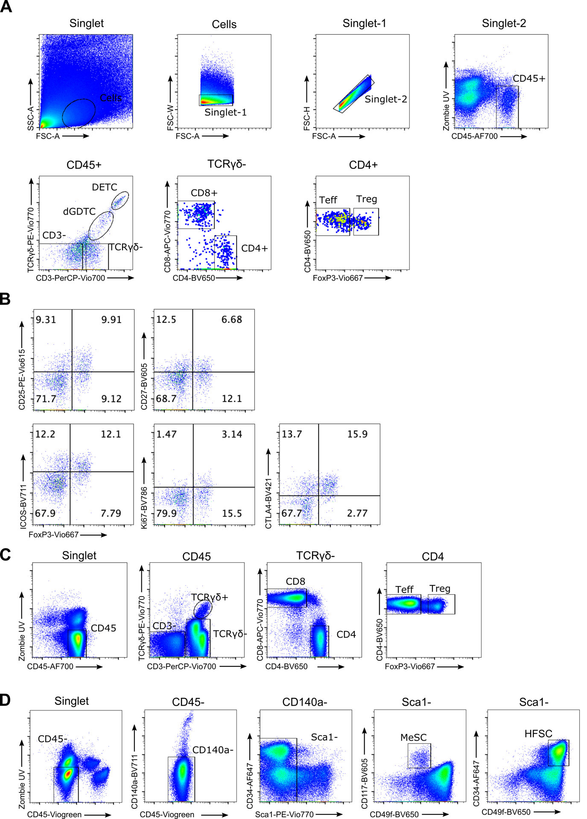
Supplementary figure 1. Flow cytometric gating strategy for analysis. A) Skin T cell gating strategy. Strict live dead and singlet inclusion criteria were applied. Immune cells were gated as CD45⁺ cells. Further subsets were gated as follows: CD3⁻ immune cells, TCRγδ^{hi} CD3⁺ DETCs (dendritic epidermal T cells), TCRγδ^{int} CD3⁺ dGDTCs (dermal gamma delta T cells), TCRγδ⁻ CD3⁺ CD8⁺ T cells, TCRγδ⁻ CD3⁺ CD4⁺ FoxP3⁻ Teffs (effector T cells), and TCRγδ⁻ CD3⁺ CD4⁺ FoxP3⁺ Tregs (regulatory T cells). B) Representative gating of Treg phenotypic marker expression in the skin. Cells were pre-gated as CD4⁺ T cells. C) Gating strategy to analyse T cells in the SDLN (skin-draining lymph node). Immune cells were gated as follows: CD3⁻ immune cells, TCRγδ⁺ cells, TCRγδ⁻ CD3⁺ CD8⁺ T cells, TCRγδ⁻ CD3⁺ CD4⁺ FoxP3⁻ Teffs (effector T cells), and TCRγδ⁻ CD3⁺ CD4⁺ FoxP3⁺ Tregs (regulatory T cells). D) Gating strategy to identify CD45⁻ CD140a⁻ Sca1⁻ CD117⁺ MeSCs (melanocyte stem cells) and CD45⁻ CD140a⁻ Sca1⁻ CD34⁺ CD49f⁺ hair follicle stem cells (HFSCs).

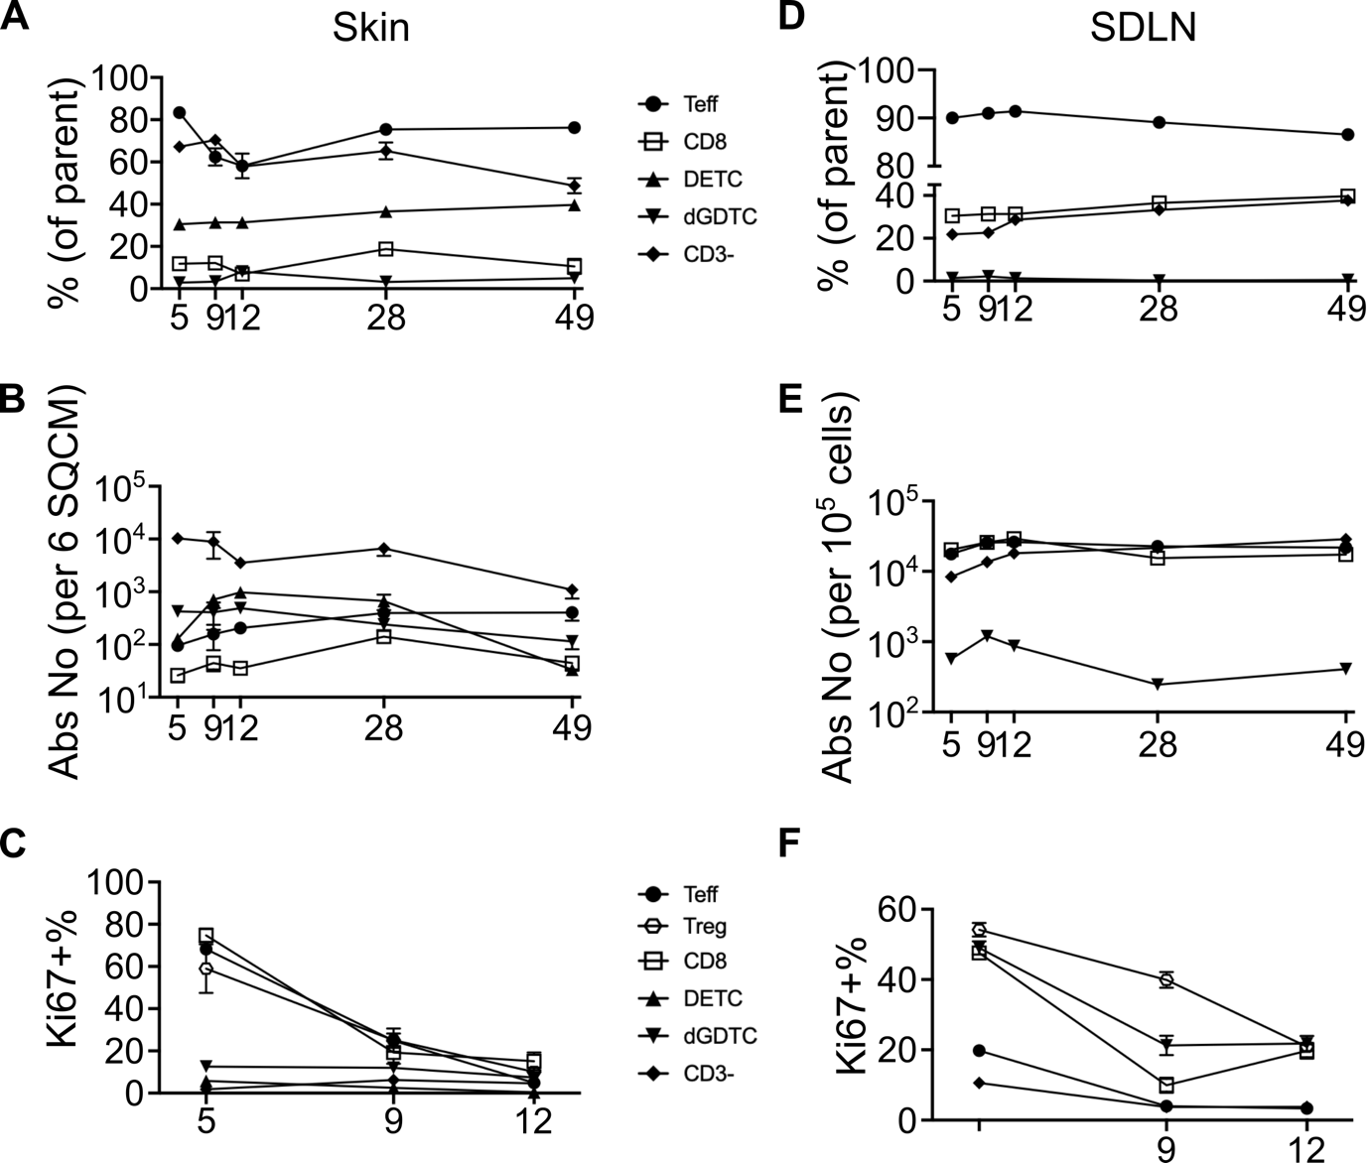
Supplementary figure 2. Flow cytometric characterisation of T cell numbers and proliferation. A-C) Skin-resident immune cells on postnatal day 5 (P5), P9, P12, P28 and P49. A) Percentage. B) Absolute number (per 6 cm² of skin). C) Percentage of proliferating Ki67⁺ subsets on P5, P9 and P12. D-F) SDLN-resident immune cells. D) Percentage. E) Absolute number (per 10⁵ total cells). F) Percentage of proliferating Ki67⁺ subsets on P5, P9 and P12. Graphs show mean ± S.E.M. Data are pooled from 2 independent experiments (n=4-6 biological replicates).

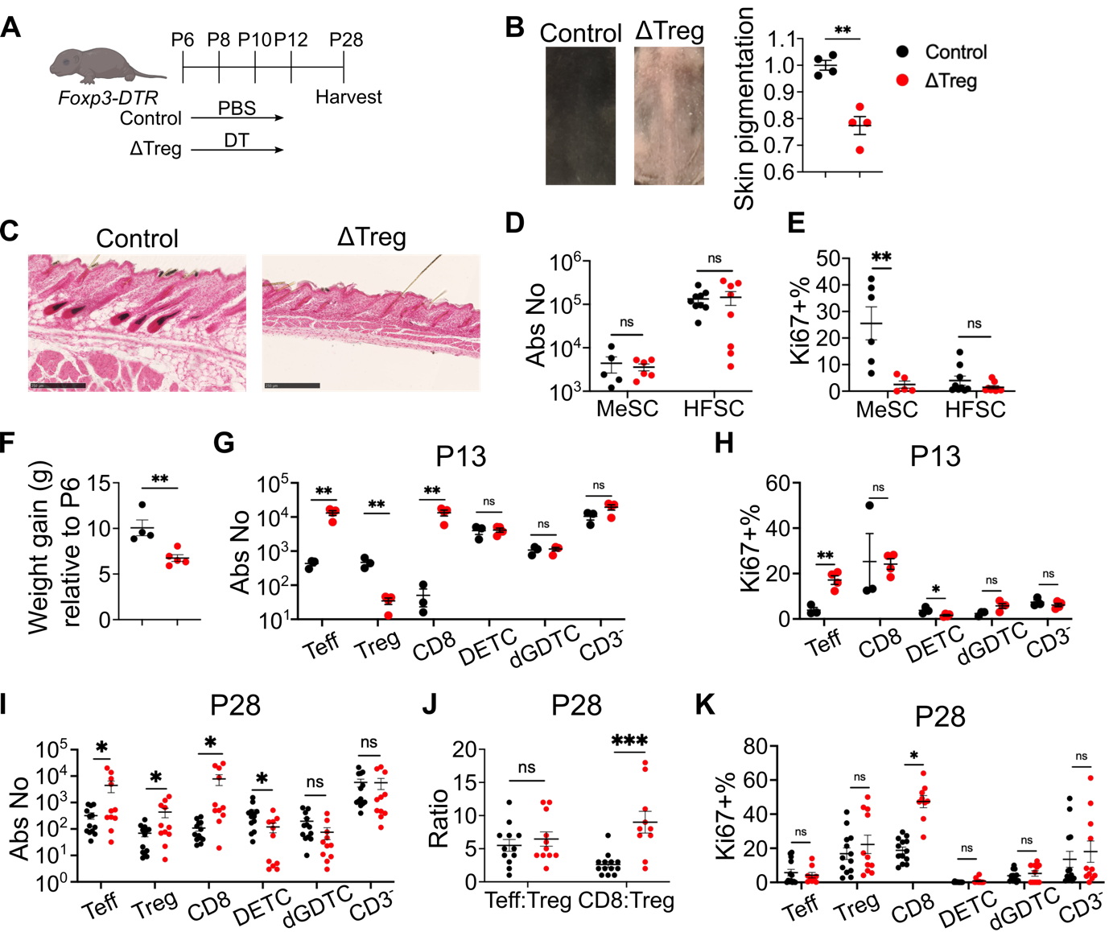Supplementary figure 3. Four-dose DT regimen causes weight loss, inflammation, and pigment defect. A) Schematic outline of experimental timeline. Tregs were depleted by intraperitoneal administration of diphtheria toxin (DT) on postnatal day 6 (P6), P8, P10 and P12 (30 ng/g per injection). Skin tissues were harvested on P28. B) Representative images of dorsal skin on P28, and associated quantification of skin pigmentation. C) Fontana & Masson (F&M) staining of P28 dorsal skin. Scale bar represents 250 µm. D-E) Flow cytometric quantification of melanocyte stem cells (MeSCs) and hair follicle stem cells (HFSCs). D) Absolute number. E) Percentage of proliferating Ki67⁺ cells. F) Weight gain from P28 to P6. G-H) Flow cytometric quantification of skin T cells on P13. G) Absolute number. H) Percentage of proliferating Ki67⁺ cells. I-K) Flow cytometric quantification of skin T cells on P28. I) Absolute number. J) Ratio of Teff:Treg and CD8:Treg. K) Percentage of proliferating Ki67⁺ subsets. Data are pooled from 4 independent experiments (n=2-4 biological replicates). Graphs show mean ± S.E.M. Unpaired t-test. ***p<0.001, **p<0.01, *p<0.05, ns p>0.05.

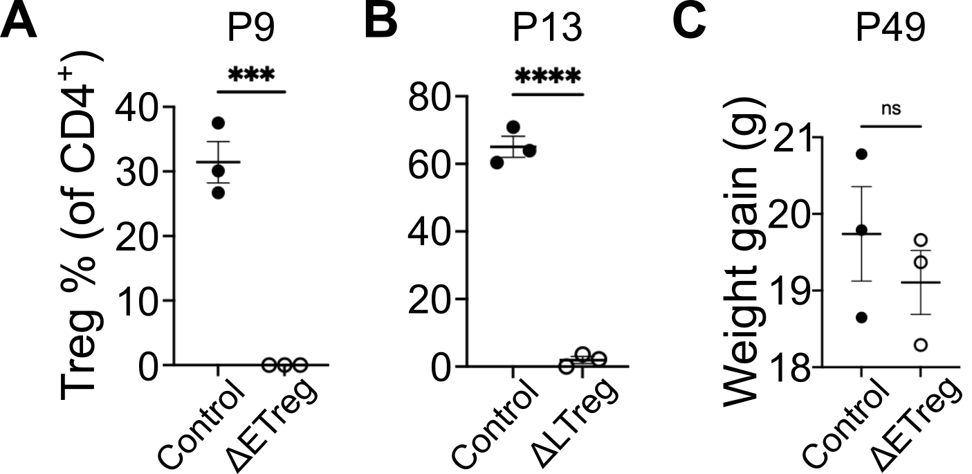Supplementary figure 4. Transient DT injection is sufficient for skin Treg depletion. Flow cytometric profiling of Treg percentage on A) P9 or B) P13 following Treg depletion in Foxp3-DTR mice. C) Weight gain from P6 to P49 in grammes. Graphs show mean ± S.E.M. Unpaired t-test. ****p<0.0001, ***p<0.001, ns p>0.05.

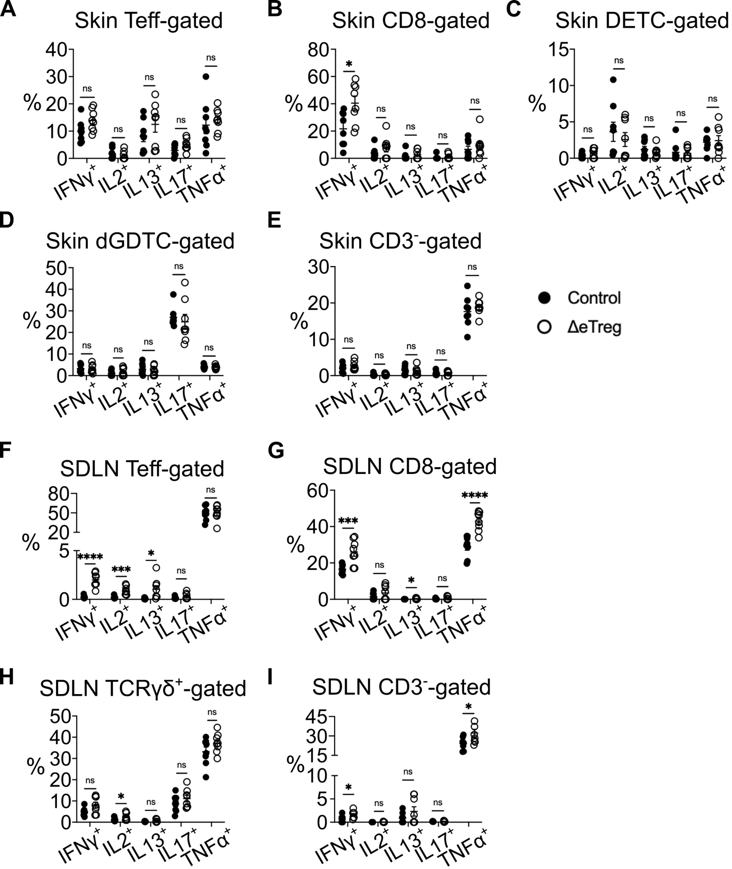Supplementary figure 5. Early Treg depletion causes inflammatory response in the skin and SDLN. Percentage production of cytokines interferon-γ (IFNγ), interleukin 2 (IL2), IL13, IL17 and tumour necrosis factor α (TNFα) on P9. A-I) Percentage expression of cytokines following stimulation with PMA/Ionomycin. A-E) Skin. A) Teffs. B) CD8⁺ T cells. C) DETCs. D) dGDTCs. E) CD3⁻ immune cells. F-I) SDLN. F) Teffs. G) CD8⁺ T cells. H) TCRγδ⁺ T cells. I) CD3⁻ immune cells. Data are pooled from two independent experiments. Graphs show mean ± S.E.M (n=4 biological replicates). Unpaired t-test. ****p<0.0001, ***p<0.001, *p<0.05, ns p>0.05.

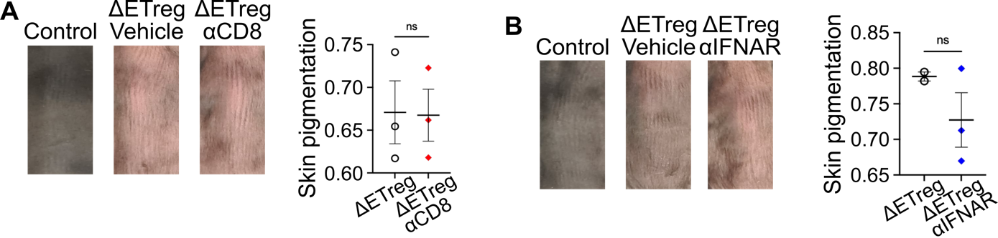Supplementary figure 6. Modulation of skin pigmentation. A-D) Mice were intraperitoneally injected on P6 and P8. Dorsal skin tissues were harvested and photographed on P28. A) Foxp3-DTR mice received PBS (control) or DT (ΔEtreg) in addition to PBS (vehicle) or 100 µg of α-CD8 depleting antibody (αCD8) per injection. αCD8 groups received further injections on P15 and P22. B) Foxp3-DTR mice received PBS (control), or DT (ΔEtreg) in addition to PBS (vehicle) or 100 µg of α-IFNAR blocking antibody (αIFNAR) per injection. Graphs show mean ± S.E.M. Data shows biological replicates (n=2-3). Unpaired t-test. ns p>0.05.

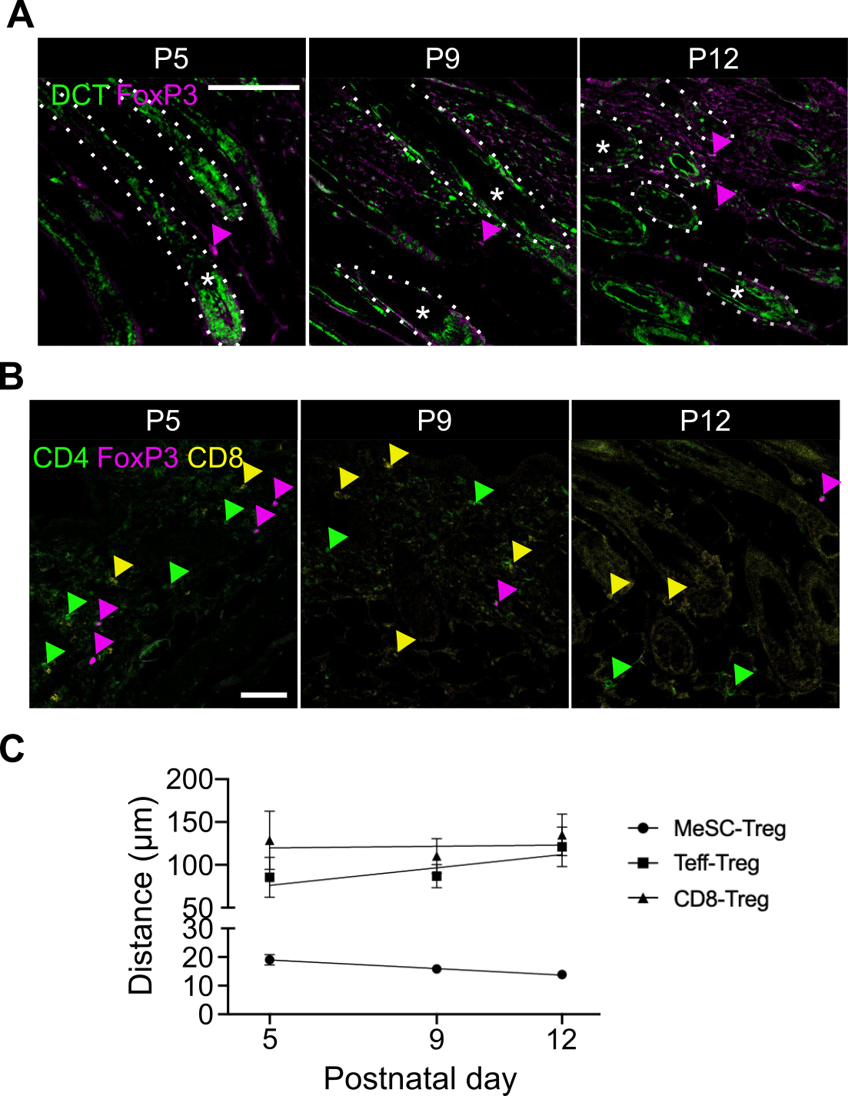Supplementary figure 7. Skin Tregs reside proximally to melanocyte stem cells, and not T cells. A-B) Histological quantification of Treg distance to melanocyte stem cells (MeSCs) on postnatal day 5 (P5), P9 and P12. A) Immunofluorescence staining of DCT⁺ MeSCs and Foxp3⁺ Tregs. Dotted lines demarcate hair follicles. B) Immunofluorescence staining of CD4⁺ FoxP3⁻ effector T cells (Teff, green arrowhead), CD4⁺ FoxP3⁺ Tregs (Magenta arrowhead), and CD8⁺ cytotoxic T cells (CD8, yellow arrowhead). C) Quantification of MeSC-Treg, Teff-Treg and CD8-Treg distances on P5, P9 and P12. Graph shows mean ± S.E.M. Data are pooled from 3 independent experiments (n=3-6 biological replicates).

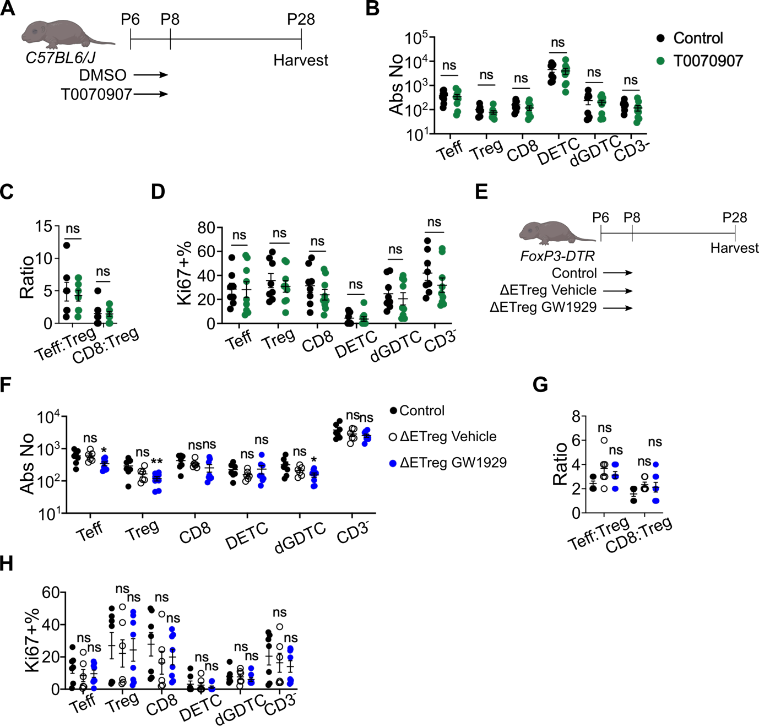Supplementary figure 8. Modulation of neonatal PPARγ signalling does not affect skin-resident immune cell numbers or proliferation. A) Schematic of experimental timeline. C57BL6/J mice received 2.5 µg/g of T0070907 or DMSO on P6 and P8. Skin tissues were harvested on P28. B-E) Flow cytometric quantification of skin-resident T cells and Tregs. B) Absolute number. C) Teff:Treg and CD8:Treg ratio. D) Percentage of proliferating Ki67⁺ cells. E) Schematic outline of rescue experiment using PPARγ agonist. Control group received PBS and DMSO on P6 and P8. Τreg-depleted ΔEtreg groups received DMSO (vehicle) or GW1929 in addition to DT on P6 and P8. Skin tissues were harvested on P28. F) Absolute number. G) Teff:Treg and CD8:Treg ratio. H) Percentage of proliferating Ki67⁺ cells. Data are pooled from two independent experiments. Graphs show mean ± S.E.M. (n=4-5 biological replicates). Unpaired t-test. ns p>0.05.

