Terminology Box 1: Terminology glossary used in SpaGFT

Functional tissue units (FTUs) are defined as the smallest multicellular tissue organization that performs a unique physiologic function in concert with the surrounding microenvironment and is replicated multiple times in a whole organ¹.

A spatial domain is a segment of tissue architecture in spatially resolved transcriptomics (SRT) studies. A spatial domain is defined as a continuous region that is spatially coherent in both gene expression and histology².

A spatially variable gene (SVG) represents a variable gene expression pattern, which varies along with the spatial distribution of tissue of interest³. Notably, SVG is not necessarily highly correlated to a spatial domain. Hence, it may be distributed within a spatial domain or across multiple spatial domains.

A spatial graph refers to a graph where the nodes represent physical locations or entities, and the edges between nodes are defined based on their physical proximity or distance⁴. Notably, the granularity of nodes, representing pixels, cells, or spots, is informed by the resolution units employed in current spatial technologies. This granularity can range from subcellular levels to broader cellular and multicellular scales.

Vertex domain. The signal on a graph (e.g., gene expression or protein intensity) is called a graph signal in the vertex domain.

Fourier mode (FM). Given a KNN graph with n nodes (e.g., spots are nodes in SRT data and edges are added based on Euclidean distance), an FM is an n-dimensional vector corresponding to an eigenvector of the Laplacian matrix of the graph. The frequency of an FM is defined as the corresponding eigenvalue. In the FM space, An FM is defined as a low-frequency FM if its corresponding eigenvalue is a small value and it represents a smooth and slow variation pattern (Fig. IA) on the graph. Similarly, an FM is defined as a high-frequency FM if its corresponding eigenvalue is a large value and it represents a rapid variation pattern on the graph (Fig. IB). The number of FMs is equal to the number of nodes in the graph, and FMs are ranked in increasing order of frequency. Notably, each FM is determined by the graph topology and does not depend on gene expression value.
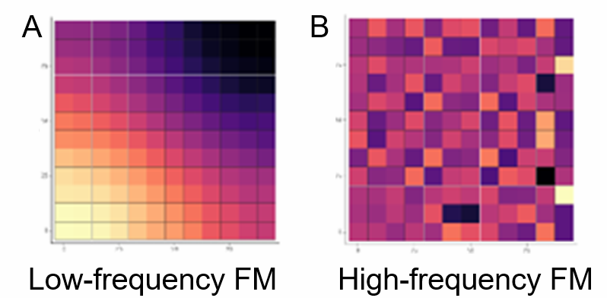
Figure I. A and B show examples of low-frequency FM and high-frequency FM.

Graph Fourier transform (GFT). In SRT studies, given the expression values of a gene on $n$ spots $f∈R^{n}$ on a KNN graph, the mathematical process of transforming $f$ to $\hat{f}$by equation $\hat{f}=U^{T}f$ is called GFT, where $U$ is the matrix consists of column vectors $u_{1},u_{2},…,u_{n}$ ($u_{i}$ is the $i^{th}$FM). Each component of $\hat{f}$ is defined as a Fourier coefficient (FC) in the frequency domain⁵, and the $i^{th}$element of $\hat{f}$ is the FC of $i^{th}$FM. Hence, expression values of a specific gene on the KNN graph can be decomposed into a linear combination of FMs, where an FC can be used for measuring the contribution of the corresponding FM. Inverse GFT (iGFT) is the mathematical process of transforming $\hat{f}$ to $f$by the function $f=U^{T}\hat{f}$.

GFTscore of a specific gene is defined as $GFTscore\left(f\right)=\sum_{l=1}^{n}{e^{-λ_{l}}}\hat{f_{i}}$, where $λ_{l}$ is the $l^{th}$ frequency and $\hat{f_{i}}$ is the normalized $l^{th}$ FC.

1 Jain, S. et al. Advances and prospects for the Human BioMolecular Atlas Program (HuBMAP). Nature Cell Biology 25, 1089-1100, doi:10.1038/s41556-023-01194-w (2023).
2 Hu, J. et al. SpaGCN: Integrating gene expression, spatial location and histology to identify spatial domains and spatially variable genes by graph convolutional network. Nature Methods, doi:10.1038/s41592-021-01255-8 (2021).
3 Li, K. et al. Computational elucidation of spatial gene expression variation from spatially resolved transcriptomics data. Molecular Therapy - Nucleic Acids 27, 404-411, doi:https://doi.org/10.1016/j.omtn.2021.12.009 (2022).
4 Browaeys, R., Saelens, W. & Saeys, Y. NicheNet: modeling intercellular communication by linking ligands to target genes. Nature Methods 17, 159-162, doi:10.1038/s41592-019-0667-5 (2020).
5 Shin, C. & Ho Cha, Y. Waveform inversion in the Laplace—Fourier domain. Geophysical Journal International 177, 1067-1079 (2009).

