Supplementary Note 1: SVG identification and evaluation using graph signal processing approach

S1 SVG identification
S1.1 Rationale. Graph Fourier transform can transform gene expression value and corresponding spatial patterns into simple but informative features in a new feature space. New features in such a space can make SVGs and non-SVGs more distinguishable compared to other feature spaces, such as principal components (PC) in the PCA feature space (Fig. 1).
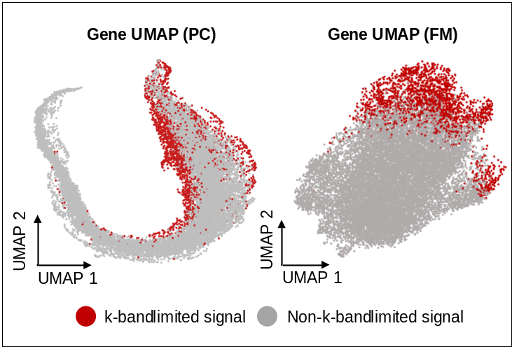
Figure 1. Comparison of the UMAPs obtained using the top 207 principal components (PCs) (left) and the top 207 FMs (right) of the Mouse Visium data (HE-coronal, 2702 spots). The principal component analysis (PCA) dimensions were generated directly from the gene-spot expression matrix using PCA analysis in Scanpy. Red dots indicate the 2,118 k-bandlimited signals (i.e., genes) identified by SpaGFT using the default settings and the other k-bandlimited signals are represented by the grey color.

S1.2 Theoretical foundation. With the support of the theoretical foundation of graph Fourier transform¹⁻³, the gene expression (defined as graph signals $f_{g}$) can be represented in a Fourier space through a linear combination of Fourier Modes (FM) $U$ (Fig. 2a). The FMs are orthogonal and determined by spatial graph topology in increasing order of their frequency, with FM₁ having the lowest frequency. Intuitively, the expression pattern of an SVG should be recovered by a set of first $k$ low-frequency FMs, other than high-frequency FMs (Fig. 2b). Therefore, SVG can be formulated as an approximate k-bandlimited graph signal, which is a smooth signal and can be represented as the linear combination of the first k FMs. We refer to the method for determining high-variant PCs from PCA analysis⁴. The determination of low-frequency and high-frequency FMs can be achieved by finding the inflection point based on the eigenvalue of the Laplacian matrix using Kneedle Algorithm⁵ (Fig. 2c). Meanwhile, the contribution of FMs to SVG expression patterns can be measured by the corresponding Fourier coefficients (FCs). If a gene is an SVG, the low-frequency FCs usually have a larger value than high-frequency FC. Herein, SVG identification can be converted to the recognition of the k-bandlimited signal problem.

S1.3 Computational formulation. Given a graph $G=\left(V,E\right)$, where $V$ is the node set with $\left|V\right|=n$, $n$ is the number of spots, and $E$ is the edge set added based on the Euclidean distance, let $μ_{1}, μ_{2},…,μ_{k}∈R^{n}$be the first $k$ low-frequency FMs. For the expression values of a gene on $n$ spots $f∈R^{n}, {\hat{f}}_{i}=\left\langle μ_{i},\right.\left.f\right\rangle$is the graph FC to describe the contribution of $μ_{i}$ to recover $f$, where $\left\langle \right.,\left.\right\rangle$ represents the dot product and $i=1, 2, …, k.$ For a fixed error $ε>0$, a gene will be considered as an SVG if the corresponding $f$ satisfies $\left\|f-\sum_{i}^{k}{{\hat{f}}_{i}μ_{i}}\right\|<ε.$

Figure 2. a. Workflow of FM identification. Spot graph is constructed by KNN, where $K$ is equal to the number of spot $n$. The degree and adjacency matrix are generated, then the Laplacian matrix can be calculated by subtracting the degree matrix and adjacency matrix. Through decomposing the Laplacian matrix, eigenvalue and eigenvector are obtained, where eigenvectors are the FMs. b. Visualizations of FM patterns in the different frequency domains of the Visium 151673 dataset, where LFM means low-frequency FM and HFM means high-frequency FM. c. The screen plot shows the rank of the eigenvalue (the x-axis) and corresponding values (the y-axis). The low-frequency FM can be determined by the first inflection point, and the high-frequency FM can be determined by the second inflection point.

S2 SVG evaluation I: GFTscore
S2.1 Rationale of GFTscore. Although we formulate the identification of SVG as the recognition of the k-bandlimited graph signal problem, characterizing the k FMs for k-bandlimited graph signals is challenging. Therefore, we plan to design the GFTscore to represent the contribution of first k FMs to the gene expression pattern. We expect a gene with a high GFTscore tends to be an SVG, and a gene with a low GFTscore tends to be a non-SVG.

S2.2 Theoretical foundation of GFTscore. The contribution of FMs can be measured by the FC⁶, which ranges from $(-∞,+∞)$. To make FC comparable among different genes, FC will be normalized to [0,1]. Furthermore, as GFTscore aims to enhance the low-frequency FM contribution across all FMs, we refer to the low pass filter processing approach³ and assign different weights calculated from frequency to all FC. Specifically, low-frequency FC will be assigned a high weight, and high-frequency will be assigned a low weight. Therefore, SVG tends to have a high GFTscore, and non-SVG tends to show a low GFTscore in this definition.

S2.3 Computational formulation of GFTscore. We designed a GFTscore to quantitatively measure the randomness of gene expressions distributed, defined as
$$GFTscore\left(f_{g}\right)=\sum_{k=1}^{n}{e^{-λ_{k}}}{\tilde{f}}_{g}^{k},$$
where $λ_{k}$ is the pre-calculated eigenvalue of $L$, and the normalized frequency signal ${\tilde{f}}_{g}^{k}$ is defined as:
$${\tilde{f}}_{g}^{k}=\frac{{|\hat{f}}_{g}^{k}|}{\sum_{i=1}^{n}{{|\hat{f}}_{g}^{i}|}}.$$

The inflection point of GFTscore can be determined by the Kneedle algorithm⁵. According to a recent study³, the weight ($e^{-λ_{k}}$) of FC was one of common forms in graph signal processing.

S3 SVG evaluation II: hypothesis testing
S3.1 Rationale of hypothesis testing. Although the above GFTscore is an indicator to rank and evaluate the potential SVGs, a rigorous statistical test is needed to calculate the p-value for SVGs and control type I error. We will use the Wilcoxon rank-sum test to test the differences between low-frequency FCs and high-frequency FCs to obtain statistical significance. If a gene has a high GFTscore and significantly adjusted p-value, the gene can be regarded as an SVG.

S3.2 The null hypothesis of testing. We use $x_{1},x_{2},…,x_{n}$ to represent the expression of a random signal on $n$ spots. $x_{i}$ is followed by Gaussian distributions and can be regarded as independent and identically distributed (i.i.d.) random variables⁷. Implementing GFT on $\left(x_{1},x_{2},…,x_{n}\right)$, we obtain $FC_{1}, FC_{2}, ⋯, FC_{p}$, where $p$ is the number of low-frequency FCs and reflects the contributions from low-frequency FMs. We also obtain the $FC_{p+1}, FC_{p+2}, ⋯, FC_{p+q}$ , where $q$ is the number of high-frequency FCs and reflects the contributions from noise. Hence, we form the null hypothesis that there exists no difference between low-frequency FCs and high-frequency FCs.

S3.3 Proof of the assumption of the null hypothesis. Give a signal $x={(x}_{1},x_{2},…,x_{n}), where$ $x_{1},x_{2},…,x_{n}$ are i.i.d random variables. Given any two FMs (corresponding to any non-zero eigenvalues), $u_{k}=\left(u_{k}^{1},u_{k}^{2},…,u_{k}^{n}\right)$ and $u_{l}=\left(u_{l}^{1},u_{l}^{2},…,u_{l}^{n}\right)$. According to the property of the Laplacian matrix defined in SpaGFT, (i) both$u_{1}$ and $u_{2}$ are orthogonal with vector $\left(1,1,…,1\right)$, and one has that $\sum_{i}^{n}{u_{k}^{i}}=\sum_{i}^{n}{u_{l}^{i}}$; (ii) $\sum_{i}^{n}{{{(u}_{k}^{i})}^{2}}=\sum_{i}^{n}{{{(u}_{l}^{i})}^{2}}$ as they are both unit vectors. The $FC_{k}=\sum_{i}^{n}{u_{k}^{i}}x_{i}$ and $FC_{l}=\sum_{i}^{n}{u_{l}^{i}}x_{i}$ are two FCs corresponding to two FMs, respectively. In the following, we can observe two properties, including (i)$E\left(FC_{k}\right)= E\left(\sum_{i}^{n}{u_{k}^{i}}x_{i}\right)=\sum_{i}^{n}{{[u}_{k}^{i}}E\left(x_{i}\right)]=E\left(x_{1}\right)\sum_{i}^{n}{u_{k}^{i}}=E\left(x_{1}\right)\sum_{i}^{n}{u_{l}^{i}=E\left(FC_{l}\right)}$; (ii) $Var\left(FC_{k}\right)= Var\left(\sum_{i}^{n}{u_{k}^{i}}x_{i}\right)=\sum_{i}^{n}{{{[(u}_{k}^{i})}^{2}}Var\left(x_{i}\right)]=Var\left(x_{1}\right)\sum_{i}^{n}{{{(u}_{k}^{i})}^{2}}=Var\left(x_{1}\right)\sum_{i}^{n}{{{(u}_{l}^{i})}^{2}=Var\left(FC_{l}\right)}$. All FCs have the same mean and variance regardless of low-frequency and high-frequency. Therefore, no difference exists between FCs corresponding to low-frequency FMs and FCs corresponding to high-frequency FMs under the null hypothesis.

1 Segarra, S., Marques, A. G., Leus, G. & Ribeiro, A. Reconstruction of graph signals through percolation from seeding nodes. IEEE Transactions on Signal Processing 64, 4363-4378 (2016).
2 Huang, L., Needell, D. & Tang, S. Robust recovery of bandlimited graph signals via randomized dynamical sampling. arXiv preprint arXiv:2109.14079 (2021).
3 Ricaud, B., Borgnat, P., Tremblay, N., Gonçalves, P. & Vandergheynst, P. Fourier could be a data scientist: From graph Fourier transform to signal processing on graphs. Comptes Rendus Physique 20, 474-488, doi:https://doi.org/10.1016/j.crhy.2019.08.003 (2019).
4 Cattell, R. B. The scree test for the number of factors. Multivariate behavioral research 1, 245-276 (1966).
5 Satopaa, V., Albrecht, J., Irwin, D. & Raghavan, B. in 2011 31st international conference on distributed computing systems workshops. 166-171 (IEEE).
6 Puy, G., Tremblay, N., Gribonval, R. & Vandergheynst, P. Random sampling of bandlimited signals on graphs. Applied and Computational Harmonic Analysis 44, 446-475 (2018).
7 Svensson, V., Teichmann, S. A. & Stegle, O. SpatialDE: identification of spatially variable genes. Nature Methods 15, 343-346, doi:10.1038/nmeth.4636 (2018).

