SUPPLEMENTARY DATA FILE
Microplastic distribution in a meandering river bed and its sedimentary predictors
Maarten Van Daele¹, Ben Van Bastelaere¹, Jens De Clercq², Inka Meyer¹, Maaike Vercauteren², Jana Asselman²
¹Renard Centre of Marine Geology, Ghent University, Krijgslaan 281, S8 (we13), 9000 Gent, Belgium
²Blue Growth Research Lab, Ghent University, Wetenschapspark 1, Bluebridge, 8400 Oostende, Belgium
Supplementary methods
Sediment sampling and data acquisition was completed from a solar powered/electric catamaran in spring 2022. During all surveys, real-time kinematic (RTK) positioning was used to achieve accurate positioning data to ensure precise comparisons between datasets.
Geophysical mapping
Multibeam echosounder (MBES)
For precisely mapping the riverbed a portable Norbit Wide Band Multibeam Sonar (Flanders Marine Institute; VLIZ) was used. The system can be used for high resolution bathymetry in shallow environments and has a depth range of 0.2 – 275 m using 512 beams. The system was operated at a frequency of 700 kHz, a ping rate of 60 Hz and a swath coverage of 150°. Real time corrections for vessel motions were possible due to the use of a Seabed-IMU-S2 motion sensor. By using two GPS antennas, directional data could be added in real-time. Due to the small size of the system and the availability of a pole mount, shallow measurements up to a depth of 0.2 m can be achieved. During the measurements, data acquisition can be followed in real-time using the software Qinsy. Hence, fast changes could be made to gather the optimum data. The study area, with a length of 4.4 km, was covered four times in total to ensure complete coverage of the shallow waters. Processing of the raw multibeam data was conducted with the Qimera software at RCMG-UGent (Renard Centre of Marine Geology; Geology Department, Ghent University). Using Global Mapper and QGIS, additional processing and analysis of the data was possible.
Side-scan sonar (SSS)
Side-scan sonar was used to detect anomalies on the riverbed such as objects that may affect sampling or human-induced disturbances. In this study, a dual-frequency Klein System 3000 was deployed, using two frequencies simultaneously, 500 kHz for high resolution and 100 kHz for low resolution. At a maximum range of 25 m on each side, short 25 µsecs pauses were achieved between transmission pulses. The high ping rates were combined with a slow traveling speed (ca. 4 knots), which led to a high cross-track and long-track resolution. Built-in sensors corrected in real-time for the roll, pitch and heading movements of the tow fish. The tow fish was towed next to the boat in front of the engine to minimize disturbances. During measurements, real-time data was shown as a waterfall image using the SonarPro software. For the processing and analysis of the SSS data, the SonarWhiz software was used at VLIZ and visualization was achieved using QGIS.
Water sampling
Water filtering
A sampling device for the extraction of MPs at various depths in a freshwater body was manually constructed for this research. The device was composed of a centrifugal pump (Leader Inoxplus 230, 800 W), installed on a mobile cart. The inlet of the pump was connected to a 5 m long green flexible hose, allowing to sample up to several meters depth in the water column. The downward extremity of the hose was connected to a cylindrical stainless-steel wire-mesh cage with 5 mm pore sizes, which prevented large debris from entering the hose and eventually damaging the pump; this pore size also corresponds to the theoretical upper limit of MPs adopted here ¹. The weight of the cage was increased with two 1 kg weights to keep the hose vertical in the water column.
The pump has two outlets, one of which was connected to a hose of 3 meter length and used to redirect some of the water back to the river to lower the flow over the filters and prevent leakage in the system due to overpressure. The second outlet was used to connect the pump to a filtration system for MPs, which was vertically installed on the cart. The filtration system consisted of two branches containing two filter holders each. During the sampling, valves allowed to alternate between both branches to ensure continuous operation of the device. One branch was then used for filtering water, whereas the used filters from the other one, that filtered the previous sample, were removed and replaced with new ones. The first filter holder of each branch held a 150 μm pore size stainless-steel filter whereas the second one held a 51 μm pore size stainless-steel filter (Spectra labs). These sizes were chosen following a trial and error procedure with the goal to use pore sizes that are sufficiently large to allow for a significant flow, but still small enough to capture as many MPs to obtain valuable results. Finally, a little bit of water remained in the filter holders after sampling. If opened, the water would have flooded out with partial or total loss of the MP sample as a result. Therefore, between each filter another valve with an air filter was installed to let air in when removing the water with a vacuum pump afterwards. The outlet of the filtration system was connected to a flowmeter (Gardena) to measure the volume that had passed through the device, and a 3 meter hose to return the ‘filtered’ water back to the river.
Between samplings, filters were thoroughly flushed with ethanol and sonicated three times for 30 minutes to remove all particulate matter and ensure no cross-contamination between samples.
Sampling strategy
During each sampling campaign, samples at both the 51 and 150 µm filter were obtained from eight different stations. Sample depths and locations were carefully chosen based on the bathymetric data and the range of the sampling device (± 4 m). The center of the straight section (East Straight; ES) and the North Bend (NB) were sampled at 1, 2 and 3 m depth, and the inner- and outer bends (NB) were both sampled at a depth of 1 m. For each sample, the goal was to filter 100 l of river water. However, when the filter clogged before reaching that volume, sampling was stopped.
From each location 5 replicates were taken, amounting to a total of 40 samples (for both 51 and 150 µm filter), over a period of 6 weeks (Supplementary Table 1). The sampling days were chosen based on the weather forecasts for that week. Sampling was planned on dry days with as little rain as possible during the preceding days. However, on the first sampling day, some mild rainfall happened near the end of the afternoon. On the other sampling days, the premises were fulfilled.
Supplementary Table 1. Timing of replicate sampling of water samples.
Replicate # | Date | Time
1 | 15 Feb 2022 | 8 AM – 5 PM
2 | 1 Mar 2022 | 10 AM – 3 PM
3 | 16 Mar 2022 | 9 AM – 1 PM
4 | 24 Mar 2022 | 9 AM – 1 PM
5 | 29 Mar 2022 | 9 AM – 1 PM
For 10 of the 40 samples more than 80 liters were filtered, and at least 50 l was filtered for half of the samples. Only in two samples less than 10 l could be filtered. Total filtered volume per station ranged between 159 l (3 m depth in ES) and 381 l (NB outer bend sample at 1 m depth), and in 7 out of 8 stations more than 225 l of river water was filtered.
Sediment sampling
On February 15 2022 (first water sampling day), surface sediments of the riverbed were sampled using a Uwitec gravity corer (USC 09000) with ball core catcher. The portable corer can be used fast for all kinds of sediments in standing and flowing waters. As a liner, a PVC tube with a diameter of 90 mm was used. To limit the microplastic contamination, core extrusion rather than core cutting was performed to retrieve the sediments. Consecutive slices of 3 cm thickness were acquired and stored in closed aluminum trays. All samples were stored at -18°C until further analysis to limit organic growth. This study focuses on the upper 0-3 cm as they are considered as surface sediments. In total, 18 surface samples were taken (North Bend: 5, South Bend: 7, East Straight: 6). From each separate sample, two replicates were analyzed for MP content.
Sediment analysis
Sediment water content
Due to the high variability in water content of sediments collected at different locations on the river bank, it is highly recommended to express MP results as dry weight (items/ kg DW). A separate wet subsample of approximately 5 grams was taken from each sample, which was not analyzed for MP content. This way, contamination issues did not need to be taken into account. The subsamples for water content were taken at the same time as the subsamples taken for MP concentration analysis. Homogenization of the sample was achieved by mixing with a metal spoon. In order to check if the homogenization was sufficient, the water content of sample ES_C1 was measured for three several subsamples. With a water content concentration of 49%, 50 % and 52 %, it can be expected that a homogeneous mixture was achieved and that the microplastic subsamples had equivalent water content percentages as the subsample on which the water content was derived. In order to calculate the water content of each sample, 5 g of sediment was placed in a crucible and was positioned in the center of a drying oven, since this is the most used drying method in freshwater sediment MP research ². The sediment was dried at a constant temperature of 60°C for several days. The crucibles were weighed until no further weight loss could be noted, which was usually after seven days. Thereafter, the water content was calculated by subtracting the dry sediment weight from the wet sediment weight.
Loss on ignition (LOI)
An estimation of the organic and carbon content of the sediment was detected based on the sequential loss on ignition method developed by Heiri, Lotter ³. At first, 1 g of dried sediment was crushed and grinded using an agate mortar and pestle and the powder was placed in a pre-weighed porcelain crucible. Next, the crucibles were heated to 105°C for 24 hours to determine the dry sediment weight (DW150). The samples then underwent a first heat treatment at 550°C for 4 hours, in which the organic matter is oxidized to gaseous carbon dioxide (CO₂) and small amounts of ash. As a final step, the crucibles were heated to 950°C for 2 hours, in which CO₂ is evolved from the carbonates (CaC0₃) and CaO is left in the crucible. By measuring the weight loss of the crucible at each step, an estimation of the organic and carbonate content of the sediment can be made as followed:
OM% = (DW105 − 𝐷W550) / 𝐷W105 𝑥 100%
𝐶𝐶% = (𝐷W105 – 𝐷W950) / 𝐷W105 𝑥 100/44 𝑥 100%
DW₅₅₀ and DW₉₅₀ are the weights of the sediments after heat treatment at 550°C and 950°C respectively. The OM% is an estimation of the percentage of organic matter that was present in the sediment sample. OM% was further corrected by subtracting the OM values of the field blank (1.53%), which had been pretreated following the LOI550 protocol, and its values can thus be attributed to water in clays. CC% reflects an estimation of the carbonate content of the sediment sample assuming all carbonate is calcium carbonate. Since weight loss at the last step is entirely due to the loss of CO₂, an additional correction based on the relative atomic weights of CO₂ and CaO is made by multiplying with a factor of 100/44.
Grain-size analysis
Grain-size analysis on the clastic fraction was determined by laser diffraction using a Malvern Master 3000 equipped with a Hydro MV module. To check for sufficient homogenization and reproducibility three replicas were taken from two samples. In order to isolate the terrigenous fraction of the sediment, samples were chemically pre-treated. For each sample, 20-40 mg of sediment was introduced in 10 ml of deionized water. The sediment was heated with 30% hydrogen peroxide, to dissolve organic material, 10% hydrochloric acid (HCl), to dissolve carbonates and 2N sodium hydroxide solution (NaOH) to dissolve biogenic silica. Finally, 1 ml Calgon ((NaPO₃)₆) solution was added to the suspension (~10 ml) to ensure the disintegration of the cohesive particles before measurement. The Malvern Master 3000 measures the grain-size distribution of the sample using the Mie Theory. By using a red and blue laser, a high sensitivity for both larger and smaller sediment particles, respectively, is ensured. For each sample, 6 measurements were conducted in order to check reproducibility of the results. The resulting data was processed and analyzed in Gradistat v9.1 ⁴.
Microplastic analysis
Microplastic extraction
The collected particles from the water column were extracted from the stainless-steel filters using 5% SDS submersion (24h, 40°C) and subsequent ultrasonication (5 min). Afterwards, the beaker and filters were flushed with ethanol and all particulate material was collected on 50 µm nylon sieves. The remains on the sieve were backflushed using 10% KOH and collected in a pre-rinsed glass beaker. The sample was incubated at 50°C for 24h to allow digestion of the organic matter. After the digestion, the sample was sieved again over a 50 μm nylon sieve and then backflushed with NaI into a falcon tube. Using NaI (1.6 g/mL) and centrifugation (5 min 3500 RPM) the sample was further processed using density separation to extract the microplastics. The floating layer, containing the microplastics, was collected on a PTFE filter (10 µm, Omnipore), according to Semmouri et al. (2023) for further analysis on the FTIR.
For the sediment samples, we follow the extraction protocol used as the gold standard in recent studies by the Flemish Environmental Agency ⁵. Two replicas of ca. 10 g of wet sediment were taken from each sediment sample. The sediment of each replica was inserted into separate 200 ml beakers after which 100 ml of 10% filtered KOH solution was added to digest organic material. The beakers were left in a water bath at 60°C for ca. 48 hours. By using low KOH concentrations as oxidizing agent at relatively low temperatures, sufficient digestion of organic matter can be achieved without affecting most polymer types ^{6, 7}. After organic digestion, the sediment/KOH solution was transferred into a polypropylene centrifuge tube and was centrifuged for 7 minutes at 2000 rpm. The supernatant was filtered over a Cellulose Nitrate (CN) membrane filter (mesh size 8 µm). The remaining pellet was diluted with a NaI solution (density = 1.6 g/cm³) and centrifuged at 2000 rpm for 7 minutes after homogenization. After the density separation, the supernatant is filtered over the same CN filter, so that all suspended particles, and thus particles with a density < 1.6 g/cm³, were collected on the filter. The density separation with NaI was repeated twice, so that in total three density separation steps were completed. If the filter was clogged due to the presence of a high amount of particles, a new cleaned CN filter was placed in the filtering system. Next, all CN filters of the same sample were added into a glass 100 ml Duran bottle and digested using a 10 % KOH solution (50 ml for each CN filter, 24 hours, 60°C). After digestion, the Duran bottles were transported to the FTIR lab and filtered over a large PVC sieve (mesh size 20 µm). The filter was rinsed using a 1,6 g/cm³ NaI solution and the particles and fluids were caught into a centrifuge tube using a glass filter. The particle/NaI solution mix was centrifuged a last time for 5 minutes at 3700 rpm. Next, the supernatant containing the potential microplastics was filtered over polytetrafluoroethylene (PTFE) filters (mesh size 10 µm) using a glass filtering system. The filtering was conducted in small steps to ensure a single layer of particles on the filer, so that each particle could be analyzed with the FTIR. Due to the high amount of particles in the samples, two to four PTFE samples were needed for each replica. Thereafter, the filters were dried in a dust free environment under a small, glass petri dish during 24 hours at room temperature before analysis.
Microplastic analysis using FTIR
The dried PTFE filters are analyzed using FTIR spectroscopy (Nicolet iN10 FT-IR Microscope; Thermo Fisher Scientific, Madison, Wi, VSA), which is the most commonly used method for microplastic identification and is highly recommended due to the ability of automated counting and polymer identification ^{8, 9}. FTIR spectroscopy is a completely non-destructive technique in which each particle on the filter is irradiated with infrared light with a given wavelength. As a result, structure specific vibrations are produced and can be detected. The characteristic spectra can then be seen as a fingerprint to allow polymer identification ⁹. Before FTIR spectroscopy measurements, a mosaic of the entire filter is taken using built-in optic microscopy. From the mosaic, each particle and their matching 2D dimensions and locations are identified using automated image analysis. Next, all particles are excited with infrared light (wavelength between 780 nm – 106 nm) and the characteristic spectrum of each particle was measured (spectral range 4000 – 1300 cm⁻¹, 100 µm step-size scanning, 150 – 150 µm aperture, spectral resolution 16 cm⁻¹). The characteristic spectrum of each particle, which is the absorbance plotted versus the related specific wavelength of infrared waves, are than correlated to both an in-house and commercial reference library using Pearson’s correlation. However, the graphs of the reference library, derived from fresher MP particles, are never 100 % the same compared to weathered particles from the sample. A particle is identified as MP particle if the correlation coefficient between the obtained absorbance spectra and the absorbance spectra of a certain polymer type from the reference libraries reached a value equal or higher than 80 %. After analysis, each filter is stored separately in a capped petri dish. All unidentified particles are removed from the dataset, while particles identified as a certain polymer type were processed. Based on the 2D dimensions of the plastic particles, an estimation on the total volume of each particle was made by simplifying the shape of each particle to an ellipsoid and by estimating the third dimensions as 0.6 times the width ^{5, 10, 11}. Thereafter, the mass of each particle was calculated using both the lowest and highest density for each specific polymer type.
Quality assurance and control
It is important to limit secondary contamination of MPs considering their omnipresent nature. Since MP research is relatively new, it lacks standardized protocols which ensure the accuracy of the results and comparability between MP studies. However, many measures have been introduced that have been practiced during the research ². Laboratory surfaces were thoroughly cleaned before use and specific lab spaces were only used for MP research. Samples were handled under a fume hood, to limit the settling of airborne MP particles. A 100% cotton lab coat was worn whilst working with samples during all steps. Nitrile lab gloves were avoided if the safety of the researcher would not be infringed. Glass and metal tools and containers were used as much as possible to limit direct exposure of the sediment to all kinds of polymer types. Sediments were stored in closed aluminum containers, mixed and transferred using metal tools and processed in glass beakers. All equipment and storage containers are rinsed before use with running demineralized water. Liquid agents such as the NaI and KOH solutions were filtered over a paper filter with a mesh size of 1.2 µm, which is smaller than the detection limit of the FTIR. All liquid agents were stored in glass containers and capped with aluminum foil or petri dishes to avoid the use of plastic caps and the resulting plastic on plastic friction when turning the caps. However, the use of plastic tools cannot be completely avoided. As previously mentioned, a core liner made from PVC had to be used in the coring device, whilst polypropylene centrifuge tubes were also frequently used. For this reason, procedural blanks were investigated that underwent the same treatment steps as the sediment samples. In order to have a similar sediment matrix to the investigated sediments, sediment samples from a previous test campaign in the same region were used to mimic the sediments as close as possible. A mix of two Van Veen grabs was pre-treated by heating the sediments at a high temperature of 550 °C for 4 hours to obtain MP-free sediment ². The clean sediment was brought on the catamaran during the sampling campaign and inserted in the coring device. Henceforth, the blank was considered as a regular sample and processed in the same way as every other sample.
For filtered water samples, blank samples were collected for contamination correction. For the blanks, in total 100L of deionized water were filtered using the equipment in a similar manner as the field samples. The filters were collected and processed in a same way as the other samples. In total 3 blank samples were collected. Using the MP concentrations in the blank samples, a correction was performed using the limit of detection (LOD) and limit of quantitation (LOQ) method ^{12, 13}. LOD and LOQ were calculated for each polymer type and all sample concentrations that were below the LOQ for a specific polymer were deemed unreliable due to potential contamination and removed from the dataset. LOD and LOQ values are presented in Supplementary Table 2.
Supplementary Table 2. LOD and LOQ values.
Polymer | LOD (particles/L) | LOQ (particles/L)
PAM | 0.03663043 | 0.0462105
PE | 1.00076900 | 1.3885453
PP | 7.16653467 | 10.4560419
PS | 0.73248188 | 0.7872436
PET | 0.003333 | 0.005774
PVC | 0 | 0

Supplementary figures
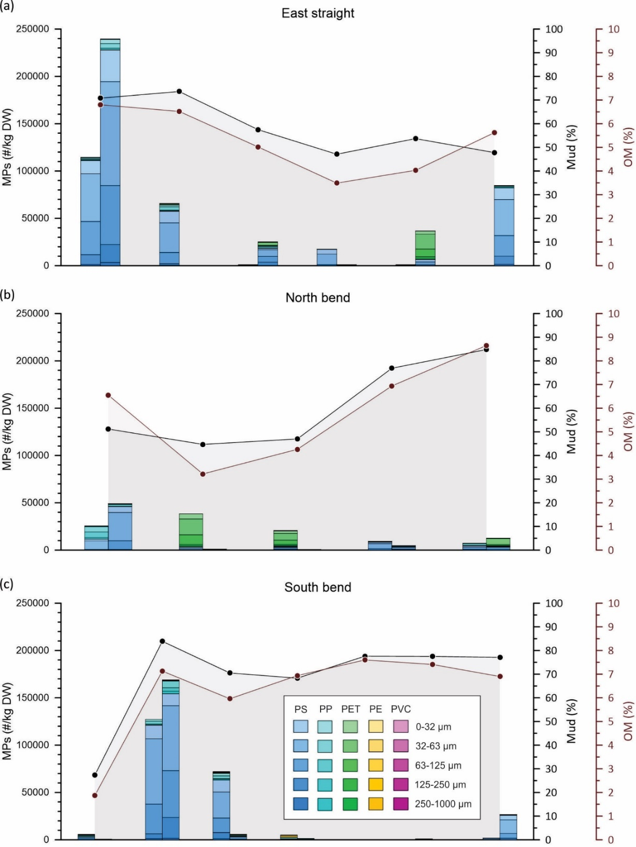
Supplementary Figure 1. Sample transects across the River Lys for each sample location MP concentration, organic matter content and mud content. MP types and particle size (5 particle-size classes) are provided for each replicate separately. (a) East Straight, (b) North Bend, (c) South Bend. For both bends the orientation of the profile is such that the outer bend is to the right-hand side. Note that all axes have the same scale to allow comparison between profiles, apart from the distance across the profiles.

Supplementary Figure 2. Correlation plot between carbonate and organic matter content estimated through loss-on-ignition (LOI). Green: field blank; orange: all sites apart from outer bank: blue outer bank sites. Outer bank sites have low calcium-carbonate content (i.e. 100/44*LOI950) relative to the organic matter content (LOI550) suggesting a different sediment composition and depositional setting.

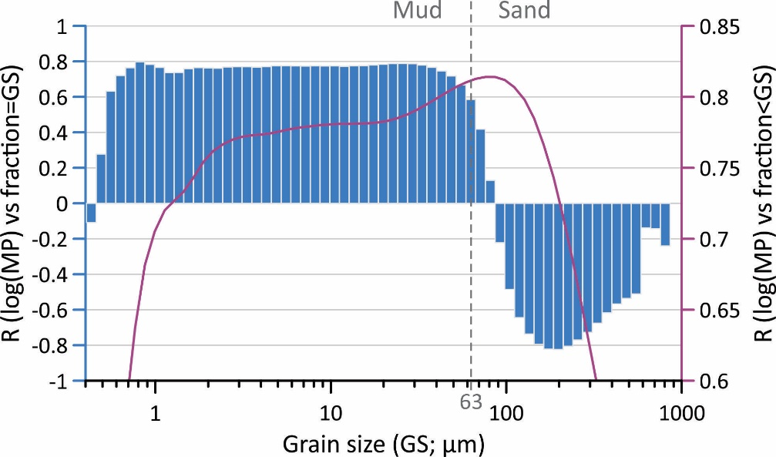
Supplementary Figure 3. Correlations (R) between log(MP) and grain-size fractions for all sites apart from the outer bank sites. The blue bar plot shows R for linear regressions between log(MP) and the grain-size fraction represented by the bar width. The purple curve shows evolution of R between log(MP) and the fraction of the sample that is finer then the grain size at which it is plotted. The bar plot shows that for any mud fraction correlations are positive, while they become negative for any sand fraction >90µm. As a result, correlations peak when taking into account the entire fraction below 76 µm (R=0.814), which is slightly higher then what we obtain for the fraction below 63 µm (i.e. mud; R=0.811), but the difference is negligible. Hence, mud content is a good predictor for log(MP).

Supplementary references
1. Galgani F, Hanke G, Werner S, De Vrees L. Marine litter within the European Marine Strategy Framework Directive. ICES J Mar Sci 70, 1055-1064 (2013).

2. Adomat Y, Grischek T. Sampling and processing methods of microplastics in river sediments - A review. Sci Total Environ 758, 143691 (2021).

3. Heiri O, Lotter AF, Lemcke G. Loss on ignition as a method for estimating organic and carbonate content in sediments: reproducibility and comparability of results. Journal of Paleolimnology 25, 101-110 (2001).

4. Blott SJ, Pye K. GRADISTAT: A grain size distribution and statistics package for the analysis of unconsolidated sediments. Earth Surface Processes and Landforms 26, 1237-1248 (2001).

5. Vercauteren M, et al. Onderzoek naar verspreiding, effecten en risico’s van microplastics in het Vlaamse oppervlaktewater-Kernrapport. (2021).

6. Foekema EM, De Gruijter C, Mergia MT, van Franeker JA, Murk AJ, Koelmans AA. Plastic in north sea fish. Environ Sci Technol 47, 8818-8824 (2013).

7. Kuhn S, van Werven B, van Oyen A, Meijboom A, Bravo Rebolledo EL, van Franeker JA. The use of potassium hydroxide (KOH) solution as a suitable approach to isolate plastics ingested by marine organisms. Mar Pollut Bull 115, 86-90 (2017).

8. Yang L, Zhang Y, Kang S, Wang Z, Wu C. Microplastics in freshwater sediment: A review on methods, occurrence, and sources. Science of The Total Environment 754, (2021).

9. Li J, Liu H, Paul Chen J. Microplastics in freshwater systems: A review on occurrence, environmental effects, and methods for microplastics detection. Water Res 137, 362-374 (2018).

10. Liu F, Olesen KB, Borregaard AR, Vollertsen J. Microplastics in urban and highway stormwater retention ponds. Science of The Total Environment 671, 992-1000 (2019).

11. Simon M, van Alst N, Vollertsen J. Quantification of microplastic mass and removal rates at wastewater treatment plants applying Focal Plane Array (FPA)-based Fourier Transform Infrared (FT-IR) imaging. Water Res 142, 1-9 (2018).

12. Semmouri I, Vercauteren M, Van Acker E, Pequeur E, Asselman J, Janssen C. Distribution of microplastics in freshwater systems in an urbanized region: A case study in Flanders (Belgium). Sci Total Environ 872, 162192 (2023).

13. Vercauteren M, et al. Assessment of road run-off and domestic wastewater contribution to microplastic pollution in a densely populated area (Flanders, Belgium). Environ Pollut 333, 122090 (2023).

