Supplementary Materials for

Gut Mycobiome Core Species Causally Modulate Metabolic Health in Mice
Mackenzie W. Gutierrez et al.

*Corresponding author. Email: marie.arrieta@ucalgary.ca

This PDF file includes:

Figs. S1 to S7
Tables S1 to S13

Other Supplementary Materials for this manuscript include the following:

Data S1

Figure S1. Bacterial Shannon diversity and relative abundance with fungal colonization (related to Figure 1). (A) Bacterial Shannon diversity index at 3 weeks of age. (B) Bacterial relative abundance at 3 weeks of age. Fungal groups are plotted with their corresponding B only control group. (C) Bacterial Shannon diversity at 12 weeks of age. (D) Bacterial relative abundance at 12 weeks of age by diet. Fungal groups are plotted beside their corresponding B only control group. Boxplots show median and interquartile range. Each dot represents an individual mouse. Normality assessed with the Shapiro-Wilk test and differences calculated with unpaired T-test or Mann-Whitney test accordingly. *p<0.05, **p<0.01, ***p<0.001.

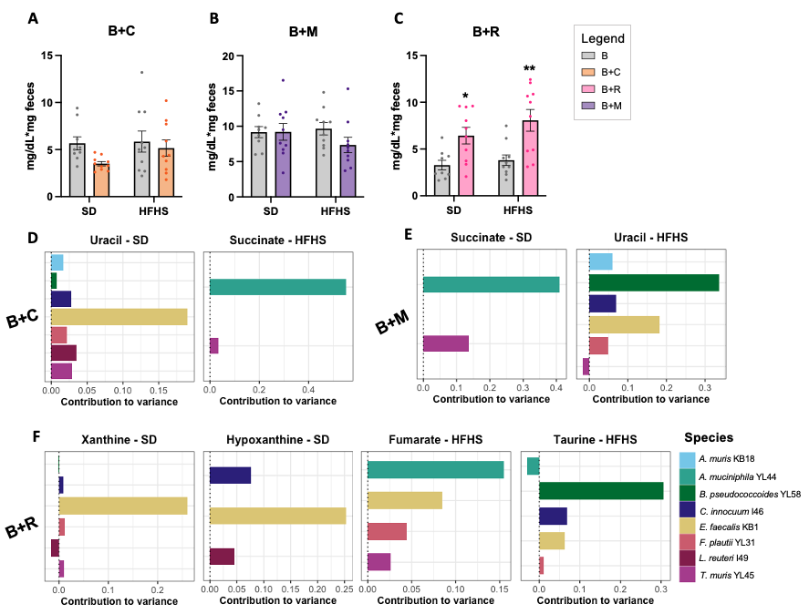
Figure S2. Fecal lipid content and bacterial contribution to variance of microbiome governed metabolites (related to Figure 2). (A-C) Fecal lipid concentration independent of sex in B+C, B+M and B+R mice, respectively. (D-F) Contribution to variance of bacterial strains to microbiome driven metabolites identified with MIMOSA2 in B+C, B+M and B+R mice, respectively. Data represents mean +/- SEM. Each dot represents an individual mouse. Significant differences defined by Two-way ANOVA with Šídák’s multiple comparisons test. *p<0.05, **p<0.01, ***p<0.001, ****p<0.0001. Metabolites were defined as microbiome driven if the linear regression between community metabolic potential and log transformed metabolite abundance had p < 0.05.

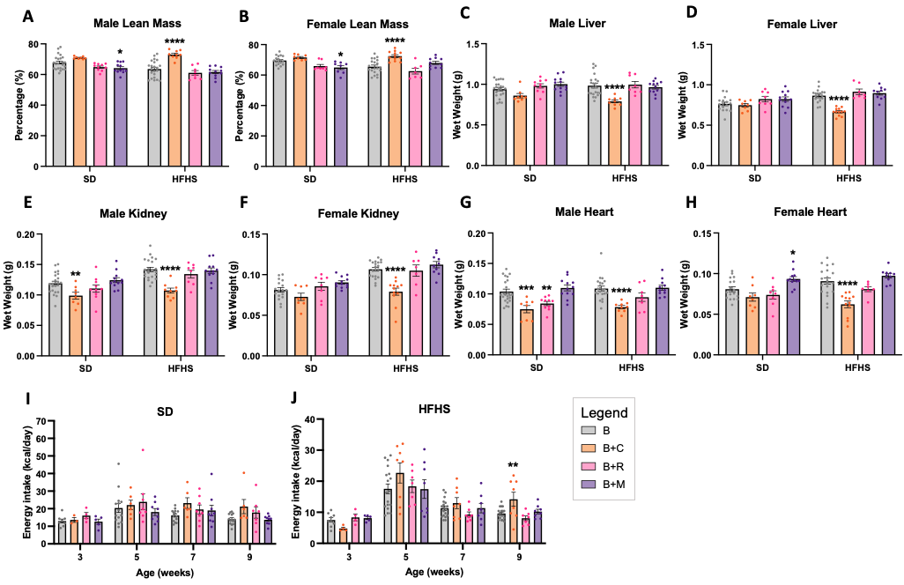
Figure S3. Fungal colonization modulates lean mass and organ weight and differences are not explained by energy intake (related to Figure 3). (A-B) Lean mass percentage in males and females, respectively. (C-D) Liver wet weight in males and females, respectively. (E-F) Kidney wet weight in males and females, respectively. (G-H) Heart wet weight in males and females, respectively. Data represents mean +/- SEM. Each dot represents an individual mouse. Significant differences defined by Two-way ANOVA with Dunnett’s multiple comparisons test relative to B only group within either diet. (I-J) Biweekly energy intake independent of sex in SD-fed and HFHS-fed mice, respectively. Each dot represents average daily energy intake per mouse in an individual cage. Normality was assessed by Shapiro-Wilk test and significant differences at each timepoint defined by Kruskal-Wallis test with Dunn’s multiple comparisons test or One-way ANOVA with Dunnett’s multiple comparisons test relative to B only group accordingly. Outliers removed with ROUT (Q = 1%). *p<0.05, **p<0.01, ***p<0.001, ****p<0.0001.

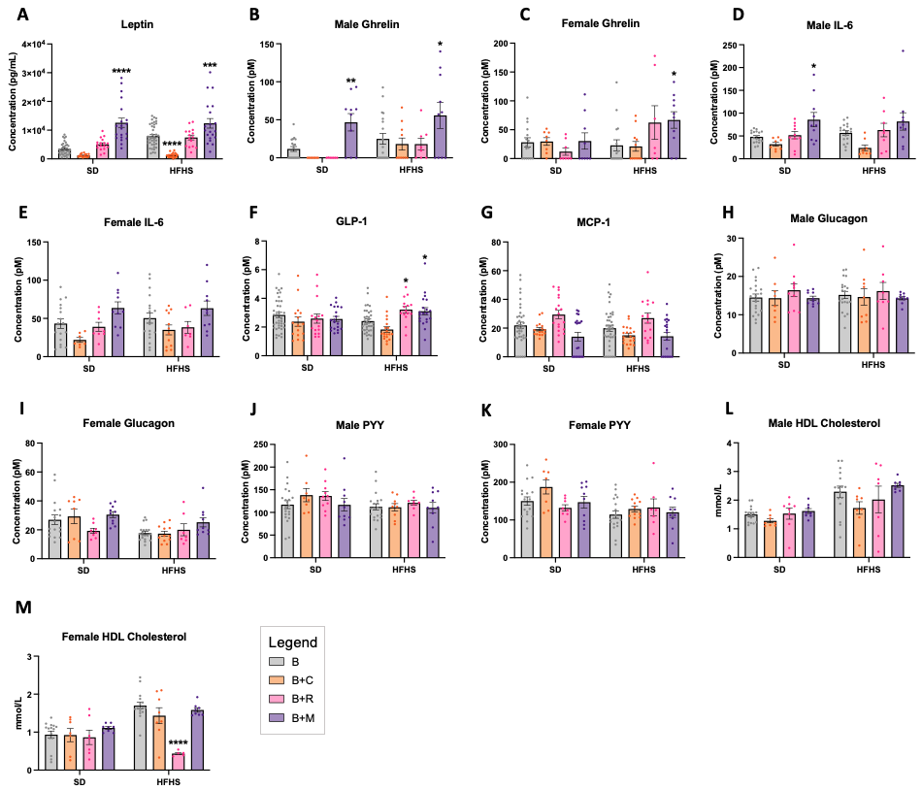
Figure S4. Fungal colonization modulates metabolic hormones and cytokines in plasma (related to Figure 4). (A) Plasma leptin independent of sex. (B-C) Plasma ghrelin in males and females, respectively. (D-E) Plasma IL-6 in males and females, respectively. (F) Plasma GLP-1 independent of sex. (G) Plasma MCP-1 independent of sex. (H-I) Plasma glucagon in males and females, respectively. (J-K) Plasma PYY in males and females, respectively. (L-M) Plasma HDL cholesterol in males and females, respectively. Data represents mean +/- SEM. Each dot represents an individual mouse. Outliers removed with ROUT (Q = 1%) and significant differences at each timepoint defined by Two-way ANOVA with Dunnett’s multiple comparisons test relative to B only group within either diet. *p<0.05, **p<0.01, ***p<0.001, ****p<0.0001.

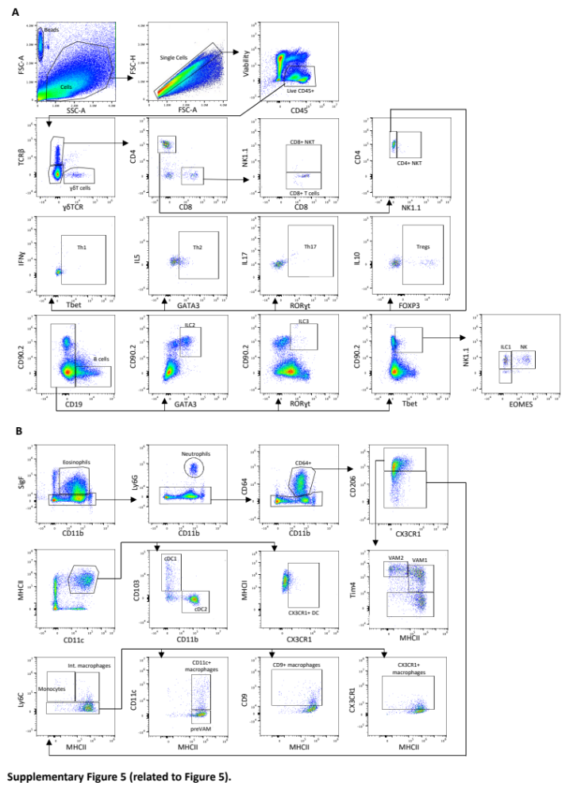
Figure S5. Flow cytometry gating strategy (related to Figure 5). (A) Lymphoid panel gating strategy. Data shown is from WAT immune cells. (B) Myeloid panel gating strategy following selection of Live CD45+ cells as shown in A. Data shown is from WAT immune cells.

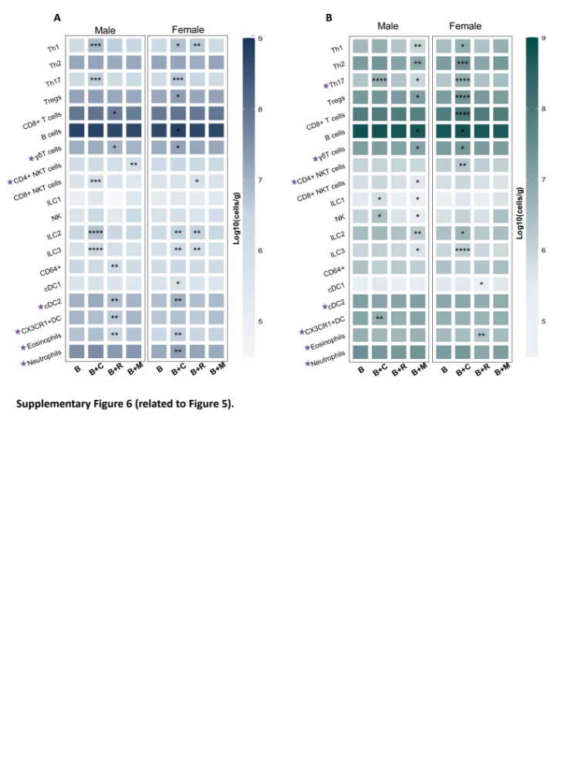
Figure S6. Fungal colonization modulates spleen immune cell populations (related to Figure 5). (A-B) Spleen immune cell populations mice fed SD and HFHS, respectively. Data represented as mean log10(cells/gram of tissue). Outliers identified with ROUT (Q = 1%). Sex effect assessed by Three-way ANOVA and p<0.05 indicated with a star. Significant differences between fungal colonized and B only group defined by Two-way ANOVA with Dunnett’s multiple comparisons test.

Figure S7. Fungi modulate the visceral WAT immune cell landscape, microbiome and metabolism in an integrated manner on HFHS (related to Figure 5). (A) WAT immune cell populations in HFHS-fed mice. Data represented as mean log10(cells/gram of tissue). Outliers identified with ROUT (Q = 1%). Sex effect assessed by Three-way ANOVA and p<0.05 indicated with a star. Significant differences between fungal colonized and B only group defined by Two-way ANOVA with Dunnett’s multiple comparisons. (B) Spearman correlation in HFHS-fed mice between variables grouped by metabolism, bacterial abundance, white adipose tissue (WAT) immunity and colonization. Correlations with coefficients >|0.6| shown.

Group | Variable | F.model | R² | p-value
B+C | Fungi | 4.0282 | 0.12020 | 0.01**
B+C | Sex | 0.4836 | 0.01443 | 0.76
B+R | Fungi | 7.1792 | 0.19581 | 0.001***
B+R | Sex | 0.4859 | 0.01325 | 0.0769
B+M | Fungi | 1.0274 | 0.03701 | 0.393
B+M | Sex | 0.7309 | 0.02633 | 0.567
Table S1. Bacterial beta-diversity statistics at three weeks. Statistical results defined by PERMANOVA for Bray-Curtis dissimilarity.

Group | Variable | F.model | R² | p-value
B+C | Fungi | 18.398 | 0.12705 | 0.001***
B+C | Sex | 63.688 | 0.43978 | 0.001***
B+C | Diet | 2.731 | 0.01886 | 0.039*
B+R | Fungi | 47.371 | 0.27078 | 0.001***
B+R | Sex | 67.036 | 0.38319 | 0.001***
B+R | Diet | 2.535 | 0.01449 | 0.083
B+M | Fungi | 4.003 | 0.02677 | 0.016*
B+M | Sex | 84.133 | 0.56264 | 0.001***
B+M | Diet | 2.397 | 0.01603 | 0.079
Table S2. Bacterial beta-diversity statistics at twelve weeks. Statistical results defined by PERMANOVA for Bray-Curtis dissimilarity.

Group | Variable | F.model | R² | p-value
B+C | Fungi | 10.610 | 0.09666 | 0.001***
B+C | Diet | 38.161 | 0.34764 | 0.001***
B+R | Fungi | 5.7794 | 0.05622 | 0.001***
B+R | Diet | 37.0133 | 0.36008 | 0.001***
B+M | Fungi | 1.3327 | 0.01418 | 0.208
B+M | Diet | 47.6212 | 0.50686 | 0.001***
Table S3. Fecal metabolome PCA statistics. Statistical results defined by PERMANOVA for Euclidean distance.

Colonization | Diet | Metabolite | Fold change | Fold change p-value (FDR) | Normalized concentration p-value (FDR)
B+C | SD | L-CYSTATHIONINE | 44.977 | 1.43E-07 | <0.000001
B+C | SD | HYPOTAURINE | 41.588 | 1.43E-07 | <0.000001
B+C | SD | SUCCINATE | 3.8693 | 3.82E-07 | <0.000001
B+C | SD | FUMARATE | 3.2729 | 5.01E-07 | <0.000001
B+C | SD | L-ARABITOL | 2.3353 | 6.87E-07 | <0.000001
B+C | SD | L-GLUTAMINE | 2.2406 | 9.06E-07 | <0.000001
B+C | SD | OMEGA-HYDROXYDODECANOIC ACID | 5.8958 | 2.74E-06 | <0.000001
B+C | SD | ADIPIC ACID | 12.49 | 3.79E-05 | 0.000005
B+C | SD | 5-HYDROXYINDOLEACETATE | 0.38238 | 2.38E-05 | 0.000003
B+C | SD | 4-METHYL-2-OXO-PENTANOIC ACID | 0.45305 | 4.24E-05 | 0.000007
B+C | SD | URATE | 0.40761 | 0.00024852 | 0.000046
B+C | SD | 3-HYDROXYBUTANOIC ACID | 0.33473 | 0.00050758 | 0.000106
B+C | SD | FERULATE | 0.37692 | 0.0010363 | 0.000229
B+C | SD | 6-CARBOXYHEXANOATE | 0.45197 | 0.01671 | 0.006606
B+C | HFHS | L-ARABITOL | 4.4372 | 2.86E-07 | <0.000001
B+C | HFHS | OMEGA-HYDROXYDODECANOIC ACID | 4.2689 | 0.00032946 | 0.000009
B+C | HFHS | ADENINE | 3.4621 | 0.00079865 | 0.000037
B+C | HFHS | HYPOTAURINE | 2.6505 | 0.0060198 | 0.000770
B+C | HFHS | DEOXYCYTIDINE | 3.1045 | 0.0081909 | 0.001238
B+C | HFHS | CORTISOL 21-ACETATE | 0.47683 | 0.0081909 | 0.001238
B+C | HFHS | THYMIDINE | 2.1614 | 0.0088629 | 0.001443
B+R | SD | L-CYSTATHIONINE | 22.796 | 1.43E-07 | <0.000001
B+R | SD | MANNITOL | 20.928 | 1.43E-07 | <0.000001
B+R | SD | ALPHA-D-GLUCOSE | 4.3656 | 1.91E-07 | <0.000001
B+R | SD | OMEGA-HYDROXYDODECANOIC ACID | 2.8494 | 8.58E-07 | <0.000001
B+R | SD | 5-HYDROXYINDOLEACETATE | 0.37957 | 5.55E-06 | <0.000001
B+R | SD | FERULATE | 0.2426 | 5.77E-05 | 0.000004
B+R | SD | STACHYOSE | 3.4831 | 6.50E-05 | 0.000005
B+R | SD | 10-HYDROXYDECANOATE | 0.45954 | 0.00015803 | 0.000015
B+R | SD | 3-HYDROXYBUTANOIC ACID | 0.25483 | 0.00022568 | 0.000024
Table S4. Metabolites identified by fold-change analysis. Fold-change analysis performed by Metaboanalyst. Direction of comparison was specified as fungal groups/B only. Test parameters were non-parametric with unequal variance and false discovery rate correction (p<0.05). Differences in normalized concentrations between B only and fungal colonized groups defined by Mann-Whitney test with false discovery rate correction.

Cell population | Panel | Markers
Eosinophils | Myeloid | CD45+ CD11b+ SigF+
Neutrophils | Myeloid | CD45+ CD11b+ SigF-Ly6G+
Monocytes & macrophages  VAM1  VAM2  Monocytes  Int. macrophages  Macrophages  CD9+ macrophages  preVAM  CD11c+ macrophages  CX3CR1+ macrophages | Myeloid | CD45+ CD11b+ SigF-Ly6G+CD64+  CD206^{hi}MHCII+Tim4^{int}  CD206^{hi}MHCII-Tim4^{hi}  CD206^{lo/int}Ly6C+MHCII-  CD206^{lo/int}Ly6C+MHCII+  CD206^{lo/int}Ly6C-MHCII+  CD9+  CD11c-  CD11c+  CX3CR1+
Dendritic cells  cDC1  cDC2  CX3CR1+ DC | Myeloid | CD45+ CD11b+ SigF-Ly6G+CD64-CD11c+MHCII+  CD103+CD11b-  CD103-CD11b+  CX3CR1+
γδT cells | Lymphoid | CD45+ɑβTCR-γδTCR+
ɑβTcells  CD8+  CD8+ NKT  CD8+ T cells  CD4+  CD4+ NKT  CD4+ Th  Th1  Th2  Th17  Treg | Lymphoid | CD45+ɑβTCR+γδTCR-  CD4-CD8+  NK1.1+  NK1.1-  CD4+CD8-  NK1.1+  NK1.1-  Tbet+  GATA3+  RORγt+IL-17A+  FOXP3+
B cells | Lymphoid | CD45+ɑβTCR-γδTCR-CD19+
Lin-  Tbet+ ILC  ILC1  NK  ILC2  ILC3 | Lymphoid | CD45+ɑβTCR-γδTCR-CD19-  CD90.2+Tbet+  NK1.1+EOMES-  NK1.1+EOMES+  CD90.2+GATA3+  CD90.2+RORγt+
Table S5. Immune cell characterization by extracellular and intracellular markers in flow cytometry panels. VAM, vascular associated macrophage; Int, intermediate; DC, dendritic cell; cDC, conventional dendritic cell; NKT; natural killer T cell; Th, T helper cell; Treg, T regulatory cell; Lin, lineage; ILC, innate lymphoid cell; NK, natural killer cell.

Cell type | B |  | B+C |  | B+R |  | B+M
Cell type | Mean | SD | Mean | SD | Mean | SD | Mean | SD
Th1 | 6.64E+02 | 5.59E+02 | 3.28E+03 | 2.23E+03 | 8.97E+02 | 7.53E+02 | 9.27E+02 | 1.27E+03
Th2 | 3.09E+03 | 2.17E+03 | 3.80E+03 | 2.45E+03 | 1.82E+03 | 1.32E+03 | 2.09E+03 | 2.09E+03
Th17 | 5.92E+02 | 4.86E+02 | 1.82E+03 | 7.05E+02 | 3.54E+02 | 1.81E+02 | 2.82E+02 | 3.45E+02
Tregs | 1.70E+03 | 9.70E+02 | 1.62E+03 | 5.31E+02 | 1.15E+03 | 9.41E+02 | 9.21E+02 | 9.24E+02
CD8+ T cells | 3.05E+03 | 1.98E+03 | 5.70E+03 | 1.81E+03 | 2.23E+03 | 1.82E+03 | 1.29E+03 | 6.97E+02
B cells | 5.03E+04 | 4.58E+04 | 1.29E+05 | 7.29E+04 | 4.97E+04 | 3.89E+04 | 1.77E+04 | 1.10E+04
γδΤ cells | 4.65E+03 | 3.14E+03 | 1.66E+04 | 4.71E+03 | 4.91E+03 | 3.26E+03 | 2.76E+03 | 1.86E+03
CD4+ NKT cells | 2.93E+02 | 2.25E+02 | 4.53E+02 | 1.63E+02 | 2.52E+02 | 2.31E+02 | 3.16E+02 | 2.88E+02
CD8+ NKT cells | 3.10E+02 | 2.66E+02 | 6.75E+02 | 4.53E+02 | 2.97E+02 | 2.99E+02 | 2.81E+02 | 2.46E+02
ILC1 | 2.47E+03 | 2.19E+03 | 8.43E+03 | 3.79E+03 | 1.96E+03 | 1.54E+03 | 1.01E+03 | 7.00E+02
NK | 2.61E+03 | 2.02E+03 | 6.73E+03 | 3.89E+03 | 1.45E+03 | 9.93E+02 | 1.77E+03 | 1.41E+03
ILC2 | 1.39E+04 | 9.65E+03 | 1.98E+04 | 2.51E+03 | 1.20E+04 | 8.14E+03 | 6.11E+03 | 2.67E+03
ILC3 | 1.96E+03 | 1.01E+03 | 3.99E+03 | 1.99E+03 | 1.86E+03 | 1.34E+03 | 1.16E+03 | 9.64E+02
CD64+ | 1.45E+05 | 1.18E+05 | 3.01E+05 | 1.11E+05 | 1.67E+05 | 8.72E+04 | 9.56E+04 | 5.56E+04
Monocytes | 1.44E+03 | 1.27E+03 | 9.54E+02 | 3.74E+02 | 1.78E+03 | 1.52E+03 | 1.28E+03 | 8.47E+02
Int. mφ | 4.13E+03 | 3.56E+03 | 1.08E+04 | 4.67E+03 | 5.18E+03 | 3.17E+03 | 2.32E+03 | 1.58E+03
CD11c+ mφ | 1.18E+04 | 1.03E+04 | 1.35E+04 | 4.35E+03 | 1.48E+04 | 8.09E+03 | 1.24E+04 | 9.36E+03
CX3CR1+ mφ | 1.61E+04 | 1.24E+04 | 2.72E+04 | 9.65E+03 | 2.02E+04 | 1.10E+04 | 1.39E+04 | 9.61E+03
CD9+ mφ | 1.56E+04 | 1.22E+04 | 1.73E+04 | 4.84E+03 | 1.78E+04 | 8.56E+03 | 1.65E+04 | 1.14E+04
preVAM | 1.51E+04 | 9.78E+03 | 3.67E+04 | 1.41E+04 | 2.50E+04 | 1.26E+04 | 1.35E+04 | 7.95E+03
VAM1 | 2.87E+04 | 2.11E+04 | 1.01E+05 | 4.33E+04 | 4.03E+04 | 2.17E+04 | 1.93E+04 | 1.18E+04
VAM2 | 1.64E+04 | 1.18E+04 | 4.32E+04 | 1.52E+04 | 2.38E+04 | 1.66E+04 | 1.19E+04 | 8.69E+03
cDC1 | 4.62E+03 | 2.97E+03 | 1.05E+04 | 3.86E+03 | 4.05E+03 | 2.54E+03 | 4.34E+03 | 3.93E+03
cDC2 | 6.14E+04 | 4.52E+04 | 8.52E+04 | 2.15E+04 | 6.55E+04 | 3.28E+04 | 4.94E+04 | 3.26E+04
CX3CR1+ DC | 1.18E+04 | 7.26E+03 | 2.14E+04 | 7.38E+03 | 1.13E+04 | 5.51E+03 | 1.18E+04 | 7.96E+03
Eosinophils | 8.25E+04 | 5.07E+04 | 1.05E+05 | 2.55E+04 | 9.37E+04 | 4.19E+04 | 3.67E+04 | 2.26E+04
Neutrophils | 9.54E+03 | 5.46E+03 | 3.11E+04 | 1.89E+04 | 1.07E+04 | 4.63E+03 | 6.49E+03 | 4.04E+03
Table S6. WAT immune cell summary statistics in males fed SD. VAM, vascular associated macrophage; Int, intermediate; DC, dendritic cell; cDC, conventional dendritic cell; NKT; natural killer T cell; Th, T helper cell; Treg, T regulatory cell; ILC, innate lymphoid cell; NK, natural killer cell.

Cell type | B |  | B+C |  | B+R |  | B+M
Cell type | Mean | SD | Mean | SD | Mean | SD | Mean | SD
Th1 | 1.25E+03 | 6.88E+02 | 1.41E+03 | 8.86E+02 | 1.08E+03 | 1.06E+03 | 6.34E+02 | 4.22E+02
Th2 | 2.95E+03 | 2.09E+03 | 2.39E+03 | 1.75E+03 | 1.40E+03 | 8.03E+02 | 1.66E+03 | 8.33E+02
Th17 | 7.02E+02 | 4.49E+02 | 1.11E+03 | 6.68E+02 | 5.64E+02 | 5.30E+02 | 3.93E+02 | 3.70E+02
Tregs | 6.29E+02 | 4.49E+02 | 6.00E+02 | 1.94E+02 | 3.62E+02 | 1.65E+02 | 3.30E+02 | 1.93E+02
CD8+ T cells | 2.43E+03 | 1.40E+03 | 3.32E+03 | 7.12E+02 | 1.63E+03 | 7.73E+02 | 1.69E+03 | 1.21E+03
B cells | 6.32E+04 | 5.15E+04 | 1.11E+05 | 4.20E+04 | 4.61E+04 | 2.79E+04 | 1.18E+04 | 8.32E+03
γδΤ cells | 2.23E+03 | 1.03E+03 | 7.00E+03 | 2.32E+03 | 3.89E+03 | 2.52E+03 | 1.43E+03 | 8.84E+02
CD4+ NKT cells | 2.59E+02 | 1.48E+02 | 2.74E+02 | 1.01E+02 | 2.94E+02 | 1.83E+02 | 1.54E+02 | 6.78E+01
CD8+ NKT cells | 1.19E+02 | 8.33E+01 | 1.89E+02 | 8.33E+01 | 2.07E+02 | 2.15E+02 | 4.81E+01 | 4.75E+01
ILC1 | 6.74E+02 | 6.17E+02 | 2.29E+03 | 1.30E+03 | 1.38E+03 | 1.08E+03 | 3.09E+02 | 8.69E+01
NK | 6.88E+02 | 6.87E+02 | 2.04E+03 | 1.43E+03 | 8.47E+02 | 7.43E+02 | 3.35E+02 | 1.88E+02
ILC2 | 1.35E+04 | 6.53E+03 | 1.70E+04 | 6.10E+03 | 2.02E+04 | 5.85E+03 | 6.87E+03 | 3.16E+03
ILC3 | 1.79E+03 | 8.51E+02 | 3.55E+03 | 2.49E+03 | 3.13E+03 | 2.01E+03 | 7.41E+02 | 3.80E+02
CD64+ | 1.41E+05 | 8.10E+04 | 3.18E+05 | 1.79E+05 | 2.83E+05 | 1.58E+05 | 7.78E+04 | 3.14E+04
Monocytes | 5.42E+02 | 3.83E+02 | 1.19E+03 | 1.02E+03 | 3.84E+02 | 1.47E+02 | 4.99E+02 | 2.74E+02
Int. mφ | 3.03E+03 | 2.58E+03 | 1.28E+04 | 9.19E+03 | 5.02E+03 | 5.02E+03 | 1.97E+03 | 8.64E+02
CD11c+ mφ | 3.66E+03 | 1.90E+03 | 6.32E+03 | 3.75E+03 | 7.34E+03 | 2.61E+03 | 6.23E+03 | 6.88E+03
CX3CR1+ mφ | 1.34E+04 | 7.77E+03 | 2.95E+04 | 1.96E+04 | 3.07E+04 | 2.29E+04 | 1.49E+04 | 9.02E+03
CD9+ mφ | 6.93E+03 | 4.02E+03 | 1.25E+04 | 9.93E+03 | 1.07E+04 | 4.23E+03 | 1.30E+04 | 5.79E+03
preVAM | 2.33E+04 | 1.35E+04 | 3.33E+04 | 2.28E+04 | 4.68E+04 | 2.67E+04 | 1.62E+04 | 8.77E+03
VAM1 | 4.55E+04 | 3.06E+04 | 1.24E+05 | 7.28E+04 | 8.95E+04 | 5.33E+04 | 1.66E+04 | 7.88E+03
VAM2 | 1.58E+04 | 1.17E+04 | 3.30E+04 | 2.85E+04 | 3.99E+04 | 2.15E+04 | 5.51E+03 | 3.13E+03
cDC1 | 2.47E+03 | 1.55E+03 | 5.69E+03 | 3.03E+03 | 4.26E+03 | 2.23E+03 | 8.61E+02 | 2.91E+02
cDC2 | 4.55E+04 | 2.55E+04 | 8.08E+04 | 3.63E+04 | 8.17E+04 | 3.88E+04 | 2.17E+04 | 1.70E+04
CX3CR1+ DC | 9.71E+03 | 3.81E+03 | 2.57E+04 | 1.05E+04 | 1.29E+04 | 5.89E+03 | 8.30E+03 | 4.10E+03
Eosinophils | 1.41E+05 | 8.90E+04 | 1.90E+05 | 5.18E+04 | 2.48E+05 | 7.88E+04 | 4.83E+04 | 2.38E+04
Neutrophils | 5.90E+03 | 3.74E+03 | 1.73E+04 | 8.37E+03 | 1.08E+04 | 5.93E+03 | 2.26E+03 | 1.07E+03
Table S7. WAT immune cell summary statistics in females fed SD. VAM, vascular associated macrophage; Int, intermediate; DC, dendritic cell; cDC, conventional dendritic cell; NKT; natural killer T cell; Th, T helper cell; Treg, T regulatory cell; ILC, innate lymphoid cell; NK, natural killer cell.

Cell type | B |  | B+C |  | B+R |  | B+M
Cell type | Mean | SD | Mean | SD | Mean | SD | Mean | SD
Th1 | 1.60E+06 | 9.87E+05 | 8.37E+06 | 4.33E+06 | 4.31E+06 | 2.97E+06 | 2.80E+06 | 2.41E+06
Th2 | 1.56E+07 | 4.39E+06 | 1.75E+07 | 8.22E+06 | 1.37E+07 | 4.18E+06 | 1.50E+07 | 1.03E+07
Th17 | 1.70E+06 | 7.16E+05 | 4.19E+06 | 5.60E+05 | 1.70E+06 | 4.81E+05 | 2.02E+06 | 1.52E+06
Tregs | 1.73E+07 | 2.98E+06 | 1.95E+07 | 2.96E+06 | 1.46E+07 | 2.26E+06 | 1.45E+07 | 6.45E+06
CD8+ T cells | 8.20E+07 | 1.57E+07 | 9.75E+07 | 2.96E+07 | 6.24E+07 | 1.27E+07 | 7.04E+07 | 3.05E+07
B cells | 5.91E+08 | 8.26E+07 | 5.78E+08 | 6.27E+07 | 5.04E+08 | 1.00E+08 | 4.99E+08 | 2.52E+08
γδΤ cells | 1.17E+07 | 1.58E+06 | 1.35E+07 | 1.36E+06 | 9.18E+06 | 1.73E+06 | 1.06E+07 | 4.20E+06
CD4+ NKT cells | 1.39E+06 | 3.06E+05 | 1.62E+06 | 3.99E+05 | 1.17E+06 | 2.20E+05 | 9.39E+05 | 4.03E+05
CD8+ NKT cells | 4.57E+05 | 1.03E+05 | 8.40E+05 | 1.73E+05 | 5.89E+05 | 2.61E+05 | 3.61E+05 | 1.91E+05
ILC1 | 9.73E+04 | 8.98E+04 | 3.35E+05 | 3.29E+05 | 2.39E+04 | 3.38E+04 | 3.44E+05 | 3.97E+05
NK | 4.10E+05 | 3.73E+05 | 2.16E+06 | 2.33E+06 | 2.08E+05 | 2.29E+05 | 2.15E+06 | 2.59E+06
ILC2 | 2.50E+06 | 5.60E+05 | 6.45E+06 | 2.55E+06 | 2.68E+06 | 1.13E+06 | 2.43E+06 | 1.73E+06
ILC3 | 8.31E+05 | 1.85E+05 | 1.57E+06 | 2.78E+05 | 8.11E+05 | 2.50E+05 | 6.81E+05 | 4.47E+05
CD64+ | 2.53E+06 | 1.06E+06 | 1.58E+06 | 6.02E+05 | 1.33E+06 | 9.48E+05 | 1.71E+06 | 1.01E+06
cDC1 | 4.73E+05 | 3.24E+05 | 6.88E+05 | 2.75E+05 | 5.01E+05 | 2.82E+05 | 3.32E+05 | 1.57E+05
cDC2 | 1.13E+07 | 3.58E+06 | 1.37E+07 | 6.17E+06 | 6.97E+06 | 2.38E+06 | 1.00E+07 | 2.44E+06
CX3CR1+ DC | 9.63E+06 | 4.06E+06 | 7.15E+06 | 4.81E+05 | 4.67E+06 | 1.48E+06 | 9.40E+06 | 4.06E+06
Eosinophils | 6.14E+06 | 2.52E+06 | 6.69E+06 | 2.12E+06 | 2.98E+06 | 1.41E+06 | 6.02E+06 | 2.30E+06
Neutrophils | 3.32E+07 | 1.29E+07 | 3.83E+07 | 8.82E+06 | 2.43E+07 | 1.09E+07 | 2.89E+07 | 1.17E+07
Table S8. Spleen immune cell summary statistics in males fed SD. VAM, vascular associated macrophage; Int, intermediate; DC, dendritic cell; cDC, conventional dendritic cell; NKT; natural killer T cell; Th, T helper cell; Treg, T regulatory cell; ILC, innate lymphoid cell; NK, natural killer cell.

Cell type | B |  | B+C |  | B+R |  | B+M
Cell type | Mean | SD | Mean | SD | Mean | SD | Mean | SD
Th1 | 1.96E+06 | 8.13E+05 | 6.43E+06 | 4.53E+06 | 5.04E+06 | 1.74E+06 | 1.93E+06 | 1.16E+06
Th2 | 1.68E+07 | 7.42E+06 | 1.64E+07 | 6.84E+06 | 1.23E+07 | 2.36E+06 | 1.72E+07 | 1.05E+07
Th17 | 1.63E+06 | 5.26E+05 | 4.74E+06 | 1.71E+06 | 2.29E+06 | 6.38E+05 | 1.63E+06 | 8.04E+05
Tregs | 1.53E+07 | 2.98E+06 | 2.09E+07 | 5.03E+06 | 1.54E+07 | 2.60E+06 | 1.76E+07 | 6.12E+06
CD8+ T cells | 7.59E+07 | 2.76E+07 | 9.16E+07 | 1.98E+07 | 7.58E+07 | 1.45E+07 | 8.28E+07 | 2.40E+07
B cells | 4.94E+08 | 9.39E+07 | 6.27E+08 | 1.57E+08 | 5.46E+08 | 6.40E+07 | 5.20E+08 | 1.55E+08
γδΤ cells | 1.30E+07 | 3.16E+06 | 1.72E+07 | 3.73E+06 | 1.41E+07 | 2.53E+06 | 1.50E+07 | 4.08E+06
CD4+ NKT cells | 1.85E+06 | 5.51E+05 | 2.29E+06 | 5.86E+05 | 1.96E+06 | 4.64E+05 | 2.12E+06 | 5.75E+05
CD8+ NKT cells | 4.88E+05 | 2.61E+05 | 7.21E+05 | 2.27E+05 | 6.95E+05 | 1.22E+05 | 3.88E+05 | 1.47E+05
ILC1 | 1.65E+05 | 9.37E+04 | 2.53E+05 | 2.37E+05 | 1.29E+05 | 1.03E+05 | 2.49E+05 | 2.88E+05
NK | 7.02E+05 | 5.66E+05 | 9.32E+05 | 7.31E+05 | 5.35E+05 | 3.12E+05 | 1.11E+06 | 1.32E+06
ILC2 | 1.95E+06 | 4.46E+05 | 3.85E+06 | 1.77E+06 | 3.59E+06 | 3.83E+05 | 2.97E+06 | 1.67E+06
ILC3 | 8.09E+05 | 2.29E+05 | 1.24E+06 | 3.33E+05 | 1.31E+06 | 2.21E+05 | 8.68E+05 | 3.82E+05
CD64+ | 1.47E+06 | 8.64E+05 | 2.18E+06 | 9.87E+05 | 1.83E+06 | 1.19E+06 | 1.49E+06 | 7.35E+05
cDC1 | 3.92E+05 | 2.57E+05 | 7.20E+05 | 3.24E+05 | 5.02E+05 | 1.47E+05 | 5.01E+05 | 2.36E+05
cDC2 | 7.17E+06 | 3.71E+06 | 1.13E+07 | 3.33E+06 | 7.07E+06 | 7.86E+05 | 8.04E+06 | 1.89E+06
CX3CR1+ DC | 5.33E+06 | 3.09E+06 | 6.85E+06 | 1.82E+06 | 4.70E+06 | 2.96E+05 | 7.07E+06 | 1.45E+06
Eosinophils | 2.50E+06 | 1.02E+06 | 4.07E+06 | 1.35E+06 | 2.85E+06 | 7.17E+05 | 3.36E+06 | 1.02E+06
Neutrophils | 1.44E+07 | 3.92E+06 | 2.11E+07 | 4.63E+06 | 1.74E+07 | 3.51E+06 | 1.39E+07 | 3.65E+06
Table S9. Spleen immune cell summary statistics in females fed SD. VAM, vascular associated macrophage; Int, intermediate; DC, dendritic cell; cDC, conventional dendritic cell; NKT; natural killer T cell; Th, T helper cell; Treg, T regulatory cell; ILC, innate lymphoid cell; NK, natural killer cell.

Cell type | B |  | B+C |  | B+R |  | B+M
Cell type | Mean | SD | Mean | SD | Mean | SD | Mean | SD
Th1 | 1.10E+03 | 6.81E+02 | 2.55E+03 | 1.85E+03 | 8.70E+02 | 3.50E+02 | 5.24E+02 | 5.72E+02
Th2 | 4.36E+03 | 2.74E+03 | 6.13E+03 | 3.56E+03 | 3.11E+03 | 1.53E+03 | 3.62E+03 | 2.68E+03
Th17 | 1.17E+03 | 7.67E+02 | 4.03E+03 | 1.58E+03 | 1.49E+03 | 6.61E+02 | 2.62E+02 | 2.44E+02
Tregs | 3.33E+03 | 2.37E+03 | 4.14E+03 | 1.50E+03 | 2.40E+03 | 6.08E+02 | 2.70E+03 | 2.51E+03
CD8+ T cells | 3.65E+03 | 2.21E+03 | 7.37E+03 | 3.03E+03 | 4.42E+03 | 2.34E+03 | 2.61E+03 | 1.99E+03
B cells | 2.13E+04 | 1.70E+04 | 5.18E+04 | 2.18E+04 | 3.05E+04 | 1.33E+04 | 1.10E+04 | 9.71E+03
γδΤ cells | 4.76E+03 | 2.11E+03 | 1.67E+04 | 7.24E+03 | 8.03E+03 | 1.99E+03 | 4.14E+03 | 2.45E+03
CD4+ NKT cells | 2.76E+02 | 1.89E+02 | 3.01E+02 | 1.46E+02 | 1.44E+02 | 6.68E+01 | 3.35E+02 | 2.72E+02
CD8+ NKT cells | 4.97E+02 | 4.53E+02 | 7.59E+02 | 4.22E+02 | 3.70E+02 | 1.40E+02 | 3.11E+02 | 2.28E+02
ILC1 | 1.92E+03 | 1.38E+03 | 5.26E+03 | 3.89E+03 | 3.00E+03 | 2.45E+03 | 1.39E+03 | 8.89E+02
NK | 2.36E+03 | 1.87E+03 | 5.82E+03 | 4.93E+03 | 2.31E+03 | 1.10E+03 | 2.18E+03 | 1.34E+03
ILC2 | 8.52E+03 | 3.77E+03 | 1.68E+04 | 6.91E+03 | 1.33E+04 | 3.85E+03 | 7.59E+03 | 4.21E+03
ILC3 | 2.33E+03 | 1.28E+03 | 2.98E+03 | 8.54E+02 | 3.57E+03 | 1.22E+03 | 1.32E+03 | 1.15E+03
CD64+ | 1.49E+05 | 8.69E+04 | 1.86E+05 | 4.10E+04 | 2.20E+05 | 6.64E+04 | 1.30E+05 | 6.46E+04
Monocytes | 3.11E+03 | 2.33E+03 | 2.89E+03 | 2.20E+03 | 3.35E+03 | 1.41E+03 | 1.78E+03 | 4.28E+02
Int. mφ | 5.03E+03 | 3.98E+03 | 6.63E+03 | 2.03E+03 | 6.68E+03 | 1.86E+03 | 4.98E+03 | 3.34E+03
CD11c+ mφ | 2.05E+04 | 1.30E+04 | 1.45E+04 | 3.94E+03 | 3.17E+04 | 1.84E+04 | 2.30E+04 | 1.37E+04
CX3CR1+ mφ | 2.06E+04 | 1.32E+04 | 1.98E+04 | 8.46E+03 | 2.89E+04 | 1.33E+04 | 1.90E+04 | 1.06E+04
CD9+ mφ | 2.36E+04 | 1.63E+04 | 1.73E+04 | 2.28E+03 | 3.62E+04 | 1.54E+04 | 2.27E+04 | 1.13E+04
preVAM | 1.71E+04 | 9.13E+03 | 2.23E+04 | 8.75E+03 | 2.23E+04 | 6.15E+03 | 1.69E+04 | 8.75E+03
VAM1 | 2.66E+04 | 1.73E+04 | 4.71E+04 | 1.18E+04 | 4.11E+04 | 1.10E+04 | 2.11E+04 | 9.53E+03
VAM2 | 1.83E+04 | 1.17E+04 | 2.32E+04 | 7.50E+03 | 2.89E+04 | 7.16E+03 | 1.31E+04 | 8.09E+03
cDC1 | 3.97E+03 | 2.29E+03 | 1.10E+04 | 7.66E+03 | 5.49E+03 | 2.94E+03 | 3.60E+03 | 2.06E+03
cDC2 | 6.25E+04 | 3.48E+04 | 7.38E+04 | 2.32E+04 | 8.30E+04 | 1.63E+04 | 5.47E+04 | 2.42E+04
CX3CR1+ DC | 1.25E+04 | 5.53E+03 | 1.70E+04 | 5.44E+03 | 1.57E+04 | 2.71E+03 | 1.32E+04 | 5.91E+03
Eosinophils | 8.18E+04 | 4.52E+04 | 1.90E+05 | 1.06E+05 | 1.00E+05 | 1.83E+04 | 6.54E+04 | 4.08E+04
Neutrophils | 8.62E+03 | 4.04E+03 | 1.99E+04 | 1.15E+04 | 1.04E+04 | 5.13E+03 | 8.73E+03 | 5.33E+03
Table S10. WAT immune cell summary statistics in males fed HFHS. VAM, vascular associated macrophage; Int, intermediate; DC, dendritic cell; cDC, conventional dendritic cell; NKT; natural killer T cell; Th, T helper cell; Treg, T regulatory cell; ILC, innate lymphoid cell; NK, natural killer cell.

Cell type | B |  | B+C |  | B+R |  | B+M
Cell type | Mean | SD | Mean | SD | Mean | SD | Mean | SD
Th1 | 1.09E+03 | 9.06E+02 | 2.28E+03 | 2.55E+03 | 6.72E+02 | 2.24E+02 | 3.03E+02 | 2.24E+02
Th2 | 2.07E+03 | 1.68E+03 | 2.32E+03 | 1.47E+03 | 1.77E+03 | 5.31E+02 | 2.82E+03 | 2.42E+03
Th17 | 5.93E+02 | 4.43E+02 | 1.39E+03 | 9.40E+02 | 7.92E+02 | 3.52E+02 | 8.81E+01 | 7.08E+01
Tregs | 5.08E+02 | 4.47E+02 | 6.96E+02 | 5.87E+02 | 5.58E+02 | 1.68E+02 | 3.98E+02 | 2.89E+02
CD8+ T cells | 2.06E+03 | 1.58E+03 | 3.45E+03 | 3.00E+03 | 2.63E+03 | 6.83E+02 | 2.49E+03 | 1.79E+03
B cells | 1.56E+04 | 1.21E+04 | 2.37E+04 | 1.73E+04 | 2.20E+04 | 1.05E+04 | 1.11E+04 | 8.26E+03
γδΤ cells | 2.74E+03 | 2.18E+03 | 4.83E+03 | 3.87E+03 | 2.92E+03 | 7.90E+02 | 1.83E+03 | 1.04E+03
CD4+ NKT cells | 1.75E+02 | 1.60E+02 | 1.70E+02 | 1.51E+02 | 1.60E+02 | 4.78E+01 | 2.26E+02 | 1.52E+02
CD8+ NKT cells | 1.11E+02 | 9.82E+01 | 3.25E+02 | 3.01E+02 | 2.11E+02 | 1.85E+02 | 1.14E+02 | 7.60E+01
ILC1 | 7.22E+02 | 6.70E+02 | 1.30E+03 | 1.18E+03 | 5.11E+02 | 2.09E+02 | 5.12E+02 | 4.89E+02
NK | 4.78E+02 | 4.44E+02 | 1.20E+03 | 1.13E+03 | 3.95E+02 | 1.68E+02 | 3.39E+02 | 2.88E+02
ILC2 | 1.10E+04 | 8.16E+03 | 1.04E+04 | 6.73E+03 | 1.34E+04 | 4.48E+03 | 7.62E+03 | 5.27E+03
ILC3 | 1.66E+03 | 1.29E+03 | 1.38E+03 | 1.11E+03 | 1.87E+03 | 4.53E+02 | 6.59E+02 | 3.71E+02
CD64+ | 1.22E+05 | 8.53E+04 | 7.14E+04 | 2.87E+04 | 1.83E+05 | 1.17E+05 | 9.71E+04 | 5.89E+04
Monocytes | 6.69E+02 | 4.35E+02 | 4.89E+02 | 3.57E+02 | 7.30E+02 | 3.41E+02 | 1.13E+03 | 9.08E+02
Int. mφ | 1.56E+03 | 1.32E+03 | 1.34E+03 | 7.78E+02 | 1.96E+03 | 9.45E+02 | 2.32E+03 | 2.27E+03
CD11c+ mφ | 6.80E+03 | 5.56E+03 | 3.12E+03 | 1.58E+03 | 7.35E+03 | 2.98E+03 | 7.38E+03 | 5.64E+03
CX3CR1+ mφ | 1.50E+04 | 1.15E+04 | 7.04E+03 | 4.03E+03 | 1.64E+04 | 5.11E+03 | 1.71E+04 | 1.07E+04
CD9+ mφ | 9.62E+03 | 7.61E+03 | 3.07E+03 | 8.25E+02 | 1.74E+04 | 1.26E+04 | 1.46E+04 | 9.17E+03
preVAM | 2.27E+04 | 1.70E+04 | 1.33E+04 | 8.55E+03 | 2.87E+04 | 1.84E+04 | 2.03E+04 | 1.27E+04
VAM1 | 2.67E+04 | 2.07E+04 | 2.41E+04 | 1.70E+04 | 4.30E+04 | 2.29E+04 | 1.94E+04 | 1.37E+04
VAM2 | 1.39E+04 | 1.02E+04 | 1.19E+04 | 8.70E+03 | 1.60E+04 | 1.35E+04 | 8.67E+03 | 5.38E+03
cDC1 | 1.88E+03 | 1.15E+03 | 3.03E+03 | 1.07E+03 | 2.69E+03 | 1.69E+03 | 2.38E+03 | 1.60E+03
cDC2 | 4.06E+04 | 2.54E+04 | 2.55E+04 | 8.00E+03 | 6.82E+04 | 3.77E+04 | 2.93E+04 | 1.81E+04
CX3CR1+ DC | 1.01E+04 | 7.52E+03 | 1.01E+04 | 4.46E+03 | 1.27E+04 | 4.09E+03 | 1.08E+04 | 5.98E+03
Eosinophils | 1.62E+05 | 1.07E+05 | 1.87E+05 | 1.27E+05 | 2.59E+05 | 1.36E+05 | 8.81E+04 | 5.45E+04
Neutrophils | 5.73E+03 | 3.49E+03 | 1.45E+04 | 5.26E+03 | 6.31E+03 | 3.24E+03 | 2.79E+03 | 1.27E+03
Table S11. WAT immune cell summary statistics in females fed HFHS. VAM, vascular associated macrophage; Int, intermediate; DC, dendritic cell; cDC, conventional dendritic cell; NKT; natural killer T cell; Th, T helper cell; Treg, T regulatory cell; ILC, innate lymphoid cell; NK, natural killer cell.

Cell type | B |  | B+C |  | B+R |  | B+M
Cell type | Mean | SD | Mean | SD | Mean | SD | Mean | SD
Th1 | 3.39E+06 | 2.29E+06 | 6.28E+06 | 4.54E+06 | 2.05E+06 | 6.35E+05 | 9.85E+05 | 3.46E+05
Th2 | 1.62E+07 | 6.46E+06 | 2.13E+07 | 9.31E+06 | 1.14E+07 | 4.23E+06 | 8.10E+06 | 3.26E+06
Th17 | 2.19E+06 | 1.02E+06 | 5.60E+06 | 1.00E+06 | 2.18E+06 | 5.04E+05 | 9.22E+05 | 2.67E+05
Tregs | 1.92E+07 | 4.72E+06 | 2.26E+07 | 3.63E+06 | 1.67E+07 | 2.86E+06 | 1.35E+07 | 6.44E+06
CD8+ T cells | 8.66E+07 | 2.36E+07 | 8.68E+07 | 1.67E+07 | 7.36E+07 | 1.90E+07 | 6.15E+07 | 2.56E+07
B cells | 6.64E+08 | 1.51E+08 | 6.37E+08 | 1.00E+08 | 6.07E+08 | 1.15E+08 | 4.85E+08 | 2.39E+08
γδΤ cells | 1.46E+07 | 3.48E+06 | 1.46E+07 | 2.51E+06 | 1.26E+07 | 2.45E+06 | 1.07E+07 | 4.66E+06
CD4+ NKT cells | 1.16E+06 | 4.52E+05 | 1.08E+06 | 3.24E+05 | 1.00E+06 | 2.33E+05 | 8.94E+05 | 5.16E+05
CD8+ NKT cells | 6.35E+05 | 2.32E+05 | 8.65E+05 | 2.65E+05 | 5.88E+05 | 2.56E+05 | 3.62E+05 | 1.62E+05
ILC1 | 3.60E+05 | 2.53E+05 | 6.52E+05 | 2.73E+05 | 1.84E+05 | 7.56E+04 | 1.05E+05 | 8.42E+04
NK | 1.09E+06 | 8.11E+05 | 2.69E+06 | 1.21E+06 | 5.10E+05 | 1.69E+05 | 2.32E+05 | 1.84E+05
ILC2 | 3.14E+06 | 1.29E+06 | 3.93E+06 | 1.71E+06 | 2.33E+06 | 6.97E+05 | 1.48E+06 | 7.70E+05
ILC3 | 9.79E+05 | 3.63E+05 | 1.23E+06 | 2.84E+05 | 9.77E+05 | 3.69E+05 | 5.27E+05 | 2.97E+05
CD64+ | 2.60E+06 | 1.58E+06 | 1.39E+06 | 2.30E+05 | 1.78E+06 | 8.00E+05 | 1.33E+06 | 3.96E+05
cDC1 | 2.21E+05 | 1.22E+05 | 3.84E+05 | 3.42E+05 | 1.08E+05 | 2.25E+04 | 2.61E+05 | 1.89E+05
cDC2 | 1.33E+07 | 5.52E+06 | 1.01E+07 | 2.70E+06 | 1.04E+07 | 3.68E+06 | 1.34E+07 | 3.62E+06
CX3CR1+ DC | 1.03E+07 | 4.27E+06 | 6.05E+06 | 1.32E+06 | 6.90E+06 | 2.22E+06 | 1.03E+07 | 3.08E+06
Eosinophils | 5.77E+06 | 2.12E+06 | 4.17E+06 | 1.53E+06 | 4.23E+06 | 1.98E+06 | 5.53E+06 | 1.78E+06
Neutrophils | 2.64E+07 | 7.92E+06 | 2.01E+07 | 4.59E+06 | 1.95E+07 | 9.69E+06 | 2.21E+07 | 5.26E+06
Table S12. Spleen immune cell summary statistics in males fed HFHS. VAM, vascular associated macrophage; Int, intermediate; DC, dendritic cell; cDC, conventional dendritic cell; NKT; natural killer T cell; Th, T helper cell; Treg, T regulatory cell; ILC, innate lymphoid cell; NK, natural killer cell.

Cell type | B |  | B+C |  | B+R |  | B+M
Cell type | Mean | SD | Mean | SD | Mean | SD | Mean | SD
Th1 | 2.98E+06 | 1.84E+06 | 6.57E+06 | 4.49E+06 | 2.55E+06 | 6.45E+05 | 5.72E+06 | 4.83E+06
Th2 | 1.40E+07 | 4.02E+06 | 2.58E+07 | 1.08E+07 | 8.90E+06 | 1.32E+06 | 1.87E+07 | 8.78E+06
Th17 | 2.06E+06 | 6.62E+05 | 5.89E+06 | 1.38E+06 | 2.42E+06 | 4.24E+05 | 3.05E+06 | 2.19E+06
Tregs | 1.60E+07 | 2.64E+06 | 2.28E+07 | 4.34E+06 | 1.70E+07 | 2.85E+06 | 1.46E+07 | 3.69E+06
CD8+ T cells | 7.61E+07 | 1.33E+07 | 1.03E+08 | 1.85E+07 | 8.13E+07 | 2.83E+06 | 7.87E+07 | 2.77E+07
B cells | 5.20E+08 | 9.21E+07 | 6.17E+08 | 9.30E+07 | 5.60E+08 | 8.52E+07 | 4.90E+08 | 1.51E+08
γδΤ cells | 1.62E+07 | 3.45E+06 | 1.94E+07 | 3.07E+06 | 1.64E+07 | 3.01E+06 | 1.53E+07 | 3.25E+06
CD4+ NKT cells | 1.35E+06 | 3.59E+05 | 1.80E+06 | 3.91E+05 | 1.35E+06 | 4.30E+05 | 1.25E+06 | 3.76E+05
CD8+ NKT cells | 6.42E+05 | 2.58E+05 | 8.60E+05 | 3.02E+05 | 6.08E+05 | 1.21E+05 | 5.13E+05 | 2.57E+05
ILC1 | 1.79E+05 | 1.23E+05 | 4.02E+05 | 3.49E+05 | 2.07E+05 | 3.06E+04 | 4.86E+05 | 4.21E+05
NK | 5.82E+05 | 3.99E+05 | 1.13E+06 | 1.12E+06 | 5.54E+05 | 1.60E+05 | 2.64E+06 | 2.67E+06
ILC2 | 2.63E+06 | 8.57E+05 | 4.28E+06 | 1.67E+06 | 1.71E+06 | 6.44E+04 | 2.85E+06 | 1.36E+06
ILC3 | 9.33E+05 | 2.77E+05 | 1.47E+06 | 2.57E+05 | 8.74E+05 | 2.30E+05 | 7.83E+05 | 3.15E+05
CD64+ | 2.41E+06 | 1.28E+06 | 1.51E+06 | 8.15E+05 | 2.17E+06 | 1.11E+06 | 3.06E+06 | 1.73E+05
cDC1 | 3.75E+05 | 2.43E+05 | 3.74E+05 | 1.80E+05 | 8.18E+04 | 3.20E+04 | 3.80E+05 | 1.65E+05
cDC2 | 8.48E+06 | 2.05E+06 | 8.84E+06 | 2.47E+06 | 7.20E+06 | 2.69E+06 | 8.07E+06 | 2.21E+06
CX3CR1+ DC | 5.80E+06 | 1.95E+06 | 5.40E+06 | 1.15E+06 | 4.97E+06 | 1.39E+06 | 6.62E+06 | 5.64E+05
Eosinophils | 3.46E+06 | 1.26E+06 | 3.01E+06 | 5.70E+05 | 1.83E+06 | 1.15E+06 | 3.22E+06 | 4.27E+05
Neutrophils | 1.61E+07 | 6.08E+06 | 1.86E+07 | 6.42E+06 | 9.66E+06 | 3.83E+06 | 1.50E+07 | 3.40E+06
Table S13. Spleen immune cell summary statistics in females fed HFHS. VAM, vascular associated macrophage; Int, intermediate; DC, dendritic cell; cDC, conventional dendritic cell; NKT; natural killer T cell; Th, T helper cell; Treg, T regulatory cell; ILC, innate lymphoid cell; NK, natural killer cell.

Data S1. (separate file)
Source data.

