SI -
Development of a new class of stable and adaptable free-standing fibre mats with high room-temperature hydroxide-ion conductivity

Servann Hérou¹, Pauline Kasongo-Ntumba², Arun Prakash Periasamy², James King², Molly McVea^{b}, Szymon Doszczeczko², Andy Bushby², Ana Belen Jorge Sobrido², Maria-Magdalena Titirici¹, Petra Ágota Szilágyi^{2*}
¹ Department of Chemical Engineering, Imperial College Road, Kensington, London SW7 2AZ, United Kingdom
² Queen Mary University of London, School of Engineering and Materials Science and Materials Research Institute, Mile End Road, E1 4NS London, UK.

Materials characterisation

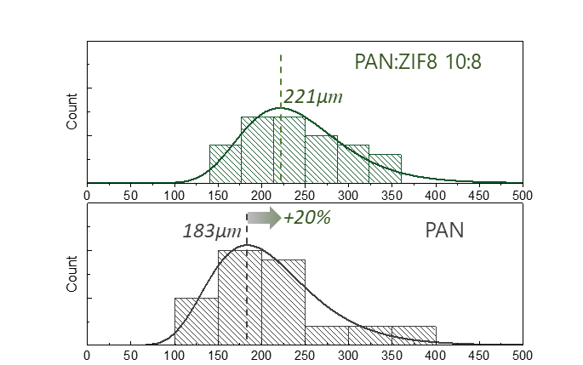
Figure S1: Diameter distribution of the nanofibres in the electrospun PAN sample and PAN:ZIF8 10:8 composite. Each diameter distribution was fitted with a lognormal curve as reported in the literature.¹
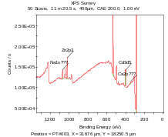
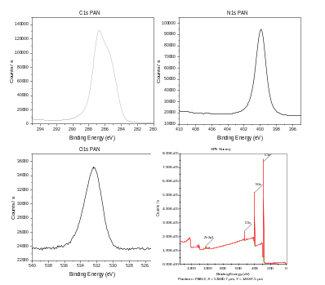
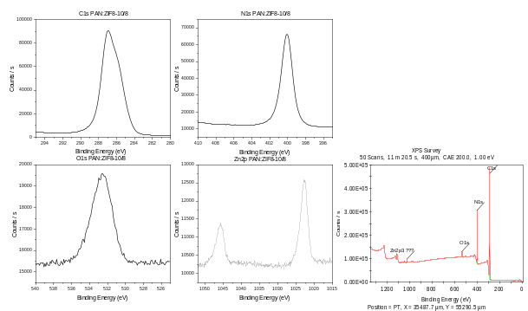
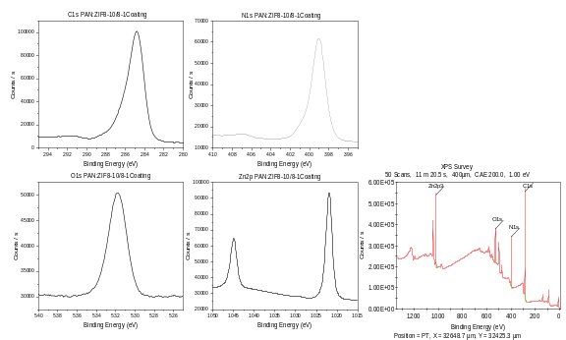
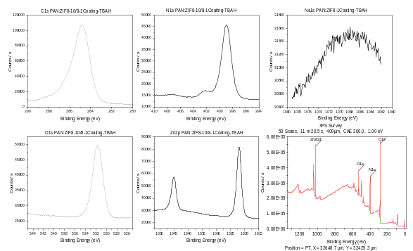
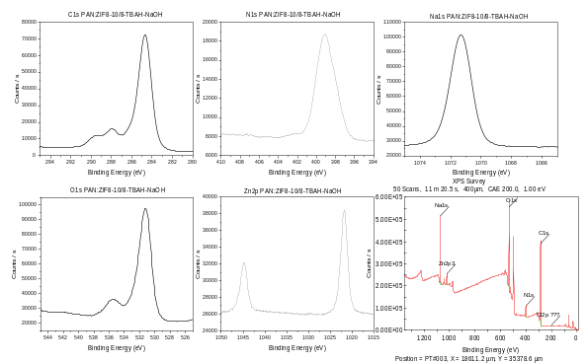
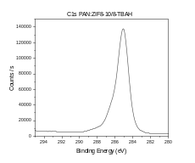
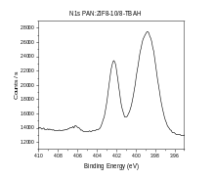
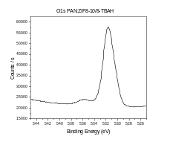
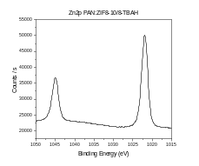
Figure S2: X-Ray Photoelectron Spectroscopy (XPS) results showing the C 1s, N 1s, O 1s and Zn 2p, Na 1s regions and survey spectra of the different samples presented; samples are: top left PAN:ZIF-8 10:8; middle left: PAN:ZIF-8 1C; bottom left PAN; top right PAN:ZIF-8 10:8 TBAH; middle right PAN:ZIF-8 10:8 1C TBAH; and bottom right PAN:ZIF-8 10:8 TBAH NaOH.

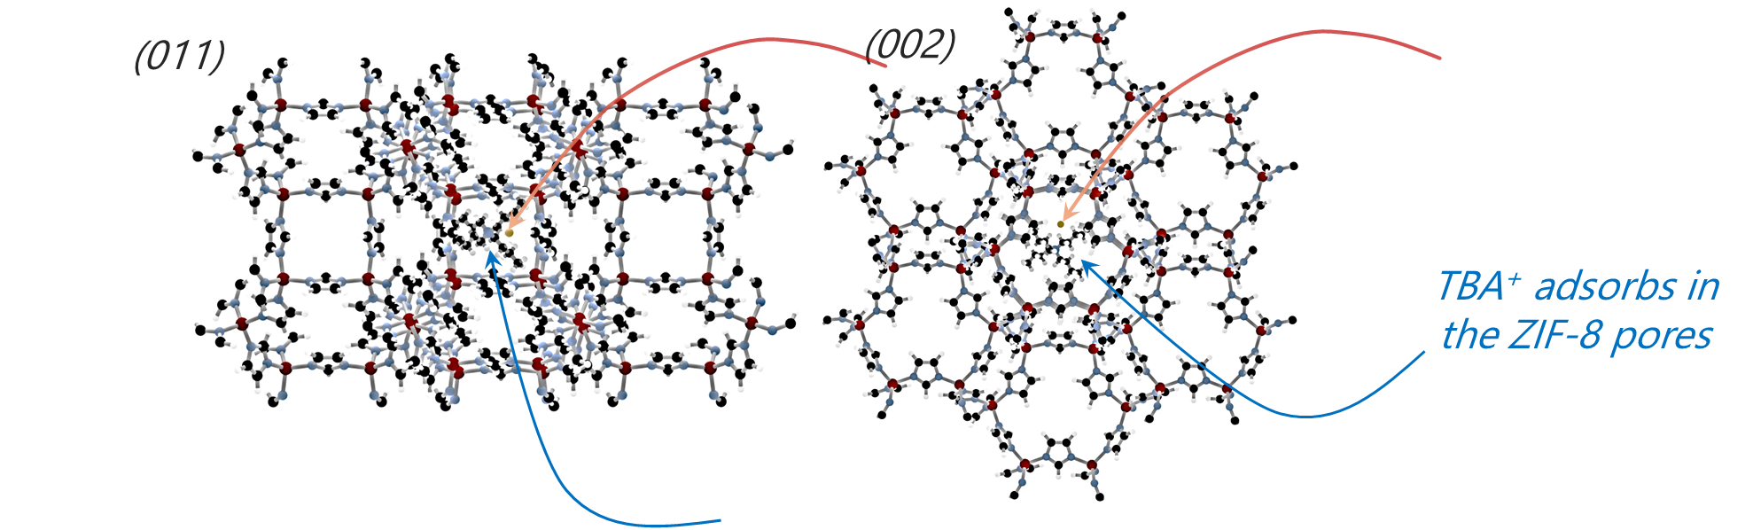
Figure S3: Representation of the (011) and the (002) planes of the ZIF-8 with the inserted TBA⁺ ions and the mobile OH⁻ in the cages of the ZIF-8
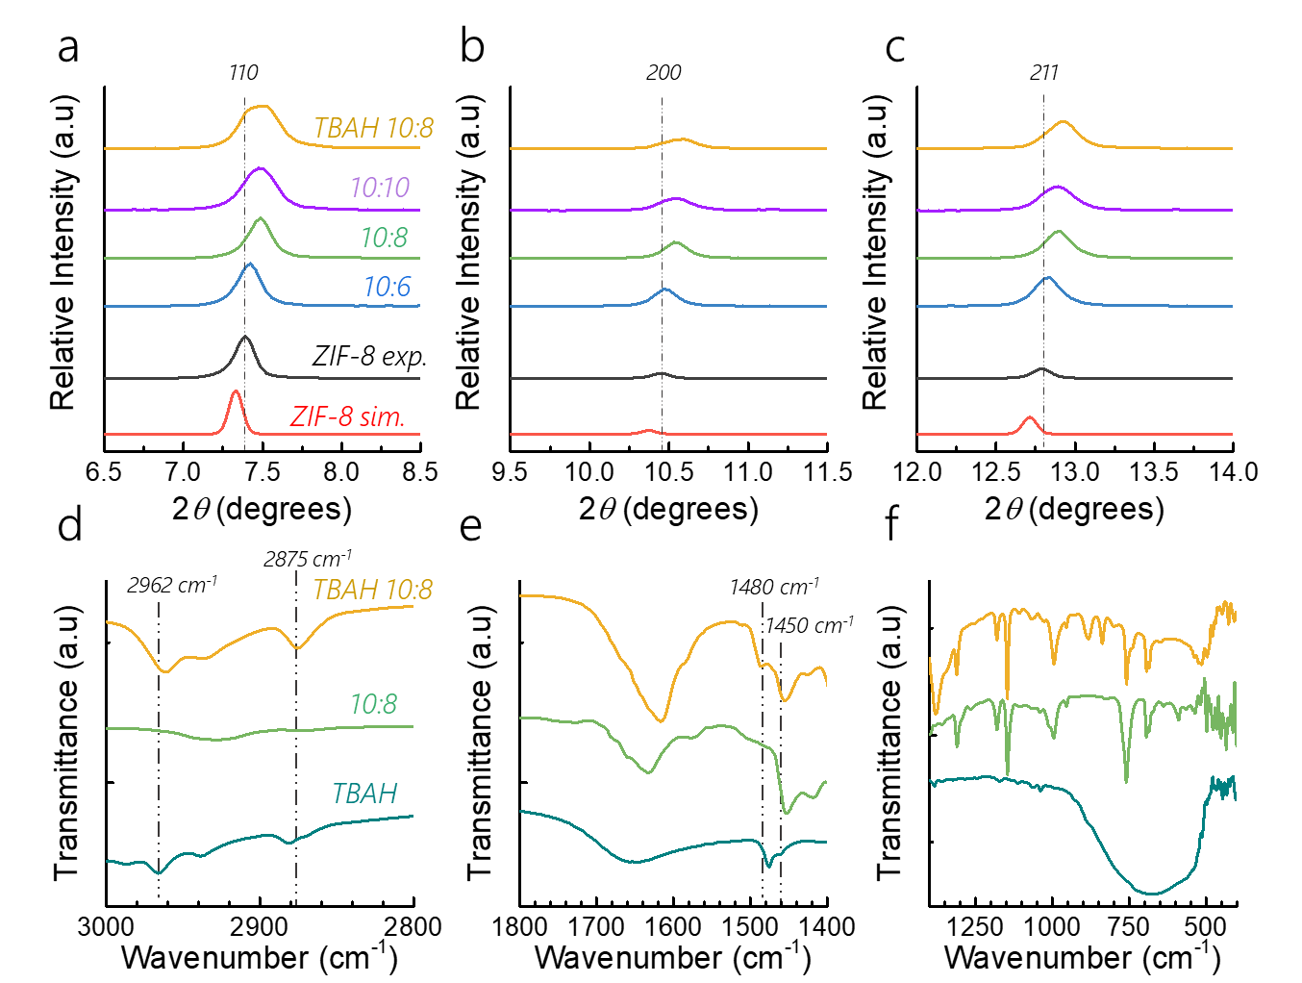
Figure S4: (a),(b) and (c) Detailed XRD patterns of simulated ZIF-8, synthesised ZIF-8, ZIF-8:PAN with ratios of 10:6, 10:8 and 10:10 and TBAH@ZIF-8:PAN 10:8. The crystallographic peaks were labelled as in the literature.² (d-f) Detailed FTIR spectra of the TBAH salt, ZIF-8:PAN 10:8 and the doped analogue TBAH@ZIF-8:PAN 10:8. Transmittance was normalized.

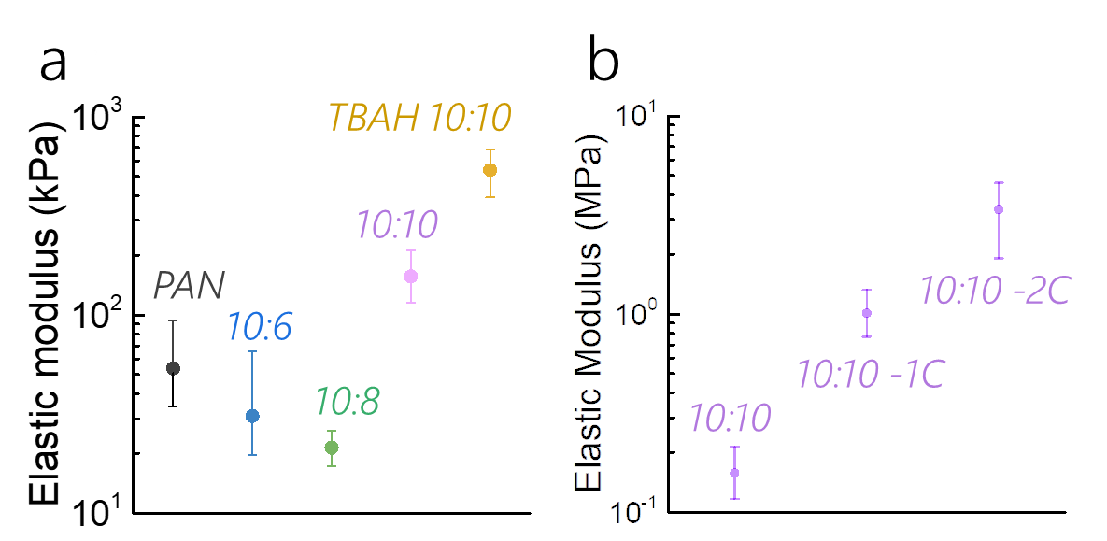
Figure S5: Nanoindentation results as (a) function of the PAN:ZIF-8 ratio and after TBAH doping and (b) function of the number of ZIF-8 coatings for 10:10.

Electrochemical Impedance spectroscopy (EIS):
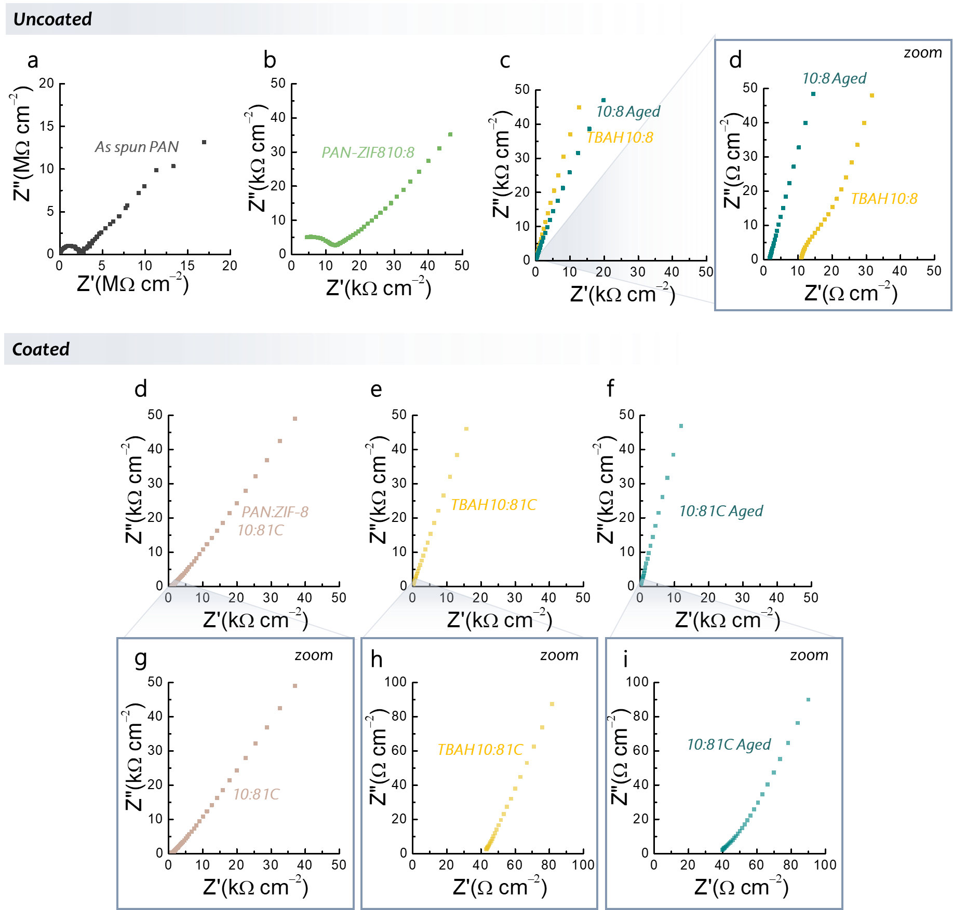
Figure S6: Nyquist plots of the (a-c) uncoated samples with (c) detailed scale; (d-f) coated samples with (f) detailed scale.
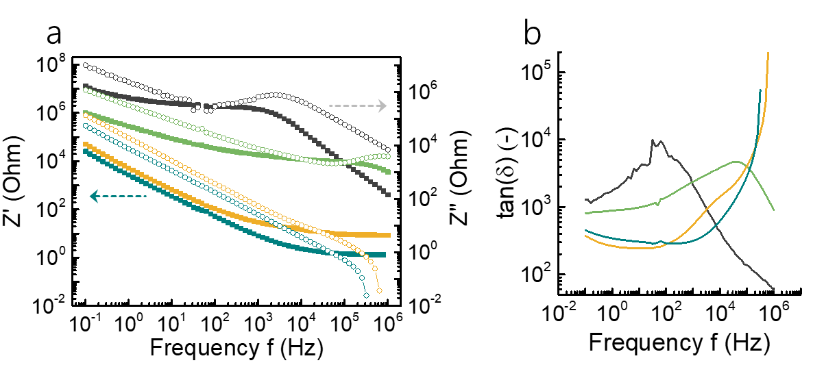
Figure S7: Nyquist plots of the (a-c) uncoated samples with (c) detailed scale; (d-f) coated samples with (f) detailed scale.

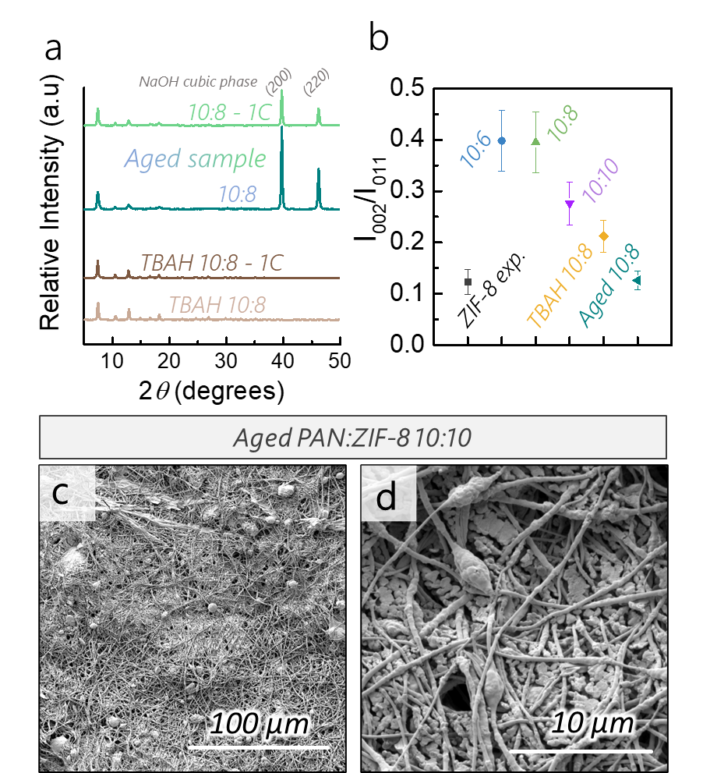
Figure S8: (a) XRD patterns of the uncoated and coated (1C) PAN:ZIF-8 10:8 after doping with TBAH and after stability testing by ageing; (b) Intensity ratios of the (002) over the (001) peak derived from the XRD patterns on Figure 1d and Figure S8a; (c,d) Scanning electron micrographs of the ZIF-8:PAN 10:10 after ageing.

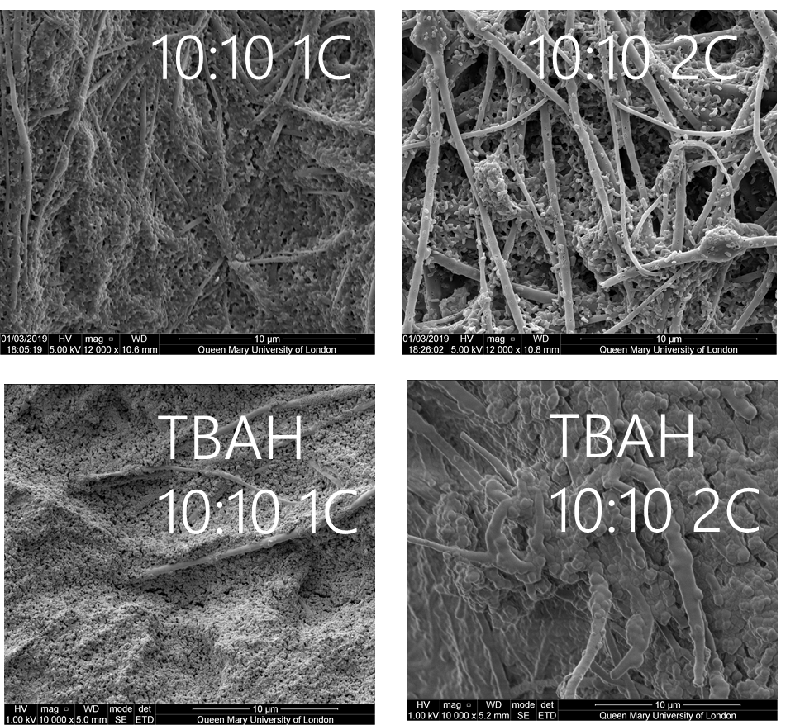
Figure S9: Scanning Electron Micrographs of the coated samples. ZIF-8:PAN 10:10-1C and ZIF-8:PAN 10:10-2C and their doped analogues TBAH@ZIF-8:PAN 10:10-1C and TBAH@ZIF-8:PAN 10:10-2.
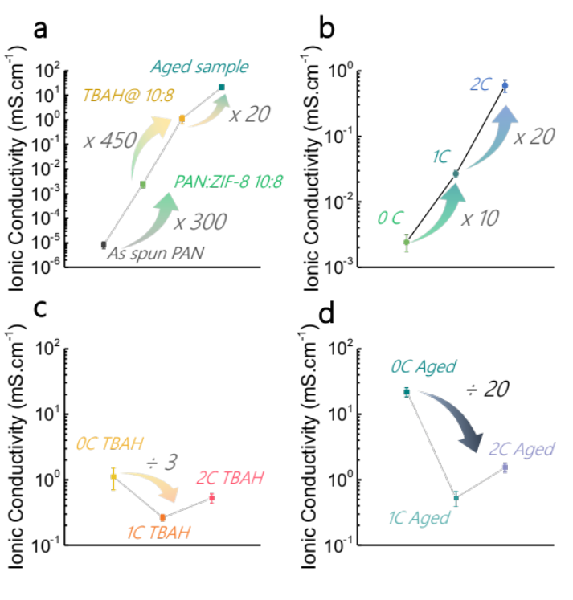
Figure S10: Ionic conductivities obtained via potentiostatic Electrochemical Impedance Spectroscopy (EIS) showing (a) The increased ionic conductivity after the various treatments; (b) the influence of coatings on the conductivity of the undoped PAN:ZIF-8 10:8 composite membranes; (c) the influence of coatings on the TBAH doped PAN:ZIF-8 10:8 composite membranes; (d) the influence of coatings on the conductivity of the aged doped PAN:ZIF-8 10:8 composite membranes

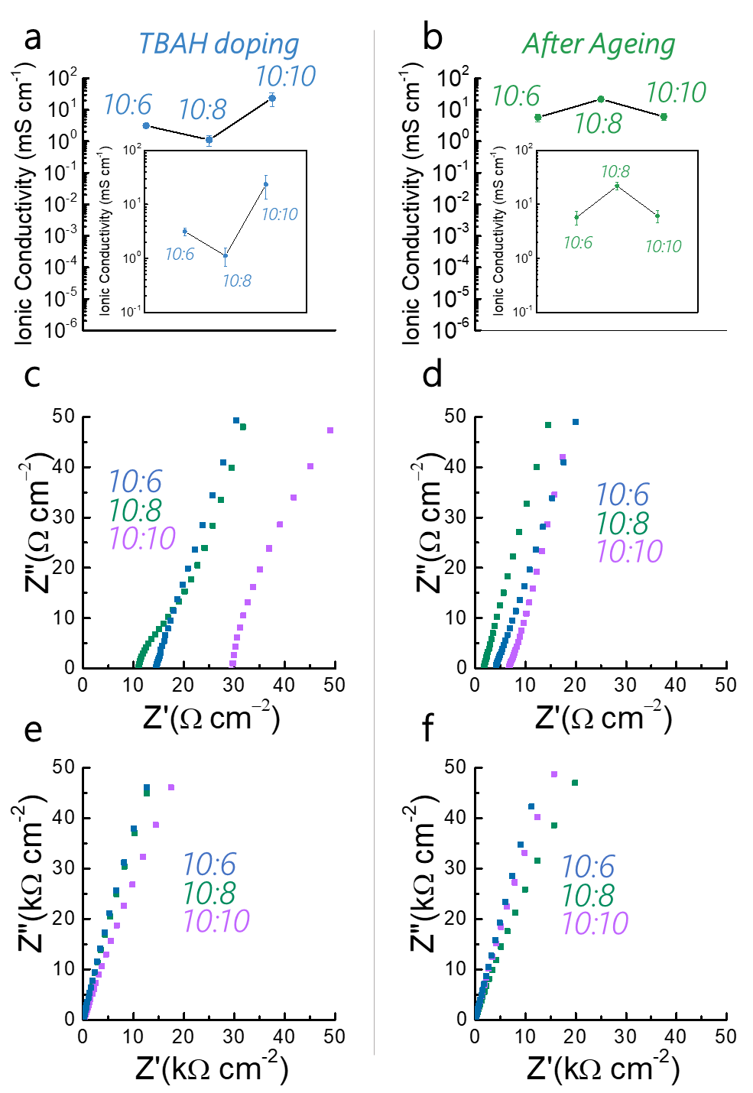
Figure S11: (a,b) Ionic conductivities obtained via potentiostatic Electrochemical Impedance Spectroscopy (EIS) showing the influence of the ZIF-8:PAN ratio in the (a) TBAH doped nanofibres and (b) Aged sample; Nyquist plots showing the high frequency (c, d) and low frequency (e,f) regions for the TBAH doped (left) and aged sample membranes.

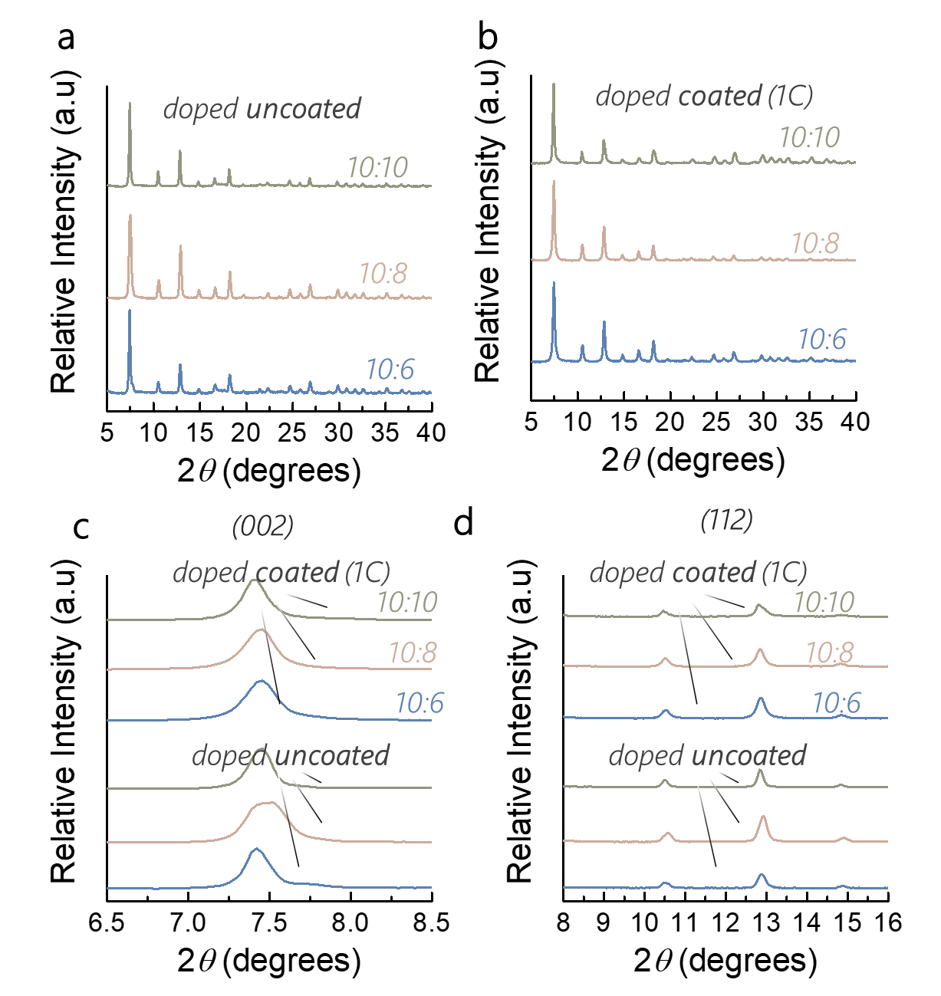
Figure S12: (a),(b) and (c) Detailed XRD patterns of ZIF-8:PAN with ratios of 10:6, 10:8 and 10:10 and their doped analogues TBAH@ZIF-8:PAN 10:6, 10:8 and 10:10. All patterns were normalised on (110) peak. The diffraction peaks were labelled as in the literature.²

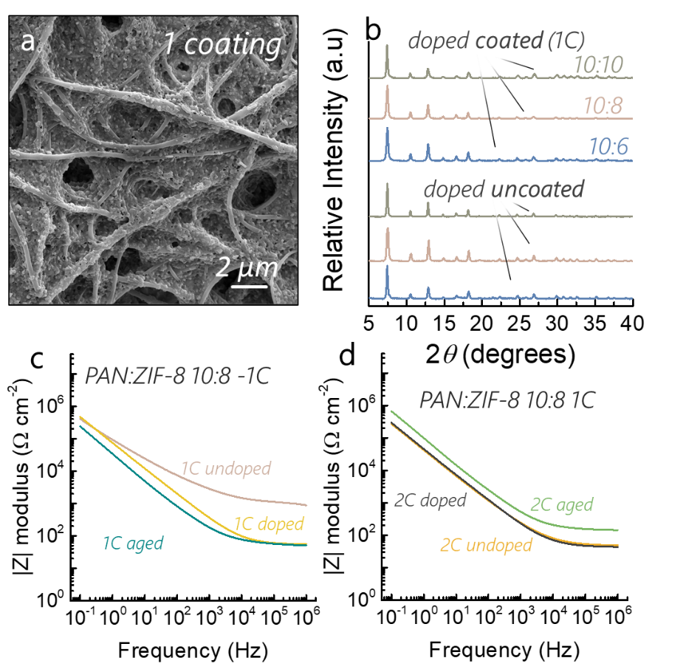
Figure S13: (a) Scanning Electron Microscope of the PAN:ZIF-8 10:8 1C; (b) X-Ray Diffractograms of various ratios of PAN:ZIF-8 in the spinning solution after 1 coating of ZIF-8 showing the similar phases of the ZIF-8 onto the fibres; Z modulus for the undoped, doped and aged PAN:ZIF-8 10:8 fibres after (c) 1 Coating -1C- and (d) 2 coatings -2C-.

References
(1) Hérou, S.; Crespo, M.; Schlee, P.; Luo, H.; Cristian, L.; Ro, C.; Titirici, M. The Impact of Having an Oxygen-Rich Microporous Surface in Carbon Electrodes for High-Power Aqueous Supercapacitors. J. Energy Chem. 2021, 53, 36–48. https://doi.org/10.1016/j.jechem.2020.04.068.
(2) Su, J.; Wu, W.; Li, Z.; Li, W. Self-Crystallization of Uniformly Oriented Zeolitic Imidazolate Framework Films at Air–Water Interfaces. Dalt. Trans. 2019, 48, 11196–11199. https://doi.org/10.1039/c9dt02359c.

