Alternative sulphur metabolism in the fungal pathogen Candida parapsilosis

Lisa Lombardi¹*, Letal I. Salzberg², Eoin Ó Cinnéide¹, Caoimhe O’Brien¹, Florent Morio³, Siobhan A. Turner¹, Kevin P. Byrne², Geraldine Butler¹*

¹School of Biomolecular and Biomedical Science, Conway Institute, University College Dublin, Belfield, Dublin, Ireland; ²School of Medicine, Conway Institute, University College Dublin, Belfield, Dublin, Ireland; ³Nantes Université, CHU Nantes, Cibles et Médicaments des Infections et de l'Immunité, UR1155, Nantes, France.

*Corresponding authors. Emails: lisa.lombardi@ucd.ie; gbutler@ucd.ie

Supplementary Note 1

Phenotypic effects of disruptions: baseline growth in YPD, SD + AS, SC + AAs
The phenotypic screen used three different base media: i) YPD media supplemented with different chemical stressors; ii) Synthetic Defined (SD) media supplemented with ammonium sulphate (AS) or alternative nitrogen sources; and iii) Synthetic Complete (SC) media supplemented with all amino acids (AAs) or lacking specific amino acid classes/adenine/histidine.
We first measured the baseline growth of the C. parapsilosis disruptions by assessing the colony size on solid media. We tested the growth of the mutant strains on i) YPD media (without any chemical stressors); ii) SD media supplemented with AS, the preferred nitrogen source, and iii) SC media supplemented with all the AAs (Supplementary Table 2) in comparison to relevant control strains, C. parapsilosis CLIB214 and C. parapsilosis CPRI¹. Because the colony sizes of C. parapsilosis CLIB214 and CPRI were similar within each of the three conditions tested, we defined Growth_{(CTRL)} as the mean of the normalized observations for both strains, and the Growth Ratio for each mutant strain in the library as (normalized size of mutant colony/Growth(CTRL)) (Supplementary Table 2 and Methods). For most strains the Growth Ratio was close to 1, meaning that the mutation introduced did not result in a baseline growth defect (Supplementary Figure 1). However, 21 strains showed a growth defect (Growth Ratio <= 0.5) in at least one media (Supplementary Figure 1).

Mutant strains disrupted in SFP1 (CPAR2_807380), GRR1 (CPAR2_100650), RSA1 (CPAR2_102070) and FIP1 (CPAR2_100690) showed a severe growth defect on the three media tested (Growth Ratio 0-0.2, Supplementary Figure 1). Loss of function of the master transcriptional regulator Sfp1 and the component of the SCF ubiquitin-ligase complex Ggr1 required for cell cycle progression are associated with a dramatic decrease in cell size in C. albicans^{2,3}. In Saccharomyces cerevisiae loss of function of Rsa1 is associated with decreased cell size and abnormal cell cycle progression⁴.
Deleting the transcriptional repressor TUP1 (CPAR2_109520) also affected growth (Growth Rate 0.3-0.4), and a similar effect was observed for the Ed ssk2 (CPAR2_403060), Ed sak1 (CPAR2_401830), and Ed pho23 (CPAR2_407350) mutants (Supplementary Figure 1). In C. albicans, mutating the Ssk2 kinase determines defects in colony morphology, in vivo proliferation³, and growth on different media⁵, while deleting SAK1 does not result in reduced growth, but it has effects on colony morphology⁶. In S. cerevisiae, deletion of PHO23 results in decreased vegetative growth rate⁷.
Disruption of SAH1 (CPAR2_101020), responsible for the conversion of S-adenosyl homocysteine to homocysteine in the methyl cycle, only marginally affected growth on YPD, but its effect was more evident on YNB and SC (Growth Rate < 0.2). However, SAH1 is essential in both C. albicans and S. cerevisiae^{8,9}, raising the possibility that a truncated version of the protein, partially maintaining gene function, may be produced in the C. parapsilosis edited strain.
Targeting Vacuolar Protein Sorting (VPS) proteins 15 and 34 (encoded by CPAR2_602810 and CPAR2_206880, respectively) also resulted in a growth defect.
In C. albicans, loss of Vps34 function results in a plethora of phenotypes, including a decreased rate of vegetative growth¹⁰⁻¹². Our library included two independent C. parapsilosis Vps34 mutants: a deletion mutant generated by Holland et al.¹, and a CRISPR-Cas9 edited strain. Notably, the phenotype was consistent in both. A decreased growth rate was also observed for the Ed swi4 and Δswi4 mutants (CPAR2_109060), similarly to what reported for C. albicans³.

Several mutations affected growth specifically on only one of the media. Deleting the GATA transcriptional activator GLN3 (CPAR2_101010), required for utilization of nonpreferred nitrogen sources in C. parapsilosis, abolished the ability to grow on SD (YNB with ammonium sulfate)¹³ (Supplementary Figure 1). Similarly, deleting GCN4 (CPAR2_806570), encoding the major activator of the General Amino Acid Control (GAAC) supra-pathway in response to starvation for any amino acid, resulted in a growth defect on SD and SC media¹³. Loss of function of ACE2 (CPAR2_204370), NRG1 (CPAR2_300790), and BNA2 (CPAR2_100040) specifically affected growth on SC in our experiment.

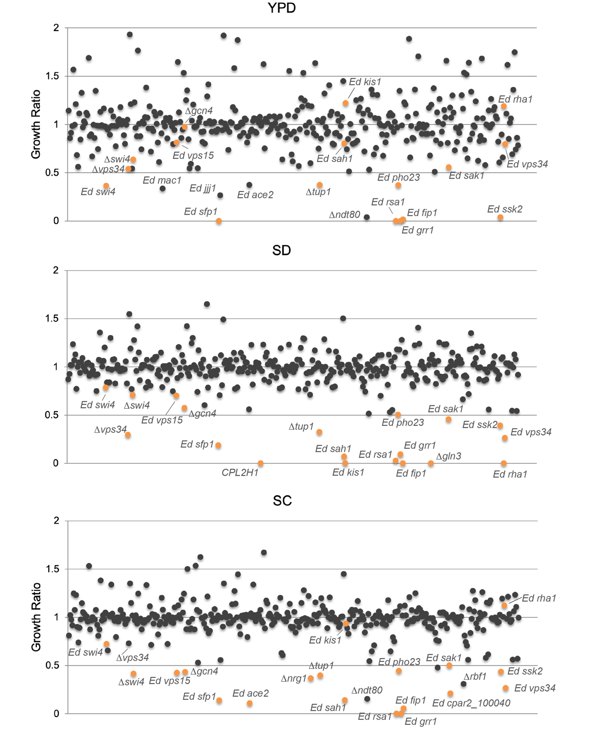
Supplementary Figure 1. Growth of the mutant library on solid control media. The panels depict the distribution of the Growth Rate values of the mutant strains when grown at 30°C on YPD, SD, and SC media for 24h (YPD) of 48h (SD, SC). For each strain, the Growth Ratio was calculated as (normalized size of colony/Growth_{(CTRL)}, where Growth_{(CTRL)} = mean of normalized growth of CLIB214 and CPRI) (see Methods). The genes are labelled based on their characterized orthologs in Candida albicans. Mutants that showed a Growth Ratio in the 0-0.5 range in at least one condition are highlighted in orange. Strains that met this criterion but showed either different behaviour between the two lineages (Ed ace2 and Ed jjj1 on YPD; Δndt80 on YPD and SC; Δvps34 on SC) or pinning inaccuracy (Δrbf1 on SC) in specific conditions are indicated with the name label but coloured in grey. Ed mac1 showed a growth defect only on YPD (Growth Rate 0.34); this strain might have a slight delay in growth that is more evident at 24h than at 48h. The strain CPL2H1 used as parental strain in the generation of deletion mutants is auxotrophic for histidine and leucine, and consequently cannot growth on SD. Similarly, both Ed kis1 and Ed rha1 lack a functional copy of MET10 and are therefore cysteine/methionine auxotrophs¹⁴; this phenotype is not related to the mutations introduced into KIS1 and RHA1.

Supplementary Table 2. C. parapsilosis CLIB214 genes involved in different cellular processes based on phenotypic screening.
Response to antifungal drugs
Caspofungin | PRK1, CLA4, RFX1,
Fluconazole | VPS34, 100630, GZF3, UPC2, ZCF29, ZCF31, PRK1, ISW2, ZCF38, RTG3, APD1
Ketoconazole | VPS34, SWI4, MAC1, 100660ª, 802280, UPC2, ZCF1, SLN1
Response to heavy metals
Copper | VPS34, PRK1, TUP1, TPK2, MNL1, PHO23, RTG3, CUP2, SSN3
Cadmium | VPS34, YAF9, CUP9, MAC1, TUP1, CAP1, MKK2, PBS2, PHO23, RFX1,
EDTA | MAC1, CSR1
Response to osmotic (Os), oxidative (Ox), cell wall (CW) stress
NaCl (Os) | 100910, KIS1, RNY11, PBS2, 100920, SAK1, APD1
LiCl (Os) | SAH1, PBS2, PHO23,
Sorbitol (Os) | PBS2, 100920
H₂O₂ (Ox) | VPS34, SWI4, MAC1, SKN7, CAP1, PBS2,
Caffeine (CW) | VPS34, RAD53
Use of alternative nitrogen sources
Alanine | VPS15, RBF1
Allantoin | VPS15, PPR1, SAH1, RBF1
Arginine | SEF1, VPS15, CAR1, 212760, BNA2, RBF1, HAC1,
Cysteine | VPS34, SFP1, TUP1, SAH1, PFK1, PHO23, GRR1, SAK1, SSK2, SSN3, RAD53
GABA | UGA3, VPS15, SAH1, BNA2, RBF1, HAC1
Glutamate | VPS15, FGR15, SAH1, RBF1, HAC1
Glutamine | VPS15, SAH1, RBF1, HAC1
Glycine | VPS15, RBF1
Isoleucine | ARO80, VPS34
Histidine | SKN7, RFX1, VPS34, SSN3, RAD53
L-ornithine | CLA4, GZF3, SFP1, PRK1, CLA4, PUT3, VPS34
Tryptophan | GAT1, ARO80, CZF1, SAH1,
Leucine | GAT1, ARO80, VPS15, PHO23, VPS34
Lysine | VPS34, PRK1, SAH1, TPK2, GRR1, BNA2, RFX1, STP4, RTG3, RFX2, SUC1, 105230, SSK2, SSN3, RAD53
Methionine | GAT1, GCN4,
Proline | ARG83, FGR15, PUT3, BNA2,
Serine | BNA2
Threonine | GAT1, ARO80, GCN4, CUP2, GCN2
Valine | ARO80, GCN4, FGR15,
Urea | NTO1, FGR3, SAH1, SSK2
Aspartate | GRR1, RTG3, VPS34
Amino acid biosynthesis
Histidine | GCN4, GLN3
Trp/Phe/Tyr | BNA2, RAD53
Asn/Thr/Met/Cys/Asp | SAH1, BNA2, CUP2
Met/Cys/Ser/Gly | SFP1, TUP1, SAK1, RFX1, RAD53
Leu/Val/Ile | SFP1, RAD53
Ala | BNA2, RAD53
Lys/Arg/Pro/Gln/Glu | GCN4, ACE2, CUP2, RFX2, RAD53
Uracil | BNA2, SSK2,RAD53
Adenine | SFP1, SSK2, RAD53
See also Supplementary Notes 2-4, Supplementary Figures 2-4, Supplementary Table 4.
^{a.} C. parapsilosis genes lacking the functional name are indicated with the six digits ID that follows the “CPAR2_” prefix: for example, 100630 stands for CPAR2_100630

Supplementary Note 2

Phenotypic effects of disruptions in the presence of different stressors
YPD was used as the base media to test cell wall, osmotic and oxidative stress phenotypes, and response to antifungal drugs and heavy metals.
Many phenotypes known or predicted from studies in C. albicans and S. cerevisiae were identified, such as sensitivity to azole drugs in response to disrupting UPC2 (CPAR2_207280)^{1,15} or the ATPase encoding gene ISW2 (CPAR2_404600)¹⁶, hypersensitivity to hydrogen peroxide in SKN7 (CPAR2_304240) disruptions¹⁶, to oxidative stress and cadmium in CAP1 (CPAR2_405030) disruptions^{17,18}, and to osmotic stress response and oxidative stress in disruptions of the MAPK kinase PBS2 (CPAR2_806570)¹⁹ (Supplementary Figure 2). Deletion of the transcriptional regulators SFU1 (CPAR2_700810) and TUP1 (CPAR2_109520) led to increased sensitivity to copper, as previously observed in C. albicans¹⁶ (Supplementary Figure 2). Disrupting CUP9 (CPAR2_301340), MAC1 (CPAR2_301500) and PBS2 (CPAR2_806750) increases sensitivity to cadmium²⁰ (Supplementary Figure 2). Disrupting the phosphatidylinositol (PI) 3-kinase VPS34 (CPAR2_206880) also induced hypersensitivity to oxidative and cell wall stresses, copper and cadmium, and azoles (Supplementary Figure 2), as also observed in C. albicans and C. glabrata^{11,12,21}.

Deleting CUP2 (CPAR2_201510), which in C. albicans induces transcription of copper resistance genes¹⁶, completely abolishes growth of C. parapsilosis in the presence of copper (Supplementary Figure 2). A very similar phenotype was observed when the gene PRK1 (CPAR2_800700) – encoding a putative protein kinase - was disrupted by insertion of a premature stop codon (Supplementary Figure 2). This phenotype was maintained in two independent lineages in which the entire PRK1 ORF was replaced by a 20-bp barcode (prk1Δ/Δ) (Supplementary Figure 2, Supplementary Table 1). CRISPR-mediated reconstitution of the wildtype sequence of PRK1 in the edited strain background recovered the ability to grow in the presence of copper, providing strong evidence that Prk1 is a novel regulator of metal sensitivity (Supplementary Figure 2).
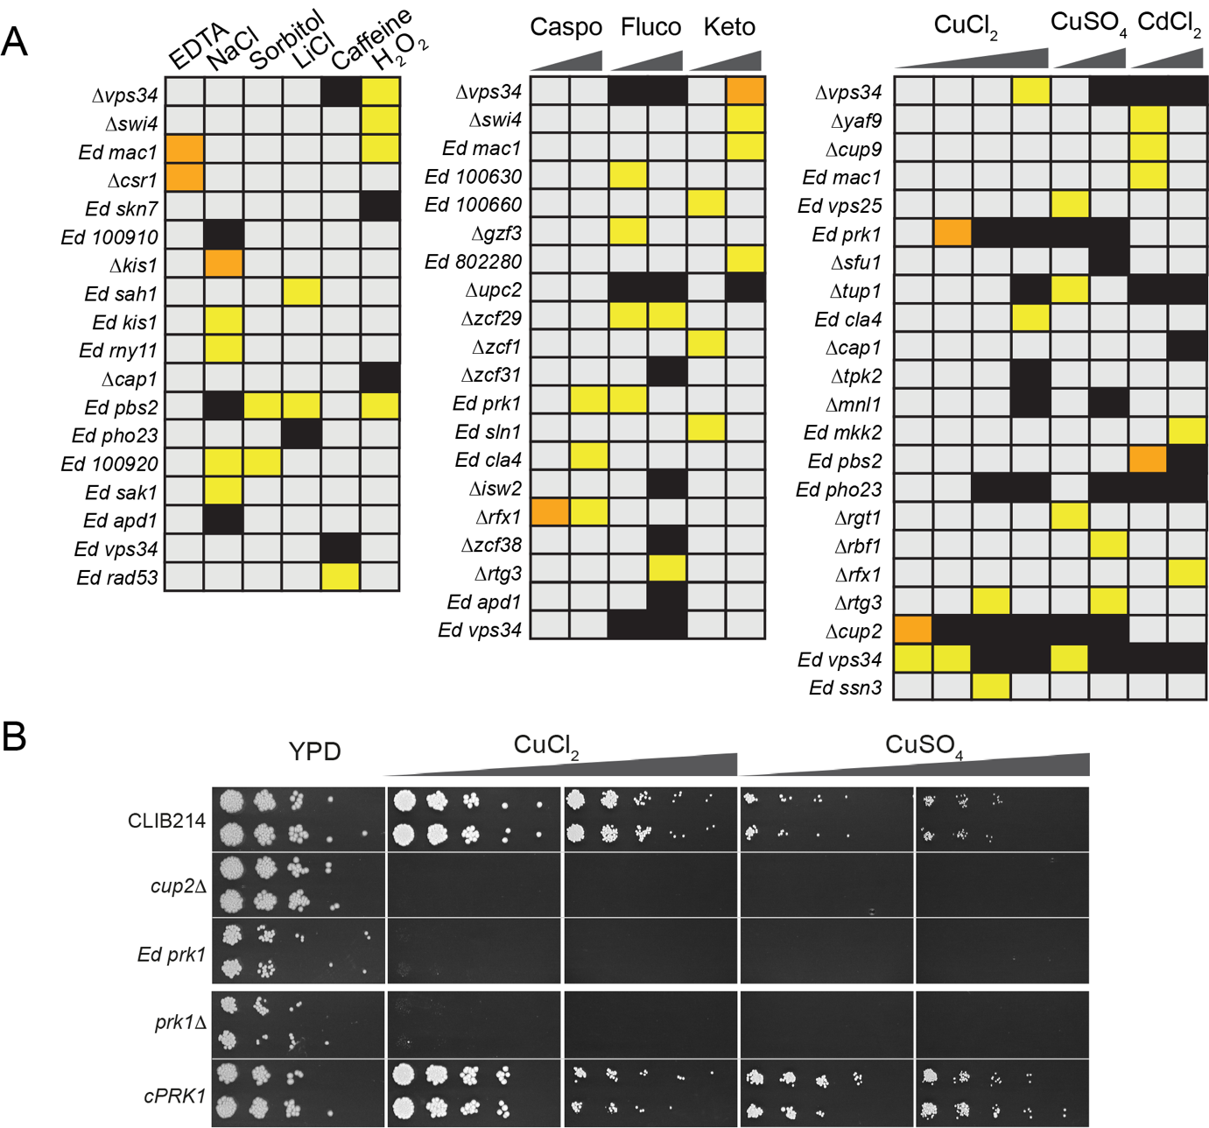
Supplementary Figure 2. Response of C. parapsilosis to oxidative and osmotic stresses, cell wall disturbing agents, antifungal drugs, and metal toxicity. (A) Growth of the mutant collection was determined in conditions designed to identify different stress phenotypes (Supplementary Table 4). The growth of each strain was compared between the control plate (YPD) and each experimental plate and strains with a Z-score >2 or < -2 (Ln Ratio values that were greater than two standard deviations below (-) or above (+) the mean for each plate) were considered to have a growth defect (or advantage). Strains with Z-scores between -3 and- 6 are indicated in yellow; strains with Z-score < -6 are indicated in orange; complete absence of growth is indicated in black. Only mutant strains that showed a growth defect in at least one condition are included in the heatmap. The concentrations of the stressing agents are indicated in Supplementary Table 3. Caspo = caspofungin; fluco = fluconazole; keto = ketoconazole (B) The involvement of the protein kinase Prk1 in response to copper toxicity was confirmed in a spot assay. The growth of two independent lineages of the edited and deleted prk1 mutants (Ed prk1 and Δprk1, respectively), and of the complemented strain cPRK1 was tested on YPD supplemented with CuCl₂ (10 and 13 mM) or CuSO₄ (13 and 15 mM). The cup2 deletion mutant was included as control. Plates are shown after 2 days of incubation at 30°C.

Supplementary Note 3

Phenotypic effects of disruptions on nitrogen metabolism
The ability of C. parapsilosis mutant strains to use amino acids as a sole nitrogen source compared to using ammonium sulphate was tested using YNB as a base media (Supplementary Figure 3, Supplementary Table 4). Loss of the Nitrogen Catabolite Repression (NCR)-sensitive Gat1 activator (CPAR2_500590) dramatically reduced growth on leucine, methionine, threonine, and tryptophan as sole nitrogen sources, as previously shown^{13,22}. Disrupting SSN3 rendered cells completely unable to use lysine or cysteine as the sole nitrogen sources, and reduced growth with histidine. Similarly, strains with disruptions or deletions of bna2, prk1, rtg3, and rfx2 were unable to use lysine as a sole nitrogen source (Supplementary Figure 3).
Deleting PUT3 (CPAR2_208790) prevents cells from using proline as a nitrogen source; this transcription factor positively regulates the expression of PUT1 and PUT2, which convert proline to glutamate^{13,23}. The role of Aro80 (CPAR2_108570) as a regulator of aromatic amino acid catabolism is conserved between C. albicans and C. parapsilosis; disruption severely impaired the ability of C. parapsilosis ability to use tryptophan as a nitrogen source²⁴. The disruption also has a growth defect on isoleucine, leucine, threonine, and valine. Disrupting ARG83 (CPAR2_400180) results in the inability to use proline as nitrogen source, similar to C. albicans¹⁶. Uga3 (CPAR2_200790) is required for use of Gamma Amino-Butyric Acid (GABA) as a sole nitrogen source, as previously observed in C. albicans¹⁶ and C. parapsilosis¹³. Disrupting the arginase-encoding CAR1 (CPAR2_100820) and deleting PPR1 (CPAR2_101530) confirmed that they are required for arginine¹³ and allantoin catabolism²⁵, respectively.
In addition, some potentially novel regulators were identified. Disrupting homologs of the Candida-specific filamentous growth regulator (FGR) gene family show that they play a role in nitrogen metabolism in C. parapsilosis: deleting FGR15 (CPAR2_213110) resulted in reduced growth on YNB + glutamate, proline or valine, and the Δfgr3 (CPAR2_302310) strain could not use urea. Deleting RBF1 (CPAR2_600470) resulted in poor growth on arginine, GABA, glutamate, glutamine, and glycine.
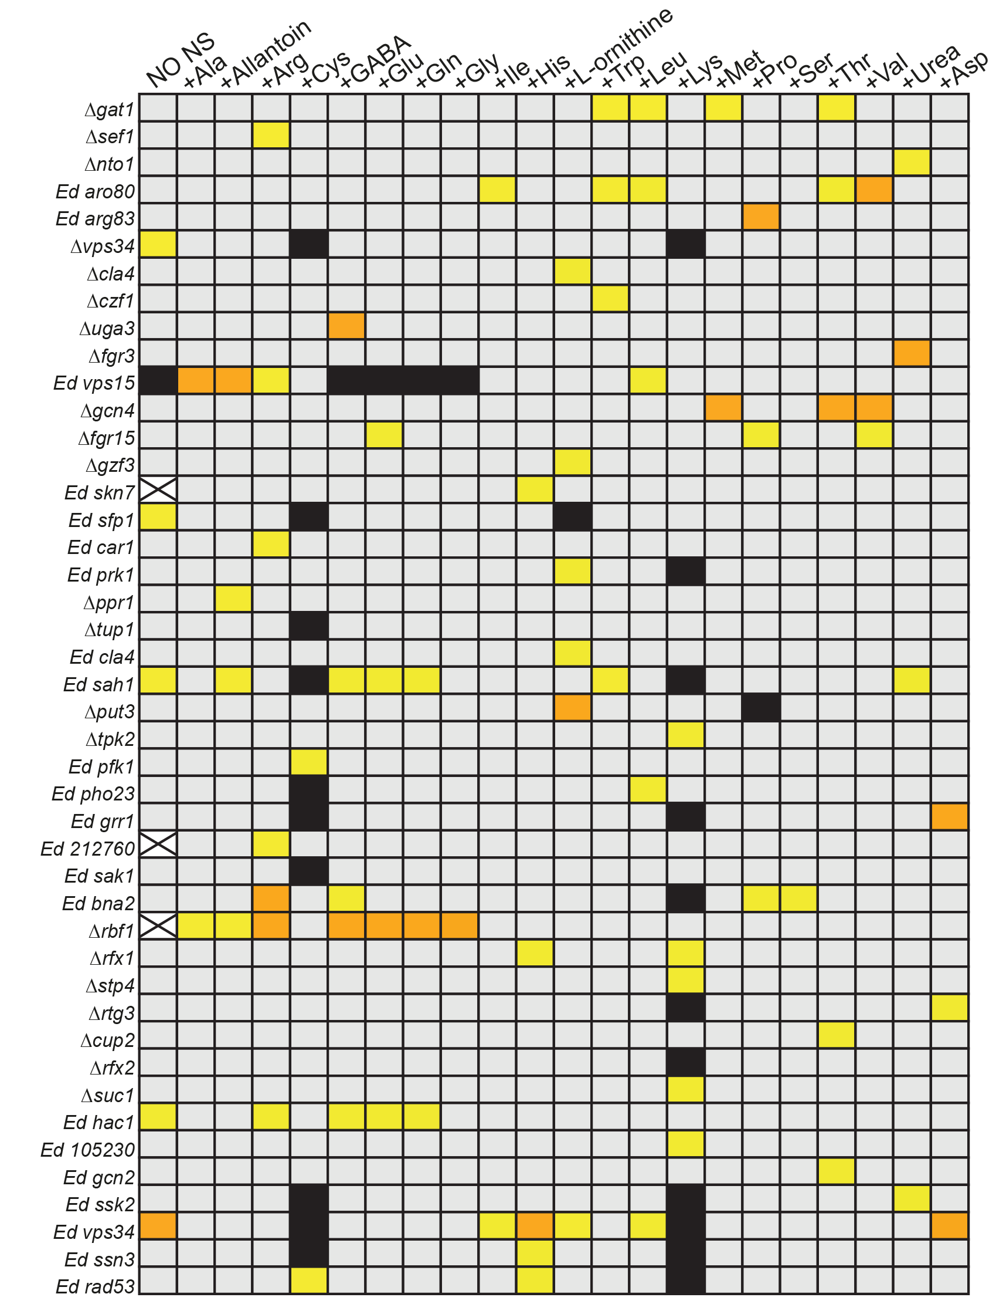
Supplementary Figure 3. Utilization of alternative nitrogen sources by the C. parapsilosis mutant collection. The ability of the mutant collection to utilize different nitrogen sources was tested (Supplementary Table 4). In order to detect growth defects compared to the control condition (YNB + ammonium sulphate), Z scores values were calculated (see Methods) and depicted in the heat-map as described in Supplementary Figure 2. White crossed boxes indicate a pinning mistake.

Supplementary Note 4

Phenotypic effects of disruptions on biosynthesis of amino acids
We evaluated the ability of the mutant collection to synthesize L-amino acids used in protein synthesis by measuring growth in the absence of specific amino acids (Supplementary Figure 4, Supplementary Table 4). The general nitrogen regulator Gcn4 is required for synthesis of several amino acids, including histidine and glutamate, whereas deletion of GLN3 completely abolished growth in the absence of histidine (Supplementary Figure 1, Supplementary Figure 4)^{13,26}. Disruption of SFP1 (CPAR2_807380) affected biosynthesis of adenine, leucine, valine, isoleucine, and amino acids from the serine family (Supplementary Figure 4). In C. albicans, Sfp1 is a regulator of biofilm formation²⁷ and stress response^{28,29}, and the S. cerevisiae homolog has a role in nitrogen metabolism³⁰. Deleting the transcription factors RFX1 (CPAR2_204990) or RFX2 (CPAR2_401290) resulted in a growth defect in the absence of the serine and glutamate amino acid families, respectively (Supplementary Figure 4). In C. albicans Rfx2 is involved in DNA damage response, morphogenesis, and virulence³¹. In addition, deleting CUP2 (CPAR2_201510) – a transcription factor that in C. albicans is required for resistance to copper³² – reduced growth when amino acids from the aspartate and glutamate families were not provided (Supplementary Figure 4).

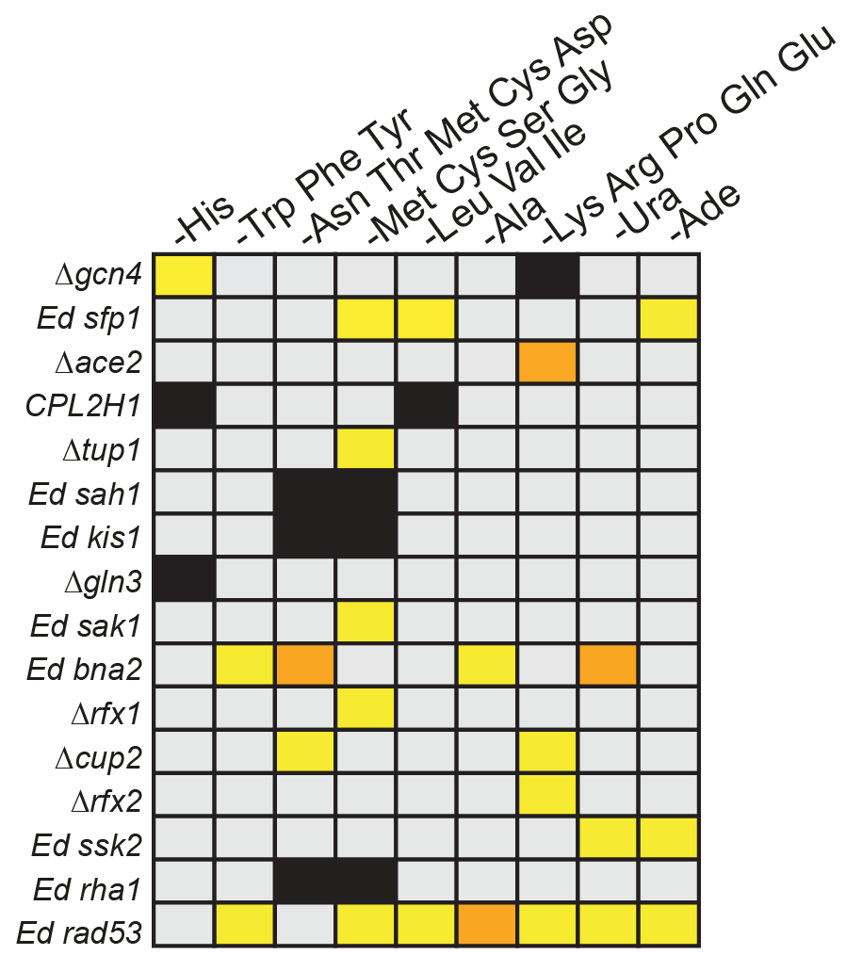
Supplementary Figure 4. Genes involved in amino acids biosynthesis in C. parapsilosis.
The mutant library was replicated on SC plates lacking amino acids, histidine, uracil or adenine (Supplementary Table 4). Plates were photographed, and Z score values were calculated to determine growth defects compared to the control condition (SC supplemented with amino acids). Only mutant strains that showed a defect in at least one condition are included in the heatmap. The strain CPL2H1 used as parental strain in the generation of deletion mutants is auxotrophic for histidine and leucine, and consequently cannot growth in their absence. Both Ed kis1 and Ed rha1 lack a functional copy of MET10 and are therefore cysteine/methionine auxotrophs¹⁴; this phenotype is not related to the mutations introduced into KIS1 and RHA1. The color-coding is the same as in Supplementary Figure 2.

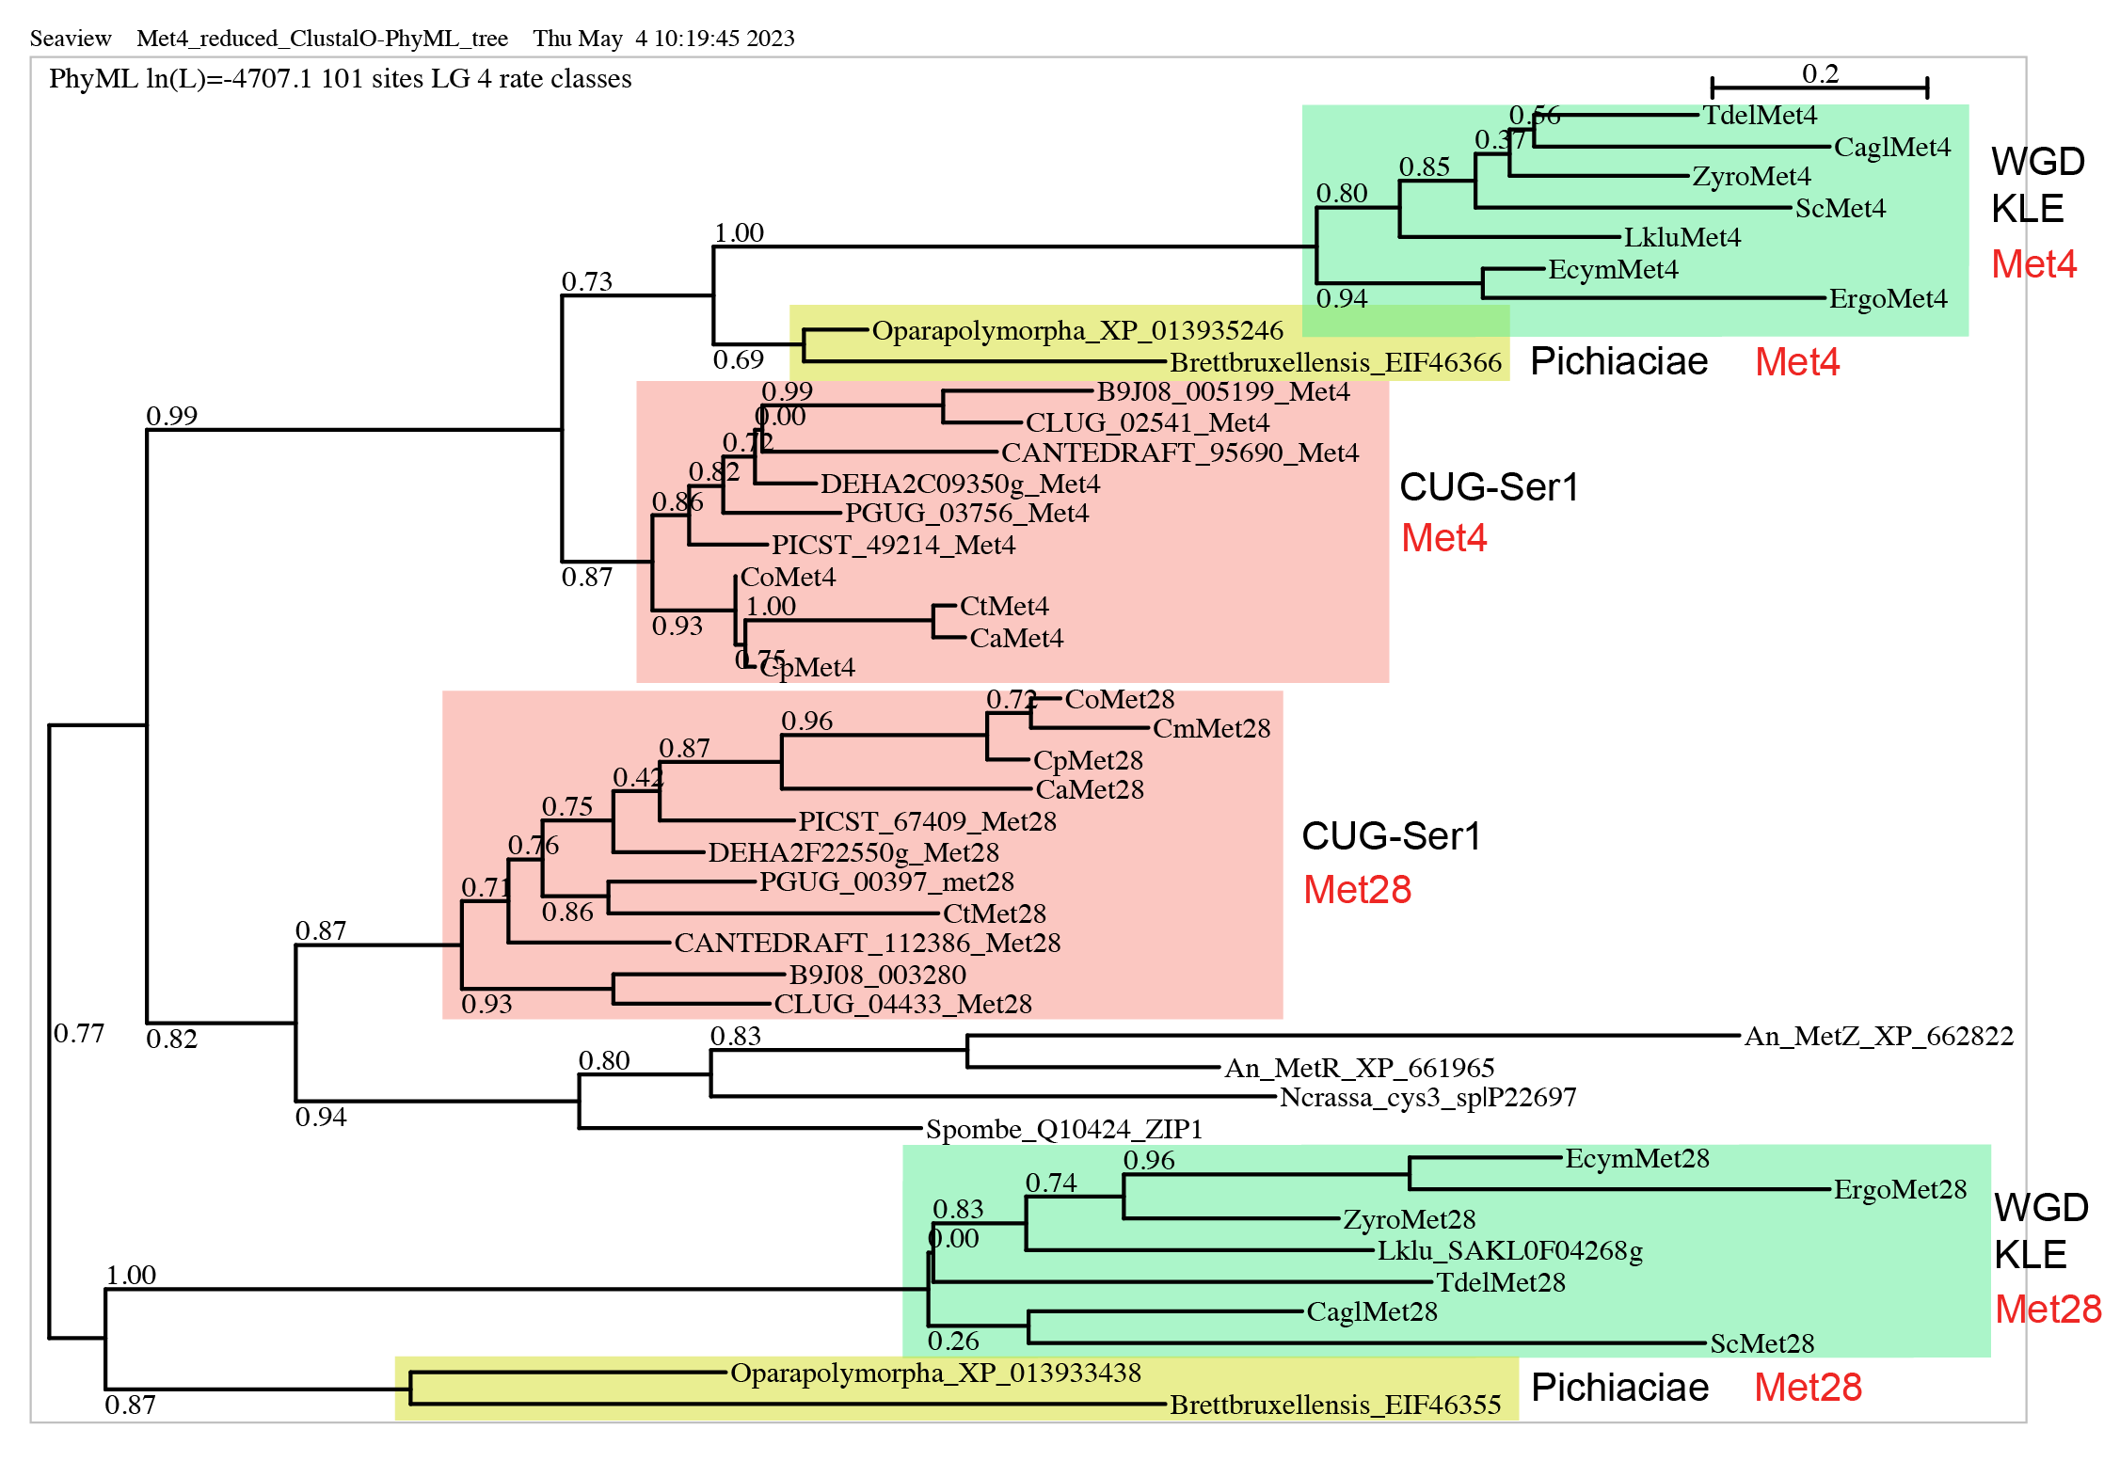
Supplementary Figure 5. Phylogeny of the Met4 and Met28 paralogs in budding yeasts. Protein sequences retrieved from YGOB³³, CGOB³⁴ or the indicated accession numbers were aligned using Muscle implemented in Seaview³⁵. Trees were inferred using PhyML restricted to conserved regions selected using Gblocks. WGD = Whole Genome Duplication; KLE = Kluyveromyces/Lachancea/Eremothecium.

Supplementary Note 6

Volcano plots as described in Fig. 4. We report here in the Supplementary the same plots presented in Fig 4, but in a size that allows the labelling of sulphur-related genes. The genes included in the rectangular label have characterized orthologs in S. cerevisiae. The genes that do not are labelled in a smaller size and by the number of their C. parapsilosis ID (e.g. 702100 is gene CPAR2_702100).

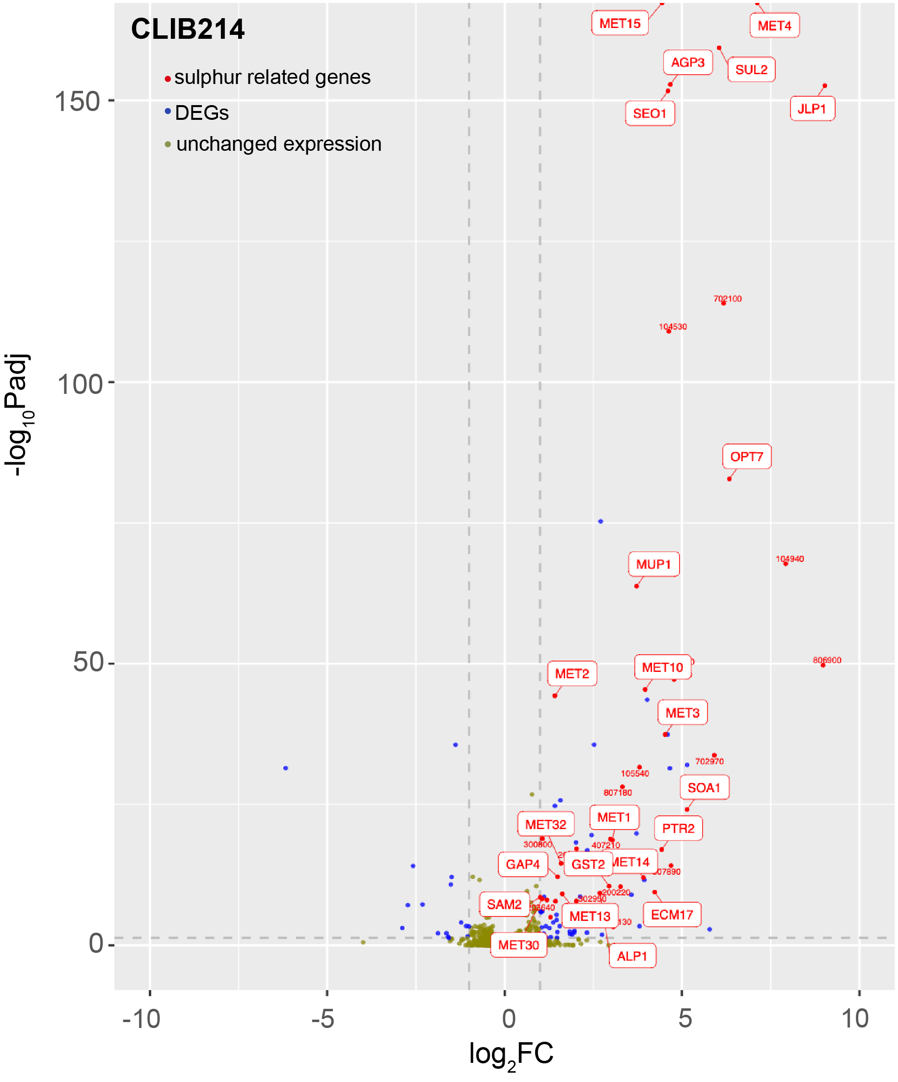
Supplementary Figure 6. CLIB214
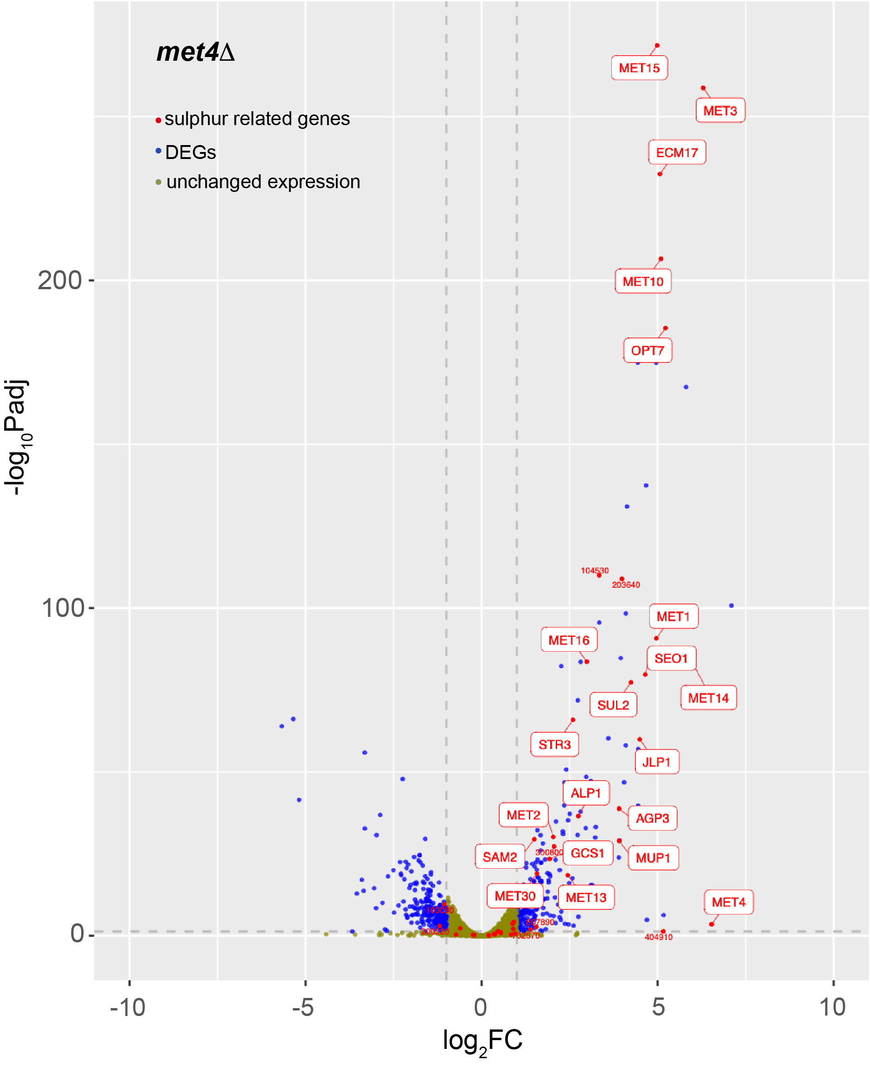
Supplementary Figure 6. met4Δ

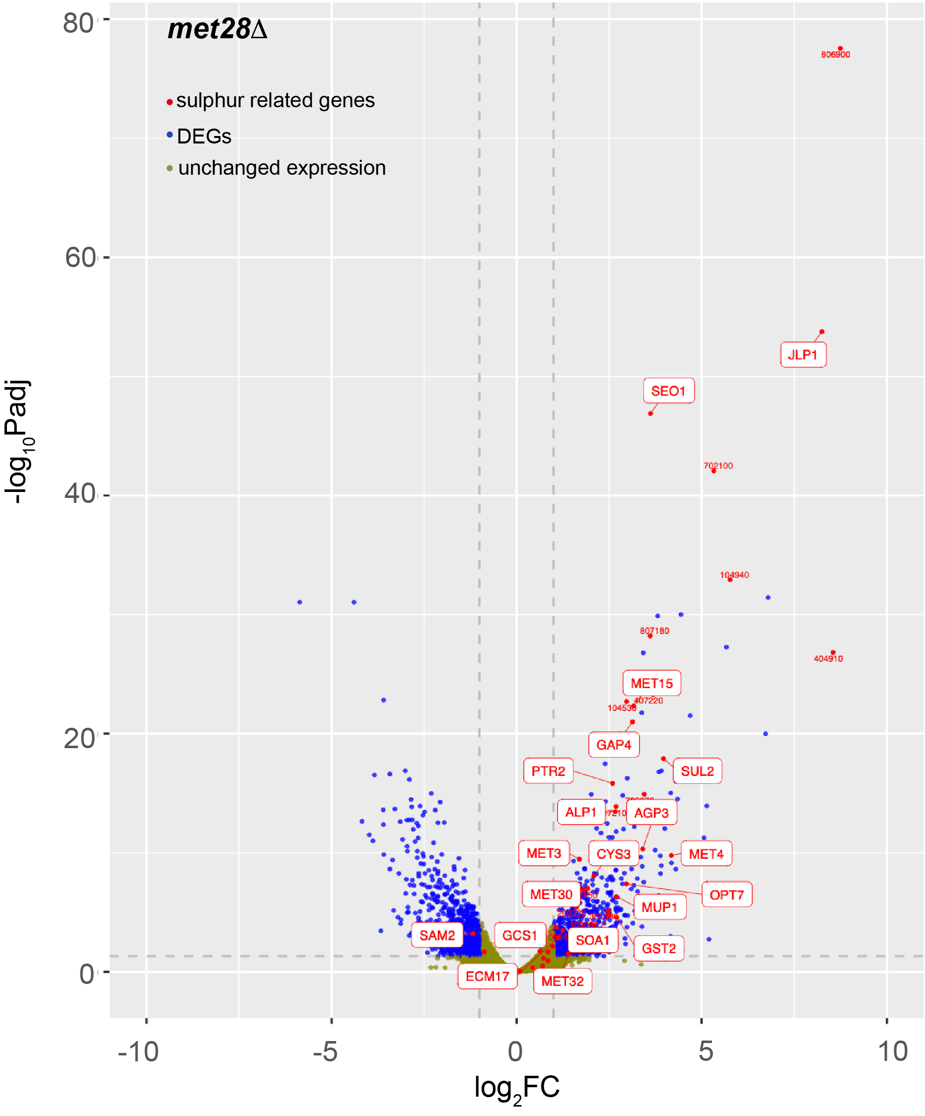 Supplementary Figure 6. met28Δ

Supplementary Table 6. Upregulated genes of C. parapsilosis CLIB214 upon Cys/Met starvation and their expression in the met4 and met28 single and double deletion mutants.
Category | CLIB214 | met4Δ | met28Δ | me4Δ/  met28Δ
TFs & regulatory proteins | MET4 (7.1)ª, MET32 (1.6), MET30 (1.1), STP1 (1) | MET30 (1.6) | MET4 (4.2), MET32 (1.4), MET30 (1.8), STP1 (1.7)
Sulphate  assimilation | MET3 (4.5), MET15 (4.4), ECM17 (4.2), MET10 (4), MET14 (3.9), MET16 (1.9), MET2 (1.4) | MET3 (6.3), MET15 (5), ECM17 (5), MET10 (5.1), MET14 (5.9), MET16 (3), MET2 (2) | MET3 (1.7), MET15 (3.1), ECM17 (1.1),
Met Metabolism | SAM2 (1), MET1 (3), MET13 (1.7) | SAM2 (1.5), MET1 (5), MET13 (2.4) | SAM2 (-1.2)
Cys Metabolism | CYS3 (1.3), STR3 (1.2), GCS1^{b} (1), GST2 (2.9) | STR3 (2.6), GCS1 (2) | CYS3 (2.1), GCS1 (1), GST2 (2.7)
Sulphate transp. | SUL2 (6) | SUL2 (4.2) | SUL2 (4)
Sulphur compound transp. | SOA1 (5.1), SEO1 (4.6), 702970^{c} (6), 200220 (3.3), 203280 (2) | SEO1 (4.6), 702970 (1.4) | SOA1 (2.5), SEO1 (3.6), 702970 (3.5), 200220 (1.6), 203280 (2.1)
AA & oligopeptide transp. | AGP3 (4.6), MUP1 (3.7), OPT7 (6.3), 807890 (4.7), PTR2 (4.4), 301130 (3), ALP1 (2.7), GAP4 (1.5) | AGP3 (3.9), MUP1 (3.9), OPT7 (5.2), 807890 (1.6), ALP1 (2.8) | AGP3 (3.4), MUP1 (2.7), OPT7 (3), PTR2 (2.6), 301130 (2.5), ALP1 (2.7), GAP4 (3.1)
Other transp. | SNQ2 (1.5), 108880 (1.8), 802720 (3.8), 108340 (2.7), YMC2 (2.7), MDR1B (1.8), 300590 (1.5) | SNQ2 (1.7), YMC2 (5), MDR1B (2.8) | SNQ2 (1), YMC2 (1). MDR1B (5.7), 108880 (2.5), 300590 (1.8) | SNQ2 (1.2), MDR1B (1.9), 300590 (1.4)
2-oxoglutarate-dep. dioxygenases | JLP1 (9), 806900 (9), 702100 (6.2), 407220 (4.8), 104530 (4.6), 404910 (4.5), | JLP1 (4.5), 104530 (3.3), | JLP1 (8.2), 806900 (8.7), 702100 (5.3), 407220 (3.7), 104530 (3), 404910 (8.6)
FMNH₂-dep. monooxygenases | 104940 (8), 807180 (3.3), 407210 (3), 302950 (2) |  | 104940 (5.8), 807180 (3.6), 407210 (2.7), 302950 (1.9)
Arylsulfatases | 103090 (4.8), 105540 (3.8) |  | 103090 (1.7), 105540 (3.9)
Oxidative stress response | FTR1 (1.1), ROX1 (1), PRX1 (4.7), 210110 (5.8), 405440 (4), 601950 (2.5), FET3 (1.7) | ROX1 (1.5), PRX1 (4.7), 601950 (4.1), FET3 (-2.7) | FTR1 (3.2), ROX1 (2.3), PRX1 (1.1), 405440 (3.5), FET3 (2.2)
Sugar transp. | HGT8 (2.3), HXT5 (1.8)
OAS pathway | 203640 (1.4), 300800 (1.1) | 203640 (4), 300800 (2.1)
Sporulation  related genes | SMA2 (5.1), SPO11 (4.6), SPO75 (1.1) | SMA2 (4.4), SPO11 (7.1), SPO75 (4) | SMA2 (2.9)
SAP/adhesin-like | 302640 (2.3), 805340 (2), 801790 (2) | 805340 (4.1), 801790 (2.4)
others | DUR4 (4), 807040 (3.7), ARO9 (2.1), TPO3 (1.3), FDH1 (1.8), BNA3 (1.4), 503870 (1.6), 500140 (1.4), PGA23 (1.3), CHA1 (1.2), 212190 (1.1) | 807040 (5.2), TPO3 (2.2), BNA3 (1.4), 503870 (2.3), 500140 (6), PGA23 (2.6), CHA1 (2), | ARO9 (1.4), DUR4 (4.7), TPO3 (3.4), CHA1 (3.4), 212190 (1.6) | CHA1 (1.8),
Unknown  function | 210700 (3.6), 102480 (2.5), 101750 (2.1), 203580 (2), 201160 (2), 704060 (1.9), 809010 (1.7), 502110 (1.6), 210410 (1.5), 203090 (1.5), 103320 (1.2), 400960 (1.1), 703250 (1.1), 805910 (1) | 203580 (1.7), 201160 (1.8), 809010 (2.5), 203090 (2.7) | 210700 (2.4), 101750 (1.5),  203580 (2.5), 201160 (3.4), 210410 (1.2), 203090 (3.4), 103320 (1.7), 703250 (2.2), 805910 (1.8) | 703250 (1.3)
Genes related to sulphur are highlighted in red in CLIB214. For the complete list of differentially regulated genes: Supplementary Table 5. The genes CPAR2_402890, CPAR2_404910, and CPAR2_402070 were not included in the met4Δ column because one of the conditions in the data set had zero reads (Supplementary Table 5).
^{a.} numbers in brackets indicate the Log₂FC in expression (SC -Cys/Met versus SC + AA) versus; only genes with adjusted p-value <0.05 are shown.
^{b.} GCS1 had a logFC = 0.98, so it was included.
^{c.} C. parapsilosis genes lacking the functional name are indicated with the six digits ID that follows the “CPAR2_” prefix: for example, 702970 stands for CPAR2_702970

Supplementary References

1 Holland, L. M. et al. Comparative phenotypic analysis of the major fungal pathogens Candida parapsilosis and Candida albicans. PLoS Pathog 10, e1004365 (2014). https://doi.org:10.1371/journal.ppat.1004365
2 Sellam, A. et al. The p38/HOG stress-activated protein kinase network couples growth to division in Candida albicans. PLoS Genet 15, e1008052 (2019). https://doi.org:10.1371/journal.pgen.1008052
3 Noble, S. M., French, S., Kohn, L. A., Chen, V. & Johnson, A. D. Systematic screens of a Candida albicans homozygous deletion library decouple morphogenetic switching and pathogenicity. Nat Genet 42, 590-598 (2010). https://doi.org:10.1038/ng.605
4 Jorgensen, P., Nishikawa, J. L., Breitkreutz, B. J. & Tyers, M. Systematic identification of pathways that couple cell growth and division in yeast. Science 297, 395-400 (2002). https://doi.org:10.1126/science.1070850
5 Oh, J. et al. Gene annotation and drug target discovery in Candida albicans with a tagged transposon mutant collection. PLoS Pathog 6, e1001140 (2010). https://doi.org:10.1371/journal.ppat.1001140
6 Ramírez-Zavala, B. et al. The Snf1-activating kinase Sak1 is a key regulator of metabolic adaptation and in vivo fitness of Candida albicans. Mol Microbiol 104, 989-1007 (2017). https://doi.org:10.1111/mmi.13674
7 Yoshikawa, K. et al. Comprehensive phenotypic analysis of single-gene deletion and overexpression strains of Saccharomyces cerevisiae. Yeast 28, 349-361 (2011). https://doi.org:10.1002/yea.1843
8 Segal, E. S. et al. Gene Essentiality Analyzed by In Vivo Transposon Mutagenesis and Machine Learning in a Stable Haploid Isolate of Candida albicans. mBio 9 (2018). https://doi.org:10.1128/mBio.02048-18
9 Giaever, G. et al. Functional profiling of the Saccharomyces cerevisiae genome. Nature 418, 387-391 (2002). https://doi.org:10.1038/nature00935
10 Bruckmann, A., Künkel, W., Härtl, A., Wetzker, R. & Eck, R. A phosphatidylinositol 3-kinase of Candida albicans influences adhesion, filamentous growth and virulence. Microbiology (Reading) 146 ( Pt 11), 2755-2764 (2000). https://doi.org:10.1099/00221287-146-11-2755
11 Kitanovic, A. et al. Phosphatidylinositol 3-kinase VPS34 of Candida albicans is involved in filamentous growth, secretion of aspartic proteases, and intracellular detoxification. FEMS Yeast Res 5, 431-439 (2005). https://doi.org:10.1016/j.femsyr.2004.11.005
12 Blankenship, J. R., Fanning, S., Hamaker, J. J. & Mitchell, A. P. An extensive circuitry for cell wall regulation in Candida albicans. PLoS Pathog 6, e1000752 (2010). https://doi.org:10.1371/journal.ppat.1000752
13 Turner, S. A., Ma, Q., Ola, M., Martinez de San Vicente, K. & Butler, G. Dal81 Regulates Expression of Arginine Metabolism Genes in Candida parapsilosis. mSphere 3 (2018). https://doi.org:10.1128/mSphere.00028-18
14 Lombardi, L., Bergin, S. A., Ryan, A., Zuniga-Soto, E. & Butler, G. CRISPR-Cas9 editing induces Loss of Heterozygosity in the pathogenic yeast Candida parapsilosis. mSphere 7, e00393-00322 (2022). https://doi.org:doi:10.1128/msphere.00393-22
15 Hoot, S. J., Oliver, B. G. & White, T. C. Candida albicans UPC2 is transcriptionally induced in response to antifungal drugs and anaerobicity through Upc2p-dependent and -independent mechanisms. Microbiology (Reading) 154, 2748-2756 (2008). https://doi.org:10.1099/mic.0.2008/017475-0
16 Homann, O. R., Dea, J., Noble, S. M. & Johnson, A. D. A phenotypic profile of the Candida albicans regulatory network. PLoS Genet 5, e1000783 (2009). https://doi.org:10.1371/journal.pgen.1000783
17 Enjalbert, B. et al. Role of the Hog1 stress-activated protein kinase in the global transcriptional response to stress in the fungal pathogen Candida albicans. Mol Biol Cell 17, 1018-1032 (2006). https://doi.org:10.1091/mbc.e05-06-0501
18 Alonso-Monge, R. et al. The Hog1 mitogen-activated protein kinase is essential in the oxidative stress response and chlamydospore formation in Candida albicans. Eukaryot Cell 2, 351-361 (2003). https://doi.org:10.1128/ec.2.2.351-361.2003
19 Arana, D. M., Nombela, C., Alonso-Monge, R. & Pla, J. The Pbs2 MAP kinase kinase is essential for the oxidative-stress response in the fungal pathogen Candida albicans. Microbiology (Reading) 151, 1033-1049 (2005). https://doi.org:10.1099/mic.0.27723-0
20 Jiang, L. et al. Cadmium-induced activation of high osmolarity glycerol pathway through its Sln1 branch is dependent on the MAP kinase kinase kinase Ssk2, but not its paralog Ssk22, in budding yeast. FEMS Yeast Res 14, 1263-1272 (2014). https://doi.org:10.1111/1567-1364.12220
21 Rai, M. N., Sharma, V., Balusu, S. & Kaur, R. An essential role for phosphatidylinositol 3-kinase in the inhibition of phagosomal maturation, intracellular survival and virulence in Candida glabrata. Cell Microbiol 17, 269-287 (2015). https://doi.org:10.1111/cmi.12364
22 Liao, W. L., Ramón, A. M. & Fonzi, W. A. GLN3 encodes a global regulator of nitrogen metabolism and virulence of C. albicans. Fungal Genet Biol 45, 514-526 (2008). https://doi.org:10.1016/j.fgb.2007.08.006
23 Tebung, W. A., Omran, R. P., Fulton, D. L., Morschhäuser, J. & Whiteway, M. Put3 Positively Regulates Proline Utilization in Candida albicans. mSphere 2 (2017). https://doi.org:10.1128/mSphere.00354-17
24 Ghosh, S., Kebaara, B. W., Atkin, A. L. & Nickerson, K. W. Regulation of aromatic alcohol production in Candida albicans. Appl Environ Microbiol 74, 7211-7218 (2008). https://doi.org:10.1128/aem.01614-08
25 Tebung, W. A., Choudhury, B. I., Tebbji, F., Morschhäuser, J. & Whiteway, M. Rewiring of the Ppr1 Zinc Cluster Transcription Factor from Purine Catabolism to Pyrimidine Biogenesis in the Saccharomycetaceae. Curr Biol 26, 1677-1687 (2016). https://doi.org:10.1016/j.cub.2016.04.064
26 Ljungdahl, P. O. & Daignan-Fornier, B. Regulation of amino acid, nucleotide, and phosphate metabolism in Saccharomyces cerevisiae. Genetics 190, 885-929 (2012). https://doi.org:10.1534/genetics.111.133306
27 Chen, H. F. & Lan, C. Y. Role of SFP1 in the Regulation of Candida albicans Biofilm Formation. PLoS One 10, e0129903 (2015). https://doi.org:10.1371/journal.pone.0129903
28 Lee, S. Y., Chen, H. F., Yeh, Y. C., Xue, Y. P. & Lan, C. Y. The Transcription Factor Sfp1 Regulates the Oxidative Stress Response in Candida albicans. Microorganisms 7 (2019). https://doi.org:10.3390/microorganisms7050131
29 Kastora, S. L., Herrero-de-Dios, C., Avelar, G. M., Munro, C. A. & Brown, A. J. P. Sfp1 and Rtg3 reciprocally modulate carbon source-conditional stress adaptation in the pathogenic yeast Candida albicans. Mol Microbiol 105, 620-636 (2017). https://doi.org:10.1111/mmi.13722
30 VanderSluis, B. et al. Broad metabolic sensitivity profiling of a prototrophic yeast deletion collection. Genome Biol 15, R64 (2014). https://doi.org:10.1186/gb-2014-15-4-r64
31 Hao, B. et al. Candida albicans RFX2 encodes a DNA binding protein involved in DNA damage responses, morphogenesis, and virulence. Eukaryot Cell 8, 627-639 (2009). https://doi.org:10.1128/ec.00246-08
32 Douglas, L. M. & Konopka, J. B. Plasma membrane architecture protects Candida albicans from killing by copper. PLoS Genet 15, e1007911 (2019). https://doi.org:10.1371/journal.pgen.1007911
33 Byrne, K. P. & Wolfe, K. H. The Yeast Gene Order Browser: combining curated homology and syntenic context reveals gene fate in polyploid species. Genome Res 15, 1456-1461 (2005). https://doi.org:10.1101/gr.3672305
34 Maguire, S. L. et al. Comparative genome analysis and gene finding in Candida species using CGOB. Mol Biol Evol 30, 1281-1291 (2013). https://doi.org:10.1093/molbev/mst042
35 Gouy, M., Guindon, S. & Gascuel, O. SeaView version 4: A multiplatform graphical user interface for sequence alignment and phylogenetic tree building. Mol Biol Evol 27, 221-224 (2010). https://doi.org:10.1093/molbev/msp259

