Table S1 Primers used in this study
Purpose | Gene Name | Forward primer (5’-3’) | Reverse primer (5’-3’)
Gene clone | MhLHCB15  MhLHCB15-PRI  MhLHCB15-BD  MhSGR1-AD  MhTHF1-AD | ATGGCAGCTTCCATGGCT  CATATGCCCGTCGACCCCGGGATGGCAGCTTCCATGGCT  ATGGCCATGGAGGCCGAATTCATGGCAGCTTCCATGGCT  ATGGCCATGGAGGCCAGTGAATTCATGGGAGCTTTGACTGCTGC  ATGGCCATGGAGGCCAGTGAATTCATGGCGGCCGTTGCTTCT | TCACTTTCCGGGAACAAAG  TCAGAATTCGGATCCGGTACCTCACTTTCCGGGAACAAAG  TGCGGCCGCTGCAGGTCGACGTCACTTTCCGGGAACAAAG  TGCAGCTCGAGCTCGATGGATCCCTTAGTTTGTTTCCTGGGTTTGCC  TGCAGCTCGAGCTCGATGGATCCCTTACTGGCAAACATAATCCCCC
Quantitative real-time PCR | qMhLHCA1  qMhLHCA3  qMhLHCA7  qMhLHCA8  qMhLHCA9  qMhLHCA10  qMhLHCB2  qMhLHCB11  qMhLHCB12  qMhLHCB13  qMhLHCB14  qMhLHCB15  qMhLHCB17  qMhLHCB18  qMhLHCB22  qMhIRT1  qMhFRO2  qMhAHA2  qMhAHA8  qMhFIT  qAtIRT1  qAtFRO2  qAtAHA2  qAtAHA8  qAtFIT | GTCACAACATGCTTGCTGGGAAG  TGGTGCCAATGCCTCCTCAAG  CAATGTTGGGTGTTGCTGGGATG  GGTCCGTTGCTGAATCCTCTAGG  TCAAGAACGGAAGGCTGGCTATG  AGCCTACGGTGAAGTCATCAACG  ACTTCAGCAGAACAGCGAGGTC  AAGCCGCTTCAGCCGTACAC  GCTCGCTTCCAGGTGACTACG  GGCAACTATGGCTCTCTCATCCC  GGATGGGACACTGCTGGACTATC  ACCTTCGCCAAGAACCGTGAG  CCAACCTAGTCCACGCTCAGAG  ACTTGGCGGGTGACATCATCG  GTGAGGCTGTTTGGTTCAAGGC  CATGGCACAAGTCCCTTTT  TCAACAACCAAAGGGCAAAAAAA  ATCTGCCCTTACTGGGGAGT  TCGGTGTGAＡTGTGAAGATGAT  GGGAAACCATCAAGGAGGTCATA  GCTCTTGCGATACCGAGTCA3  GGTTATGGTGTGCGGAGGAA  AGCTGATGCCCGTCTACTTG  CAAGAATCGTCGGTTGTGGATGG  GGAGAAGGTGTTGCTCCATC | AGCTGCCAGGGAACCACAATG  CCTAGCCGAAGTGGGTCAAATCC  GGTGGACGAAGAGGCGAAGTAC  GGGTCCCACATGAGTCACAGATG  CGAGGTGAGCGAAGAGGTTGTC  GGAACCAAGGAAGGGCAGTCTC  TCTTCATCAGCGGGAGCAACAG  AACCACTACACGATCTGCACTCC  TACCAACGACTGCCGCCATTG  AACCCTACCGTTTCCTTGGACAG  CGAACTTGACGCCATTCCTTGAC  GCCGAACTTGACACCGTTGC  GTTGCCCTCTCCTACGCCATC  GCTCGCACTCCCTAAACCTCTG  TCCACGGCACCCATCAAGATAAC  ACCACAGCCATCTCTTGGTC  AAGGCAATGAACATCACCAGGAAAG  AAATGCAGAAGTTCCCGATG  TCAGGAAATACTCAGCAAATC  AGCCATTCATCATAAGCTCAGGA  5GATACAACCGCCAAGACCCA  TGGCAAGACAAGATCGAGCA  CCAGTGGCAATAACAACCGC  GTGAGAGCGTAACGGATGATGAAC  TCCGGAGAAGGAGAGCTTAG
Reference genes | MhGAPDH  AtActin | TGAGGGCAAGGTGAAGGGTATCTT  CCACATGCTATTCTGCGTTTGGACC | TCAAGTCAACCACACGCGTACTGT  CATCCCTTACGATTTCACGCTCTGC
Note: Sequences underlined indicate enzyme restriction site.

Table S2 Physicochemical properties of 33 MhLHC family members.
Gene accession | Gene name | pI | MW (Da) | Amino  acids | Positive  residues | Negative residues | Aliphatic  index | Instability  index | Grand average hydropathicity | Chr.position | Subcellular  localization
MD02G1095600  MD06G1195000  MD07G1175900  MD08G1101900  MD09G1134800  MD13G1119100  MD14G1202000  MD15G1083400  MD16G1119500  MD17G1123800  MD00G1103100  MD00G1161400  MD01G1132800  MD03G1218900  MD04G1151300  MD05G1000500  MD05G1289200  MD05G1289300  MD06G1001700  MD07G1215200  MD07G1220500  MD08G1220900  MD09G1292900  MD09G1122500  MD10G1265300  MD10G1265400  MD11G1236900  MD12G1165400  MD15G1411600  MD17G1137800  MD17G1281900  MD17G1109600  MD17G1113400 | MhLHCA1  MhLHCA2  MhLHCA3  MhLHCA4  MhLHCA5  MhLHCA6  MhLHCA7  MhLHCA8  MhLHCA9  MhLHCA10  MhLHCB1  MhLHCB2  MhLHCB3  MhLHCB4  MhLHCB5  MhLHCB6  MhLHCB7  MhLHCB8  MhLHCB9  MhLHCB10  MhLHCB11  MhLHCB12  MhLHCB13  MhLHCB14  MhLHCB15  MhLHCB16  MhLHCB17  MhLHCB18  MhLHCB19  MhLHCB20  MhLHCB21  MhLHCB22  MhLHCB23 | 5.44  5.84  5.85  9.46  7.84  9.26  6.43  8.65  6.10  7.83  6.00  6.00  5.15  5.10  5.46  6.00  5.29  5.97  8.87  6.70  4.54  6.16  5.59  6.97  5.29  5.29  5.10  5.48  7.79  5.12  7.06  4.93  5.69 | 29436.96  27891.87  26724.69  15474.15  29944.26  36522.64  27897.88  28119.51  30036.10  29909.22  31014.58  31014.58  31204.69  28577.63  31128.37  30969.60  28202.08  31176.65  38200.48  6272.21  21163.37  27541.49  35115.81  33739.57  28073.95  28175.05  28603.61  31792.06  27279.28  25026.40  35577.51  26356.71  28525.55 | 267  253  247  138  277  336  253  260  277  277  290  290  283  264  286  290  265  291  350  56  187  259  329  312  264  265  264  290  257  233  332  242  265 | 23  21  22  15  23  32  22  23  24  23  28  28  27  20  26  27  21  23  33  5  18  22  25  27  21  21  20  27  22  18  28  16  23 | 28  24  25  9  22  26  23  21  26  22  30  30  34  26  31  29  26  26  28  5  30  23  30  27  26  26  26  32  21  24  28  22  26 | 82.96  85.57  83.36  98.99  84.58  74.14  84.82  94.54  75.45  84.58  89.62  89.62  84.81  85.34  83.71  90.66  78.11  78.18  96.43  81.96  99.57  81.85  78.94  79.17  78.41  78.11  86.44  81.52  84.44  79.18  80.57  80.25  81.40 | 39.33  43.46  45.99  47.65  35.55  43.06  42.70  24.51  35.56  35.99  30.76  30.76  44.04  19.21  34.01  30.40  22.45  23.30  42.11  38.80  53.05  28.92  30.41  44.43  21.88  21.84  22.08  37.46  25.62  25.35  23.53  25.18  31.55 | -0.015  -0.106  -0.107  -0.016  -0.057  -0.193  -0.087  0.075  -0.074  -0.045  -0.007  -0.007  -0.112  0.010  -0.125  0.015  -0.033  0.009  0.070  0.086  -0.095  0.064  -0.129  -0.132  -0.020  -0.023  0.015  -0.198  0.068  -0.078  -0.109  -0.099  -0.037 | Chr02:7545569:7547316  Chr06:32950773:32952478  Chr07:25530799:25532598  Chr08:8552990:8554014  Chr09:10357399:10359051  Chr13:8734032:8736151  Chr14:29086734:29088171  Chr15:5705169:5707176  Chr16:8572390:8574105  Chr17:10760912:10762734  Chr00:21773062:21775104  Chr00:35891516:35894002  Chr01:24270803:24273012  Chr03:30339429:30341036  Chr04:23988140:23989799  Chr05:105876:109341  Chr05:42171376:42172173  Chr05:42174118:42175040  Chr06:212350:217034  Chr07:29241996:29242166  Chr07:29781292:29783802  Chr08:28364908:28366375  Chr09:37566547:37567556  Chr09:9443330:9444730  Chr10:35874032:35874907  Chr10:35876497:35877337  Chr11:34455547:34457139  Chr12:24641675:24644144  Chr15:51099008:51100141  Chr17:12344937:12345638  Chr17:34100469:34101524  Chr17:9422610:9423427  Chr17:9725278:9726436 | Chloroplast.  Chloroplast.  Chloroplast.  Chloroplast.  Chloroplast.  Chloroplast.  Chloroplast.  Chloroplast.  Chloroplast.  Chloroplast.  Chloroplast.  Chloroplast.  Chloroplast.  Chloroplast.  Chloroplast.  Chloroplast.  Chloroplast.  Chloroplast.  Chloroplast.  Chloroplast.  Chloroplast.  Chloroplast.  Chloroplast.  Chloroplast.  Chloroplast.  Chloroplast.  Chloroplast.  Chloroplast.  Chloroplast.  Chloroplast.  Chloroplast.  Chloroplast.  Chloroplast.

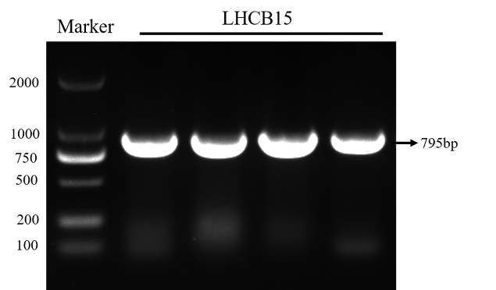
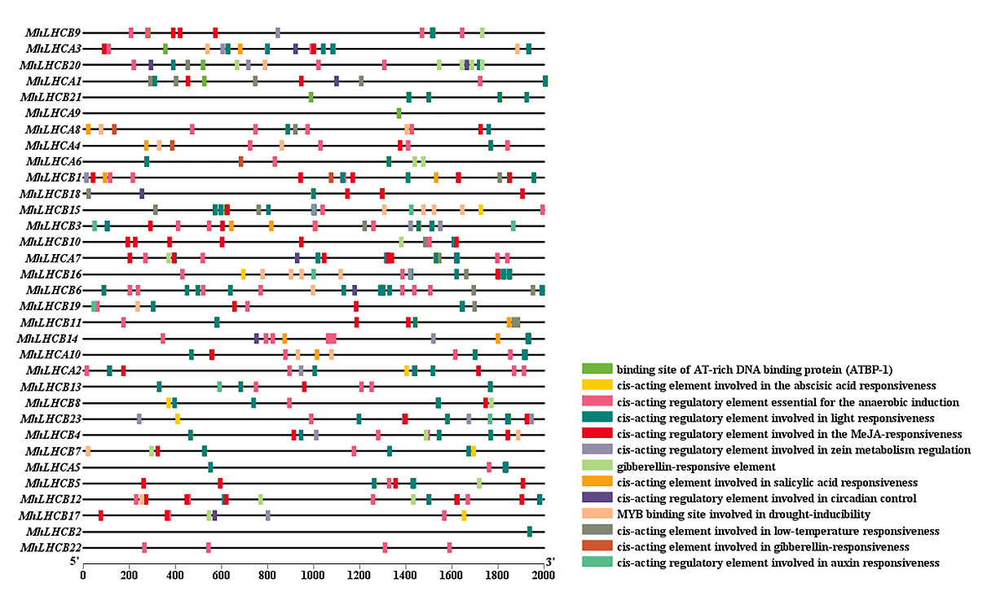
Fig.S1 Analysis of cis-acting elements in the promoter region of MhLHC genes.
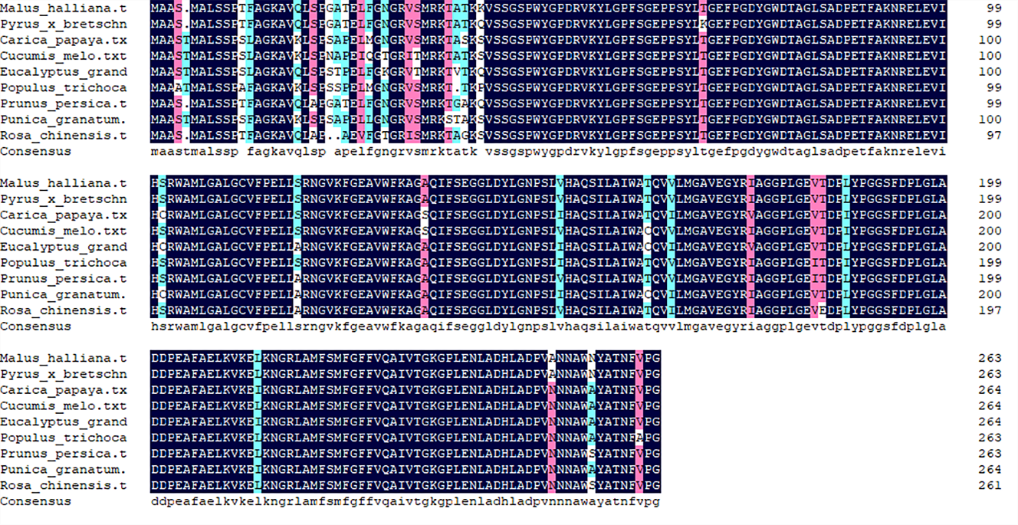
Fig.S2 Ampliﬁed fragment size of MhLHCB15 gene in Malus halliana.
Fig.S3 Protein sequence analysis of MhLHCB15 gene in M. halliana and the protein of other species.
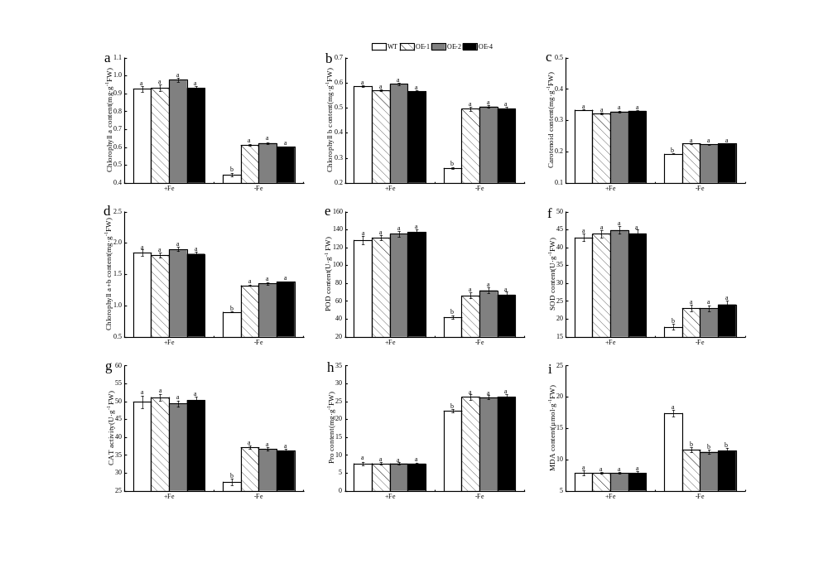
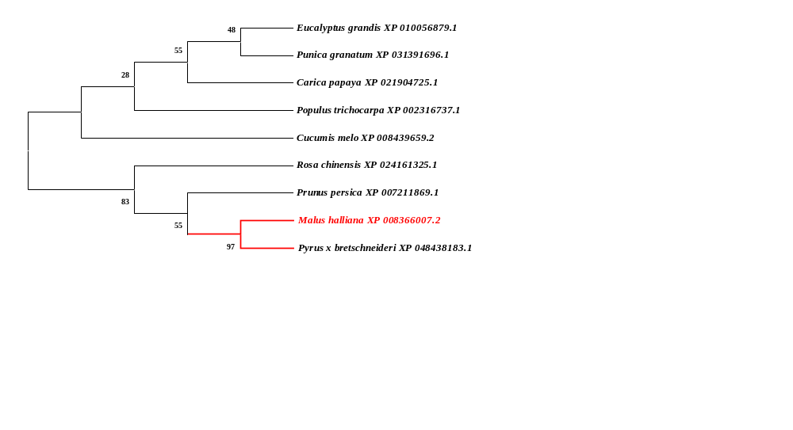
Fig.S4 Phylogenetic analysis of this protein of MhLHCB15 from M. halliana and other species families. The number at the branch of the evolutionary tree indicates the confidence of the branch, the larger the value, the higher the reliability.
Fig.S5 The photosynthetic pigments content, antioxidant enzymes and osmoregulatory substances of wild type (WT) and MhLHCB15 transgenic Arabidopsis thaliana grown for 20 days under Fe-sufﬁcient(+Fe) or Fe-deﬁcient(-Fe) conditions. a Chlorophyll a content; b Chlorophyll b content; c Carotenoid content; d Chlorophyll a+b content; e POD content; f SOD content; g CAT activity; h Pro content; i MDA content.
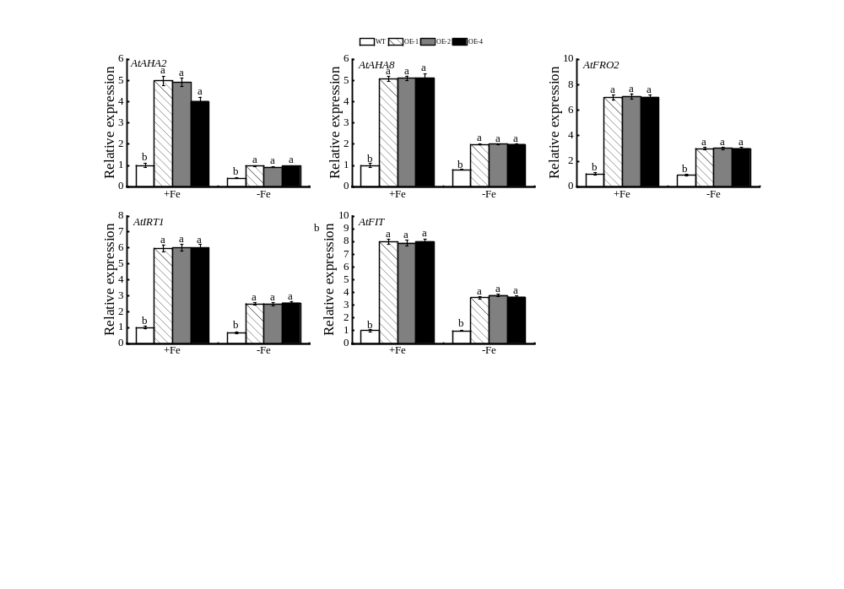
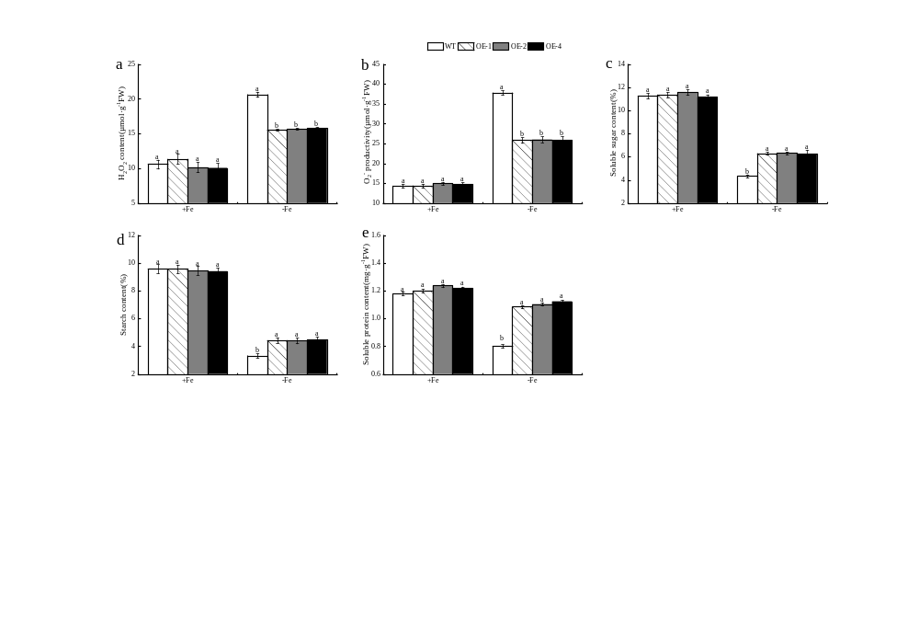
Fig.S6 The Reactive oxygen species (ROS) and photosynthesis products of wild type (WT) and MhLHCB15 transgenic A. thaliana grown for 20 days under Fe-sufﬁcient (+Fe) or Fe-deﬁcient (-Fe) conditions. a O₂⁻ content; b H₂O₂ content; c Souble sugar content (SS); d Starch content (St); e Souble protein content (SP).
Fig.S7 Expression of genes related to Fe absorption in wild type (WT) and MhLHCB15 transgenic Arabidopsis thaliana grown for 20 days under Fe-sufﬁcient (+Fe) or Fe-deﬁcient (-Fe) conditions.

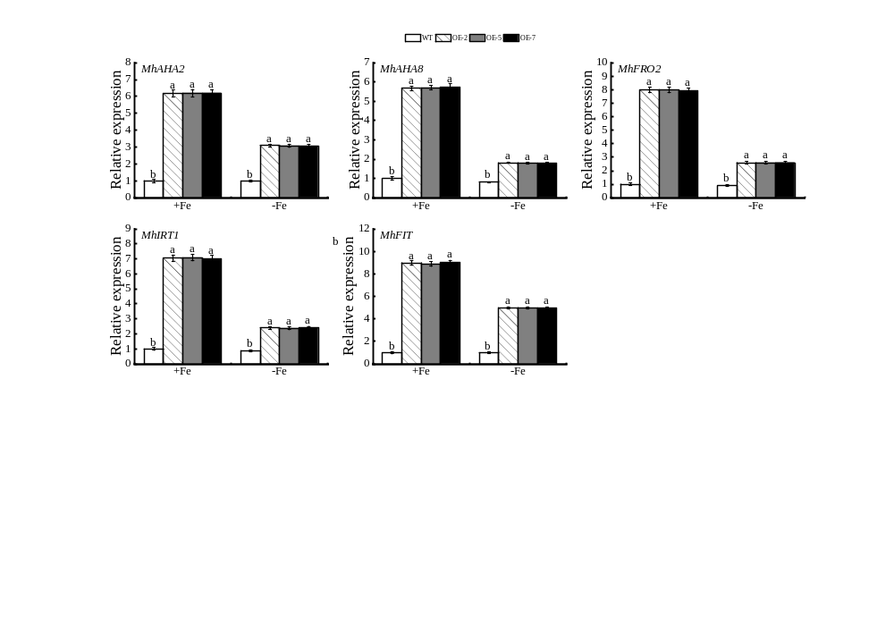
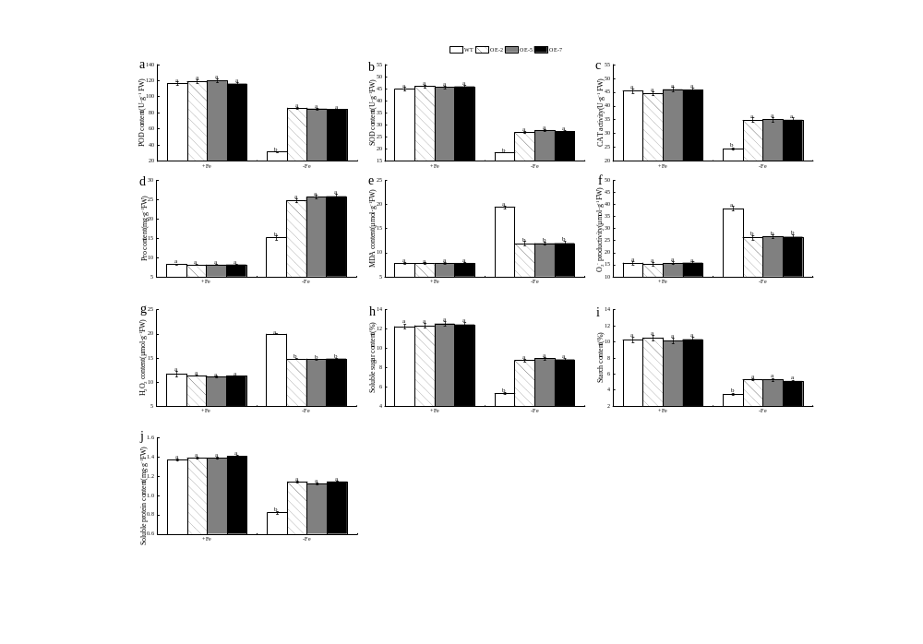
Fig.S8 The physiological parameter of wild type (WT) and MhLHCB15 transgenic apple calli grown for 20 days under Fe-sufﬁcient (+Fe) or Fe-deﬁcient (-Fe) conditions. a POD content; b SOD content; c CAT activity; d Pro content; e MDA content; f O₂⁻ content; g H₂O₂ content; h Souble sugar content (SS); i Starch content (St); j Souble protein content (SP).
Fig.S9 Expression of genes related to Fe absorption in wild type (WT) and MhLHCB15 transgenic apple calli grown for 20 days under Fe-sufﬁcient (+Fe) or Fe-deﬁcient (-Fe) conditions.
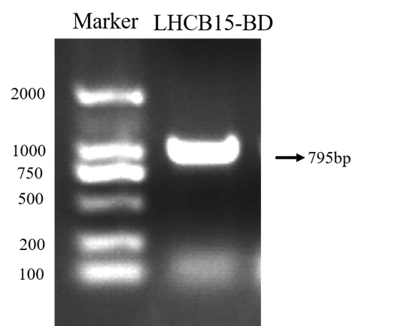
Fig.S10 Ampliﬁed fragment size of pGBKT7-MhLHCB15 gene in M. halliana.

