  - Title: Differential Item Functioning and Response Shift may reveal hidden differences between groups and over time in anxiety and depression in patients with early-stage melanoma or breast cancer: interpretation and impact using the RespOnse Shift ALgorithm at the Item level (ROSALI)
  - -
  - Electronic Supplementary Materials
Investigation of the lack of measurement invariance among the items of the Hospital Anxiety and Depression Scale (HADS) in breast cancer and melanoma patients with the 'RespOnse Shift Algorithm at the Item level ' (ROSALI) algorithm
- Overview of ROSALI
ROSALI ('RespOnse Shift Algorithm at the Item level' with one covariate) is an iterative item-by-item procedure aiming at investigating lack of measurement invariance between groups (i.e. Differential Item Functioning, DIF) and over time (i.e. recalibration Response Shit, recalibration RS) based on participant responses to a self-reported questionnaire targeting a latent construct (e.g, anxiety or depression using the HADS questionnaire). In ROSALI, it is assumed that this unobservable/latent construct is represented by a continuous variable known as 'latent variable'.
The version of ROSALI we used in the manuscript is the one that integrates one binary covariate G, forming two groups (e.g., cancer type), G₀ [reference group] and G₁ and considers two time points (T₁ and T₂) []. It consists in of two sequential algorithms:
- Algorithm 1: dedicated to DIF detection between groups G₀ and G₁ at the first time point T₁
- Algorithm 2: dedicated to recalibration RS detection between T₁ and T₂
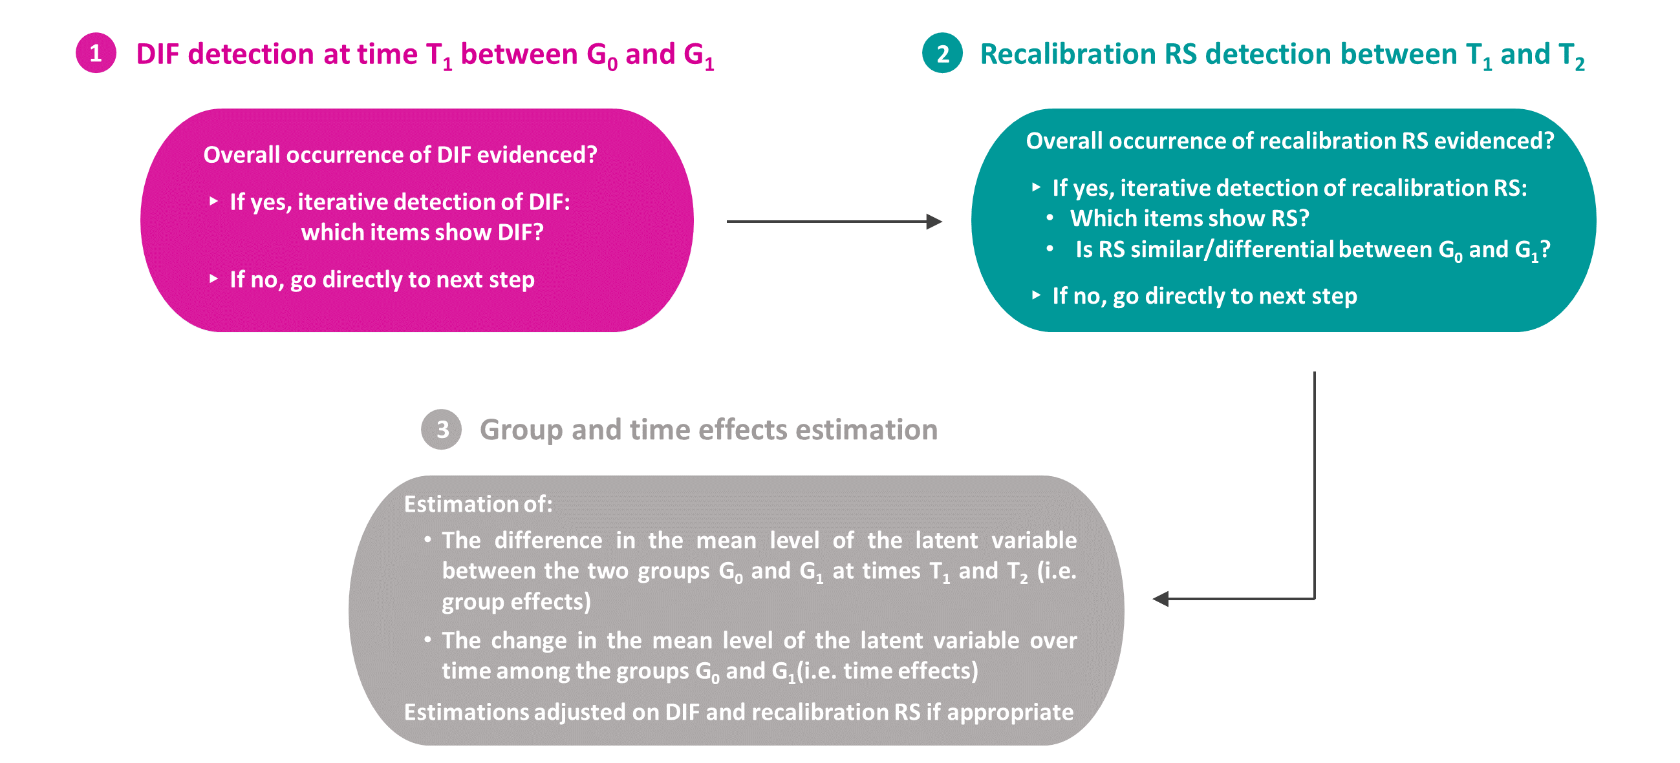
ROSALI with one covariate and two time points can be depicted as follows (Figure S.1):

Figure S.1: ROSALI algorithm with one binary covariate G and two time points T₁ and T₂
Adapted from Hammas et al. Frontiers in Psychology, 2020
- Psychometric model and detection of DIF and recalibration RS in ROSALI
Taking the anxiety subscale of the HADS as an illustration and without loss of generality, patient responses to the "anxiety" subscale are modelled as a function of a latent variable (assumed to represent the level of the target construct) and based on Rasch models. These are probabilistic models which assume that the higher the level of the latent variable (e.g., anxiety), the higher the item responses. A graphical representation of such models is given in Figure S.2 as an illustration for one hypothetical item $j$ with 4 ordered response categories (denoted 0, 1, 2 and 3). These curves are named category characteristic curves; they represent the probability of endorsing each response category according to the level of the latent variable. Of note, the expected item response curves depicted in the manuscript (e.g., Figure 1) derive directly from these category characteristic curves.
In Figure S.2., three latent variable levels have been highlighted by green vertical dashed lines:
- $δ_{j1}$ : This is the latent variable level for which it is assumed that an individual is as likely to choose category 0 as category 1 in response to item $j$.
- $δ_{j2}$ : This is the latent variable level for which it is assumed that an individual is as likely to choose category 1 as category 2 in response to item $j$.
- $δ_{j3}$ : This is the latent variable level for which it is assumed that an individual is as likely to choose category 2 as category 3 in response to item $j$.
These parameters are known as item thresholds. The higher this parameter, the higher the level of latent variable (e.g., anxiety) required to endorse this response category. Of note, if an item has $p$response categories, then there are $p-1$ thresholds in the model related to this item in the model.
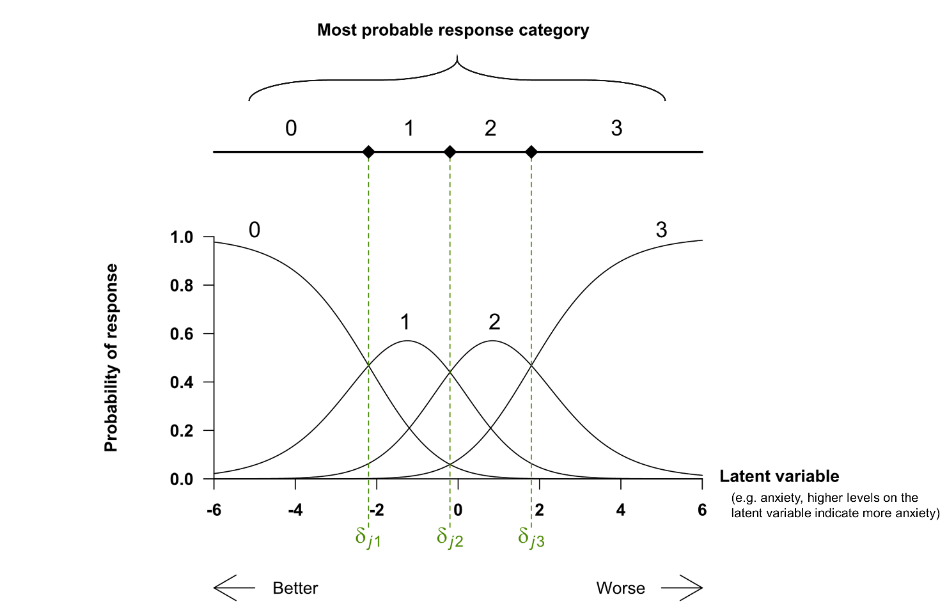

Figure S.2: Category characteristic curves for an item with four response categories under a Rasch model. Vertical dashed lines highlight the item threshold $δ_{jp}$, characterizing the items in Rash models
In the ROSALI algorithm, DIF and recalibration RS detection are based on statistical testing (accounting for multiple testing) of the item threshold parameters. For a given item:
- DIF is found between G₀ and G₁ if its thresholds vary significantly between both groups,
- Recalibration RS is found between T₁ and T₂ if its thresholds vary significantly over time.

Preliminary analysis to perform before using ROSALI
Before conducting DIF and RS detection with the ROSALI algorithm, we assessed the fit to a Rasch model for both subscales of the HADS at T₁ (one-month post-diagnosis) using fit indices based on residuals, namely inlier-sensitive INFIT and outlier-sensitive fit OUTFIT. As a result, item 11 "I feel restless as if I have to be on the move" was discarded from further analysis due to item misfit at T₁ in both groups (large INFIT and OUTFIT, indicating that the item responses were more random than predicted by the model). Besides, two adjacent response categories were collapsed for some items to either deal with dysfunctioning items (i.e., items showing disordered thresholds, for instance $δ_{j1}> δ_{j2}$) or to ensure that all frequencies within the two-way contingency table "item response*cancer type" were above 0 at each time point. All collapsing performed are summarized in Table S.1.
Table S.1: Summary of the response categories which were collapsed
 | Before collapsing |  |  | After collapsing
 | Code | Response categories |  | Code | Response categories
(a) HADS-Anxiety
9. I get a sort of frightened feeling like butterflies in the stomach | 0  1  2  3 | Not at all  Occasionally  Quite often  Very often |  | 0  1  2 | Not at all  Occasionally  Quite often + Very often
13. I get sudden feelings of panic | 0  1  2  3 | Not at all  Not very often  Quite often  Very often |  | 0  1  2 | Not at all  Not very often  Quite often + Very often
(b) HADS-Depression
2. I still enjoy the things I used to enjoy | 0  1  2  3 | Definitely as much  Not quite so much  Only a little  Hardly at all |  | 0  1  2 | Definitely as much  Not quite so much  Only a little + Hardly at all
4. I can laugh and see the sunny side of things | 0  1  2  3 | As much as I always could  Not quite so much now  Definitely not so much now  Not at all |  | 0  1  2 | As much as I always could  Not quite so much now  Definitely not so much now +  Not at all
6. I feel cheerful | 0  1  2  3 | Most of the time  Sometimes  Not often  Not at all |  | 0  1  2 | Most of the time  Sometimes  Not often + Not at all
10. I have lost interest in my appearance | 0  1  2  3 | I take just as much care as ever  I may not take quite as much care  I don’t take as much care as I should  Definitely |  | 0  1  2 | I take just as much care as ever  I may not take quite as much care +  I don’t take as much care as I should  Definitely
12. I look forward with enjoyment to things | 0  1  2  3 | As much as I ever did  Rather less than I used  Definitely less than I used  Hardly at all |  | 0  1  2 | As much as I ever did  Rather less than I used  Definitely less than I used + Hardly at all
14. I can enjoy good book or radio or TV program | 0  1  2  3 | Often  Sometimes  Not often  Very seldom |  | 0  1  2 | Often  Sometimes  Not often + Very seldom

Subscale Anxiety (HADS-A) : size of the DIF and recalibration RS effects found
- Item 7: affected by DIF according to cancer type
Item wording: I can sit at ease and feel relaxed
Response categories: 0 = Definitely, 1 = Usually, 2 = Not often, 3 = Not at all
The item has 3 thresholds: $δ_{71}$, $δ_{72}$ and $δ_{73}$. The threshold estimates among breast cancer and melanoma patients at both time points are given in Table S.2 alongside the DIF size estimates.
Table S.2: Estimates of the item 7 (“I can sit at ease and feel relaxed”) thresholds among breast cancer (BC) and melanoma (M) patients at both time points alongside the estimates of the DIF size (DIF according to cancer type). The standard errors associated with these estimates are given in brackets. Of note, threshold estimates at T₁ and T₂ are identical as no recalibration response shift has been found between T₁ and T₂.

 | Thresholds |  |  |  |  |  | DIF size  at time T₁ and T₂
 | Time T₁  Diagnosis + 1 month |  |  | Time T₂  Diagnosis + 6 months |  |  | DIF size  at time T₁ and T₂
 | BC | M |  | BC | M |  | (M versus BC [reference])
$$δ_{71}$$ | -3.93 (0.20) | -4.25 (0.23) |  | -3.93 (0.20) | -4.25 (0.23) |  | -0.32 (0.16)
$$δ_{72}$$ | 0.35 (0.12) | 0.03 (0.18) |  | 0.35 (0.12) | 0.03 (0.18) |  | -0.32 (0.16)
$$δ_{73}$$ | 3.01 (0.21) | 2.68 (0.25) |  | 3.01 (0.21) | 2.68 (0.25) |  | -0.32 (0.16)
-0.32
-0.32

DIF:

- Item 3: affected by recalibration RS between T₁ and T₂ occurring similarly among breast cancer and melanoma patients
Item wording: I get a sort of frightened feeling as if something awful is about to happen
Response categories: 0 = Not at all, 1 = A little, but it doesn’t worry me, 2 = Yes, not too badly, 3 = Very definitely and quite badly
The item has 3 thresholds: $δ_{31}$, $δ_{32}$, $δ_{33}$. The threshold estimates at time T₁ and T₂ are given in Table S.3 alongside the recalibration RS size estimates.
Table S.3: Estimates of the item 3 (“I get a sort of frightened feeling as if something awful is about to happen”) thresholds among breast cancer (BC) and melanoma (M) patients at both time points alongside the estimates of the recalibration response shift (RS) size. The standard errors associated with these estimates are given in brackets. Of note, threshold estimates are equal between breast cancer and melanoma patients at both time points as no DIF according to cancer type has been found.

 | Thresholds |  |  |  | Recalibration RS size  among BC and M
 | Time T₁  Diagnosis + 1 month |  | Time T₂  Diagnosis + 6 months |  | Recalibration RS size  among BC and M
 | BC + M |  | BC + M |  | (T₂ versus T₁ [reference])
$$δ_{31}$$ | -2.19 (0.15) |  | -1.63 (0.15) |  | +0.56 (0.12)
$$δ_{32}$$ | -0.09 (0.13) |  | 0.47 (0.15) |  | +0.56 (0.12)
$$δ_{33}$$ | 0.72 (0.15) |  | 1.28 (0.17) |  | +0.56 (0.12)
+0.56
Recalibration RS:

Subscale Depression (HADS-D): size of the recalibration RS effects found
- Item 2: affected by recalibration RS between T₁ and T₂ occurring similarly among breast cancer and melanoma patients
Item wording: I still enjoy the things I used to enjoy
Response categories: 0 = Definitely as much, 1 = Not quite so much, 2 = Only a little + Hardly at all (collapsed response categories)
The item has 2 thresholds: $δ_{21}$ and $δ_{22}$. The threshold estimates at time T₁ and T₂ are given in Table S.4 alongside the recalibration RS size estimates.
Table S.4: Estimates of the item 4 (“I still enjoy the things I used to enjoy”) thresholds among breast cancer (BC) and melanoma (M) patients at both time points alongside the estimates of the recalibration response shift (RS) size. The standard errors associated with these estimates are given in brackets. Of note, threshold estimates are equal between breast cancer and melanoma patients at both time points as no DIF according to cancer type has been found.
 | Thresholds |  |  |  | Recalibration RS size  among BC and M
 | Time T₁  Diagnosis + 1 month |  | Time T₂  Diagnosis + 6 months |  | Recalibration RS size  among BC and M
 | BC + M |  | BC + M |  | (T₂ versus T₁ [reference])
$$δ_{41}$$ | 0.31 (0.13) |  | -0.09 (0.15) |  | -0.41 (0.14)
$$δ_{42}$$ | 2.44 (0.17) |  | 2.03 (0.17) |  | -0.41 (0.14)
Recalibration RS:
-0.41

- Item 8: affected by recalibration RS between T₁ and T₂ occurring differentially among breast cancer and melanoma patients

Item wording: I feel as if I am slowed down
Response categories: 0 = Not at all, 1 = Sometimes, 2 = Very often, 3 = Nearly all the time
The item has 3 thresholds: $δ_{81}$, $δ_{82}$and $δ_{83}$. The threshold estimates at time T₁ and T₂ are given in Table S.5 alongside the recalibration RS size estimates.

Table S.5: Estimates of the item 8 (I feel as if I am slowed down) thresholds among breast cancer (BC) and melanoma (M) patients at both time points alongside the estimates of the recalibration response shift (RS) size. The standard errors associated with these estimates are given in brackets. Of note, threshold estimates are equal between breast cancer and melanoma patients at T₁ as no DIF according to cancer type has been found at this time point. However, threshold estimates differ at T₂ as the evidenced recalibration RS occurred differently between the two groups.

 | Thresholds |  |  |  |  | Recalibration RS size  among BC |  | Recalibration RS size  among M
 | Time T₁  Diagnosis + 1 month |  | Time T₂  Diagnosis + 6 months |  |  | Recalibration RS size  among BC |  | Recalibration RS size  among M
 | BC + M |  | BC | M |  | (T₂ versus T₁ [ref]) |  | (T₂ versus T₁ [ref])
$$δ_{81}$$ | -1.23 (0.15) |  | -2.81 (0.26) | -1.89 (0.24) |  | -1.57 (0.28) |  | -0.66 (0.21)
$$δ_{82}$$ | 2.03 (0.17) |  | 0.44 (0.18) | 1.37 (0.23) |  | -1.59 (0.21) |  | -0.66 (0.21)
$$δ_{83}$$ | 3.39 (0.29) |  | 2.82 (0.27) | 2.74 (0.31) |  | -0.57 (0.38) |  | -0.66 (0.21)
-1.57 ; -1.59 ; -0.57
-0.66
Recalibration RS:

[] This procedure if fully described in Hammas, K., Sébille, V., Brisson, P., Hardouin, J.-B., & Blanchin, M. (2020). How to Investigate the Effects of Groups on Changes in Longitudinal Patient-Reported Outcomes and Response Shift Using Rasch Models. Frontiers in Psychology, 11. https://www.frontiersin.org/article/10.3389/fpsyg.2020.613482

